**1.22**

**a.** The estimated regression function: Y=168.60+2.03X

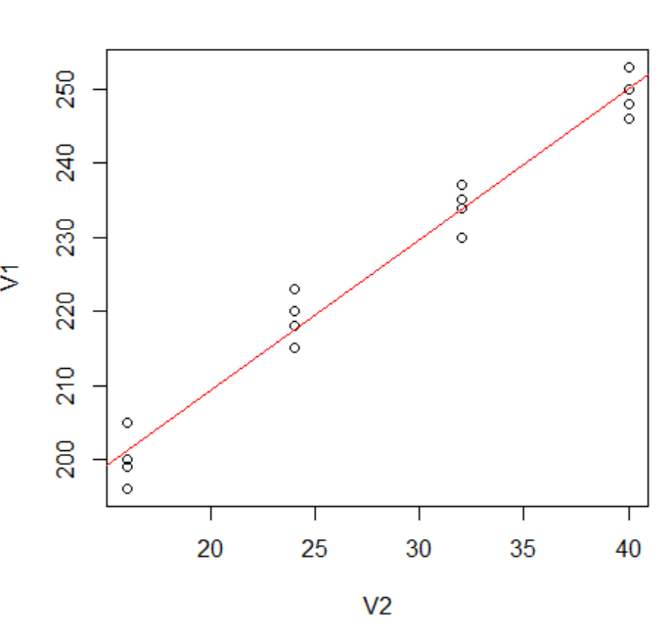

From the figure above, the linear regression function appear to give a good fit here.

**b.** The mean hardness when X=40: ¼ *(250+253+248+246) = 249.25

**c.** A point estimate of the change in mean hardness when X increase by 1 hour = 2.03

**1.26**

**a.** The residuals are as follows:

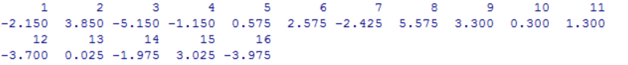

Yes, they sum to zero in accord with (1.17).

**b.** Estimate σ^2=10.46, Estimate σ=3.23, expressed in Brinell units.

**1.42**

**a.**



We use the equation to estimate the variance σ^2. Therefore, Sum((Yi – β1*Xi)^2)=(6-2)*16=64

Sum(Yi)- β1*Sum(Xi)=8

β1 = (Sum(Yi) – 8)/Sum(Xi) =17.87

**b.** In order to find the largest likelihood function, we just need to find β1 to get least squares: Q=Sum((Yi – β1*Xi)^2). For β1=17,18,19, Q=1696, 42, 2248. Therefore, in these three numbers, when β1=18, we get largest likelihood.

**c.** b1=17.93. This estimate is quite close to the results in part(b)

**d.**

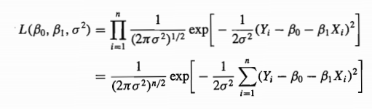

Here β 0=0, σ^2=16, n=6. The graphics of likelihood function is as follows:

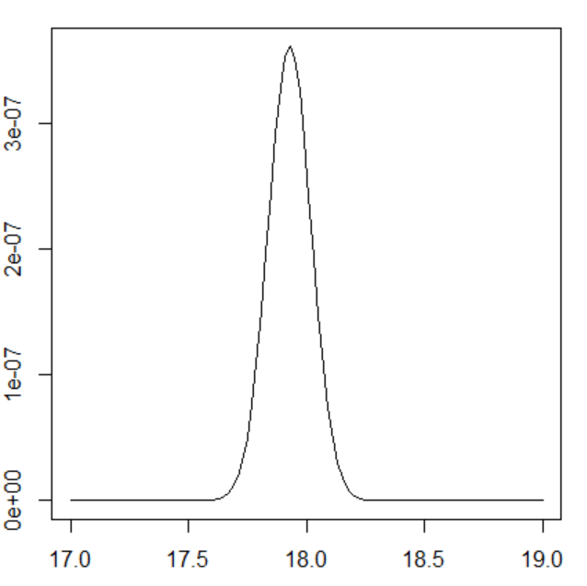

Yes. The point at which the likelihood function is maximized in the above figure corresponds to the maximum likelihood estimate found in part (c).