1. The following is the plot of x, I find many observations of x have the same value.

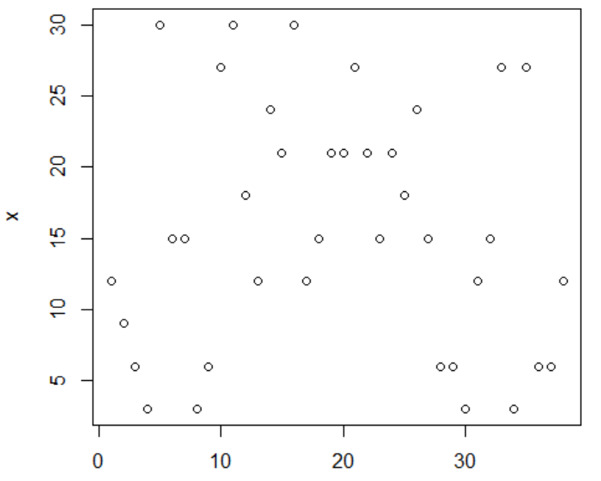

The following is plot y verses x, I find that when x equals, the values of y are close. I also find that y seems to have positive linear relationship with x.

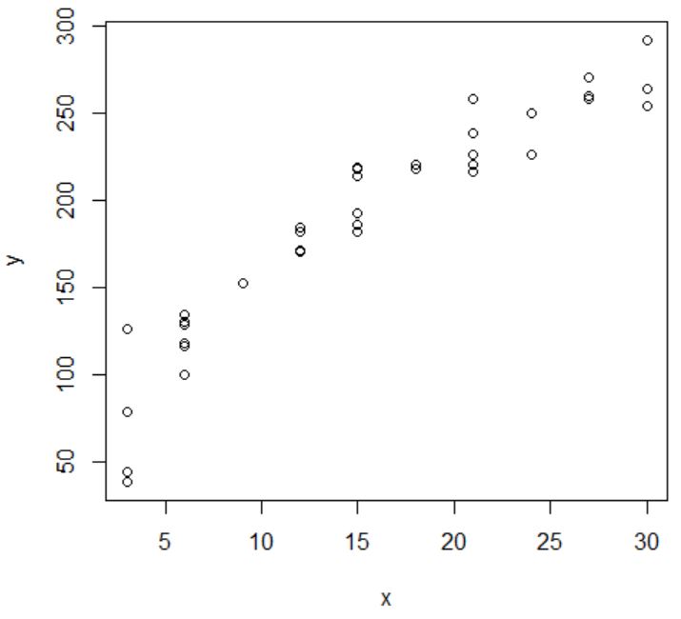

(b)

**Lack of fit test:**

For testing the appropriateness of a linear regression relation, the alternatives are:

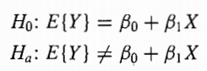

Decision rules here are:

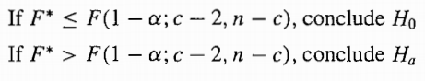

SSE=17595

SSPE=9617

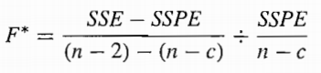=2.904

If the levels of significance is to be α=0.01, we require F(0.99;8,28)=3.226. So F*<3.226, we conclude H0, the regression function is linear.

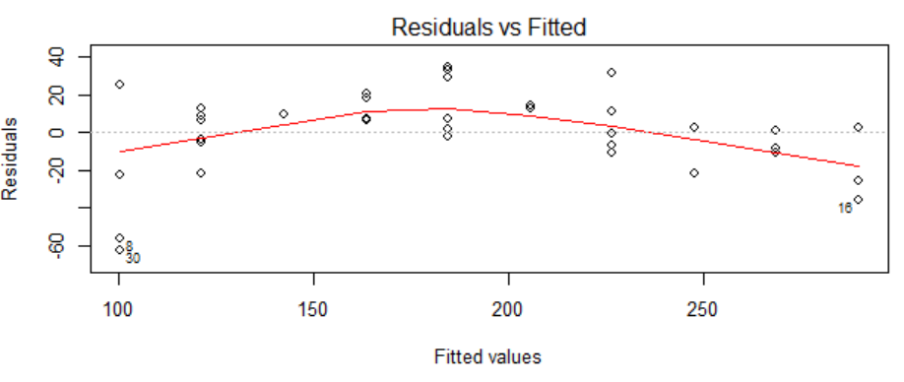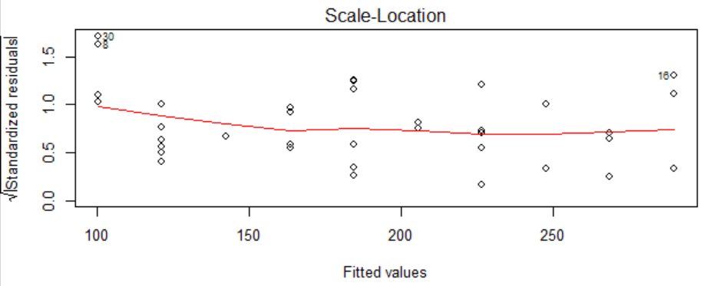

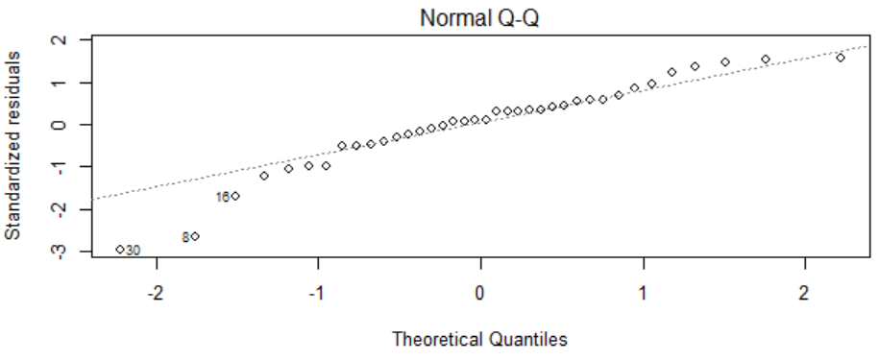

The residuals analysis indicates the need for a curvilinear regression function from the linear regression model.

c. lamda =1

d.

y=79.34+7.01x

e. 7.01

f. yes. Yhat=

g. y=-269.94+273.14*x^0.2