**Assignment 2_part 2**

1. 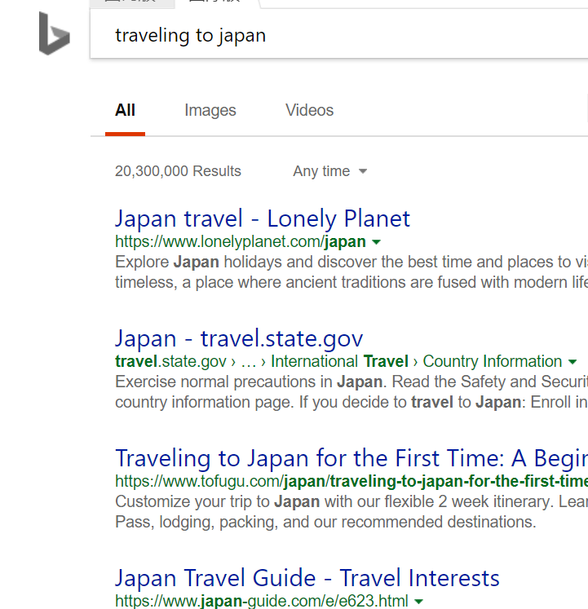investigating Bing:
2. 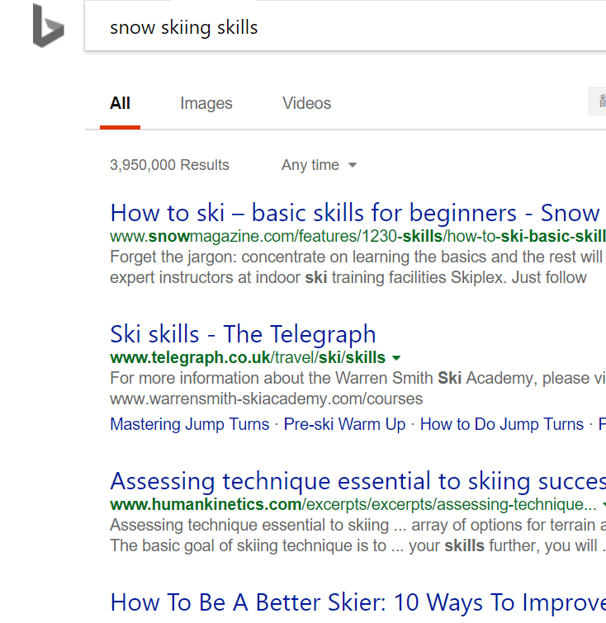Yes, it uses stemming. Because when I put in ‘travelling to japan’, most top search result include travel other than travelling. Another example is when I put in ‘snow skiing skills’, top search result include ski other than skiing.
3. Yes, it filters stop words. For example, I put in ‘it is a very beautiful place in hong kong’. Top search results filter out stop words like ‘is’, ‘it’ and ‘a’.

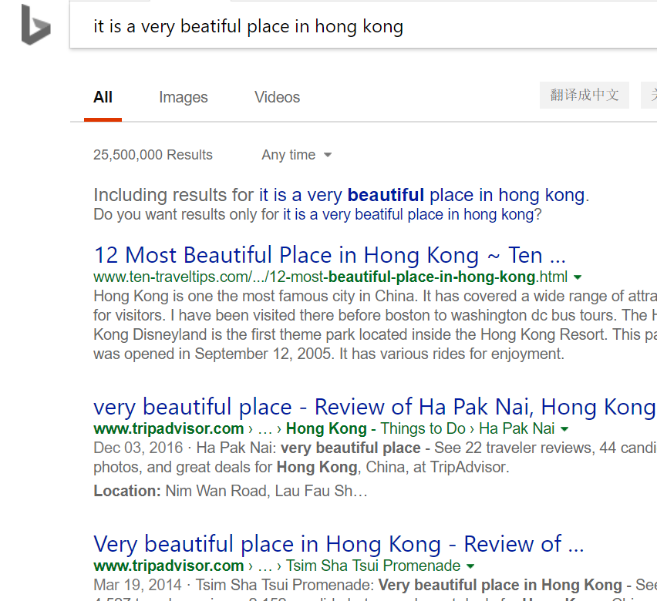

1. Yes, it uses spelling correction. When I search ‘genet algoritm’, there are spelling errors in 2 words and Bing corrected the spelling automatically, then put out information about genetic algorithm. When I put in ‘beartiful life stye’, Bing put out the corrected information about ‘beautiful lifestyle’.

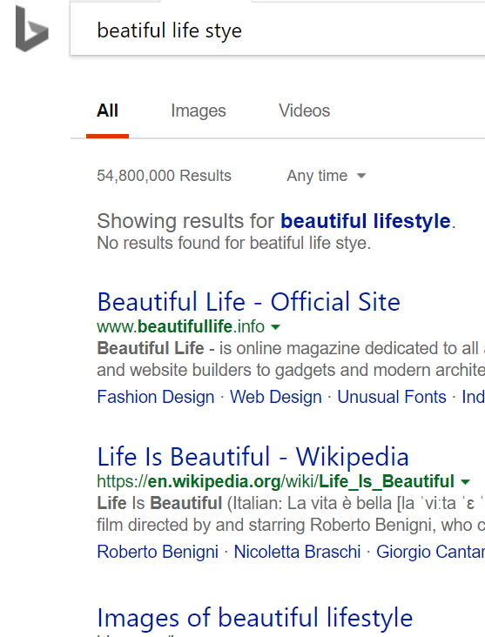

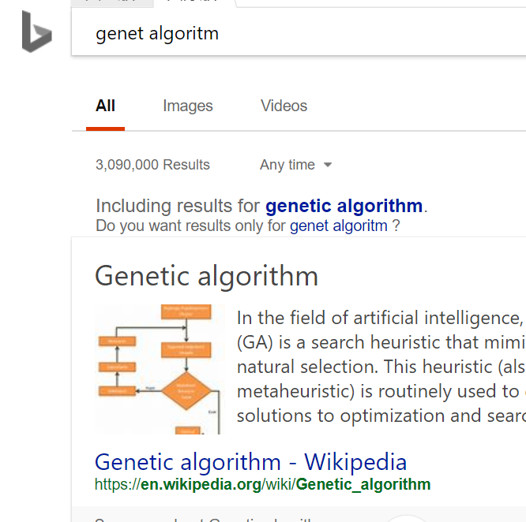

2.

1. Precision: 14/(14+16)=46.7%
2. Recall: 14/80=17.5%