After calculating tf-idf vectors on each document’s content, I randomly choose k vectors as initial centers.

For each document, I calculate the Euclidean distance between this document and each center, then assign the document to the cluster with nearest distance. Next, I recalculate each center by meaning all the document’s vectors which belong to this cluster. Repeat above two steps till the center do not change. I use abs(newCenters-centers).sum() as stopping criteria of k-means clustering. The reason is when this criteria is very small, all the centers and each document’s cluster do not change obviously anymore.

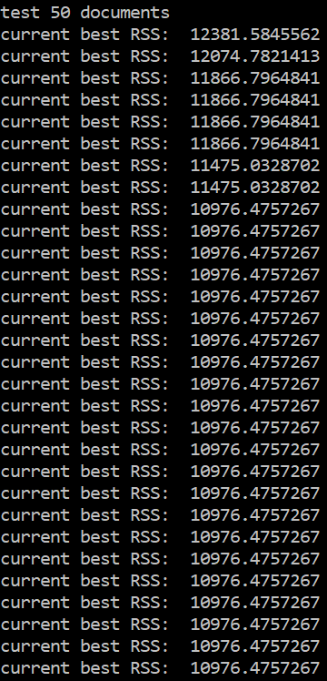My restart number is 30. In each restart, I calculate RSS and record the current best RSS. I select this number because when I restart 30 times, the best RSS can usually decrease to the point I get when I restart 100 times.

