计算机体系结构加速作业
由于代码太大,要下载代码请在链接：https://pan.baidu.com/s/1EpixlLd8tJprQX6yJXi0qg 下载
提取码：pltp

使用TensorRT加速yolov5模型检测图片中行人速度
具体过程:
1.generate .wts from pytorch with .pt, or download .wts from model zoo
git clone -b v5.0 https://github.com/ultralytics/yolov5.git
git clone https://github.com/wang-xinyu/tensorrtx.git
// download https://github.com/ultralytics/yolov5/releases/download/v5.0/yolov5s.pt
cp {tensorrtx}/yolov5/gen_wts.py {ultralytics}/yolov5
cd {ultralytics}/yolov5
python gen_wts.py -w yolov5s.pt -o yolov5s.wts
// a file 'yolov5s.wts' will be generated.
2.build tensorrtx/yolov5 and run
cd {tensorrtx}/yolov5/
// update CLASS_NUM in yololayer.h if your model is trained on custom dataset
mkdir build
cd build
cp {ultralytics}/yolov5/yolov5s.wts {tensorrtx}/yolov5/build
cmake ..
make
sudo ./yolov5 -s [.wts] [.engine] [s/m/l/x/s6/m6/l6/x6 or c/c6 gd gw] // serialize model to plan file
sudo ./yolov5 -d [.engine] [image folder] // deserialize and run inference, the images in [image folder] will be processed.
// For example yolov5s
sudo ./yolov5 -s yolov5s.wts yolov5s.engine s
sudo ./yolov5 -d yolov5s.engine ../samples
// For example Custom model with depth_multiple=0.17, width_multiple=0.25 in yolov5.yaml
sudo ./yolov5 -s yolov5_custom.wts yolov5.engine c 0.17 0.25
sudo ./yolov5 -d yolov5.engine ../samples

3.check the images generated, as follows. _zidane.jpg and _bus.jpg

4.optional, load and run the tensorrt model in python
// install python-tensorrt, pycuda, etc.
// ensure the yolov5s.engine and libmyplugins.so have been built
python yolov5_trt.py

结果:
加速前:
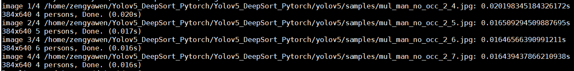
加速后:
