浙江工商大学
计算机与信息工程学院实验报告（1）
课程名称： Windows高级编程 姓 名： 罗金荣 学 号： 1712190120
指导教师： 杨文武 班 级： 计科1701 日 期： 2018/9/28
━━━━━━━━━━━━━━━━━━━━━━━━━━━━━━━━━━━━━━━
实验内容及要求：
见附件1
要求：请同学把解决问题方案、步骤、程序框图、调试好的程序及存在的问题写在下面（不够可以附页）。

//3-1
点击前：
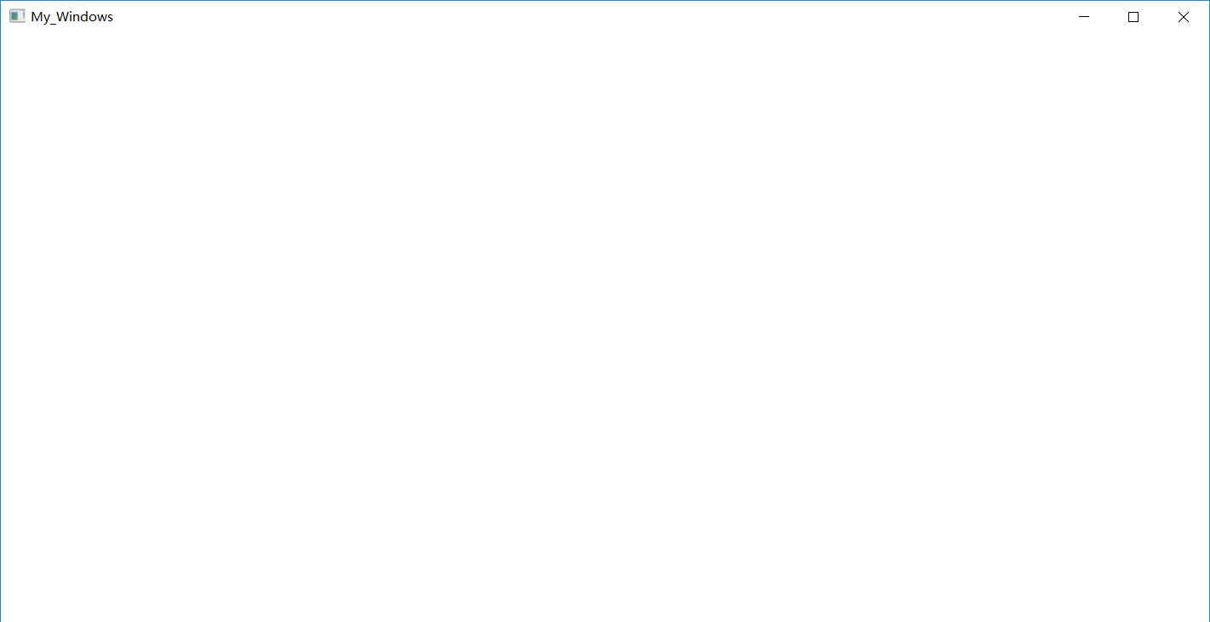
点击后：
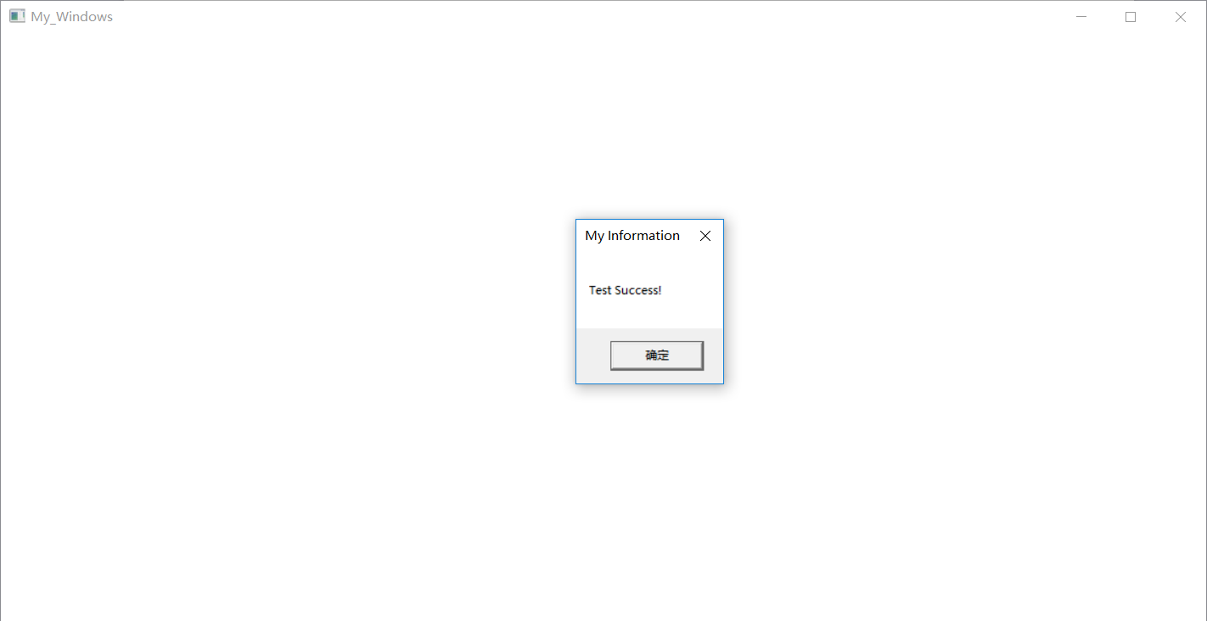
- #include<windows.h> //包含应用程序中所需的数据类型和数据结构的定义
- #include<tchar.h>
- HWND hwnd;
- MSG Msg;
- WNDCLASSEX wndclass;
- TCHAR lpszClassName[] = "窗口"; //窗口类名
- TCHAR lpszTitle[] = "My_Windows"; //窗口标题名

- ATOM MyRegisterClass(HINSTANCE hInstance);//注册窗口函数

- BOOL Create(HINSTANCE hInstance, int nCmdShow);//创建窗口实例函数

- int Run(); //窗口消息循环函数

- LRESULT CALLBACK WndProc(HWND, UINT, WPARAM, LPARAM); //窗口函数说明

- void OnLButtonDown(HWND hwnd, UINT message, WPARAM wparam, LPARAM lparam);//左键点击处理

- //--------------- 以下初始化窗口类 ----------------------
- int WINAPI WinMain(HINSTANCE hInstance,
- HINSTANCE hPrevInst, LPSTR lpszCmdLine, int nCmdShow)
- {
- //MyRegisterClass(hInstance);
- Create(hInstance, nCmdShow);

- Run();
- }

- //------------注册窗口函数--------------------------------------
- ATOM MyRegisterClass(HINSTANCE hInstance) {

- //窗口类的定义
- wndclass.cbSize = sizeof(WNDCLASSEX);
- wndclass.style = 0; //窗口类型为缺省类型
- wndclass.lpfnWndProc = WndProc; //定义窗口处理函数
- wndclass.cbClsExtra = 0; //窗口类无扩展
- wndclass.cbWndExtra = 0; //窗口实例无扩展
- wndclass.hInstance = hInstance; //当前实例句柄
- wndclass.hIcon = LoadIcon(NULL, IDI_APPLICATION);
- //窗口的最小化图标为缺省图标
- wndclass.hCursor = LoadCursor(NULL, IDC_ARROW);
- //窗口采用箭头光标
- wndclass.hbrBackground = (HBRUSH)GetStockObject(WHITE_BRUSH);
- //窗口背景为白色
- wndclass.lpszMenuName = NULL; //窗口中无菜单
- wndclass.lpszClassName = lpszClassName;
- wndclass.hIconSm = LoadIcon(wndclass.hInstance, MAKEINTRESOURCE(IDI_APPLICATION));

- //窗口类名为"窗口"
- //--------------- 以下进行窗口类的注册 -------
- if (!RegisterClassEx(&wndclass))//如果注册失败则发出警告
- {
- MessageBeep(0);
- MessageBox(NULL, _T("窗口注册失败！"), _T("窗口注册"), NULL);
- return FALSE;
- }
- return TRUE;

- }

- //------------创建窗口实例函数----------------------------------
- BOOL Create(HINSTANCE hInstance, int nCmdShow) {
- //-------------- 窗口注册 -----------------------
- if (!MyRegisterClass(hInstance)) {
- return FALSE;
- }
- hwnd = CreateWindow(
- lpszClassName, //窗口类名
- lpszTitle, //窗口实例的标题名
- WS_OVERLAPPEDWINDOW, //窗口的风格
- CW_USEDEFAULT,
- CW_USEDEFAULT, //窗口左上角坐标为缺省值
- CW_USEDEFAULT,
- CW_USEDEFAULT, //窗口的高和宽为缺省值
- NULL, //此窗口无父窗口
- NULL, //此窗口无主菜单
- hInstance, //创建此窗口的应用程序的当前句柄
- NULL //不使用该值
- );
- //--------------- 显示窗口 ----------------------
- ShowWindow(hwnd, nCmdShow);
- //-------------- 绘制用户区 ---------------------
- UpdateWindow(hwnd);
- }

- //------------窗口消息循环函数----------------------------------
- int Run() {
- while (GetMessage(&Msg, NULL, 0, 0))
- {
- TranslateMessage(&Msg);
- DispatchMessage(&Msg);
- }
- return Msg.wParam;
- }

- //------------窗口消息处理函数----------------------------------
- LRESULT CALLBACK WndProc(HWND hwnd, UINT message, WPARAM wParam, LPARAM lParam)
- {
- switch (message)
- {
- case WM_DESTROY:
- PostQuitMessage(0);
- case WM_LBUTTONDOWN:
- OnLButtonDown(hwnd, message, wParam, lParam);
- default: //缺省时采用系统消息缺省处理函数
- return DefWindowProc(hwnd, message, wParam, lParam);
- }
- return(0);
- }

- void OnLButtonDown(HWND hwnd, UINT message, WPARAM wparam, LPARAM lparam)
- {
- MessageBox(hwnd, "Test Success!","My Information",MB_OK);
- }

//4-1
点击前：
点击后：
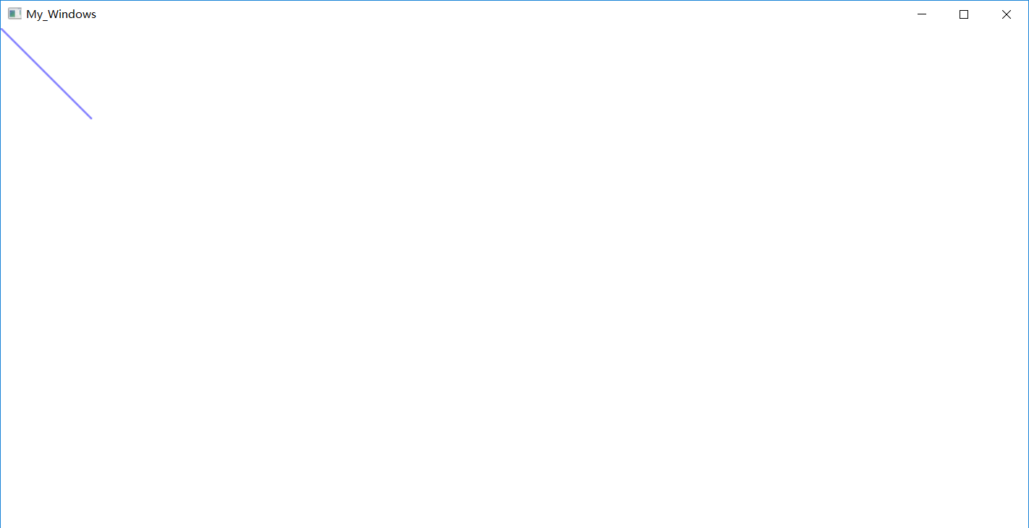
最小化重新打开：
- #include<windows.h> //包含应用程序中所需的数据类型和数据结构的定义
- #include<tchar.h>
- HWND hwnd;
- MSG Msg;
- WNDCLASSEX wndclass;
- TCHAR lpszClassName[] = "窗口"; //窗口类名
- TCHAR lpszTitle[] = "My_Windows"; //窗口标题名

- ATOM MyRegisterClass(HINSTANCE hInstance);//注册窗口函数

- BOOL Create(HINSTANCE hInstance, int nCmdShow);//创建窗口实例函数

- int Run(); //窗口消息循环函数

- LRESULT CALLBACK WndProc(HWND, UINT, WPARAM, LPARAM); //窗口函数说明

- void OnLButtonDown(HWND hwnd, UINT message, WPARAM wparam, LPARAM lparam);//左键点击处理

- //--------------- 以下初始化窗口类 ----------------------
- int WINAPI WinMain(HINSTANCE hInstance,
- HINSTANCE hPrevInst, LPSTR lpszCmdLine, int nCmdShow)
- {
- //MyRegisterClass(hInstance);
- Create(hInstance, nCmdShow);

- Run();
- }

- //------------注册窗口函数--------------------------------------
- ATOM MyRegisterClass(HINSTANCE hInstance) {

- //窗口类的定义
- wndclass.cbSize = sizeof(WNDCLASSEX);
- wndclass.style = 0; //窗口类型为缺省类型
- wndclass.lpfnWndProc = WndProc; //定义窗口处理函数
- wndclass.cbClsExtra = 0; //窗口类无扩展
- wndclass.cbWndExtra = 0; //窗口实例无扩展
- wndclass.hInstance = hInstance; //当前实例句柄
- wndclass.hIcon = LoadIcon(NULL, IDI_APPLICATION);
- //窗口的最小化图标为缺省图标
- wndclass.hCursor = LoadCursor(NULL, IDC_ARROW);
- //窗口采用箭头光标
- wndclass.hbrBackground = (HBRUSH)GetStockObject(WHITE_BRUSH);
- //窗口背景为白色
- wndclass.lpszMenuName = NULL; //窗口中无菜单
- wndclass.lpszClassName = lpszClassName;
- wndclass.hIconSm = LoadIcon(wndclass.hInstance, MAKEINTRESOURCE(IDI_APPLICATION));

- //窗口类名为"窗口"
- //--------------- 以下进行窗口类的注册 -------
- if (!RegisterClassEx(&wndclass))//如果注册失败则发出警告
- {
- MessageBeep(0);
- MessageBox(NULL, _T("窗口注册失败！"), _T("窗口注册"), NULL);
- return FALSE;
- }
- return TRUE;

- }

- //------------创建窗口实例函数----------------------------------
- BOOL Create(HINSTANCE hInstance, int nCmdShow) {
- //-------------- 窗口注册 -----------------------
- if (!MyRegisterClass(hInstance)) {
- return FALSE;
- }
- hwnd = CreateWindow(
- lpszClassName, //窗口类名
- lpszTitle, //窗口实例的标题名
- WS_OVERLAPPEDWINDOW, //窗口的风格
- CW_USEDEFAULT,
- CW_USEDEFAULT, //窗口左上角坐标为缺省值
- CW_USEDEFAULT,
- CW_USEDEFAULT, //窗口的高和宽为缺省值
- NULL, //此窗口无父窗口
- NULL, //此窗口无主菜单
- hInstance, //创建此窗口的应用程序的当前句柄
- NULL //不使用该值
- );
- //--------------- 显示窗口 ----------------------
- ShowWindow(hwnd, nCmdShow);
- //-------------- 绘制用户区 ---------------------
- UpdateWindow(hwnd);
- }

- //------------窗口消息循环函数----------------------------------
- int Run() {
- while (GetMessage(&Msg, NULL, 0, 0))
- {
- TranslateMessage(&Msg);
- DispatchMessage(&Msg);
- }
- return Msg.wParam;
- }

- //------------窗口消息处理函数----------------------------------
- LRESULT CALLBACK WndProc(HWND hwnd, UINT message, WPARAM wParam, LPARAM lParam)
- {
- HDC hDC; //定义设备环境句柄.
- HPEN hPen; //定义画笔句柄
- PAINTSTRUCT PtStr; //定义包含绘图信息的结构体变量
- switch (message)
- {
- case WM_DESTROY:
- PostQuitMessage(0);
- break;
- case WM_LBUTTONDOWN:
- OnLButtonDown(hwnd, message, wParam, lParam);
- break;
- default: //缺省时采用系统消息缺省处理函数
- return DefWindowProc(hwnd, message, wParam, lParam);
- }
- return(0);
- }

- void OnLButtonDown(HWND hwnd, UINT message, WPARAM wparam, LPARAM lparam)
- {
- HDC hDC; //定义设备环境句柄.
- HPEN hPen; //定义画笔句柄
- PAINTSTRUCT PtStr; //定义包含绘图信息的结构体变量
- hDC = GetDC(hwnd); //得到设备环境句柄
- SetMapMode(hDC, MM_ANISOTROPIC); //设置映射模式.
- SetWindowOrgEx(hDC, 0, 0, NULL); //设置坐标原点.
- hPen = CreatePen(PS_SOLID, 2, RGB(132, 129, 255)); //创新淡蓝色画笔.
- SelectObject(hDC, hPen);
- MoveToEx(hDC, 0, 0, NULL);
- LineTo(hDC, 100, 100);
- DeleteObject(hPen);
- ReleaseDC(hwnd, hDC);
- }

//4-2
点击前：
点击后：
最小化重新打开：

- #include<windows.h> //包含应用程序中所需的数据类型和数据结构的定义
- #include<tchar.h>
- HWND hwnd;
- MSG Msg;
- WNDCLASSEX wndclass;
- TCHAR lpszClassName[] = "窗口"; //窗口类名
- TCHAR lpszTitle[] = "My_Windows"; //窗口标题名
- int flag = 0;//标记是否已绘制直线

- ATOM MyRegisterClass(HINSTANCE hInstance);//注册窗口函数

- BOOL Create(HINSTANCE hInstance, int nCmdShow);//创建窗口实例函数

- int Run(); //窗口消息循环函数

- LRESULT CALLBACK WndProc(HWND, UINT, WPARAM, LPARAM); //窗口函数说明

- void OnLButtonDown(HWND hwnd, UINT message, WPARAM wparam, LPARAM lparam);//左键点击处理

- //--------------- 以下初始化窗口类 ----------------------
- int WINAPI WinMain(HINSTANCE hInstance,
- HINSTANCE hPrevInst, LPSTR lpszCmdLine, int nCmdShow)
- {
- //MyRegisterClass(hInstance);
- Create(hInstance, nCmdShow);

- Run();
- }

- //------------注册窗口函数--------------------------------------
- ATOM MyRegisterClass(HINSTANCE hInstance) {

- //窗口类的定义
- wndclass.cbSize = sizeof(WNDCLASSEX);
- wndclass.style = 0; //窗口类型为缺省类型
- wndclass.lpfnWndProc = WndProc; //定义窗口处理函数
- wndclass.cbClsExtra = 0; //窗口类无扩展
- wndclass.cbWndExtra = 0; //窗口实例无扩展
- wndclass.hInstance = hInstance; //当前实例句柄
- wndclass.hIcon = LoadIcon(NULL, IDI_APPLICATION);
- //窗口的最小化图标为缺省图标
- wndclass.hCursor = LoadCursor(NULL, IDC_ARROW);
- //窗口采用箭头光标
- wndclass.hbrBackground = (HBRUSH)GetStockObject(WHITE_BRUSH);
- //窗口背景为白色
- wndclass.lpszMenuName = NULL; //窗口中无菜单
- wndclass.lpszClassName = lpszClassName;
- wndclass.hIconSm = LoadIcon(wndclass.hInstance, MAKEINTRESOURCE(IDI_APPLICATION));

- //窗口类名为"窗口"
- //--------------- 以下进行窗口类的注册 -------
- if (!RegisterClassEx(&wndclass))//如果注册失败则发出警告
- {
- MessageBeep(0);
- MessageBox(NULL, _T("窗口注册失败！"), _T("窗口注册"), NULL);
- return FALSE;
- }
- return TRUE;

- }

- //------------创建窗口实例函数----------------------------------
- BOOL Create(HINSTANCE hInstance, int nCmdShow) {
- //-------------- 窗口注册 -----------------------
- if (!MyRegisterClass(hInstance)) {
- return FALSE;
- }
- hwnd = CreateWindow(
- lpszClassName, //窗口类名
- lpszTitle, //窗口实例的标题名
- WS_OVERLAPPEDWINDOW, //窗口的风格
- CW_USEDEFAULT,
- CW_USEDEFAULT, //窗口左上角坐标为缺省值
- CW_USEDEFAULT,
- CW_USEDEFAULT, //窗口的高和宽为缺省值
- NULL, //此窗口无父窗口
- NULL, //此窗口无主菜单
- hInstance, //创建此窗口的应用程序的当前句柄
- NULL //不使用该值
- );
- //--------------- 显示窗口 ----------------------
- ShowWindow(hwnd, nCmdShow);
- //-------------- 绘制用户区 ---------------------
- UpdateWindow(hwnd);
- }

- //------------窗口消息循环函数----------------------------------
- int Run() {
- while (GetMessage(&Msg, NULL, 0, 0))
- {
- TranslateMessage(&Msg);
- DispatchMessage(&Msg);
- }
- return Msg.wParam;
- }

- //------------窗口消息处理函数----------------------------------
- LRESULT CALLBACK WndProc(HWND hwnd, UINT message, WPARAM wParam, LPARAM lParam)
- {
- switch (message)
- {
- case WM_PAINT:
- if (flag) {
- OnLButtonDown(hwnd, message, wParam, lParam);
- }
- break;
- case WM_DESTROY:
- PostQuitMessage(0);
- break;
- case WM_LBUTTONDOWN:
- OnLButtonDown(hwnd, message, wParam, lParam);
- flag = 1;
- break;
- default: //缺省时采用系统消息缺省处理函数
- return DefWindowProc(hwnd, message, wParam, lParam);
- }
- return(0);
- }

- void OnLButtonDown(HWND hwnd, UINT message, WPARAM wparam, LPARAM lparam)
- {
- HDC hDC; //定义设备环境句柄.
- HPEN hPen; //定义画笔句柄
- PAINTSTRUCT PtStr; //定义包含绘图信息的结构体变量
- hDC = GetDC(hwnd); //得到设备环境句柄
- SetMapMode(hDC, MM_ANISOTROPIC); //设置映射模式.
- SetWindowOrgEx(hDC, 0, 0, NULL); //设置坐标原点.
- hPen = CreatePen(PS_SOLID, 2, RGB(132, 129, 255)); //创建淡蓝色画笔.
- SelectObject(hDC, hPen);
- MoveToEx(hDC, 0, 0, NULL);
- LineTo(hDC, 100, 100);
- DeleteObject(hPen);
- ReleaseDC(hwnd, hDC);
- }

//4-3
点击前：
一次点击：
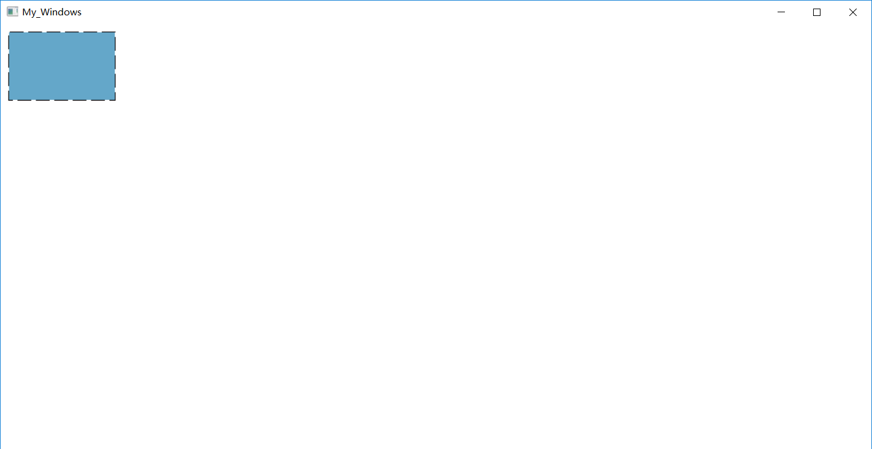
两次点击：
三次点击：
- #include<windows.h> //包含应用程序中所需的数据类型和数据结构的定义
- #include<tchar.h>
- HWND hwnd;
- MSG Msg;
- WNDCLASSEX wndclass;
- TCHAR lpszClassName[] = "窗口"; //窗口类名
- TCHAR lpszTitle[] = "My_Windows"; //窗口标题名
- BOOL bStatus = TRUE;

- ATOM MyRegisterClass(HINSTANCE hInstance);//注册窗口函数

- BOOL Create(HINSTANCE hInstance, int nCmdShow);//创建窗口实例函数

- int Run(); //窗口消息循环函数

- LRESULT CALLBACK WndProc(HWND, UINT, WPARAM, LPARAM); //窗口函数说明

- void OnLButtonDown(HWND hwnd, UINT message, WPARAM wparam, LPARAM lparam);//左键点击处理

- //--------------- 以下初始化窗口类 ----------------------
- int WINAPI WinMain(HINSTANCE hInstance,
- HINSTANCE hPrevInst, LPSTR lpszCmdLine, int nCmdShow)
- {
- //MyRegisterClass(hInstance);
- Create(hInstance, nCmdShow);

- Run();
- }

- //------------注册窗口函数--------------------------------------
- ATOM MyRegisterClass(HINSTANCE hInstance) {

- //窗口类的定义
- wndclass.cbSize = sizeof(WNDCLASSEX);
- wndclass.style = 0; //窗口类型为缺省类型
- wndclass.lpfnWndProc = WndProc; //定义窗口处理函数
- wndclass.cbClsExtra = 0; //窗口类无扩展
- wndclass.cbWndExtra = 0; //窗口实例无扩展
- wndclass.hInstance = hInstance; //当前实例句柄
- wndclass.hIcon = LoadIcon(NULL, IDI_APPLICATION);
- //窗口的最小化图标为缺省图标
- wndclass.hCursor = LoadCursor(NULL, IDC_ARROW);
- //窗口采用箭头光标
- wndclass.hbrBackground = (HBRUSH)GetStockObject(WHITE_BRUSH);
- //窗口背景为白色
- wndclass.lpszMenuName = NULL; //窗口中无菜单
- wndclass.lpszClassName = lpszClassName;
- wndclass.hIconSm = LoadIcon(wndclass.hInstance, MAKEINTRESOURCE(IDI_APPLICATION));

- //窗口类名为"窗口"
- //--------------- 以下进行窗口类的注册 -------
- if (!RegisterClassEx(&wndclass))//如果注册失败则发出警告
- {
- MessageBeep(0);
- MessageBox(NULL, _T("窗口注册失败！"), _T("窗口注册"), NULL);
- return FALSE;
- }
- return TRUE;

- }

- //------------创建窗口实例函数----------------------------------
- BOOL Create(HINSTANCE hInstance, int nCmdShow) {
- //-------------- 窗口注册 -----------------------
- if (!MyRegisterClass(hInstance)) {
- return FALSE;
- }
- hwnd = CreateWindow(
- lpszClassName, //窗口类名
- lpszTitle, //窗口实例的标题名
- WS_OVERLAPPEDWINDOW, //窗口的风格
- CW_USEDEFAULT,
- CW_USEDEFAULT, //窗口左上角坐标为缺省值
- CW_USEDEFAULT,
- CW_USEDEFAULT, //窗口的高和宽为缺省值
- NULL, //此窗口无父窗口
- NULL, //此窗口无主菜单
- hInstance, //创建此窗口的应用程序的当前句柄
- NULL //不使用该值
- );
- //--------------- 显示窗口 ----------------------
- ShowWindow(hwnd, nCmdShow);
- //-------------- 绘制用户区 ---------------------
- UpdateWindow(hwnd);
- }

- //------------窗口消息循环函数----------------------------------
- int Run() {
- while (GetMessage(&Msg, NULL, 0, 0))
- {
- TranslateMessage(&Msg);
- DispatchMessage(&Msg);
- }
- return Msg.wParam;
- }

- //------------窗口消息处理函数----------------------------------
- LRESULT CALLBACK WndProc(HWND hwnd, UINT message, WPARAM wParam, LPARAM lParam)
- {
- switch (message)
- {
- case WM_DESTROY:
- PostQuitMessage(0);
- break;
- case WM_LBUTTONDOWN:
- InvalidateRect(hwnd, NULL, TRUE);
- UpdateWindow(hwnd);
- OnLButtonDown(hwnd, message, wParam, lParam);
- bStatus = !bStatus;
- break;
- default: //缺省时采用系统消息缺省处理函数
- return DefWindowProc(hwnd, message, wParam, lParam);
- }
- return(0);
- }

- void OnLButtonDown(HWND hwnd, UINT message, WPARAM wparam, LPARAM lparam)
- {
- HDC hDC; //定义设备环境句柄.
- HPEN hPen; //定义画笔句柄
- HBRUSH hBrush;
- PAINTSTRUCT PtStr; //定义包含绘图信息的结构体变量
- hDC = GetDC(hwnd); //得到设备环境句柄
- if (!bStatus) {
- SetMapMode(hDC, MM_ANISOTROPIC); //设置映射模式.
- SetWindowOrgEx(hDC, 0, 0, NULL); //设置坐标原点.
- hPen = CreatePen(PS_SOLID, 2, RGB(132, 129, 255)); //创新淡蓝色画笔.
- SelectObject(hDC, hPen);
- MoveToEx(hDC, 0, 0, NULL);
- LineTo(hDC, 100, 100);
- DeleteObject(hPen);
- }
- else {
- hPen = CreatePen(PS_DASH, 1, BLACK_PEN);
- hBrush = CreateSolidBrush(RGB(100, 167, 201));
- SelectObject(hDC, hPen);
- Rectangle(hDC, 10, 10, 150, 100);
- SelectObject(hDC, hBrush);
- Rectangle(hDC, 10, 10, 150, 100);
- DeleteObject(hPen);
- DeleteObject(hBrush);
- }
- ReleaseDC(hwnd, hDC);
- }

//4-4
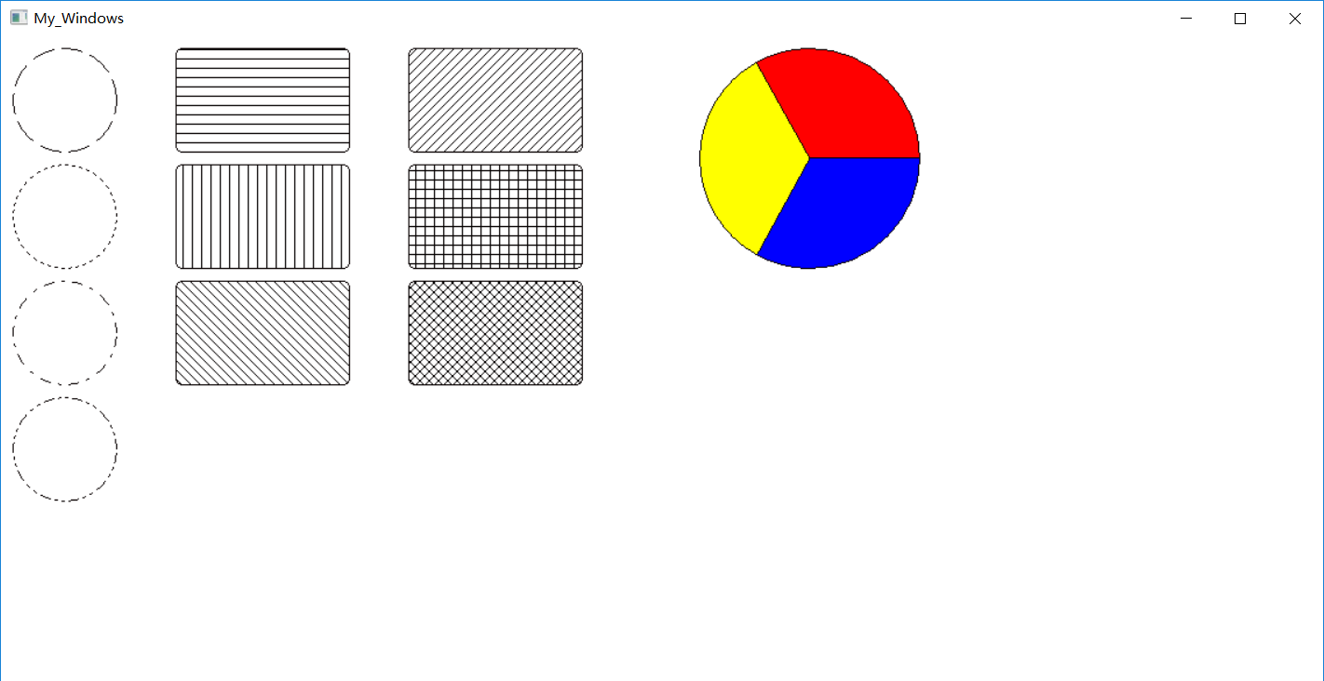
- #include<windows.h> //包含应用程序中所需的数据类型和数据结构的定义
- #include<tchar.h>
- HWND hwnd;
- MSG Msg;
- WNDCLASSEX wndclass;
- TCHAR lpszClassName[] = "窗口"; //窗口类名
- TCHAR lpszTitle[] = "My_Windows"; //窗口标题名

- ATOM MyRegisterClass(HINSTANCE hInstance);//注册窗口函数

- BOOL Create(HINSTANCE hInstance, int nCmdShow);//创建窗口实例函数

- int Run(); //窗口消息循环函数

- LRESULT CALLBACK WndProc(HWND, UINT, WPARAM, LPARAM); //窗口函数说明

- void OnLButtonDown(HWND hwnd, UINT message, WPARAM wparam, LPARAM lparam);//左键点击处理

- //--------------- 以下初始化窗口类 ----------------------
- int WINAPI WinMain(HINSTANCE hInstance,
- HINSTANCE hPrevInst, LPSTR lpszCmdLine, int nCmdShow)
- {
- //MyRegisterClass(hInstance);
- Create(hInstance, nCmdShow);

- Run();
- }

- //------------注册窗口函数--------------------------------------
- ATOM MyRegisterClass(HINSTANCE hInstance) {

- //窗口类的定义
- wndclass.cbSize = sizeof(WNDCLASSEX);
- wndclass.style = 0; //窗口类型为缺省类型
- wndclass.lpfnWndProc = WndProc; //定义窗口处理函数
- wndclass.cbClsExtra = 0; //窗口类无扩展
- wndclass.cbWndExtra = 0; //窗口实例无扩展
- wndclass.hInstance = hInstance; //当前实例句柄
- wndclass.hIcon = LoadIcon(NULL, IDI_APPLICATION);
- //窗口的最小化图标为缺省图标
- wndclass.hCursor = LoadCursor(NULL, IDC_ARROW);
- //窗口采用箭头光标
- wndclass.hbrBackground = (HBRUSH)GetStockObject(WHITE_BRUSH);
- //窗口背景为白色
- wndclass.lpszMenuName = NULL; //窗口中无菜单
- wndclass.lpszClassName = lpszClassName;
- wndclass.hIconSm = LoadIcon(wndclass.hInstance, MAKEINTRESOURCE(IDI_APPLICATION));

- //窗口类名为"窗口"
- //--------------- 以下进行窗口类的注册 -------
- if (!RegisterClassEx(&wndclass))//如果注册失败则发出警告
- {
- MessageBeep(0);
- MessageBox(NULL, _T("窗口注册失败！"), _T("窗口注册"), NULL);
- return FALSE;
- }
- return TRUE;

- }

- //------------创建窗口实例函数----------------------------------
- BOOL Create(HINSTANCE hInstance, int nCmdShow) {
- //-------------- 窗口注册 -----------------------
- if (!MyRegisterClass(hInstance)) {
- return FALSE;
- }
- hwnd = CreateWindow(
- lpszClassName, //窗口类名
- lpszTitle, //窗口实例的标题名
- WS_OVERLAPPEDWINDOW, //窗口的风格
- CW_USEDEFAULT,
- CW_USEDEFAULT, //窗口左上角坐标为缺省值
- CW_USEDEFAULT,
- CW_USEDEFAULT, //窗口的高和宽为缺省值
- NULL, //此窗口无父窗口
- NULL, //此窗口无主菜单
- hInstance, //创建此窗口的应用程序的当前句柄
- NULL //不使用该值
- );
- //--------------- 显示窗口 ----------------------
- ShowWindow(hwnd, nCmdShow);
- //-------------- 绘制用户区 ---------------------
- UpdateWindow(hwnd);
- }

- //------------窗口消息循环函数----------------------------------
- int Run() {
- while (GetMessage(&Msg, NULL, 0, 0))
- {
- TranslateMessage(&Msg);
- DispatchMessage(&Msg);
- }
- return Msg.wParam;
- }

- //------------窗口消息处理函数----------------------------------
- LRESULT CALLBACK WndProc(HWND hwnd, UINT message, WPARAM wParam, LPARAM lParam)
- {
- switch (message)
- {
- case WM_DESTROY:
- PostQuitMessage(0);
- break;
- case WM_PAINT:
- HPEN hPen;
- HDC hDC;
- PAINTSTRUCT PtStr;
- hDC = BeginPaint(hwnd, &PtStr);
- for (int i = 1; i < 5; i++) {
- hPen = CreatePen(i, 1, BLACK_PEN);
- SelectObject(hDC, hPen);
- Ellipse(hDC, 10, 100*i-90, 100, 100*(i));
- DeleteObject(hPen);
- }
- hPen = CreatePen(PS_SOLID, 1, BLACK_PEN);
- SelectObject(hDC, hPen);
- HBRUSH hbr;
- for (int i = 150; i < 400; i += 200) {
- for (int j = 1; j < 4; j++) {
- hbr = CreateHatchBrush((i / 200) * 2 + j, BLACK_BRUSH);
- SelectObject(hDC, hbr);
- RoundRect(hDC, i, j * 100 - 90, i + 150, j * 100, 10, 10);
- DeleteObject(hbr);
- }
- }
- hbr = CreateSolidBrush(RGB(255, 0, 0));
- SelectObject(hDC, hbr);
- Pie(hDC, 600, 10, 790, 200, 790, 105, 642, 10);
- DeleteObject(hbr);
- hbr = CreateSolidBrush(RGB(255, 255, 0));
- SelectObject(hDC, hbr);
- Pie(hDC, 600, 10, 790, 200, 642, 10, 643, 200);
- DeleteObject(hbr);
- hbr = CreateSolidBrush(RGB(0, 0, 255));
- SelectObject(hDC, hbr);
- Pie(hDC, 600, 10, 790, 200, 643, 200, 795, 105);
- DeleteObject(hbr);
- EndPaint(hwnd, &PtStr);
- break;
- /*case WM_LBUTTONDOWN:
- OnLButtonDown(hwnd, message, wParam, lParam);
- break;*/
- default: //缺省时采用系统消息缺省处理函数
- return DefWindowProc(hwnd, message, wParam, lParam);
- }
- return(0);
- }

- void OnLButtonDown(HWND hwnd, UINT message, WPARAM wparam, LPARAM lparam)
- {
- HDC hDC; //定义设备环境句柄.
- HPEN hPen; //定义画笔句柄
- PAINTSTRUCT PtStr; //定义包含绘图信息的结构体变量
- hDC = GetDC(hwnd); //得到设备环境句柄
- SetMapMode(hDC, MM_ANISOTROPIC); //设置映射模式.
- SetWindowOrgEx(hDC, 0, 0, NULL); //设置坐标原点.
- hPen = CreatePen(PS_SOLID, 2, RGB(132, 129, 255)); //创新淡蓝色画笔.
- SelectObject(hDC, hPen);
- MoveToEx(hDC, 0, 0, NULL);
- LineTo(hDC, 100, 100);
- DeleteObject(hPen);
- ReleaseDC(hwnd, hDC);
- }

//4-5
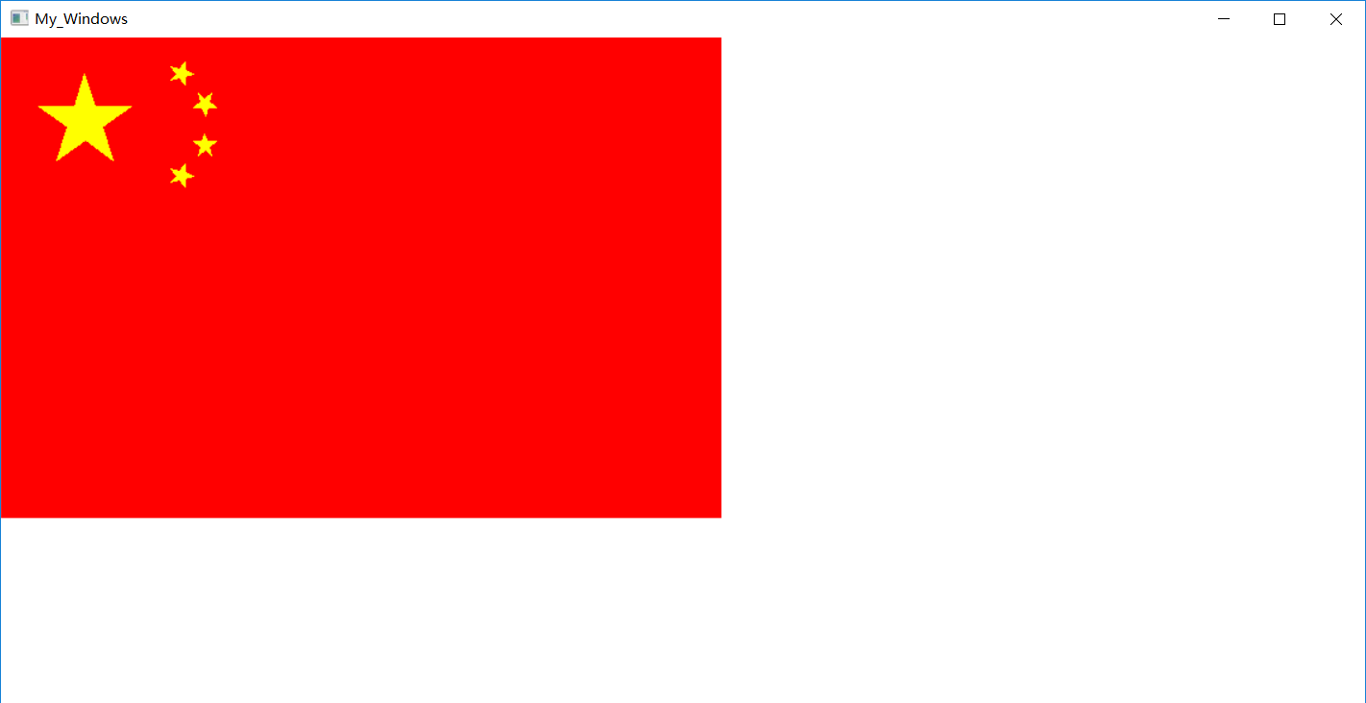
- #include<windows.h> //包含应用程序中所需的数据类型和数据结构的定义
- #include<tchar.h>
- #include<math.h>
- const double Pi = 3.1415926535;
- HWND hwnd;
- MSG Msg;
- WNDCLASSEX wndclass;
- TCHAR lpszClassName[] = "窗口"; //窗口类名
- TCHAR lpszTitle[] = "My_Windows"; //窗口标题名

- ATOM MyRegisterClass(HINSTANCE hInstance);//注册窗口函数

- BOOL Create(HINSTANCE hInstance, int nCmdShow);//创建窗口实例函数

- int Run(); //窗口消息循环函数

- LRESULT CALLBACK WndProc(HWND, UINT, WPARAM, LPARAM); //窗口函数说明

- void Draw_five_angle_star(HWND hwnd, HDC hDC, double Out_r, int c_x, int c_y, double xie);//绘制五角星
- //--------------- 以下初始化窗口类 ----------------------
- int WINAPI WinMain(HINSTANCE hInstance,
- HINSTANCE hPrevInst, LPSTR lpszCmdLine, int nCmdShow)
- {
- //MyRegisterClass(hInstance);
- Create(hInstance, nCmdShow);

- Run();
- }

- //------------注册窗口函数--------------------------------------
- ATOM MyRegisterClass(HINSTANCE hInstance) {

- //窗口类的定义
- wndclass.cbSize = sizeof(WNDCLASSEX);
- wndclass.style = 0; //窗口类型为缺省类型
- wndclass.lpfnWndProc = WndProc; //定义窗口处理函数
- wndclass.cbClsExtra = 0; //窗口类无扩展
- wndclass.cbWndExtra = 0; //窗口实例无扩展
- wndclass.hInstance = hInstance; //当前实例句柄
- wndclass.hIcon = LoadIcon(NULL, IDI_APPLICATION);
- //窗口的最小化图标为缺省图标
- wndclass.hCursor = LoadCursor(NULL, IDC_ARROW);
- //窗口采用箭头光标
- wndclass.hbrBackground = (HBRUSH)GetStockObject(WHITE_BRUSH);
- //窗口背景为白色
- wndclass.lpszMenuName = NULL; //窗口中无菜单
- wndclass.lpszClassName = lpszClassName;
- wndclass.hIconSm = LoadIcon(wndclass.hInstance, MAKEINTRESOURCE(IDI_APPLICATION));

- //窗口类名为"窗口"
- //--------------- 以下进行窗口类的注册 -------
- if (!RegisterClassEx(&wndclass))//如果注册失败则发出警告
- {
- MessageBeep(0);
- MessageBox(NULL, _T("窗口注册失败！"), _T("窗口注册"), NULL);
- return FALSE;
- }
- return TRUE;

- }

- //------------创建窗口实例函数----------------------------------
- BOOL Create(HINSTANCE hInstance, int nCmdShow) {
- //-------------- 窗口注册 -----------------------
- if (!MyRegisterClass(hInstance)) {
- return FALSE;
- }
- hwnd = CreateWindow(
- lpszClassName, //窗口类名
- lpszTitle, //窗口实例的标题名
- WS_OVERLAPPEDWINDOW, //窗口的风格
- CW_USEDEFAULT,
- CW_USEDEFAULT, //窗口左上角坐标为缺省值
- CW_USEDEFAULT,
- CW_USEDEFAULT, //窗口的高和宽为缺省值
- NULL, //此窗口无父窗口
- NULL, //此窗口无主菜单
- hInstance, //创建此窗口的应用程序的当前句柄
- NULL //不使用该值
- );
- //--------------- 显示窗口 ----------------------
- ShowWindow(hwnd, nCmdShow);
- //-------------- 绘制用户区 ---------------------
- UpdateWindow(hwnd);
- }

- //------------窗口消息循环函数----------------------------------
- int Run() {
- while (GetMessage(&Msg, NULL, 0, 0))
- {
- TranslateMessage(&Msg);
- DispatchMessage(&Msg);
- }
- return Msg.wParam;
- }

- //------------窗口消息处理函数----------------------------------
- LRESULT CALLBACK WndProc(HWND hwnd, UINT message, WPARAM wParam, LPARAM lParam)
- {
- HDC hDC; //定义设备环境句柄.
- HPEN hPen; //定义画笔句柄
- HBRUSH hbr; //定义画刷句柄
- PAINTSTRUCT PtStr; //定义包含绘图信息的结构体变量
- switch (message)
- {
- case WM_DESTROY:
- PostQuitMessage(0);
- break;
- case WM_PAINT:
- hDC = BeginPaint(hwnd, &PtStr);//获取设备环境
- SetMapMode(hDC, MM_ANISOTROPIC);//设置映射模式
- SetWindowOrgEx(hDC, 0, 0, NULL);//设置坐标原点
- hPen = CreatePen(PS_SOLID, 1, RGB(255, 0, 0));
- SelectObject(hDC, hPen);
- hbr = CreateSolidBrush(RGB(255, 0, 0));
- SelectObject(hDC, hbr);
- Rectangle(hDC, 0, 0, 600, 400);//画底
- DeleteObject(hPen);
- DeleteObject(hbr);

- hPen = CreatePen(PS_SOLID, 1, RGB(255, 255, 0));
- SelectObject(hDC, hPen);
- hbr = CreateSolidBrush(RGB(255, 255, 0));
- SelectObject(hDC, hbr);
- Draw_five_angle_star(hwnd, hDC, 40, 70, 70, -18);//画星星
- Draw_five_angle_star(hwnd, hDC, 10, 150, 30, 0);
- Draw_five_angle_star(hwnd, hDC, 10, 170, 55, 18);
- Draw_five_angle_star(hwnd, hDC, 10, 170, 90, -18);
- Draw_five_angle_star(hwnd, hDC, 10, 150, 115, 0);
- DeleteObject(hPen);
- DeleteObject(hbr);
- EndPaint(hwnd, &PtStr);
- break;
- default: //缺省时采用系统消息缺省处理函数
- return DefWindowProc(hwnd, message, wParam, lParam);
- }
- return(0);
- }

- void Draw_five_angle_star(HWND hwnd, HDC hDC, double Out_r, int c_x, int c_y, double xie) {
- double In_r;//内部正五边形外接圆得半径
- POINT lpOuterPoints[5], lpInnerPoints[5];//定义外,内正五边形点结构数组.
- POINT lpTriangle[3]; //定义三角形点结构数组.
- In_r = Out_r * sin(0.1*Pi) / sin(126.0 / 180 * Pi);//根据外圆半径计算内圆半径
- //计算内外正五边形的点坐标.
- for (int i = 0; i < 5; i++)
- {
- lpOuterPoints[i].x = (long)((Out_r*cos(i*72.0 / 180 * Pi + xie / 180 * Pi)) + c_x);
- lpOuterPoints[i].y = (long)((Out_r*sin(i*72.0 / 180 * Pi + xie / 180 * Pi)) + c_y);
- lpInnerPoints[i].x = (long)((In_r*cos(i*72.0 / 180 * Pi + (xie + 36.0) / 180 * Pi)) + c_x);
- lpInnerPoints[i].y = (long)((In_r*sin(i*72.0 / 180 * Pi + (xie + 36.0) / 180 * Pi)) + c_y);
- }
- //Polygon(hDC, lpOuterPoints, 5); //画正五边形.
- //填充正五边形的不同区域.
- for (int i = 0; i<5; i++)
- {
- lpTriangle[0] = lpOuterPoints[i % 5]; //生成图形中的三角形区域的坐标.
- lpTriangle[1] = lpInnerPoints[i % 5];
- lpTriangle[2] = lpOuterPoints[(i + 1) % 5];
- //Polygon(hDC, lpTriangle, 3); //画三角形区域.
- lpTriangle[2] = lpInnerPoints[(i + 4) % 5]; //生成图形中的三角形区域的坐标.
- Polygon(hDC, lpTriangle, 3); //画三角形区域.
- }
- Polygon(hDC, lpInnerPoints, 5); //画中心的五边形.

- //用不同种颜色的画笔来绘制五角星.
- MoveToEx(hDC, lpOuterPoints[0].x, lpOuterPoints[0].y, NULL);
- for (int i = 1; i <= 5; i++)
- {
- //LineTo(hDC, lpOuterPoints[(i + 2) % 5].x, lpOuterPoints[(i + 2) % 5].y);
- }
- }

//C-1
Input
10
1 2 3 4 5 6 7 8 9 0
Output
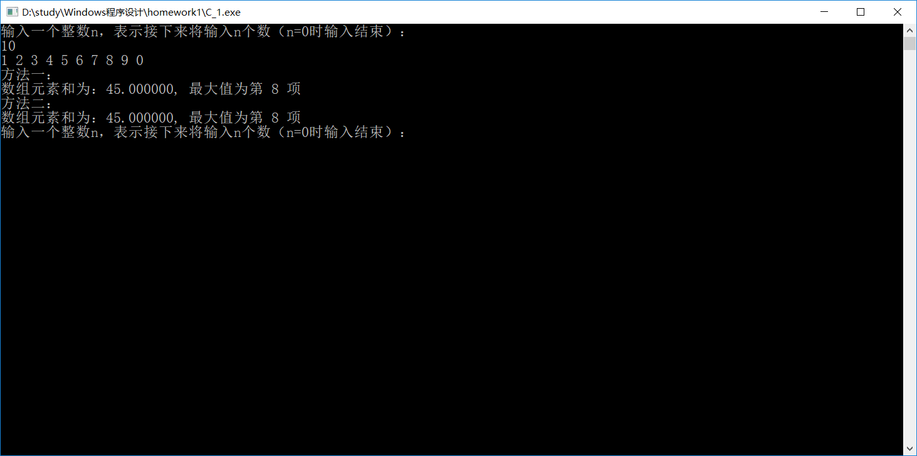
- #include<stdio.h>

- const int maxn = 105;
- int n, max_index;
- double arr[maxn], max, sum;

- void GetSumAndMaxIndex() {//全局变量处理
- max = sum = arr[0];
- max_index = 0;
- for (int i = 1; i < n; i++) {
- sum += arr[i];
- if (max < arr[i]) {
- max = arr[i];
- max_index = i;
- }
- }
- }

- double GetSumAndMaxIndex(double a[], int length, int* index) {//指针传参处理
- double sum = a[0], max = a[0];
- *index = 0;
- for (int i = 1; i < length; i++) {
- sum += a[i];
- if (max < a[i]) {
- max = arr[i];
- *index = i;
- }
- }
- return sum;
- }

- int main() {
- while (printf("输入一个整数n，表示接下来将输入n个数（n=0时输入结束）：\n"), scanf("%d", &n), n) {
- for (int i = 0; i < n; i++) {
- scanf("%lf", &arr[i]);
- }
- GetSumAndMaxIndex();
- printf("方法一：\n数组元素和为：%lf, 最大值为第 %d 项\n", sum, max_index);
- printf("方法二：\n数组元素和为：%lf, 最大值为第 %d 项\n", GetSumAndMaxIndex(arr, n, &max_index), max_index);
- }
- }

//C-2
输入当前日期：
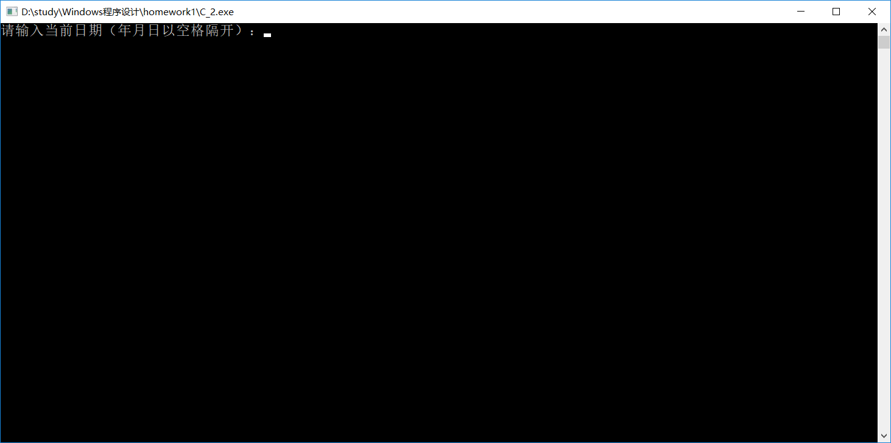
进入预定系统（预定顺序：创建顾客信息→预定房间→预定早餐）：
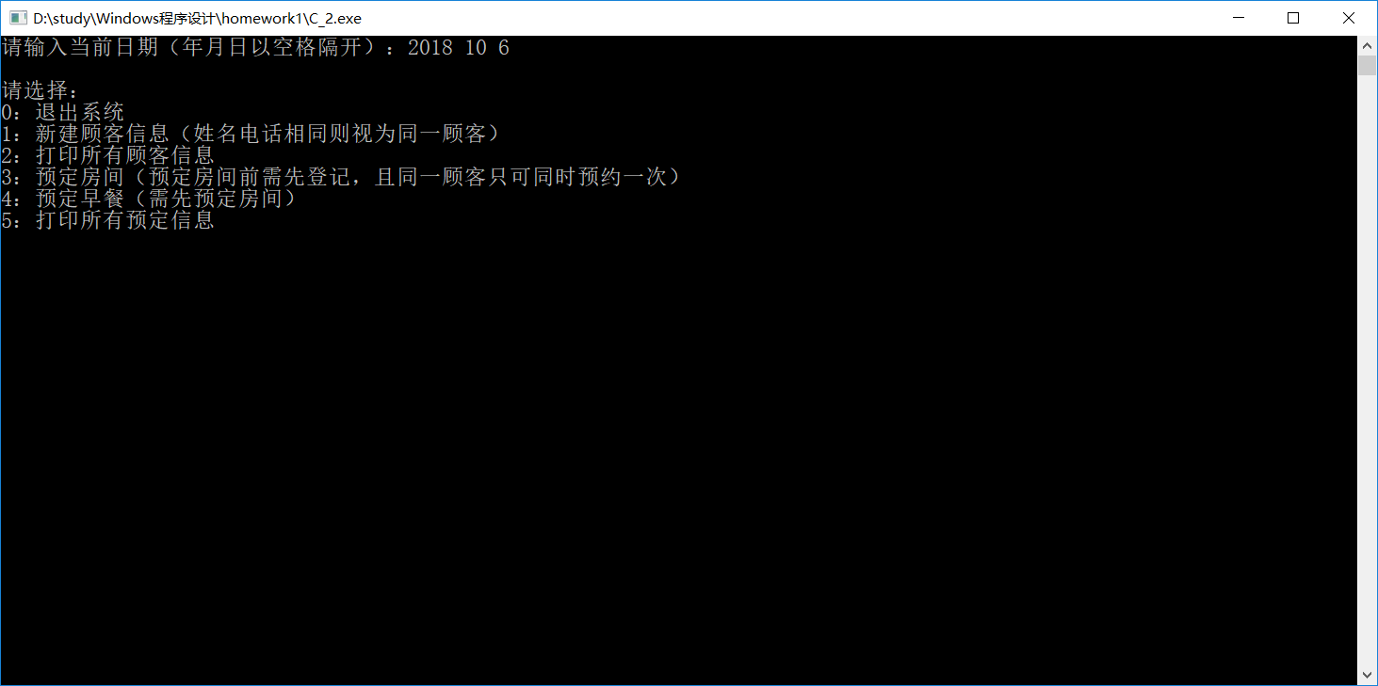
新建顾客信息：
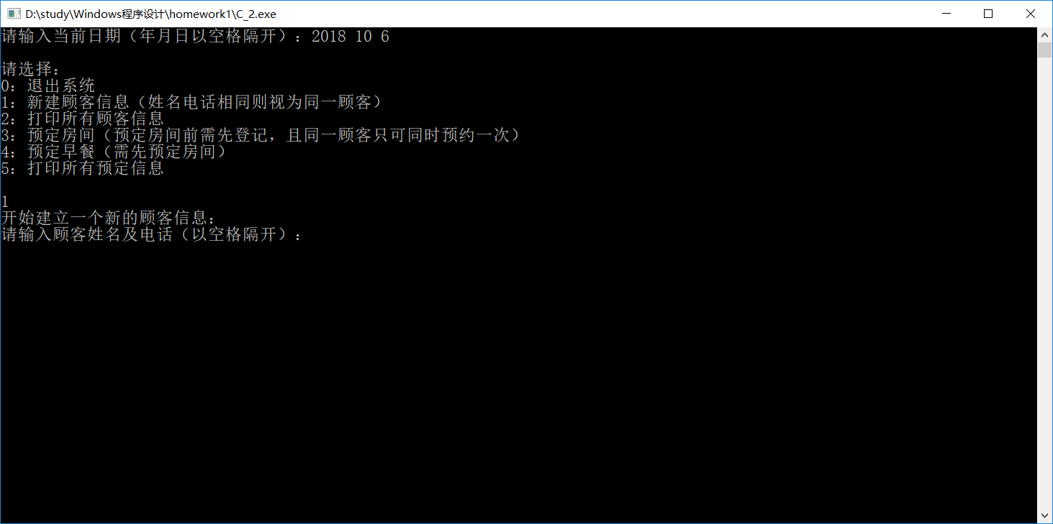
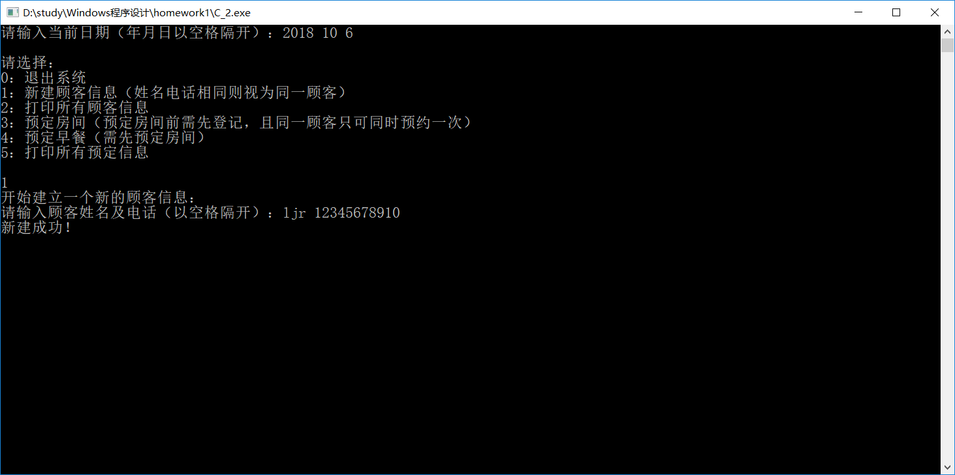
打印顾客信息：
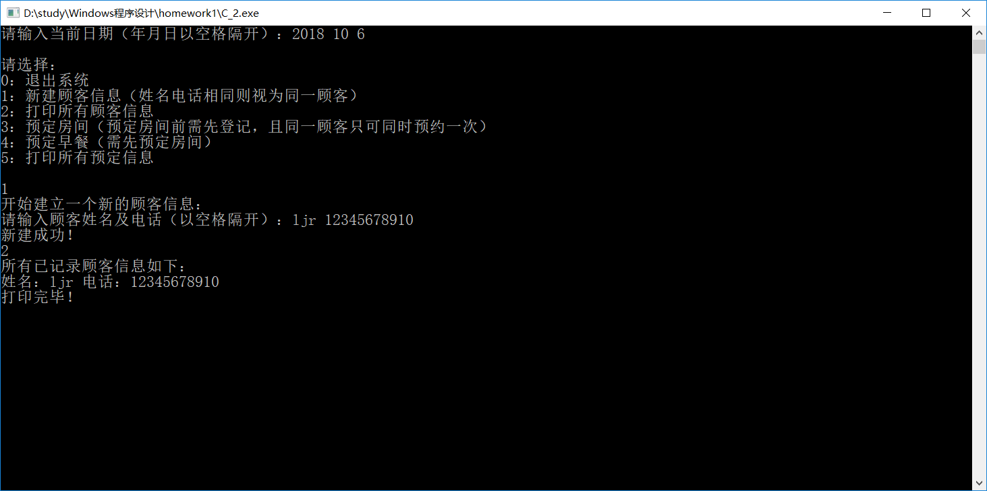
预定房间：
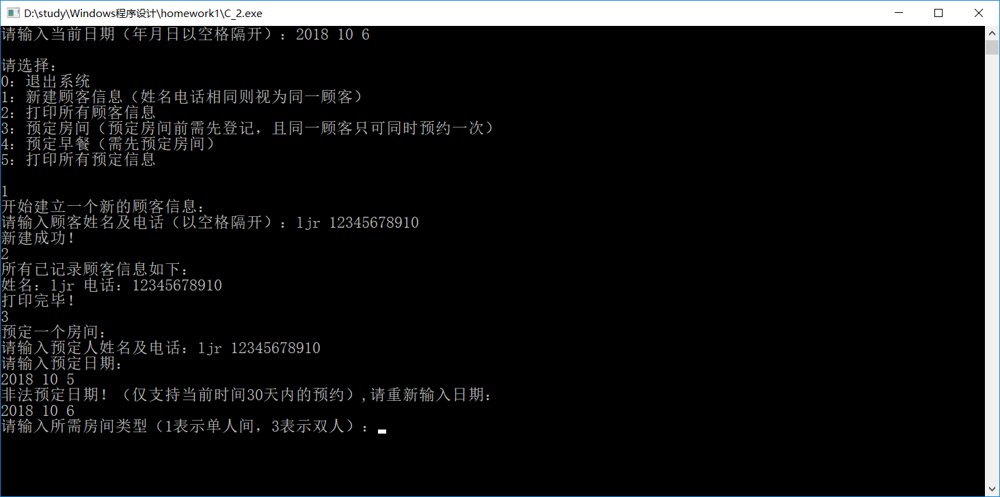
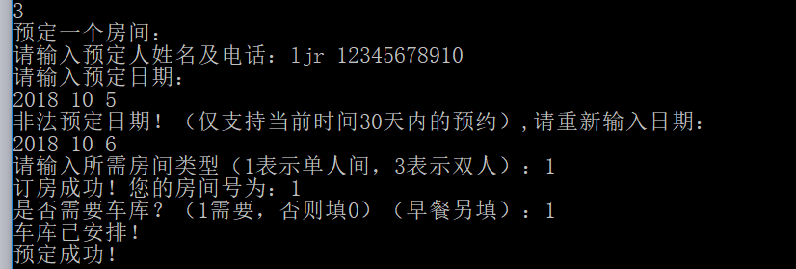
预定早餐：
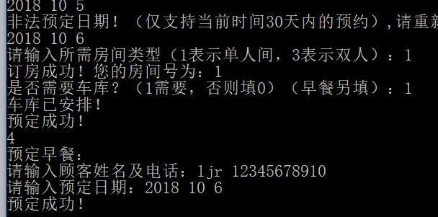
打印预定信息：
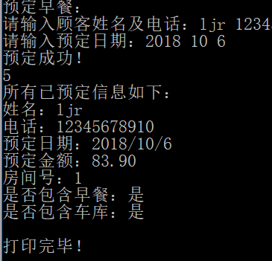
冲突已处理（包括但不限于以下）：
- 重复创建顾客信息
- 重复订房
- 房间已订满
- #include<stdio.h>
- #include<stdlib.h>
- #include<string.h>

- struct data {//存储日期，yy、mm、dd分别为年月日
- int yy, mm, dd;
- };

- struct customer {//记录顾客信息
- char name[50], Phone[20];
- struct customer *next;
- };

- struct info {//预定信息
- struct customer *cus;//顾客信息
- struct data advan_da, bre_da;//预定房间日期，预定早餐日期
- int bre, gar, room;//是否需要早餐及车库，房间号
- float money;//所需金额
- struct info *next;
- };

- struct adv {//旅馆房间预定情况
- struct data d;
- int f[5];
- }a[30];//只存储近一个月
- int mon[13] = { 0,31,29,31,30,31,30,31,31,30,31,30,31 };//每月的天数
- struct info *i_head;
- struct customer *c_head;
- struct data now;//当前时间

- int cal_d(struct data now, struct data ad);//计算两时间间隔天数（0<间隔<30的时候）

- void pre();//预处理

- void op_1();

- void op_2();

- void op_3();

- void op_4(struct data now);

- void op_5();

- int main() {
- i_head = NULL;
- c_head = NULL;
- int menu;
- pre();
- while (scanf("%d", &menu), menu) {
- switch (menu)
- {
- case 1:
- op_1();
- break;
- case 2:
- op_2();
- break;
- case 3:
- op_3();
- break;
- case 4:
- op_4(now);
- break;
- case 5:
- op_5();
- break;
- default:
- printf("操作非法，请重新输入！\n");
- break;
- }
- }
- }

- int cal_d(struct data now, struct data ad) {
- if (now.yy * 10000 + now.mm * 100 + now.dd > ad.yy * 10000 + ad.mm * 100 + ad.dd) {//判断时间先后
- return -1;
- }
- else {
- if (now.yy != ad.yy) {
- if (now.mm != 12 && ad.mm != 1) {
- return -1;
- }
- else {
- return (31 - now.dd + ad.dd);
- }
- }
- else if (ad.mm - now.mm > 1) {
- return -1;
- }
- else if (ad.mm - now.mm == 1) {
- return (mon[now.mm] - now.dd + ad.dd);
- }
- else {
- return ad.dd - now.dd;
- }
- }
- }

- void pre() {
- int flag_r = 0;
- printf("请输入当前日期（年月日以空格隔开）：");
- while (!flag_r) {
- scanf("%d%d%d", &now.yy, &now.mm, &now.dd);
- if (now.yy % 400 == 0 || (now.yy % 400 != 0 && now.yy % 4 == 0)) {//计算这一年二月天数
- mon[2] = 28;
- }
- if (now.mm < 1 || now.mm>12) {//月份不合法
- ;
- }
- else if (now.dd<1 || now.dd>mon[now.mm]) {//天数不合法
- ;
- }
- else {//日期合法
- flag_r = 1;
- }
- if (!flag_r) {
- printf("日期非法，请重新输入：");
- }
- }
- for (int i = 0; i < 30; i++) {//对近30天房间预定情况初始化
- a[i].d.yy = now.yy;
- a[i].d.mm = now.mm;
- a[i].d.dd = now.dd + i;
- if (a[i].d.dd > mon[a[i].d.mm]) {
- a[i].d.dd -= mon[a[i].d.mm];
- a[i].d.mm++;
- if (a[i].d.mm > 12) {
- a[i].d.mm -= 12;
- a[i].d.yy++;
- }
- }
- memset(a[i].f, 0, sizeof(int));
- }
- printf("\n请选择：\n0：退出系统\n1：新建顾客信息（姓名电话相同则视为同一顾客）\n2：打印所有顾客信息\n3：预定房间（预定房间前需先登记，且同一顾客只可同时预约一次）\n4：预定早餐（需先预定房间）\n5：打印所有预定信息\n\n");
- }

- void op_1() {
- printf("开始建立一个新的顾客信息：\n");
- printf("请输入顾客姓名及电话（以空格隔开）：");
- struct customer *tmp_1 = (struct customer*)malloc(sizeof(struct customer));
- struct customer *tmp = c_head;
- int flag = 0;
- char n[50], P[20];
- scanf("%s%s", n, P);
- while (tmp) {//检查用户是否存在
- if (!strcmp(n, tmp->name) && !strcmp(P, tmp->Phone)) {
- printf("该用户信息已存在，请勿重复录入！\n");
- flag = 1;
- break;
- }
- tmp = tmp->next;
- }
- if (!flag) {//不存在用户，新建
- tmp_1->next = c_head;
- c_head = tmp_1;
- strcpy(tmp_1->name, n);
- strcpy(tmp_1->Phone, P);
- printf("新建成功！\n");
- }
- }

- void op_2() {
- struct customer *tmp_2 = c_head;
- printf("所有已记录顾客信息如下：\n");
- while (tmp_2) {
- printf("姓名：%s 电话：%s\n", tmp_2->name, tmp_2->Phone);
- tmp_2 = tmp_2->next;
- }
- printf("打印完毕！\n");
- }

- void op_3() {
- printf("预定一个房间：\n");
- struct customer *ctmp = c_head;
- struct info *itmp = i_head;
- char n_3[50], P_3[20];
- int flag_3 = 0;
- printf("请输入预定人姓名及电话：");
- scanf("%s%s", n_3, P_3);
- while (itmp) {//查找该顾客是否存在预定信息
- if (!strcmp(n_3, itmp->cus->name) && !strcmp(P_3, itmp->cus->Phone)) {
- flag_3 = 1;
- break;
- }
- itmp = itmp->next;
- }
- if (!flag_3) {
- while (ctmp) {//查找是否存在该顾客信息
- if (!strcmp(n_3, ctmp->name) && !strcmp(P_3, ctmp->Phone)) {
- flag_3 = 1;
- break;
- }
- ctmp = ctmp->next;
- }
- if (flag_3) {//为该顾客创建预定信息
- itmp = (struct info*)malloc(sizeof(struct info));
- itmp->money = 0;
- itmp->next = i_head;
- i_head = itmp;
- i_head->cus = ctmp;
- /*strcpy(i_head->cus->name, ctmp->name);
- strcpy(i_head->cus->Phone, ctmp->Phone);*/
- int ri_f = 0, index;//日期是否合法
- printf("请输入预定日期：\n");
- while (scanf("%d%d%d", &itmp->advan_da.yy, &itmp->advan_da.mm, &itmp->advan_da.dd)) {
- for (int i = 0; i < 30; i++) {
- if (itmp->advan_da.yy == a[i].d.yy&&itmp->advan_da.mm == a[i].d.mm&&itmp->advan_da.dd == a[i].d.dd) {
- ri_f = 1;
- index = i;
- break;
- }
- }
- if (ri_f) {
- while (printf("请输入所需房间类型（1表示单人间，3表示双人）：")) {
- scanf("%d", &itmp->room);
- if (itmp->room != 1 && itmp->room != 3) {
- printf("输入非法！");
- }
- else {
- if (itmp->room == 1) {//判断单人房是否住满
- if (a[index].f[1] == 0) {
- a[index].f[1] = 1;
- itmp->room = 1;
- itmp->money += 49;
- }
- else if (a[index].f[2] == 0) {
- a[index].f[2] = 1;
- itmp->room = 2;
- itmp->money += 49;
- }
- else {
- printf("当日单人间住满！订单已取消！\n");
- return;
- }
- }
- else {//判断双人间是否住满
- if (a[index].f[3] == 0) {
- a[index].f[3] = 1;
- itmp->room = 3;
- itmp->money += 169;
- }
- else if (a[index].f[4] == 0) {
- a[index].f[4] = 1;
- itmp->room = 4;
- itmp->money += 169;
- }
- else {
- printf("当日双人间住满！订单已取消！\n");
- return;
- }
- }
- while (printf("订房成功！您的房间号为：%d\n是否需要车库？（1需要，否则填0）（早餐另填）：", itmp->room)) {
- scanf("%d", &itmp->gar);
- if (itmp->gar != 0 && itmp->gar != 1) {
- printf("输入非法！请重新输入（1需要，否则填0）：");
- }
- else {
- if (itmp->gar == 1) {
- itmp->money += 15;
- printf("车库已安排！\n");

- }
- printf("预定成功！\n");
- return;
- }
- }
- }
- }

- }
- else {
- printf("非法预定日期！（仅支持当前时间30天内的预约）,请重新输入日期：\n");
- }
- }
- }
- else {
- printf("未找到该顾客信息，请先创建！\n");
- }
- }
- else {
- printf("该顾客已存在预定记录，无法再次预定！\n");
- }
- }

- void op_4(struct data now) {
- printf("预定早餐：\n");
- printf("请输入顾客姓名及电话：");
- char n_4[50], P_4[20];
- int flag_4 = 0;
- struct data ad;
- scanf("%s%s", n_4, P_4);
- struct info *i_tmp_4 = i_head;
- while (i_tmp_4) {//检查该顾客是否存在订房记录
- if (!strcmp(n_4, i_tmp_4->cus->name) && !strcmp(P_4, i_tmp_4->cus->Phone)) {
- flag_4 = 1;
- break;
- }
- i_tmp_4 = i_tmp_4->next;
- }
- if (flag_4) {
- while (printf("请输入预定日期：")) {
- scanf("%d%d%d", &i_tmp_4->bre_da.yy, &i_tmp_4->bre_da.mm, &i_tmp_4->bre_da.dd);
- if (cal_d(now, i_tmp_4->bre_da) == -1 || cal_d(now, i_tmp_4->bre_da) > 30) {
- printf("输入日期非法，请重新输入");
- }
- else {
- i_tmp_4->money += 19.9;
- i_tmp_4->bre = 1;
- printf("预定成功！\n");
- break;
- }
- }
- }
- else {
- printf("未找到该顾客预定信息，请先预定房间！\n");
- }
- }

- void op_5() {
- printf("所有已预定信息如下：\n");
- struct info *i_tmp_5 = i_head;
- while (i_tmp_5) {
- printf("姓名：%s\n电话：%s\n预定日期：%d/%d/%d\n预定金额：%.2f\n房间号：%d\n是否包含早餐：%s\n是否包含车库：%s\n\n", i_tmp_5->cus->name, i_tmp_5->cus->Phone, i_tmp_5->advan_da.yy, i_tmp_5->advan_da.mm, i_tmp_5->advan_da.dd, i_tmp_5->money, i_tmp_5->room, i_tmp_5->bre==1 ? "是" : "否", i_tmp_5->gar==1 ? "是" : "否");
- i_tmp_5 = i_tmp_5->next;
- }
- printf("打印完毕！\n");
- }

