[**微软2013暑假实习生笔试题**](http://blog.csdn.net/fengbingyang/article/details/8764931)

**1. Which of the following calling convention(s) support(s) supportvariable-length parameter(e.g. printf)?**(3 Points)

    A. cdecl

    B. stdcall

    C. pascal

    D. fastcall

**2. What's the output of the following code?**(3 Points)

**[cpp]** [view plaincopy](http://blog.csdn.net/fengbingyang/article/details/8764931)

1. **class** A
2. {
3. **public**:
4. **virtual** **void** f()
5. {
6. cout<<"A::f()"<<endl;
7. }
8. **void** f() **const**
9. {
10. cout<<"A::f() const"<<endl;
11. }
12. };
14. **class** B: **public** A
15. {
16. **public**:
17. **void** f()
18. {
19. cout<<"B::f()"<<endl;
20. }
21. **void** f() **const**
22. {
23. cout<<"B::f() const"<<endl;
24. }
25. };
27. **void** g(**const** A* a)
28. {
29. a->f();
30. }
32. **int** main()
33. {
34. A* a = **new** B();
35. a->f();
36. g(a);
37. **delete** a ;
38. }

    A. B::f()B::f()const

    B. B::f()A::f()const

    C. A::f()B::f()const

    D. A::f()A::f()const

**3. What is the difference between a linked list and an array?**(3 Points)

    A. Search complexity when both are sorted

    B. Dynamically add/remove

    C. Random access efficiency

    D. Data storage type

**4. About the Thread and Process in Windows, which description(s) is(are) correct:**(3 Points)

    A. One application in OS must have one Process, but not a necessary to have one Thread

    B. The Process could have its own Stack but the thread only could share the Stack of its parent Process

    C. Thread must belongs to a Process

    D. Thread could change its belonging Process

**5. What is the output of the following code?**(3 Points)

**[cpp]** [view plaincopy](http://blog.csdn.net/fengbingyang/article/details/8764931)

1. {
2. **int** x = 10 ;
3. **int** y = 10 ;
4. x = x++ ;
5. y = ++y ;
6. printf("%d, %d\n",x,y);
7. }

    A. 10, 10

    B. 10, 11

    C. 11, 10

    D. 11, 11

**6. For the following Java or C# code**(3 Points)

**[csharp]** [view plaincopy](http://blog.csdn.net/fengbingyang/article/details/8764931)

1. **int** [][] myArray3 =
2. **new** **int**[3][]{
3. **new** **int**[3]{5,6,2},
4. **new** **int**[5]{6,9,7,8,3},
5. **new** **int**[2]{3,2}};

**What will** myArray3[2][2]

**returns?**

    A. 9

    B. 2

    C. 6

    D. overflow

**7. Please choose the right statement about const usage:**(3 Points)

    A. const int a; //const integer

    B. int const a; //const integer

    C. int const *a; //a pointer which point to const integer

    D. const int *a; //a const pointer which point to integer

    E. int const *a; // a const pointer which point to integer

**8. Given the following code:**(3 Points)

**[cpp]** [view plaincopy](http://blog.csdn.net/fengbingyang/article/details/8764931)

1. #include <iostream>
3. **class** A{
4. **public**:
5. **long** a;
6. };
8. **class** B : **public** A
9. {
10. **public**:
11. **long** b;
12. };
14. **void** seta(A* data, **int** idx)
15. {
16. data[idx].a = 2;
17. }
19. **int** _tmain(**int** argc, _TCHAR *argv[])
20. {
21. B data[4];
23. **for**(**int** i=0; i<4; ++i)
24. {
25. data[i].a = 1;
26. data[i].b = 1;
27. seta(data, i);
28. }
30. **for**(**int** i=0; i<4; ++i)
31. {
32. std::cout<<data[i].a<<data[i].b;
33. }
35. **return** 0;
36. }

**What is the correct result?**

    A. 11111111

    B. 12121212

    C. 11112222

    D. 21212121

 【此题答案貌似应该是22221111】

B data[4];连开64个字节空间 传进函数后强转成A*也就是加法操作每次移动的是sizeof(A)也就是8个字节 而B本身是16个字节 就相当于四次把前两个B的32个字节的值全都赋成了2 于是22221111

***分析: 第一个for循环第一次的时候,使得data[0].a=1,data[0].b=1,data[0].a=2,这个时候data[0].a=2,data[0].b=1,进入for第二次循环,使得data[1].a=1,data[1].b=1,data[1].a=2,这个时候data[1].b影响的是data[0].b,所以此时data[1].a=1,data[1].b=1,之前的data[0].b=2,类似分析.(注意:类A占用4个字节,类B占用8个字节).***

***结果输出:22221111***

**9. 1 of 1000 bottles of water is poisoned which will kill a rat in 1 week if the rat drunk any amout of the water. Given the bottles of water have no visual difference, how many rats are needed at least to find the poisoned one in 1 week?**(5 Points)

    A. 9

    B. 10

    C. 32

    D. None of the above

**10. Which of the following statement(s) equal(s) value 1 in C programming language?**(5 Points)

    A. the return value of main function if program ends normally

    B. return (7&1)

    C. char *str="microsoft"; return str=="microsoft"

    D. return "microsoft"=="microsoft"

    E. None of the above

**11. If you computed 32 bit signed integers F and G from 32 bit signed X using F = X / 2 and G = (X>>1), and you found F!=G, this implies that**(5 Points)

    A. There is a compiler error

    B. X is odd

    C. X is negative

    D. F - G = 1

    E. G - F = 1

**12. How many rectangles you can find from 3*4 grid?**(5 Points)

    A. 18

    B. 20

    C. 40

    D. 60

    E. None of above is correct

**13. One line can split a surface to 2 part, 2 line can split a surface to 4 part. Given 100 lines, no two parallel lines, no tree lines join at same point, how many parts can 100 line split?**(5 Points)

    A. 5051

    B. 5053

    C. 5510

    D. 5511

**14. Which of the following sorting algorithm(s) is(are) stable sorting?**(5 Points)

    A. bubble sort

    B. quick sort

    C. heap sort

    D. merge sort

    E. Selection sort

**15. Model-View-Controller(MVC) is an architectural pattern that frequently used in web applications. Which of the following statement(s) is(are) correct:**(5 Points)

    A. Models often represent data and the business logics needed to manipulate the data in the application

    B. A view is a (visual) representation of its model. It renders the model into a form suitable for interaction, typically a user interface element

    C. A controller is the link between a user and the system. It accepts input from the user and instructs the model and a view to perform actions based on that input

    D. The common practice of MVC in web applications is, the model receives GET or POST input from user and decides what to do with it, handing over to controller and which hand control to views(HTML-generating components)

    E. None of the above

**16. we can recover the binary tree if given the output of**(5 Points)

    A. Preorder traversal and inorder traversal

    B. Preorder traversal and postorder traversal

    C. Inorder traversal and postorder traversal

    D. Postorder traversal

**17. Given a string with n characters, suppose all the characters are different from each other, how many different substrings do we have?**(5 Points)

    A. n+1

    B. n^2

    C. n(n+1)/2

    D. 2^n-1

E. n!

看对substring怎么理解了。如果理解成subsequence就是D。不然是C

**18. Given the following database table, how many rows will the following SQL statement update?**(5 Points)

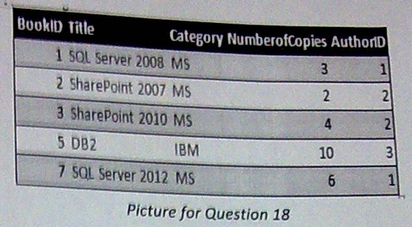

    A. 1

    B. 2

    C. 3

    D. 4

    E. 5

**19. What is the shortest path between node S and node T, given the graph below? Note: the numbers represent the lengths of the connected nodes.**(13 Points)

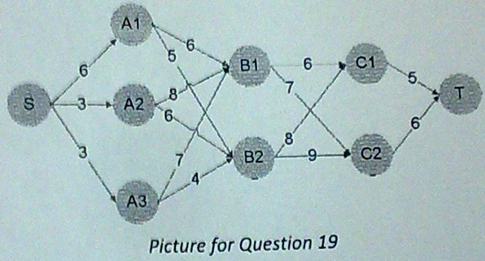

    A. 17

    B. 18

    C. 19

    D. 20

    E. 21

**20. Given a set of N balls and one of which is defective (weighs less than others), you are allowed to weigh with a balance 3 times to find the defective. Which of the following are possible N?**(13 Points)

    A. 12

    B. 16

    C. 20

    D. 24

    E. 28

<http://blog.csdn.net/fengbingyang/article/details/8764931>

<http://blog.csdn.net/chenglinhust/article/details/8765676>