Copyright

by

Anh Dinh Luong

2014

HIDDEN TEXT: Optional—If you do not include a copyright page, delete entire page and the following page break.

HIDDEN TEXT: NOTE: this page in hard copy with all original signatures must be submitted with the dissertation to the Graduate School; this is required whether the document is in electronic format or on paper. Whereas, the page included in the electronic document will be unsigned unless it is scanned in.

The Report Committee for Anh Dinh Luong

Certifies that this is the approved version of the following report:

ClosetStylist - an Android app for digitizing closets and programmatically consulting on what to wear

**APPROVED BY**

**SUPERVISING COMMITTEE:**

|  |
| --- |
| **Supervisor:** |
| Adnan Aziz |
| Christine Julien |

HIDDEN TEXT: The top line is for the Supervisor’s signature. There should be as many lines as there are members on the committee. Lines must be solid, not dotted. To delete signature lines, select the line you want to delete, go to the Table menu, select Table Properties, click on the Table tab, and click on the Borders and Shading button, then remove the bottom border of the table. Use the professor's name without titles or degrees

ClosetStylist - an Android app for digitizing closets and programmatically consulting on what to wear

by

Anh Dinh Luong, B.S.

HIDDEN TEXT: Given first name, and previous academic degrees (B.A. or higher) B.A., B.S., etc. Your official name is the name which appears on your UT transcript.

Report

Presented to the Faculty of the Graduate School of

The University of Texas at Austin

in Partial Fulfillment

of the Requirements

for the Degree of

Master of Science in Engineering

HIDDEN TEXT: The degree sought must be worded in the form given in the Graduate Catalog, such as Doctor of Philosophy, Doctor of Musical Arts, Doctor of Education.

The University of Texas at Austin

December 2014

Dedication

To my parents and my wife.

Acknowledgements

I would like to thank my supervisor, Professor Adnan Aziz, who has provided guidance on the ClosetStylist project, and to my reader Professor Christine Julien, who has helped review this paper. I would also like to thank Ile Jugovski and Truong Nguyen for their support to create a beautiful and user friendly UI for ClosetStylist. Most importantly, I want to thank my parents and my wife for all the hard work and sacrifices they have always made to support me throughout my work and studies.

ClosetStylist - an Android app for digitizing closets and programmatically consulting on what to wear

Anh Dinh Luong, M.S.E.

The University of Texas at Austin, 2014

Supervisor: Adnan Aziz

ClosetStylist is an Android app that helps users digitize their clothing inventory for better usage, manage outfit worn history, laundry bags, and last but not least, suggest what to wear based on occasion and weather. The app utilizes a variety of off-the-shelf services such as location and weather services, combining with our own clothes matching algorithm to recommend the most suitable outfit to users. In addition to the main features, ClosetStylist offers a friendly user interface that enables smooth navigation and keeps users engaged. As for quality assurance, the app was executed under different mock weather conditions with two sets of wardrobe, specifically a male closet of 24 items and a female closet of 86 items. The recommended outfits were displayed on the screen within three seconds of the moment the user initiated the options from the main menu. The app recommended satisfying results which we would hand-pick as our daily outfits. We are going to describe the design, the algorithm, the implementation, and the result of the first prototype of ClosetStylist in this report.

## Table of Contents

Table of Contents vii

List of Tables ix

List of Figures x

Chapter 1 Introduction 1

1.1 Motivation 1

1.2 Report organization 2

1.3 Motivation 2

Chapter 2 User Interface Design 3

2.1 Overview 3

2.2 Features Lists 3

2.3 Use Cases 3

2.4 Mockups 12

Chapter 3 Implementation 19

3.1 Technology stack 19

3.2 Architecture 33

3.3 Class diagrams 40

Chapter 4 Results 42

4.1 Outfit Of The Day Result 42

4.2 Display Picture 43

4.3 Weather service and location service 44

4.4 Screenshots 44

4.5 Costs and level of effort 49

4.6 Lessons learned 52

Chapter 5 Conclusion 56

5.1 Summary 56

5.2 Related work 57

5.3 Future work 58

References 60

## List of Tables

Table 3.1: Development environment. 19

Table 3.2a: Temperature range per Style for male. 23

Table 3.2b: Temperature range per Style for female. 24

Table 3.3: Occasion Matching score table for male. 25

Table 3.4: Occasion Matching score table for female. 26

Table 3.5: Pair Matching score table for male. 27

Table 3.6: Pair Matching score table for female. 28

Table 3.7: Color Matching score table for male and female. 30

Table 4.1: ClosetStylist development costs. 50

## List of Figures

Figure 2.1: Register diagram 4

Figure 2.2: Login diagram 6

Figure 2.3: Add new item diagram 7

Figure 2.4: View or edit item diagram 8

Figure 2.5: Pick an outfit diagram 9

Figure 2.6: View outfit history diagram 11

Figure 2.7: Laundry bag diagram 12

Figure 2.8: Balsamiq user login mockups. 13

Figure 2.9: User login and registration mockups.. 14

Figure 2.10: Main Screen and Side Menu mockups. 15

Figure 2.11: My Closet and Add Item mockups. 16

Figure 2.12: Outfit of the Day and Laundry bag mockups. 17

Figure 2.13: Outfit History and Outfit Preview mockups. 18

Figure 3.1: 5-step clothes matching algorithm. 21

Figure 3.2: ClosetStylist top-level architecture. 34

Figure 3.3a: Database tables populated during run time. 36

Figure 3.3b: Database tables for clothes matching algorithm. 37

Figure 3.4: Factory Method Pattern for storage. 38

Figure 3.5: AbstractFactory classes and ConcreteFactory classes. 39

Figure 3.6: AbstractProduct classes and ConcreteProduct classes. 39

Figure 3.7: ClosetStylist class diagram. 41

Figure 4.1: User login and registration screenshots. 45

Figure 4.2: Main Screen and Side Menu screenshots. 46

Figure 4.3: My Closet and Add Item screenshots. 47

Figure 4.4: Outfit of the Day and Laundry bag screenshots. 48

Figure 4.5: Outfit History and Outfit Preview screenshots. 49

Figure 4.6: Metrics with CodePro AnalytiX. 51

Figure 4.7: Foot print of Closet Stylist. 52

## Chapter 1 Introduction

### Motivation

Wardrobe stylists are often hired by celebrities, models, public figures, and wealthy individuals to select their clothing for public appearances, or by professionals in the entertainment industry for special events. Their services are usually too expensive for the majority of people. Therefore, while most people love fashion and desire to look fashionable, not many people can afford these expensive types of services. The goal of the app to is help people with limited time and style to favorably present themselves and efficiently organize their closet.

An average person spends hundreds of dollars every year on new clothes, which often end up getting lost in the closet after a couple times of usage. There are quite a few issues that this app aspires to address. How should we organize all the items in our closets? How do we mix and match them wisely to utilize all items in our wardrobe without breaking our bank account for expensive consultation from costly stylists? How do we know when our laundry bag is full to avoid running out of clothes? For those people without a washer and dryer at home, doing laundry could cost several hours waiting in the Laundromat (if we do not want to pay some extra money to have it done and folded, but we do not know how careful the assistant would be to our clothes).

Most people are busy in the morning to prepare for work or school. The lack of time and failure to check the weather forecast before selecting what to wear usually lead to a wrong outfit choice for the day. Such trouble can be avoided with an app that can recommend a suitable outfit based on weather and occasion.

### Report organization

ClosetStylist is a mobile app developed to solve the above problems. Its core functionalities includes assisting women and men to pick the right outfit from their clothing inventory, organizing their closets digitally, managing their laundry bags, and keeping track of worn history. The ultimate goal is to help clients get the most fashion value for their dollar by helping them manage their closets wisely.

### Motivation

The remainder of the report is organized as follows: chapter 2 discusses the user interface including mockups and workflow of the app, chapter 3 reviews the technology stack used in the app, chapter 4 describes the results and pain points, and chapter 5 ends the report with summary, related and future work.

## Chapter 2 User Interface Design

### 2.1 Overview

In this chapter, we explain the user interface design by first providing a list of features this app offers through some usage scenarios. We then describe in detail some use cases to clarify the UI/UX flow for the main features of the app. We end this section with some mockups to show the look and feel of the app.

### 2.2 Features Lists

The below bullet points highlight some features that ClosetStylist has achieved:

* Users can easily flip through every item in their own closet, which is a digital storage of pictures of their clothes taken by built-in camera phone or imported from a gallery.
* Users can find how many dirty items are in their laundry bag and schedule laundry.
* Users can go through their worn history and look for what garments they have worn on any particular date in the past.
* Users can choose any outfits that the app has programmatically picked from their closets based on occasion and the weather at the current location, and they can mix match with other garments if they do not like the app’s initial suggestion.

### 2.3 Use Cases

[Amb] has illustrated an effective methodology to model and document the structures and behavior of software projects. The use cases presented in this section followed this Agile modeling approach to depict the interaction between the user and the ClosetStylist app. Each use case consists of a UML activity diagram between two actors – the user and the ClosetStylist Android app – a precondition that must be satisfied before starting this case, a purpose (or result) of this use case which describes the achievement after following the procedure, and the steps to achieve this result.

#### 2.3.1 Register



Figure 2.1: Register diagram

**The precondition**: ClosetStylist has already been installed on the device under test.

**The purpose**: show how the user can register an account to use the app for the very first time and how to populate all the required fields.

**The steps**: shown in Figure 2.1. The app has its own simple authenticating method to validate, independent of any social networks, so that the users can still use the app if they choose to not enable any social network feature. Upon the very first time the app is launched, users have to click on “Don’t have account – register here” and fill in the required fields, one of which is the postal code. This field is mentioned here because it is treated as the default location that the app will use if for any reason it fails to obtain the current location. If users do not know their current zipcode, they can click on “Get Location” and the app will find the zip code of the current location. Once the users have filled in all the required fields, they can click on the “Register” button to log in to the app. The user’s information is also persisted to the database so that the user can login the next time without repeating the registration step.

#### 2.3.2 Login

**The precondition**: user has already registered.

**The purpose**: user has to enter his or her credentials to login after registration step.

**The steps**: shown in Figure 2.2. The user launches the app and enter his or her username and password. The app will navigate to the main screen where the user will find helpful information such as the current location, date, weather, and the user can proceed to any of the four main screens: Outfit of the day, My Closet, My Laundry Bag, My Outfit History.



Figure 2.2: Login diagram

#### 2.3.3 Add new item

**The precondition**: user is logged in.

**The purpose**: user has to populate his or her closet with the pictures of his or her clothes taken by built-in camera.

**The steps**: shown in Figure 2.3. From the main screen, the user clicks on “My Closet”. In the bottom of the My Closet screen, there is “ADD ITEM” button. After filling in the required fields, users can take picture of the clothes by clicking on the camera icon. Once saved, users can crop the newly taken picture to get rid of the unnecessary parts. Users can choose either “Reset” all of the fields to their default values or “Save” the detail of this item by clicking on the corresponding button.



Figure 2.3: Add new item diagram

#### 2.3.4 View or edit an item



Figure 2.4: View or edit item diagram

**The precondition**: the item has been added to the closet.

**The purpose**: users can view the detail of an item and update the information if needed.

**The steps**: shown in Figure 2.4. From the main screen, users click on “My Closet”. The wardrobe is categorized as “Outer”, “Top”, and “Bottom”. Users choose the tab that the wardrobe belongs to and click on the items they want to see. They can change any of the fields, or can even mark an item is dirty to be sent to laundry bag.

#### 2.3.5 Pick an outfit



Figure 2.5: Pick an outfit diagram

**The precondition**: “My Closet” has been populated with some items in both Top and Bottom.

**The purpose**: the app suggests a list of outfits that best fit the user based on the weather and the chosen occasion.

**The steps**: shown in Figure 2.5. From the main screen, users click on “Outfit of the Day”. The app will display a list of suggested outfits based on the current weather and the occasion set to “Casual”. There are five options for Occasion – “Formal”, “Semi_Formal”, “Casual”, “Day_Out”, “Night_Out” and users can choose the Occasion best fit their situation. There are arrows to switch to another Top or Bottom. There are double-arrows to let the user traverse through the list of suggested outfits. Once the users decide to choose a particular outfit, they can click on the “WEAR” button at the bottom and they will be navigated to the “My Outfit History” screen. There is also a rank to inform the users how far they are from the first suggestion.

#### 2.3.6 View outfit history

**The precondition**: users have already chosen to wear some outfits.

**The purpose**: the app displays the outfits that users have already worn on any particular day.

**The steps**: shown in Figure 2.6. From the main screen, users click on “My Outfit History”. This screen displays the outfits that users have worn on a particular day, starting from today. If users have worn several outfits on the same day, all of them will be listed in chronological order, starting with the one worn earliest on that day. User can click on any of them and they will be navigated to the “Outfit Preview” to see a more detailed picture of the outfit.



Figure 2.6: View outfit history diagram

#### 2.3.7 Laundry bag

**The precondition**: users have already chosen to wear some outfits.

**The purpose**: the app displays the dirty items so that the users can schedule to wash them.

**The steps**: shown in Figure 2.7. From the main screen, users click on “My Laundry Bag”. This screen displays all the dirty items as a list. Users can click on any of them to view more detail.



Figure 2.7: Laundry bag diagram

### 2.4 Mockups

Balsamiq [Bal] was initially used to create mockups as it was user friendly and its online version was free for students. Figure 2.8 is an example of original mockups.

As the development continued, some limitations of Balsamiq such as the lack of Android UI elements and the difficulty in sharing feedbacks showed up. Fortunately, our UI/UX designer, Ile Jugovski, introduced us to InVision App [Inv] which is an extremely powerful prototyping tool with many great features. He used Adobe Photoshop to design different assets for the app such as buttons, icons, logos, and backgrounds. Afterwards, those assets were imported to Invision to create a fully interactive prototype and a wireframe based on our original Balsamiq mockups. Besides, Invision enabled collaboration among stakeholders to share vision and gain feedback.

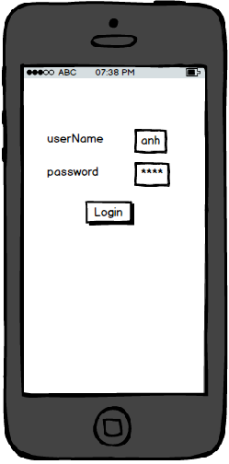

Figure 2.8: Balsamiq user login mockups.

All of the mockups created by Ile will be illustrated in the following section together with a storyboard we created to help readers easily visualize the workflow of the app.

#### 2.4.1 Login and Registration

|  |  |
| --- | --- |
|  |  |

Figure 2.9: User login and registration mockups. Registration screen is scrollable, but the above right image was modified to show all of the fields.

To begin with, the new user will register with the app using their username, password, and default location as shown in Figure 2.9. After registration is done, the user can login and logout of the app.

#### 2.4.2 Main Screen and Side Menu

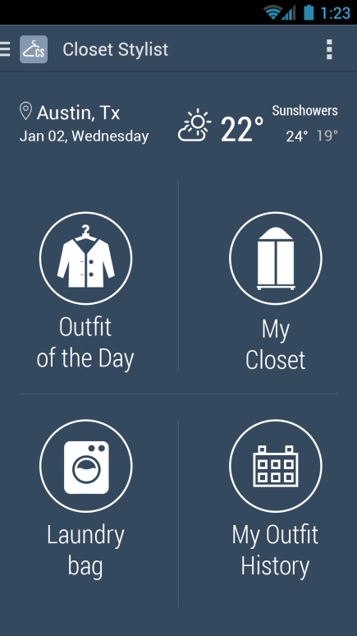 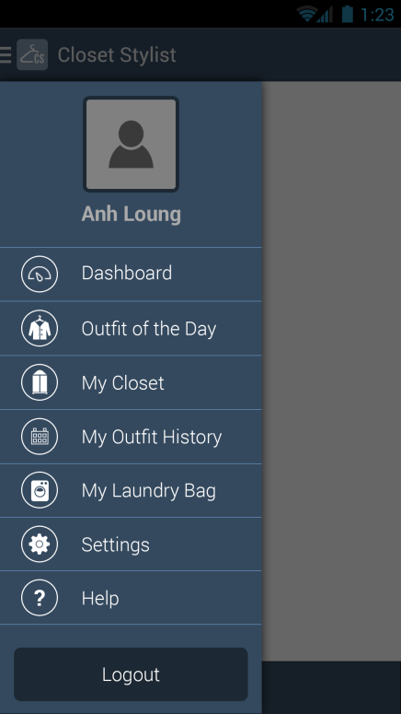

Figure 2.10: Main Screen and Side Menu mockups.

After registration for the first time or after login, users will come to the main screen in Figure 2.10 which displays useful information about the current location, date, and temperature. It also provides options to navigate to the main features of the app such as picking the Outfit of the Day, organizing My Closet, managing Laundry bag, or viewing My Outfit History.

To make navigation between screens in the app easier, users can take advantage of the provided navigation drawer. This panel, which displays the important navigation options, is hidden except when users swipe from left to right or tap the app icon in the action bar.

#### 2.4.3 My Closet and Add Item

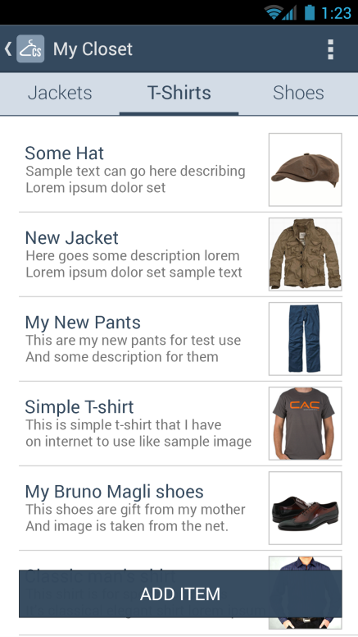 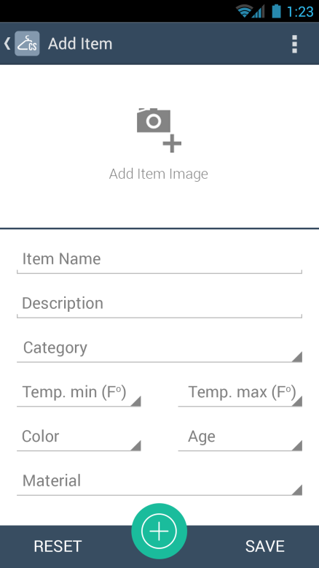

Figure 2.11: My Closet and Add Item mockups.

In order to use the app, users need to import photos of their clothes from the phone’s built-in camera and enter additional information about the items. Each item will be categorized as either top or bottom, together with its corresponding styles, materials, and color.

After the item is saved in the closet, users can also edit or delete the item from the closet. Once the closet is fully populated with all the items, “My Closet” screen should look like the mockup in Figure 2.11.

#### 2.4.4 Outfit of the Day and Laundry bag

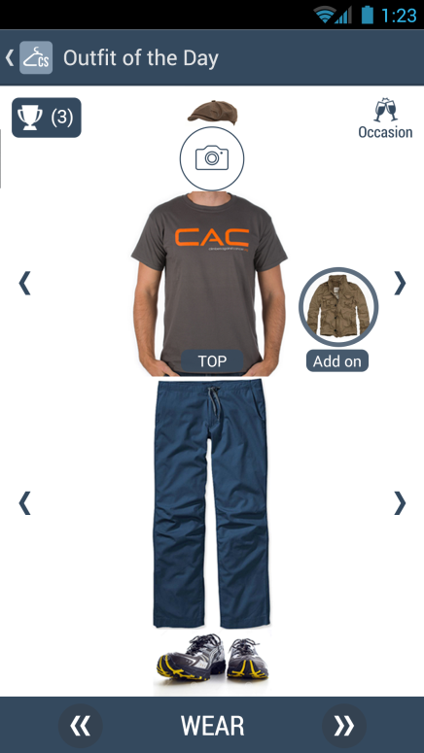 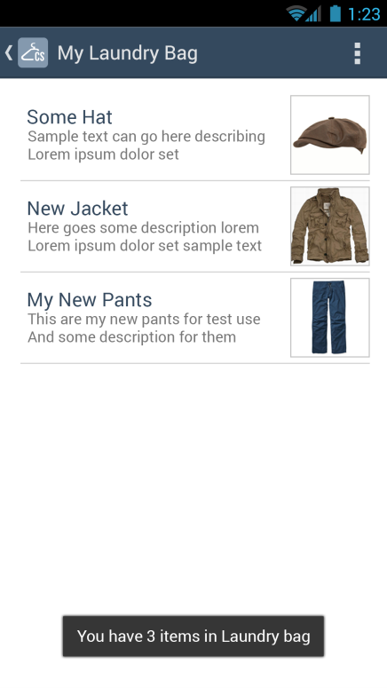

Figure 2.12: Outfit of the Day and Laundry bag mockups.

When the user is ready to pick the outfit, he/she can navigate to the Outfit of the Day shown in Figure 2.12 and find the list of suggested outfits based on today’s weather and the occasion. The selection algorithm ranks different outfits (combination of top, bottom, and maybe outer laye if the weather is cold). The user can choose among different occasions including formal, semi-formal, casual, day-out, night-out and different outfits will be recommended. A mix and match option is also provided through the arrows next to top and bottom if user wants a different piece in the recommended outfit. User can move back and forth between suggested outfits by pressing double arrows at the bottom of the screen.

The user can decide to wear the outfit by clicking on the “Wear” button, and items will be processed to determine if it is dirty or not and placed in laundry bag as shown in Figure 2.12. The reason for processing an item instead of moving it to the laundry bag right away because there are certain pieces of clothes that we can wear more than once such as jackets or jeans.

#### 2.4.5 Outfit History and Outfit Preview

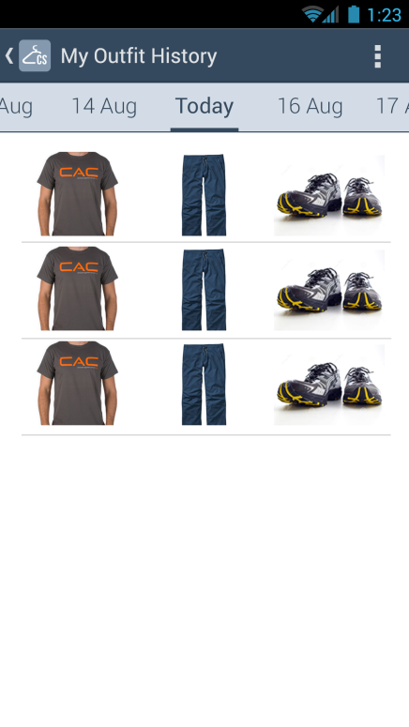 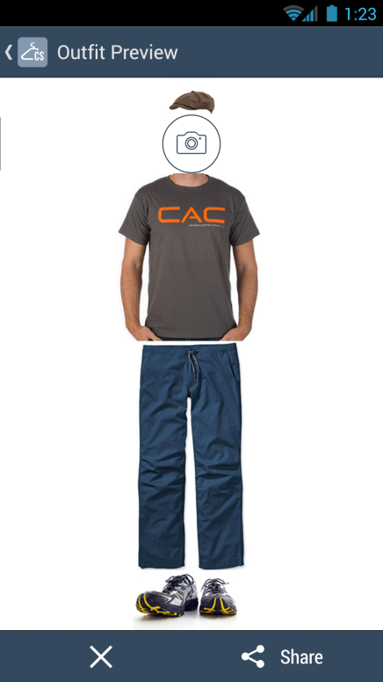

Figure 2.13: Outfit History and Outfit Preview mockups.

When the user clicks on the “Wear” button as described in the previous section, the app will take the user to the Outfit History screen which lists all the outfits have been chosen today and in the past as shown in Figure 2.13. This screen can also be accessed from the main screen or the side menu.

Once the user is in the Outfit History screen, the outfit worn today is shown first and if there is more than one outfit, they will be displayed in chronological order. The user can find what he/she has worn on any particular day in the past by moving to the tab for that day, clicking on an outfit entry in the list, and the outfit will be displayed in the Outfit Preview screen as in Figure 2.13.

## Chapter 3 Implementation

### 3.1 Technology stack

ClosetStylist is an Android app and hence Java is used as the main programming language. As stated in [LAAD], Android runs on top of Linux kernel. It is a software stack for mobile devices, and includes system libraries, application frameworks, and key apps. In Android, there are four main application components, each with its corresponding functionality is listed below:

* Activity – the presentation layer.
* Service – the processing layer
* Broadcast Receivers – the communication layer
* Content Providers – the data storage layer

Table 3.1 below shows a summary of my development environment.

|  |  |
| --- | --- |
| Language | Java |
| IDE | Eclipse Juno 4.2, Kepler 4.3 |
| Additional code editor | GVIM |
| SDKs | JDK 1.6, Android 2.3.3, Facebook 3.0 |
| Test equipment | Samsung S3 |
| System | Windows 7 64-bit, Ubuntu 12.04 32-bit, Ubuntu 12.10 64-bit |

Table 3.1: Development environment.

The app was initially developed on a laptop with Intel i7-3720 2.6GHz, 16GB RAM, Windows 64-bit to run on the Android simulator. Due to a Samsung Galaxy S3 connection problem in the Windows system, the development on the S3 device was moved to a laptop with Intel Core 2 duo, 4GB RAM, Ubuntu 12.10 32-bit, and a desktop with AMD Quad-Core, 16GB RAM, Ubuntu 12.04 64-bit

In addition to the development environment, several technologies were applied in this app. Some were open-source, and others were our own implementation. We are going to describe each of the main technologies, the reason why we chose them over others, and the deployment.

#### 3.1.1 Location Service

In this app, GeoNames database was used as a service to convert geographic coordinates (the longitude and latitude) of a location to postal code. Geonames was chosen over Yahoo service (Yahoo BOSS PlaceFinder) because its free web service of 20 requests per hour was good enough for this prototype, and Yahoo service used proprietary WOEID (Where On Earth Identification number). Besides, the later was subject to change by Yahoo, and would cause problem if we decide to switch to another service. GeoNames also offers a variety of premium web service plans with higher request limits and meets our requirements for later revisions of this app.

GeoNames provided a lot of services in many formats such as XML and JSON. In this app, we employed the service that converted geographic coordinates to postal code (and then city and country) and vice versa by sending a GET HTTP request. The HTTP response was in JSON format, and our tasks were to collect and parse the response and then display it in the main screen of the app.

#### 3.1.2 Weather Service

We looked at several weather services including Yahoo Weather, World Weather Online, and Open Weather Map. [SWA] provided the sample code to retrieve weather information from Open Weather Map and made it an ideal choice for our weather service. The weather response consisted of a lot of information including but not limited to current conditions, weather forecasts, weather maps, sunrise, and sunset. As of this writing, only a subset of the returned data was used, including current conditions for current temperature and its range, and weather map for geographic coordinates.

Open Weather Map offers different pricing plans for different support levels, for example free, developer, professional, and enterprise. The free plan supports a maximum of 3,000 requests per minute and 4,000,000 requests per day, which is more than enough for our first prototype.

#### 3.1.3 Clothes Matching Service

This service utilizes our own algorithm and implementation to provide suggestions on which wardrobe users should put on based on the available items in their closets, the current weather information, and the occasion of the event, and gender.

##### 3.1.3.1 High-level design



Figure 3.1: 5-step clothes matching algorithm.

There are five steps to create the list of suggested outfits. Each step is an essential part of the algorithm and must be executed in the same order described in Figure 3.1. The inputs to the algorithm are all of the factors mentioned above and the output is a list of outfits in descending order of score. Each outfit consists of a top, bottom, and an optional outer layer if the temperature is in a certain range. While the first two steps are used to obtain a valid set of items to select from, the last three steps are used to score points for each outfit based on several factors. An overview of each step is given below.

Laundry Filter: eliminate dirty items from the process.

Temperature Filter: eliminate items that do not cover the range of today’s maximum temperature and minimum temperature of the current location.

Occasion Matching: each item is given a score for the chosen occasion. For example, a short is graded low for the “Formal” occasion but it gets high score in the “Day_Out” occasion.

Pair Matching: each combination of a top item with a bottom item (and optionally an outer layer) will be scored based on its category. This point is added together with the point of each item in the previous step to the outfit.

Color Matching: the color combination of the top, the bottom, and the outer of the outfit will be given a score. This is added to the points from the previous steps to produce the final score. The result is a list of outfits in the order of descending points.

##### 3.1.3.2 Low-level design:

A deeper discussion on the low-level design and implementation is provided for each of the five steps.

###### 3.1.3.2.1 Step 1 - Laundry Filter

This step is pretty simple, given that each item has a “dirty” attribute to specify an item is clean or dirty. The implementation is simply a query the database of clothes in the closet to obtain a list of clean items.

###### 3.1.3.2.2 Step 2 - Temperature Filter

This step eliminates items that are not in today's temperature range. As for implementation, we assigned each item an appropriate range of temperature. The range needed to be chosen carefully to not exclude items that can be layered together in cold weather. This explains the reason for assigning a wide temperature range for most items (-999 to 999) to not filter them out. The numbers -999 and 999 were chosen for the sole purpose of representing an extremely low or high temperature, and there was no calculation in our algorithm that requires an exact value. As a result, any big number that was substantially higher than the maximum and lower than the minimum of the regular temperature range could certainly be used in lieu of -999 and 999 in this step.

|  |  |  |
| --- | --- | --- |
| **Style – Men** | Temp Min | Temp Max |
| Pants | -999 | 999 |
| Jeans | -999 | 999 |
| Shorts | -999 | 999 |
| Dress_Shirt | -999 | 999 |
| Casual_Button_Down_Shirt | -999 | 999 |
| Polo | -999 | 999 |
| T_Shirt_Short_Sleeve | -999 | 999 |
| T_Shirt_Long_Sleeve | -999 | 999 |
| Sweater_And_Sweatshirt | -999 | 999 |
| Coat_And_Jacket_Light | -999 | 75 |
| Coat_And_Jacket_Heavy | -999 | 40 |

Table 3.2a: Temperature range per Style for male.

|  |  |  |
| --- | --- | --- |
| **Style - Women** | Temp Min | Temp Max |
| Pants | -999 | 999 |
| Jeans | -999 | 999 |
| Legging_Skinny | -999 | 999 |
| Shorts | -999 | 999 |
| Skirts | -999 | 999 |
| Collared_And_Button_Down | -999 | 999 |
| Blouse_Short_Sleeve | -999 | 999 |
| Blouse_Long_Sleeve | -999 | 999 |
| Blouse_Sleeveless | -999 | 999 |
| T_Shirt_Long_Sleeve | -999 | 999 |
| T_Shirt_Short_Sleeve | -999 | 999 |
| Tank_Camisoles | -999 | 999 |
| Party_Top | -999 | 999 |
| Tunic | -999 | 999 |
| Pull_Over | -999 | 999 |
| Cardigan | -999 | 999 |
| Sweater_And_Sweatshirt | -999 | 999 |
| Vest | -999 | 999 |
| Coat_And_Jacket_Light | -999 | 75 |
| Coat_And_Jacket_Heavy | -999 | 40 |

Table 3.2b: Temperature range per Style for female.

We could not possibly assign a temperature range for every single existing clothing piece; hence we chose to classify them into various groups. The attributes of each item were good candidates for classification because they already grouped items into small sets with something in common. The next task was to select the single attribute that was most correlated to the temperature range of an item. This attribute must not be too common to avoid grouping too many items to the same range but not too specific to avoid creating a massive look-up table. Material and style were the contenders of our attribute selection process. Style was chosen over material because of two reasons. First, most of the items had a mix of fabric materials, and therefore it was difficult to indicate what range an item covered based on the materials. Second, we often layered up as long as all the items look good together, which indicated that style was a better pick than material.

The look-up Table 3.2a and 3.2b is used to define the range of each style per gender.

###### 3.1.3.2.3 Step 3 - Occasion Matching

Each item was given different point based on gender, category, style, and occasion. This step had higher weight than pairing and color matching steps because occasion matching was more important to the final outfit in our opinions.

In this step, the list of items output from the above steps was processed together with the selected occasion by the methods of the OccasionMatching object, and the result was two lists of items with score, one for top and one for bottom.

Table 3.3 and Table 3.4 shows the score tables of Occasion Matching of male and female, respectively.

|  |  |  |  |  |  |  |
| --- | --- | --- | --- | --- | --- | --- |
|  |  | Point | | | | |
| **Category** | **Style** | **Formal** | **Semi_Formal** | **Casual** | **Day_Out** | **Night_Out** |
| Bottom | Pants | 40 | 40 | 5 | 0 | 20 |
| Bottom | Jeans | 5 | 20 | 40 | 20 | 40 |
| Bottom | Shorts | 0 | 0 | 20 | 40 | 0 |
| Top | Dress_Shirt | 40 | 40 | 5 | 0 | 5 |
| Top | Casual_Button_Down_Shirt | 5 | 20 | 20 | 20 | 40 |
| Top | Polo | 5 | 20 | 40 | 5 | 20 |
| Top | T_Shirt_Short_Sleeve | 0 | 0 | 20 | 40 | 5 |
| Top | T_Shirt_Long_Sleeve | 0 | 5 | 20 | 5 | 20 |
| Top | Sweater_And_Sweatshirt | 0 | 5 | 20 | 20 | 5 |
| Top | Coat_And_Jacket_Light | 40 | 40 | 5 | 0 | 20 |
| Top | Coat_And_Jacket_Heavy | 5 | 5 | 5 | 5 | 20 |

Table 3.3: Occasion Matching score table for male.

|  |  |  |  |  |  |  |
| --- | --- | --- | --- | --- | --- | --- |
|  |  | Point | | | | |
| **Category** | **Style** | **Formal** | **Semi_Formal** | **Casual** | **Day_Out** | **Night_Out** |
| Bottom | Pants | 40 | 40 | 5 | 0 | 20 |
| Bottom | Jeans | 5 | 20 | 40 | 20 | 20 |
| Bottom | Legging_Skinny | 0 | 5 | 20 | 20 | 40 |
| Bottom | Shorts | 0 | 0 | 5 | 40 | 5 |
| Bottom | Skirts | 5 | 20 | 20 | 20 | 20 |
| Top | Collared_And_Button_Down | 40 | 20 | 0 | 0 | 5 |
| Top | Blouse_Short_Sleeve | 20 | 40 | 20 | 20 | 20 |
| Top | Blouse_Long_Sleeve | 40 | 40 | 5 | 5 | 20 |
| Top | Blouse_Sleeveless | 5 | 20 | 20 | 40 | 20 |
| Top | T_Shirt_Long_Sleeve | 5 | 20 | 40 | 5 | 5 |
| Top | T_Shirt_Short_Sleeve | 0 | 5 | 40 | 40 | 5 |
| Top | Tank_Camisoles | 0 | 0 | 5 | 40 | 20 |
| Top | Party_Top | 0 | 0 | 5 | 20 | 40 |
| Top | Tunic | 0 | 5 | 20 | 20 | 20 |
| Top | Pull_Over | 0 | 0 | 20 | 20 | 0 |
| Top | Sweater_And_Sweatshirt | 20 | 20 | 5 | 5 | 20 |
| Top | Coat_And_Jacket_Light | 40 | 20 | 0 | 0 | 20 |
| Top | Cardigan | 40 | 40 | 20 | 5 | 20 |
| Top | Vest | 40 | 20 | 5 | 0 | 20 |
| Top | Coat_And_Jacket_Heavy | 5 | 5 | 5 | 5 | 20 |

Table 3.4: Occasion Matching score table for female.

###### 3.1.3.2.4 Step 4 - Pair matching

In this step, each of the items in the top list was paired with an item in the bottom list outputted from the previous step; and an optional outer item was picked from the top list. At the end of this step, we obtained a single list, in which each entry contained a combination of a top item, a bottom item, and an optional outer piece, together with the total score of this combination.

The score came from look-up tables (Table 3.5 and Table 3.6). Each row contained a top style, a bottom style, and an optional outer piece based on the top-bottom style and gender. Style played a critical role in these tables as it was the first and foremost factor considered when we paired top and bottom garments in reality. We assigned a score to the combination in each row according to our own fashion judgment; but the design was flexible enough to adjust to any different score system simply by modifying the score in these tables. It is worthwhile to point out that the grading scale was lower than that of the occasion matching step because this step was considered less important, and as a result should have less weight on the final score.

|  |  |  |  |
| --- | --- | --- | --- |
| **Bottom** | **Top** | **Point** | **Outer** |
| Pants | Dress_Shirt | 20 | No |
| Pants | Casual_Button_Down_Shirt | 5 | No |
| Pants | Polo | 20 | No |
| Jeans | Casual_Button_Down_Shirt | 5 | No |
| Jeans | Polo | 16 | No |
| Jeans | T_Shirt_Short_Sleeve | 20 | No |
| Jeans | T_Shirt_Long_Sleeve | 20 | No |
| Shorts | Casual_Button_Down_Shirt | 6 | No |
| Shorts | Polo | 6 | No |
| Shorts | T_Shirt_Short_Sleeve | 20 | No |
| Shorts | T_Shirt_Long_Sleeve | 5 | No |

Table 3.5: Pair Matching score table for male.

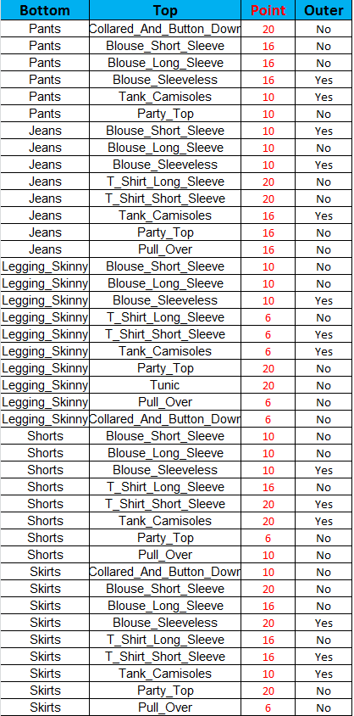

Table 3.6: Pair Matching score table for female.

###### 3.1.3.2.5 Step 5 - Color matching

It is impossible to list every existing shade of color because the number is infinite. We decided on twelve basic colors: beige, black, blue, brown, gray, green, orange, pink, red, violet, white, yellow, and an additional option of ‘multicolor_pattern’ to accommodate items with more than one color. Therefore, we had a total of 13 colors to work with. Subsequently, these 13 colors were further divided into two groups – “Color” (blue, green, violet, red, yellow, orange, pink, multicolor_pattern) and “Neutral” (gray, white, black, brown, beige). [CWL] listed which colors were complementary to one another. Besides, “Neutral” colors could be easily matched with other while the “Color” colors were more restricted. These relations were expressed through the points given to each combination of these colors in the color score Table 3.7. The reason that we opted for a single group called multicolor_pattern to represent all the multiple colored and patterned items was to avoid foreseeable issues that could be incurred later on. First, it was potentially difficult for users to interpret the multicolor pattern accurately. We could alternatively write an excellent image analysis program that can detect the right colors and pattern of the item. However, this option would be beyond the scope of this project. Secondly, even if the app could automatically obtain the accurate color and pattern of any item, it would take substantial research efforts to create a reasonable algorithm for clothes matching to account for the infinite number of multiple colors and patterns.

In this step, the list resulting from the above step was run with the ColorMatching object to create a final list of the same objects as in step 4, with the score updated to include the color factor. It should be emphasized that there was only one table for both genders because we did not see any extra benefit to separate color scoring scheme based on gender. Nevertheless, our design could be easily expanded and modified to include different tables for male and female if needed down the road.

|  |  |  |
| --- | --- | --- |
| **Bottom** | **Top** | **Point** |
| Beige | Black | 2 |
| Beige | Blue | 4 |
| Beige | Brown | 22 |
| Beige | Gray | 24 |
| Beige | Green | 20 |
| Beige | Multicolor_Pattern | 6 |
| Beige | Orange | 10 |
| Beige | Pink | 8 |
| Beige | Red | 16 |
| Beige | Violet | 18 |
| Beige | White | 12 |
| Beige | Yellow | 14 |
| Black | Beige | 4 |
| Black | Blue | 6 |
| Black | Brown | 24 |
| Black | Gray | 20 |
| Black | Green | 18 |
| Black | Multicolor_Pattern | 8 |
| Black | Orange | 10 |
| Black | Pink | 12 |
| Black | Red | 22 |
| Black | Violet | 14 |
| Black | White | 2 |
| Black | Yellow | 16 |
| Blue | Beige | 6 |
| Blue | Black | 8 |
| Blue | Brown | 10 |
| Blue | Gray | 12 |
| Blue | Orange | 2 |
| Blue | White | 4 |
| Brown | Beige | 2 |
| Brown | Black | 16 |
| Brown | Blue | 10 |
| Brown | Gray | 12 |
| Brown | Green | 8 |

Table 3.7: Color Matching score table for male and female.

|  |  |  |
| --- | --- | --- |
| Brown | Multicolor_Pattern | 8 |
| Brown | Orange | 10 |
| Brown | Pink | 12 |
| Brown | Red | 18 |
| Brown | Violet | 14 |
| Brown | White | 4 |
| Brown | Yellow | 6 |
| Gray | Beige | 24 |
| Gray | Black | 20 |
| Gray | Blue | 10 |
| Gray | Brown | 18 |
| Gray | Green | 12 |
| Gray | Multicolor_Pattern | 8 |
| Gray | Orange | 2 |
| Gray | Pink | 6 |
| Gray | Red | 4 |
| Gray | Violet | 14 |
| Gray | White | 22 |
| Gray | Yellow | 16 |
| Green | Beige | 14 |
| Green | Black | 12 |
| Green | Brown | 10 |
| Green | Gray | 8 |
| Green | White | 6 |
| Green | Yellow | 4 |
| Green | Blue | 2 |
| Multicolor_Pattern | Beige | 2 |
| Multicolor_Pattern | Black | 4 |
| Multicolor_Pattern | Brown | 10 |
| Multicolor_Pattern | Gray | 8 |
| Multicolor_Pattern | White | 6 |
| Orange | Beige | 10 |
| Orange | Black | 4 |
| Orange | Blue | 2 |
| Orange | Brown | 6 |
| Orange | Gray | 12 |
| Orange | White | 8 |

Table 3.7: Color Matching score table for male and female (cont.).

|  |  |  |
| --- | --- | --- |
| Pink | Beige | 6 |
| Pink | Black | 2 |
| Pink | Brown | 4 |
| Pink | Gray | 10 |
| Pink | White | 8 |
| Red | Beige | 6 |
| Red | Black | 10 |
| Red | Brown | 8 |
| Red | Gray | 4 |
| Red | White | 2 |
| Violet | Beige | 8 |
| Violet | Black | 10 |
| Violet | Brown | 12 |
| Violet | Gray | 14 |
| Violet | White | 4 |
| Violet | Yellow | 2 |
| Violet | Pink | 6 |
| White | Beige | 10 |
| White | Black | 2 |
| White | Blue | 12 |
| White | Brown | 8 |
| White | Gray | 24 |
| White | Green | 20 |
| White | Multicolor_Pattern | 4 |
| White | Orange | 18 |
| White | Pink | 16 |
| White | Red | 6 |
| White | Violet | 14 |
| White | Yellow | 22 |
| Yellow | Beige | 8 |
| Yellow | Black | 4 |
| Yellow | Brown | 6 |
| Yellow | Gray | 10 |
| Yellow | Green | 12 |
| Yellow | Violet | 2 |
| Yellow | White | 14 |

Table 3.7: Color Matching score table for male and female (cont.).

#### 3.1.4 Robotium

[Rob] Robotium is a powerful Android test automation tool for both emulator and real devices. It was applied to run several ClosetStylist’s unit test cases that do not span over two applications, i.e., when launching the camera app to take pictures of new items or importing pictures from the gallery, due to the limitation of Robotium. The test cases include registering, logging in, verifying that the main screen displays correct information, checking “My Closet”, picking “Outfit of the Day”, managing “Laundry Bag”, and traversing “Outfit History”.

This tool has been very helpful to catch unexpected behaviors every time our code was modified, or new features were added.

### 3.2 Architecture

The ClosetStylist design is composed of three main layers: presentation layer, application layer, and data layer. The layer design is mainly for code reusability and portability. Thanks to this design, we were able to save to a lot of time and effort when switching to new UI implementation as described in the following sections. In addition, multiple design patterns have been applied to provide flexibility to switch between different services.

Figure 3.2 below shows the top-level architectural design of ClosetStylist.



Figure 3.2: ClosetStylist top-level architecture.

#### 3.2.1 Core

The core code includes common classes, common interfaces, helper classes, and enum classes that are used to glue different layers together. The purpose of this layer is to connect different layers through common interfaces and features so that upper layers can work seamlessly with the information of the lower layers.

#### 3.2.2 Presentation layer

This layer contains the UI and UX modules of the app. The purpose of this layer is to implement the behavioral logic and to provide good user experience with the app’s flow as well as look and feel of the app. The design of this layer strictly follows that of Android design and eases the task of UI update in the future.

We first drafted and implemented our own UI design to verify that it worked with the backend code. Although the UI was fully functional, it was primitive and was not well polished to attract users. We decided to hire Ile, a professional UI/UX designer, to provide consultation on our UX flow and create beautiful UI elements. After UI/UX design was established, we contracted Truong to write the UI code to create the layout through XML files, setup event listeners to intercept user’s interaction with the app such as touching a view, and swiping left to right to access the drawer. We then implemented the handlers to take the right action when the registered listeners were triggered by user interaction. The layer design proved to be helpful as we were able to keep most of the back end code intact when switching our code base to the new UI implementation.

#### 3.2.3 Application layer

The application layer consists of all the services employed in this app, including the weather service, location service, and clothes matching service. The purpose of this layer is to implement application logic and provide all the features of the app including organizing the user’s closet, programmatically suggesting outfits, keeping track of outfit history, and managing the laundry bag. This layer contains most of the backend work that we implemented ourselves to send HTTP requests and parse HTTP responses from weather and location services, to run our matching algorithm, and to interface with the UI layer above and the data layer below.

#### 3.2.4 Data layer

This layer includes two main components: the storage to store big-size pictures and the database to store smaller information about the user’s profile, clothing items, outfit history, and look-up tables for the matching service. The purpose of this layer is to provide data management for the app. The SD card was chosen over Cloud storage as the picture storage because we wanted to keep the picture-retrieving latency low to help the responsiveness of the app. For small information, we used the Android built-in database SQLite to manage. It should be noted that for each item, only the path to the SD card is saved in the SQLite of the item table and this is how we can link the information in the SQLite database and the pictures in SD card.

An overview of the data tables created for the app is shown in Figure 3.3a and 3.3b.



Figure 3.3a: Database tables populated during run time.



Figure 3.3b: Database tables for clothes matching algorithm, populated at built time.

#### 3.2.5 Design patterns

[HFDP] shows many design patterns to provide flexibility for future expansion while keeping closed for code modification. In this section, we describe how some of these are employed in our design for this app.

##### 3.2.5.1 Factory Method Pattern

This pattern is applied to create different concrete storage types. The SD card is chosen at the moment for the main storage for pictures, but the design is opened to replace SD card with another type of storage such as Google App Engine with much of the code intact because the creator class is written without knowledge of the actual products that will be created. In other words, the implementation of the product is decoupled from its use. In addition, a new storage type will not affect the Creator class. Figure 3.9 follows the Factory Method Pattern defined in [HFDP] to illustrate the deployment in our app.



Figure 3.4: Factory Method Pattern for storage.

In Figure 3.4, the abstract Creator class is StorageFactory, and the concrete Creator classes are SDCardStorageFactory and GoogleAppEngineStorageFactory. The Product is StorageInterface; the concrete Product classes implementing this interface are SDCardStorage and GoogleAppEngineStorage; the Factory Method is createStorage.

##### 3.2.5.2 Abstract Factory Pattern

The Clothes Matching service consists of five steps. While steps one and two can be filtered by querying the database, steps three to five require more complicated implementation based on gender (limited to male and female for now). Abstract Factory pattern was applied to provide an interface to create a family of matching steps: occasion matching, pair matching, color matching. Writing code using this interface helped us decouple our code from actual factory that created these concrete matching steps (i.e., object classes). This also enables us to expand to a variety of genders if we need to in the future. Once the user registers his or her genders, we can subsequently assign the correct matching steps. Figure 3.5 and Figure 3.6 follows the Abstract Factory Pattern defined in [HFDP] to illustrate the deployment in our app.

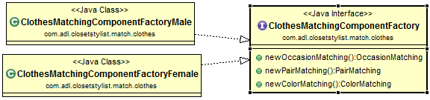

Figure 3.5: AbstractFactory classes and ConcreteFactory classes of Abstract Factory Pattern applied in Clothes Matching service.

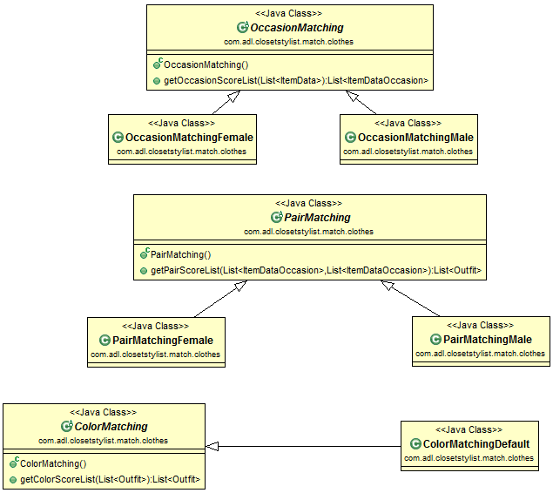

Figure 3.6: AbstractProduct classes and ConcreteProduct classes of the Abstract Factory Pattern applied in Clothes Matching service (OccasionMatching, PairMatching, and ColorMatching classes).

##### 3.2.5.2 Template Pattern

This pattern is applied to the ClothesMatching class to encapsulate the five-step algorithm described above. ClothesMatchingMale and ClothesMatchingFemale are the two subclasses of ClothesMatching and we can modify the implementation steps if we need to tailor our need for each gender. This provides a framework to plug in new genders in the future. Besides, the algorithm lives in one place (ClothesMatching class), so it is easy for code change later on. ClothesMatching focuses on the algorithm and lets subclasses such as ClothesMatchingMale and ClothesMatchingFemale redefine certain steps of that algorithm without changing the algorithm’s five-step structure.

### 3.3 Class diagrams

Figure 3.7 displays a simplified class diagram, which consists of the main classes such as item information, user profile, place record (or location), weather information, four main UI fragments, and how they are linked together. It is easy to recognize most of the UI fragments classes were designed to decouple as much as possible from the core classes for expansibility and flexibility. Throughout this project, this goal is always treated as the highest priority in our design.

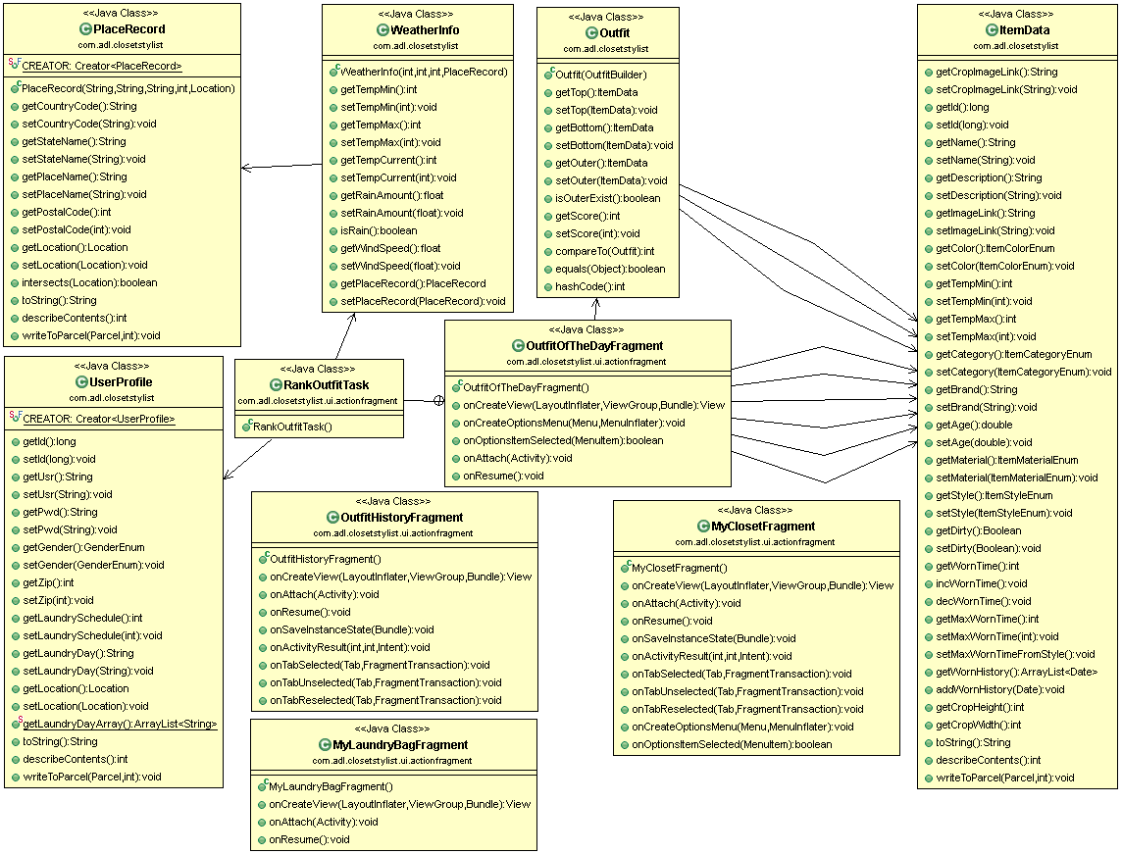

Figure 3.7: ClosetStylist class diagram.

## Chapter 4 Results

ClosetStylist utilizes both off-the-shelf weather and location technologies together with our clothes matching algorithms; therefore, it is essential that each one fulfills its part and works with one another smoothly to provide great user experience. Besides, it is also important for the app to deliver accurate weather information, provide reasonable outfit suggestions, and be responsive to users.

### 4.1 Outfit Of The Day Result

The five-step clothes matching algorithm was considered the most important feature of the app. Therefore, many different trials were executed to fine-tune this algorithm until the result was optimal. The tables in each step were used as the knobs to control the clothes matching service. We tried making the temperature filter dependent on both style and material by creating temperature filter tables for both style and material. As we conducted more experiments, the material did not turn out to be an obvious indicator (as explained above, because we could layer up with multiple clothing pieces); so we removed the temperature range based on material. In addition, upon realizing that the list of suggestions did not change significantly among occasion options, we decided to increase the weight of occasion matching scores. This change proved to be helpful as it made the algorithm produce similar results as we would have hand-picked the outfits.

Although the app works properly in many scenarios, we are aware of certain limitations to the algorithm:

* If the closet does not have many items in various styles, the service will recommend very similar outfits.
* If there are many items in the same style, the algorithm tends to provide the same suggestion lists for different occasions.
* At the moment, the suggestion list is not much different between these 2 pairs of occasions: Formal and Semi_Formal, Day_Out and Night_Out.
* When the weather is cold, the outer item is not changed drastically when traversing through the suggested outfit list.
* Our data tables were created based on two sample sets of wardrobe: a male set of 24 items and a female set of 86 items. More testing samples are needed to assure that the algorithm can return optimal results in a wide variety of clothing inventory.

### 4.2 Display Picture

Loading images of garments is critical for most of the features of this app. Displaying the pictures taken by the cell phones bears a lot of unanticipated problems. Android devices have a limitation as little as 16MB memory for an application due to the constrained system resource of handheld devices. Rich images taken by cell phones usually have a size in megabytes and can easily exhaust per-app limit on some devices. When the bitmap object is loaded, it consumes the entire available memory budget, the app usually crashes with the following message “java.lang.OutofMemoryError: bitmap size exceeds VM budget.” To avoid these types of exceptions, images must be processed before being loaded in the app.

[DAN] provides guidelines and sample code to process images off the UI thread, and then load them efficiently to the app. We applied the guidelines to sample images using AsyncTask on a different thread from the UI thread. Once the images were resized, we displayed the newly processed images on the screen. This allowed us to display a list of the images in My Closet screen or multiple images in Outfit of the Day screen smoothly as the user scrolled up and down.

### 4.3 Weather service and location service

The app uses the location service from geonames [Geo] to find the city and country based on the current location, and then obtains the weather information from Open Weather Map service.

The result for location service provided the correct city and country, but the zip code was not quite exact. However, this result was acceptable for our app because we did not need exact location with the assumption that the weather within a city did not change significantly.

Regarding the weather, we compared the temperature returned from the Open Weather Map service with the weather.com information, and it was within the -5 to +5 Fahrenheit range. This was acceptable because the granularity in our algorithm was bigger than this.

### 4.4 Screenshots

In this section, some screenshots whose mockups were presented earlier are shown to compare between the original design and the result. There are many factors led to modifications from the originals, for example, change in design, imperfect pictures of clothes, etc. All of the changes will be explained in the following.

#### 4.4.1 Login and Registration

Figure 4.1 shows the screenshots of the mockups in Figure 2.9. In the user login screenshot, the Facebook login was removed because we decided to implement our own login, and Facebook login is treated as an option to enable certain social features. The other method we could have chosen was to utilize Facebook login to authorize people using our app. The decision was made to give users a freedom to opt out of social features if they want to and also to reduce some features in this first ClosetStylist prototype.

|  |  |
| --- | --- |
|  |  |

Figure 4.1: User login and registration screenshots.

In the register mockups, there was a user’s profile picture, which was intended to be used in the Outfit of the Day screen to help the user visualize the outfit on his or her body. However, that screen already looked a little busy with too many items, and hence the profile picture was removed in the registration step.

#### 4.4.2 Main Screen and Side Menu

The screenshots in Figure 4.2 look like their mockups in Figure 2.10, and there was no change from the original design.

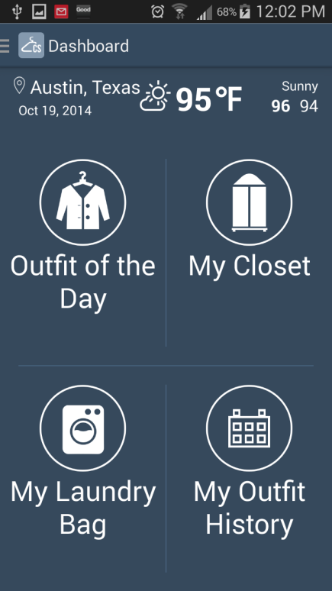 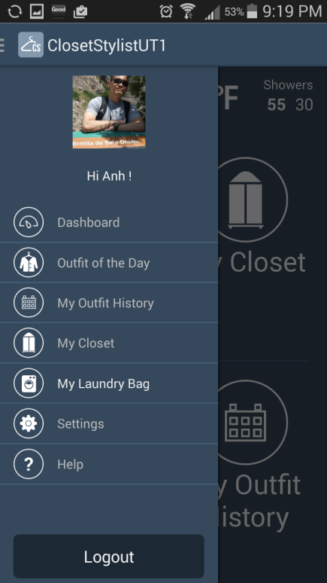

Figure 4.2: Main Screen and Side Menu screenshots.

#### 4.4.3 My Closet and Add Item

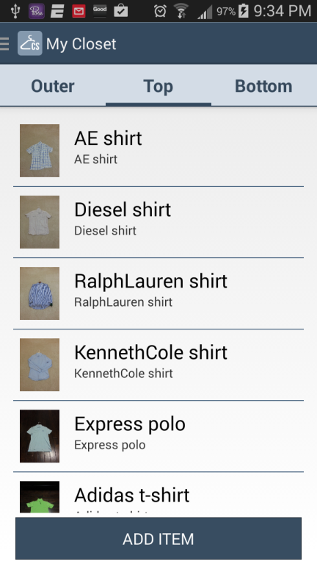 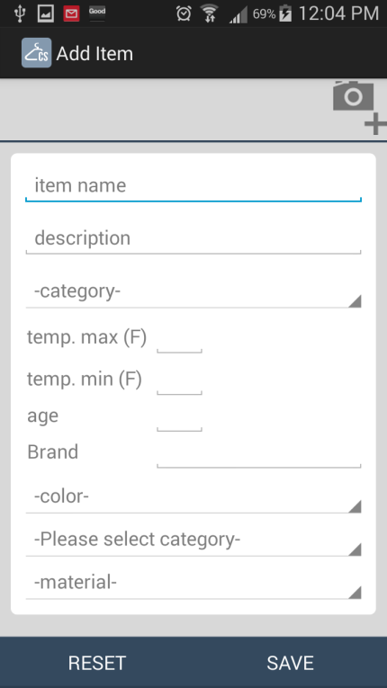

Figure 4.3: My Closet and Add Item screenshots.

Compared to their mockups in Figure 2.11, there was some cosmetic change to the screenshots in Figure 4.3. In My Closet screen, the tabs’ titles were changed to more generic terms such as “Jacket” to “Outer”, “T-Shirt” to “Top”, while “Shoes” was omitted as it would be too complex for the first prototype. The fields in Add Item were re-arranged to fit longer category, style, and material fields.

#### 4.4.4 Outfit of the Day and Laundry bag

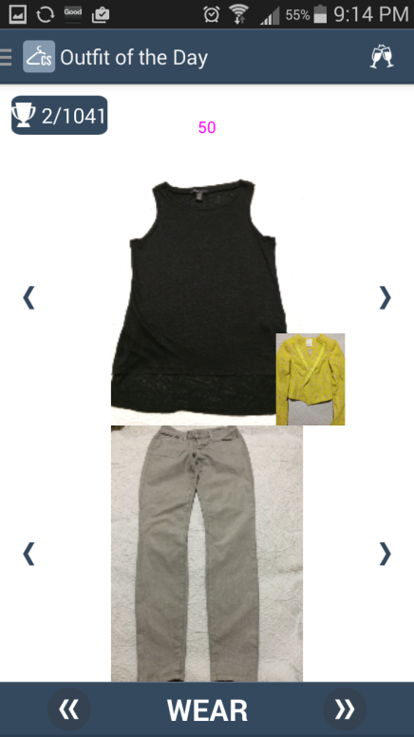 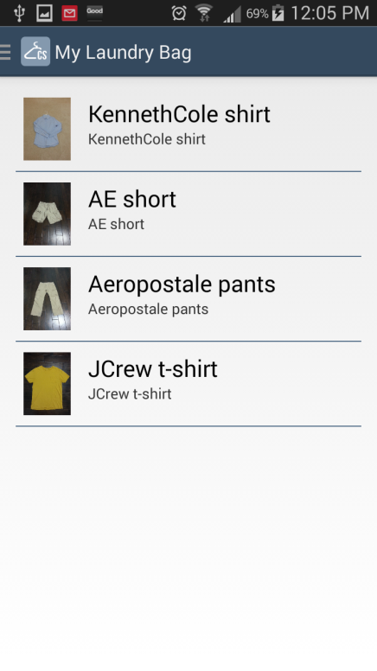

Figure 4.4: Outfit of the Day and Laundry bag screenshots.

There were some changes from the screenshots in Figure 4.4 compared to their counterpart in Figure 2.12. It can be easily noticed that hat, shoes, and user’s profile picture were omitted from the original design due to limited space on the screen. It was very complex to scale all items as in the original design because each image could be taken at different angles and different zoom levels. To simplify our app, some items were omitted. There was not much change in My Laundry bag.

#### 4.4.5 Outfit History and Outfit Preview

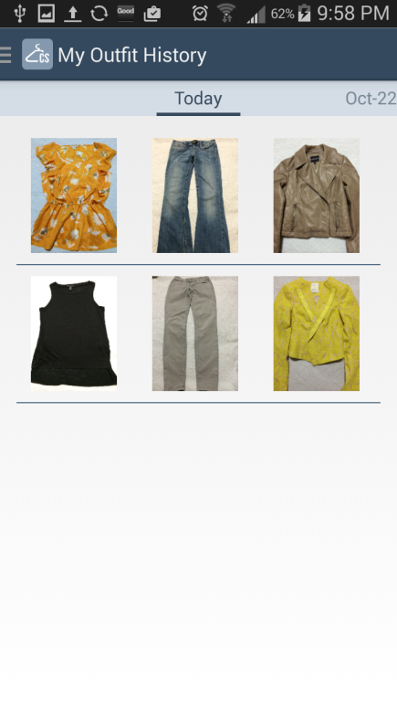 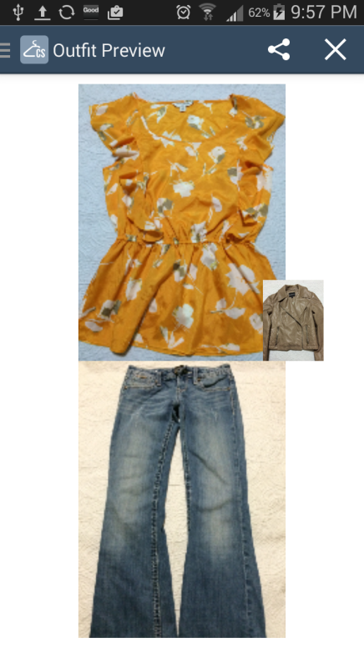

Figure 4.5: Outfit History and Outfit Preview screenshots.

Similar to the change in Figure 4.4, screenshots in Figures 4.5 had the hat, shoes, and user’s profile picture deleted.

### 4.5 Costs and level of effort

During development, GitHub was used as the source control tool, and the project was left as public to be used for free. Table 4.1 shows the cost of equipment and services spent on the ClosetStylist app.

|  |  |
| --- | --- |
| Item | Costs |
| Samsung S3 | Free |
| UI/UX Design | $150 |
| UI Development | $500 |

Table 4.1: ClosetStylist development costs.

The app was developed from March to August of 2014. The following section shows how many hours were spent on different aspects of the project:

* 40 hours for architecture design.
* 30 hours for original UI design.
* 10 hours for final UI design.
* 20 for UI development collaboration.
* 260 hours for studying Android, researching, coding, and testing.
* 40 hours for writing the report.

Figure 4.5 shows the result after running CodePro AnalytiX tool [Cpro] against the multiple metrics. An entry in red means there is some code violation in some predefined criteria of metric, and there is room for improvement. For example, the cyclomatic complexity violation simply means the average number of branched keywords per method such as “if”, “while”, “for”, etc. is above a predefined threshold in the metric. There is some other basic information about code such as 10427 lines of code were written in 92 Java files and 39 XML files, the average number of lines per method were 8.74, etc.

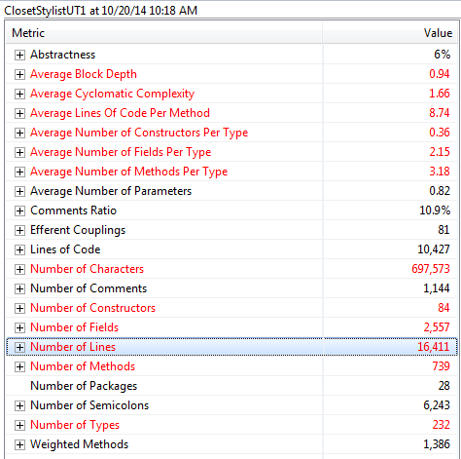

Figure 4.6: Metrics with CodePro AnalytiX.

Figure 4.7 shows the foot print of ClosetStylist from the Android Application Manager, it occupies the total of 4.65 MB memory, of which 4.58 MB is for application code and 68 KB is for data.

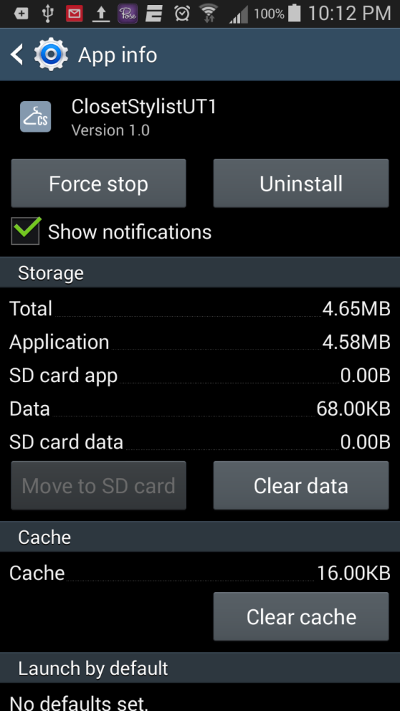

Figure 4.7: Foot print of Closet Stylist.

### 4.6 Lessons learned

Android is a very powerful framework, and it takes a lot of time and effort to master and use it efficiently. Starting to learn Android from the beginning of 2014, I had encountered quite a few challenges while implementing the app. Nevertheless, as Android is being used in hundreds of millions of devices, the eco system is huge and it was often easy to find the solution for problems I was facing as someone else had dealt with similar problems. Stackoverflow and Android developer websites were my companions throughout the project.

Git is another new tool I learned in this project. Although I was familiar with SVN, another source control tool, I decided to learn Git and used it as the source control for this project. It did take me a lot of time to get used to running Git from command line because I often worked with TortoiseSVN – a UI tool on Windows systems. [VCG], which is referenced in Advanced Programming Tool class [APT], is a helpful source that has helped me tremendously throughout the development process.

Below are the most highlighted things to do and not to do that I collected after finishing the first prototype of ClosetStylist:

**Dos**:

* Use mock data to avoid running out of request quota for location service. I learned this trick from [APT] while working on MileageRun lab, and this proved to be helpful to avoid hitting the limit on number of requests per time unit.
* Design UI/UX carefully to avoid missing any features, especially close to the release date. Hiring a professional designer to assist you is a great idea because there are many subtle front-end elements that back-end developers may consider trivial but could turn out to be quite significant to users.
* Use Robotium to leverage test efforts. Although this tool has certain shortcomings as it cannot run test cases such as launching camera app or gallery app, it is still a very powerful tool that can save you a lot of time and effort.
* Put more efforts into processing the images taken from built-in camera or imported from a gallery. Taking pictures of clothes is not as easy as it may seem, and is time-consuming even with a handy camera phone. We ended up laying our clothes on the floor and the couch to take pictures, trying not to catch the shadow in the background. If we want to release this app, we must figure out a better way to tackle this issue.

**Dont’s**:

* Couple UI with the backend code. To some degree, the Android architecture provides a tight coupling between the UI and core. Attention needs to be paid to avoid this coupling as it will be catastrophic if any change in UI (which happens quite often) requires a change in backend code or vice versa.
* Wait until the last minute to integrate social media, especially Facebook. For a simple post, it is straightforward with the provided sample code. For customized post including pictures, mastering the sample code and the APIs is essential. Another problem is their APIs change more often than their guidance and many samples are obsolete due to deprecated APIs. Also, beware that their APIs may not be compatible with the latest development Android version.
* Connect Samsung Galaxy S3 phone to Windows system to run Android app. Although it was easy to find the driver and configure the phone to work on the Ubuntu systems, the Windows system was not the same. I tried different software ranging from the official Kies program from Samsung to some unofficial software found on Internet but to no avail. It caused inexplicable errors when I ran the Microsoft C compiler, which is the build tool I used at work; and I had to re-install Windows.

## Chapter 5 Conclusion

### 5.1 Summary

After six months of development, the first prototype of ClosetStylist app was completed and met all of the original goals. The architecture was designed with certain flexibility and extensibility for future work. Some off-the-shelf technologies such as location service and weather service were integrated to work coherently with our clothes matching service to deliver the following key features of the app: picking outfit programmatically based on weather and occasion options, viewing outfit history, organizing closet, and managing laundry. The clothes matching algorithm provided good suggestions resulted in nice outfits.

With all that said, the app still leaves a lot to be desired.

* The image processing method needs to be enhanced to provide user with more edit capability than just cropping.
* Social media needs to be integrated more aggressively than just simply a login to Facebook such as letting friends vote on the outfits and sharing them.
* Items such as hat, bags, and shoes are part of a complete outfit and should be part of the recommendation.

In conclusion, the prototype of the ClosetStylitst app has integrated well with multiple technologies to implement features that can help people get the most out of what they already had in their closets. It has laid out a good foundation for future work towards releasing an official Android app.

### 5.2 Related work

There are many fashion apps available but not many of them offer all of the features of ClosetStylist. [5FADYC] lists some apps that can help to digitize our closets, and while all of them support iOS, only two of them support Android. The following section will review the most interesting ones of them and compare with the supported features in ClosetStylist.

#### 5.2.1 Stylebook

This is an iOS app, and it has the most similar functionalities with our ClosetStylist app. Their goal is to curate customers wardrobe’s and choose new pieces that fit into their current closet.

The app provides many neat functionalities: match other pieces in the closet with a specific top, make quick outfit collage, search for the right items to buy by using shopping features, mix match different pieces in the outfit editor, suggest which items in closet should be replaced.

Although our ClosetStylist app offers some similar features, we differentiate from this app by programmatically suggesting outfits based on the current weather.

#### 5.2.2 Pose

Pose is a tool to keep track of daily outfits and it is available in both iOS and Android. It is deeply integrated into social networks and resembles Instagram in many ways, for example, it let users share and discover inspiring looks from other users as well as your own garments’ pictures.

Although this offers great experience in social networks, it does not provide some fundamental features of ClosetStylist such as managing laundry bag or suggesting outfit to wear.

#### 5.2.3 Netrobe

This app is only available in iOS. It offers quite appealing features including managing clothes, and mixmatching outfits from the garments populated. The ClosetStylist features lacked in this app are laundry bag maintenance and outfit suggestion.

### 5.3 Future work

This ClosetStylist prototype serves multiple purposes: prove a concept, learn how to program Android, learn how to manage a smart phone app project with a professional UI/UX designer and a UI developer. Although we were successfully developed a prototype, the features offered at the moment is still a very small subset of the full feature set that could attract high adoption. Some of them are discussed in the following sections.

#### 5.3.1 Integration with social networks such as Facebook

We were able to login to Facebook, but we did not have enough time to implement sharing the outfit on Facebook because sharing images of the outfit is a complicated process. Given that this app requires displaying pictures, Twitter may not be a good social network to share. Instagram may be a better choice.

Without social media, it is very difficult to promote the app, and that is why this is the highest priority in our to-do list.

#### 5.3.2 Detect the item’s color automatically

Manually entering color is not too much work, but it would be nice if we can detect the color of the item and fulfill it automatically. The challenge is with multi-color items. Another obstacle is how to distinguish between the item and the background. Although this is a nice feature to have, the effort would be massive unless we can find a library or tools out there that already support this.

#### 5.3.3 Support more items

Currently, the app can handle regular “Tops” items, such as blouse, shirt, t-shirt, etc. but not dress. Other things that users would like to put together when going out including hats, shoes, bags, belts are not supported. These bear a lot of work because not only displaying them will make the phone screen too crowded but also the algorithm to choose an outfit will be much more complex. Nevertheless, these are essential to make a fully functional app.

#### 5.3.4 Add support for travelling

Adding support for travelers to pick the items for their trip is another functionality that we would like to add in the future. The user will enter his or her destination or a list of destinations together with the begin and end dates, and the app will programmatically suggest the outfits they should pack to be most efficient for their trip based on the weather forecast at the destinations.

#### 5.3.5 Create app for iOS

Although Android powers about 70 percent of mobile devices, iOS is still a very big player in this area, especially in terms of money. If we want to make a popular app, iOS must be supported to bring in customers and generate revenue.

## References

[Amb] "UML 2 Activity Diagramming Guidelines." UML 2 Activity Diagramming Guidelines. Ed. Scott Ambler. Ambysoft Inc. Web. 23 Oct. 2014. <http://www.agilemodeling.com/style/activityDiagram.htm>.

[Bal] "Balsamiq." . Rapid, Effective and Fun Wireframing Software. Balsamiq. Web. 23 Oct. 2014. <http://www.balsamiq.com>.

[Ecl] "Eclipse Downloads." Eclipse RSS. Eclipse Foundation, 1 Jan. 2004. Web. 23 Oct. 2014. <http://www.eclipse.org/downloads/>.

[SWA] Azzola, Francesco. "Surviving W/ Android." Android Weather App: JSON, HTTP and Openweathermap. 21 May 2013. Web. 23 Oct. 2014. <http://www.survivingwithandroid.com/2013/05/build-weather-app-json-http-android.html>.

[Inv] "Free Web & Mobile (iOS, Android) Prototyping and UI Mockup Tool | InVision." InVision. InVision. Web. 23 Oct. 2014. <http://www.invisionapp.com/>.

[Geo] "GeoNames." GeoNames. Web. 23 Oct. 2014. <http://www.geonames.org/>.

[Rob] Reda, Renas. "User Scenario Testing for Android." Robotium - The World's Leading Android™ Test Automation Framework. Google. Web. 23 Oct. 2014. <https://code.google.com/p/robotium>.

[TCW] Centeno, Antonio. "The Color Wheel – Color Coordination for Men." Real Men Real Style. RMRS. Web. 23 Oct. 2014. <http://www.realmenrealstyle.com/color-wheel-color-coordination-men/>.

[HFDP] Elisabeth Freeman , Eric Freeman , Bert Bates , Kathy Sierra, Head First Design Patterns, O' Reilly & Associates, Inc., 2004

[DAN] "Displaying Bitmaps Efficiently." Android Developers. Google. Web. 23 Oct. 2014. <http://developer.android.com/training/displaying-bitmaps/index.html>.

[Cpro] "Java Developer Tools." CodePro Analytix User Guide. Google. Web. 23 Oct. 2014. <https://developers.google.com/java-dev-tools/codepro/doc/>.

[5FADYC] "5 Fashion Apps to Digitize Your Closet." Mashable. Mashable, 1 Jan. 2013. Web. 23 Oct. 2014. <http://mashable.com/2012/07/13/closet-management-apps/>.

[LAAD] Jackson, Wallace. "Exploring Android App Development: The Lingo of Android and Building Your First Hello World App!" Learn Android App Development. Berkeley, Calif.: Apress, 2013. Print.

[VCG] Loeliger, Jon, and Matthew McCullough. Version Control with Git. Second ed. (California): O'Reilly, 2012. Print.

[APT] Aziz, Adnan. "EE382V - Advanced Programming Tools." Advanced Programming Tools. 1 Aug. 2013. Web. 5 Nov. 2014.