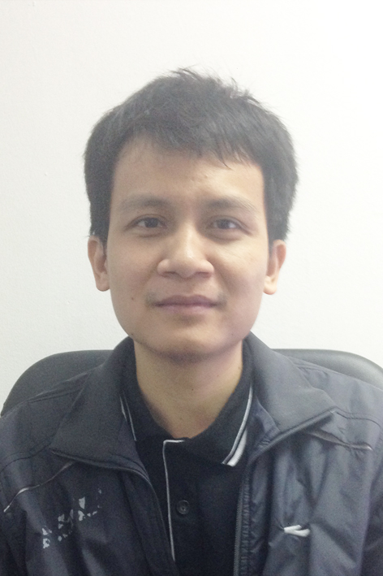
Lương Đỗ Long
Address: My Dinh 1, Nam Tu Liem, Ha Noi, Viet Nam
Birthday: January 12, 1985
Phone: 0902088968
Email: luongdolong@gmail.com Skype: luongdolong

Summary: Full-Stack software engineer with 10+ years experiences coding technically sophisticated web applications, smartphone applications, server API using Spring Framework, JS, Java, Objective-C/Swift, Microsoft Technologies, C/C++ three-tiered architecture and more. Strong knowledge in software development such as: design pattern, software framework, algorithms. Strong analytical skills and level headed problem solver. Understanding client requirements and communicating the progress of projects are core values in achieving long lasting business relationships.

Career Objective: Become a technical manager and good software architect, talent developer with deep knowledge of machine learning.

EDUCATION

- University of Engineering and Technology, VNU
(2003 – 2007)
Bachelor's degree, Computer Science

- University of Engineering and Technology, VNU
(2009 – 2011)
Master's degree, Computer Science

SKILLS & TECHNOLOGIES

Languages | Framework | Operating Systems | Networking | Database
- Java  - Objective-C  - Swift  - C/C++  - Python  - VB.NET  - ASP.NET  - C#  - HTML/XML  - JavaScript | - Spring  - Hibernate  - JSF  - Struts  - .Net framework  - Android/iOS  - Xamarin  - jQuery  - AngularJS  - Note.js  - Scikit-Learn | - Linux  - Solaris  - MaxOS  - Windows | - TCP/IP  - RPC  - HTTP  - Security  - J2EE/Servlets | - Oracle  - MySQL  - Postgresql  - SQL Server

PROFESSIONAL EXPERIENCE

Luvina Software JSC 2007 – Present
A Software outsourcing company for the Japanese market in Hanoi City, Vietnam.
Senior Software Developer & Technical Leader

Leading a technical team on a variety of development projects and delivering solutions to meet and exceed clients’ briefs.

Responsibilities:
- Wrote very high quality code and fix bug
- Analysing and debugging code
- Maintaining the stability of all live systems
- Found out a serious error that had existed in the system
- Technical support for colleagues
- Designed the architecture and provided the implementation system
- Identified key software architecture decisions, discussed with PM to plan best structure for future feature additions.
- Designed reusable components by utilizing various standard frameworks
- Evaluated requirements, made technology recommendations that supported optimal construction, maintenance and performance
- Set priorities, assigned tasks and gave feedback to developers on team.
- Mentoring team members in development and technical progression
- Technical training for new staff

HOBBIES
Football, Reading, Science, Vietnam History, Buddhism, DeepLearning

