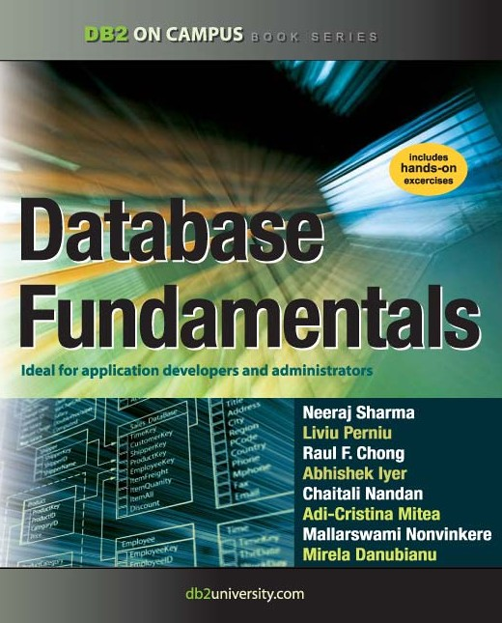

Database Fundamentals



**A book for the community by the community**

#### Neeraj Sharma, Liviu Perniu, Raul F. Chong, Abhishek Iyer, Chaitali Nandan, Adi-Cristina Mitea, Mallarswami Nonvinkere, Mirela Danubianu

**F I R S T E D I T I O N**

First Edition (November 2010)

**© Copyright IBM Corporation 2010. All rights reserved.**

IBM Canada

8200 Warden Avenue Markham, ON

L6G 1C7

Canada

This edition covers IBM® DB2® Express-C Version 9.7 for Linux®, UNIX® and Windows®.

**Notices**

This information was developed for products and services offered in the U.S.A.

IBM may not offer the products, services, or features discussed in this document in other countries. Consult your local IBM representative for information on the products and services currently available in your area. Any reference to an IBM product, program, or service is not intended to state or imply that only that IBM product, program, or service may be used. Any functionally equivalent product, program, or service that does not infringe any IBM intellectual property right may be used instead. However, it is the user's responsibility to evaluate and verify the operation of any non-IBM product, program, or service.

IBM may have patents or pending patent applications covering subject matter described in this document. The furnishing of this document does not grant you any license to these patents. You can send license inquiries, in writing, to:

*IBM Director of Licensing IBM Corporation*

*North Castle Drive Armonk, NY 10504-1785 U.S.A.*

For license inquiries regarding double-byte character set (DBCS) information, contact the IBM Intellectual Property Department in your country or send inquiries, in writing, to:

*Intellectual Property Licensing Legal and Intellectual Property Law IBM Japan, Ltd.*

*3-2-12, Roppongi, Minato-ku, Tokyo 106-8711*

**The following paragraph does not apply to the United Kingdom or any other country where such provisions are inconsistent with local law:** INTERNATIONAL BUSINESS MACHINES CORPORATION PROVIDES THIS PUBLICATION "AS IS" WITHOUT WARRANTY OF ANY KIND, EITHER EXPRESS OR IMPLIED, INCLUDING, BUT NOT LIMITED TO, THE IMPLIED WARRANTIES OF NON-INFRINGEMENT, MERCHANTABILITY OR FITNESS FOR A

PARTICULAR PURPOSE. Some states do not allow disclaimer of express or implied warranties in certain transactions, therefore, this statement may not apply to you.

This information could include technical inaccuracies or typographical errors. Changes are periodically made to the information herein; these changes will be incorporated in new editions of the publication. IBM may make improvements and/or changes in the product(s) and/or the program(s) described in this publication at any time without notice.

Any references in this information to non-IBM Web sites are provided for convenience only and do not in any manner serve as an endorsement of those Web sites. The materials at those Web sites are not part of the materials for this IBM product and use of those Web sites is at your own risk.

IBM may use or distribute any of the information you supply in any way it believes appropriate without incurring any obligation to you.

The licensed program described in this document and all licensed material available for it are provided by IBM under terms of the IBM Customer Agreement, IBM International Program License Agreement or any equivalent agreement between us.

Any performance data contained herein was determined in a controlled environment. Therefore, the results obtained in other operating environments may vary significantly. Some measurements may have been made on development-level systems and there is no guarantee that these measurements will be the same on generally available systems. Furthermore, some measurements may have been estimated through extrapolation. Actual results may vary. Users of this document should verify the applicable data for their specific environment.

Information concerning non-IBM products was obtained from the suppliers of those products, their published announcements or other publicly available sources. IBM has not tested those products and cannot confirm the accuracy of performance, compatibility or any other claims related to non-IBM products. Questions on the capabilities of non-IBM products should be addressed to the suppliers of those products.

All statements regarding IBM's future direction or intent are subject to change or withdrawal without notice, and represent goals and objectives only.

This information contains examples of data and reports used in daily business operations. To illustrate them as completely as possible, the examples include the names of individuals, companies, brands, and products. All of these names are fictitious and any similarity to the names and addresses used by an actual business enterprise is entirely coincidental.

COPYRIGHT LICENSE:

This information contains sample application programs in source language, which illustrate programming techniques on various operating platforms. You may copy, modify, and distribute these sample programs in any form without payment to IBM, for the purposes of developing, using, marketing or distributing application programs conforming to the application programming interface for the operating platform for which the sample programs are written. These examples have not been thoroughly tested under all conditions. IBM, therefore, cannot guarantee or imply reliability, serviceability, or function of these programs. The sample programs are provided "AS IS", without warranty of any kind. IBM shall not be liable for any damages arising out of your use of the sample programs.

References in this publication to IBM products or services do not imply that IBM intends to make them available in all countries in which IBM operates.

If you are viewing this information softcopy, the photographs and color illustrations may not appear.

**Trademarks**

IBM, the IBM logo, and ibm.com are trademarks or registered trademarks of International Business Machines Corp., registered in many jurisdictions worldwide. Other product and service names might be trademarks of IBM or other companies. A current list of IBM trademarks is available on the Web at “[Copyright and trademark information”](http://www.ibm.com/legal/copytrade.shtml) at [www.ibm.com/legal/copytrade.shtml.](http://www.ibm.com/legal/copytrade.shtml)

Java and all Java-based trademarks are trademarks of Sun Microsystems, Inc. in the United States, other countries, or both.

Microsoft and Windows are trademarks of Microsoft Corporation in the United States, other countries, or both.

Linux is a registered trademark of Linus Torvalds in the United States, other countries, or both. UNIX is a registered trademark of The Open Group in the United States and other countries.

Other company, product, or service names may be trademarks or service marks of others.

**Table of Contents**

Preface 15

Who should read this book? 15

How is this book structured? 15

A book for the community 15

Conventions 15

What’s next? 16

About the Authors 17

Contributors 19

Acknowledgements 21

Chapter 1 - Databases and information models 23

* 1. What is a database? 23
  2. What is a database management system? 23
     1. The evolution of database management systems 24
  3. Introduction to information models and data models 26
  4. Types of information models 27
     1. Network model 28
     2. Hierarchical model 28
     3. Relational model 29
     4. Entity-Relationship model 30
     5. Object-relational model 31
     6. Other data models 32
  5. Typical roles and career path for database professionals 32
     1. Data Architect 32
     2. Database Architect 32
     3. Database Administrator (DBA) 33
     4. Application Developer 34
  6. Summary 34
  7. Exercises 35
  8. Review questions 35

Chapter 2 – The relational data model 37

* 1. Relational data model: The big picture 37
  2. Basic concepts 38
     1. Attributes 38
     2. Domains 39
     3. Tuples 40
     4. Relations 40
     5. Schemas 41
     6. Keys 41
  3. Relational data model constraints 44
     1. Entity integrity constraint 44
     2. Referential integrity constraint 45
     3. Semantic integrity constraints 46
  4. Relational algebra 49

Database Fundamentals 10

* + 1. Union 49
    2. Intersection 49
    3. Difference 50
    4. Cartesian product 51
    5. Selection 52
    6. Projection 53
    7. Join 54
    8. Division 56
  1. Relational calculus 57
     1. Tuple-oriented relational calculus 58
     2. Domain-oriented relational calculus 59
  2. Summary 60
  3. Exercises 60
  4. Review questions 62

Chapter 3 – The conceptual data model 65

* 1. Conceptual, logical and physical modeling: The big picture 65
  2. What is a model? 67
     1. Data model 67
     2. Database model 67
     3. Conceptual data model concepts 68
  3. A case study involving a Library Management System - Part 1 of 3 77
     1. Developing the conceptual model 77
  4. Summary 85
  5. Exercises 85
  6. Review questions 85

Chapter 4 – Relational Database Design 89

* 1. The problem of redundancy 89
     1. Insertion Anomalies 90
     2. Deletion Anomalies 90
     3. Update Anomalies 90
  2. Decompositions 91
  3. Functional Dependencies 92
  4. Properties of Functional Dependencies 94
     1. Armstrong’s Axioms 94
     2. Computing the closure set of attributes 95
     3. Entailment 96
  5. Normal Forms 96
     1. First Normal Form (1NF) 96
     2. Second Normal Form (2NF) 98
     3. Third Normal Form (3NF) 99
     4. Boyce-Codd Normal Form (BCNF) 100
  6. Properties of Decompositions 101
     1. Lossless and Lossy Decompositions 102
     2. Dependency-Preserving Decompositions 103
  7. Minimal Cover 103
  8. Synthesis of 3NF schemas 105
  9. 3NF decomposition 106
  10. The Fourth Normal Form (4NF) 106
      1. Multi-valued dependencies 107
  11. Other normal forms 108
  12. A case study involving a Library Management System - Part 2 of 3 108
  13. Summary 111
  14. Exercises 112
  15. Review questions 112

Chapter 5 – Introduction to SQL 115

* 1. History of SQL 115
  2. Defining a relational database schema in SQL 116
     1. Data Types 116
     2. Creating a table 117
     3. Creating a schema 120
     4. Creating a view 121
     5. Creating other database objects 121
     6. Modifying database objects 121
     7. Renaming database objects 122
  3. Data manipulation with SQL 122
     1. Selecting data 122
     2. Inserting data 123
     3. Deleting data 124
     4. Updating data 124
  4. Table joins 125
     1. Inner joins 125
     2. Outer joins 126
  5. Union, intersection, and difference operations 128
     1. Union 129
     2. Intersection 130
     3. Difference (Except) 130
  6. Relational operators 131
     1. Grouping operators 131
     2. Aggregation operators 132
     3. HAVING Clause 132
  7. Sub-queries 132
     1. Sub-queries returning a scalar value 133
     2. Sub-queries returning vector values 133
     3. Correlated sub-query 133
     4. Sub-query in FROM Clauses 134
  8. Mapping of object-oriented concepts to relational concepts 134

5.10 A case study involving a Library Management System - Part 3 of 3 135

* 1. Summary 139
  2. Exercises 140
  3. Review questions 140

Chapter 6 – Stored procedures and functions 143

* 1. Working with IBM Data Studio 143
     1. Creating a project 144
  2. Working with stored procedures 146
     1. Types of procedures 147
     2. Creating a stored procedure 148
     3. Altering and dropping a stored procedure 152
  3. Working with functions 153
     1. Types of functions 153
     2. Creating a function 154
     3. Invoking a function 155
     4. Altering and dropping a function 156
  4. Summary 157
  5. Exercises 157
  6. Review Questions 157

Chapter 7 – Using SQL in an application 161

* 1. Using SQL in an application: The big picture 161
  2. What is a transaction? 162
  3. Embedded SQL 163
     1. Static SQL 163
     2. Dynamic SQL 168
     3. Static vs. dynamic SQL 172
  4. Database APIs 173
     1. ODBC and the IBM Data Server CLI driver 173
     2. JDBC 175
  5. pureQuery 176
     1. IBM pureQuery Client Optimizer 179
  6. Summary 179
  7. Exercises 180
  8. Review Questions 180

Chapter 8 – Query languages for XML 183

* 1. Overview of XML 183
     1. XML Elements and Database Objects 183
     2. XML Attributes 185
     3. Namespaces 186
     4. Document Type Definitions 187
     5. XML Schema 188
  2. Overview of XML Schema 189
     1. Simple Types 189
     2. Complex Types 191
     3. Integrity constraints 192
     4. XML Schema evolution 193
  3. XPath 194
     1. The XPath data model 194
     2. Document Nodes 194
     3. Path Expressions 196
     4. Advanced Navigation in XPath 196
     5. XPath Semantics 196
     6. XPath Queries 198
  4. XQuery 199
     1. XQuery basics 200
     2. FLWOR expressions 200
     3. Joins in XQuery 201
     4. User-defined functions 202
     5. XQuery and XML Schema 202
     6. Grouping and aggregation 202
     7. Quantification 204
  5. XSLT 204
  6. SQL/XML 206
     1. Encoding relations as XML Documents 206
     2. Storing and publishing XML documents 207
     3. SQL/XML Functions 207
  7. Querying XML documents stored in tables 211
  8. Modifying data 212
     1. XMLPARSE 212
     2. XMLSERIALIZE 213
     3. The TRANSFORM expression 213
  9. Summary 214
  10. Exercises 215
  11. Review questions 215

Chapter 9 – Database Security 221

* 1. Database security: The big picture 221
     1. The need for database security 222
     2. Access control 224
     3. Database security case study 225
     4. Views 231
     5. Integrity Control 231
     6. Data encryption 231
  2. Security policies and procedures 232
     1. Personnel control 232
     2. Physical access control 232
  3. Summary 233
  4. Exercises 233
  5. Review Questions 233

Chapter 10 – Technology trends and databases 235

* 1. What is Cloud computing? 235
     1. Characteristics of the Cloud 236
     2. Cloud computing service models 237
     3. Cloud providers 237
     4. Handling security on the Cloud 241

Database Fundamentals 14

* + 1. Databases and the Cloud 242
  1. Mobile application development 243
     1. Developing for a specific device 244
     2. Developing for an application platform 245
     3. Mobile device platform 246
     4. Mobile application development platform 247
     5. The next wave of mobile applications 248
     6. DB2 Everyplace 248
  2. Business intelligence and appliances 249
  3. db2university.com: Implementing an application on the Cloud (case study) 249
     1. Moodle open source course management system 250
     2. Enabling openID sign-in 253
     3. Running on the Amazon Cloud 254
     4. Using an Android phone to retrieve course marks 255
  4. Summary 256

Appendix A – Solutions to review questions 259

Appendix B – Up and running with DB2 264

* 1. DB2: The big picture 264
  2. DB2 Packaging 265
     1. DB2 servers 265
     2. DB2 Clients and Drivers 266
  3. Installing DB2 267
     1. Installation on Windows 267
     2. Installation on Linux 268
  4. DB2 tools 268
     1. Control Center 268
     2. Command Line Tools 270
  5. The DB2 environment 273
  6. DB2 configuration 274
  7. Connecting to a database 275
  8. Basic sample programs 276
  9. DB2 documentation 278

Resources 279

Web sites 279

Books 279

References 280

Contact 281

## Preface

Keeping your skills current in today's world is becoming increasingly challenging. There are too many new technologies being developed, and little time to learn them all. The DB2® on Campus Book Series has been developed to minimize the time and effort required to learn many of these new technologies.

This book helps new database professionals understand database concepts with the right blend of breadth and depth of information.

### Who should read this book?

This book is tailored for new database enthusiasts, application developers, database administrators, and anyone with an interest in the subject and looking to get exposure such as university students and new graduates.

### How is this book structured?

This book is divided into chapters, starting with the basic database concepts and information models in Chapter 1. Chapter 2 covers relational data models. Chapter 3 and 4 explain conceptual modeling and relational database design. In Chapters 5, 6 and 7 the focus is geared towards SQL. Chapter 8 highlights XML data storage and retrieval via SQL and XQuery. Chapter 9 addresses database security aspects. The book then concludes with an overview of various other key technologies and relevant applications that are increasingly popular in the industry today.

Exercises and review questions can be found with most chapters. The solutions have been provided in Appendix A.

### A book for the community

This book was created by a community of university professors, students, and professionals (including IBM employees). Members from around the world have participated in developing this book. The online version of this book is released to the community at no charge. If you would like to provide feedback, contribute new material, improve existing material, or help with translating this book to another language, please send an email of your planned contribution to [db2univ@ca.ibm.com](mailto:db2univ@ca.ibm.com) with the subject “Database fundamentals book feedback”.

### Conventions

Many examples of commands, SQL statements, and code are included throughout the book. Specific keywords are written in uppercase bold. For example: A **NULL** represents an unknown state. Commands are shown in lowercase bold. For example: The **dir** command lists all files and subdirectories on Windows. SQL statements are shown in

upper case bold. For example: Use the **SELECT** statement to retrieve information from a table.

Object names used in our examples are shown in bold italics. For example: The ***flights***

table has five columns.

Italics are also used for variable names in the syntax of a command or statement. If the variable name has more than one word, it is joined with an underscore. For example: **CREATE TABLE *table_name***

### What’s next?

We recommend that you review the following books in this book series for more details about related topics:

* *Getting started with* DB2 Express-C
* *Getting started with InfoSphere Data Architect*
* *Getting started with data warehousing*
* *Getting started with DB2 application development*

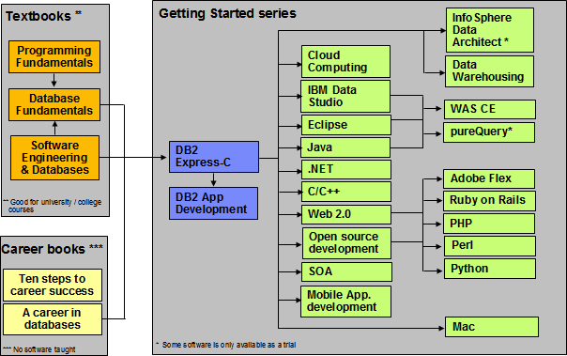The following figure shows all the different eBooks in the DB2 on Campus book series available free at [**db2university.com**](http://www.db2university.com/)

The DB2 on Campus book series

## About the Authors

**Neeraj Sharma** is a senior IT specialist at the Dynamic Warehousing Center of Competency, IBM India Software Labs. His primary role is design, configuration and implementation of large data warehouses across various industry domains; implementation of custom proof of concept (POC) exercises, and execution of performance benchmarks at customer's request. He holds a bachelor’s degree in electronics and communication engineering and a master’s degree in software systems.

**Liviu Perniu** is an Associate Professor in the Automation Department at Transilvania University of Brasov, Romania, teaching courses in the area of Data Requirements, Analysis, and Modeling. He is an IBM 2006 Faculty Award recipient as part of the Eclipse Innovation Awards program.

**Raul F. Chong** is the DB2 on Campus program manager based at the IBM Toronto Laboratory, and a DB2 technical evangelist. His main responsibility is to grow the DB2 community around the world. Raul joined IBM in 1997 and has held numerous positions in the company. As a DB2 consultant, Raul helped IBM business partners with migrations from other relational database management systems to DB2, as well as with database performance and application design issues. As a DB2 technical support specialist, Raul has helped resolve DB2 problems on the OS/390®, z/OS®, Linux®, UNIX® and Windows platforms. Raul has taught many DB2 workshops, has published numerous articles, and has contributed to the DB2 Certification exam tutorials. Raul has summarized many of his DB2 experiences through the years in his book *Understanding DB2 - Learning Visually with Examples 2nd Edition (ISBN-10: 0131580183)* for which he is the lead author. He has also co-authored the book *DB2 SQL PL Essential Guide for DB2 UDB on Linux, UNIX, Windows, i5/OS, and z/OS (ISBN* 0131477005), and is the project lead and co-author of many of the books in the DB2 on Campus book series.

**Abhishek Iyer** is an engineer at the Warehousing Center of Competency, IBM India Software Laboratory. His primary role is to create proof of concepts and execute performance benchmarks on customer requests. His expertise includes data warehouse implementation and data mining. He holds a bachelor’s degree in computer science.

**Chaitali Nandan** is a software engineer working in the DB2 Advanced Technical Support team based at the IBM India Software Laboratory. Her primary role is to provide first relief and production support to DB2 Enterprise customers. She specializes in critical problem solving skills for DB2 production databases. She holds a Bachelor of Engineering degree in Information Technology.

**Adi-Cristina Mitea** is an associate professor at the Computer Science Department, “Hermann Oberth” Faculty of Engineering, “Lucian Blaga” University of Sibiu, Romania. She teaches courses in the field of databases, distributed systems, parallel and distributed algorithms, fault tolerant systems and others. Her research activities are in these same areas. She holds a bachelor’s degree and a Ph.D in computer science.

**Mallarswami Nonvinkere** is a pureXML® specialist with IBM’s India Software Laboratory and works for the DB2 pureXML enablement team in India. He works with IBM customers and ISVs to help them understand the use of pureXML technology and develop high performance applications using XML. Mallarswami helps customers with best practices and is actively involved in briefing customers about DB2 related technologies. He has been a speaker at various international conferences including IDUG Australasia, IDUG India and

IMTC and has presented at various developerWorks® forums.

**Mirela Danubianu** is a lecturer at Stefan cel Mare University of Suceava, Faculty of Electrical Engineering and Computer Science. She received a MS in Computer Science at University of Craiova (1985 – Automatizations and Computers) and other in Economics at Stefan cel Mare University of Suceava, (2009 - Management). She holds a PhD in Computers Science from Stefan cel Mare University of Suceava (2006 - Contributions to the development of data mining and knowledge methods and techniques). Her current research interests include databases theory and implementation, data mining and data warehousing, application of advanced information technology in economics and health care area. Mirela has co-authored 7 books and more than 25 papers. She has participated in more than 15 conferences, and is a member of the International Program Committee in three conferences.

## Contributors

The following people edited, reviewed, provided content, and contributed significantly to this book.

|  |  |  |  |
| --- | --- | --- | --- |
| **Contributor** | **Company/University** | **Position/Occupation** | **Contribution** |
| Agatha Colangelo | ION Designs, Inc | Data Modeler | Developed the core table of contents of the book |
| Cuneyt Goksu | VBT Vizyon Bilgi Teknolojileri | DB2 SME and IBM  Gold Consultant | Technical review |
| Marcus Graham | IBM US | Software developer | English and technical review of Chapter 10 |
| Amna Iqbal | IBM Toronto Lab | Quality Assurance - Lotus Foundations | English review of the entire book except chapters 5 and 7 |
| Leon Katsnelson | IBM Toronto Lab | Program Director, IBM Data Servers | Technical review, and contributor to Chapter 10 content |
| Jeff (J.Y.) Luo | IBM Toronto Lab | Technical Enablement Specialist | English review of chapter 7 |
| Fraser McArthur | IBM Toronto Lab | Information Management Evangelist | Technical review |
| Danna Nicholson | IBM US | STG ISV Enablement, Web Services | English review of the entire book. |
| Rulesh Rebello | IBM India | Advisory Manager - IBM Software Group Client Support | Technical review |
| Suresh Sane | DST Systems, Inc | Database Architect | Review of various chapters, especially those related to SQL |
| Nadim Sayed | IBM Toronto Lab | User-Centered Design Specialist | English review of chapter 1 |

Database Fundamentals 20

|  |  |  |  |
| --- | --- | --- | --- |
| Ramona Truta | University of Toronto | Lecturer | Developed the core table of contents of the book. |

## Acknowledgements

We greatly thank the following individuals for their assistance in developing materials referenced in this book.

Natasha Tolub for designing the cover of this book. Susan Visser for assistance with publishing this book.

# 1

## Chapter 1 - Databases and information models

Data is one of the most critical assets of any business. It is used and collected practically everywhere, from businesses trying to determine consumer patterns based on credit card usage, to space agencies trying to collect data from other planets. Data, as important as it is, needs robust, secure, and highly available software that can store and process it quickly. The answer to these requirements is a solid and a reliable database.

Database software usage is pervasive, yet it is taken for granted by the billions of daily users worldwide. Its presence is everywhere-from retrieving money through an automatic teller machine to badging access at a secure office location.

This chapter provides you an insight into the fundamentals of database management systems and information models.

### What is a database?

Since its advent, databases have been among the most researched knowledge domains in computer science. A ***database*** is a repository of data, designed to support efficient data storage, retrieval and maintenance. Multiple types of databases exist to suit various industry requirements. A database may be specialized to store binary files, documents, images, videos, relational data, multidimensional data, transactional data, analytic data, or geographic data to name a few.

Data can be stored in various forms, namely tabular, hierarchical and graphical forms. If data is stored in a tabular form then it is called a ***relational database***. When data is organized in a tree structure form, it is called a ***hierarchical database***. Data stored as graphs representing relationships between objects is referred to as a ***network database***. In this book, we focus on relational databases.

### What is a database management system?

While a database is a repository of data, a ***database management system***, or simply DBMS, is a set of software tools that control access, organize, store, manage, retrieve and maintain data in a database. In practical use, the terms database, database server,

database system, data server, and database management systems are often used interchangeably.

Why do we need database software or a DBMS? Can we not just store data in simple text files for example? The answer lies in the way users access the data and the handle of corresponding challenges. First, we need the ability to have multiple users insert, update and delete data to the same data file without "stepping on each other's toes". This means that different users will not cause the data to become inconsistent, and no data should be inadvertently lost through these operations. We also need to have a standard interface for data access, tools for data backup, data restore and recovery, and a way to handle other challenges such as the capability to work with huge volumes of data and users. Database software has been designed to handle all of these challenges.

The most mature database systems in production are relational database management systems (RDBMS’s). RDBMS's serve as the backbone of applications in many industries including banking, transportation, health, and so on. The advent of Web-based interfaces has only increased the volume and breadth of use of RDBMS, which serve as the data repositories behind essentially most online commerce.

##### 1.2.1 The evolution of database management systems

In the 1960s, network and hierarchical systems such as CODASYL and IMSTM were the state-of-the-art technology for automated banking, accounting, and order processing systems enabled by the introduction of commercial mainframe computers. While these systems provided a good basis for the early systems, their basic architecture mixed the physical manipulation of data with its logical manipulation. When the physical location of data changed, such as from one area of a disk to another, applications had to be updated to reference the new location.

A revolutionary paper by E.F. Codd, an IBM San Jose Research Laboratory employee in 1970, changed all that. The paper titled *“A relational model of data for large shared data banks”* [1.1] introduced the notion of data independence, which separated the physical representation of data from the logical representation presented to applications. Data could be moved from one part of the disk to another or stored in a different format without causing applications to be rewritten. Application developers were freed from the tedious physical details of data manipulation, and could focus instead on the logical manipulation of data in the context of their specific application.

*Figure 1.1* illustrates the evolution of database management systems.

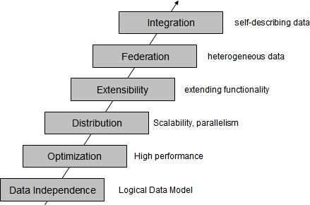

Figure 1.1 Evolution of database management systems

The above figure describes the evolution of database management systems with the relational model that provide for data independence. IBM's System R was the first system to implement Codd's ideas. System R was the basis for SQL/DS, which later became DB2. It also has the merit to introduce SQL, a relational database language used as a standard today, and to open the door for commercial database management systems.

Today, relational database management systems are the most used DBMS's and are developed by several software companies. IBM is one of the leaders in the market with DB2 database server. Other relational DBMS's include Oracle, Microsoft SQL Server, INGRES, PostgreSQL, MySQL, and dBASE.

As relational databases became increasingly popular, the need to deliver high performance queries has arisen. DB2's optimizer is one of the most sophisticated components of the product. From a user's perspective, you treat DB2's optimizer as a black box, and pass any SQL query to it. The DB2's optimizer will then calculate the fastest way to retrieve your data by taking into account many factors such as the speed of your CPU and disks, the amount of data available, the location of the data, the type of data, the existence of indexes, and so on. DB2's optimizer is cost-based.

As increased amounts of data were collected and stored in databases, DBMS's scaled. In DB2 for Linux, UNIX and Windows, for example, a feature called Database Partitioning Feature (DPF) allows a database to be spread across many machines using a shared- nothing architecture. Each machine added brings its own CPUs and disks; therefore, it is easier to scale almost linearly. A query in this environment is parallelized so that each machine retrieves portions of the overall result.

Next in the evolution of DBMS's is the concept of extensibility. The Structured Query Language (SQL) invented by IBM in the early 1970's has been constantly improved through the years. Even though it is a very powerful language, users are also empowered

to develop their own code that can extend SQL. For example, in DB2 you can create user- defined functions, and stored procedures, which allow you to extend the SQL language with your own logic.

Then DBMS's started tackling the problem of handling different types of data and from different sources. At one point, the DB2 data server was renamed to include the term "Universal" as in "DB2 universal database" (DB2 UDB). Though this term was later dropped for simplicity reasons, it did highlight the ability that DB2 data servers can store all kinds of information including video, audio, binary data, and so on. Moreover, through the concept of federation a query could be used in DB2 to access data from other IBM products, and even non-IBM products.

Lastly, in the figure the next evolutionary step highlights integration. Today many businesses need to exchange information, and the eXtensible Markup Language (XML) is the underlying technology that is used for this purpose. XML is an extensible, self- describing language. Its usage has been growing exponentially because of Web 2.0, and service-oriented architecture (SOA). IBM recognized early the importance of XML;

therefore, it developed a technology called pureXML® that is available with DB2 database

servers. Through this technology, XML documents can now be stored in a DB2 database in hierarchical format (which is the format of XML). In addition, the DB2 engine was extended to natively handle XQuery, which is the language used to navigate XML documents. With pureXML, DB2 offers the best performance to handle XML, and at the same time provides the security, robustness and scalability it has delivered for relational data through the years.

The current "hot" topic at the time of writing is Cloud Computing. DB2 is well positioned to work on the Cloud. In fact, there are already DB2 images available on the Amazon EC2 cloud, and on the IBM Smart Business Development and Test on the IBM Cloud (also known as IBM Development and Test Cloud). DB2's Database Partitioning Feature previously described fits perfectly in the cloud where you can request standard nodes or servers on demand, and add them to your cluster. Data rebalancing is automatically performed by DB2 on the go. This can be very useful during the time when more power needs to be given to the database server to handle end-of-the-month or end-of-the-year transactions.

### Introduction to information models and data models

An information model is an abstract, formal representation of entities that includes their properties, relationships and the operations that can be performed on them. The entities being modeled may be from the real world, such as devices on a network, or they may themselves be abstract, such as the entities used in a billing system.

The primary motivation behind the concept is to formalize the description of a problem domain without constraining how that description will be mapped to an actual implementation in software. There may be many mappings of the Information Model. Such mappings are called data models, irrespective of whether they are object models (for

example, using unified modeling language - UML), entity relationship models, or XML schemas.

Modeling is important as it considers the flexibility required for possible future changes without significantly affecting usage. Modeling allows for compatibility with its predecessor models and has provisions for future extensions.

Information Models and Data Models are different because they serve different purposes. The main purpose of an Information Model is to model managed objects at a conceptual level, independent of any specific implementations or protocols used to transport the data. The degree of detail of the abstractions defined in the Information Model depends on the modeling needs of its designers. In order to make the overall design as clear as possible, an Information Model should hide all protocol and implementation details. Another important characteristic of an Information Model is that it defines relationships between managed objects.

Data Models, on the other hand, are defined at a more concrete level and include many details. They are intended for software developers and include protocol-specific constructs. A data model is the blueprint of any database system. *Figure 1.1* illustrates the relationship between an Information Model and a Data Model.

Concrete/detailed model

for implementors

Data Model

Conceptual/abstract model

for designers and operators

Information Model

Data Model

Data Model

Figure 1.1 - Relationship between an Information Model and a Data Model

Since conceptual models can be implemented in different ways, multiple Data Models can be derived from a single Information Model.

### Types of information models

Information model proposals can be split into nine historical epochs:

* + - Network (CODASYL): 1970’s
    - Hierarchical (IMS): late 1960’s and 1970’s
    - Relational: 1970’s and early 1980’s
    - Entity-Relationship: 1970’s
    - Extended Relational: 1980’s
    - Semantic: late 1970’s and 1980’s
    - Object-oriented: late 1980’s and early 1990’s
    - Object-relational: late 1980’s and early 1990’s
    - Semi-structured (XML): late 1990’s to the present

The next sections discuss some of these models in more detail.

##### Network model

In 1969, CODASYL (Committee on Data Systems Languages) released its first specification about the network data model. This followed in 1971 and 1973 with specifications for a record-at-a-time data manipulation language. An example of the CODASYL network data model is illustrated in *Figure 1.2*.

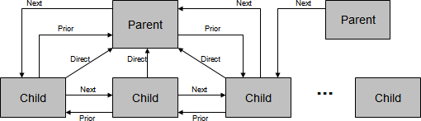

Figure 1.2 - A network model

The figure shows the record types represented by rectangles. These record types can also use keys to identify a record. A collection of record types and keys form a CODASYL network or CODASYL database. Note that a child can have more than one parent, and that each record type can point to each other with next, prior and direct pointers.

##### Hierarchical model

The hierarchical model organizes its data using a tree structure. The root of the tree is the parent followed by child nodes. A child node cannot have more than one parent, though a parent can have many child nodes. This is depicted in *Figure 1.3*

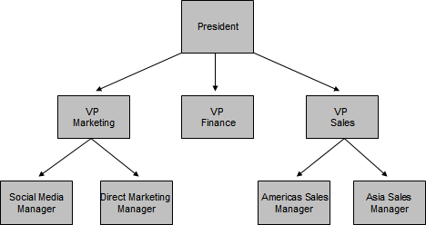

Figure 1.3 - A Hierarchical model

In a hierarchical model, a collection of named fields with their associated data types is called a record type. Each instance of a record type is forced to obey the data description indicated in the definition of the record type. Some fields in the record type are keys.

The first hierarchical database management system was IMS (Information Management System) released by IBM in 1968. It was originally built as the database for the Apollo space program to land the first humans on the moon. IMS is a very robust database that is still in use today at many companies worldwide.

##### Relational model

The relational data model is simple and elegant. It has a solid mathematic foundation based on sets theory and predicate calculus and is the most used data model for databases today.

One of the drivers for Codd's research was the fact that IMS programmers were spending large amounts of time doing maintenance on IMS applications when logical or physical changes occurred; therefore, his goal was to deliver a model that provided better data independence. His proposal was threefold:

* + - Store the data in a simple data structure (tables)
    - Access it through a high level set-at-a-time Data Manipulation Language (DML)
    - Be independent from physical storage

With a simple data structure, one has a better chance of providing logical data independence. With a high-level language, one can provide a high degree of physical data independence. Therefore, this model allows also for physical storage independence. This was not possible in either IMS or CODASYL. *Figure 1.4* illustrates an example showing an Entity-Relationship (E-R) diagram that represents entities (tables) and their relationships for a sample relational model. We discuss more about E-R diagrams in the next section.

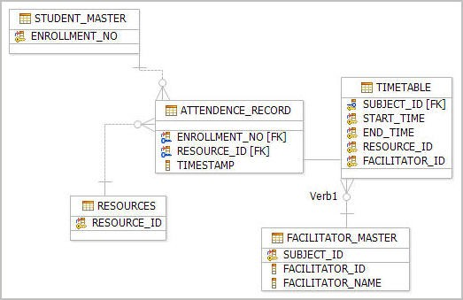

Figure 1.4 - An E-R diagram showing a sample relational model

##### Entity-Relationship model

In the mid 1970’s, Peter Chen proposed the entity-relationship (E-R) data model. This was to be an alternative to the relational, CODASYL, and hierarchical data models. He proposed thinking of a database as a collection of instances of entities. Entities are objects that have an existence independent of any other entities in the database. Entities have attributes, which are the data elements that characterize the entity. One or more of these attributes could be designated to be a key. Lastly, there could be relationships between entities. Relationships could be 1-to-1, 1-to-n, n-to-1 or m-to-n, depending on how the entities participated in the relationship. Relationships could also have attributes that described the relationship. *Figure 1.5* provides an example of an E-R diagram.

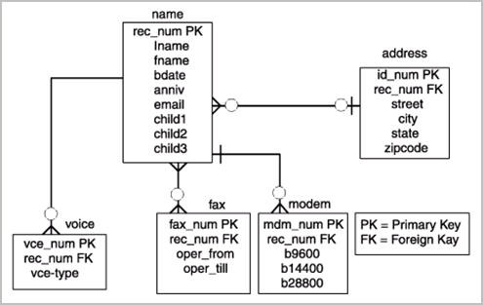

Figure 1.5 - An E-R Diagram for a telephone directory data model

In the figure, entities are represented by rectangles and they are ***name***, ***address***, ***voice***, ***fax***, and ***modem***. Attributes are listed inside each entity. For example, the ***voice*** entity has the ***vce_num***, ***rec_num***, and ***vce-type*** as attributes. PK represents a primary key, and FK a foreign key. The concept of keys is discussed in more detail later in this book.

Rather than being used as a model on its own, the E-R model has found success as a tool to design relational databases. Chen’s papers contained a methodology for constructing an initial E-R diagram. In addition, it was a simple process to convert an E-R diagram into a collection of tables in third normal form. For more information on the Third normal form and the normalization theory see the later parts of the book.

Today, the ability to create E-R diagrams are incorporated into data modeling tools such as IBM InfoSphere™ Data Architect. To learn more about this tool refer to the eBook *Getting started with InfoSphere Data Architect*, which is part of the DB2 on Campus book series.

##### Object-relational model

The Object-Relational (OR) model is very similar to the relational model; however, it treats every entity as an object (instance of a class), and a relationship as an inheritance. Some features and benefits of an Object-Relational model are:

* + - Support for complex, user defined types
    - Object inheritance
    - Extensible objects

Object-Relational databases have the capability to store object relationships in relational form.

##### Other data models

The last decade has seen a substantial amount of work on semi-structured, semantic and object oriented data models.

XML is ideal to store semi-structured data. XML-based models have gained a lot of popularity in the industry thanks to Web 2.0 and service-oriented architecture (SOA).

Object oriented data models are popular in universities, but have not been widely accepted in the industry; however, object-relational mapping (ORM) tools are available which allow a seamless integration of object-oriented programs with relational databases.

### Typical roles and career path for database professionals

Like any other work profile, the database domain has several of roles and career paths associated with it. The following is a description of some of these roles.

##### Data Architect

A data architect is responsible for designing an architecture that supports the organization's existing and future needs for data management. The architecture should cover databases, data integration and the means to get to the data. Usually the data architect achieves his goals by setting enterprise data standards. A Data Architect is also referred to as a Data Modeler. This is in spite of the fact that the role involves much more than just creating data models.

Some fundamental skills of a Data Architect are:

* + - * Logical Data modeling
      * Physical Data modeling
      * Development of a data strategy and associated policies
      * Selection of capabilities and systems to meet business information needs

##### Database Architect

This role is similar to a Data Architect, though constraints more towards a database solution. A database architect is responsible for the following activities:

* + - * Gather and document requirements from business users and management and address them in a solution architecture.
      * Share the architecture with business users and management.
      * Create and enforce database and application development standards and processes.
      * Create and enforce service level agreements (SLAs) for the business, specially addressing high availability, backup/restore and security.
      * Study new products, versions compatibility, and deployment feasibility and give recommendations to development teams and management.
      * Understand hardware, operating system, database system, multi-tier component architecture and interaction between these components.
      * Prepare high-level documents in-line with requirements.
      * Review detailed designs and implementation details.

It is critical for a database architect to keep pace with the various tools, database products, hardware platforms and operating systems from different vendors as they evolve and improve.

##### Database Administrator (DBA)

A database administrator (DBA) is responsible for the maintenance, performance, integrity and security of a database. Additional role requirements are likely to include planning, development and troubleshooting.

The work of a database administrator (DBA) varies according to the nature of the employing organization and the level of responsibility associated with the post. The work may be pure maintenance or it may also involve specializing in database development.

Typical responsibilities include some or all of the following:

* + - * Establishing the needs of users and monitoring user access and security;
      * Monitoring performance and managing parameters to provide fast query responses to front-end users;
      * Mapping out the conceptual design for a planned database in outline;
      * Take into account both, back-end organization of data and front-end accessibility for end users;
      * Refining the logical design so that it can be translated into a specific data model;
      * Further refining the physical design to meet system storage requirements;
      * Installing and testing new versions of the database management system (DBMS);
      * Maintaining data standards, including adherence to the Data Protection Act;
      * Writing database documentation, including data standards, procedures and definitions for the data dictionary (metadata);
      * Controlling access permissions and privileges;
      * Developing, managing and testing backup and recovery plans;
      * Ensuring that storage, archiving, backup and recovery procedures are functioning correctly;
      * Capacity planning;
      * Working closely with IT project managers, database programmers and Web developers;
      * Communicating regularly with technical, applications and operational staff to ensure database integrity and security;
      * Commissioning and installing new applications.

Because of the increasing levels of hacking and the sensitive nature of data stored, security and recoverability or disaster recovery have become increasingly important aspects.

##### Application Developer

A database application developer is a person in charge of developing applications that access databases. An application developer requires knowledge of the following:

* + - * Integrated database application development environments (IDEs).
      * Database plug-ins for IDEs.
      * SQL development tools
      * Database performance monitoring and debugging
      * Application server environments, application deployment, application performance monitoring and debugging

An example of an IDE is IBM Data Studio, a free Eclipse-based environment which allows developers to work with DB2 objects such as tables, views, indexes, stored procedures, user-defined functions and Web services. It also provides facilities for debugging, development of SQL and XQuery, and integration with different application servers such as

WebSphere® Application Server.

DB2 also includes add-ins that extend Microsoft® Visual Studio development environment with a comprehensive set of tools for developing DB2 objects (tables, views, stored procedures, user-defined functions etc.). This way, .NET developers do not need to switch back and forth between Microsoft Visual Studio and DB2 tools.

The roles and responsibilities discussed so far are very broad classifications. Different organizations have their own definition of roles within their organization’s context. These roles are listed to provide a big picture on various dimensions around database administration, application development and usage.

### Summary

In this chapter, we discussed several database fundamental concepts starting with simple definitions of a database and extending to a database management system. Then, we discussed information and data models such as the network, hierarchical, and relational models. At the end of the chapter, various roles associated with the database domain were discussed. In the upcoming chapters we will discuss database concepts in more detail.

### Exercises

* + 1. Learn more about databases by practicing with DB2 Express-C, the free version of DB2 database server. You can download this product at [ibm.com/db2/express](http://db2express.com/download?S_TACT=DOCBOOK01&amp;S_CMP=ECDDWW01)
    2. Learn more about IDEs by practicing with the free IBM Data Studio. You can download this product also at [ibm.com/db2/express](http://www.ibm.com/db2/express/download.html?S_CMP=ECDDWW01&amp;S_TACT=DOCBOOK01)

### Review questions

1. What is a database?
2. What is a database management system?
3. What is the difference between an Information model, and a Data model?
4. What is the main advantage of the relational model versus other models?
5. List two common tasks a DBA has to perform
6. Which of the following is not an information model:
   1. A. pureXML model
   2. B. Relational model
   3. C. Hierarchical model
   4. D. Network model
   5. E. None of the above
7. In the evolution of database management systems, what does optimization refer to?
8. A. High availability
9. B. Security
10. C. Performance
11. D. Scalability
12. E. None of the above
13. Which of the following is not listed in the evolution of database management systems:
    1. A. Distribution
    2. B. Data Independence
    3. C. Integration
    4. D. Federation
    5. E. None of the above
14. In the evolution of database management systems, in which stage would pureXML be?
15. A. Data independence
16. B. Extensibility
17. C. Optimization
18. D. Integration
19. E. None of the above
20. What is one key differentiator of DB2 on the Cloud?
21. A. It has a spatial extender
22. B. Its Database Partitioning Feature
23. C. Its pureXML technology
24. D. All of the above
25. E. None of the above

# 2

## Chapter 2 – The relational data model

In this chapter, we discuss the basics of the relational data model. We introduce concepts like attributes, tuples, relations, domains, schemas and keys. We also describe the different types of relational model constraints and some information about relational algebra and calculus. This chapter is closely related to *Chapter 3, The conceptual data model*, where you will learn how to translate a conceptual data model into a relational database schema, and to *Chapter 4, Relational database design*, which presents important issues for designing a relational database. This chapter is also important for a better understanding of the SQL language.

In this chapter, you will learn about:

* + The big picture of the relational data model
  + The definitions of attributes, tuples, relations, domains, schemas and keys
  + The relational model constraints
  + Relational algebra operations
  + Relational calculus

### Relational data model: The big picture

Information models try to put the real-world information complexity in a framework that can be easily understood. Data models must capture data structure and characteristics, the relationships between data, the data validation rules and constraints and all transformations the data must support. You can think of it as a communication tool between designers, programmers and end-users of a database. There are several types of data models on the market today and each of it has its own features. However, in this chapter we focus on the relational data model, which is the prevalent one in today's database market.

We present the main aspects of the relational data model below in *Figure 2.1*.

**The Network Data Model**

**Relational Algebra**

**The Hierarchical**

**Data Model**

**Information Models**

Figure 2.1 - Relational data model in context of information models: The big picture

**The Object – Relational Data Model**

**The Relational Data Model**

**Relational Calculus**

**Constraints**

**Entity integrity**

**Referential integrity**

**Semantic constraints**

**Concepts Attributes Tuples Relations Domains Schemas Keys**

*Figure 2.1* shows the main aspects of the relational data model:

* + - Specific relational data model ***concepts*** like attributes, tuples, domains, relations, domains, schemas, keys
    - The relational data model ***constraints*** like entity integrity, referential integrity, and semantic constraints which are used to enforce rules on a relational database
    - ***Relational algebra*** operations like union, intersection, difference, Cartesian product, selection, projection, join and division which are used to manipulate relations in a relational data model
    - ***Relational calculus*** which is an alternative to the relational algebra as a candidate for the manipulative part of the model

### Basic concepts

The relational data model uses formal terms to define its concepts. In the following chapters, we use formal relational terminology like: attribute, domain, tuple, relation, schema, candidate key, **primary key** and foreign key. Let’s define each of these terms.

##### Attributes

An ***attribute*** is a characteristic of data. A real-world data feature, modeled in the database, will be represented by an attribute. An attribute has to have a name, so you can refer to

that feature, and the name has to be as relevant as possible for that feature. For example, for a person the attributes can be: **Name**, **Sex**, **DateOfBirth**. Informal terms used to define an attribute are: ***column*** in a table or ***field*** in a data file.

In *Figure 2.2,* you can see the attributes of a car: **Type**, **Producer**, **Model**, **FabricationYear**, **Color**, **Fuel**. Other elements in the figure as discussed in the upcoming sections.

##### CARS Relation

Attribute

Header



|  |  |  |  |  |  |
| --- | --- | --- | --- | --- | --- |
| **TYPE** | **PRODUCER** | **MODEL** | **FABRICATION YEAR** | **COLOR** | **FUEL** |
| LIMOUSINE | BMV | 740 | 2008 | BLACK | GAS |
| VAN | VW | TRANSPORTER | 2007 | RED | DIESEL |
| LIMOUSIN | MERCEDES | 320 | 2008 | WHITE | GAS |
| LIMOUSINE | AUDI | ALLROAD | 2009 | BLUE | DIESEL |
| LIMOUSINE | BMW | 525 | 2007 | GREY | DIESEL |

Body

Value

Tuple

Figure 2.2 - CARS Relation – Header with attributes and body with tuples

##### Domains

A ***domain*** is a set of atomic values that are all of the same type. A ***value*** is the smallest unit of data in the relational model. For example, **BMW**, **Mercedes**, **Audi**, and **VW** are values for the attribute **Producer**. Those values are considered to be atomic, that is they are non-decomposable as far as the model is concerned. The domain for the **Producer** is the set of all possible car producer names. An attribute always has a domain associated with it. This domain gives the possible values for that attribute. Two or more attributes can be defined on the same domain.

A domain has a name, so we can make references to it, and a dimension. The dimension is given by the number of values that domain has. For example, **Fuel** attribute domain has only two values (**GAS, DIESEL**). A domain can be seen as a **pool of values**, from which the actual values appearing in attributes are drawn. Note that at any given time, there will be values included in a domain that do not currently appear in any of the attributes that correspond to that domain.

Domains have a certain operational significance. If two attributes draw their values from the same domain, then the comparisons operations involving those two attributes make sense as they are comparing similar values. Conversely, if two attributes draw their values from

Database Fundamentals 40

different domains, comparisons operations involving those two attributes do not make sense.

Domains are primarily conceptual in nature. In most cases, they are not explicitly stored in the database. The domains should be specified as a part of the database definition and then each attribute definition should include a reference to the corresponding domain, so that the system is aware of those attributes that are comparable to each other.

A given attribute may have the same name as the corresponding domain, but this situation should be avoided because it can generate confusion. However, it is possible to include the domain name as the trailing portion of the attribute name for the purpose of including more information in that attribute name.

##### Tuples

A ***tuple*** is an ordered set of values that describe data characteristics at one moment in time. In *Figure 2.2* above, you can see an example of a tuple. Another formal term used to define a tuple is ***n-tuple***. Informal terms used for tuples are: ***row*** in a table or ***record*** in a data file.

##### Relations

A relation is the core of the relational data. According to *intr**oduction to database* systems [2.1] a ***relation*** on domains **D1, D2, …, Dn** (not necessarily distinct) consists of a heading and a body.

The ***heading*** consists of a fixed set of attributes **A1, A2, …, An**, such that each attribute

**Ai** corresponds to exactly one of the underlying domains **Di (i=1, 2, …, n)**.

The ***body*** consists of a time-varying set of tuples, where each tuple in turn consists of a set of attribute-value pairs **(Ai:vi) (i=1, 2, …, n)**, one such pair for each attribute **Ai** in the heading. For any given attribute-value pair **(Ai:vi)**, **vi** is a value from the unique domain **Di** that is associated with the attribute **Ai**.

In *Figure 2.2,* you can see the **CARS** relation. The relation heading consists of a fixed set of 6 attributes: Type, Producer, Model, FabricationYear, Color, Fuel. Each attribute has a corresponding domain. The relation body consists of a set of tuples (5 tuples are shown in the figure, but this set varies with time) and each tuple consists of a set of 6 attribute-value pairs, one such pair for each of the 6 attributes in the heading.

A ***relation degree*** is equivalent with the number of attributes of that relation. The relation from *Figure 2.2* has a degree of 6. A relation of degree one is called **unary**, a relation of degree two **binary**, a relation of degree three **ternary**, and so on. A relation of degree n is called **nary**.

Relation ***cardinality*** is equivalent with the number of tuples of that relation. The relation from *Figure 2.2* has a cardinality equal to 5. The cardinality of a relation changes with time, whereas the degree does not change that often.

As you see in the relation, the body consists of a time-varying set of tuples. At one moment in time, the relation cardinality may be *m*, while another moment in time the same relation may have the cardinality *n*. The state in which a relation exists at one moment in time is called a ***relation instance***. Therefore, during a relation’s lifetime there may be many relation instances.

Relations possess certain important properties. These properties are all of them consequences of the relation definition given above. The four properties are as follows:

* + - There are no duplicate tuples in a relation
    - Tuples are unordered (top to bottom)
    - Attributes are unordered (left to right)
    - All attribute values are atomic

Informal terms used for relations are ***table*** or ***data file***.

##### Schemas

A ***database schema*** is a formal description of all the database relations and all the relationships existing between them. In *Chapter 3, Conceptual data modeling*, and *Chapter 4, Relational database design*, you will learn more about a relational database schema.

##### Keys

The relational data model uses keys to define identifiers for a relation’s tuples. The keys are used to enforce rules and/or constraints on database data. Those constraints are essential for maintaining data consistency and correctness. Relational DBMS permits definition of such keys, and starting with this point the relational database management system is responsible to verify and maintain the correctness and consistency of database data. Let’s define each type of key.

* + - 1. Candidate keys

A ***candidate key*** is a unique identifier for the tuples of a relation. By definition, every relation has at least one candidate key (the first property of a relation). In practice, most relations have multiple candidate keys.

1. J. Date in [2.2] gives the following definition for a candidate key:

Let **R** be a relation with attributes **A1, A2, …, An**. The set of **K=(Ai, Aj, …, Ak)** of **R** is said to be a candidate key of **R** if and only if it satisfies the following two time- independent properties:

* + Uniqueness

At any given time, no two distinct tuples of **R** have the same value for **Ai**, the same value for **Aj**, …, and the same value for **Ak**.

* + Minimality

None of **Ai, Aj, …, Ak** can be discarded from **K** without destroying the uniqueness property.

Every relation has at least one candidate key, because at least the combination of all of its attributes has the uniqueness property (the first property of a relation), but usually exist at least one other candidate key made of fewer attributes of the relation. For example, the **CARS** relation shown earlier in *Figure 2.2* has only one candidate key **K=(Type, Producer, Model, FabricationYear, Color, Fuel)** considering that we can have multiple cars with the same characteristics in the relation. Nevertheless, if we create another relation **CARS** as in *Figure 2.3* by adding other two attributes like **SerialNumber** (engine serial number) and **IdentificationNumber** (car identification number) we will have 3 candidate keys for that relation.

**The new CARS Relation**

Candidate keys

|  |  |  |  |  |  |  |  |
| --- | --- | --- | --- | --- | --- | --- | --- |
| **TYPE** | **PRODUCE R** | **MODEL** | **FABRICA TION YEAR** | **COLOR** | **FUEL** | SERIAL NUMBER | IDENTIFI CATION NUMBER |
| LIMOUSINE | BMV | 740 | 2008 | BLACK | GAS | WBADL9105 GW65796 | SB24MEA |
| VAN | VW | TRANSPO RTER | 2007 | RED | DIESEL | QASMD8209 NF37590 | AB08DGF |
| LIMOUSIN | MERCEDES | 320 | 2008 | WHITE | GAS | XEFAR2096 WM19875 | SB06GHX |
| LIMOUSINE | AUDI | ALLROAD | 2009 | BLUE | DIESEL | AKLMD8064 MW79580 | SB52MAG |
| LIMOUSINE | BMW | 525 | 2007 | GREY | DIESEL | QMXAS4390 WQ21998 | AB02AMR |

Figure 2.3 – The new CARS Relation and its candidate keys

A candidate key is sometimes called a ***unique key***. A unique key can be specified at the Data Definition Language (DDL) level using the **UNIQUE** parameter beside the attribute name. If a relation has more than one candidate key, the one that is chosen to represent the relation is called the ***primary key,*** and the remaining candidate keys are called ***alternate keys***.

**Note:**

To correctly define candidate keys you have to take into consideration all relation instances to understand the attributes meaning so you can be able to determine if duplicates are possible during the relation lifetime.

* + - 1. Primary keys

A ***primary key*** is a unique identifier of the relation tuples. As mentioned already, it is a candidate key that is chosen to represent the relation in the database and to provide a way to uniquely identify each tuple of the relation. A database relation always has a **primary key**.

Relational DBMS allow a **primary key** to be specified the moment you create the relation (table). The DDL sublanguage usually has a **PRIMARY KEY** construct for that. For example, for the **CARS** relation from *Figure 2.3* the **primary key** will be the candidate key **IdentificationNumber**. This attribute values must be “UNIQUE” and “NOT NULL” for all tuples from all relation instances.

There are situations when real-world characteristic of data, modeled by that relation, do not have unique values. For example, the first **CARS** relation from *Figure 2.2* suffers from this inconvenience. In this case, the **primary key** must be the combination of all relation attributes. Such a **primary key** is not a convenient one for practical matters as it would require too much physical space for storage, and maintaining relationships between database relations would be more difficult. In those cases, the solution adopted is to introduce another attribute, like an **ID**, with no meaning to real-world data, which will have unique values and will be used as a **primary key**. This attribute is usually called a ***surrogate key***. Sometimes, in database literature, you will also find it referenced as ***artificial key***.

Surrogate keys usually have unique numerical values. Those values grow or decrease automatically with an increment (usually by 1).

* + - 1. Foreign keys

A ***foreign key*** is an attribute (or attribute combination) in one relation R2 whose values are required to match those of the **primary key** of some relation R1 (R1 and R2 not necessarily distinct). Note that a foreign key and the corresponding **primary key** should be defined on the same underlying domain.

For example, in *Figure 2.4* we have another relation called **OWNERS** which contains the data about the owners of the cars from relation **CARS**.

OWNERS Relation

Primary key

Foreign key

|  |  |  |  |  |  |  |  |
| --- | --- | --- | --- | --- | --- | --- | --- |
| **ID** | **FIRST NAME** | **LAST NAME** | **CITY** | **STREET** | **NUMBER** | PHONE | IDENTIFI CATION NUMBER |
| 1 | JOHN | SMITH | SIBIU | MORILOR | 29 | 223778 | SB24MEA |
| 2 | MARY | FORD | ALBA | TEILOR | 14 | 431034 | AB08DGF |
| 3 | ANNE | SHEPARD | SIBIU | SEBASTIAN | 22 | 231024 | SB06GHX |
| 4 | WILLIAM | HILL | SIBIU | OCNA | 55 | 213866 | SB52MAG |
| 5 | JOE | PESCI | ALBA | MOLD OVA | 89 | 493257 | AB02AMR |

Figure 2.4 – The OWNERS relation and its primary and foreign keys

The **IdentificationNumber** foreign key from the **OWNERS** relation refers to the **IdentificationNumber primary key** from **CARS** relation. In this manner, we are able to know which car belongs to each person.

Foreign-to-primary-key matches represent references from one relation to another. They are the **“glue”** that holds the database together. Another way of saying this is that foreign-to-primary-key matches represent certain relationships between tuples. Note carefully, however, that not all such relationships are represented by foreign-to-primary-key matches.

The DDL sublanguage usually has a **FOREIGN KEY** construct for defining the foreign keys. For each foreign key the corresponding **primary key** and its relation is also specified.

### Relational data model constraints

In a relational data model, data integrity can be achieved using integrity rules or constraints. Those rules are general, specified at the database schema level, and they must be respected by each schema instance. If we want to have a correct relational database definition, we have to declare such constraints [2.2]. If a user attempts to execute an operation that would violate the constraint then the system must then either reject the operation or in more complicated situations, perform some compensating action on some other part of the database.

This would ensure that the overall result is still in a correct state. Now, let’s see what the relational data model constraints are.

##### 2.3.1 Entity integrity constraint

The ***entity integrity constraint*** says that no attribute participating in the **primary key** of a relation is allowed to accept null values.

A ***null*** represents **property inapplicable** or **information unknown**. Null is simply a marker indicating the absence of a value, an undefined value. That value that is understood by convention not to stand for any real value in the applicable domain of that attribute. For example, a null for the car color attribute of a car means that for the moment we do not know the color of that car.

The justification for the entity integrity constraint is:

* + - Database relations correspond to entities from the real-world and by definition entities in the real-world are distinguishable, they have a unique identification of some kind
    - **Primary keys** perform the unique identification function in the relational model
    - Therefore, a null **primary key** value would be a contradiction in terms because it would be saying that there is some entity that has no identity that does not exist.

##### Referential integrity constraint

The ***referential integrity constraint*** says that if a relation **R2** includes a foreign key **FK** matching the **primary key PK** of other relation **R1**, then every value of **FK** in **R2** must either be equal to the value of **PK** in some tuple of **R1** or be wholly null (each attribute value participating in that **FK** value must be null). **R1** and **R2** are not necessarily distinct.

The justification for referential integrity constraint is:

* + - * If some tuple **t2** from relation **R2** references some tuple **t1** from relation **R1**, then tuple **t1** must exist, otherwise it does not make sense
      * Therefore, a given foreign key value must have a matching **primary key** value somewhere in the referenced relation if that foreign key value is different from null
      * Sometimes, for practical reasons, it is necessary to permit the foreign key to accept null values

For example, in our **OWNERS** relation the foreign key is **IdentificationNumber**. This attribute value must have matching values in the **CARS** relation, because a person must own an existing car to become an owner. If the foreign key has a null value, that means that the person does not yet have a car, but he could buy an existing one.

For each foreign key in the database, the database designer has to answer three important questions:

* + - * Can the foreign key accept null values?

For example, does it make sense to have an owner for which the car he owns is not known? Note that the answer to this question depends, not on the whim of the database designer, but on the policies in effect in the portion of the real-world that is to be represented in the database.

* + - * What should happen on an attempt to delete the **primary key** value tuple of a foreign key reference?

For example, an attempt to delete a car which is owned by a person? In general, there are three possibilities:

1. CASCADE – the delete operation **“cascades”** to delete those matching tuples

also (the tuples from the foreign key relation). In our case, if the car is deleted the owner is deleted, too.

1. RESTRICT - the delete operation is **“restricted”** to the case where there are no such matching tuples (it is rejected otherwise). In our case, the car can be deleted only if it is not owned by a person.
2. NULLIFIES – the foreign key is set to null in all such matching cases and the tuple containing the **primary key** value is then deleted (of course, this case could not apply if the foreign key cannot accept null values). In our case, the car can be deleted after the **IdentificationNumber** attribute value of its former owner is set to null.

* What should happen on an attempt to update the **primary key** value of a foreign key reference?

In general, there are also three possibilities:

1. CASCADE – the update operation **“cascades”** updates the foreign key value of those matching tuples (including the tuples from the foreign key relation). In our case, if the car identification number is updated the car owner identification number is updated, too.
2. RESTRICT - the update operation is **“restricted”** to the case where there are no such matching tuples (it is rejected otherwise). In our case, the car identification number can be updated only if it is not owned by a person.
3. NULLIFIES – the foreign key is set to null in all such matching cases and the tuple containing the **primary key** value is then updated (of course, this case could not apply if the foreign key cannot accept null values). In our case, the car identification number can be updated after the **IdentificationNumber** attribute value of its former owner is set to null.

##### Semantic integrity constraints

A ***semantic integrity constraint*** refers to the correctness of the meaning of the data. For example, the street number attribute value from the **OWNERS** relation must be positive, because the real-world street numbers are positive.

A semantic integrity constraint can be regarded as a predicate that all correct states of relations instances from the database are required to satisfy.

If the user attempts to execute an operation that would violate the constraint, the system must then either reject the operation or possibly, in more complicated situations, perform some compensating action on some other part of the database to ensure that the overall result is still a correct state. Thus, the language for specifying semantic integrity constraints

should include, not only the ability to specify arbitrary predicates, but also facilities for specifying such compensating actions when appropriate.

Semantic integrity constraints must be specified typically by a database administrator and must be maintained in the system catalog or dictionary. The DBMS monitors user interactions to ensure that the constraints are in fact respected. Relational DBMS permits several types of semantic integrity constraints such as domain constraint, null constraint, unique constraint, and check constraint.

* + - 1. Domain constraint

A ***domain constraint*** implies that a particular attribute of a relation is defined on a particular domain. A domain constraint simply states that values of the attribute in question are required to belong to the set on values constituting the underlying domain.

For example, the **Street** attribute domain of **OWNERS** relation is **CHAR(20)**, because streets have names in general and **Number** attribute domain is **NUMERIC**, because street numbers are numeric values.

There are some particular forms of domain constraints, namely format constraints and range constraints. A ***format constraint*** might specify something like a data value pattern.

For example, the **IdentificationNumber** attribute values must be of this type **XX99XXX**, where **X** represents an alphabet letter and **9** represents a digit. A ***range constraint*** requires that values of the attribute lie within the range values. For example, the **FabricationYear** attribute values might range between 1950 and 2010.

* + - 1. Null constraint

A ***null constraint*** specifies that attribute values cannot be null. On every tuple, from every relation instance, that attribute must have a value which exists in the underlying attribute domain. For example, **FirstName** and **LastName** attributes values cannot be null, this means that a car owner must have a name.

A null constraint is usually specified with the **NOT NULL** construct. The attribute name is followed by the words **NOT NULL** for that. Along with NOT NULL, the additional keyword “WITH DEFAULT” can optionally be specified so that the system generates a default value for the attribute in case it is null at the source while inserting. WITH DEFAULT is only applicable for numeric (integer, decimal, float etc.) and date (date, time, timestamp) data types. For other types, default value should be provided explicitly in the DDL.

* + - 1. Unique constraint

A ***unique constraint*** specifies that attribute values must be different. It is not possible to have two tuples in a relation with the same values for that attribute. For example, in the **CARS** relation the **SerialNumber** attribute values must be unique, because it is not possible to have two cars and only one engine. A unique constraint is usually specified with an attribute name followed by the word **UNIQUE**. Note that NULL is a valid unique value.

|  |  |  |  |  |  |  |  |  |  |
| --- | --- | --- | --- | --- | --- | --- | --- | --- | --- |
|  | **Note:**  NULL is not part of any domain; therefore, a basic SQL comparison returns “unknown” when any one of the values involved in the processing is NULL. Therefore to handle NULL correctly, SQL provides two special predicates, “IS NULL” and “IS NOT NULL” to check if the data is null or not. Below is a brief summary table that indicates how NULL ("Unknown") is handled by SQL. Different database vendors/platforms may have a different ways of handling NULL. | | | | | | | | |
|  | A | B | A OR B | A AND B | A = B |  | A | NOT A |  |
|  | True | True | True | True | True | True | False |
|  | True | False | True | False | False | False | True |
|  | True | Unknown | True | Unknown | Unknown | Unknown | Unknown |
|  | False | True | True | False | False |  | | |
|  | False | False | False | False | False |
|  | False | Unknown | Unknown | False | False |
|  | Unknown | True | True | Unknown | Unknown |
|  | Unknown | False | Unknown | False | False |
|  | Unknown | Unknown | Unknown | Unknown | Unknown |
|  |  | | | | | | | | |

* + - 1. Check constraint

A ***check constraint*** specifies a condition (a predicate) on a relation data, which is always checked when data is manipulated. The predicate states what to check, and optionally what to do if the check fails (violation response). If this violation response is omitted, the operation is rejected with a suitable return code. When the constraint is executed, the system checks to see whether the current state of the database satisfies the specified constraint. If it does not, the constraint is rejected, otherwise it is accepted and enforced from that time on.

For example, an employee's salary can’t be greater than his manager's salary or a department manager can’t have more that 20 people reporting to him. For our previous relations, for example, the fabrication year of a car can’t be greater than the current year or a car can be owned by a single person.

This type of constraint can sometimes be specified in the database using a **CHECK** construct or a trigger. The check constraint can be checked by the system before or after operations like insert, update, and delete.

### Relational algebra

***Relational algebra*** is a set of operators to manipulate relations. Each operator of the relational algebra takes either one or two relations as its input and produces a new relation as its output.

Codd [2.3] defined 8 such operators, two groups of 4 each:

* + - The traditional set operations: union, intersection, difference and Cartesian product
    - The special relational operations: select, project, join and divide.

##### Union

The ***union*** of two union-compatible relations **R1** and **R2**, **R1 UNION R2**, is the set of all tuples **t** belonging to either **R1** or **R2** or both.

Two relations are ***union-compatible*** if they have the same degree, and the **i**th attribute of each is based on the same domain.

The formal notation for a union operation is U.

**UNION** operation is associative and commutative.

*Figure 2.5* provides an example of a **UNION** operation. The operands are relation **R1** and relation **R2** and the result is another relation **R3** with 5 tuples.

R1 R2

|  |  |  |
| --- | --- | --- |
| Name | Age | Sex |
| A | 20 | M |
| C | 21 | M |
| B | 21 | F |

|  |  |  |
| --- | --- | --- |
| Name | Age | Sex |
| D | 20 | F |
| A | 20 | M |
| E | 21 | F |

R3= R1 U R2

|  |  |  |
| --- | --- | --- |
| Name | Age | Sex |
| A | 20 | M |
| C | 21 | M |
| B | 21 | F |
| D | 20 | F |
| E | 21 | F |

Figure 2.5 – Example of a UNION operation on two relations: R1 and R2

##### Intersection

The ***intersection*** of two union-compatible relations **R1** and **R2**, **R1 INTERSECT R2**, is the set of all tuples **t** belonging to both **R1** and **R2**.

The formal notation for an intersect operation is ∩.

**INTERSECT** operation is associative and commutative.

*Figure 2.6* provides an example of an **INTERSECT** operation. The operands are relation **R1**

and relation **R2** and the result is another relation **R3** with only one tuple.

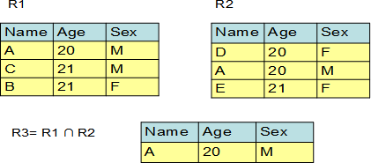

Figure 2.6 – Example of an INTERSECT operation on two relations: R1 and R2

##### Difference

The ***difference*** between two union-compatible relations **R1**and **R2**, **R1 MINUS R2**, is the set of all tuples **t** belonging to **R1** and not to **R2**.

The formal notation for a difference operation is -

**DIFFERENCE** operation is not associative and commutative.

*Figure 2.7* provides an example of a **DIFFERECE** operation. The operands are relation **R1** and relation **R2** and the result is another relation **R3** with two tuples. As you can see, the result of **R1-R2** is different from **R2-R1**.

R1 R2

|  |  |  |
| --- | --- | --- |
| Name | Age | Sex |
| A | 20 | M |
| C | 21 | M |
| B | 21 | F |

|  |  |  |
| --- | --- | --- |
| Name | Age | Sex |
| D | 20 | F |
| A | 20 | M |
| E | 21 | F |

R3= R1 - R2

|  |  |  |
| --- | --- | --- |
| Name | Age | Sex |
| C | 21 | M |
| B | 21 | F |

R3= R2 – R1

Figure 2.7 – Example of a DIFFERENCE operation on two relations: R1 and R2

|  |  |  |
| --- | --- | --- |
| Name | Age | Sex |
| D | 20 | F |
| E | 21 | F |

##### Cartesian product

The ***Cartesian product*** between two relations **R1** and **R2**, **R1 TI****MES R2**, is the set of all tuples **t** such that **t** is the concatenation of a tuple **r** belonging to **R1** and a tuple **s** belonging to **R2**. The concatenation of a tuple **r = (r1, r2, …, rm)** and a tuple **s = (sm+1, sm+2, …, sm+n)** is the tuple t = (**r1, r2, …, rm, sm+1, sm+2, …, sm+n**).

**R1** and **R2** don’t have to be union-compatible.

The formal notation for a Cartesian product operation is ×.

If **R1** has degree **n** and cardinality **N1** and **R2** has degree **m** and cardinality **N2** then the resulting relation **R3** has degree **(n+m)** and cardinality **(N1*N2)**. This is illustrated in *Figure 2.8*.

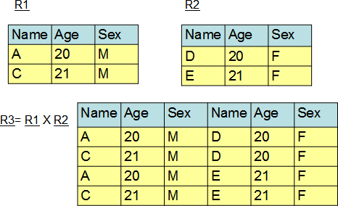

Figure 2.8 – Example of a CARTESIAN PRODUCT operation on two relations

##### Selection

The ***select*** operation selects a subset of tuples from a relation. It is a unary operator, that is, it applies on a single relation. The tuples subset must satisfy a selection condition or predicate.

The formal notation for a select operation is:

σ <select condition> (<relation>)

where **<select condition>** is

<attribute> <comparison operator> <constant value>/<attribute> [AND/OR/NOT <attribute> <comparison operator> <constant value>/<attribute>…]

The comparison operator can be **<, >, <=, >=, =, <>** and it depends on attribute domain or data type constant value.

The resulting relation degree is equal with the initial relation degree on which the operator is applied. The resulting relation cardinality is less or equal with the initial relation cardinality. If the cardinality is low we say that the select condition selectivity is high and if the cardinality is high we say that the select condition selectivity is low.

Selection is commutative.

In *Figure 2.9*, there are two select operation examples performed on relation **R**. First the select condition is **Age=20** and the result is relation **R1** and second the select condition is **(Sex=M) AND (Age>19)** and the result is relation **R2**.

R R1= σ(Age=20)(R)

|  |  |  |
| --- | --- | --- |
| Name | Age | Sex |
| A | 20 | M |
| M | 21 | F |
| B | 20 | F |
| F | 19 | M |
| A | 20 | F |
| R | 21 | F |
| C | 21 | M |

|  |  |  |
| --- | --- | --- |
| Name | Age | Sex |
| A | 20 | M |
| B | 20 | F |
| A | 20 | F |

R2= σ(Sex=M AND Age>19)(R)

|  |  |  |
| --- | --- | --- |
| Name | Age | Sex |
| A | 20 | M |
| C | 21 | M |

Figure 2.9 – Example of a SELECT operation (two different select conditions)

##### Projection

The ***project*** operation builds another relation by selecting a subset of attributes of an existing relation. Duplicate tuples from the resulting relation are eliminated. It is also a unary operator.

The formal notation for a project operation is:

π <attribute list> (<relation>)

where **<attribute list>** is the subset attributes of an existing relation.

The resulting relation degree is equal with the number of attributes from **<attribute list>** because only those attributes will appear in the resulting relation. The resulting relation cardinality is less or equal with the initial relation cardinality. If the list of attributes contains a relation candidate key, then the cardinality is equal with the initial relation cardinality. If it does not contain a candidate key, then the cardinality could be less because of the possibility to have duplicate tuples, which are eliminated from the resulting relation.

Projection is not commutative.

In *Figure 2.10* there are two project operation examples performed on relation **R**. First the projection is made on attributes **Name** and **Sex** and the result is relation **R1** and second the projection is made on attributes **Age** and **Sex** and the result is relation **R2**.

#### R1= **π**(Name, Sex)(R)

|  |  |
| --- | --- |
| Name | Sex |
| A | M |
| M | F |
| B | F |
| F | M |
| A | F |

R

|  |  |  |
| --- | --- | --- |
| Name | Age | Sex |
| A | 20 | M |
| M | 21 | F |
| B | 20 | F |
| F | 19 | M |
| A | 20 | F |

R2= **π**(Age, Sex)(R)

|  |  |
| --- | --- |
| Age | Sex |
| 20 | M |
| 21 | F |
| 20 | F |
| 19 | M |

Figure 2.10 – Example of a PROJECT operation (two different lists attributes)

##### Join

The ***join*** operation concatenates two relations based on a joining condition or predicate. The relations must have at least one common attribute with the same underlying domain, and on such attributes a joining condition can be specified.

The formal notation for a join operation is:

**R <join condition> ►◄S**

where **<join condition>** is

<attribute from R> <comparison operator> < <attribute from S>

The comparison operator can be **<, >, <=, >=, =, <>** and it depends on attributes domain.

If relation **R** has attributes **A1, A2, …, An** and relation **S** has attributes **B1, B2, …, Bm** and attribute **Ai** and attribute **Bj** have the same underlying domain we can define a join operation between relation **R** and relation **S** on a join condition between attribute **Ai** and **Bj**. The result is another relation **T** that contains all the tuples **t** such that **t** is the concatenation of a tuple **r** belonging to **R** and a tuple **s** belonging to **S** if the join condition is true. This type of join operation is also called ***theta-join***. It follows from the definition that the result of a join must include two identical attributes from the point of view of their values. If one of those two attributes is eliminated the result is called ***natural join***.

There are also other forms of join operations. The most often used is the ***equijoin***, which means that the comparison operator is =.

There are situations when not all the tuples from relation R have a corresponding tuple in relation S. Those tuples won’t appear in the result of a join operation between R and S. In practice, sometimes it is necessary to have all tuples in the result, so, another form of join was created: the ***outer join***. There are 3 forms of outer join: ***left outer join***, where all tuples from R will be in the result, ***right outer join***, where all tuples from S will be in the result, and ***full outer join***, where all tuples from R and S will be in the result. If there is not a corresponding tuple, the system considers that there is a hypothetical tuple, with all attribute values null, which will be used for concatenation.

In *Figure 2.11* there are two relations **R1** and **R2** joined on a join condition where **LastName** from relation **R1** is equal with **LastName** from relation **R2**. The resulting relation is **R3**.

R2

R1

|  |  |
| --- | --- |
| Last  Name | Sex |
| Ann | F |
| John | M |
| Mary | F |
| Bill | M |

|  |  |
| --- | --- |
| First Name | Last Name |
| A | Mary |
| B | John |
| C | Ann |

R3=R1(Last Name=Last name) R2

|  |  |  |  |
| --- | --- | --- | --- |
| First Name | Last Name | Last  Name | Sex |
| A | Mary | Mary | F |
| B | John | John | M |
| C | Ann | Ann | F |

Figure 2.11 – Example of a JOIN operation

In *Figure 2.12* you could see the results for a natural join between **R1** and **R2** and also the results for a right outer join.

Natural Join

|  |  |  |
| --- | --- | --- |
| First Name | Last Name | Sex |
| A | Mary | F |
| B | John | M |
| C | Ann | F |

Right Outer Join

|  |  |  |  |
| --- | --- | --- | --- |
| First Name | Last Name | Last  Name | Sex |
| A | Mary | Mary | F |
| B | John | John | M |
| C | Ann | Ann | F |
| NULL | NULL | Bill | M |

Figure 2.12 – Examples of a NATURAL JOIN and a RIGHT OUTER JOIN operation

##### Division

The ***division*** operator divides a relation **R1** of degree **(n+m)**by a relation **R2** of degree **m** and produces a relation of degree **n**. The **(n+i)**th attribute of **R1** and the **i**th attribute from **R2** should be defined on the same domain. The result of a division operation between **R1** and **R2** is another relation, which contains all the tuples that concatenated with all **R2** tuples are belonging to **R1** relation.

The formal notation for a division operation is ÷.

*Figure 2.13* provides an example of a division operation between relation **R1** and **R2.**

R1

|  |  |
| --- | --- |
| Name | Sex |
| A | M |
| B | F |
| A | F |
| C | F |
| D | M |
| C | M |

R3= R1÷ R2

|  |
| --- |
| Name |
| A |
| C |

R2

|  |
| --- |
| Sex |
| M |
| F |

Figure 2.13 – Example of a DIVISION operation

### Relational calculus

***Relational calculus*** represents an alternative to relational algebra as a candidate for the manipulative part of the relational data model. The difference between the two is as follows:

* + - Algebra provides a collection of explicit operations like union, intersect, difference, select, project, join, etc., that can be actually used **to build** some desired relation from the given relations in the database.
    - Calculus provides a notation for formulating **the definition** of that desired relation in terms of those given relations.

For example, consider the query *“Get owners’ complete names and cities for owners who own a red car.”*

An algebraic version of this query could be:

* + - Join relation **OWNERS** with relation **CARS** on **IdentificationNumber** attributes
    - Select from the resulting relation only those tuples with car **Colour = ”RED”**
    - Project the result of that restriction on owner **FirstName**, **LastName** and **City**

A calculus formulation, by contrast, might look like:

* + - Get **FirstName**, **LastName** and **City** for cars owners such that there exists a car with the same **IdentificationNumber** and with **RED** color.

Here the user has merely stated the defining characteristics of the desired set of tuples, and it is left to the system to decide exactly how this will be done. We might say that the calculus formulation is *descriptive* where the algebraic one is *prescriptive*. The calculus simply states what the problem *is* while algebra gives a procedure for *solving* that problem.

The fact is that algebra and calculus are precisely equivalent to one another. For every expression of the algebra, there is an equivalent expression in the calculus; likewise, for every expression of the calculus, there is an equivalent expression in the algebra. There is a one-to-one correspondence between the two of them. The different formalisms simply represent different styles of expression. Calculus is more like natural language while algebra is closer to a programming language.

Relational calculus is founded on a branch of mathematical logic called the **predicate** calculus. Kuhns [2.4] seems to be the father of this idea of using predicate calculus as the basis for a database language, but Codd was the first who proposed the concept of relational calculus, an applied predicate calculus specifically tailored to relational databases, in [2.3]. A language explicitly based on relational calculus was also presented by Codd in [2.5]. It was called **data sublanguage ALPHA** and it was never implemented in the original form. The language QUEL from INGRES is actually very similar to data sublanguage ALPHA. Codd also gave an algorithm, Codd’s reduction algorithm, by which

an arbitrary expression of the calculus can be reduced to a semantically equivalent expression of the algebra.

There are two types of relational calculus:

* + - Tuple-oriented relational calculus – based on tuple variable concept
    - Domain-oriented relational calculus – based on domain variable concept

##### Tuple-oriented relational calculus

A ***tuple variable*** is a variable that ranges over some relation. It is a variable whose only permitted values are tuples of that relation. In other words, if tuple variable **T** ranges over relation **R**, then, at any given time, **T** represents some tuple **t** of **R**.

A tuple variable is defined as:

RANGE OF T IS X1; X2; …; Xn

where **T** is a tuple variable and **X1, X2, …, Xn** are tuple calculus expressions, representing relations **R1, R2, …, Rn**. Relations **R1, R2, …, Rn** must all be union- compatible and corresponding attributes must be identically named in every relation. Tuple variable **T** ranges over the union of those relations. If the list of tuple calculus expressions identifies just one named relation **R** (the normal case), then the tuple variable **T** ranges over just the tuples of that single relation.

Each occurrence of a tuple variable can be **free** or **bound**. If a tuple variable occurs in the context of an attribute reference of the form **T.A**, where **A** is an attribute of the relation over which **T** ranges, it is called a free tuple variable. If a tuple variable occurs as the variable immediately following one of the quantifiers: **the existential quantifier**  or **the universal quantifier**  it is called a bound variable.

A tuple calculus expression is defined as:

T.A, U.B, …, V.C WHERE f

where **T, U, …, V** are tuple variables, **A, B, …, C** are attributes of the associated relations, and **f** is a relational calculus formula containing exactly **T, U, …, V** as free variables. The value of this expression is defined to be a projection of that subset of the extended Cartesian product **T×U×…×V** (where **T, U, …, V** range all of their possible values) for which **f** evaluates to true or if **“WHERE f”** is omitted a projection of that entire Cartesian product. The projection is taken over the attributes indicated by **T.A, U.B, …,**

**V.C**. No target item may appear more than once in that list.

For example, the query “Get **FirstName**, **LastName** and **City** for cars owners such that there exists a car with the same **IdentificationNumber** and with **RED** color” can be expressed as follows:

RANGE OF OWNERS IS

OWNERS.FirstName, OWNERS.LastName, OWNERS.City WHERE

 CARS(CARS.IdentificationNumber=OWNERS.IdentificationNumber

AND CARS.Color=’RED’)

The tuple calculus is formally equivalent to the relational algebra.

The QUEL language from INGRES is based on tuple-oriented relational calculus.

##### Domain-oriented relational calculus

Lacroix and Pirotte in [2.6] proposed an alternative relational calculus called the domain calculus, in which tuple variables are replaced by domain variables. A domain variable is a variable that ranges over a domain instead of a relation.

Each occurrence of a domain variable can be also **free** or **bound**. A bound domain variable occurs as the variable immediately following one of the quantifiers: **the existential quantifier**  or **the universal quantifier** . In all other cases, the variable is called a free variable.

Domain-oriented relational calculus uses **membership conditions**. A membership condition takes the form

R (term, term, …)

where **R** is a relation name, and each **term** is a pair of the form **A:v,** where **A** is an attribute of **R** and **v** is either a domain variable or a constant. The condition evaluates to true if and only if there exists a tuple in relation **R** having the specified values for the specified attributes.

For example, the expression **OWNERS(IdentificationNumber:’SB24MEA’, City:’SIBIU’)** is a membership condition which evaluates to true if and only if there exists a tuple in relation **OWNERS** with **IdentificationNumber** value **SB24MEA** and **City** value **SIBIU**. Likewise, the membership condition

R (A:AX, B:BX, …)

evaluates to true if and only if there exists an **R** tuple with **A** attribute value equal to the current value of domain variable **AX** (whatever that may be), the **B** attribute value equal to the current value of domain variable **BX** (again, whatever that may be) and so on.

For example, the query “Get **FirstName**, **LastName** and **City** for cars owners such that there exists a car with the same **IdentificationNumber** and with **RED** color” can be expressed as follows:

FirstNameX, LastNameX, CityX WHERE  IdentificationNumberX (OWNERS (IdentificationNumber:IdentificationNumberX,

FirstName:FirstNameX, LastName:LastNameX, City:CityX) AND CARS(IdentificationNumber:IdentificationNumberX, Color:’RED’)

The domain calculus is formally equivalent to the relational algebra.

A language, called ILL, based on that calculus is presented by Lacroix and Pirotte in [2.7]. Another relational language based on domain relational calculus is Query-By-Example (QBE).

### Summary

This chapter discussed the basic concepts of the relational data model. Concepts like attributes, tuples, relations, domains, schemas, candidate keys, primary keys, alternate keys, and foreign keys were explained and examples were given to get a better understanding of the concepts.

The chapter also presented relational model constraints. Different types of relational model constraints like entity integrity constraint, referential integrity constraint, semantic integrity constraints were discussed and their role and benefit to a relational database.

Relational algebra operators like union, intersection, difference, Cartesian product, selection, projection, join, and division were also explained in detail in this chapter. It is important to fully understand what each relational algebra operator does on a relational environment, because all the queries you perform on a relational database are based on these operators.

Relational calculus was presented as an alternative to relational algebra for the manipulative part of the relational data model. The differences between them were explained. Tuple-oriented relational calculus, based on the tuple variable concept and domain-oriented relational calculus, based on the domain variable concept, were also described in the chapter.

### Exercises

In this chapter you learned basic concepts of the relational data model. To understand them better, let’s consider the following real-world situation and model it in a relational database:

* A company has many departments. Each department has a department number, a department name, a department manager, an address and a budget. Two different departments cannot have the same department number and the same manager. Each department has only one manager. Each department has different employees. For an employee you need to know the employee name, job, salary, birth date and the employee ID, which is unique.

This information could be modeled in a relational database. For that, you will need two relations:

* DEPARTMENTS
* EMPLOYEES

**DeptNo**, **DepName**, **Manager**, **Address**, **Budget** will be attributes for **DEPARTMENTS**

relation.

Chapter 2 – The relational data model 61

**ID**, **EmpName**, **Job**, **Salary**, **BirthDate**, **DepNo** will be attributes **for EMPLOYEES**

relation.

Each attribute must have a domain. For example, for your relations the attributes domain could be:

DEPARTMENTS EMPLOYEES

**DepNo Numeric(2,0) ID Numeric(3,0)**

**DepName Character(20) EmpName Character(30)**

**Manager Numeric(3,0) Job Character(10)**

**Address Character(50) Salary Numeric(7,2)**

**Budget Numeric(10,2) BirthDate Date**

**DepNo Numeric(2,0)**

Each relation must have a **primary key**. The candidate keys for the **DEPARMENTS** relation are: **DepNo** and **Manager**. One of them will be the **primary key** of your relation and the other will be the alternate key. For example, **DepNo** will be the **primary key** and **Manager** the alternate key. The **primary key** for **EMPLOYEES** relation will be **ID**. This will be expressed using **primary key** constraints. Some attributes must have not null values, so you will need also **NOT NULL** constraints.

In DB2 you can create these relations using the following commands:

CREATE TABLE Departments (

**DepNo Numeric(2,0) NOT NULL PRIMARY KEY,**

**DepName Char(20) NOT NULL, Manager Numeric(3,0) NOT NULL, Address Char(50),**

**Budget Numeric(10,2) );**

**CREATE TABLE Employees (**

**ID Numeric(3,0) NOT NULL PRIMARY KEY,**

**EmpName Char(30) NOT NULL, Job Char(10) NOT NULL,**

**Salary Numeric(7,2), BirthDate Date NOT NULL, DepNo Numeric(2,0) );**

There is a relationship between **DEPARTMENTS** and **EMPLOYEES** relations. Each employee works in one and only one department. This will be expressed using a foreign key constraint. **DepNo** will be the foreign key for **EMPLOYEES** relation and it will reference the **primary key DepNo** from **DEPARTMENTS** relation.

In DB2 this can be expressed using a referential integrity constraint like this:

ALTER TABLE Employees ADD FOREIGN KEY (DepNo)

**REFERENCES Departments (DepNo) ON DELETE RESTRICT**

**ON UPDATE RESTRICT**

**ENFORCED ENABLE QUERY OPTIMIZATION;**

Tuples from **EMPLOYEES** and **DEPARTMENTS** relations and their values, which take in consideration all the statements from above, can be seen in *Figure 2.14*.

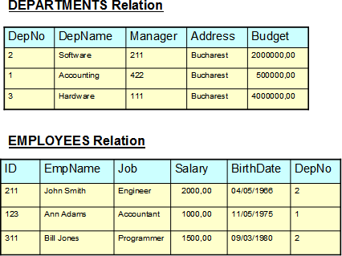

Figure 2.14 – DEPARTMENTS and EMPLOYEES relations

### Review questions

1. There is a supplier relation with four attributes: **Id** – supplier identification number (unique, not null), **Name** – supplier name (not null), **Address** – supplier address, **Discount** – discount offered by that supplier (not null, values between 0 % and 50

%). Indicate the constraints there are necessary to correctly define the relation.

1. There are five primitive algebraic operations: union, difference, Cartesian product, selection and projection. The others can be expressed using them. Give a definition of intersection, join and division in terms of those five primitive algebraic operations.
2. For the relation defined earlier in question #1, get the supplier name for suppliers from New York that gave a discount greater than 5%, using relational algebra operations.
3. Repeat question #3 using tuple-oriented relational calculus.
4. Repeat question #3 using domain-oriented relational calculus.
5. Which of the following statements can define an attribute from a relational data model point-of-view?
   1. A real-world data feature modeled in the database.
   2. A set of atomic values.
   3. A data characteristic.
   4. An ordered set of values that describe data characteristics.
   5. None of the above
6. Which of the following are relation properties?
   1. The **primary key** can’t have null values.
   2. There aren’t duplicate tuples in a relation.
   3. Attributes have atomic values.
   4. There are duplicate tuples in a relation.
   5. None of the above
7. A relation can have:
   1. A domain.
   2. An instance.
   3. A value.
   4. A degree.
   5. None of the above
8. Which of the following statements is true?
   1. A **primary key** is also a candidate key.
   2. Each relation has at least one foreign key.
   3. Foreign keys can’t have null values.
   4. A **primary key** is also an alternate key.
   5. None of the above
9. When deleting a tuple from a relation that has a **primary key** defined, which of the following options on a foreign key clause would delete all tuples with the same value in the foreign key relation?
   1. Restrict.
   2. Set to null.
   3. Delete.
   4. Cascade.
   5. None of the above

# 3

## Chapter 3 – The conceptual data model

This chapter explores the concepts of developing a conceptual database model, and describes an end-to-end view of implementing one.

After completing this chapter, you should be able to:

* Provide the necessary information to accurately describe the business;
* Prevent mistakes and misunderstandings;
* Facilitate discussion;
* Provide the set of business rules;
* Form a sound basis for logical database design;
* Take into account regulations and laws governing a specific organization.

### 3.1 Conceptual, logical and physical modeling: The big picture

The terms ***conceptual modeling***, ***logical modeling*** and ***physical modeling***are often used when working with databases.

Conceptual modeling emphasizes information as seen by the business world. It identifies entities and relationships of the business. Logical modeling is based on a mathematical model. It presents the information and entities in a fully normalized manner where there is no duplication of data. Physical modeling implements a given logical model specifically to a particular database product and version. This chapter focuses on the conceptual model, where all starts, but it will include topics related to logical and physical modeling. At the end of the chapter, there is a case study where a conceptual model is developed, and later transformed into a logical model (in Chapter 4), and a physical model (in Chapter 5).

It is important to develop models based on requirements analysis to better understand client’s objectives and avoid misunderstandings. Examples of tools that you can use for this purpose are IBM’s Rational RequisitePro, and IBM's InfoSphere Data Architect. *Figure*

* 1. shows where conceptual modeling, logical modeling, and physical modeling fit within the data modeling lifecycle and the corresponding IBM tools you can use to develop data models.

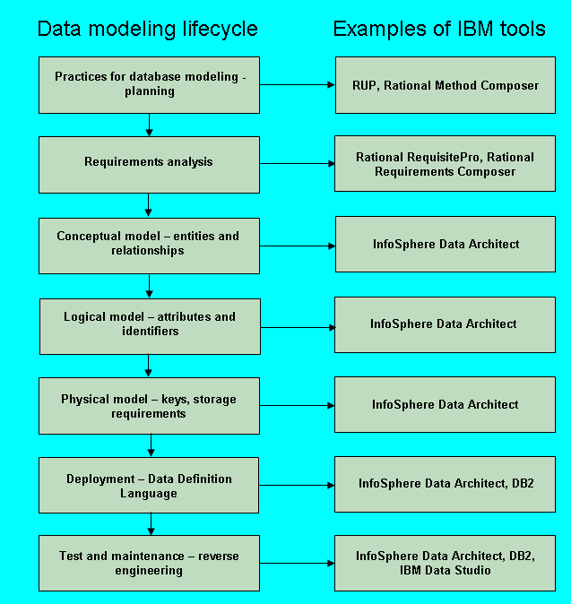

Figure 3.1 - Conceptual, logical and physical modeling within the data modeling lifecycle

A data model describes how data is represented and accessed. It defines data elements and relationships between them.

Data is a collection of letters, numbers, facts and documents that can be interpreted in many ways. It is meaningless if it is not processed; but when it is, it becomes valuable information. *Figure 3.2* provides an overview of the relationship between data and information.

**Data**

**Input**

**Information system**

**Information**

Figure 3.2 - Data processing

|  |  |  |  |
| --- | --- | --- | --- |
|  | **Process/transformation** | **Output** | |
|  |  |
| **Feedback** | | |

In the figure, data is the input that is processed and transformed, and information is the output. An example of data in the context of a university would be the name of a student. An example of information in the same context would be the number of students in a university.

### What is a model?

A model is an abstraction or representation of the real world that reveals all the features of interest to the users of the information in the model. Models are created to better understand a process, phenomenon, or activity.

You use a model to provide a representation of items, events and relationship sets between them, and to provide all the basic concepts and rules for good communication between developers and users.

##### Data model

Data modeling defines all the required information from the real world. When you model data be certain that information is represented only once. As Connolly states, “a data model is a tool for data abstraction, represents the organization itself and help users clearly and accurately to communicate their understanding of the organizational data” [3].

Data modeling is the first part of the database development process.

##### Database model

A database model is used to represent data about data, also known as metadata. A database model is an integrated collection of concepts for data description, data relationships, data semantics, and data constraints. Usually, a database model is used for a database schema description.

The types of database models are:

* External data model. This model is used for viewing a representation of every user and is also called Universe of Discourse. The main model is the Records-based Logical Model.
* Conceptual data model. This model is used for a general view of the data and is independent of a specific DBMS. The Object-based Logical Model represents this model.
* Internal data model. This model is used for a translation of the conceptual model to a specific DBMS. The Physical Data Model represents this model.

The most widely used model today is the Relational database model. It is an Entity- Relationship Model, based on the conceptual model. In building a business rules system, the most important characteristics about the relational model is that it is simple, and theoretically sound.

The components of a database model are:

* Structural component – This means a set of common rules for developing a database.
* Manipulation component – Defines the operations applied on the database (for searching or updating data in a database, or for modifying the database structure).
* Data Integrity component – A set of integrity rules which guarantees the correctness of data.

##### Conceptual data model concepts

In the process of creating a data model, a conceptual model of the data should be created first.

Conceptual data model is a mental image of a familiar physical object and are not specific to a database. At a high-level, they describe the things that an organization wants to collect data from and the relationships between these objects.

The objective of a conceptual database design is to build a conceptual data model. To do that, it is important to follow some steps:

* + - 1. Draw an Entity-Relationship Diagram. First create entity sets to identify attributes and to establish the proper relationship sets.
      2. Define integrity constraints. Identify and document integrity constraints such as required data, referential integrity, attribute domain constraints, enterprise constraints, and entity integrity.
      3. Review the final model. This requires you remove M:N relationships, remove recursive relationships, remove super types, remove relationships with attributes, and re-examine 1:1 relationships, which are normally not necessary.
      4. Entity-Relationship Model

As discussed in *Chapter 1*, rather than being used as a model on its own, the E-R model has been mainly successful as a tool to design relational databases. An entity relationship diagram (ERD) is often used to represent data requirements regardless of the type of database used, or even if a database is used at all. An ERD is a representation of structured data.

The concepts used in an Entity-Relationship model are:

* + - * + Entity set
        + Attribute
        + Relationship set
        + Constraint
        + Domain
        + Extension
        + Intension
      1. Entities and entity sets

An entity set is a set of entities of the same type that share the same properties. A noun is used to represent an entity set.

An entity is an instance of an entity set. An entity is a self-determining and distinguishable item within an entity set. For example, an entity can be:

* + - * + concrete (TEACHER or STUDENT)
        + insubstantial (GRADE)
        + an occurrence (EXAM)

*Figure 3.3* provides an example of entities and entity sets. The figure is self-explanatory.

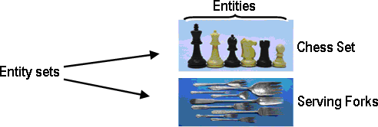

Figure 3.3 - Examples of entity sets and entities

Depending on the context, a given noun like TEACHER could be used as an entity, or an entity set. For example, if you need different types of people, such as TEACHER or STUDENT, you will create an entity set called PERSON with the entities TEACHER and STUDENT.

If the context is a university setting, use TEACHER as an entity set with the entities of PROFESSOR, ASSOCIATE PROFESSOR, ASSISTANT PROFESSOR, and so on.

**Note:**

In the Logical Model, entities are called tuples, and entity sets are called relations. For example, you can create a relation called PERSON with two attributes: NAME and ADDRESS. In this case you write: PERSON=(NAME, ADDRESS)

* + - 1. Attributes

An attribute is a data item that describes a property of an entity set. Attributes determine, explain, or categorize an entity set.

Attributes have values, which can be of different data types such as numbers, character strings, dates, images, sounds, and so on. Each attribute can have only one value for each instance of the entity set.

In a physical model, an attribute is a named column in a table, and has a domain. Each table has a list of attributes (or columns).

The types of attributes are:

* + - * + Simple (atomic) attribute – This type of attribute has a single component. For example, the **Gender** attribute has a single component with two values.
        + Composite attribute – A composite attribute consists of many components. For example, the **Name** attribute has the components last name and first name.
        + Single valued attribute – This type of attribute has one value for one entity. For example, the **Title** attribute has a single value for each teacher.
        + Multi-valued attribute – A multi-valued attribute has many values for one entity. For example, a person has many phone numbers. Each attribute can have only one value for each instance of the entity set. When you encounter a multi-valued attribute you need to transfer it to another entity set.
        + Derived attribute – A derived attribute has its value computed from another attribute or attributes. For example, the sum of all students in a faculty. A derived attribute is not a part of a table from a database, but is shown for clarity or included for design purposes even though it adds no semantic information; it also provides clues for application programmers.
        + Unstable attributes - This type of attribute have values that always change. For example, the study year of a student.
        + Stable attributes - Stable attributes will change on the odd occasion, if ever.

**Note:**

Try to use, all the time, stable attributes; for example, use starting date of study for a student as an alternative of the study year

* + - * + Mandatory attributes - Mandatory attributes must have a value. For example, in most businesses that track personal information, **Name** is required.

**Note:**

In InfoSphere Data Architect, you can find the required option on the Attributes tab within the Properties page when you select an entity set from an Entity- Relationship Diagram. This is illustrated *Figure 3.4* below.

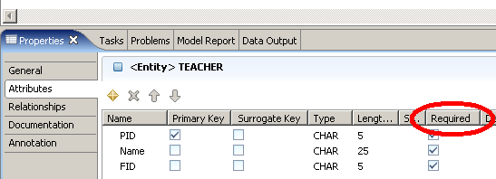

Figure 3.4 - Setting an attribute as mandatory

* + - * + Optional attributes - Optional attributes may have a value or be left null;
        + Unique identifier - This type of attribute distinguishes one entity from another. For example, in a classroom, you can distinguish between one student and another using a student ID.

In the case of Logical Model you use a special approach for unique identifier. The equivalent concept for unique identifier within Logical Model is a ***key***. A key is a field or a set of fields that has/have a unique value for each record in the relation. You need a key to ensure that you do not meet redundancies within a relation There are several types of keys each having slightly different characteristics:

* + - * + **Candidate key** – A candidate key is an attribute or set of attributes that uniquely identifies a record in a relation.
        + **Primary key** – A primary key is one of the candidate keys from a relation. Every relation must have a primary key. A primary key shall be at least:

Stable. The value of a primary key must not change or become null throughout the life of the entity. For example, consider a student record; using the age field as the primary key would not be appropriate because the value of the primary key must not change over time.

Minimal. The primary key should be composed of the minimum number of fields to ensure the occurrences are unique.

* + - * + **Alternate key** – An alternate key is any candidate key that is not chosen to be the primary key. It may become the primary key if the selected primary key is not appropriate.
        + **Surrogate key** – A surrogate key acts as a primary key but does not exist in the real world as a real attribute of an entity set. Because the surrogate key says nothing about the entity set and provides improper data which artificially increases the size of the database, it is not a good practice to use it. Using a tool like InfoSphere Data Architect, you can add surrogate keys as shown in *Figure 3.5*.

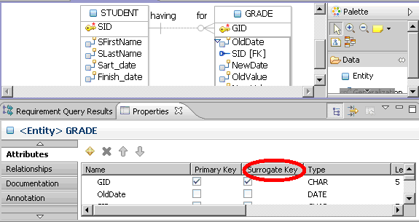

Figure 3.5 - Adding a surrogate key

* + - * + **Simple keys** – these keys have a single attribute.
        + **Composite keys** – these keys have multiple attributes.
        + **Foreign keys** – these keys exist usually when there are two or more relations. An attribute from one relation has to exist in the other(s) relation. Relationship sets exist between the two attributes. A special situation is encountered when you meet a unary relationship set. In this situation, you have to use a foreign key inside the same relation.
      1. Relationship sets

A relationship set is a set of relationships between two or more sets of entities, and are regularly represented using a verb. A relationship is an instance of a relationship set and establishes an association between entities that are related. These relationships represent something important in the model.

A relationship set always exists between two entity sets (or one entity set relating to itself). You need to read a relationship set in double sense, from one entity set to the other.

A relationship set can be more formally defined as a mathematical relation on entity sets as follows. Let the following concepts be represented by the following variables:

Entity set: ***E***

Entity: ***e***

Relationship set: ***R***

Relationship: ***r***

Given a set of entities ***E1, E2… Ek*** a relation ***R*** defines a rule of correspondence between these entity sets. An instance ***R(E1, E2,…, EK)*** of the ***R*** relation means entities ***E1, E2… Ek*** are in a relation ***R*** at this instance.

* + - 1. Constraints

Every business has restrictions on which attribute values and which relationships are allowed. In the conceptual data model constraints are used to handle these restrictions. A constraint is a requirement that entity sets must satisfy in a relationship. Constraints may refer to a single attribute of an entity set, or to relationship sets between entities. For example, "every ***TEACHER*** must work in one and only one ***DEPARTMENT***".

The types of constraints are:

* + - * + Cardinalities – they are based on the number of possible relationship sets for every entity set. The different cardinality constraints are listed below. Given a binary relation ***R*** between ***E*** (left entity in the figures below) and ***F*** (right entity in the figures below), ***R*** is said to be:

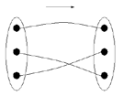one-to-one (***1:1***) - If both ***E*** and ***F*** have single-valued participation as depicted in the figure below.

one-to-many (***1:M***) - if ***E*** has single and ***F*** has multi-valued participation as depicted in the figure below.

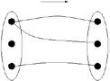

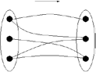many-to-many (***M:M***) - if both ***E*** and ***F*** have multi-valued participation

Many-to-many relationships are not supported by the relational model and must be resolved by splitting the original ***M:M*** relationship set into two ***1:M*** relationship sets. Usually, the unique identifiers of the two entity sets participate in building the unique identifier of the third entity set.

* + - * + Participation cardinalities (optionality). This type of constraint specifies whether the existence of an entity set depends on being related to another entity set via the relationship set. Participation cardinalities can be:

Total or mandatory: Each entity set must participate in a relationship and it cannot exist without that participation; the participation is compulsory.

Partial or optional: Each entity set may participate in a relationship; the participation is non-compulsory.

*Figure 3.6* summarizes both, the cardinality and optionality constraints.

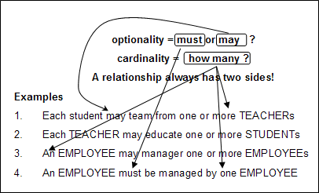

Figure 3.6 - Cardinality and optionality

* + - * + Subsets and supersets

When a group of instances has special properties such as attributes or relationship sets that exist only for that group, it makes sense to subdivide an entity set into subsets. The entity set is a superset called a parent. Each group is a subset called a child.

A subset consists in all attributes of the superset and takes over all relationship sets of the superset. A subset exists only along with other subset(s) and may have subsets of its own. A subset regularly adds its own attributes or relationship sets to the parent superset. Using subsets and supersets you can create hierarchies.

Example

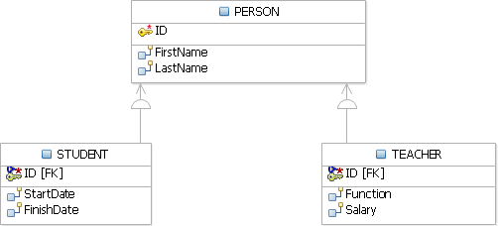An entity set ***PERSON*** can be divided in subsets ***STUDENT*** and ***TEACHER*** as depicted in *Figure 3.7* below.

**Figure 3.7 - *PERSON* superset, and its respective *STUDENT* and *TEACHER***

subsets

* + - * + Hierarchy

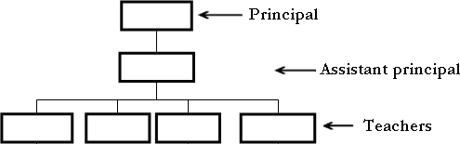A hierarchy represents an ordered set of items. For example in a school, there may be a hierarchy as illustrated in *Figure 3.8*.

Figure 3.8 - Example of a hierarchy in a school

* + - * + Unary relationship set - In this type of constraint, the same entity set participates many times in the same relationship sets. It is also known as the recursive relationship set.

Example

An assistant principal is also a teacher, so there can be a relationship between the subordinated teachers using a relationship set between the TEACHER entity set and itself. The same entity set participates many times in the same relationship set. *Figure 3.9* provides an example.

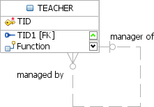

Figure 3.9 – Example of a unary relationship set

* + - * + History

In some cases, you need to preserve data along databases. For example, when attribute values are changing, or when relationship sets are changing. You can use historical data as a time-related constraint; for example, the constraint can specify the end date to always be later than the start date for a given attribute. In the physical model you can use a **CHECK** constraint for this purpose. Constraints to consider include that the start date may be changed to an earlier date, the activity has already begun, or the start and end date not be the same date.

Example

A student must graduate after he started his studies, not before. In this case, the end date must be greater than the start date.

**Note**:

To add a check constraint, refer to the section *Adding constraints* in the eBook

*Getting Started with InfoSphere Data Architect*, which is part of this eBook series.

In addition, when there is a need to modify existing information you need to keep the previous values. This is particularly important in situations where the information is sensitive, such as a student grade change.

Example

If a student’s grade is changed, it is useful to record when it was changed, the old grade, the new grade, and who changed it. *Figure 3.10* illustrates an example of journaling.

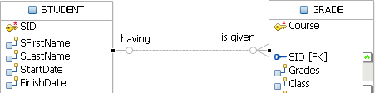

Figure 3.10 - Example of journaling

* + - 1. **Domain**

A domain is a set of possible values for one or more attributes. The user can define the domain definition. Domain models allow the user to define specific data types for the business.

**Note**

With InfoSphere Data Architect, it is possible to use domain models to constrain the values and patterns of business level data types.

The **CHECK** clause in the SQL standard allows domains to be restricted. The **CHECK** clause permits the schema designer to specify a predicate that must be satisfied by any value assigned to a variable whose type is in the domain.

* + - 1. Extension

Databases change over time. Data in a database at a particular point in time is called an extension of the database. Extension refers to the current set of tuples in a relation, it is an instance of the record sets and the relationship sets between them.

* + - 1. Intension

Intension or schema is the logical model of a database and is represented by entity sets. An instance describes and constrains the structure of tuples it is allowed to contain. An instance is represented by entity sets, and is the model of a database. Data manipulation operations on tuples are allowed only if they observe the expressed intensions of the affected relations.

### A case study involving a Library Management System - Part 1 of 3

This case study describes a simple Library Management System. Assume the requirements for the system were written by your client exactly in these terms:

"*The system will manage author's and loaner's information, and keep track of books loaned. The borrower's information include name, address, e-mail, and phone. The author's information include name, address and e-mail.*

*New books, authors and clients are entered into the system. When a client checks out a book, the system will register the date the book was loaned and calculate the days the book can be loaned. It will also calculate the date the book is due to be returned. If the borrower returns the book late, he must pay a fine based on the number of days overdue."*

##### Developing the conceptual model

The following steps need to be followed to develop a conceptual model:

Step 1 - Identify entities

To identify an entity set, you need to review the requirements specification carefully, and highlight all nouns you encounter. You can create a list with all of these nouns including duplicates, and discard later the ones that are not relevant. In our scenario the following nouns were found:

books, authors, name, address, e-mail, loaner, client, borrowers, name, address, e-mail, phone, loan date, return date, loan days, fine.

Every noun could be an entity set, but some could be attributes. You need to decide which ones are entity sets. Start by identifying dependencies. In our example, name, address, and e-mail, depend on authors; and name, address, e-mail and phone depend on borrowers.

With this first analysis, we decide on the following entities: LIBRARY, BOOK, AUTHOR, BORROWER, CLIENT, and LOANER as entity sets for our model, since these are the objects of interest in the system. Outcomes for this step are the following entity sets:

|  |  |
| --- | --- |
| **No.** | **Entity set** |
| 1 | LIBRARY |
| 2 | BOOKS |

|  |  |
| --- | --- |
| 3 | AUTHORS |
| 4 | BORROWERS |
| 5 | CLIENTS |
| 6 | LOANERS |

Step 2 - Remove duplicate entities

When business users write their requirements, it is common to find different terms for the same thing. Ensure that the entity sets identified are indeed separate entity sets. In our example, we have many synonyms: *borrowers*, *loaners*, and *clients*. Only one of these should be considered. In our case we choose *borrowers*.

Don't include the system as an entity set. In our example, we are modeling for a library system, therefore there should not be a library entity set.

Finally, determine the type of the entity set: Is it weak or strong? An entity set is weak if its existence lays on the existence of another entity set. An entity set is strong if its existence is an independent one. This is required later when you need to specify the relationship set type.

Outcomes for this step are the following revised entity sets (in singular) and their types:

|  |  |  |
| --- | --- | --- |
| **No.** | **Entity set** | **Type** |
| 1 | BOOK | Strong |
| 2 | AUTHOR | Strong |
| 3 | BORROWER | Strong |

Step 3 - List the attributes of each entity set

Ensure that the entity sets are really needed. Are any of them attributes of another entity set? For example, is phone an entity set, or an attribute of the AUTHOR entity set?

Speak with your client about other attributes he may need for the entity sets identified. In our example, we have identified several attributes for every entity set as shown in the following tables:

BORROWER entity set

|  |  |  |  |
| --- | --- | --- | --- |
| **Attribute name** | **Type** | **Domain** | **Optional** |
| BORROWER_ID | Unique identifier | Text | No |

|  |  |  |  |
| --- | --- | --- | --- |
| NAME | Composite attribute | Text | No |
| EMAIL | Single valued attribute | Text | Yes |
| PHONE | Multi-valued attribute | Text | Yes |
| ADDRESS | Composite attribute | Text | Yes |
| BOOK_ID | Single valued attribute | Text | No |
| LOAN_DATE | Single valued attribute | Text | No |
| DUE_DATE | Derived attribute | Text | No |
| RETURN_DATE | Derived attribute | Text | No |

**AUTHOR entity set**

|  |  |  |  |
| --- | --- | --- | --- |
| **Attribute name** | **Type** | **Domain** | **Optional** |
| AUTHOR_ID | Unique identifier | Text | No |
| NAME | Composite attribute | Text | No |
| EMAIL | Single valued attribute | Text | Yes |
| PHONE | Multi-valued attribute | Text | Yes |
| ADDRESS | Composite attribute | Text | Yes |

**BOOK entity set**

|  |  |  |  |
| --- | --- | --- | --- |
| **Attribute name** | **Type** | **Domain** | **Optional** |
| BOOK_ID | Unique identifier | Text | No |
| TITLE | Single valued attribute | Text | No |
| EDITION | Single valued attribute | Numeric | Yes |
| YEAR | Single valued attribute | Numeric | Yes |

|  |  |  |  |
| --- | --- | --- | --- |
| PRICE | Single valued attribute | Numeric | Yes |
| ISBN | Single valued attribute | Text | Yes |
| PAGES | Single valued attribute | Numeric | Yes |
| AISLE | Single valued attribute | Text | Yes |
| DECRIPTION | Single attribute | Text | Yes |

As discussed in section *3.2.3.3 Attributes*, there are a few things to consider about the attributes listed in the above tables:

* + - 1. Make a decision about composite attributes: leave it or split it. In our case say our client wants to search based on first name or last name. Therefore, it is better to have separate attributes, so you split the NAME attribute into FIRST_NAME and LAST_NAME.
      2. When you encounter a multi-valued attribute, you need to transfer it to another entity set. For this case, you don’t need more phone numbers, a single phone number is enough, so you change the type of the PHONE attribute from multi- valued to single value.
      3. DUE_DATE is a derived attribute which can be calculated by the system based on the LOAN_DATE. In our example, every book can be loaned only for 10 days, therefore adding 10 days to the LOAN_DATE would be the due date. We chose to remove this attribute.

After this analysis, the outcomes for this step are the following attributes for every entity set:

BORROWER entity set

|  |  |  |  |
| --- | --- | --- | --- |
| **Attribute name** | **Type** | **Domain** | **Optional** |
| BORROWER_ID | Unique identifier | Text | No |
| FIRST_NAME | Single valued attribute | Text | No |
| LAST_NAME | Single valued attribute | Text | No |
| EMAIL | Single valued attribute | Text | Yes |
| PHONE | Single valued attribute | Text | Yes |
| ADDRESS | Composite attribute | Text | Yes |
| BOOK_ID | Single valued attribute | Text | No |

|  |  |  |  |
| --- | --- | --- | --- |
| LOAN_DATE | Single valued attribute | Text | No |
| RETURN_DATE | Single valued attribute | Text | No |

**AUTHOR entity set**

|  |  |  |  |
| --- | --- | --- | --- |
| **Attribute name** | **Type** | **Domain** | **Optional** |
| AUTHOR_ID | Unique identifier | Text | No |
| FIRST_NAME | Single valued attribute | Text | No |
| LAST_NAME | Single valued attribute | Text | No |
| EMAIL | Single valued attribute | Text | Yes |
| PHONE | Single valued attribute | Text | Yes |
| ADDRESS | Composite attribute | Text | Yes |

**BOOK entity set**

|  |  |  |  |
| --- | --- | --- | --- |
| **Attribute name** | **Type** | **Domain** | **Optional** |
| BOOK_ID | Unique identifier | Text | No |
| TITLE | Single valued attribute | Text | No |
| EDITION | Single valued attribute | Numeric | Yes |
| YEAR | Single valued attribute | Numeric | Yes |
| PRICE | Single valued attribute | Numeric | Yes |
| ISBN | Single valued attribute | Text | Yes |
| PAGES | Single valued attribute | Numeric | Yes |
| AISLE | Single valued attribute | Text | Yes |
| DECRIPTION | Single valued attribute | Text | Yes |

**Step 4 - Choose a unique identifier**

For the BOOK entity set you have the choice of using the BOOK_ID attribute or the ISBN attribute. In our example, it is better to choose BOOK_ID because it is a unique ID for this library system. Also, our client does not have a manual scanner, so to check-in and check- out books, the librarian has to type all the numbers in the ISBN which can be bothersome and inefficient.

Step 5 - Define the relationship sets

In this step you need to examine the relationships between the different entity sets. You may find many relationship sets for a given pair of entity sets. For example, a book may be written by a person, or may me borrowed by a person.

Describe the cardinality and optionality of the relationship sets you find, and remove redundant relationship sets. You need also to specify if the relationship set is strong or weak. *Weak relationships* are connections between a strong entity set and weak entity set. S*trong relationships* are connections between two strong entities. In InfoSphere Data Architect, these are called *identifying* and *non-identifying* respectively. An identifying relationship set is selected to specify that the relationship set is one in which one of the child entities is also a dependent entity. Non-Identifying relationship set is selected to specify that the relationship set is one in which both entities are independent.

In order to identify relationship sets you need to select pairs of entity sets and analyze all possible scenarios. One simple approach is to use a table as show below:

|  |  |  |  |  |  |  |
| --- | --- | --- | --- | --- | --- | --- |
|  | **Relationship set** | **Identifying** | **Left verb** | **Right verb** | **Cardinality** | **Optionality** |
| 1 | BORROWER -> BOOK | No | Borrows | Be borrowed | Many-to- many | May |
| 2 | AUTHOR - > BOOK | No | Write | Is written | Many-to- many | May |
| 3 | AUTHOR - > BOOK | No | Borrows | Be borrowed | Many-to- many | May |

The table above shows 3 many-to-many relationship sets that you need to resolve. This is done by decomposing the initial many-to-many relationship set into two one-to-many relationship sets. To do that, you have to find a third intermediate entity set. In our case we have:

1. BORROWER - > BOOK.

The COPY entity set is created as the intermediate entity set to remove the many-to-many relationship set between BORROWER and BOOK. You don't borrow a book, but a copy of it. The new COPY entity set will look like this:

COPY entity set

|  |  |  |  |
| --- | --- | --- | --- |
| **Attribute name** | **Type** | **Domain** | **Optional** |
| COPY_ID | Unique identifier | Text | No |
| STATUS | Single valued attribute | Text | No |

1. **AUTHOR - > BOOK**

The AUTHOR_LIST entity set is created to remove the many-to-many relationship set between AUTHOR and BOOK. The new entity set will look like this:

AUTHOR_LIST entity set

|  |  |  |  |
| --- | --- | --- | --- |
| **Attribute name** | **Type** | **Domain** | **Optional** |
| ROLE | Single valued attribute | Text | No |

So the new updated table with relationship sets is:

|  |  |  |  |  |  |
| --- | --- | --- | --- | --- | --- |
| **Relationship set** | **Identifying** | **Left verb** | **Right verb** | **Cardinality** | **Optionality** |
| BORROWER - > COPY | No | Borrows | Be borrowed | One-to- many | May |
| BOOK - > COPY | No | Has | Is created | One-to- many | May |
| AUTHOR - > AUTHOR_LIST | No | Appear | Has | One-to- many | May |
| AUTHOR_LIST - > BOOK | No | Is created | Has | Many-to- many | May |

1. AUTHOR - > BOOK

The third relationship set that would need to also be decomposed is listed again here for your convenience:

|  |  |  |  |  |  |
| --- | --- | --- | --- | --- | --- |
| **Relationship set** | **Identifying** | **Left verb** | **Right verb** | **Cardinality** | **Optionality** |
| AUTHOR - > BOOK | No | Borrows | Be borrowed | Many-to- many | May |

Throughout this case study, you may have been wondering why this model has an entity set AUTHORS and another entity set BORROWERS, where most attributes are the same. Why doesn't the model use only one single entity PERSONS that is a superset of AUTHORS and BORROWERS? After all, AUTHORS can also borrow books.

We could have implemented the model with one single entity set PERSONS; however, there were two main reasons why we prefered to have two entity sets instead of one:

* + Simplicity to understand this model (mainly pedagogical reasons for you, as the reader, to understand concepts more easily)
  + Simplicity when developing an application for this model. Assuming this system is for the library of a very small town, and the chances of a book author living in this community are very slim, which means that the chances of an author borrowing a book are also very slim. Then, why handle such scenario in the application? In the unlikely case there is an author living in the same community, the librarian can ask him to create an account also as a borrower. This way, the developer can work on one single user interface regardless of whether the borrower is an author or not. Of course, some of these issues could have also be seen as business rules.

Other considerations that will be discussed later are related to constraints on the data that is collected. For example, there should be a constraint that checks that the return date is always later than the loan date. We discuss more about this when we talk about **CHECK** constraints in the physical model. This is covered in Chapter 5.

Step 6 - Define business rules

Business rules have to be implemented by an application program. In our example, we consider the following rules:

1. Only system administrators can change data
2. Allow the system to handle book reservations. Each borrower can see his position in the waiting list for all books of interest.
3. The application program sends e-mail reminders to the borrower to indicate a book is to be returned within 3 days of sending the e-mail.
4. If the borrower does not return the book on time, he will be fined 0.1% of the book's price per day.

This case study presented you with some of the best practices we encourage you to follow. However, conceptual modeling is an iterative process, so you need to draw several versions, and refine each one until you are happy with it. There is no right or wrong answer to the problem, but some solutions may be better than others.

This case study continues in Chapter 4, when we discuss the logical model design for this library system.

### Summary

This chapter discussed about conceptual modeling. It explained how to work with an Entity Relationship Diagram, and explained different concepts such as entity sets, attributes, relationships, constraints, domains and so on.

Using a graphical tool like InfoSphere Data Architect, is very convenient, especially when you have complex projects, for conceptual model creation, and then share those models among team members who are working on logical or physical data models. The basic concepts of conceptual modeling are further explained in the *Getting Started with InfoSphere Data Architect* ebook.

This chapter also discussed how to organize the data model using rules for constructing an ER model and creating diagrams.

Although this is not an application development book, this chapter provided you with the foundation to understand conceptual modeling by using examples with the InfoSphere Data Architect tool.

### Exercises

Given the following entity sets in a university context:

* Faculty
* Teacher
* Function
* Course
* Student

Provide a graphical representation of the relationships and entity sets. Write down all the graphical representation items and the Entity-Relationship diagram using InfoSphere Data Architect. For more information about this tool, refer to the *Getting started with InfoSphere Data Architect* book that is part of this series.

### Review questions

* + 1. Which of the following corresponds to an entity set:
       1. A column in a table
       2. Collection of real-world objects or concepts
       3. Data that describes a feature of an object or concept
       4. Set of entities of the same type that shares the same properties.
       5. None of the above
    2. Unstable attributes:
       1. have values that frequently change
       2. change on the odd occasion, if ever
       3. have values provided by another attribute or other attributes
       4. has many values for one entity
       5. None of the above
    3. You should resolve a M:M relationship set. The new relationship sets are always:
       1. Optional on the many side
       2. Mandatory on the one side
       3. Mandatory on the many side
       4. Redundant on the many side
       5. Recursive on the one side
    4. Which of this is true about Conceptual Modeling?
       1. An entity set should occur only once on a data model
       2. A Conceptual Model should model derived attributes
       3. All data must be represented on the data model
       4. All of the above
       5. None of the above
    5. Which of the following is NOT a definition of an entity set?
       1. An entity set is a collection of real-world objects or concepts that have the same characteristics
       2. An entity set is an instance of real-world objects
       3. An entity set is an item that exists and is distinguishable from other items
       4. All of the above
       5. None of the above
    6. Which of the following is NOT true about a relationship set?
       1. Relationship set shows how entities are related to each other.

Chapter 3 – The conceptual data model 87

* + - 1. Relationship set always exists among two entity sets
      2. Relationship set should be read in double sense
      3. Relationship set is a noun
      4. All of the above
    1. Which of the following is true about mandatory relationship sets?
       1. They show how entities are related to each other
       2. Each entity set must participate in a relationship
       3. Each entity set may participate in a relationship
       4. There are a number of possible relationship sets for every entity set
       5. None of the above
    2. A group of instances, which has attributes or relationship sets that exist only for that group is called a:
       1. Constraint
       2. Cardinality
       3. Superset
       4. Subset
       5. All of the above
    3. Name a clause in the SQL standard, which allows domains to be restricted:
       1. RELATIONSHIP
       2. PRIMARY KEY
       3. CHECK
       4. CONSTRAINT
       5. None of the above
    4. Data in a database at a particular point in time is called:
       1. Intension
       2. Extension
       3. Schema
       4. Instance
       5. None of the above

# 4

## Chapter 4 – Relational Database Design

This chapter explores relational database design concepts that will help model the real- world enterprise in a relational database. It provides guidelines to define tables, columns, and establish relationships between tables so that there is minimum redundancy of data.

In this chapter, you will learn about:

* Modeling real-world objects into relational tables
* Identifying problems and minimizing redundancy
* Identifying dependencies and incorporating them into the relational database design
* Refining relational tables to have the most optimal design

### The problem of redundancy

Data redundancy implies finding the same data in more than one location within database tables. Redundancy in a relational schema is a non-optimal relational database design because of the following problems:

* + - Insertion Anomalies
    - Deletion Anomalies
    - Update Anomalies

*Table 4.1* shows an example of data redundancy where college information and student information are stored together. Under this design we store the same college information a number of times, once for each student record from a particular college. For example, the information that IIT college has a level of 1 is repeated twice, one for student *George Smith*, the other one for student *Will Brown*.

|  |  |  |  |  |
| --- | --- | --- | --- | --- |
| **STUDENT_ID** | **STUDENT** | **RANK** | **COLLEGE** | **COLLEGE_LEVEL** |
| 0001 | Ria Sinha | 6 | Fergusson | 4 |
| 0002 | Vivek Kaul | 15 | PICT | 5 |

|  |  |  |  |  |
| --- | --- | --- | --- | --- |
| 0003 | George Smith | 9 | IIT | 1 |
| 0004 | Will Brown | 1 | IIT | 1 |

Table 4.1 – A Data Redundancy Example (Student schema)

**Note:**

*Table 4.1* will be used for all the examples in this chapter. The **STUDENT_ID** column, representing university roll numbers, is the unique **primary key** in this Student schema

##### Insertion Anomalies

An insertion anomaly happens when the insertion of a data record is not possible unless we also add some additional unrelated data to the record. For example, inserting information about a student requires us to insert information about the college as well (COLLEGE_LEVEL column in *Table 4.2*).

|  |  |  |  |  |
| --- | --- | --- | --- | --- |
| **STUDENT_ID** | **STUDENT** | **RANK** | **COLLEGE** | **COLLEGE_LEVEL** |
| 0005 | Susan Fuller | 10 | Fergusson |  |

Table 4.2 – Insertion Anomalies – Example

Moreover, there will be a repetition of the information in different locations in the database since the COLLEGE_LEVEL has to be input for each student.

##### Deletion Anomalies

A deletion anomaly happens when deletion of a data record results in losing some unrelated information that was stored as part of the record that was deleted from a table.

For example, by deleting all such rows that refer to students from a given college, we lose the COLLEGE and COLLEGE_LEVEL mapping information for that college. This is illustrated in *Table 4.3*, where we lose the information about the college ‘IIT’ if we delete the information about the two students *George Smith* and *Will Brown*.

|  |  |  |  |  |
| --- | --- | --- | --- | --- |
| **STUDENT_ID** | **STUDENT** | **RANK** | **COLLEGE** | **COLLEGE_LEVEL** |
| 0003 | George Smith | 9 | IIT | 1 |
| 0004 | Will Brown | 1 | IIT | 1 |

Table 4.3 – Deletion Anomalies - Example

##### Update Anomalies

An update anomaly occurs when updating data for an entity in one place may lead to inconsistency, with the existing redundant data in another place in the table.

For example, if we update the COLLEGE_LEVEL to '1' for **STUDENT_ID** 0003, then college 'Fergusson' has conflicting information with two college levels, 1 and 4.

|  |  |  |  |  |
| --- | --- | --- | --- | --- |
| **STUDENT_ID** | **STUDENT** | **RANK** | **COLLEGE** | **COLLEGE_LEVEL** |
| 0001 | Ria Sinha | 6 | Fergusson | **4** |
| 0003 | George Smith | 9 | Fergusson | **1** |

Table 4.4 – Update Anomalies – Example

In the following sections, we suggest how to overcome the above problems caused by data redundancy.

### Decompositions

Decomposition in relational database design implies breaking down a relational schema into smaller and simpler relations that avoid redundancy. The idea is to be able to query the smaller relations for any information that we were previously able to retrieve from the original relational schema.

For example, for the Student schema, *Figure 4.1* illustrates how the decomposition would work.

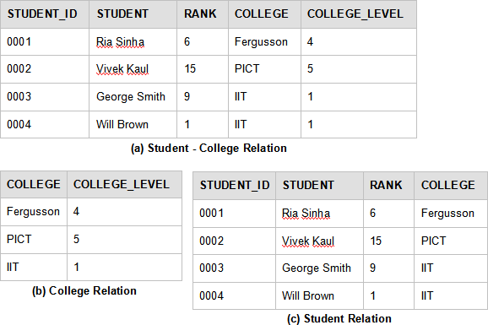

Figure 4.1 – Decomposition example

In *Figure 4.1*, we decompose the Student schema shown in (a) and store it into a College relation and Student relation as shown in (b) and (c). Hence, the COLLEGE_LEVEL information is not redundantly stored, but contains only a single entry for each existing college.

The college a student belongs to is chosen here as an attribute of the student relation, so that it can help put together the original information of which college a student belongs to.

Had we decomposed this into two relations, as follows:

|  |  |
| --- | --- |
| **COLLEGE** | **COLLEGE_LEVEL** |

|  |  |  |
| --- | --- | --- |
| **STUDENT_ID** | **STUDENT** | **RANK** |

This would have resulted in loss of information, as we could not map which college a student belongs to.

Another such example would be:

|  |  |  |
| --- | --- | --- |
| **COLLEGE** | **COLLEGE_LEVEL** | **STUDENT_ID** |

|  |  |  |
| --- | --- | --- |
| **STUDENT_ID** | **STUDENT** | **RANK** |

This would result in a number of entries again (redundancy) for the COLLEGE_LEVEL of each student.

While breaking down a given relational schema helps to avoid redundancy, one should be careful not to lose information. That is, it should be possible to reconstruct the original relational schema back from the smaller relations. ***Functional dependencies*** guide us to achieve this reversibility of information.

### Functional Dependencies

Functional Dependency (FD) is a type of integrity constraint that extends the idea of a super key. It defines a dependency between subsets of attributes of a given relation. A formal definition of a functional dependency is provided below:

**Definition:** Given a relational schema **R**, with subset of attributes **A** and **B** , we say that a functional dependency **A** → **B** exists if the values in **A** literally implies the values that **B** can hold for any instance r of the relation **R**.

Hence, we say that an FD generalizes the idea of a super key because the attributes in set **A** uniquely determines the attributes in set **B** for a given relation **R**. In addition, function dependency **A** → **B** exists when the values of **B** are functionally dependent on **A**. We say ‘functionally’ because similar to the concept of a function, an FD helps to map one set of attributes **A** to another set **B**.

An **FD holds on relation R** if it exists for all legal instances **r** of the relation **R**.

At the same time, to check whether an **instance r satisfies an FD**, we need to check whether every tuple in instance r is in compliance with the FD defined i.e. **A** → **B** (**A** determines **B** or **A** implies **B** for each row of data stored in a table at a given instant).

Functional Dependency can be understood as “**A** determines **B**”, “**B** is dependent on **A**” or “**A** implies **B**” and denoted as “**A** → **B**”.

If **A1** → **B1 , A2** → **B2, A3** → **B3 … An** → **Bn,** then we denote it as

A1 A2 A3…. An → B1 B2 B3… Bn

Below is an instance of relation **R ( A, B, C, D )** where **A** → **D** :

|  |  |  |  |
| --- | --- | --- | --- |
| **A** | **B** | **C** | **D** |
| a1 | b1 | c1 | d1 |
| a2 | b2 | c2 | d1 |
| a3 | b3 | c3 | d1 |
| a4 | b3 | c4 | d2 |

Table 4.5 – Functional Dependency

One of the FDs above is **A** ---→ **D**. It is easier to understand this considering why the reverse **D** ---→ **A** is not true. This is because given the same values in **D**, the corresponding value of **A** changes as seen from tuple **(a1 , b1 , c1, d1)** and **(a2, b2, c2, d1)**.

Example

Using the Student schema of our first example and shown in Table 4.7, a FD, **STUDENT_ID** → COLLEGE **holds on** the Student schema, while an FD, STUDENT→ COLLEGE will not hold over relation schema because there maybe students with the same name in two different colleges.

|  |  |  |  |
| --- | --- | --- | --- |
| **STUDENT_ID** | **STUDENT** | **RANK** | **COLLEGE** |
| 0001 | Ria Sinha | 6 | Fergusson |
| 0002 | Vivek Kaul | 15 | PICT |
| 0003 | George Smith | 9 | IIT |
| 0004 | Will Brown | 1 | IIT |

Table 4.7 – Functional Dependency Example

The following set of FDs also holds true:

{ **STUDENT_ID** → COLLEGE , **STUDENT_ID** → STUDENT ,

**STUDENT_ID** → STUDENT → COLLEGE

**STUDENT_ID** → STUDENT → RANK }

**Trivial Functional Dependencies -** A functional dependency that holds true for all values of a given attribute is a trivial FD.

Example

(First-name, last-name) → first-name

In general, a functional dependency **A** → **B** is trivial if **B** is a subset of **A,** that is, **B** is contained within **A** (the right hand side will be a part of the left hand side).

In a relational database design we are typically more interested in the non-trivial FDs as these help determine the integrity constraints on a relation while the trivial FDs are just obvious and will exist in any case.

### Properties of Functional Dependencies

In order to determine all the functional dependencies that exist from a given set of functional dependency, we define an important property of FD called Closure Set of Functional Dependencies.

**Closure Set of Functional Dependencies -** All the functional dependencies that are implied from a given set of functional dependency, S is called Closure Set of Function Dependency, S+.

Hence, it follows that any instance of the relation r that satisfies the given set of FD, S will also satisfy the closure set of this FD, S+.

In the following sub-sections, we will go through the rules to compute the closure set of functional dependencies.

##### Armstrong’s Axioms

Armstrong's axioms are also known as **‘Inference Rules’** which help us infer all the implied functional dependencies from a given set of FDs.

There are three Inference Rules:

1. ***Reflexivity*:** If **B** is a subset of attributes in set **A**, then **A** → **B**. (by **trivial FD**)
2. ***Augmentation*:** If **A** → **B** and **C** is another attribute, then **AC** → **BC**

Applying reflexivity to this rule, we can also say that, **AC** → **B**.

1. ***Transitivity*:** If **A** → **B** and **B** → **C**, then **A** → **C**.

In addition, we have the following **additional rules** that can be proved from the above 3 axioms to ease out our task of building the closure set of FD from a given FD.

1. ***Union*:** If **A** → **B** and **A** → **C**, then **A** → **BC**.
2. ***Decomposition*:** If **A** → **BC**, then **A** → **B** and **A** → **C**.

Armstrong’s Axioms are sound and complete. They generate only FDs in the closure set of a given FD, S+ and they generate the complete set of FDs in S+.

##### Computing the closure set of attributes

This is an alternate method to build the closure set of functional dependencies from a given FD. It can also be used to determine if a given attribute set is the super key in a relation.

**Closure set of attributes** of a given attribute, **A**, is set of all attributes in the relation, **R** that can be uniquely determined by **A**, based on the given FDs.

Note: Given closure(**A**), and **A**+ is such a set that it includes all the attributes in a given relation R, then we can say that attribute A is a super key for the relation R.

Computation

Given a relation, **R** with a set of attributes, we calculate closure set of attributes for **A**, closure (**A**) as follows:

1. Initially set closure (**A**) = **A**
2. For each given FD, if **A** → **B**, then add **B** to closure (**A**), that is, closure (**A**) U **B**
3. For any subset of **A**, (let **C** be a subset of **A**), **A**→ **C** (by trivial FD) and if **C** → **D** such that **D** is not a subset of **A**, then add **D** to the closure (**A**)
4. Repeat step 3 until there are no more attribute sets to be added to closure (**A**)

Example

Consider a relation, **R (A, B, C, D, E)** with the given FDs **A** → **B, B** → **DE** and **D** → **C**

Computation

Step 1. Closure (**A**) = **A**

Step 2. **A** → **B**, hence closure (**A**) = **A** U **B**, can be denoted as **AB**

Step 3.

1st Iteration: **B** → **DE** and **B** is now a subset of closure (**A**), hence closure (**A**) = **ABDE**

2nd Iteration: **AD** → **C, D** is a subset of closure (**A**) and **C** in not a subset of closure (**A**), hence closure **(A), A+ = ABDEC.**

Similarly, closure (**B**), **B**+ = **BDEC**

Closure(**C**), **C**+ = **C** Closure (**D**), **D**+= **DC** Closure (**E**), **E**+= **E**

##### Entailment

Functional Dependencies (FDs) guide us on how to best decompose relations so that the dependent values may be stored in a single table.

When data is inserted into the database, it needs to conform to the constraints specified. Apart from other integrity constraints, the data also needs to conform to the functional dependencies.

The properties of functional dependencies help us reason about the closure set of functional dependencies so that we have a structured formula to derive an exhaustive set of constraints to effectively model the real-world dependencies.

Armstrong’s Axioms help us work out such a sound and complete set. The Closure of Attributes for a given set of functional dependencies not only provides an alternate method to calculate the closure set of FDs but also help us determine the super key of a relation and check whether a given functional dependency, **X** → **Y** belongs to the closure set of functional dependency.

### Normal Forms

Normalization is a procedure in relational database design that aims at converting relational schemas into a more desirable form. The goal is to remove redundancy in relations and the problems that follow from it, namely insertion, deletion and update anomalies.

The Normal forms progress towards obtaining an optimal design. Normalization is a step- wise process, where each step transforms the relational schemas into a higher normal form. Each Normal form contains all the previous normal forms and some additional optimization over them.

##### First Normal Form (1NF)

A relation is considered to be in ***first normal form*** if all of its attributes have domains that are indivisible or atomic.

The idea of atomic values for attribute ensures that there are no ‘repeating groups’ . This is because a relational database management system is capable of storing a single value only at the intersection of a row and a column. Repeating Groups are when we attempt to store multiple values at the intersection of a row and a column and a table that will contain such a value is not strictly relational.

As per C. J. Date’s extended definition [4.8], “A table is in 1NF if and only if it satisfies the following five conditions:

* + - * There is no top-to-bottom ordering to the rows.
      * There is no left-to-right ordering to the columns.
      * There are no duplicate rows.
      * Every row-and-column intersection contains exactly one value from the applicable domain (and nothing else).
      * All columns are regular [i.e. rows have no hidden components such as row IDs, object IDs, or hidden timestamps]. ”

A column storing "Relatives of a family" for example, are not an atomic value attribute as they refer to a set of names. While a column, like Employee Number, which cannot be broken down further is an atomic value.

Example

Consider the following table that shows the *Movie* relation. In the relation, {Movie_Title, Year} form a candidate key.

|  |  |  |  |  |  |  |
| --- | --- | --- | --- | --- | --- | --- |
| **Movie_Title** | **Year** | **Type** | **Director** | **Director_D OB** | **yr_releases_cnt** | **Actors** |
| Notting Hill | 1999 | Romantic | Roger M | 05/06/1956 | 30 | Hugh G  Rhys I |
| Lagaan | 2000 | Drama | Ashutosh G | 15/02/1968 | 50 | Aamir K  Gracy S |

Table 4.8 - Non-normalized relation *Movie*

The above relation is not in 1NF and is not even strictly relational. This is because it contains the attribute *Actors* with values that are further divisible. In order to convert it into a 1NF relation, we decompose the table further into **Movie Table** and **Cast Table** as shown in *Figure 4.2* below

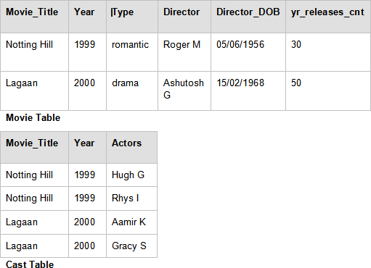

Figure 4.2 – Converting to First Normal Form. Example of a relation in 1NF

In *Figure 4.2*, the intersection of each row and column in each table now holds an atomic value that cannot be broken down further and thus the decomposition has produced a relation in 1NF, assuming the actor name in the *Actors* column is not divisible further as ‘first name’ and ‘surname’.

##### Second Normal Form (2NF)

A relation is in ***second formal form*** when it is in 1NF and there is no such non-key attribute that depends on part of the candidate key, but on the entire candidate key.

It follows from the above definition that a relation that has a single attribute as its candidate key is always in 2NF.

Example

To normalize the above 1NF movie relation further, we try to convert it to 2NF by eliminating any dependency on part of the candidate key. In the above, *Yr_releases_cnt* depends on *Year*. That is, *Year → Yr_releases_cnt* but the candidate key is {Movie_Title, Year}.

So to achieve 2NF, we further decompose the above tables into ***Movie relation, Yearly releases relation*** and ***Cast relation*** as shown in *Figure 4.3*.

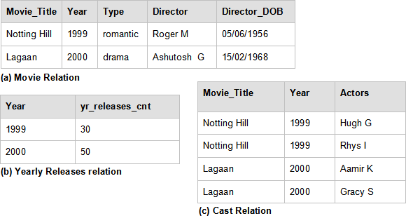

Figure 4.3 – Converting to Second Normal Form

In the above figure, each non–key attribute is now dependent on the entire candidate key and not a part of it. Thus, the above decomposition has now produced a relation in 2NF.

##### Third Normal Form (3NF)

A relation is in ***third normal form*** if it is in 2NF and there is no such non-key attribute that depends transitively on the candidate key. That is every attribute depends directly on the **primary key** and not through a transitive relation where an attribute **Z** may depend on a non-key attribute **Y** and **Y** in turn depends on the **primary key** X.

Transitivity, as seen earlier, means that when **X**→**Y** and **Y**→ **Z**, then **X**→**Z**.

It follows from 3NF relation that the non-key attributes are mutually independent.

Example

To normalize the above 2NF movie relation further, we try to convert it to 3NF by eliminating any transitive dependency of non-prime attribute on the **primary key**. In the above *Figure 4.3*, *Director_DOB* depends on *Director*, that is *Director → Director_DOB*.

Nevertheless, the candidate key is {Movie_Title, Year}. So here {Movie_Title, Ye→ar} Director and Director → Director_DOB hence there is transitive dependency.

Therefore, to achieve 3NF, we further decompose the above tables into **Movie relation, Director Relation**, **Yearly releases relation** and **Cast relation** as shown in *Figure 4.4.*

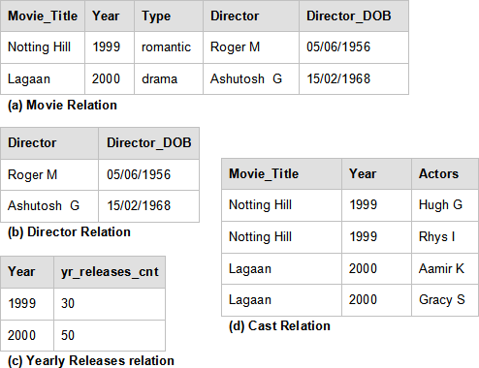

Figure 4.4 – Converting to Third Normal Form

In the figure above, each non–key attribute is mutually independent and depend on just the whole candidate key. Thus, the above decomposition has now produced a relation in 3NF.

##### Boyce-Codd Normal Form (BCNF)

Boyce-Codd Normal Form is a stricter version of 3NF that applies to relations where there may be overlapping candidate keys.

A relation is said to be in ***Boyce-Codd normal form*** if it is in 3NF and every non-trivial FD given for this relation has a candidate key as its determinant. That is, for every **X** → **Y, X** is a candidate key.

Example

Consider a ***Guest Lecture relation*** for a college as shown in *Table 4.9* below. Assume each teacher teaches only one subject.

Candidate Keys: {Subject, Lecture_Day}, {Lecture_Day, Teacher}

|  |  |  |
| --- | --- | --- |
| **Subject** | **Lecture_Day** | **Teacher** |
| Graphics | Monday | Dr. Arindham Singh |
| Databases | Monday | Dr. Emily Jose |
| Java | Wednesday | Dr. Prasad |
| Graphics | Tuesday | Dr. Arindham Singh |
| Java | Thursday | Dr. George White |

Table 4.9 - Guest Lecture relation

In the above relation, there are no non-atomic values hence, it is in 1NF. All the attributes are part of candidate keys hence it is in 2NF and 3NF.

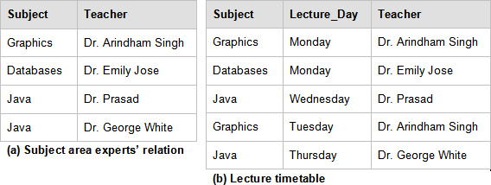An FD, Teacher → Subject exists for the above relation. However, Teacher alone is not a candidate key; therefore, the above relation is not a BCNF. To convert it into a BCNF relation, we decompose it into relations **Subject area experts** and **Lecture timetable** as shown in *Figure 4.5*.

Figure 4.5 – Converting to Boyce-Codd Normal Form

The relation in *Table 4.9* is now decomposed into BCNF as for non–trivial FD, Teacher →

Subject. Teacher is now a candidate key in *Figure 4.5 (a) Subject area experts’ relation*.

### Properties of Decompositions

We revisit Decomposition in this section to review its desirable properties.

Decomposition is breaking up a relational schema into smaller relations such that each of the attributes is present in at least one of the new relations, and has a more optimized design. The underlying goal is to remove redundancy.

##### Lossless and Lossy Decompositions

Decomposition of a relation **R** into relations **X** and **Y** is **lossless** if no information from the original relation is lost after the decomposition. In other words, the original relation can be constructed back from the decomposed relations and no spurious rows of information are added as data to the resulting rows.

It follows then, that if a decomposition results in loss of information from the original relation

**R** then the decomposition is **lossy** and is obviously not a desirable property.

Let **R** be a relation with functional dependency **F** that is decomposed into **R**1 and **R**2. Then the decomposition is lossless if one of the following FDs is true for the decomposed relations **R**1 and **R**2:

**R**1 ∩ **R**2 → **R**1 or **R**1 ∩ **R**2 → **R**2

More simply if the common attributes in **R**1 and **R**2 (i.e. **R**1 ∩ **R**2) form a super key for either **R**1 or **R**2, then the original relation R has undergone a lossless decomposition into **R**1 and **R**2.

An essential property of decomposition in relational database design is that they should be lossless. A lossless join of decomposed relation **X** and **Y** into **R** results in no information loss and no addition of extra misguiding information when joining **X** and **Y** to get back the original relation **R**.

Example

Consider the relation ***employee*** as follows:

|  |  |  |  |  |
| --- | --- | --- | --- | --- |
| **EMP_ID** | **EMP_NAME** | **WORK_EXP** | **DEPT_ID** | **DEPT_NAME** |

A desired ***lossless decomposition*** for the above relation employee is as follows:

|  |  |
| --- | --- |
| **DEPT_ID** | **DEPT_NAME** |

|  |  |  |  |
| --- | --- | --- | --- |
| **EMP_ID** | **EMP_NAME** | **WORK_EXP** | **DEPT_ID** |

Department relation Employee relation

In the above, (Department∩) (Employee) = DEPT_ID and DEPT_ID → { DEPT_ID ,

DEPT_NAME}, that is, DEPT_ID is a super key for the ***Department*** relation and the decomposition is lossless.

A ***lossy decomposition*** for the above would be:

|  |  |  |
| --- | --- | --- |
| **DEPT_ID** | **DEPT_NAME** | **EMP_NAME** |

|  |  |  |
| --- | --- | --- |
| **EMP_ID** | **EMP_NAME** | **WORK_EXP** |

Department relation Employee relation

In the above, (Department)∩ (Employee) = EMP_NAME which is not a super key for

department or employee table hence the decomposition is lossy.

From the above example, an EMP_NAME is not guaranteed to be unique and hence we cannot say for sure which employee works for which department. This shows the result of information loss.

##### Dependency-Preserving Decompositions

Decomposition of a relation **R** into relations **X** and **Y** is dependency-preserving when all the FDs that hold on **X** and **Y** separately, when put together correspond to all the FDs that exist in the closure of functional dependency **F**+ that hold on the original relation, **R**.

On a projection of a set of FD of relation **R, F** is a set of its attributes, **X** is the set of FDs of the form **C** → **D** where **C** and **D** both are in **X**. This is denoted as **Fx**.

Thus a decomposition of a relation **R** into **X** and **Y** is dependency-preserving if the union of the closure set of FDs on **X** and **Y** is equivalent to the closure of set of functional dependencies **F**+ that holds on **R.** That is, **Fx** U **Fy** implies **F**+ where **Fx** are the set of FDs in **F**+ that can be checked in only **X,** and **Fy** are the set of FDs that can be checked only in **Y**.

It follows from the above that given a dependency preserving decomposition, if we can check all the constraints against the decomposed table only, we need not check it against the original table.

Dependency-preserving decomposition does not imply a lossless join decomposition and vice versa. While lossless join is a must during decomposition, dependency-preservation may not be achieved every time.

### Minimal Cover

Minimal cover, **Fc** is the smallest set of functional dependencies such that the closure set of function dependencies for both minimal cover and given set of FDs **F** for a relation **R** are equivalent. That is, **F+ = F +**

**c**

The purpose of having a minimal cover is to make constraint checking easier when data is entered into an RDBMS. The data entered into the tables must satisfy the constraints that exist on a given relation. With a minimal cover, we thus have minimum number of checks to compute as compared to the original set of FDs that exist on a relation and hence constraint checking is more economical using the minimal cover.

Minimal cover, Fc is derived from F such that:

* + 1. The RHS for each FD in the minimal cover is a single attribute.
    2. If you reduce any attributes from the LHS for each FD, the closure of the minimal cover changes.
    3. Removing any FD from the minimal cover causes the closure of the minimal cover to change.

Minimal Cover for a given set of FDs is not unique.

Extraneous attribute.

For each ***α*** → ***β*** that exists in **F**, extraneous attribute is such that if we remove such an attribute from ***α*** and ***β*** the closure set of FDs does not change.

That is, eliminate **A** from ***α*** when **F**c implies ( **F**c – { ***α*** → ***β*** } ) U ( {***α*** – **A**} → ***β*** ) and eliminate **B** from ***β*** when **F**c implies ( **F**c – { ***α*** → ***β*** } ) U ( ***α*** → { ***β*** –**B** } ) .

To compute the minimal cover **F**c, follow these steps:

1. Using decomposition rules from Armstrong’s Axioms decompose each FD to have a single attribute on the RHS.
2. Reduce LHS for each FD in **F**c to remove any extraneous attribute.
3. Use Armstrong’s Axioms to further reduce any redundant FDs remaining in the minimal cover such that its closure does not change. That is, we maintain **F+ = F +**

**c**

Example

Consider the relation **R** as follows: **R (A, B, C, D)** with a given set of FDs **F**: **A** → **BC**,

**B** → **C**, **A** → **B**, **AB** → **C**, **AC** → **D**

To compute the minimal cover **F**c following the steps described earlier, note the changes highlighted in bold below:

Step 1: We reduce each FD in the set such that RHS contains a single attribute (Using decomposition: If **X** → **YZ**, then **X** → **Y** and **X** → **Z**).

A → B, A → C, B → C,

**A** → **B**, **AB** → **C**, **AC** → **D**

Step 2: Reducing LHS to remove extraneous attribute if any We have **B** → **C** and **AB** → **C** hence **A** is extraneous in **AB** → **C**. Replace with **B → C** which already exists in our set of FD.

Similarly, **A** → **C** and **AC** → **D** thus **C** is extraneous in **AC** → **D**. Replace with **A** → **D**

Thus, the minimal set becomes: **A** → **B**, **A** → **C**, **B** → **C**,

**A** → **B**, **B → C,**

**A** → **D**

Step 3: Removing redundant FDs

We have duplicates **A** → **B** and **B** → **C**. From them we have the transitive relation

**A** → **C**,

Then the minimal set leaves us with:

**A** → **B**, **B** → **C**,

**A** → **D**

***Minimal Cover* Fc = { A → B , B → C, A → D }.**

### Synthesis of 3NF schemas

Synthesis of 3NF schemas is a bottom-up approach to build lossless join and dependency preserving decompositions of a relation into 3NF. Synthesis is bottom-up because we start from the minimum set of FDs and construct the decomposed schemas directly by adding one schema at a time to the list, thus constructing the decomposed relations in 3NF.

We build the decomposed schemas directly from the minimal cover of a given set of FDs of a relation **R**. We then check that the schemas formed are a lossless join decomposition. If not, we add another schema to it with just the candidate key so that it now becomes a lossless join decomposition into 3NF.

The procedure for synthesis of 3NF schemas to decompose **R** into **R**1, **R**2 ,**R**3 ..... , **R**n follows:

* + 1. For each FD, ***α*** → ***β*** in the Minimal Cover **F**c , if none in the schemas **R**1, **R**2 ,**R**3 .....

, **R**n contains ***α***, ***β*** yet, then add schema **R**i = ( ***α, β*** ).

* + 1. For each **R**i in the list **R**1, **R**2 ,**R**3 ..... , **R** n check that at least one of these relations contains a candidate key of R. If it does not, then add another relation to the set of decomposed schemas R n +1 such that R n +1 is a candidate key for R.

### 3NF decomposition

A 3NF decomposition can be achieved using a top-down method by the process of ***normalization*** where we decompose a relation as per the definition of 3NF and then ensure that it is lossless and dependency-preserving by performing certain checks on the relations thus created. Section 4.5.3 provided an illustration of this approach.

In this section, we will consider an example of a 3NF decomposition into relational schemas following a bottom-up approach such that it is lossless and dependency- preserving using the synthesis algorithm explained above.

Example

Consider the relational schema, **Book ( book_name, author, auth_dob, sales, rating)**

with the following set of FDs:

( book_name, author ) → sales author → auth_dob

sales → rating

and candidate key { book_name, author }

Using synthesis algorithm described in the last section, we can decompose the Book into 3NF schemas as follows:

**Step 1**: The above set of FDs is a minimal cover

**Step 2**: From each FD in the given set we get the following relations – ( book_name, author, sales )

( author, auth_dob ) ( sales, rating )

**Step 3**: As ( book_name, author, sales ) already contains the candidate key, we don't need to add any more relations to this decomposed set of schemas.

Hence, the 3NF decomposition obtained is: ( book_name, author, sales )

( author, auth_dob ) ( sales, rating )

### The Fourth Normal Form (4NF)

The ***fourth normal form*** can be understood in terms of multi-valued dependencies. The Fourth Normal Form (4NF) for a relational schema is said to exist when the non-related multi-valued dependencies that exist are not more than one in the given relation.

In order to understand this clearly we must first define a multi-valued dependency.

##### Multi-valued dependencies

We say that an attribute **A** multi-determines another attribute **B** when for a given value of **A**, there are multiple values of **B** that exist.

***Multi-valued Dependency*** (MVD) is denoted as, **A** →→ **B.** This means that A multi- determines **B, B** is multi-dependent on **A** or **A** double arrow **B**.

A relation is in 4NF when there are no two or more MVDs in a given relation such that the multi-valued attributes are mutually independent. More formally, a relation **R(A,B,C)** is in 4NF if there are MVDs in the given relation such that **A** →→ **B** and **A** →→ **C** then **B** and **C** are not mutually independent, that is, they are related to each other.

Example

Consider the relation ***ice cream*** as shown in *Table 4.10*.

|  |  |  |
| --- | --- | --- |
| **Vendor** | **I_Type** | **I_Flavour** |
| Amul | Scoop | Vanilla |
| Amul | Softy | Vanilla |
| Amul | Scoop | Chocolate |
| Amul | Softy | Chocolate |
| Baskin Robbins | Scoop | Chocolate |
| Baskin Robbins | Sundae | Chocolate |
| Baskin Robbins | Scoop | Strawberry |
| Baskin Robbins | Sundae | Strawberry |
| Baskin Robbins | Scoop | Butterscotch |
| Baskin Robbins | Sundae | Butterscotch |

Table 4.10 - The ice cream relation in BCNF

The above relation is in BCNF as all the attributes are part of the candidate key. The following MVDs exist,

Vendor →→ I_Type

Vendor →→ I_Flavour

Hence, there is a good amount of redundancy in the above table that will lead to update anomalies. Therefore, we convert it into a 4NF relation as shown in *Figure 4.6*.

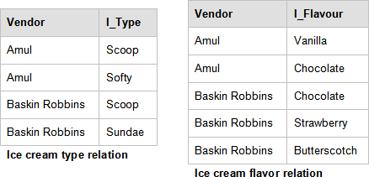

Figure 4.6 - Relations in 4NF

The relations in *Figure 4.6* are now decomposed into 4NF as there are no more than one mutually independent MVD in the decomposed relation.

### Other normal forms

There are three additional normal forms. They are ***fifth normal fo******rm*** [4.10], ***domain key normal form (DKNF)*** [4.11] and ***sixth normal form*** [4.12, 4.13]. These forms are advanced in nature and therefore are not discussed here. To learn more about them you can follow the provided references.

### A case study involving a Library Management System - Part 2 of 3

In this part of this case study, our focus is to develop a logical model based on the conceptual model. The logical model will validate the conceptual model using the technique of normalization, where relations are tested with a set of rules called normal forms. This is useful to remove redundancies which the conceptual model cannot detect.

The following table shows the correspondence between the conceptual model and the logical model:

|  |  |
| --- | --- |
| **Conceptual modeling concept** | **Logical modeling concept** |
| Name of entity set | Relation variable, R |
| Entity set | Relation |
| Entity | Tuple |

|  |  |
| --- | --- |
| Attribute | Attribute, A1, A2, etc. |
| Relationship set | A pair of primary key – foreign key |
| Unique identifier | Primary key |

In our example, transforming the conceptual model to the logical model would mean the schema would become as follows (the primary key is underlined):

**BORROWER = {**BORROWER_ID, FIRST_NAME, LAST_NAME, EMAIL, PHONE, ADDRESS, BOOK_ID, LOAN_DATE, RETURN_DATE}

**AUTHOR = {**AUTHOR_ID, FIRST_NAME, LAST_NAME, EMAIL, PHONE, ADDRESS)

**BOOK = {**BOOK_ID, TITLE, EDITION, YEAR, PRICE, ISBN, PAGES, AISLE, DECRIPTION}

**COPY = {**COPY_ID, STATUS}

**AUTHOR_LIST = {**ROLE}

To preserve relationship sets for data integrity and avoid data loss, you need to insert corresponding foreign keys. Therefore, the relations become as follows: (the foreign key is underlined with a dotted line):

###### **BORROWER = {**BORROWER_ID, COPY_ID, FIRST_NAME, LAST_NAME, EMAIL, PHONE, ADDRESS, LOAN_DATE, RETURN_DATE}

**AUTHOR = {**AUTHOR_ID, FIRST_NAME, LAST_NAME, EMAIL, PHONE, ADDRESS)

**BOOK = {**BOOK_ID, TITLE, EDITION, YEAR, PRICE, ISBN, PAGES, AISLE, DECRIPTION}

**COPY = {**COPY_ID, BORROWER_ID, BOOK_ID, STATUS}

**AUTHOR_LIST = {**AUTHOR_ID, BOOK_ID, ROLE}

Now, say because of business rules, a borrower can only borrow one book per day. So the BORROWER relation should have as primary key a composite key consisting of the following: {BORROWER_ID, COPY_ID, LOAN_DATE}.

Let's now test every relation against normal forms.

To validate a relation against the first normal form you have to ensure that there are no ‘repeating groups’ and that attributes are indivisible. In our example, not all attributes are indivisible such as the ADDRESS attribute in the BORROWER and AUTHORS relations. You can decompose it into {ADDRESS, CITY, COUNTRY}. At the same time, you find that there are repeating groups within BORROWER, because a borrower may loan many books over time, so you need to decompose the BORROWER relation into BORROWER and LOAN relations as follows:

**BORROWER = {**BORROWER_ID, FIRST_NAME, LAST_NAME, EMAIL, PHONE, ADDRESS}

**LOAN = {**BORROWER_ID, COPY_ID, LOAN_DATE, RETURN_DATE}

At the end of this process, you conclude that the relations are in the first normal form.

Now, let's test against the 2nd normal form. The rule of the 2nd normal form says that every attribute of a relation depends on the entire key not on part of it. In our example, every relation that has a primary key consisting of a single attribute is automatically in the 2nd normal form, so you need to test just relations that have a composite key. Consequently,

{LOAN_DATE, RETURN_DATE} depends on both BORROWER_ID and COPY_ID, and ROLE depends on AUTHOR_ID and BOOK_ID. Therefore all relations are in the 2nd normal form.

For the 3rd normal form you need to test if there is a non-key attribute that depends on other non-key attribute. In our example, there is no such a situation; therefore, there is no reason to continue further with decomposition. All relations are in the 3rd normal form.

Now you can take a second look at the conceptual model and make appropriate changes: Create the LOAN entity set, build relationship sets, watch for foreign keys, and arrange all entity sets. Having a useful tool like InfoSphere Data Architect (IDA) will help in this process. The figure below created with IDA show the final logical model:

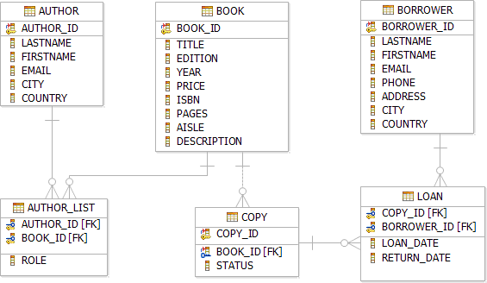

Figure 4.7 – The final logical model

Another approach to obtaining the final logical model is to start from the beginning with a logical model that includes all the relations and attributes you found in part 1 of this case study, during the conceptual model analysis. You then proceed to refine the model by specifying primary keys, and proceed to normalize the model. In the end, you should reach the same final logical model.

Part 3 of this case study continues in Chapter 5. In part 3 we explain how you can transform the logical model into a physical model.

### Summary

In this chapter we described how to model the real-world objects of a given business domain into appropriate tables within a relational database, what properties to associate with these objects as its columns and how to relate these tables so as to establish a relation between them that best models the real-world scenario.

Redundant storage of data in these relational tables leads to a number of problems like insert, update and delete anomalies and hence, we try to refine relational schemas with the underlying goal of having minimum redundancy.

We reviewed normal forms for relational tables and the process of normalization to have the most optimal relational database design. Each higher normal form is a refinement over the previous form, where decomposition of relations is the means to achieving higher normal forms. Functional dependencies between attributes of a table guide us on how best to decompose these tables.

Properties of function dependencies: Armstrong’s Axioms and Closure Set of attributes help us work most efficiently through the given set of functional dependencies to perform most economical checks. We try to decompose relations such that the desirable properties of decomposition --lossless join and dependency-preservation-- hold in the existing database design.

After understanding this chapter, you should be able to perform an end- to-end relational database design so that all the information in the real-world can be modeled within a database and it is optimized to have the most efficient storage without redundancy and yet facilitates easy retrieval of data.

### Exercises

* + 1. Compute the Closure set of attributes for each attribute of the given relation

**R(A,B,C,D,E)** for the given set of

FDs { **AB** →**C , A** → **DE , B** → **D, A** → **B , E**→**C** }

Also find the super key.

* + 1. Which normal form is the following relation in?

Order ( product_id, customer_id , price, quantity, order_type )

Where ( product_id , customer_id ) forms the candidate key and order_type is defined as ‘luxury’ if price > 1000$ and ‘regular’ if price <1000$.

Normalize it further to achieve 3NF.

* + 1. Calculate the minimal cover of the relation **R (A, B, C, D)** from the given set of FDs

**AB** → **C, B**→**C, A**→**CD**

* + 1. For the relation Library Book ( Book_id, bookname, author, subject ) synthesis a 3NF relation which is dependency-preserving and lossless.
    2. Compute the Closure set of Functional Dependencies F+ for the given relation

**R(A,B,C,D,E)** with the given set of

FDs { **AB** →**C ,A** → **DE ,B** → **D, A** → **B , E**→**C** }

### Review questions

* + 1. Show that the following decomposition is a lossless-join decomposition for a wedding organizer:

Order ( customer_id, bride, groom, budget ) Wedding Category ( budget, wedding_type )

* + 1. Given the following ***Cell phone*** relation:

|  |  |  |
| --- | --- | --- |
| **mobile** | **brand** | **head_office** |
| N93 | Nokia | New Delhi |
| Diamond | HTC | Hyderabad |
| N97 | Nokia | New Delhi |
| MotoSlim | Motorola | Mumbai |
| 3315 | Nokia | New Delhi |
| ZN50 | Motorola | Mumbai |

Cell phone relation

Which of the following update statement for the given relation will result in an update anomaly?

* + - 1. UPDATE cellphone set mobile = ‘6600’ where mobile = ‘N97’
      2. UPDATE cellphone set brand = ‘Samsung’ where mobile = ‘ZN50’
      3. UPDATE cellphone set head_office = ‘Bangalore’ where mobile = ‘N97’
      4. UPDATE cellphone set brand = ‘Samsung’ , mobile = ‘X210’ where mobile = ‘MotoSlim’
      5. None of the above
    1. Identify the normal form for the ***library - book relation*** given below: Library Book ( Book_id, bookname, author, subject )
       1. First Normal Form
       2. Second Normal Form
       3. Third Normal Form
       4. Boyce - Codd Normal Form
       5. Fourth Normal Form
    2. Which of the following cannot be determined from the properties of Functional dependencies?
       1. Closure set of functional dependencies, **F**+
       2. Decomposition is lossless
       3. **X** → **Y** belongs to **F**+
       4. Super key
       5. None of the above
    3. For a BCNF relation when multiple Multi-valued Dependencies (MVDs) exist, it is in 4NF only when:
       1. The MVDs are mutually independent.
       2. The MVDs are related to each other.
       3. Candidate key determines the MVDs.
       4. Candidate keys are overlapping.
       5. None of the above
    4. Which of the following sentences is incorrect?
       1. Lossless join decomposition must be achieved at all times.
       2. Functional Dependencies are a kind of integrity constraints.
       3. Dependency preserving implies lossless join and vice-versa.
       4. BCNF is not always achievable.
       5. None of the above

# 5

## Chapter 5 – Introduction to SQL

Structured Query Language (SQL) is a high-level language that allows users to manipulate relational data. One of the strengths of SQL is that users need only specify the information they need without having to know how to retrieve it. The database management system is responsible for developing the access path needed to retrieve the data. SQL works at a set level, meaning that it is designed to retrieve rows of one or more tables.

SQL has three categories based on the functionality involved:

* + - * DDL – Data definition language used to define, change, or drop database objects
      * DML – Data manipulation language used to read and modify data
      * DCL – Data control language used to grant and revoke authorizations

In this chapter, you will learn the history of SQL and how to work with this powerful language. We will focus on four basic SQL operations commonly used by most applications: Create, Read, Update, and Delete (CRUD).

### History of SQL

Don Chamberlin and Ray Boyce from IBM Corporation developed the SQL language in the 1970's as part of the System R project; a project established to provide a practical implementation to Codd's relational model.

Originally, the language was termed “Structured English Query Language” or SEQUEL, but it was later changed to SQL as SEQUEL was a registered trademark of a UK based company.

SQL today is accepted as the standard language for relational databases. SQL was adopted as a standard language in 1986 by the ***American National Standards Institute*** (***ANSI***) and by the ***International Standards Organization*** (***ISO***) in 1987. Since its standardization, SQL standards have been updated six times. The last update was in 2008 and is popularly referred as SQL:2008.

SQL is an English-like language with database specific constructs and keywords that are simple to use and understand. It supports multiple access mechanisms to address different usages and requirements. We will discuss these mechanisms one by one in the following sections.

### Defining a relational database schema in SQL

As discussed in previous chapters, a relational database schema is a formal description of all the database relations and all the relationships. You can build a physical implementation of this schema (also known as "physical data model") in SQL. Though most database vendors support ANSI and ISO SQL; there are slight differences in the SQL syntax for each vendor. Therefore, a physical data model is normally specific to a particular database product. In this book, we use [DB2 Express-C,](http://db2express.com/download?S_CMP=ECDDWW01&amp;S_TACT=DOCBOOK01) the free version of IBM DB2 database server.

Various elements and properties are part of a physical data model. We will discuss them in more detail below and their implementation using SQL.

##### Data Types

Like any programming language, databases also support a limited set of data types, which can be used to define the types of data a column can store. Basic data types include **integer**, **float**, **decimal**, **char, date, time, blob**, and so on.

You also have the option to create user-defined data types; however, these type definitions are also limited to a combination of the basic supported data types. User-defined types can be, for example **address**, **country, phone number**, **social security number**, **postal zip code**, to name a few.

* + - 1. Dates and Times

All databases support various date and time specific data types and functions. DB2 has the following data types for date and time.

* + - * + Date (YYYY-MM-DD)
        + Time (HH:MM:SS)
        + Timestamp (YYYY-MM-DD-HH:MM:SS:ssssss)

Where, ssssss, represents part of the timestamp in microseconds.

The following, is a partial set of functions specialized for date and time:

* + - * + Year
        + Month
        + Day
        + Dayname
        + Hour
        + Minute
        + Second
        + Microsecond

##### Creating a table

A table is a data set, organized and stored in rows and columns. A table holds data for like items, for example students, professors, subjects, books etc.

Entities in a data model generally map to tables when implemented in databases. Attributes of entities map to columns of the table.

Let’s start creating a simple table with the least amount of information required. For example:

**create table myTable (col1 integer)**

The statement above creates a table with the name ***myTable***, having one column with the name ***col1*** that can store data of type ***integer***. This table will accept any integer or NULL value as a valid value for ***col1.*** NULL values are described later in this section.

* + - 1. Default Values

When data is inserted into a table, you may want to automatically generate default values for a few columns. For example, when users to your Web site register to your site, if they leave the ***profession*** field empty, the corresponding column in the ***USERS*** table defaults to ***Student***. This can be achieved with the following statement:

CREATE TABLE USERS

(NAME CHAR(20),

AGE INTEGER,

PROFESSION VARCHAR(30) with default 'Student')

To define a column that will generate a department number as an incremented value of the last department number, we can use following statement:

CREATE TABLE DEPT

(DEPTNO SMALLINT NOT NULL

GENERATED ALWAYS AS IDENTITY (START WITH 500, INCREMENT BY 1),

DEPTNAME VARCHAR(36) NOT NULL, MGRNO CHAR(6),

ADMRDEPT SMALLINT NOT NULL, LOCATION CHAR(30))

The SQL statement above creates a table DEPT, where the column DEPTNO will have default values generated starting from 500 and incremented by one. When you insert rows into this table, do no provide a value for DEPTNO, and the database will automatically generate the value as described, incrementing the value for this column for each row inserted.

* + - 1. NULL values

A NULL represents an unknown state. For example, a table that stores the course marks of students can allow for NULL values. This could mean to the teacher that the student did not submit an assignment, or did not take an exam. It is different from a mark of zero, where a student did take the exam, but failed on all the questions. There are situations

when you don't want a NULL to be allowed. For example, if the country field is required for your application, ensure you prevent NULL values as follows:

**create table myTable (name varchar(30), country varchar(20) NOT NULL)**

The statement above indicates that NULL values are not allowed for the ***country*** column; however, duplicate values are accepted.

* + - 1. Constraints

Constraints allow you to define rules for the data in your table. There are different types of constraints:

* A UNIQUE constraint prevents duplicate values in a table. This is implemented using unique indexes and is specified in the CREATE TABLE statement using the keyword UNIQUE. A NULL is part of the UNIQUE data values domain.
* A PRIMARY KEY constraint is similar to a UNIQUE constraint, however it excludes NULL as valid data. Primary keys always have an index associated with it.
* A REFERENTIAL constraint is used to support referential integrity which allows you to manage relationships between tables. This is discussed in more detail in the next section.
* A CHECK constraint ensures the values you enter into a column are within the rules specified in the constraint.

The following example shows a table definition with several CHECK constraints and a PRIMARY KEY defined:

CREATE TABLE EMPLOYEE

(ID INTEGER NOT NULL PRIMARY KEY,

NAME VARCHAR(9),

DEPT SMALLINT CHECK (DEPT BETWEEN 10 AND 100),

JOB CHAR(5) CHECK (JOB IN ('Sales','Mgr','Clerk')), HIREDATE DATE,

SALARY DECIMAL(7,2),

**CONSTRAINT YEARSAL CHECK** ( YEAR(HIREDATE) > 1986

OR SALARY > 40500 )

)

For this table, four constrains should be satisfied before any data can be inserted into the table. These constraints are:

* PRIMARY KEY constraint on the column ID

This means that no duplicate values or nulls can be inserted.

* CHECK constraint on DEPT column

Only allows inserting data if the values are between 10 and 100.

* CHECK constraint on JOB column

Only allows inserting data if the values are ‘Sales’, ‘Mgr’ or ‘Clerk'.

* CHECK constraint on the combination of the HIREDATE and SALARY columns

Only allows to insert data if the hire date year is greater than 1986 and the SALARY is greater than 40500.

* + - 1. Referential integrity

As discussed in Chapter 2, referential integrity establishes relationships between tables. Using a combination of primary keys and foreign keys, it can enforce the validity of your data. Referential integrity reduces application code complexity by eliminating the need to place data level referential validation at the application level.

A table whose column values depend on the values of other tables is called ***dependant, or child table***; and a table that is being referenced is called the ***base*** or ***parent*** table. Only tables that have columns defined as UNIQUE or PRIMARY KEY can be referenced in other tables as foreign keys for referential integrity.

Referential integrity can be defined during table definition or after the table has been created as shown in the example below where three different syntaxes are illustrated:

Syntax 1:

CREATE TABLE DEPENDANT_TABLE

(ID INTEGER REFERENCES BASE_TABLE(UNIQUE_OR_PRIMARY_KEY), NAME VARCHAR(9),

:

:

:

**);**

Syntax 2:

CREATE TABLE DEPENDANT_TABLE (ID INTEGER,

NAME VARCHAR(9),

:

:

:,

CONSTRAINT constraint_name FOREIGN KEY (ID) REFERENCES BASE_TABLE(UNIQUE_OR_PRIMARY_KEY)

**);**

Syntax 3:

CREATE TABLE DEPENDANT_TABLE (ID INTEGER,

NAME VARCHAR(9),

:

:

:

**);**

ALTER TABLE DEPENDANT_TABLE

ADD CONSTRAINT constraint_name FOREIGN KEY (ID) REFERENCES BASE_TABLE(UNIQUE_OR_PRIMARY_KEY);

In the above sample code, when the constraint name is not specified, the DB2 system will generate the name automatically. This generated string is 15 characters long, for example ‘CC1288717696656’.

What happens when an application needs to delete a row from the base table but there are still references from dependant tables? As discussed in *Chapter 2*, there are different rules to handle deletes and updates and the behavior depends on the following constructs used when defining the tables:

* CASCADE

As the name suggests, with the cascade option the operation is cascaded to all rows in the dependant tables that are referencing the row or value to be modified or deleted in the base table.

* SET NULL

With this option all the referring cells in dependant tables are set to NULL

* NO ACTION

With this option no action is performed as long as referential integrity is maintained before and after the statement execution.

* RESTRICT

With this option, the update or delete of rows having references to dependant tables are not allowed to continue.

The statement below shows where the delete and update rules are specified:

ALTER TABLE DEPENDANT_TABLE

ADD CONSTRAINT constraint_name FOREIGN KEY column_name

ON DELETE *<delete_action_type>*

ON UPDATE *<update_action_type>*

;

A delete action type can be a CASCADE, SET NULL, NO ACTION, or RESTRICT. An update action type can be a NO ACTION, or RESTRICT.

##### Creating a schema

Just in the same way we store and manage data files on a computer in directories or folders and keep related or similar files together; a schema in DB2 is a database object that allows you to group related database objects together. In DB2, every object has two parts, a schema name, and the name of the object.

To create a schema, use this statement:

**create schema mySchema**

To create a table with the above schema, explicitly include it in the CREATE TABLE statement as follows:

**create table mySchema.myTable (col1 integer)**

When the schema is not specified, DB2 uses an implicit schema, which is typically the user ID used to connect to the database. You can also change the implicit schema for your current session with the SET CURRENT SCHEMA command as follows:

**set current schema mySchema**

##### Creating a view

A view is a virtual table derived from one or more tables or other views. It is virtual because it does not contain any data, but a definition of a table based on the result of a SELECT statement. For example, to create a view based on the EMPLOYEE table you can do:

**CREATE VIEW MYVIEW AS**

**SELECT LASTNAME, HIREDATE FROM EMPLOYEE**

Once the view is created, you can use it just like any table. For example, you can issue a simple SELECT statement as follows:

**SELECT * FROM MYVIEW**

Views allow you to hide data or limit access to a select number of columns; therefore, they can also be used for security purposes.

##### Creating other database objects

Just as there is a CREATE TABLE statement in SQL for tables, there are many other CREATE statements for each of the different database objects such as indexes, functions, procedures, triggers, and so on. For more information about these statements, refer to the [DB2 9.7 Information Center.](http://publib.boulder.ibm.com/infocenter/db2luw/v9r7/index.jsp)

##### Modifying database objects

Once a database object is created, it may be necessary to change its properties to suit changing business requirements. Dropping and recreating the object is one way to achieve this modification; however, dropping the object has severe side effects.

A better way to modify database objects is to use the ALTER SQL statement. For example, assuming you would like to change a table definition so that NULLs are not allowed for a given column, you can try this SQL statement:

**alter table myTable alter column col1 set not null**

Similarly, other modifications to the table like adding or dropping a column, defining or dropping a **primary key**, and so on, can be achieved using the appropriate **alter table** syntax. The ALTER statement can also be used with other database objects.

##### Renaming database objects

Once database objects are created, they can be renamed using the SQL statement, RENAME. To rename any database object use the following SQL syntax:

**RENAME <object type> <object name> to <new name>**

Where the object type can be for example, a table, table space, or index. Not all database objects can be renamed after they are created.

To rename a column, the ALTER TABLE SQL statement should be used in conjunction with RENAME. For example:

**ALTER TABLE <table name> RENAME COLUMN <column name> TO <new name>**

### Data manipulation with SQL

This section discusses how to perform read, update and delete operations with SQL.

##### Selecting data

Selecting data in SQL is an operation that allows you to read (retrieve) rows and columns from a relational table. Selecting data is performed using the SELECT statement.

Assuming a table name of **myTable**, the simplest statement to select data from this table is:

**select * from myTable**

The special character **‘*’**, represents all the columns from the table. Using the **‘*’** in a query is not recommended unless specifically required because you may be asking more information than what you really need. Typically, not all columns of a table are required; in which case, a selective list of columns should be specified. For example,

**select col1, col2 from myTable**

retrieves **col1** and **col2** for all rows of the table **myTable** where **col1** and **col2** are the names of the columns to retrieve data from.

* + - 1. Ordering the result set

A SELECT statement returns its result set in no particular order. Issuing the same SELECT statement several times may return the same set of rows, but in different order. To guarantee the result set is displayed in the same order all the time, either in ascending or descending order of a column or set of columns, use the ORDER BY clause.

For example this statement returns the result set based on the order of col1 in ascending order:

SELECT col1 FROM myTable ORDER BY col1 ASC

**ASC** stands for ascending, which is the default. Descending order can be specified using

**DESC** as shown below:

SELECT col1 FROM myTable ORDER BY col1 DESC

* + - 1. Cursors

A cursor is a result set holding the result of a SELECT statement. The syntax to declare, open, fetch, and close a cursor is shown below:

**DECLARE <cursor name> CURSOR [WITH RETURN <return target>]**

**<SELECT statement>; OPEN <cursor name>;**

**FETCH <cursor name> INTO <variables>; CLOSE <cursor name>;**

Rather than returning all the rows of an SQL statement to an application at once, a cursor allows the application to process rows one at a time. Using FETCH statements within a loop in the application, developers can navigate through each row pointed by the cursor and apply some logic to the row or based on the row contents. For example, the following code snippet sums all the salaries of employees using a cursor.

**...**

**DECLARE p_sum INTEGER; DECLARE p_sal INTEGER; DECLARE c CURSOR FOR**

**SELECT SALARY FROM EMPLOYEE; DECLARE SQLSTATE CHAR(5) DEFAULT '00000';**

**SET p_sum = 0; OPEN c;**

**FETCH FROM c INTO p_sal; WHILE(SQLSTATE = '00000') DO**

**SET p_sum = p_sum + p_sal; FETCH FROM c INTO p_sal;**

**END WHILE;**

**CLOSE c;**

**...**

Cursors are the most widely used method for fetching multiple rows from a table and processing them inside applications.

##### Inserting data

To insert data into a table use the INSERT statement. There are different ways to insert data. For instance, you can insert one row per INSERT statement, multiple rows per INSERT statement or all the rows of a result set from another query as illustrated in the following examples.

In this first example, the statements insert one row at a time into the table myTable.

**insert into myTable values (1);**

**insert into myTable values (1, ‘myName’, ‘2010-01-01’);**

In this second example, the statements insert multiple (three) rows into the table **myTable**.

**insert into myTable values (1),(2),(3);**

**insert into myTable values (1, ‘myName1’,’2010-01-01’),**

**(2, ‘myName2’,’2010-02-01’),**

**(3, ‘myName3’,’2010-03-01’);**

Finally, in this third example, the statement inserts all the rows of the sub-query **“select**

**\* from myTable2”** into the table **myTable**.

**insert into myTable (select * from myTable2)**

##### Deleting data

The DELETE statement is used to delete rows of a table. One or multiple rows from a table can be deleted with a single statement by specifying a delete condition using the WHERE clause. For example, this statement deletes all the rows where **col1 > 1000** in table **myTable.**

**DELETE FROM myTable WHERE col1 > 1000**

Note that care should be taken when issuing a delete statement. If the **WHERE** clause is not used, the DELETE statement will delete all rows from the table.

##### Updating data

Use the UPDATE statement to update data in your table. One or multiple rows from a table can be updated with a single statement by specifying the update condition using a WHERE clause. For each row selected for update, the statement can update one or more columns.

For example:

**UPDATE myTable SET col1 = -1 WHERE col2 < 0 UPDATE myTable SET col1 = -1,**

**col2 = ‘a’,**

**col3 = ‘2010-01-01’ WHERE col4 = ‘0’**

Note that care should be taken when issuing an update statement without the **WHERE**

clause. In such cases, all the rows in the table will be updated.

### 5.4 Table joins

A simple SQL select statement is one that selects one or more columns from any single table. The next level of complexity is added when a select statement has two or more tables as source tables. This leads to multiple possibilities of how the result set will be generated.

There are two types of table joins in SQL statements:

1. Inner join
2. Outer join

These are explained in more detail in the following sections.

##### Inner joins

An ***inner join*** is the most common form of join used in SQL statements. It can be classified into:

* + - * Equi-join
      * Natural join
      * Cross join
      1. Equi-join

This type of join happens when two tables are joined based on the equality of specified columns; for example:

**SELECT \***

**FROM student, enrollment**

**WHERE student.enrollment_no=enrollment.enrollment_no**

**OR**

**SELECT \***

**FROM student**

**INNER JOIN enrollment**

**ON student.enrollment_no=enrollment.enrollment_no**

* + - 1. Natural join

A ***natural join*** is an improved version of an equi-join where the joining column does not require specification. The system automatically selects the column with same name in the tables and applies the equality operation on it. A natural join will remove all duplicate attributes. Below is an example.

**SELECT \***

**FROM STUDENT**

**NATURAL JOIN ENROLLMENT**

Natural joins bring more doubt and ambiguity than the ease it provides. For example, there can be problems when tables to be joined have more than one column with the same name, or when the tables do not have same name for the joining column. Most commercial databases do not support natural joins.

* + - 1. Cross join

A cross join is simply a Cartesian product of the tables to be joined. For example:

**SELECT \***

**FROM STUDENT, ENROLLMENT**

##### Outer joins

An ***outer join*** is a specialized form of join used in SQL statements. In an outer joins, the first table specified in an SQL statement in the FROM clause is referred as the LEFT table and the remaining table is referred as the RIGHT table. An outer join is of the following three types:

* + - * Left outer join
      * Right outer join
      * Full outer join

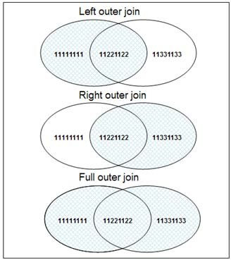*Figure 5.1* shows a diagram depicting the three outer join types.

Figure 5.1 - The different outer join types

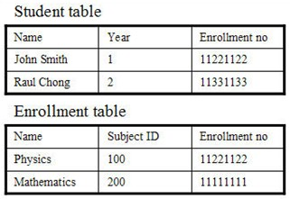In the next sections, we describe each of these types in more detail. For a better understanding of each case, examples are provided using the tables shown in *Figure 5.2*.

Figure 5.2 - Input tables to use in outer-join examples

* + - 1. **Left outer join**

In a left outer join, the result set is a union of the results of an equi-join, including any non- matching rows from the LEFT table. For example, the following statement would return the rows shown in *Figure 5.3*.

**SELECT \***

**FROM STUDENT**

**LEFT OUTER JOIN ENROLLMENT**

**ON STUDENT.ENROLLMENT_NO = ENROLLMENT_NO**

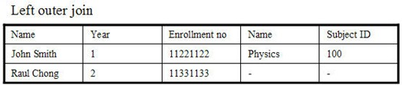

Figure 5.3 - Output of a left outer join

* + - 1. **Right outer join**

In a right outer join, the result set is the union of results of an equi-join, including any non- matching rows from the RIGHT table. For example, the following statement would return the rows shown in *Figure 5.4.*

**SELECT \***

**FROM STUDENT**

**RIGHT OUTER JOIN ENROLLMENT**

**ON STUDENT.ENROLLMENT_NO = ENROLLMENT_NO**

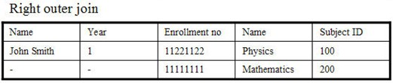

Figure 5.4 - Output of a right outer join

* + - 1. **Full outer join**

In a full outer join, the result set is the union of results of an equi- join, including any non- matching rows of the LEFT and the RIGHT table. For example, the following statement would return the rows shown in *Figure 5.5.*

**SELECT \***

**FROM STUDENT**

**FULL OUTER JOIN ENROLLMENT**

**ON STUDENT.ENROLLMENT_NO = ENROLLMENT_NO**

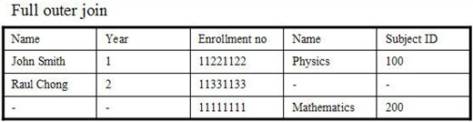

Figure 5.5 - Output of a full outer join

Different outer joins return different data sets; therefore, these should be used explicitly as per the business requirements. For example, if we need a list of students who have enrolled in any subject as well as those who have not yet enrolled, then probably what we need is a left outer join.

### Union, intersection, and difference operations

The set theory operators, union, intersection, and complement are supported in SQL statements as long as basic requirements for the operator are satisfied.

##### Union

The **Union** operator can be used to join two data sets having the same column definitions and in the same order. The union operator removes any duplicate rows from the resulting data set. For example, the following statement returns the rows shown in *Figure 5.6.*

**SELECT * FROM student_table_a UNION**

**SELECT * FROM student_table_b**

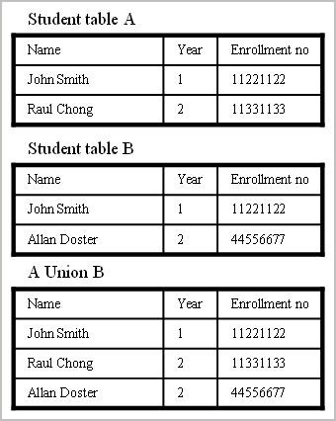

Figure 5.6 - Example of a Union operator

In *Figure 5.6*, note that the union operator removed duplicate rows. There may be situations where duplicate removal is not required. In such a case, **UNION ALL** should be used instead of UNION, as follows:

**SELECT * from student_table_a UNION ALL**

**SELECT * from student_table_b**

*Figure 5.7* shows the sample output of a UNION ALL operator.

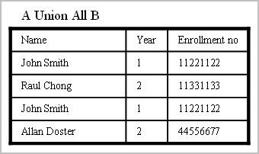

Figure 5.7 - Example of a UNION ALL operator

##### Intersection

The intersection operator **INTERSECT** returns a result set common to both data sets as shown in the following statement:

**select * from student_table_a INTERSECT**

**select * from student_table_b**

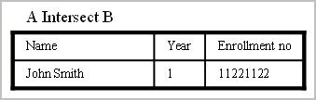*Figure 5.8* shows the sample output for the above statement.

Figure 5.8 - Sample output for the INTERSECT operator

The intersect operator will return all common data sets that exist in both tables A and B, however common data sets are listed only once, even if there are multiple duplicate rows in either table A or B. In order to return all data sets with duplicates in the result set, use the INTERSECT ALL operator. For example:

**select * from student_table_a INTERSECT ALL**

**select * from student_table_b**

##### Difference (Except)

The difference operator (EXCEPT) returns the result set that exists only in the LEFT table. Logically speaking,

A EXCEPT B = A MINUS [A INTERSECT B]

For example:

**select * from student_table_a EXCEPT**

**select * from student_table_b**

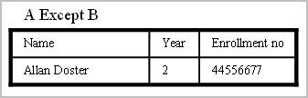would return the output shown in *Figure 5.9.*

Figure 5.9 - Sample output for the EXCEPT operator

The **EXCEPT** operator will return a data set that exists in table A, but not in table B; however, common data sets are listed only once, even if there are multiple duplicate rows in table A. In order to return all data sets with duplicates in a result set, use the EXCEPT ALL operator. For example:

**select * from student_table_a EXCEPT ALL**

**select * from student_table_b**

### Relational operators

Relational operators are basic tests and operations that can be performed on data. These operators include:

* + - Basic mathematical operations like ‘+’, ‘-‘, ‘*’ and ‘/’
    - Logical operators like ‘AND’, ‘OR’ and ‘NOT’
    - String manipulation operators like ‘CONCATENATE’, ‘LENGTH’, ‘SUBSTRING’
    - Comparative operators like ‘=’, ‘<’, ‘>’, ‘>=’, ‘<=’ and ‘!=’
    - Grouping and aggregate operators
    - Other miscellaneous operations like DISTINCT

We will skip the discussion of basic mathematical, comparative and logical operators and jump directly into the discussion of the other operators.

##### Grouping operators

Grouping operators perform operations on two or more rows of data, and provide a summarized output result set. For example, let’s say we have a table with a list of all

students and the courses that they are enrolled in. Each student can enroll in multiple courses and each course has multiple students enrolled in the course. To get a count of all students we can simply execute the following SQL statement:

**select count(*) from students_enrollment**

However, if we need a count of students that are enrolled for each course offered, then we need to order the table data by offered courses and then count the corresponding list of students. This can be achieved by using the GROUP BY operator as follows:

**select course_enrolled, count(*)**

**from students_enrollment group by course_enrolled**

**---------------Resultset---------------- COURSE_ENROLLED STUDENT_COUNT**

**------------------------- -------------**

**English 10**

**Mathematics 30**

**Physics 60**

Grouping can also be performed over multiple columns together. In that case, the order of grouping is done from the leftmost column specified to the right.

##### Aggregation operators

Operators, which perform on two or more tuples or rows, and return a scalar result set, are called aggregate operators. Examples include: COUNT, SUM, AVERAGE, MINIMUM, MAXIMUM, and so on. These operators are used together with the GROUP BY clause as shown in the SQL statements above.

##### HAVING Clause

HAVING is a special operator, which can be used only with a GROUP BY clause to filter the desired rows in grouped data. Refer to the example cited in the grouping operators section; if it is required to list only those offered courses which have less than 5 enrollments, then we can use the HAVING clause to enforce this requirement as shown below:

**SELECT course_enrolled, count(*)**

**FROM students_enrollment GROUP BY course_enrolled HAVING count(*) < 5**

To filter out scalar data sets, a WHERE clause can be used; however, it cannot be used for the grouped data set.

### Sub-queries

When a query is applied within a query, the outer query is referred to as the main query or parent query and the internal query is referred as the sub-query or inner query. This sub query may return a scalar value, single or multiple tuples, or a NULL data set. Sub-queries are executed first, and then the parent query is executed utilizing data returned by the sub- queries.

##### Sub-queries returning a scalar value

Scalar values represent a single value of any attribute or entity, for example Name, Age, Course, Year, and so on. The following query uses a sub-query that returns a scalar value, which is then used in the parent query to return the required result:

**SELECT name FROM students_enrollment**

**WHERE age = ( SELECT min(age) FROM students )**

The above query returns a list of students who are the youngest among all students. The sub-query “SELECT min(age) FROM students” returns a scalar value that indicates the minimum age among all students. The parent query returns a list of all students whose age is equal to the value returned by the sub-query.

##### Sub-queries returning vector values

When a sub-query returns a data set that represents multiple values for a column (like a list of names) or array of values for multiple columns (like Name, age and date of birth for all students), then the sub-query is said to be returning vector values. For example, to get a list of students who are enrolled in courses offered by the computer science department, we will use the following nested query:

**SELECT name FROM students WHERE course_enrolled IN (**

**SELECT distinct course_name FROM courses**

**WHERE department_name = ‘Computer Science’**

**)**

Here the sub-query returns a list of all courses that are offered in the “Computer Science” department and the outer query lists all students enrolled in the courses of the sub-query result set.

Note that there may be multiple ways to retrieve the same result set. The examples provided in this chapter demonstrate various methods of usage, not the most optimal SQL statement.

##### Correlated sub-query

When a sub-query is executed for each row of the parent table, instead of once (as shown in the examples above) then the sub-query is referred to as a correlated sub-query. For example:

**SELECT dept, name, marks**

**FROM final_result a WHERE marks = (**

**SELECT max(marks) FROM final_result WHERE dept = a.dept**

**)**

The above statement searches for a list of students with their departments, who have been awarded maximum marks in each department. For each row on the LEFT table, the sub- query finds max(marks) for the department of the current row and if the values of marks in the current row is equal to the sub-query result set, then it is added to the outer query result set.

##### Sub-query in FROM Clauses

A sub-query can be used in a FROM clause as well, as shown in following example:

**SELECT dept, max_marks, min_marks, avg_marks FROM**

**(**

**SELECT dept,**

**max(marks) as max_marks, min(marks) as min_marks, avg(marks) as avg_marks**

**FROM final_result GROUP BY dept**

**)**

**WHERE (max_marks – min_marks) > 50 and avg_marks < 50**

The above query uses a sub-query in the FROM clause. The sub-query returns maximum, minimum and average marks for each department. The outer query uses this data and filters the data further by adding filter conditions in the WHERE clause of the outer query.

### 5.8 Mapping of object-oriented concepts to relational concepts

Many developers today use object-oriented programming languages; however, they need to access relational databases. The following table maps some object-oriented concepts to their corresponding relational database concept. This list is not exhaustive.

|  |  |
| --- | --- |
| **Object-oriented concept - Class elements** | **Relational database concept** |
| Name | Table name |
| Attribute | Column name |
| Method | Stored procedure |
| Constructor/Destructor | Triggers |
| Object identifier | Primary Key |

Table 5.1 Mapping object-oriented concepts to relational database concepts

Object-relational mapping (ORM) libraries such as Hibernate are popular to provide a framework for this mapping between the object-oriented world and the relational world. pureQuery, a new technology from IBM provides further support and performance improvements in this area. For more information about pureQuery refer to the free eBook *Getting started with pureQuery* which is part of this book series.

### A case study involving a Library Management System - Part 3 of 3

This final part of this case study shows you how to transform the logical model into a physical model where we will create objects in a DB2 database. The table below shows the correspondence between conceptual, logical and physical model concepts:

|  |  |  |
| --- | --- | --- |
| **Conceptual modeling concept** | **Logical modeling concept** | **Physical modeling concept** |
| Name of entity set | Relation variable, R | Table name |
| Entity set | Relation | Table |
| Entity | Tuple | Row |
| Attribute | Attribute, A1, A2, etc. | Column |
| Relationship set | A pair of primary key – foreign key | Constraint |
| Unique identifier | Primary key | Primary key |

The transformation from the logical model to the physical model is straightforward. From the logical model you have all the relations and associations you need to create the Library Management System database. All you have to do now is specify the sub domain (data type) for every attribute domain you encounter within every table, and the corresponding constraint. Every constraint name has its own prefix. We suggest the following prefixes for constraint names:

* + - PRIMARY KEY: pk_
    - UNIQUE: uq_
    - DEFAULT: df_
    - CHECK: ck_
    - FOREIGN KEY: fk_

Let's take a look at each relation again adding the sub domain and constraint:

BORROWER relation

|  |  |  |  |  |
| --- | --- | --- | --- | --- |
| **Attribute name** | **Domain** | **Sub-domain** | **Optional** | **Constraints** |
| BORROWER_ID | Text | CHAR(5) | No | Pk_ |
| FIRST_NAME | Text | VARCHAR(30) | No |  |
| LAST_NAME | Text | VARCHAR(30) | No |  |
| EMAIL | Text | VARCHAR(40) | Yes |  |
| PHONE | Text | VARCHAR(15) | Yes |  |
| ADDRESS | Text | VARCHAR(75) | Yes |  |
| CITY | Text | CHAR(3) | No |  |
| COUNTRY | Text | DATE | No |  |

**AUTHOR relation**

|  |  |  |  |  |
| --- | --- | --- | --- | --- |
| **Attribute name** | **Domain** | **Sub-domain** | **Optional** | **Constraints** |
| AUTHOR_ID | Text | CHAR(5) | No | Pk_ |
| FIRST_NAME | Text | VARCHAR(30) | No |  |
| LAST_NAME | Text | VARCHAR(30) | No |  |
| EMAIL | Text | VARCHAR(40) | Yes |  |
| PHONE | Text | VARCHAR(15) | Yes |  |
| ADDRESS | Text | VARCHAR(75) | Yes |  |
| CITY | Text | VARCHAR(40) | Yes |  |
| COUNTRY | Text | VARCHAR(40) | Yes |  |

**BOOK relation**

|  |  |  |  |  |
| --- | --- | --- | --- | --- |
| **Attribute name** | **Domain** | **Sub-domain** | **Optional** | **Constraints** |
| BOOK_ID | Text | CHAR(5) | No | Pk_ |

|  |  |  |  |  |
| --- | --- | --- | --- | --- |
| TITLE | Text | VARCHAR(40) | No |  |
| EDITION | Numeric | INTEGER | Yes |  |
| YEAR | Numeric | INTEGER | Yes |  |
| PRICE | Numeric | DECIMAL(7,2) | Yes |  |
| ISBN | Text | VARCHAR(20) | Yes |  |
| PAGES | Numeric | INTEGER | Yes |  |
| AISLE | Text | VARCHAR(10) | Yes |  |
| DECRIPTION | Text | VARCHAR(100) | Yes |  |

**LOAN relation**

|  |  |  |  |  |
| --- | --- | --- | --- | --- |
| **Attribute name** | **Domain** | **Sub-domain** | **Optional** | **Constraints** |
| BORROWER_ID | Text | CHAR(5) | No | Pk_, fk_ |
| COPY_ID | Text | VARCHAR(30) | No | Pk_, fk_ |
| LOAN_DATE | Text | DATE | No | < RETURN_DATE |
| RETURN_DATE | Text | DATE | No |  |

**COPY relation**

|  |  |  |  |  |
| --- | --- | --- | --- | --- |
| **Attribute name** | **Domain** | **Sub-domain** | **Optional** | **Constraints** |
| COPY_ID | Text | CHAR(5) | No | Pk_ |
| BOOK_ID | Text | VARCHAR(30) | No | Fk_ |
| STATUS | Text | VARCHAR(30) | No |  |

**AUTHOR_LIST relation**

|  |  |  |  |  |
| --- | --- | --- | --- | --- |
| **Attribute name** | **Domain** | **Sub-domain** | **Optional** | **Constraints** |
| AUTHOR_ID | Text | CHAR(5) | No | Pk_, fk_ |

|  |  |  |  |  |
| --- | --- | --- | --- | --- |
| BOOK_ID | Text | VARCHAR(30) | No | Pk_, fk_ |
| ROLE | Text | VARCHAR(30) | No |  |

Now you can create tables using the following syntax:

**CREATE TABLE AUTHOR**

**(**

**AUTHOR_ID CHAR(5) CONSTRAINT AUTHOR_PK PRIMARY KEY(AUTHOR_ID) NOT NULL,**

**LASTNAME VARCHAR(15) NOT NULL, FIRSTNAME VARCHAR(15) NOT NULL, EMAIL VARCHAR(40),**

**CITY VARCHAR(15), COUNTRY CHAR(2)**

**)**

**CREATE TABLE AUTHOR_LIST (**

**AUTHOR_ID CHAR(5) NOT NULL CONSTRAINT AUTHOR_LIST_AUTHOR_FK FOREIGN KEY(AUTHOR_ID) REFERENCES AUTHOR (AUTHOR_ID),**

**BOOK_ID CHAR(5) NOT NULL,**

**ROLE VARCHAR(15) CONSTRAINT AUTHOR_LIST_PK PRIMARY KEY (AUTHOR_ID,BOOK_ID) NOT NULL**

**)**

**CREATE TABLE BOOK**

**(**

**BOOK_ID CHAR(3) CONSTRAINT BOOK_PK PRIMARY KEY(BOOK_ID)**

**CONSTRAINT AUTHOR_LIST_BOOK_FK FOREIGN KEY(BOOK_ID) REFERENCES BOOK (BOOK_ID) NOT NULL,**

**TITLE VARCHAR(40) NOT NULL, EDITION INTEGER,**

**YEAR INTEGER,**

**PRICE DECIMAL(7 , 2), ISBN VARCHAR(20), PAGES INTEGER,**

**AISLE VARCHAR(10), DESCRIPTION VARCHAR(100)**

**)**

**CREATE TABLE COPY**

**(**

**COPY_ID CHAR(5) CONSTRAINT COPY_PK PRIMARY KEY(COPY_ID) NOT NULL,**

**BOOK_ID CHAR(5) CONSTRAINT COPY_BOOK_FK FOREIGN KEY(BOOK_ID) REFERENCES BOOK(BOOK_ID) NOT NULL,**

**STATUS VARCHAR(10)**

**)**

**CREATE TABLE LOAN**

**(**

**COPY_ID CHAR(5) CONSTRAINT LOAN_COPY_FK FOREIGN KEY(COPY_ID) REFERENCES COPY(COPY_ID) NOT NULL,**

**BORROWER_ID CHAR(5) CONSTRAINT LOAN_BORROWER_FK FOREIGN KEY (BORROWER_ID)REFERENCES BORROWER (BORROWER_ID) NOT NULL, LOAN_DATE DATE NOT NULL,**

**LOAN_DAYS INTEGER NOT NULL,**

**RETURN_DATE DATE CONSTRAINT LOAN_PK PRIMARY KEY(COPY_ID, BORROWER_ID)**

**)**

**CREATE TABLE BORROWER**

**(**

**BORROWER_ID CHAR(5) NOT NULL CONSTRAINT BORROWER_PK PRIMARY KEY (BORROWER_ID),**

**LASTNAME VARCHAR(15) NOT NULL, FIRSTNAME VARCHAR(15) NOT NULL, EMAIL VARCHAR(40),**

**PHONE VARCHAR(15), ADDRESS VARCHAR(60), CITY VARCHAR(15), COUNTRY CHAR(2)**

**)**

InfoSphere Data Architect can automatically transform the logical model into a physical model, and also generate the DDL for you.

### Summary

In this chapter we provided a high-level overview of SQL and some of its features. In addition to the ISO/ANSI SQL standard requirements, various vendors implement additional features and functionalities. These features leverage internal product design and architecture and therefore provide enhanced performance in comparison to standard SQL functions. One example of such a feature is the indexing mechanism in databases. Basic index behavior is the same in all databases, however all vendors provide additional features on top of the default ones to enhance data read/write via their proprietary algorithms. For detailed information and an exhaustive list of SQL commands, keywords and statement syntax, please refer to the SQL Reference Guide [5.3].

### Exercises

* + 1. Create a table with columns of type integer, date, and char having default values.
    2. Insert 10 rows in this table using one INSERT SQL statement.
    3. Write an SQL statement with a sub-query with INNER JOIN.
    4. Write an SQL statement with correlated sub-query with GROUP BY clause.
    5. Write an SQL statement with aggregate functions and WHERE, HAVING clauses.
    6. Write an SQL statement with ORDER BY on multiple columns.

### Review questions

* + 1. What are the basic categories of the SQL language based on functionality?
       1. Data definition
       2. Data modification
       3. Data control
       4. All the above
       5. None of the above
    2. Who invented the SQL language?
       1. Raymond F. Boyce
       2. E F Codd
       3. Donald D. Chamberlin
       4. A and C
       5. None of the above
    3. SQL has been adopted as standard language by?
       1. American National Standards Institute
       2. Bureau of International Standards
       3. International Standards Organizations
       4. All of the above
       5. None of the above
    4. Which of the following are valid mappings from the object-oriented world to the relational world?
       1. Name - Table name
       2. Attribute - Column name
       3. Method - Stored procedure
       4. All the above
       5. None of the above
    5. Which of the following functions are specialized for date and time manipulations?
       1. Year
       2. Dayname
       3. Second
       4. All the above
       5. None of the above
    6. What is the default sorting mode in SQL?
       1. Ascending
       2. Descending
       3. Randomly selected order
       4. None of the above
       5. All of the above
    7. An INSERT statement can not be used to insert multiple rows in single statement?
       1. True
       2. False
    8. Which of the following are valid types of inner join?
       1. Equi-join
       2. Natural join
       3. Cross join
       4. All the above
       5. None of the above
    9. Which of the following are valid types of outer join?
       1. Left outer join
       2. Right outer join
       3. Full outer join
       4. All the above
       5. None of the above
    10. The Union operator keeps duplicate values in the result set.
        1. True

Database Fundamentals 142

* + - 1. False

# 6

## Chapter 6 – Stored procedures and functions

Stored procedures and functions are database application objects that can encapsulate SQL statements and business logic. Keeping part of the application logic in the database provides performance improvements as the amount of network traffic between the application and the database is considerably reduced. In addition, they provide a centralized location to store the code, so other applications can reuse them.

In this chapter you will learn about:

* How to use IBM Data Studio to develop functions and stored procedures
* How to work with SQL functions
* How to work with stored procedures

### Working with IBM Data Studio

IBM Data Studio is used in this chapter to develop user-defined functions (UDFs) and stored procedures. IBM Data Studio is an Eclipse-based software development and administration tool that is free. It is not included with DB2, but provided as a separate image; and it comes in two flavors:

* + - IDE: Allows you to share the same Eclipse (shell sharing) with other products such as InfoSphere Data Architect and Rational products. It also provides support for Data Web services.
    - Stand-alone: This version provides almost the same functionality as the IDE version but without support for Data Web services and without shell sharing. The footprint for this version is a lot smaller.

**Note:**

For a thorough coverage about IBM Data Studio, refer to the free eBook [*Getting started*](http://www.ibm.com/db2/books)[*with IBM Data Studio for DB2*](http://www.ibm.com/db2/books) which is part of this DB2 on Campus free book series.

In this chapter we use the stand-alone version which can be downloaded from [ibm.com/db2/express.](http://www.ibm.com/db2/express/download.html?S_CMP=ECDDWW01&amp;S_TACT=DOCBOOK01) *Figure 6.1* shows IBM Data Studio 2.2.

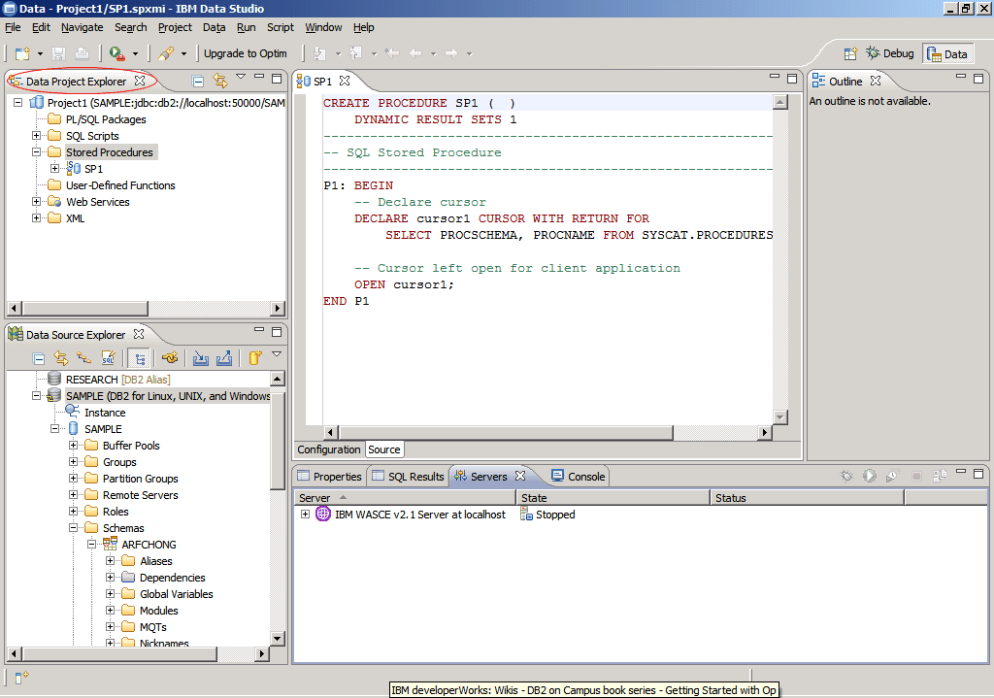

Figure 6.1 – IBM Data Studio 2.2

In this chapter we focus on the *Data Project Explorer* view highlighted at the top left corner of the figure. This view focuses on data server-side development.

##### 6.1.1 Creating a project

Before you can develop stored procedures, or UDFs in Data Studio, you need to create a project. From the Data Studio menu, choose *File -> New -> Project* and choose *Data Development Project*. This is shown in *Figure 6.2*.

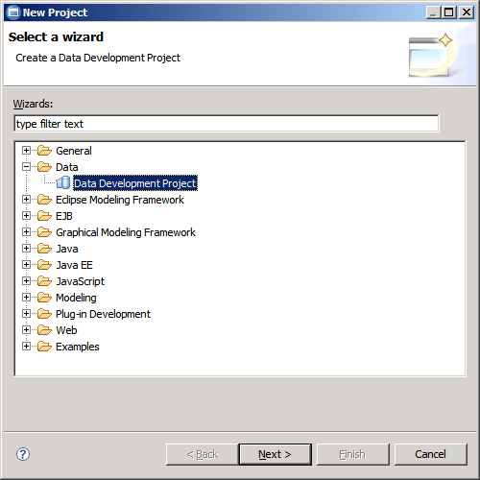

Figure 6.2 – Creating a data development project

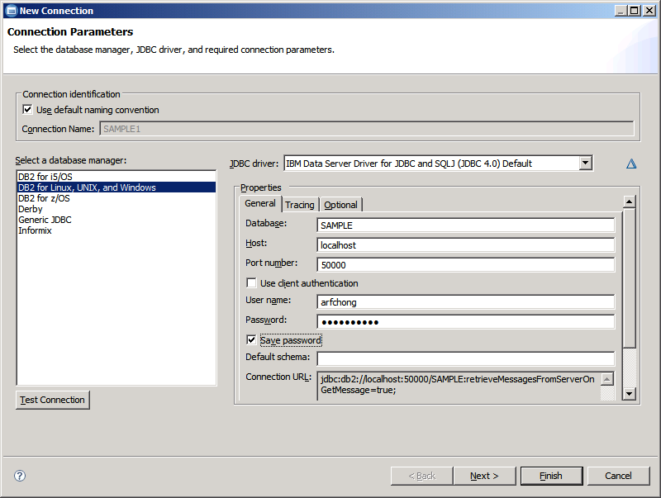Follow the steps from the wizard to input a name for your project, and indicate which database you want your project associated with. If you do not have any existing database connection, click on the *New* button in the *Select Connection* panel, and a window as shown in *Figure 6.3* will appear.

Figure 6.3 – New connection parameters

In *Figure 6.3*, make sure to choose *DB2 for Linux, UNIX and Windows* in the *Select a database manager field* on the left side of the figure. For the *JDBC driver* drop down menu, the default after choosing *DB2 for Linux, UNIX and Windows* is the JDBC type 4 driver listed as *IBM Data Server Driver for JDBC and SQLJ (JDBC 4.0) Default*. Use this default driver and complete the specified fields. For the *host* field, you can input an IP address or a hostname. In the example IBM Data Studio and the DB2 database reside on the same computer, so ***localhost*** was chosen. Ensure to test that your connection to the database is working by clicking on the *Test Connection* button shown on the lower left corner of the figure. If the connection test was successful, click *Finish* and the database name will be added to the list of connections you can associate your project to. Select the database, then click *Finish* and your project should be displayed on the *Data Project Explorer* view. In this view, if you click on the "+" symbol, you can drill down the project to see different folders such as PL/SQL packages, SQL scripts, stored procedures, etc.

### Working with stored procedures

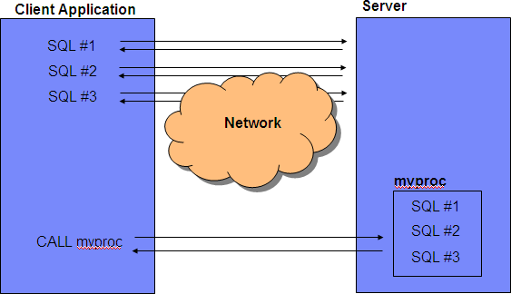A stored procedure is a database application object that can encapsulate SQL statements and business logic. It helps improve performance by reducing network traffic. *Figure 6.2* illustrates how stored procedures work.

Figure 6.2 – Network traffic reduction with stored procedures

At the top left corner of the figure, you see several SQL statements executed one after the other. Each SQL is sent from the client to the data server, and the data server returns the result back to the client. If many SQL statements are executed like this, network traffic increases. On the other hand, at the bottom, you see an alternate method that incurs less network traffic. This second method calls a stored procedure ***myproc*** stored on the server, which contains the same SQL; and then at the client (on the left side), the CALL statement

is used to call the stored procedure. This second method is more efficient, as there is only one call statement that goes through the network, and one result set returned to the client.

Stored procedures can also be helpful for security purposes in your database. For example, you can let users access tables or views only through stored procedures; this helps lock down the server and keep users from accessing information they are not supposed to access. This is possible because users do not require explicit privileges on the tables or views they access through stored procedures; they just need to be granted sufficient privilege to invoke the stored procedures.

##### Types of procedures

There are primarily two types of stored procedures: SQL procedures and external procedures. SQL procedures are written in SQL; external procedures are written in a host language. However, you should also consider several other important differences in behavior and preparation.

SQL procedures and external procedures consist of a procedure definition and the code for the procedure program. Both an SQL procedure definition and an external procedure definition require the following information:

* + - * The procedure name.
      * Input and output parameter attributes.
      * The language in which the procedure is written. For an SQL procedure, the language is SQL.
      * Information that will be used when the procedure is called, such as runtime options, length of time that the procedure can run, and whether the procedure returns result sets.

The following example shows a definition for an SQL procedure.

CREATE PROCEDURE UPDATESALARY (1)

(IN EMPNUMBR CHAR(10), (2) IN RATE DECIMAL(6,2))

LANGUAGE SQL (3)

UPDATE EMP (4)

SET SALARY = SALARY * RATE WHERE EMPNO = EMPNUMBR

In the example:

1. The stored procedure name is UPDATESALARY.
2. There are two parameters, EMPNUMBR with data type CHAR(10), and RATE with data type DECIMAL(6,2). Both are input parameters.
3. LANGUAGE SQL indicates that this is an SQL procedure, so a procedure body follows the other parameters.
4. The procedure body consists of a single SQL UPDATE statement, which updates rows in the employee table.

The following example shows a definition for an equivalent external stored procedure that is written in COBOL. The stored procedure program, which updates employee salaries is called UPDSAL.

CREATE PROCEDURE UPDATESALARY (1)

(IN EMPNUMBR CHAR(10), (2) IN RATE DECIMAL(6,2))

LANGUAGE COBOL (3)

EXTERNAL NAME UPDSAL; (4)

In the example:

1. The stored procedure name is UPDATESALARY.
2. There are two parameters, EMPNUMBR with data type CHAR(10), and RATE with data type DECIMAL(6,2). Both are input parameters.
3. LANGUAGE COBOL indicates that this is an external procedure, so the code for the stored procedure is in a separate COBOL program.
4. The name of the load module that contains the executable stored procedure program is UPDSAL.

##### Creating a stored procedure

To create a Java, PL/SQL or SQL PL stored procedure in Data Studio, follow the steps below. Note that stored procedures in other languages cannot be created from Data Studio. In the following steps, we choose SQL (representing SQL PL) as the language for the stored procedure, however similar steps apply to Java and PL/SQL languages.

Step 1: Write or generate the stored procedure code

When you want to create a stored procedure, right-click on the Stored Procedures folder and choose *New -> Stored Procedure*. Complete the information requested in the *New Stored Procedure* wizard such as the project to associate the procedure with, the name and language of the procedure, and the SQL statements to use in the procedure. By default, Data Studio gives you an example SQL statement. Take all the defaults for all the other panels, or at this point, you can click *Finish* and a stored procedure is created using some template code and the SQL statement provided before as an example. This is shown in *Figure 6.3*.

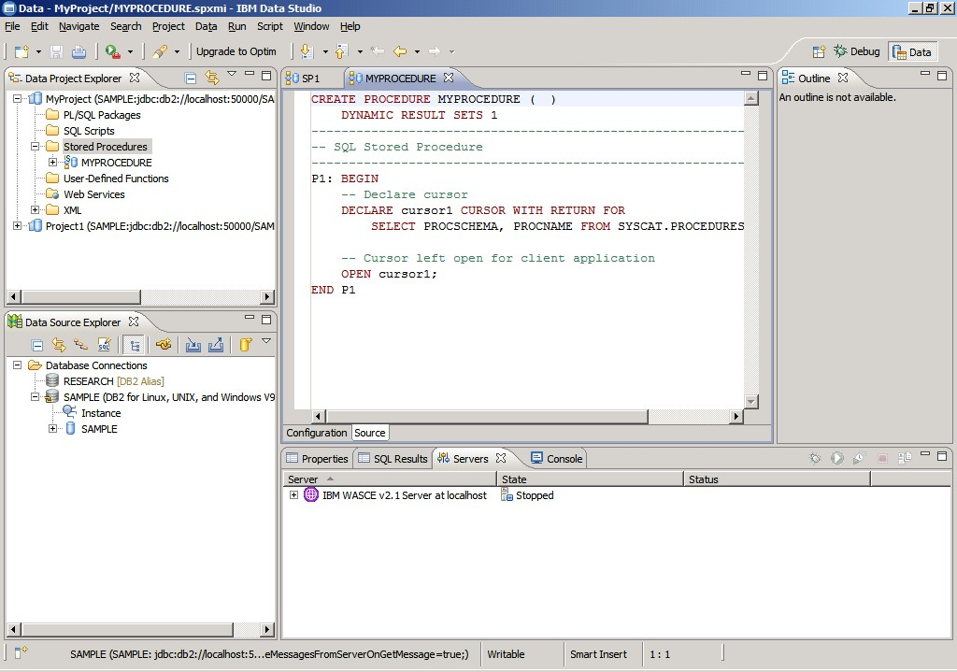

Figure 6.3 – A sample stored procedure

In *Figure 6.3*, the code for the sample stored procedure ***MYPROCEDURE*** was generated. You can replace all of this code with your own code. For simplicity, we will continue in this chapter using the above sample stored procedure as if we had written it.

Step 2: Deploy a stored procedure

Once the stored procedure is created, to deploy it, select it from the *Data Project Explorer* view, right-click on it, and then choose *Deploy*. Deploying a stored procedure is essentially executing the **CREATE PROCEDURE** statement, compiling the procedure and storing it in the database. *Figure 6.4* illustrates this step.

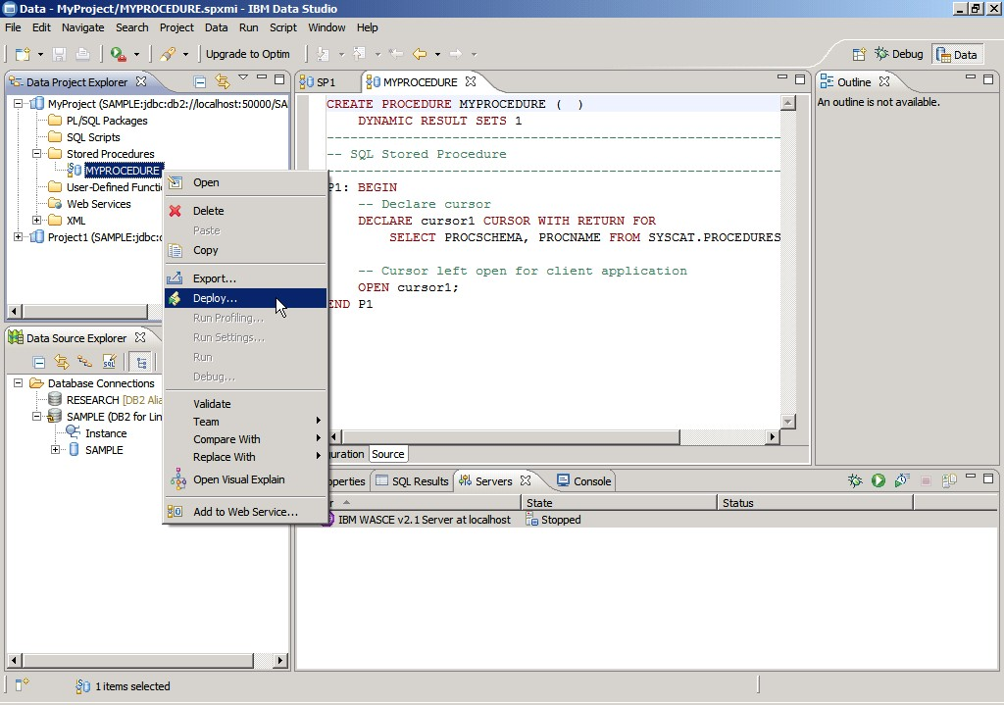

Figure 6.4 – Deploying a stored procedure

After clicking *Deploy*, in the *Deploy options* panel, taking the defaults and clicking on *Finish*

is normally good enough.

Step 4: Run a stored procedure

Once the stored procedure has been deployed, you can run it by right-clicking on it and choosing *Run*. The results would appear in the *Results* tab at the bottom right corner of the Data Studio workbench window as shown in *Figure 6.5*.

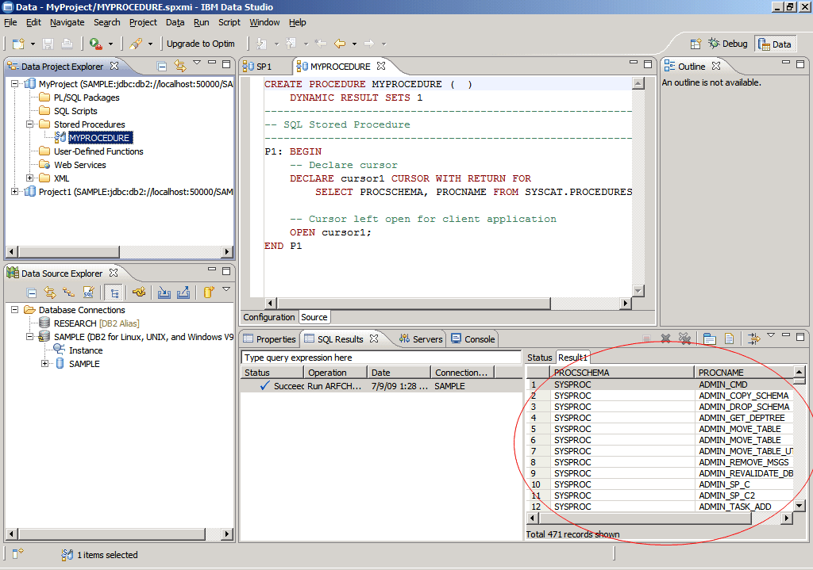

Figure 6.5 – Output after running a stored procedure

To run a stored procedure from the DB2 Command Window or the Command Editor, you can use the **CALL <procedure name>** statement. Remember you first need to connect to the database since this is where the stored procedure resides. *Figure 6.6* illustrates this.

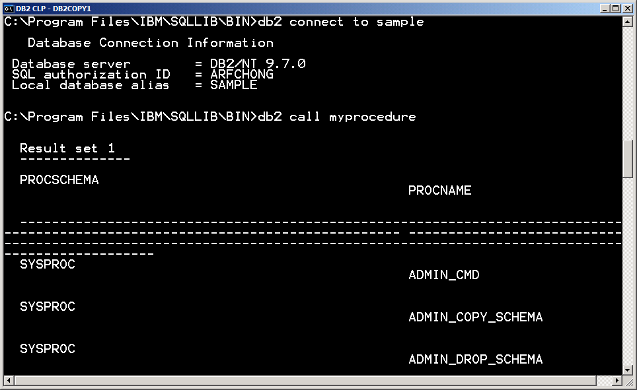

Figure 6.6 – Calling a stored procedure from the DB2 Command Window

Just like you can call a stored procedure from the DB2 Command Window, you can also do so from a Java program, a C program, a Visual Basic program, and so on. You just need to use the correct syntax for the given language.

##### Altering and dropping a stored procedure

There are two ways to alter an existing stored procedure:

1. Drop the existing procedure and recreate the procedure again with a new definition.
2. Use ‘CREATE OR REPLACE PROCEDURE syntax instead of ‘CREATE PROCEDURE'.

There is also an ALTER PROCEDURE statement, but it can only be used to alter specific properties of the procedure rather than the code itself.

To drop a procedure, use the fully qualified name of the procedure with the ‘DROP PROCEDURE’ command as shown in example below.

drop procedure myschema.EMPLOYEE_COUNT

To alter a procedure it is preferred to use the **CREATE OR REPLACE PROCEDURE** syntax in the first place rather than dropping and recreating the procedure. This is because dropping a procedure may have other consequences like invalidating objects depending on the procedure. With the **CREATE OR REPLACE PROCEDURE** syntax this invalidation does not occur.

### Working with functions

An SQL function is a method or a command that takes in zero or more input parameters and returns a single value. All databases have a few standard pre-defined functions for mathematical operations, string manipulations and a few other database specific methods. A user can also create custom defined functions, also known as user-defined functions, to fulfill any requirements that are not served by the default functions library.

##### Types of functions

Functions can be classified into the following types based on their behavior and input data set they operate on:

* + - * Scalar
        + Aggregate
        + String
      * Table

In addition to this classification you can have built-in functions, that is, functions supplied with the database software, and User-defined functions (UDFs), that is, custom functions created by users. A UDF is an extension to the SQL language. It is a small program that you write, similar to a host language subprogram or function. However, a user-defined function is often the better choice for an SQL application because you can invoke it in an SQL statement. In DB2, you can create scalar or table UDFs using SQL PL, PL/SQL, C/C++, Java, CLR (Common Language Runtime), and OLE (Object Linking and Embedding).

* + - 1. Scalar functions

A scalar function is a function that, for each set of one or more scalar parameters, returns a single scalar value. Scalar functions are commonly used to manipulate strings or perform basic mathematical operations within SQL statements. Scalar functions cannot include SQL statements that will change the database state; that is, INSERT, UPDATE, and DELETE statements are not allowed.

For example, the LENGTH built-in function returns the length of a string as shown below:

**SELECT length('Mary') FROM sysibm.sysdummy1**

The above SQL statement executed while connected to a DB2 database returns the value of 4 which is the length of the string 'Mary'.

Scalar functions can be referenced anywhere that an expression is valid within an SQL statement, such as in a select-list, or in a FROM clause. For example:

**SELECT** EMPNO, LASTNAME, **YEAR**(**CURRENT DATE** - BRTHDATE)

**FROM** EMPLOYEE

**WHERE** WORKDEPT = 'D01'

The above example shows the YEAR function which is used to retrieve the year from the output of "CURRENT DATE - BRTHDATE".

Built-in scalar functions perform well because their logic is executed on the database server as part of the SQL statement that references it. When used in predicates, scalar function usage can improve overall query performance. When a scalar function is applied to a set of candidate rows, it can act as a filter, limiting the number of rows that must be returned to the client.

* + - * 1. Aggregate functions

An aggregate function is a function that, for each set of one or more scalar parameters, returns a single scalar value. For example, AVG(COL_NAME) returns the average value of column ’COL_NAME’.

* + - * 1. String functions

A string function is a function that accepts at least one or more scalar string parameters and zero or more scalar integer parameters of a single scalar value (of type string or integer). For example, SUBSTR('abcdefghi',3,4) takes three parameters (source string, substring start location, and number of characters from start location) and returns the appropriate substring. In this example, the output would be 'cdef'

6.3.1.2 Table functions

Table functions return a table of rows. You can call them in the FROM clause of a query. Table functions, as opposed to scalar functions, can change the database state; therefore, INSERT, UPDATE, and DELETE statements are allowed. Some built-in table functions in DB2 are SNAPSHOT_DYN_SQL( ) and MQREADALL( ). Table functions are similar to views, but since they allow for data modification statements (INSERT, UPDATE, and DELETE) they are more powerful.

Below is an example of a table function that enumerates a set of department employees:

**CREATE FUNCTION getEnumEmployee(p_dept VARCHAR(3)) RETURNS TABLE**

**(empno CHAR(6), lastname VARCHAR(15), firstnme VARCHAR(12))**

**SPECIFIC getEnumEmployee RETURN**

**SELECT e.empno, e.lastname, e.firstnme FROM employee e**

**WHERE e.workdept=p_dept**

##### Creating a function

Similarly to a stored procedure, you can use IBM Data Studio to create a user-defined function, the only difference is that you need to right-click on the *user-defined functions* folder instead of the *Stored procedures* folder. Then follow similar steps described earlier for procedures.

Chapter 6 – Stored procedures and functions 155

The CREATE FUNCTION statement is used to register or define a user-defined function or a function template at the current database server. The listing below provides a simplified syntax of this statement:

>>-CREATE--+------------+--FUNCTION--*function-name*--------------> '-OR REPLACE-'

.-IN------.

>--(--+---------+--*parameter-name*--| data-type1 |--+-------------+--|-)-->

| | '-| default-clause |-'

+-OUT-----+

'-INOUT---'

>-- RETURNS--+-| data-type2 |-------------+--| option-list |-----> '-+-ROW---+--| column-list |-'

'-TABLE-'

>--| SQL-function-body |---------------------------------------><

For example, the following SQL PL function reverses a string:

CREATE FUNCTION REVERSE(INSTR VARCHAR(40)) RETURNS VARCHAR(40)

DETERMINISTIC NO EXTERNAL ACTION CONTAINS SQL BEGIN ATOMIC

DECLARE REVSTR, RESTSTR VARCHAR(40) DEFAULT ''; DECLARE LEN INT;

IF INSTR IS NULL THEN RETURN NULL;

END IF;

SET (RESTSTR, LEN) = (INSTR, LENGTH(INSTR)); WHILE LEN > 0 DO

SET (REVSTR, RESTSTR, LEN)

= (SUBSTR(RESTSTR, 1, 1) CONCAT REVSTR,

SUBSTR(RESTSTR, 2, LEN - 1),

LEN - 1); END WHILE; RETURN REVSTR;

END

@

For comprehensive information on the CREATE FUNCTION syntax and available options, refer to the [DB2 v9.7 Information Center.](http://publib.boulder.ibm.com/infocenter/db2luw/v9r7/index.jsp)

##### Invoking a function

Functions can be invoked within any SQL statement or within any data manipulation operation. Functions can not be called explicitly using the ‘CALL’ statement. Typically

functions are invoked in a SELECT or VALUES statement. For example, the function REVERSE defined earlier can be invoked as follows:

SELECT reverse(col_name) from myschema.mytable

OR

VALUES reverse('abcd')

In the case of a TABLE function, the function has to be invoked in the FROM clause of an SQL statement since it returns a table. The special TABLE() function must be applied and an alias must be provide after its invocation. For example, to invoke the getEnumEmployee table function created in an earlier section, try the SELECT statement shown in *Figure 6.1* below.

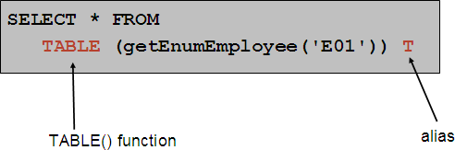

Figure 6.1 – Invoking a table function.

##### Altering and dropping a function

There are two ways to alter any existing user-defined function:

1. Drop the existing function and recreate the function again with a new definition.
2. Use the ‘CREATE OR REPLACE FUNCTION’ syntax instead of ‘CREATE FUNCTION’.

There is also an ALTER FUNCTION statement, but it can only be used to alter specific properties of the function rather than the code itself.

To drop a function use the fully qualified name of the function with the ‘DROP FUNCTION’ statement as shown in example below:

DROP FUNCTION myschema.reverse

To alter a function it is preferred to use the **CREATE OR REPLACE FUNCTION** syntax in the first place rather than dropping and recreating the function. This is because dropping a function may have other consequences like invalidating objects depending on the function. With the **CREATE OR REPLACE FUNCTION** syntax this invalidation does not occur.

### Summary

Stored procedures and functions are very important and useful tools to implement domain specific methods that are not available with databases by default. Stored procedures and functions require ‘EXECUTE’ permission for any user to invoke them. They provide a way to improve performance by reducing network traffic, centralize code on the database, and enhance security.

### Exercises

* + 1. Create an SQL PL stored procedure using IBM Data Studio. Using the DB2 SAMPLE database, the procedure should take an employee ID as input parameter and retrieve all the columns for the employee with this employee ID from the EMPLOYEE table.
    2. Create a UDF for the same requirement as in exercise (1).
    3. Create a SQL function which does not accept any input parameters and returns a day name as string (like Monday, Tuesday and so on) by picking the system’s current date as the source date.
    4. Create a SQL function which accepts a date as an input parameter and returns a day name as a string (like Monday, Tuesday and so on) of the input date.
    5. Create a procedure which does not accept any input parameters and returns the number of tables in the database.
    6. Create a procedure which accepts one table name as an input parameter and returns the number of rows in that table.

### Review Questions

* + 1. Which of the following is a valid function?
       1. Select
       2. Update
       3. Count
       4. Delete
       5. None of the above
    2. Which of following is not a valid function?
       1. avg
       2. count
       3. insert
       4. substr
       5. None of the above
    3. Which of the following is a scalar function?
       1. avg
       2. count
       3. max
       4. substr
       5. All of the above
    4. Which of the following is not a scalar function
       1. trim
       2. upper
       3. min
       4. substr
       5. None of the above
    5. Which of the following is an aggregate function?
       1. lcase
       2. year
       3. max
       4. substr
       5. None of the above
    6. Which of the following is not an aggregate function?
       1. sum
       2. min
       3. max
       4. len
       5. None of the above
    7. Which of the following is string function?
       1. avg
       2. year
       3. max
       4. substr
       5. None of the above
    8. Which languages are supported in Data Studio to develop stored procedures?
       1. SQL PL
       2. PL/SQL
       3. Java
       4. All of the above
       5. None of the above
    9. A function can be invoked with the VALUES statement
       1. True
       2. False
    10. A procedure can be invoked with the ‘CALL’ statement
        1. True
        2. False

4.

# 7

## Chapter 7 – Using SQL in an application

In the previous chapters, we discussed Structured Query Language (SQL), which is a standardized language to interact with a database, manipulate its objects and retrieve the data that it contains. This chapter will introduce you to the concepts of how SQL can be invoked from within applications that are generally written in popular host languages like C, C++, Java, .NET, and others.

In this chapter you will learn about:

* The concept of transaction
* Working with embedded SQL
* The differences between static and dynamic SQL
* Database APIs like ODBC, CLI and JDBC
* An introduction to pureQuery

### Using SQL in an application: The big picture

SQL is a standard language that allows users to communicate with a database server. However, to be able to write large functional applications that require a database as a back-end, SQL alone will not suffice. Application development languages such as C, C++ or Java allow users much more control and power of functional logic. These languages, known as ***host languages*** can integrate well with SQL to interact with databases within the application. In this case, the SQL is embedded in the host application.

Other techniques allow you to directly use database application programming interface (API) calls to access the database. For example, ODBC, CLI and JDBC are such database APIs.

All of the SQL application techniques and the way they interact with the database are illustrated in *Figure 7.1* below. They will be discussed in more detail in the next sections.

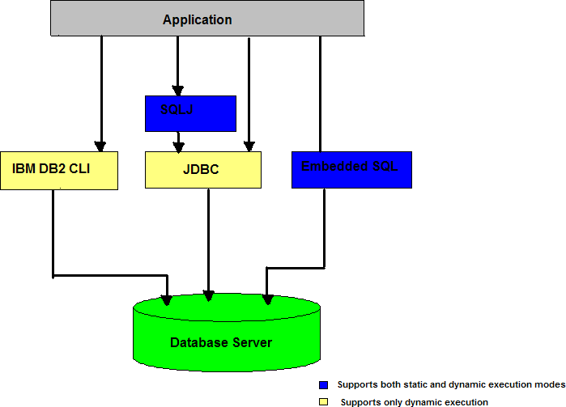

Figure 7.1 - Summary of all the SQL application techniques

### What is a transaction?

Before diving into the details of different SQL application techniques, you need to understand the concept of a transaction. A ***transaction*** or ***unit of work*** is a set of database operations all of which should be executed successfully in order to call the transaction successful.

For example, if a bank has to transfer 1,000 dollars from account A to account B, then the following steps are required before the transfer is successful.

* + - Reduce the balance of account A by the amount of 1,000
    - Increase the balance of account B by the amount of 1,000

In SQL terms, the above steps will require two SQL statements. If any one or more of those SQL statements fails, the money transfer would not be successful. Therefore, for this example, these two SQL statements together form a transaction. SQL handling in applications provide means to commit or roll back a unit of work so that the integrity of the data is maintained. Common examples for applications using transactions are an online reservation systems, online shopping, and so on.

### Embedded SQL

As the name suggests, embedded SQL implies embedding SQL statements inside a host application written in a high-level host programming languages such a C, C++, or COBOL. The host application contains the necessary business logic and calls the SQL statements as required to access the information in the database.

A question now arises: how would you compile applications written in high-level programming languages that contain SQL statements embedded in them? None of the programming language compilers has support for SQL compilation and syntax validation.

The answer to this question is pre-compilation. In the case of DB2, it provides a pre- compiler which performs the necessary conversion of the SQL syntax directly into DB2 runtime service API calls. The precompiled code is then compiled and linked by the host language development tools.

Embedded SQL statements in host languages need to be identified with a given sentence or block. In the case of C, C++, and COBOL, the statement initializer EXEC SQL is used for this purpose. This statement is followed by the SQL statement string to be executed, and ends with a semicolon (;), which is the statement terminator. For example:

**EXEC SQL**

**UPDATE employee.details**

**SET emp_desig = 'Mgr' WHERE emp_desig = 'Asst Mgr';**

SQL statements can also be embedded in Java applications and such embedded SQL Java applications are referred to as **SQLJ** applications. Similar to the EXEC SQL statement initializer, SQLJ applications require SQL statements to start with **#sql**.

For example, the same UPDATE SQL statement shown above if written within an SQLJ application, would look like this:

**#sql {**

**UPDATE employee.details**

**SET emp_desig = 'Mgr' WHERE emp_desig = 'Asst Mgr'};**

Both examples mentioned above contain ***static SQL*** statements, because the table name, column names, and other database objects in the SQL syntax are all known and constant each time the application runs.

On the other hand, if these objects were provided as input to the program at run time, then we would be talking about ***Dynamic SQL*** since the exact SQL statement is determined at run time. We discuss static and dynamic SQL in more detail in the next sections.

##### Static SQL

Static SQL is the most traditional way of building embedded SQL applications. Static SQL applications are designed for scenarios where the applications need to issue the same SQL statements every time it interacts with the database. For example, an application which updates the inventory stock, would always issue the same SQL statement to add

new stock. Similarly, an online reservation system would always update the same table and mark the same column as ‘reserved’ for a new reservation. To get the latest reservation status, it would always issue the same SELECT statement on the same table.

An embedded SQL application where the syntax of the SQL is fully known beforehand and where the SQL statements are hard-coded within the source code of the application is known as a ***static embedded SQL application***. The only input(s) that can be fed to the SQL statements from the application are the actual data values that need to be inserted into the table or the predicate values of the SQL statements. These input values are provided to the SQL statements using **host variables**.

* + - 1. Host variables

Host variables are programming language variables that should only be used for static SQL processing. These host variables need to be declared in the application prior to using them. A good practice is to initialize them with default values, as soon as they are declared. Another good practice is to append the host variable names with ‘**_hv**’ to differentiate them from other variables as well as from column names.

Consider the embedded SQL C code snippet shown in *Listing 7.1*

**EXEC SQL**

**SELECT emp_name, emp_dept, emp_salary INTO :name_hv, :dept_hv, :salary_hv FROM employee.details**

**WHERE emp_id = :id_hv ;**

**EXEC SQL**

**UPDATE employee.details**

**SET emp_salary = :new_salary_hv WHERE emp_id = :id_hv ;**

Listing 7.1 - Embedded SQL C code snippet

In both statements, the table name (**employee.details**), and the column names (**emp_name, emp_dept,** etc.) are all hard-coded. The information that can be fed to the SQL statements at runtime are passed using host variables (**id_hv, dept_hv,** etc.). The colon (**:**) before each of the host variables is part of the embedded SQL syntax.

* + - 1. Embedded SQL application structure

Irrespective of the host language, all embedded SQL applications are comprised of the following three main elements, which are required to setup and execute SQL statements.

* + - * + A DECLARE SECTION for declaring host variables.
        + The main body of the application, which consists of the setup and execution of SQL statements.
        + Placements of logic that either commits or rollbacks the changes made by the SQL statements (if required).

*Listing 7.2* illustrates an embedded SQL C code snippet that demonstrates these three elements.

int getDetails( int employee_id, double new_salary)

{

int ret_code = 1;

EXEC SQL INCLUDE SQLCA;

EXEC SQL BEGIN DECLARE SECTION;

sqlint32 id_hv = 0; // employee id

char name_hv[129] = {0}; // employee name

char dept_hv[129] = {0}; // employee department double salary_hv = 0; // employee salary

EXEC SQL END DECLARE SECTION;

// Copy the employee id and salary passed to this function

// into the host variables id_hv = employee_id; salary_hv = new_salary;

// Issue the UPDATE statement to set the new salary of an employee EXEC SQL

UPDATE employee.details

SET emp_salary = :salary_hv WHERE emp_id = :id_hv;

if (SQLCODE < 0)

{

printf(“\n UPDATE SQL Error:%ld\n”,SQLCODE); EXEC SQL ROLLBACK; // Rollback the transaction ret_code = 0; // error

}

else

{

EXEC SQL COMMIT; // Commit the transaction

// Issue a SELECT to fetch updated salary information EXEC SQL

SELECT emp_name, emp_dept, emp_salary INTO :name_hv, :dept_hv, :salary_hv FROM employee.details

WHERE emp_id = :id_hv;

if (SQLCODE < 0)

{

printf(“\n SELECT SQL Error:%ld\n”,SQLCODE);

Ret_code = 0;

}

else

{

// Display the updated salary information printf(“\n Employee name: %s”,name_hv); printf(“\n Employee Id: %d”,id_hv); printf(“\n Employee Department: %s”,dept_hv);

printf(“\n Employee New Salary: Rs. %ld p.a”,salary_hv);

}

}

return ret_code;

}

Listing 7.2 - Embedded SQL C code application structure

The above example demonstrated how SQL statements can be embedded in C as a host language. Other host languages like C++, COBOL, Java, and so on also have the same three main elements as described above.

* + - 1. SQL communications area, SQLCODE and SQLSTATE

The SQL Communications Area (SQLCA) is a data structure that is used as a communication medium between the database server and its clients. The SQLCA data structure comprises of a number of variables that are updated at the end of each SQL execution. The SQLCODE is one such variable in the data structure which is set to 0 (zero) after every successful SQL execution. If the SQL statement completes with a warning, it is set with a positive, non-zero value; and if the SQL statement returns an error, it is set with a negative value.

SQLCODE values may correspond to either hardware-specific or operating system-specific issues; for example, when the file system is full, or when there is an error accessing a file. It is a good idea to check for the SQLCODE returned after each SQL execution as shown in the above application.

SQLSTATE is another variable provided in the SQLCA which stores a return code as a string that also indicates the outcome of the most recently executed SQL statement. However, SQLSTATE provides a more generic message that is standardized across different database vendor products.

* + - 1. Steps to compile a static SQL application

As discussed earlier, embedded SQL applications need to be pre-compiled first using the DB2 pre-compiler. The pre-compiler checks for SQL statements within the source code, replaces them with equivalent DB2 runtime APIs supported by the host language and re- writes the entire output (with commented SQL statements) into a new file which can then be compiled and linked using the host language development tools.

The DB2 pre-compiler is invoked using the DB2 **PRECOMPILE (**or **PREP)** command. Apart from the SQL replacement, the DB2 pre-compiler performs the following tasks:

1. It validates the SQL syntax for each coded SQL statement and ensures that appropriate data types are used for host variables by comparing them with their respective column types. It also determines the data conversion methods to be used while fetching or inserting the data into the database.
2. It evaluates references to database objects, creates **access plans** for them and stores them in a **package** in the database. An access plan of an SQL statement is the most optimized path to data objects that the SQL statement will reference. The DB2 optimizer estimates these access plans at the time of pre-compilation of the static embedded SQL statement. This estimate is based on the information that is available to the optimizer at the time of the pre-compilation, which is basically fetched from the system catalogs.

Moreover, each application is **bound** to its respective package residing on the database. The benefit of storing these access plans in the database is that every time the application is run, the access plan for the corresponding SQL statement is fetched from the package and used. This makes SQL execution very fast in the database, since the most optimized way of accessing the required database objects is already known in advance.

At this point, we could also define static SQL statements to be the ones whose access plan can be determined and known in advance and stored in the database for faster execution. Thus for an SQL statement to be embedded statically in an application, its syntax must be known at pre-compile time.

Once the embedded SQL application is pre-compiled and bound to the database, it can then be compiled and linked using the host language development tools. It is also possible to defer the binding of the application to just before execution. This can be done by specifying the **BINDFILE** *<bindfile>* clause in the PRECOMPILE command, which creates a bindfile that contains the data required to create a package on a database. This

*<bindfile>* can then be used with the DB2 **BIND** utility to create a package on the database

and bind the application to it. This is also termed as *deferred binding*.

*Figure 7.2* below describes the entire static SQL compilation process. This diagram represents general flow of actions in the compilation process and may be different for a specific compiler.

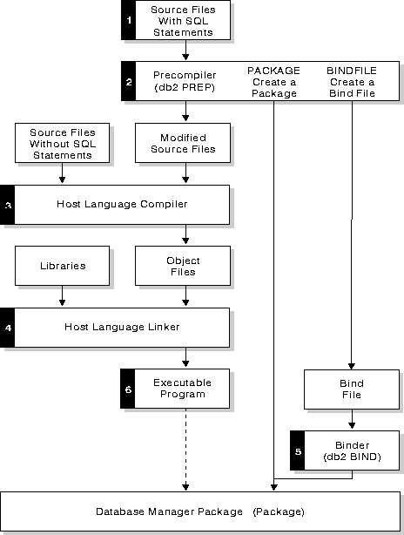

Figure 7.2 -Static SQL compilation and execution process

For **SQLJ** applications, similar to the DB2 pre-compiler for embedded SQL applications, the **SQLJ translator** detects the SQL clauses within the SQLJ application and converts them into JDBC statements. JDBC will be covered in detail in later sections.

##### Dynamic SQL

Dynamic SQL statements include parameters whose values are not known until runtime, when they are supplied as input to the application. Dynamic SQL statements are very

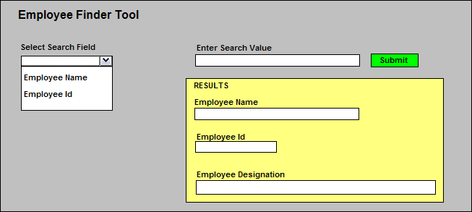common for user-driven interactive applications where the user provides most of the information required to construct the exact SQL. Consider the application depicted in *Figure 7.3*, "Employee finder tool", which could be part of a larger HR application in a company.

Figure 7.3 - An Employee finder tool

The above tool allows a user to get details about an employee’s designation. The search arguments are either the *Employee Name* or the *Employee Id*. For this type of applications, the exact SQL that would need to be issued cannot be known until execution time. This is an example where Dynamic SQL is required.

Contrary to the static SQL technique, the **access plans** for dynamic SQL queries can only be generated at runtime.

7.3.2.1 Embedded SQL application structure

*Listing 7.3* provides the code corresponding to the Employee Finder Tool shown in *Figure*

*7.3*. It demonstrates how to execute an SQL statement dynamically from an embedded SQL C application.

int findEmployee(char * field, char * value, char * emp_name, char * emp_id, char * emp_desig)

{

int ret_code = 1;

char sqlstmt[250] = {0}; EXEC SQL INCLUDE SQLCA;

EXEC SQL BEGIN DECLARE SECTION;

char name_hv[129] = {0}; // employee name

char desig_hv[129] = {0}; // employee designation char id_hv[10] = {0}; // employee id

char value_hv[250] = {0}; // Field value EXEC SQL END DECLARE SECTION;

// Copy the Search Field passed to this function into

// the sqlstmt string

sprintf(sqlstmt,”SELECT emp_name, emp_id, emp_desig

FROM employee.details WHERE %s = ?”,field);

// Copy the field value passed to this function into the

// host variable

strcpy(value_hv,value) ;

// Prepare the dynamic SQL statement first. This statement would

// create the access plan at runtime

EXEC SQL PREPARE dynsqlstmt FROM :sqlstmt; if (SQLCODE <0)

{

printf(“\n Error during Prepare statement:%ld”,SQLCODE); ret_code = 0; //error

}

else

{

EXEC SQL DECLARE cur1 CURSOR FOR :dynsqlstmt; if (SQLCODE <0)

{

printf(“\n Error during Declare Cursor:%ld”,SQLCODE); ret_code = 0; //error

}

else

{

EXEC SQL OPEN cur1 USING :value_hv; if (SQLCODE <0)

{

printf(“\n Error during Open Cursor:%ld”,SQLCODE); ret_code = 0; //error

}

else

{

EXEC SQL FETCH cur1 INTO :name_hv, :id_hv, :design_hv; if (SQLCODE <0)

{

printf(“\n Error during Fetch cursor:%ld”,SQLCODE); ret_code = 0; //error

}

else

{

EXEC SQL CLOSE cur1; if (SQLCODE <0)

{

printf(“\n Error during Close cursor:%ld”,SQLCODE); Ret_code = 0; //error

}

else

{

// Copy the fetched results into the target variables strcpy(emp_name,:name_hv);

strcpy(emp_id,:id_hv); strcpy(emp_desig,:desig_hv);

}

}

}

}

}

return ret_code;

}

Listing 7.3 - Embedded SQL C with static and dynamic SQL

In the above listing, the information pertaining to the Search Field of the Employee Finder Tool (which the user provides at runtime) is first captured in a variable called **field**. This information is copied into the SQL statement which is then stored in a string variable (see **sqlstmt** above).

Let’s say the user selected **Employee Id** as the search field. In that case, the SQL statement (without the predicate values) would look like this:

**SELECT emp_name, emp_id, emp_desig from employee.details WHERE emp_id =?**

The question mark (?) used in the statement is referred to as a **parameter marker**. These markers are used in place of predicate values, which indicate that the actual values will be provided later at runtime. Since the exact predicate values are not necessary for access plan generation, the complete SQL information is available at this point-of-time to generate

an access plan. The access plan is generated by ‘**preparing**’ the dynamic SQL statement (see EXEC SQL PREPARE in the code listing above).

Had the user selected **Employee Name** as the search field, the SQL would have become:

**SELECT emp_name, emp_id, emp_desig from employee.details WHERE emp_name =?**

Thus, the exact SQL that needs to be issued is generated only at execution time and the preparation of this SQL statement would have led to a different access plan than the previous one.

Once the statement is prepared successfully, it is possible to execute it using the predicate values provided by the user. In case of a SELECT statement, this is achieved by first declaring a cursor for the SQL statement, then opening it with the predicate values provided and then fetching the results of the query into the host variables. The cursor needs to be closed eventually.

1. The above code snippet still contains some static SQL statements needed for statement preparation, cursor declarations, and so on. This would mean that such applications would also require pre-compilation or SQL translation (for SQLJ applications), since they are still not totally free from static SQL statements.
2. If there is a way to replace all such static SQL statements by equivalent APIs, the pre-compilation/SQL translation of the application would not be required at all. The question now arises about how to write such dynamic SQL applications which do not have any static SQL statements (even for PREPARE, EXECUTE, CURSOR declaration, and so on). The answer to this question is provided in subsequent sections.

##### Static vs. dynamic SQL

The following are some of the main differences between static and dynamic execution modes of an embedded SQL application:

* + - 1. Unlike static SQL statements, access plans for dynamic statements are generated only at runtime; hence, dynamic statements need to be prepared in the application.
      2. The time taken to generate an access plan at runtime makes dynamic SQL applications a little slower than static SQL. However, they offer much more flexibility to application developers and hence, are more robust than static SQL applications.
      3. Sometimes a dynamic SQL statement performs better than its static SQL counterpart, because it is able to exploit the latest statistics available in the database at the time of execution. The access plan generated for a static SQL statement is stored in advance and may become outdated in case certain database statistics change, which is not the case with dynamic SQL.
      4. One advantage of dynamic SQL over static SQL is seen whenever the application is modified or upgraded. If the **static SQL part** of the application is modified, then regeneration of access plans would be needed. This means pre-compilation of the

Chapter 7 – Using SQL in an application 173

application and rebinding of packages would have to be done again. In the case of dynamic SQL execution, since the access plans are generated at runtime, pre- compilation and rebinding is not needed.

### Database APIs

As we saw earlier, even though embedded SQL has the capabilities of executing SQL statements dynamically, it still contains some static SQL statements which mandates the pre-compilation or SQL translation step.

Moreover, there needs to be a connection to the database while pre-compiling the embedded SQL application, since in order to generate access plans, statistics information from the database catalog is required.

This brings us to another world of SQL application development that uses Database Application Programming Interfaces (APIs). Database APIs are totally dynamic in nature and can be developed independently of the database software being used, and without the need for pre-compilation.

Database APIs, as the name suggests, are a set of APIs exposed by database vendors pertaining to different programming languages like C, C++, Java and so on, which gives application developers a mechanism to interact with the database from within the application by just calling these *SQL callable interfaces*.

The intermediate layer between the application and the database server, which makes this interaction possible, is the **database connectivity driver**. The database vendors themselves provide these drivers and once the driver libraries are linked with the source code libraries, the application source code can be easily compiled and then executed.

Applications can now be developed independently of target databases, without the need for database connection at the compilation phase. This also provides application developers much more flexibility without having to know embedded SQL syntax. The following sections describe in detail these database connectivity drivers.

##### ODBC and the IBM Data Server CLI driver

In order to achieve some level of standardization amongst all the database vendors who offer connectivity drivers, the X/Open Company and the SQL Access Group jointly developed a specification for a callable SQL interface referred to as the X/Open Call Level Interface. The goal of this interface was to increase the portability of applications by enabling them to become independent of any one database vendor's programming interface. Most of the X/Open Call Level Interface specifications have been accepted as part of the ISO Call Level Interface International Standard (ISO/IEC 9075-3:1995 SQL/CLI).

Microsoft developed a callable SQL interface called Open Database Connectivity (ODBC) for Microsoft operating systems, based on a preliminary draft of X/Open CLI. However, ODBC is no longer limited to Microsoft operating systems and currently many implementations are available on other platforms as well.

The IBM Data Server CLI driver is the DB2 Call level Interface which is based on the Microsoft® ODBC specifications, and the International Standard for SQL/CLI. These specifications were chosen as the basis for the DB2 Call Level Interface in an effort to follow industry standards and to provide a shorter learning curve for those application programmers already familiar with either of these database interfaces. In addition, some DB2 specific extensions have been added to help the application programmer specifically exploit DB2 features. The DB2 CLI is a C and C++ application programming interface for relational database access that uses function calls to pass dynamic SQL statements as function arguments.

Even for PREPARE and EXECUTE statements there are equivalent APIs such as **SQLPrepare(),** and **SQLExecute()** respectively, which accept the SQL statement as argument. This means that there would be no need for any static EXEC SQL statements in the application. For example, consider a dynamic SQL statement that needs to be prepared using the SQLPrepare() API. Recall that using embedded SQL, we achieved the same by using EXEC SQL PREPARE statement.

SQLCHAR *stmt = (SQLCHAR *)"UPDATE employee.details SET emp_id = ? WHERE emp_name = ? ";

/* prepare the statement */

int rc = SQLPrepare(hstmt, stmt, SQL_NTS);

Similarly, IBM CLI offers other callable interfaces like SQLConnect(), SQLFetch(), SQLExecute, and so on.

The ODBC specifications also includes an operating environment, where database specific ODBC Drivers are dynamically loaded at runtime by a driver manager based on the data source (database name) provided on the connect request. The IBM DB2 Call Level Interface driver conforms to the ODBC 3.51 standards, which means it also acts as an ODBC driver when loaded by an ODBC driver manager.

*Figure 7.4* depicts where the IBM DB2 CLI driver sits in a dynamic SQL application development environment. It also depicts how the IBM DB2 CLI driver can act as any other ODBC driver, when loaded through the ODBC driver manager.

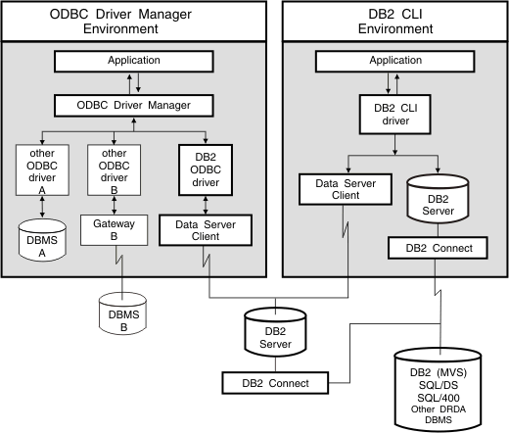

Figure 7.4 - IBM DB2 CLI and ODBC

##### JDBC

JDBC stands for Java Database Connectivity. As its name suggests, it is an SQL application programming interface similar to ODBC and CLI, but for Java applications.

In a CLI application development, the dependent CLI libraries needed to be linked to the application. Similarly, in JDBC, the relevant Java packages that contain the support for the JDBC APIs need to be imported.

An example of how a SELECT statement can be issued from a JDBC application is shown in *Listing 7.4*.

// SQL for SELECT. The name, country, street and province information

// which has been provided by the user are stored in respective variables.

String sqlSel = "select “+name+”, ” +country+”, “+street+”, “+province+”, “+zip+” from CUSTOMER where Customer = ?";

//prepare the SELECT statement

PreparedStatement pstmt=con.prepareStatement(sqlSel); pstmt.setString (1, "custCountry"); //set the Input parameter

pstmt.execute(); //execute SELECT statement ResultSet result = pstmt.getResultSet (); //get the results and set

//values

List<Customer> custList = new ArrayList<Customer>(); while (result.next ()) {

Customer cust = new Customer(); cust.name = result.getString (1); cust.country = result.getString (2); cust.street = result.getString (3); cust.province = result.getString (4); cust.zip = result.getString (5); custList.add (cust);

}

}catch (SQLException e) {e.pringStackTrace ();}

Listing 7.4 - Code snippet using JDBC

In the above code snippet:

* + - * The complete SQL statement, once formed, is first stored in a string variable (sqlSel above).
      * The dynamic SQL statement is then prepared using **parameter markers** in place of predicate values.
      * Before execution of the SQL statement, the actual values are **bound** to the respective parameter markers. The JDBC statement “pstmt.setString (1, "custCountry")”" would replace the **first** parameter marker in the dynamic SQL statement with the value ‘custCountry’.
      * Once executed, the programmers would need to map the results returned by JDBC to respective Java objects.

### pureQuery

Dynamic SQL provides flexibility to application developers, but it comes with an overhead. For each SQL statement that is executed, the statement first needs to be prepared in the application, the actual predicate values then have to be bound to their respective

parameter markers and then the results returned by the JDBC driver need to be mapped to Java application objects.

**pureQuery** is a platform offered to Java developers that exploits the advantages of dynamic SQL without having to bother about preparation and object mapping overheads.

Consider the JDBC application snippet discussed in *Listing 7.4*. The same SQL SELECT statement, when written using pureQuery, is limited to much fewer lines of code as shown below in *Listing 7.5*.

//The name, country, street and province are variables which would be

//populated at runtime using user inputs.

String sqlSel = "select “+name+”, ” +country+”, “+street+”, “+province+”, “+zip+” from CUSTOMER where Customer = ?";

Data data = DataFactory.getData (con);

//execute the Select and get the list of customer List<Customer> customerList = data.queryList (sqlSel, Customer. class, "custCountry");

Listing 7.5 - Code snippet using pureQuery

The pureQuery API queryList will execute the sqlSel statement with the predicate value “custCountry” and return the query results into cutomerList. Like JDBC, the SQL statement is generated at runtime here as well, whereas the same code has been written in much less lines of code as compared to the JDBC application. It not only maximizes the application development speed, but also helps in reducing the complexity.

The above method of pureQuery is referred to as an **inline method,** which supports dynamic SQL execution. pureQuery also supports static execution of SQL applications using the **annotated method**.

With the inline method, SQL statements are created as Java string objects and passed to the pureQuery API. On the other hand, with the annotated method, the SQL string is defined as a pureQuery **annotation**. The method annotations defined by pureQuery are the following:

* + - @Select (which annotates SQL queries)
    - @Update (which annotates SQL DML statements)
    - @Call (which annotates SQL CALL statements). Consider the SELECT statement

SELECT Name, Country, Street, Province, Zip FROM customer where Customer =?

For pureQuery, all that is required is to:

* + - Place the SELECT SQL in the appropriate annotation.

Database Fundamentals 178

* + - Then declare a user-defined function that is used onwards to execute the same SQL.

For example, in *Listing 7.6*, the SELECT SQL statement is placed in the @Select annotation.

public interface CustomerData

{

//Select PDQ_SC.CUSTOMER by parameters and populate Customer bean with

//results

@Select(sql="select Name, Country, Street, Province,Zip from CUSTOMER where Customer =?")

Customer getCustomer(int cid);

}

Listing 7.6 - @Select annotation

Now to execute this SQL statement, the application does not need to implement the above **CustomerData** interface. pureQuery implements these user defined interfaces by using a built-in utility called pureQuery generator, which creates the data access layer for the application.

The application can directly create an instance variable of **CustomerData** using the pureQuery API and call the **getCustomer()**method directly to execute the above SQL statement, as shown in *Listing 7.7*.

// use the DataFactory to instantiate the user defined interface CustomerData cd = DataFactory.getData(CustomerData.class, con);

// execute the SQL for getCustomer() and get the results in Customer beans Iterator<Customer> cust = cd.getCustomer();

Listing 7.7 - Executing the SQL statement using pureQuery and the annotation method

The output of the generator utility is an implemented Java file (**CustomerDataImpl.java** in the above example**)** of the user-defined interface (**CustomerData)**. This implemented Java file has the actual SQL statements and the definition of declared methods (getCustomer).

In this programming style, an application developer specifies all the SQL statements and their corresponding methods within the interfaces. These methods are then used to execute the SQL statements in the application. In this way, SQL statements are **separated** from the business logic in the application code.

The pureQuery annotated method programming style supports the static mode of execution of an application, whereas the inline method supports dynamic execution. As per user requirements, either one of these pureQuery programming styles can be used to develop a Java database application.

For more details on pureQuery coding techniques, refer to the following links:

Chapter 7 – Using SQL in an application 179

http://publib.boulder.ibm.com/infocenter/idm/v2r2/index.jsp?topic=/com.ibm.datatools.javat ool.runtime.overview.doc/topics/helpindex_pq_sdf.html

http://publib.boulder.ibm.com/infocenter/idm/v2r2/index.jsp?topic=/com.ibm.datatools.javat ool.runtime.overview.doc/topics/helpindex_pq_sdf.html

##### IBM pureQuery Client Optimizer

A very interesting feature supported by pureQuery, is the pureQuery Client Optimizer. In sections above, we discussed the performance overhead of dynamic SQL applications. The pureQuery Client Optimizer offers a technique to reduce this overhead. Existing JDBC dynamic application can be optimized to run certain SQL statements statically, without making any change to the application code. Using the pureQuery Client Optimizer, the following steps need to be undertaken:

* + - * When the dynamic application is first run, the pureQuery Client Optimizer captures the different SQL statements issued from an application into a pureQueryXml capture file.
      * The captured SQL statements in the XML file are then divided into packages, by running the command line tool **Configure**.
      * Using the staticBinder, these packages are then created on the database server and the application is bound to these packages.
      * Finally, the execution mode of the application needs to be set to ‘static’, which allows some of the SQL statements to run in static mode.

7. Basically, each SQL issued from the application is matched with the SQL statements captured in the capture file. As soon as a match is found, the corresponding package details are fetched from the capture file and since the SQL is already bound to the corresponding package at the database server, the statement can be run statically. Each new SQL, which does not find a match, stills runs in dynamic execution mode.

### Summary

This chapter discussed different techniques to use SQL in an application. It started describing the concept of "transaction" followed by a description of how SQL statements could be embedded in an application.

The chapter explained the differences between static and dynamic modes of execution, where it established that static SQL had the advantage of delivering better performance, whereas dynamic SQL offered much more development flexibility and the ability to develop and execute applications without the need for pre-compilation and a connection to the database. The choice between static and dynamic approaches totally depends upon the requirement of the application and its design. There is no hard and fast rule that either approach should always be preferred over the other.

Database Fundamentals 180

Embedded SQL and SQLJ can support both, static and dynamic SQL. However, even if an embedded SQL application uses mostly dynamic SQL statements, it still requires some static SQL statements which means the application still needs to be precompiled and connected to the database.

A different approach using database APIs such as ODBC, CLI and JDBC provide a totally dynamic approach to application development. This approach overcomes many of the issues encountered with embedded SQL. The main advantage is that developers can code standard code that could be used with any database management system with very little code change.

Lastly the chapter talked about pureQuery, and IBM technology that allows you to take advantages of dynamic SQL without having to bother about preparation and object mapping overheads.

### Exercises

Design an end-to-end Library management system application which performs the following tasks:

* + 1. Updates new books into the database.
    2. Searches any given book based on author name or title.
    3. Maintains an entry into the database for every book issued with the return date.
    4. On any given date, lists all the books along with their issuers, which must be returned.

Try highlighting which queries are better suited for dynamic execution and which ones are more suited for static execution.

### Review Questions

1. Static execution of SQL means the access plan:
   1. will only be generated at application runtime
   2. is generated at pre-compilation time itself.
   3. All of the above
   4. None of the above
2. Dynamic execution of SQL:
   1. does not require the complete information about the SQL syntax before hand
   2. requires the complete information about the SQL syntax at the pre-compilation stage itself.
   3. All of the above
   4. None of the above

Chapter 7 – Using SQL in an application 181

1. Embedded SQL C/C++ applications:
   1. do not require the DB2 pre-compiler.
   2. do require the DB2 pre-compiler.
2. SQLJ is an:
   1. Embedded SQL application technique for Java applications
   2. Is a SQL programmable call level interface.
3. ODBC stands for:
   1. Open Database Community
   2. Open Database Connectivity
   3. Open source database community
   4. Open database connection.
   5. None of the above
4. The following supports both static and dynamic mode of execution:
   1. JDBC
   2. SQLJ
   3. DB2 CLI
   4. All of the above
   5. None of the above
5. A database connection is required for pre-compilation/compilation of which applications?
   1. JDBC
   2. SQLJ
   3. DB2 CLI
   4. All of the above
   5. None of the above
6. Parameter markers (‘?’) can be used as placeholders for:
   1. Predicate values which are provided at runtime
   2. Column names, table names etc.
   3. The SQL statement itself.
   4. All of the above
   5. None of the above

Database Fundamentals 182

1. pureQuery ‘annotated style’ supports:
   1. dynamic SQL statements
   2. static SQL statements
   3. All of the above
   4. None of the above
2. The pureQuery Client Optimizer:
   1. Requires code changes to existing JDBC applications so that they can then be run in static mode
   2. Does not require any application code change in existing JDBC applications to make them run in static mode.

# 8

## Chapter 8 – Query languages for XML

In today’s world data can be represented using more than one data model. The traditional relational model for data representation has been used for more than a decade but the needs are changing to include data captured from all possible sources. Data may not always be in a structured relational format. In fact, most of the data being captured today is in either a semi-structured or unstructured format. Unstructured data can be in the form of pictures and images, whereas structured data carries metadata along with it. Semi- structured data does not impose a rigid format, like records in tables, and as a result is much more flexible and can represent different kind of business objects.

XML is a very good method of representing semi-structured data and has been used successfully for some time now. XML has become the de facto standard for exchanging information over the internet. With more and more transactions happening online and over the internet, there is a realization that there is a need to keep track of all these transactions and preserve them for future use. Some organizations store such information for audit and compliance requirements and others for gaining a competitive edge by doing analytics on the information being stored. This makes it necessary to have a powerful database that provides true support for efficiently storing and querying large amount of XML data. DB2 is one such data server that provides native support for both relational and XML data and accordingly is known as a hybrid data server.

### Overview of XML

XML stands for eXtensible Markup Language. XML is a hierarchical data model consisting of nodes of several types linked together through an ordered parent/child relationship. An XML data model can also be represented in text or binary format.

##### XML Elements and Database Objects

An XML element is the most fundamental part of an XML document. Every XML document must have at least one XML element, also known as the root or document element. This element can further have any number of attributes and child elements.

Given below is an example of a simple XML element

<name>I am an XML element</name>

Every XML element has a start and end tag. In the above example <name> is the start tag and </name> is the end tag. The element also has a text value which is “I am an XML element”.

Given below is an XML document with multiple XML elements and an attribute

<employees>

<employee id=”121”>

<firstname>Jay</firstname>

<lastname>Kumar</lastname>

<job>Asst. manager</job>

<doj>2002-12-12</doj>

</employee>

</employees>

In the above example <employees> is the document element of the XML document which has a child element <employee>. The <employee> element has several child elements along with an attribute named ***id*** with the value ***121***. In DB2, the entire XML document gets stored as single column value. For example for the table structure below

department(id integer, deptdoc xml)

The ***id*** column stores the integer ***id*** of each department whereas the ***deptdoc*** column, which is of type XML, will store one XML document per department. Therefore, the entire XML document is treated as a single object/value. Below is the graphical representation of the way XML data is stored in DB2.

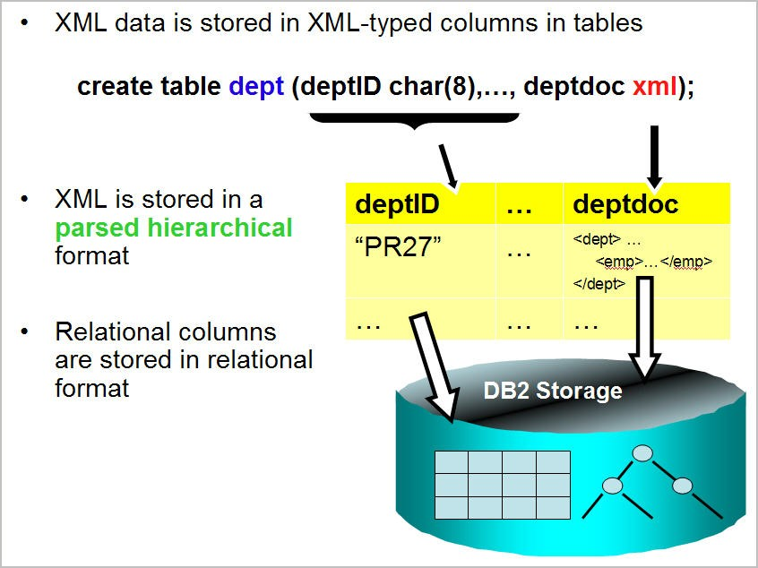

Figure 8.1 - Native XML Storage

In DB2 the XML document is parsed during insertion and the parsed hierarchical format is stored inside the database. Due to this DB2 does not need to parse the XML document during querying and therefore yields better query performance.

##### XML Attributes

Attributes are always part of an element and provide additional information about the element of which they are a part of. Below is an example of an element with two attributes, ***id*** and ***uid*** with values ***100-233-03*** and ***45***, respectively.

<product id=”100-233-03” uid=”45”/>

Note that in a given element, attribute names must be unique, that is, the same element cannot have two attributes with same name.

For example, the following element declaration will result in a parsing error.

<product id=”100-233-03” id=”10023303”/>

Note that attribute values are always in quotes.

In an XML Schema definition, attributes are defined after all the elements in the complex element have been defined. Given below is an example of a complex element with one attribute and two child elements.

<xs:element name="employee">

<xs:complexType>

<xs:sequence>

<xs:element name="firstname" type="xs:string"/>

<xs:element name="lastname" type="xs:string"/>

</xs:sequence>

<xs:attribute name=”empid” type=”xs:integer”/>

</xs:complexType>

</xs:element>

##### Namespaces

XML namespaces provide a mechanism to qualify an attribute, and an element name to avoid the naming conflict in XML documents. For example, if a health insurance company receives insurer information from a different company as an XML document, it is quite possible that two or more companies have the same element name defined, but representing different things in different formats. Qualifying the elements with a namespace resolves the name-conflict issue. In XML, a name can be qualified by a namespace. A qualified name has two parts:

* + - * A namespace Uniform Resource Identifier (URI)
      * Local name

For example, [***http://www.acme.com/names***](http://www.acme.com/names) is a namespace URI and *customer* is a local name. Often, the qualified name uses a namespace prefix instead of the URI. For example the customer element belonging to the [***http://www.acme.com/names***](http://www.acme.com/names)URI may also be written as *acme:customer,* where acme is the namespace prefix for [***http://www.acme.com/names*.**](http://www.acme.com/names) Namespace prefixes can be declared in the XQuery prolog as shown below.

**Declare namespace *acme* "**[***http://www.acme.com/names***](http://www.acme.com/names)**"**

Also, the namespace prefix can be declared in the element constructors as shown below.

<book xmlns:acme="[***http://www.acme.com/names***](http://www.acme.com/names)">

Note that the namespace declaration has the same scope as that of the element declaring it, that is, all child elements can refer to this namespace declaration.

The following namespace prefixes are predefined and should not be used as user-defined namespace prefixes:

Xml, xs, xsi, fn, xdt.

One can also declare a default namespace, a namespace without a prefix in the following ways:

|  |
| --- |
| declare default element namespace [‘http://www.acme.org/names’](http://www.acme.org/names)  (in XQuery Prolog) |
| <book [xmlns="http://www.acme.com/names](http://www.acme.com/names)">  (In element constructor) |

##### Document Type Definitions

A Document Type Definition (DTD) defines the legal building blocks of an XML document. It defines the document structure with a list of legal elements and attributes. A DTD can be declared inline inside an XML document, or as an external reference.

Given below is an example of a DTD.

<!DOCTYPE TVSCHEDULE [

<!ELEMENT PRODUCTS (PRODUCT+)>

<!ELEMENT PRODUCT (NAME,PRICE,DESCRIPTION)>

<!ELEMENT NAME (#PCDATA)>

<!ELEMENT PRICE (#PCDATA)>

<!ELEMENT DESCRIPTION (#PCDATA)>

<!ATTLIST PRODUCTS ID CDATA #REQUIRED>

]>

Both of the following XML documents are valid as per the DTD above.

<PRODUCTS>

<PRODUCT ID=”100-200-43”>

<NAME>Laptop</NAME>

<PRICE>699.99</PRICE>

<DESCRIPTION>This is a Laptop with 15 inch wide screen, 4 GB RAM, 120 GB HDD </DESCRIPTION>

</PRODUCT>

</PRODUCTS>

<PRODUCTS>

<PRODUCT ID=”100-200-56”>

<NAME>Printer</NAME>

<PRICE>69.99</PRICE>

<DESCRIPTION>This is a line printer </DESCRIPTION>

</PRODUCT>

<PRODUCT ID=”100-200-89”>

<NAME>Laptop</NAME>

<PRICE>699.99</PRICE>

<DESCRIPTION>This is a Laptop with 13 inch wide screen, 4 GB RAM, 360 GB HDD </DESCRIPTION>

</PRODUCT>

</PRODUCTS>

##### XML Schema

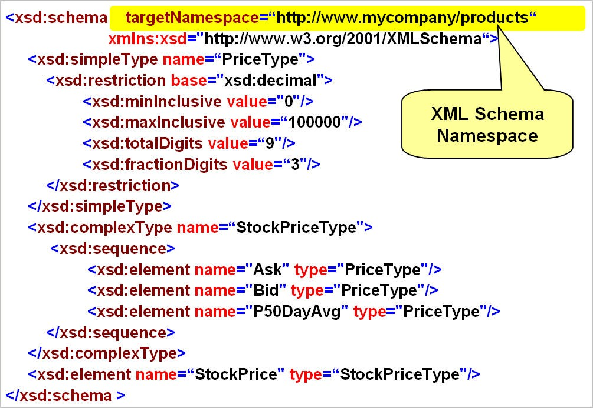An xml schema defines the structure, content and data types for the XML document. It can consist of one or more schema documents. A schema document can define a namespace.

Figure 8.2 - XML Schema: An example

An XML Schema is an XML-based alternative to DTDs. An XML Schema describes the structure of an XML document. The XML Schema language is also referred to as XML Schema Definition (XSD). XML Schemas are more powerful than DTDs, because XML schemas provide better control over the XML instance document. Using XML schemas one can not only make use of basic data types like integer, date, decimal, and datetime, but also create their own user-defined types, complex element types, etc. One can specify the length, maximum and minimum values, patterns of allowed string values and enumerations as well. One can also specify the sequence of the occurrence of elements in the XML document. Another advantage of using XML Schema over DTDs is its ability to support XML Namespaces. Additionally, XML schema provides support for type inheritance. XML Schema became a W3C Recommendation on May 2001.

Here is one example of one XML schema consisting of three schema documents and two namespaces.

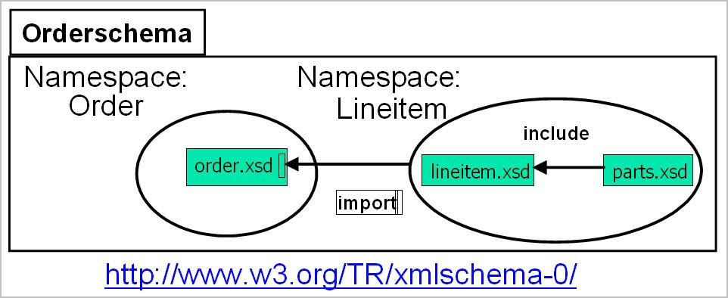

Figure 8.3 - Multiple namespaces in an XML Schema

In DB2, use of XML Schemas is optional and is on a per-document basis. This means you can use the same XML columns to store both kind of XML documents, one with an XML schema and one without an XML schema association. Therefore, there is no need for a fixed schema per XML column. XML document validation is per document (that is, per row). One can use zero, one, or many schemas per XML column. One can also choose to mix validated & non-validated documents in one column. DB2 also allows the user to detect or prevent insert of non-validated documents using the ‘IS VALIDATED’ clause in the SELECT statement.

### Overview of XML Schema

XML is a very small conforming subset of Standard Generalized Markup Language (SGML). It is very powerful and easy to use. XML has no limits on namespace or structural complexity. XML, being a meta-language, supports the definition of languages for market verticals or specific industries. XML supports a large set of data types and integrity constraints. We will discuss each of them.

##### Simple Types

The W3C XML Schema specifies a number of simple types as shown below in *Figure 8.4*.

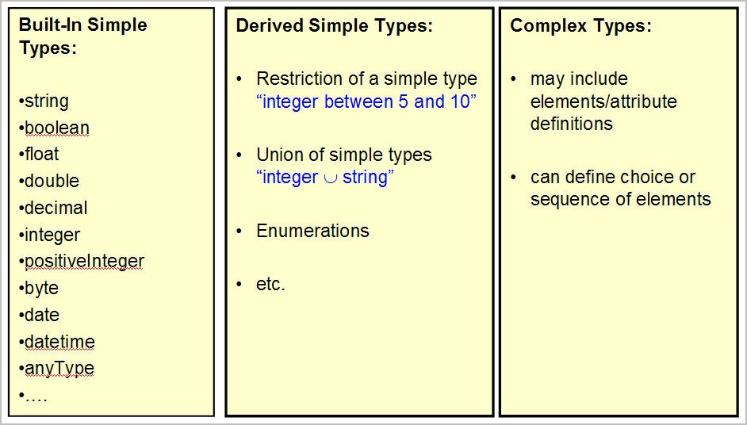

Figure 8.4 - Types in XML Schema

There are many more simple types that can be used to specify data types for elements in an XML document. Apart from defining elements using these simple types, one can also create user defined types from these simple types.

For example, given below is a derivation of a user defined type ‘myInteger’ from simple type xs:integer, which allows only values in the range of -2 to 5.

<xs:simpleType name= "myInteger" >

<xs:restriction base= "xs:integer" >

<xs:minInclusive value = "-2" />

<xs:maxExclusive value = "5" />

</xs:restriction>

</xs:simpleType>

This type of derivation is known as derivation by restriction.

Given below is an example of another derivation that makes use of the enumeration schema element:

<xs:simpleType name= "passGrades" >

<xs:restriction base= "xs:string" >

<xs:enumeration value = "A" />

<xs:enumeration value = "B" />

<xs:enumeration value = "C" />

</xs:restriction>

</xs:simpleType>

Any element defined of type passGrades can only have one of the three possible values (A, B or C). Any other value for this element will raise an XML schema error.

One can also specify a pattern of values that can be held in an element, as shown in the example below:

<xs:simpleType name= "CapitalNames" >

<xs:restriction base= "xs:string" >

<xs:pattern value = "([A-Z]( [a-z]*)?)+" />

</xs:restriction>

</xs:simpleType>

The other two types of derivations are derivation by list and derivation by union. Given below is an example of derivation by list.

<xs:simpleType name= "myintegerList" >

<xs:list itemType= "xs:integer" />

</xs:simpleType>

This data type can be used to define attributes or elements that accept a whitespace separated list of integers, like "1 234 333 -32321".

Given below is an example of derivation by union.

<xs:simpleType name= "intordate" >

<xs:union memberTypes= "xs:integer xs:date" />

</xs:simpleType>

This data type can be used to define attributes or elements that accept a whitespace separated list of integers like “1 223 2001-10-26". Note that in this case we have data with different types (integer and date) as list members.

##### Complex Types

Complex types are a description of the markup structure and they make use of simple types for construction of individual elements or attributes that make up the complex type. Simply put, elements of a complex type contain other elements/attributes. A complex element can be empty. It can also contain other elements, text, or both along with attributes. Given below is an example of a complex type.

<xs:complexType name=”employeeType>

<xs:sequence>

<xs:element name="firstname" type="xs:string"/>

<xs:element name="lastname" type="xs:string"/>

</xs:sequence>

</xs:complexType>

An element of the above complex type, can be created as shown below.

<xs:element name="employee" type=“employeeType”>

Another way of creating an element with the same complex type is as below.

<xs:element name="employee">

<xs:complexType>

<xs:sequence>

<xs:element name="firstname" type="xs:string"/>

<xs:element name="lastname" type="xs:string"/>

</xs:sequence>

</xs:complexType>

</xs:element>

The difference in both of the approaches is that the first complex type definition is independent of the element and can be reused while defining different elements.

##### Integrity constraints

XML schemas allow ways to identify and reference the pieces of information that it contains. One can directly emulate the ID and IDREFs attribute types from XML DTDs using XML Schema type xs:ID and xs:IDREFs; however, in XML Schemas, xs:ID and xs:IDREFs, can also be used with elements and not just with attributes, as in the case of DTDs. One can also enforce uniqueness among elements using the xs:unique element type, as shown in the example below.

<xs:element name =”book” >

<xs:complexType>

….

</xs:complexType>

<xs:unique name=”book”>

<xs:selector xpath=”book”/>

<xs:field xpath=”isbn”/>

</xs:unique>

</xs:element>

This will make sure that there is a unique ISBN for each book in the XML document.

One can also use xs:key and xs:keyref to enforce integrity constraints. A key is a unique constraint with an additional restriction that all nodes corresponding to all fields are required. The definition is similar to a unique element definition:

<xs:element name =”book” >

<xs:complexType>

….

</xs:complexType>

<xs:key name=”book”>

<xs:selector xpath=”book”/>

<xs:field xpath=”isbn”/>

</xs:key>

</xs:element>

The xs:keyref can be used to refer to this key from its current scope. Note that the referring attribute of the xs:keyref element should refer to an xs:key or xs:unique element defined under the same element or under one of their ancestors.

##### XML Schema evolution

One of the reasons for the growing use of XML is its flexibility as a data model. It can easily accommodate changes in schema. Today every industry segment has an industry standard specification in the form of an XML schema document. These industry standards are evolving and there is a growing need to be compliant with them. There is a need to adapt quickly to these changes without any application downtime. DB2 provides a lot of flexibility in handling these schema changes. In DB2, one can store XML documents with or without a schema association, within the same column. Similarly, one can also store XML documents compliant with different XML schemas within the same XML column. DB2 also provides a function to check the compatibility of two XML schema versions. If found compatible it also provides the facility to update the current schema with the newer version.

If you are validating your stored documents against a schema that is about to change, then there are two ways to proceed in DB2 pureXML:

* + - * If the two schemas are sufficiently alike (*compatible*), you can register the new schema in the XML Schema Repository (XSR), by replacing the original schema and continue validating. Both of the schema names (the SQL name and the schema location URI) remain the same across the two compatible schemas.
      * In cases where the two XML schemas are not alike (*not compatible)*, you register the new schema with a new SQL name and new schema location URI.

After evolving the new compatible schema when using XMLVALIDATE, you can continue to refer to the new XML schema using the existing SQL name, or you can rely on the schema location URI in the XML instance documents provided that the URI remains unchanged across the existing and new XML instance documents. Typically, compatible schema evolution is used when the changes in the schema are minor.

For example, let's take a look at a case where there are some minor schema changes. The steps to follow would be to replace the existing schema with the new modified schema on successful evolution of an XML schema in the XSR:

1. Call the [XSR_REGISTER](http://www.ibm.com/developerworks/data/library/techarticle/dm-0803faraaz/?open&amp;S_TACT=105AGY17&amp;S_CMP=TECHSUG&amp;resources%23resources) stored procedure or run the [REGISTER XMLSCHEMA](http://www.ibm.com/developerworks/data/library/techarticle/dm-0803faraaz/?open&amp;S_TACT=105AGY17&amp;S_CMP=TECHSUG&amp;resources%23resources) command to register the new XML schema in the XSR. Note that no documents should be validated against the new registered XML schema, if the plan is to replace the existing schema with the new schema as described in the next step.
2. Call the [XSR_UPDATE](http://www.ibm.com/developerworks/data/library/techarticle/dm-0803faraaz/?open&amp;S_TACT=105AGY17&amp;S_CMP=TECHSUG&amp;resources%23resources) stored procedure or run the [UPDATE XMLSCHEMA command](http://www.ibm.com/developerworks/data/library/techarticle/dm-0803faraaz/?open&amp;S_TACT=105AGY17&amp;S_CMP=TECHSUG&amp;resources%23resources) to update the new XML schema in the XSR by replacing the existing schema.

Successful schema evolution replaces the original XML schema. Once evolved, only the updated XML schema is available.

If the ***dropnewschema*** option is used on the XSR_UPDATE stored procedure or on the update XMLSCHEMA command, then the new schema is available under the existing schema name only, and is not available under the name used to register it.

### XPath

XPath 2.0 is an expression language for processing values that conform to the XQuery/XPath Data Model (XDM). XPath uses path expressions to navigate through XML documents. It is a major element in both XSLT and XQuery and is a W3C recommendation.

##### The XPath data model

XDM provides a tree representation of XML documents. Values in the XDM are sequences containing zero or more items that could be:

* + - * Atomic values such as integers, strings, or Booleans
      * XML nodes such as documents, elements, attributes, or text

XQuery or XPath expressions work with XDM instances and produce XDM instances. A sequence is an instance of XDM. A sequence is an ordered collection of zero or more items. An item can be an atomic value as mentioned above or a node. Atomic values and nodes can be mixed in any order in a sequence. Sequences cannot be nested. When two or more sequences are combined, the result is a sequence containing all of the items found in the source sequences.

For example, inserting the sequence (<x/>, <y/>, 45) between the two items in sequence ("beta", 2) results in the sequence ("beta", <x/>, <y/>, 45, 2). The notation used in the example is consistent with the syntax used to construct sequences in XQuery. The whole sequence is enclosed in parentheses and the items are separated by a comma.

##### Document Nodes

A document node is a node within every XML document that signifies the start of a document. Every XML document must have a document node and there cannot be more than one document node in a single XML document. In DB2, for a sequence returned by an XQuery or XPath statement to be treated as an XML document, the document node

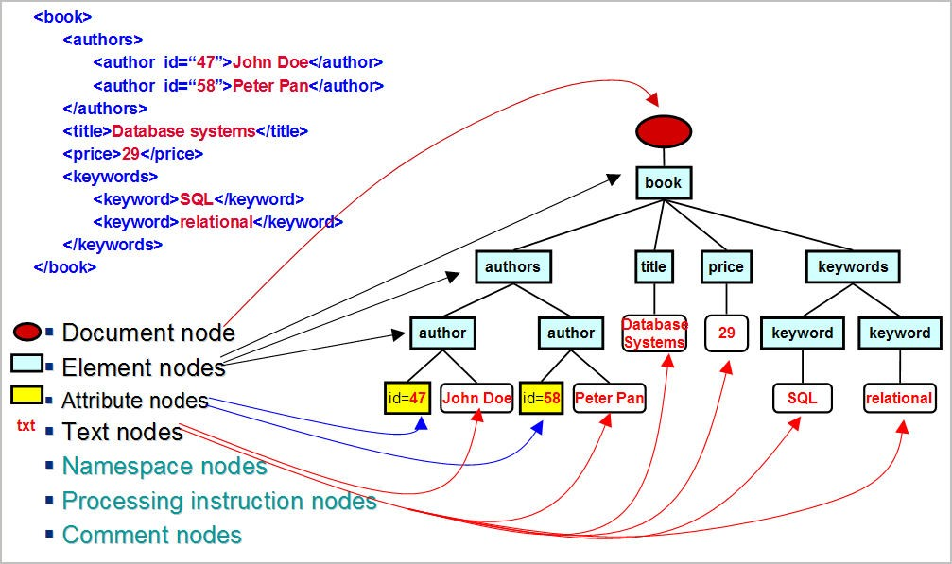constructor is used. *Figure 8.5* shows the various types of nodes that are part of an XML data model.

Figure 8.5 - XML Data Model: Node Types

For example, the following statement includes a content expression that returns an XML document that contains a root element named customer-list:

document

{

<customer-list>

{db2-fn:xmlcolumn('MYSCHEMA.CUSTOMER.INFO')/ns1:customerinfo/name}

</customer-list>

}

In a normal well-formed XML document the first node is the document node.

For example, in the XML document below, the <products> element is the document node. The document node is sometimes referred to as the root node.

<products>

<product pid="100-201-01"><description>

<name>Ice Scraper, Windshield 4 inch</name>

<price>3.99</price></description>

</product>

</products>

##### Path Expressions

Path expressions are the most commonly used expressions in XPath. They consist of one or more steps that are separated by a slash (/) or a double-slash (//). Each step produces a sequence of nodes that are used as context nodes for the step that follows. The value of the path expression is the sequence of the items produced from the final step in the path expression.

The first step defines the starting point of the location path. Often, it is a function call or a variable reference that returns a sequence of nodes. An initial "/" means that the path begins from the root node. An initial "//" means that the path begins with a sequence formed from the root node plus all of its descendants.

##### Advanced Navigation in XPath

Each step can be another axis step or filter expression. An axis step consists of three parts:

* + - * An optional axis that specifies a direction of movement through the XML document or fragment;
      * A node test that defines the criteria used to select nodes; and
      * Zero or more predicates that filter the sequence produced by the step.

The result of an axis step is a sequence of nodes, and each node is assigned a context position that corresponds to its position in the sequence. Context positions allow every node to be accessed by its position.

##### XPath Semantics

The table given below shows the various axes supported in DB2.

|  |  |  |
| --- | --- | --- |
| **Axis** | **Description** | **Direc****tion** |
| Self | Returns the context node. | Forward |
| Child | Returns the children of the context node | Forward |
| descendant | Returns the descendants of the context node | Forward |
| descendant-or-self | Returns the context node and its descendants | Forward |
| Parent | Returns the parent of the context node | Reverse |
| Attribute | Returns the attributes of the context node | Forward |

A node test is a condition that must be true for each node that is selected by an axis step. The node test can be either a name test or kind test.

A name test filters nodes based on their names. It consists of a QName or a wildcard and, when used, selects the nodes (elements or attributes) with matching QNames. The QNames match if the expanded QName of the node is equal to the expanded QName in the name test. Two expanded QNames are equal if they belong to the same namespace and their local names are equal.

The table given below describes all name tests supported

|  |  |
| --- | --- |
| **Test** | **Description** |
| QName | Matches all nodes whose QName is equal to the specified QName |
| NCName.* | Matches all nodes whose namespace URI is the same as the namespace to which the specified prefix is bound |
| *.NCName | Matches all nodes whose local name is equal to the specified NCName |
| * | Matches all nodes |

A kind test filters nodes based on their kind. The table given below describes all kind tests supported in DB2.

|  |  |
| --- | --- |
| **Test** | **Description** |
| node() | Matches any node |
| text() | Matches any text node |
| comment() | Matches any comment node |
| processing-instruction() | Matches any processing instruction node |
| element() | Matches any element node |
| attribute() | Matches any attribute node |
| Document-node() | Matches any document node |

There are two syntaxes for axis steps: unabbreviated and abbreviated. The unabbreviated syntax consists of an axis name and node test that are separated by a double colon (::). In the abbreviated syntax, the axis is omitted by using shorthand notations.

The table given below describes abbreviated syntax supported in DB2.

|  |  |
| --- | --- |
| **Abbreviated syntax** | **Description** |
| No Axis specified | child:: except when the node test is attribute(). In that case, omitted |

|  |  |
| --- | --- |
|  | axis shorthand for attribute:: |
| @ | attribute:: |
| // | /descedent-or-self::node() except when it appear in the beginning of path expression. In that case, axes step selects the root of the tree plus all nodes that are its descendents |
| . | self::node() |
| .. | Parent::node() |

For example, the following table shows equivalent path expressions.

|  |  |
| --- | --- |
| **Path expression** | **Path Expression using abbreviated syntax** |
| /dept/emp/firstname/child::node() | /dept/emp/firstname |
| /dept/emp//firstname/parent::node()/@id | /dept/emp/firstname/../@id |

##### XPath Queries

In DB2 one can write the XPath expressions by embedding the path expressions in XQuery.

For example, the following XQuery returns names (name elements) of all products stored in the DESCRIPTION column of the PRODUCT table.

XQuery db2-fn:xmlcolumn('PRODUCT.DESCRIPTION')/product/description/name Execution result

1

------------------------------------------------------

<name>Snow Shovel, Basic 22 inch</name>

<name>Snow Shovel, Deluxe 24 inch</name>

<name>Snow Shovel, Super Deluxe 26 inch</name>

<name>Ice Scraper, Windshield 4 inch</name>

4 record(s) selected.

As shown above, ***xmlcolumn*** is an XQuery function that takes a string argument of the form SCHEMANAME.TABLENAME.XMLCOLUMNNAME. If the table to be queried is in the default schema then only TABLENAME.XMLCOLUMNNAME needs to be specified. Db2-fn is the name of the namespace that the xmlcolumn function belongs to. The xmlcolumn function returns all the XML documents stored in the specified XML column.

DB2 provides another XQuery function called ***sqlquery*** to achieve the same result as ***xmlcolumn*** function. The difference between the two functions is in the ability of the ***sqlquery*** function to specify specific XML document as opposed to all XML documents

returned by the ***xmlcolumn*** function. For example, the XQuery below returns the names of only those products whose pid is 100-201-01, where pid is a relational column.

XQuery db2-fn:sqlquery("select DESCRIPTION from PRODUCT where pid= '100- 201-01'")/product/description/name

Execution result : 1

---------------------------------------------------

<name>Ice Scraper, Windshield 4 inch</name>

1 record(s) selected.

### XQuery

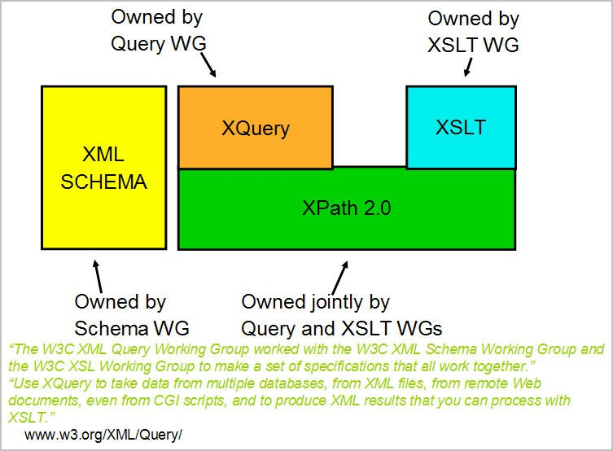XQuery is a query language designed for XML data sources. XQuery was developed by the W3C working group and is now in recommendation status. XQuery is being used as an industry standard query language for XML. It provides declarative access to XML data just as SQL does for relational data. *Figure 8.6* shows XQuery and other XML related standards. The figure illustrates that XPath and XQuery both use XPath as the foundation and makes use of XPath expressions.

Figure 8.6 - XQuery and related standards

##### XQuery basics

Every XQuery consists of two parts:

* + - * The prolog, which is optional, consists of declarations that define the execution environment of the query.
      * The query body consists of an expression that provides the result of the query. The input and output of the XQuery are always XDM instances.

Given below is an example of an XQuery, where the declare default element namespace statement is the prolog and the body consists of FLWOR expression. The FLWOR expression will be described in a later section.

XQUERY

declare default element namespace ["http://posample.org";](http://posample.org/) for $cust in db2-fn:xmlcolumn('CUSTOMER.DESCRIPTION') return $cust/Name/LastName;

The body of an XQuery can consists of any or all of the following expressions:

* + - * Literals and variables
      * Path expressions
      * Predicates
      * If ..then..else
      * Constructors
      * Comparisons
      * FLWOR expressions

##### FLWOR expressions

FLWOR expressions are a major portion of the XQuery language. FLWOR is an abbreviated form of the FOR LET WHERE ORDER BY and RETURN expression of XQuery.

Often the FLWOR expression is compared with the SELECT FROM WHERE ORDER BY statement in SQL.

Given below is an example of a simple FLWOR expression in an XQuery.

XQuery

for $x in db2-fn:xmlcolumn('PRODUCT.DESCRIPTION') let $p := $x/product/description/name

where $x/product/description/price < 3

return <cheap_products> {$p} </cheap_products>

The “for” clause iterates through a sequence and binds a variable to items in the sequence, one at a time. Here $x is the binding to the sequence of XML documents stored in

DESCRIPTION column. During each iteration of the “for” clause, $x holds one item (XDM instance) from the set of XML documents XQuery variable $p. For example, if the XML document bound with $x has four product names, then all the product names will become part of the sequence and will be bound to the variable $p.

The “where” clause is similar to the where clause in SQL and filters the result set based on the given predicate. In the given example, the where clause selects only those products whose price is less than “3”.

The “return” clause specifies the XDM instance to be returned. The XDM instance can be returned just as it comes out from the query evaluation or by combination with additional elements constructed in the return clause,. An example of this can be seen above.

Given below are a few more examples of XQuery FLWOR:

1. XQuery for $i in (1 to 3) return $i

OR

1. XQuery for $x in db2-fn:xmlcolumn(‘PRODUCT.DESCRIPTION’)//text()

Execution Result 1

----- 1

2

3

The above query will return all the text nodes from all the XML documents stored in DESCRIPTION column of the PRODUCT table.

##### Joins in XQuery

One can also have joins over multiple XML sources in XQuery. This is useful when we need to query XML data from more than one XML column. Given below, is an example of joins in XQuery.

for $book in db2-fn:xmlcolumn('BOOKS.DOC')/book

for $entry in db2-fn:xmlcolumn('REVIEWS.DOC')/entry where $book/title = $entry/title

return <review>

{$entry/review/text()}

</review>;

Here, the join is over two XML columns named DOC from two different tables, namely, BOOKS and REVIEWS. The DOC column in the BOOKS table, stores all the basic information about books, like, title, author and price of the book in XML format. The DOC column of the REVIEWS table, stores the review information of the books like the title of the book and the reviewers of the book along with the review description itself. The above XQuery returns the review information (text nodes only) about only those books for which there is an entry in both the BOOKS table and the REVIEWS table.

##### User-defined functions

According to the XQuery specification, one can create user-defined functions within the scope of XQuery and can invoke such functions during the execution period of the XQuery. DB2 provides plenty of built-in functions that can be used inside XQuery. It has functions to manipulate strings, numbers and date values. It also provides many functions to perform operations on sequences like reversing a sequence, etc. For example, this XQuery makes use of the “contains” function provided by DB2:

XQuery

declare default element namespace ["http://posample.org";](http://posample.org/) for $x in db2-fn:xmlcolumn('PRODUCT.DESCRIPTION')

let $p := $x/product/description/name

where $x/product/description/name/fn:contains(text(),'Scraper') return $p

Execution result 1

---------------------------------------------------------------------

<name>Ice Scraper, Windshield 4 inch</name>

1 record(s) selected.

##### XQuery and XML Schema

XQuery and XML schema are both standards developed by the working group of W3C. The XML Schema specification deals with associating a data type to the XDM instance.

DB2 provides built in functions to explicitly cast various node values into XML schema types, for example, the XQuery given below makes use of the built in function xs:double.

XQuery

declare default element namespace ["http://posample.org";](http://posample.org/) for $x in db2-fn:xmlcolumn('PRODUCT.DESCRIPTION')

let $p := $x/product/description/name

where $x/product/description/xs:double(price) = 3.99 return $p

##### Grouping and aggregation

XQuery supports both grouping and aggregation of XML data.

Given below, is an example of grouping XML data from two XML columns from two different tables. The following query groups customer names in the CUSTOMER table.

The “for” clause iterates over the customer info documents and binds each city element to the variable *$city*. For each city, the “let” clause binds the variable *$cust-names* to an unordered list of all the customer names in that city. The query returns city elements that each contain the name of a city and the nested name elements of all of the customers who live in that city.

XQuery

for $city in fn:distinct-values(db2-fn:xmlcolumn('CUSTOMER.INFO')

/customerinfo/addr/city)

let $cust-names := db2-fn:xmlcolumn('CUSTOMER.INFO')

/customerinfo/name[../addr/city = $city] order by $city

return <city>{$city, $cust-names} </city>

The query returns the following result:

Execution result : 1

<city>Aurora

<name>Robert Shoemaker</name>

</city>

<city>Markham

<name>Kathy Smith</name>

<name>Jim Noodle</name>

</city>

<city>Toronto

<name>Kathy Smith</name>

<name>Matt Foreman</name>

<name>Larry Menard</name>

</city>

Below is an example of aggregation in an XQuery. Here the query iterates over each PurchaseOrder element with an order date in 2005 and binds the element to the variable

$po in the “for” clause. The path expression $po/item/ then moves the context position to each item element within a PurchaseOrder element. The nested expression (price * quantity) determines the total revenue for that item. The fn:sum function adds the resulting sequence of total revenue for each item. The “let” clause binds the result of the fn:sum function to the variable $revenue. The “order by” clause then sorts the results by total revenue for each purchase order.

for $po in db2-fn:xmlcolumn('PURCHASEORDER.PORDER')/ PurchaseOrder[fn:starts-with(@OrderDate, "2005")]

let $revenue := sum($po/item/(price * quantity)) order by $revenue descending

return

<tr>

<td>{string($po/@PoNum)}</td>

<td>{string($po/@Status)}</td>

<td>{$revenue}</td>

</tr>

##### Quantification

Quantified expressions return true or false depending on whether some or every item in one or more sequence satisfies a specific condition. Here are two examples:

some $i in (1 to 10) satisfies $i mod 7 eq 0

every $i in (1 to 5) , $j in (6, 10) satisfies $i < $j

The quantified expression begins with a quantifier: some or every. The quantifier is then followed by one or more clauses that bind variables to sequences that are returned by expressions. In our first example, $i is the variable and (1 to 10) is the sequence. In the second example we have two variables $i and $j that are bound to (1 to 5) and (6 to 10). Then we have a test expression, in which bound variables are referenced. The test expression is used to determine if some or all of the bound variables satisfy a specific condition. In our first example, the condition is if $i mod 7 is equal to 0. The qualifier for this expression is “some”, and there is a value for which the test expression is true, so the result is true. In the second example, the condition is if $i is less than $j. The qualifier is “every”, so we check to see if every $i is less than every $j. The result is true.

### XSLT

XSLT stands for eXtensible Stylesheet Language Transformations. It is part of the XSL standard and describes how to transform (change) the structure of an XML document into an XML document with a different structure. This helps in representing the same piece of data in different formats. For example, the details of a purchase order stored as an XML document can be transformed using different style sheets into various formats. The same purchase order document can be shown on a web site in tabular format by embedding HTML tags into it. *Figure 8.7* illustrates how XSLT works.

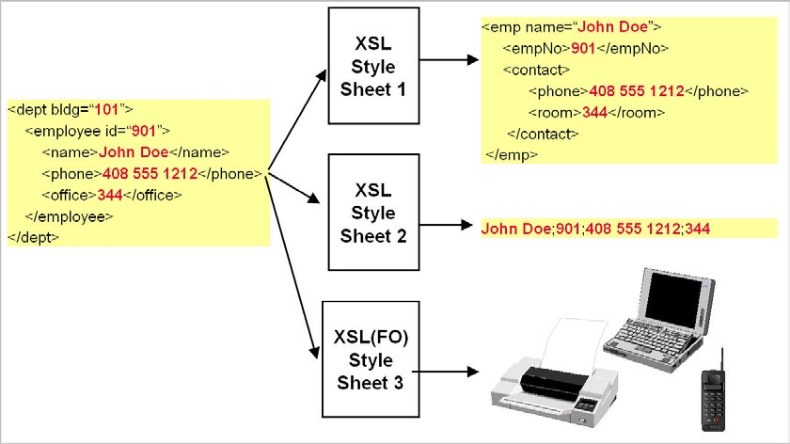

Figure 8.7 - eXtensible Stylesheet Language (XML): one source and many targets

In DB2 9.7, to perform XSLT transformations the following two things are required.

* + 1. Source XML document
    2. XSLT Stylesheet

An XSLT style sheet is also a well-formed XML document and hence can be stored in DB2 in an XML column. Below is an example of a XSLT style sheet document.

<xsl:stylesheet version="1.0" [xmlns:xsl="http://www.w3.org/1999/XSL/Transform">](http://www.w3.org/1999/XSL/Transform)

<xsl:template match="/">

<html>

<body>

<h2>Product Details</h2>

<table border="1">

<tr >

<th>Name</th>

<th>Price</th>

</tr>

<xsl:for-each select="product/description">

<tr>

<td><xsl:value-of select="name"/></td>

<td><xsl:value-of select="price"/></td>

</tr>

</xsl:for-each>

</table>

</body>

</html>

</xsl:template>

</xsl:stylesheet>

Sample XML source document to be transformed:

<products>

<product pid="100-201-01">

<description>

<name>Ice Scraper, Windshield 4 inch</name>

<details>Basic Ice Scraper 4 inches wide, foam handle</details>

<price>3.99</price>

</description>

</product>

</products>

DB2 9.7 provides the ***XSLTransform*** function that takes the source XML document and XSLT stylesheet as input and returns the transformation result (also an XML document).

For example, the following SELECT statement using the ***XSLTransform*** function returns the HTML document which can be saved as a .html file

SELECT XSLTRANSFORM (description USING stylesheet AS CLOB (10M)) FROM product where pid like ‘100-201-01’

Execution Result : 1

----------------------------------------------------------

<html>

<body>

<h2>Product Details</h2>

<table border="1">

<tr>

<th>Name</th><th>Price</th>

</tr>

</table>

</body>

</html>

1 record(s) selected.

### SQL/XML

SQL/XML defines a standard mechanism for using XML data with SQL statements. It’s an ANSI/ISO standard that defines the various SQL based extensions (functions) that allow various operations on relational and XML data. It also defines XML as a data type. These functions are treated as extensions to the SQL statements. It also defines functions to parse XML documents and to validate XML documents against an XML schema. There are other functions such as XMLCONCAT and XMLAGG that can be used to combine XML fragments into one or more large XML documents.

##### Encoding relations as XML Documents

SQL/XML defines functions to transform relational data in XML format and vice versa. It defines functions to validate, parse and serialize XML documents. Publishing functions are useful when there is a need for sending data in XML format to the application. For example, if a web service is invoked that returns the stock quote for the given stock code (as an XML document) then the stock information which is stored in relational tables can be transformed into XML format and then the web service can send the same XML to the requesting application. On many occasions, it may be necessary to use the relational equivalent of some XML fragments, as there can be some reporting or business intelligence tools that use this relational data from an XML fragment and process it further.

##### Storing and publishing XML documents

Publishing functions are SQL/XML functions that are used to transform relational data to XML and vice versa.

##### SQL/XML Functions

Let’s look at some of the SQL/XML functions and their syntax.

* + - 1. XMLELEMENT and XMLATTRIBUTES

XMLELEMENT and XMLATTRIBUTES are two of the most commonly used publishing functions. As the name suggests, XMLELEMENT function constructs an XML element from given relational data. For example, the following SELECT statement produces the result as given below.

Select XMLELEMENT(NAME "firstname", firstnme) from employee Execution Result:

1

--------------------------------------------

<FIRSTNAME>CHRISTINE</FIRSTNAME>

<FIRSTNAME>MICHAEL</FIRSTNAME>

<FIRSTNAME>SALLY</FIRSTNAME>

<FIRSTNAME>JOHN</FIRSTNAME>

<FIRSTNAME>IRVING</FIRSTNAME>

<FIRSTNAME>EVA</FIRSTNAME>

6 record(s) selected.

Here NAME is a keyword indicating that the string following the keyword is the name of the element to be constructed. The string indicating the name of element is then followed by the relational column name, which is firstname, in the given example. The XMLATTRIBUTES function is used to construct attributes from relational data. For example, the following SELECT statement will produce the result as shown below.

Select XMLELEMENT(NAME "emp" , XMLATTRIBUTES(EMPNO AS "employee_num" )) from employee

Execution Result : 1

-------------------------------------------------------

<EMP EMPLOYEE_NUM="000010"/>

<EMP EMPLOYEE_NUM="000020"/>

<EMP EMPLOYEE_NUM="000030"/>

<EMP EMPLOYEE_NUM="000050"/>

<EMP EMPLOYEE_NUM="000060"/>

6 record(s) selected.

The XMLATTRIBUTES function takes both the attribute name and its value as a single parameter in the form A AS "B", where A is the value of the attribute, which can be a relational column (empno) followed by the keyword AS, which is followed by a string indicating the name of the attribute (employee_num).Note that the element EMP does not have any text value.

Given below is another example of the XMLATTRIBUTES function where the EMP element has two attributes (NUM and SALARY). It also has two child elements (FIRST and LAST), indicating the first and last names of the employee.

Select

XMLELEMENT(NAME "emp" ,

XMLATTRIBUTES(EMPNO AS "NUM",SALARY as "salary" ),

XMLELEMENT(NAME "first" , firstnme), XMLELEMENT(NAME "last", lastname) )

from employee Execution Result : 1

-----------------------------------------------------------

<EMP NUM="000010" SALARY="152750.00"><FIRST>CHRISTINE</FIRST><LAST>HAAS</LAST></EMP>

<EMP NUM="000020" SALARY="94250.00"><FIRST>MICHAEL</FIRST><LAST>THOMPSON</LAST></EMP>

<EMP NUM="000030" SALARY="98250.00"><FIRST>SALLY</FIRST><LAST>KWAN</LAST></EMP>

<EMP NUM="000050" SALARY="80175.00"><FIRST>JOHN</FIRST><LAST>GEYER</LAST></EMP>

<EMP NUM="000060" SALARY="72250.00"><FIRST>IRVING</FIRST><LAST>STERN</LAST></EMP>

* + - 1. XMLQUERY

One of the advantages of using SQL/XML over XQuery-only queries is the fact that one can retrieve both relational and XML data from the table at the same time. XMLQUERY is the SQL/XML function that allows this operation to be performed. The XMLQUERY function takes an XQuery-expression-constant, an expression that results in values of type XML. For example, the following SELECT statement returns ids and names of all the products from the PRODUCT table.

"PRODUCTNAME" FROM product

Execution Result :

PID PRODUCTNAME

------------------------------------------------------------

|  |  |  |  |
| --- | --- | --- | --- |
| 100-100-01 | <name>Snow | Shovel, | Basic 22 inch</name> |
| 100-101-01 | <name>Snow | Shovel, | Deluxe 24 inch</name> |
| 100-103-01 | <name>Snow | Shovel, | Super Deluxe 26 inch</name> |

100-201-01 <name>Ice Scraper, Windshield 4 inch</name>

4 record(s) selected.

The product names are part of the DESCRIPTION column that contains XML documents describing the product. Note that if there is more than one DESCRIPTION column (as a result of join over two or more tables), then one can use the PASSING clause as shown below.

SELECT pid , XMLQUERY('$D/product/description/name' PASSING prod.description as "D" ) AS "PRODUCTNAME" FROM product prod, purchaseorder po

If the XML documents contain any namespaces then the same query will have to be re- written as given below.

SELECT pid , XMLQUERY('$DESCRIPTION/*:product/*:description/*:name' ) AS "PRODUCTNAME" FROM product

Execution Result :

PID PRODUCTNAME

--------------------------------------------------------------------

100-100-01 <name [xmlns="http://posample.org">Snow](http://posample.org/) Shovel, Basic 22 inch</name>

100-101-01 <name [xmlns="http://posample.org">Snow](http://posample.org/) Shovel, Deluxe 24 inch</name>

100-103-01 <name [xmlns="http://posample.org">Snow](http://posample.org/) Shovel, Super Deluxe 26 inch</name>

100-201-01 <name [xmlns="http://posample.org">Ice](http://posample.org/) Scraper, Windshield 4 inch</name>

4 record(s) selected.

Here the XMLQUERY is returning an XML sequence from all the XML documents in that column. If one wishes to retrieve a specific product name based on a predicate then the XMLEXISTS function needs to be used along with XMLQUERY.

For example, the following SELECT statement will retrieve names of the products having pid 100-103-01 and with price of the product being 49.99

"PRODUCTNAME" FROM product

where XMLEXISTS(‘$DESCRIPTION/*:product[@pid="100-103-

01"]/*:description[*:price="49.99"]’) Execution Result :

PID PRODUCTNAME

----------------------------------------------------------------------

100-103-01 <name [xmlns="http://posample.org">Snow](http://posample.org/) Shovel, Super Deluxe 26 inch</name>

1 record(s) selected.

One important aspect of using XMLEXISTS along with XMLQUERY for predicate match is that it helps in eliminating empty sequences. These are returned by XMLQUERY for non- matching rows. XMLEXISTS will return a true or a false based on whether the predicate match takes place or not. The XMLQUERY function will then return a sequence for every corresponding true value returned by XMLEXISTS function and thus eliminating empty sequences.

For example, if the SELECT statement with predicates is written without XMLEXISTS as below, the result will lead to confusion. In the SELECT statement below, the predicate is part of the XQuery-expression-constant parameter of the XMLQUERY function

SELECT pid , XMLQUERY('

$DESCRIPTION/*:product[@pid="100-103- 01"]/*:description[*:price="49.99"]/*:name')

AS "PRODUCTNAME"

FROM product Execution Result:

PID PRODUCTNAME

----------------------------------------------------------------------- 100-100-01

100-101-01

100-103-01 <name [xmlns="http://posample.org">Snow](http://posample.org/) Shovel, Super Deluxe 26 inch</name>

100-201-01

4 record(s) selected.

The reason behind the 3 empty sequences is that XMLQUERY always returns a sequence. It will return a matching sequence if the predicate is satisfied and an empty sequence if the predicate match fails. Hence it is recommended to make use of XMLEXISTS function in tandem with XMLQUERY for predicate match.

* + - 1. XMLAGG

The XMLAGG function returns an XML sequence that contains an item for each non-null value in a set of XML values. For example, the following SELECT statement will aggregate employees belonging to a department into one group:

XMLELEMENT (NAME "Department",

XMLATTRIBUTES (e.workdept AS "name" ),

XMLAGG ( XMLELEMENT (NAME "emp", e.firstnme) )

) AS "dept_list" FROM employee e

GROUP BY e.workdept;

Execution Result:

dept_list

--------------------------------------------------------------------

<Department name="A00">

<emp>CHRISTINE</emp>

<emp>VINCENZO</emp>

<emp>SEAN</emp>

<emp>GREG</emp>

</Department>

<Department name="B01">

<emp>MICHAEL</emp>

</Department>

<Department name="C01">

<emp>SALLY</emp>

<emp>DELORES</emp>

<emp>HEATHER</emp>

<emp>KIM</emp>

</Department>

<Department name="D21">

<emp>EVA</emp>

<emp>MARIA</emp>

</Department>

<Department name="E01">

<emp>JOHN</emp>

</Department>

### Querying XML documents stored in tables

Apart from constructing XML documents from relational data using SQL/XML functions- one can also use XQuery to query the XML documents that are stored in columns of type XML. If the need is it to use SQL SELECT as the primary language, then one can use the SQL/XML function XMLQUERY and pass the XQuery as a parameter to this function.

The choice of query language depends on what type of data needs to be retrieved. If only XML data is required, then one has the choice of using XQuery or the XMLQUERY function, as part of the SQL SELECT statement. On the other hand, if both relational and

XML data needs to be retrieved, then SQL SELECT statement along with the XMLQUERY is the ideal choice.

### Modifying data

Storing XML documents inside a database is an important aspect of data management. It is a requirement of today’s business needs to be compliant with standards, and should be able cater to the changing needs of customers in a timely manner. DB2 not only provides for efficient storage of XML documents, with its native storage technology, but also provides ways to manipulate the XML data being stored. It provides various functions like XMLPARSE and XMLSERIALIZE, to convert the text presentation of XML documents into the native XML format and vice versa

##### XMLPARSE

As mentioned above XMLPARSE is a function that parses the given XML text and then converts it into native XML format (i.e. hierarchical tree format). While inserting DB2 by default does an implicit parse of the XML text, but if the user wants to explicitly parse the XML text, then the XMLPARSE function can be used.

For example, the following INSERT statement first parses the given XML text and if it finds that the XML document is well-formed, it goes ahead with insertion of the XML document into the specified column of the table.

INSERT INTO PRODUCT(PID,DESCRIPTION) VALUES(‘100-345-01’, XMLPARSE(

DOCUMENT ‘<product [xmlns="http://posample.org"](http://posample.org/) pid="100-100-01">

<description><name>Snow Shovel, Basic 22 inch</name>

<details>Basic Snow Shovel, 22 inches wide, straight handle with D- Grip</details>

<price>9.99</price>

<weight>1 kg</weight>

</description>

</product> ‘))

Another reason for using XMLPARSE is that it allows one to specify the way whitespace is to be treated. By default DB2 strips boundary whitespace between elements, but if the user wants to preserve the whitespace, then the PRESERVE WHITESPACE clause can be used as shown below.

INSERT INTO PRODUCT(PID,DESCRIPTION) VALUES(‘100-345-01’, XMLPARSE(

DOCUMENT ‘<product [xmlns="http://posample.org"](http://posample.org/) pid="100-100-01">

<description><name>Snow Shovel, Basic 22 inch</name>

<details>Basic Snow Shovel, 22 inches wide, straight handle with D- Grip</details>

<price>9.99</price>

<weight>1 kg</weight>

</description>

</product> ‘ PRESERVE WHITESPACE))

##### XMLSERIALIZE

As the name suggests, the function XMLSERIALIZE is used to serialize the XML tree structure into string/binary format. It allows the XML tree format to be serialized into CHAR/CLOB/BLOB formats. This type of serialization is necessary when you need to manipulate the XML in text format, because any data returned by XQuery from the set of XML documents is by default of type XML.

For example, the following SELECT statement will fetch XML documents from the PRODUCT table’s DESCRIPTION column and return them as serialized character large objects (CLOB) belonging to the product with pid ‘10010001’.

SELECT XMLSERIALIZE(DESCRIPTION AS CLOB(5K)) FROM PRODUCT WHERE PID LIKE ‘10010001’

Execution Result:

1

------------------------------------------------------------------------

<product [xmlns="http://posample.org"](http://posample.org/) pid="100-100-01">

<description><name>Snow Shovel, Basic 22 inch</name>

<details>Basic Snow Shovel, 22 inches wide, straight handle with D- Grip</details><price>9.99</price><weight>1 kg</weight>

</description>

</product>

1 record(s) selected.

##### The TRANSFORM expression

In DB2 9.5, the TRANSFORM expression was introduced, which allows the user to make modifications to existing XML documents stored in XML columns. The transform expression is part of the XQuery Update facility which facilitates the following operations on an XDM instance.

* Insertion of a node
* Deletion of a node
* Modification of a node by changing some of its properties while preserving its identity
* Creation of a modified copy of a new node with a new identity.

Given below is an example using transform expression that updates the XML document of customer having cid=1000. The transform expression is updating both the text value of phone number element and the value of attribute ‘type’ with ‘home’.

The XML document before execution of the update statement:

<customerinfo>

<name>John Smith</name>

<addr country=“Canada">

<street>Fourth</street>

<city>Calgary</city>

<state>Alberta</state>

<zipcode>M1T 2A9</zipcode>

</addr>

**<phone type="work">963-289-4136</phone>**

</customerinfo>

The update statement with transform expression:

update customer

set info = xmlquery( 'copy $new := $INFO

modify (

do replace value of $new/customerinfo/phone with "416-123-4567", do replace value of $new/customerinfo/phone/@type with "home" )

return $new')

where cid = 1000;

The XML document after execution of the update statement:

<customerinfo>

<name>John Smith</name>

<addr country=“Canada">

<street>Fourth</street>

<city>Calgary</city>

<state>Alberta</state>

<zipcode>M1T 2A9</zipcode>

</addr>

**<phone type="work">963-289-4136</phone>**

</customerinfo>

### Summary

XML is a very flexible data model and is best suited for certain applications. It is an ideal choice for applications with changing requirements, evolving schemas and for objects that are nested or hierarchical in nature. The ability to represent semi-structured data makes XML a good choice for data exchange and integration from diverse data sources. DB2

provides native support for storing XML documents. It efficiently manages and allows for easy querying of XML documents. It provides the user with the choice of language: One can either use XQuery or SQL/XML, depending on the data to be accessed and familiarity with the querying language. DB2 also provides a great deal of flexibility in terms of XML schema storage and validation of XML instance documents against these XML schema documents.

The transform feature in DB2 provides an easy way to make modifications to existing XML documents without having to do any modification at the application level.

### Exercises

1. Create a table with one relational (cid) and one XML column. Then insert XML documents of the following XML structure.

<customer id=”C62”>

<firstname>Pete</firstname>

<lastname>Bush</lastname>

<address>

<door>No 34</door>

<building>Galaxy Apartment</building>

<road>Meera road</road>

<city>Mumbai</city>

<zip>411202</zip>

</address>

</customer>

1. Insert 5 customer details as XML documents using the same XML structure as given above, using the INSERT statement. Make sure the cid of those 5 customers is 10, 13, 15, 20, 23 respectively.
2. Do a SELECT on the table to retrieve all the relational and XML data.
3. Write XQuery to retrieve full XML (all the XML docs stored in table).
4. Write XQuery to retrieve selected XML documents from the XML whose cid is between 10 and 20 only

### Review questions

1. Which of the following SQL/XML functions is not a publishing function?
   1. XMLELEMENT
   2. XMLATTRIBUTE
   3. XMLCONCAT
   4. XMLPARSE
   5. None of the above
2. Given the following table definition:

create table clients(

id int primary key not null,

name varchar(50),

status varchar(10), contactinfo xml )

and the XML data in column contactinfo

<customerinfo>

<name>Kathy Smith>

<addr country=”Canada>

<city>Toronto</city>

<prov-state>Ontario</prov-state>

<zip>M5H-4C9</zip>

</addr>

</customerinfo>

<customerinfo>

<name>Amit Singh>

<addr country=”Canada>

<city>Markham</city>

<prov-state>Ontario</prov-state>

<zip>N9C-3T6</zip>

</addr>

</customerinfo>

What is the output of the following query?

select xmlquery('$c/customerinfo/addr/city[1]' passing info as "c") \

from xmlcustomer \

where xmlexists('$c/customerinfo/addr[prov-state="Ontario"]' \ passing xmlcustomer.info as "c")

* 1. Toronto

Markham

* 1. <City>Toronto</City>

<City>Markham</City>

* 1. <City>Toronto

Markham</City>

* 1. None of the Above

1. XML parsing is the process of converting
   1. Relational data from its relational format to hierarchical format
   2. XML data from its serialized string format to its hierarchical format
   3. XML data from its hierarchical format to its serialized string format
   4. XML data from its hierarchical format to relational format
   5. None of the above
2. FLWOR stands for:
   1. For, Lower, Where, Or, Run
   2. From, Let, Where, Or, Reset
   3. For, Let, Where, Order by, Reset
   4. For, Let, Where, Order by, Return
3. When invoking XQuery within SQL
   1. Care should be taken since XQuery is case sensitive while SQL is not.
   2. Care should not be taken since both are case insensitive.
   3. Care should be taken since SQL is case sensitive, while XQuery is not.
   4. No care is required.
   5. None of the above
4. What is the following XQuery doing

" xquery db2-fn:xmlcolumn('NNXML1.XMLCOL')/a/b "

* 1. retrieve element b, which is a child of element a, from the XML column named XMLCOL of table NNXML1
  2. retrieve element a, which is a child of root b, from the XML column named XMLCOL of table NNXML1
  3. retrieve element b, which is a child of root a, from the XML column named NNXML1 of table XMLCOL
  4. retrieve element a from the XML column named XMLCOL of table NNXML1

1. If the following table has a single XML document in the DOC column as below. Table description: CONTEST (DOC XML)

<dept bldg="111">

<employee id="901">

<name>Ajit Patil</name>

<phone>567 789 1342</phone>

<office>124</office>

</employee>

<employee id="922">

<name>Peter Jose</name>

<phone>121 768 3456</phone>

<office>213</office>

</employee>

</dept>

Which of the following queries will return the name element <name>Peter Jose</name>?

* 1. db2-fn:xmlcolumn('CONTEST.DOC')/dept/employee[@id="922"]/name
  2. select xmlquery('$d/dept/employee[@id="922"]/name' passing DOC as "d") from contest
  3. Both a and b
  4. None of the above

1. Which of the following is equivalent to the given XQuery

xquery db2-fn:xmlcolumn('CONTEST.DOC')/dept/employee[@id="922"]/name

* 1. xquery db2-fn:xmlcolumn(‘CONTEST.DOC’)

/dept/employee/name[../@id=“922”]

* 1. xquery db2-fn:xmlcolumn(‘CONTEST.DOC’)

/dept/employee[../@id=“922”]/name

* 1. xquery db2-fn:xmlcolumn(‘CONTEST.DOC’) /dept/employee/name[@id=“922”]
  2. None of the above

1. In DB2 9.7, which of the following is true about the given update statement if the XPath expression ‘$new/customer/phone ‘ returns more than one phone elements

update customer set info =

xmlquery('copy $new := $information

modify do replace value of $new/customer/phone with "091-454-8654" return $new')

where cid = 67;

* 1. The UPDATE statement fails and an error message will be displayed
  2. The UPDATE statement will replace all phone elements with new phone element having text value "091-454-8654"
  3. The UPDATE statement will replace only the first occurrence of the phone element with the new phone element having text value "091-454-8654"
  4. None of the above

# 9

## Chapter 9 – Database Security

With the development of information technology organizations have accumulated a huge volume of data regarding many aspects of their activities. All this data can be the basis for critical decisions, which means that data has become an extremely valuable resource for organizations, so it is necessary to pay close attention to data security. For these reasons, everyone in an organization must be sensitive to security threats and take measures to protect the data within their domains.

Our discussion in this chapter will be on the need for database security, concepts underlying access control and security in a database management system and different aspects regarding security policies and procedures.

### Database security: The big picture

Often the problems related to security are complex and may involve legal, social or ethical aspects, or issues related to policies implemented or related to control of the physical equipment. Database security relates to protecting the database against intentional or unintentional threats, using elements of control that may or may not be based on the computing equipment.

The analysis of database security includes not only services provided by a DBMS, but a wider range of issues associated with database and the environment security.

Furthermore, security considerations not only apply to data contained in the database, because the gaps of security can affect other parts of the system, which in turn may affect the database.

In consequence, by focusing on database security alone will not ensure a secure database. All parts of the system must be secure: the database, the network, the operating system, the building in which the database resides physically and the persons who have an opportunity to access the system.

*Figure 9.1* illustrates the big picture of database security.

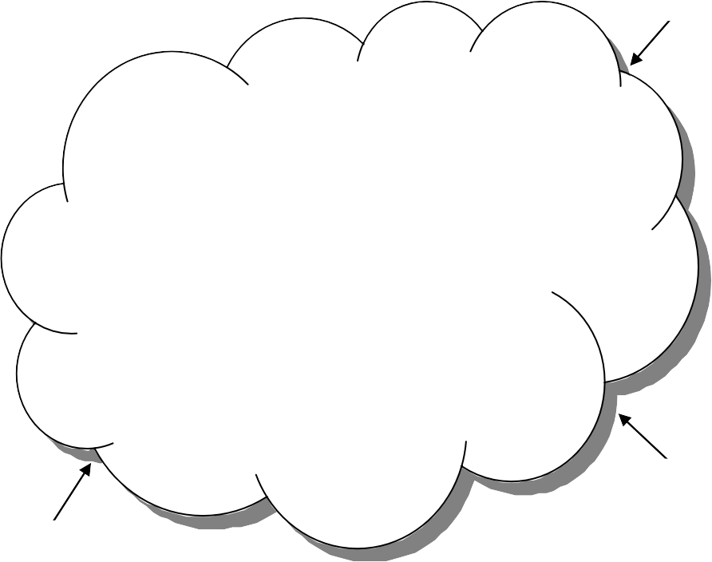

Threats

DB Client

DB Client

….

Data Encryption

Authentication

Authorization and

privileges

Threats

Threats

Figure 9.1 – Database security big picture

Designing and implementing a secure database involves achieving the following objectives:

* + - Privacy, which means that data should not be known by unauthorized users;
    - Integrity, which means that only authorized users can change data;
    - Availability, which means that authorized users should not be denied access;

To achieve these objectives, a clear security policy must be developed that describes measures to be imposed. In particular, it must be determined which users can access the database, and to which data they can access. Moreover, we must specify which operations can be run on the data.

Then we will call upon the security mechanism provided by the DBMS or the operating system. Any external mechanism, such as securing access to the building or room where the database physically resides, is beyond the scope of this discussion. The person responsible for the security of a database is the database administrator (DBA), who needs to take into account the various threats to the system.

The DBA defines the authorization rules that determine who can access the database, what parts of it can be accessed by each user, and which operations are allowed.

##### The need for database security

The reason that database security has become such an important issue is because of the increasing quantities of crucially important data that is collected and stored on computers.

Everyone recognizes that any loss of availability or loss of data could be potentially disastrous. A database is an essential collective resource which must be adequately insured, using appropriate control elements.

Threats on data security may be any situation or event, intentional or unintentional, which will negatively affect a system and finally an organization. The damage caused can be tangible (loss of data) or intangible (loss of credibility or trust of a client). Any threat should be viewed as a potential breach in the security system, which if successful, will have an impact on the organization.

Some examples of potential threats that may occur include:

* + - * data use by a user having disk media access
      * collection or unauthorized copying of data
      * alteration of programs
      * illegal access by a hacker
      * theft of data, programs or equipment
      * inadequate training of staff
      * unauthorized disclosures of data
      * calamities (fires, floods, bombings)
      * breaking or disconnecting cables
      * viruses

How much the organization suffers as a result of threat materialization depends on several factors, such as the existence of security measures and plans for exceptional circumstances.

For example, if a hardware failure occurs that alters the capacity of secondary storage, all the processing activities must cease until the problem is resolved. The period of inactivity and the speed with which the database is restored, will depend on the ability to use alternative elements of hardware and software; when the last backup was executed; the time required to restore the system; and the possibility that lost data cannot be restored and recovered.

It is necessary for organizations to identify the types of threats that they may be exposed to and initiate plans and appropriate measures, taking into account the cost of their implementation.

Spending a considerable amount of time, effort and money on some potential threats that would only result in some minor inconveniences may prove ineffective, economically. Business could influence, in turn, the types of threats to be considered, some of which might have very rare occurrences. However, rare events should be considered especially if their impact would be significant.

Database Fundamentals 224

No matter how secure a computing system may seem to be, adequate data security can only be achieved if the environment is also secure.

The following threats must be addressed in any complete data security plan:

* + - * + Theft and fraud. These actions may be perpetrated by people and may or may not alter data. In this case, attention should focus on each possible location where data or applications reside physically. Concrete physical security must be established so that unauthorized persons are unable to gain access to rooms where computers, servers, or computer files are located. Using a firewall to protect unauthorized access to inappropriate parts of the database through outside communication links, is a procedure that will stop people who are intent on theft or fraud.
        + Loss of privacy or confidentiality. Confidentiality refers to the need to preserve the secrecy of data. This is of major importance for the organization, and the privacy concerns need to protect data about individuals. Loss of privacy may lead to loss of competitiveness and failure to control privacy may lead to blackmail, bribery, public embarrassment, or stealing of user passwords. Some of these may lead to legal measures against the organization.
        + Loss of data integrity. If data integrity is impacted, data will be invalid or corrupted. In this case, an organization may suffer important losses or make wrong decisions based on incorrect data.
        + Loss of availability. This means that the data, the system, or both, cannot be accessed. Sometimes this phenomenon is accompanied by alteration of data and may lead to severe operational difficulties. This may arise as a result of sabotage of hardware, network or application, or as a result of introducing viruses.
        + Accidental losses of data. This may be the result of a human error, or software and hardware breaches. To avoid accidental loss of data, an organization should establish clear procedures for user authorization, uniform software installation, and hardware maintenance. As in any action that involves human beings, some losses are inevitable, but it is desirable that the used policies and procedures will lead to minimal loss.

Database security aims to minimize losses caused by the events listed above in an efficient way in terms of cost, and without undue constraints on users. Since computer-based crime is booming and this type of crime can threaten all the components of a system, appropriate security measures are vital.

The most used measures to ensure protection and integrity of data include: access control, views, integrity controls and encryption. It is also necessary to establish appropriate security policies and procedures, which refer to personnel and physical access control.

##### Access control

In practice, there are two major approaches to data security. These are known as ***discretionary control*** and ***mandatory control***. In both cases, the unit of data or data object to be protected can vary from the entire database to one or more records. By

Chapter 9 – Database Security 225

discretionary control, a user will have different access rights, also known as privileges on individual items. Obviously, there are various limitations in terms of rights that different users have on various objects.

For example, in a system for which the discretionary control is used, a user may be able to access object X of the database, but cannot access object Y, while user B can access object Y, but cannot access object X.

Discretionary control schemes are very flexible. You can combine rights and assign to users and objects according to your needs.

In the case of mandatory control, each data object is associated with a certain classification level and each user is given a certain permission level. A given data object can then be accessed only by users with the appropriate permission. Mandatory schemes are hierarchic in nature and are hence more rigid than discretionary ones.

Regardless of the type of security scheme that is used, all decisions on the rights that various users have regarding the database objects are business decisions not technical ones.

In order to decide what security constraints are applicable to a request for access, the system must be able to recognize the source of the request. In other words, it must recognize the user that launched the application and it must verify the user’s rights.

##### Database security case study

In this section we analyze how DB2, IBM's leading data server solves these security problems with its own security mechanisms. Security mechanisms for DB2 contain two main operations: authentication and authorization, which are running together in order to ensure security of access to DB2 resources.

* + - 1. Authentication

Authentication is the first action performed to successfully connect to a DB2 database. Authentication is the process by which users are identified by the DBMS and prove their identity to access the database.

User and group identity validation is achieved through security facilities located outside of the DBMS that is, they are performed as part of the operating system or using a third-party security facility, such as Kerberos or Lightweight Directory Access Protocol (LDAP). Authentication of a user requires two elements: a user ID and an authentication token.

The user ID allows the security component to identify the user and by supplying the correct authentication token (a password known only by the user and the security component), the user identity is verified. Sometimes if greater flexibility is needed you can build custom security plug-in modules for DB2 to use.

After successful authentication of a user, the authenticated user ID is mapped to an authorization ID. This mapping is determined by the authentication security plug-in. If the default IBM shipped authentication security plug-in is used, there are two derived authorization IDs provided: system and session IDs. In this case both authorization IDs are

Database Fundamentals 226

derived in the same way from the user ID and are identical. The system authorization ID is used for checking the connect privilege to establish a connection. The session authorization ID is the primary ID for the next connection.

* + - 1. Authorization

After a user is authenticated, it is necessary to determine whether that user is authorized to access certain data or resources. Authorization is the process of granting privileges, which allows a subject to have legitimate access to a system or an object in a system. The definition of authorization contains the terms subject and object. The subject refers to a user or program and the term object addresses a table, a view, an application, procedure or any other object that can be created in the system.

Authorization control can be implemented by software elements and it can regulate both systems and objects to which a user has access and what a user can do with them. For this reason, the authorization is also called access control. For example, a user may be authorized to read records in a database, but cannot modify or insert a record.

Authorization rules are controls incorporated in the DBMS that restrict the action that user may take when they access data. DB2 tables and configuration files are used to record the permissions associated with each authorization name.

When an authenticated user tries to access data, the authorization name of the user and the set of privileges granted to them, directly or indirectly through a group or a role, are compared with the recorded permissions. The result of the compare is used to decide whether to allow or reject the requested access.

For an authorization ID, there are more sources of permissions. Firstly, there are the permissions granted to the authorization ID directly. Then there are those granted to the groups and/or roles in which the authorization ID is member. Public permissions are those granted to a PUBLIC group, while context-sensitive permissions are those granted to a trusted context role.

In order to perform different tasks, the DBMS requires that each user be specifically, implicitly, or explicitly authorized. Explicit privileges are granted to a user, a group or a role, whereas implicit privileges are those acquired through groups to which the user belongs or through the roles assigned.

DB2 works with three forms of recorded authorization: administrative authority, privileges, and Label-Based Access Control (LBAC) credentials. A user, a group or a role can have one or more of these authorizations.

* + - 1. Administrative Authority

Administrative authority confers to a person the right to control the database and have the responsibility for data integrity. DB2 administrative authority is hierarchical. On the highest level there is SYSADM. Under SYSADM there are two kinds of authorities: instance level and database level. The levels of authority provide a method of grouping different privileges.

Chapter 9 – Database Security 227

DB2 instance authority applies to all databases within the instance and is associated with group membership. The group names that are associated with this authority level are stored in the database manager configuration files for a given instance.

At this level there are four DB2 instance authorities:

* + - * + SYSADM (system administrator) authority level controls all the resources created and maintained by the database manager. Users with SYSADM authority can perform the following tasks: migrate databases, modify the database manager configuration and database configuration files, perform database and log file backups and restoration of database and database objects such as table spaces, grant and revoke other authorities and privileges to and from users, groups or roles, full control of instances and manage audit on the instance level.
        + SYSCTRL (system control) authority provides control over operations that affect system resources. A user with SYSCTRL authority can create, update start, and stop a database. It can also start and stop an instance, but cannot access data from tables.
        + SYSMAINT (system maintenance) is an authority level which allows performing maintenance operations on all databases associated with an instance. These operations refer to update the database configuration, backup a database or a table space, restore an existing database or monitor a database. SYSMAINT does not allow access to data.
        + SYSMON (system monitor) may operate at the instance level. Concretely, it provides the authority required to use the database system monitor.

DB2 database authorities refer to a specific database within the DB2 instance. These include:

* + - * + DBADM (database administrator) which applies at the database level and provides administrative authority over a single database. A database administrator has all the privileges to create objects, execute database commands, and access all data. He can also grant and revoke individual privileges. A database administrator can create log files, query system catalog tables, update log history files, reorganize database tables or collect catalog statistics.
        + SECADM (security administrator) has the authority to create, drop, grant and revoke authorization or privileges, and transfer ownership of security objects (e.g. roles and LBAC labels). It has no privileges to access data from tables.
        + CONNECT allows the user to connect to the database.
        + BINDADD enables the user to create new packages in the database.
        + CREATETAB allows the user to create new tables in the database.
        + CREATE_EXTERNAL_ROUTINE permits the user to create a procedure for use by applications and other users of the database.

Database Fundamentals 228

* + - * + CREATE_NOT_FENCED_ROUTINE allows the user to create a user-defined function (UDF) or procedure that is not fenced.
        + IMPLICIT_SCHEMA permits any user to create a schema by creating an object by CREATE statement with a schema name that does not already exist. In this case, SYSIBM becomes the owner of the implicitly created schema and PUBLIC has the privilege to create objects in this schema.
      1. Privileges

Privileges are authorities assigned to users, groups or roles, which allow them to accomplish different activities on database objects. *Figure 9.2*, presents some DB2 privileges [9.1].

CREATE NOT FENCED

BINDADD

CONNECT

CREATETAB

CONTROL (Indexes)

Privileges

ALL ALTER DELETE INDEX INSERT

REFERENCES SELECT UPDATE

BIND EXECUTE

IMPLICIT SCHEMA

CONTROL (Packages)

CONTROL (Tables)

ALTERIN CREATEIN DROPIN

Schema Owners

CONTROL (IViews)

ALL DELETE INSERT SELECT

UPDATE

Figure 9.2 - List of some DB2 privileges

Privileges define the tasks user can perform on database objects and can be granted to individual users, groups, roles or PUBLIC.

Chapter 9 – Database Security 229

PUBLIC is a special group, for which certain database authorities and privileges can be granted to and revoked from. This can be done by any user who successfully authenticates with the DB2 instance. After a database is created the following database privileges are granted to PUBLIC by default: CONNECT, CREATETAB, BINDADD, IMPLICIT_SCHEMA, SELECT, UPDATE, EXECUTE, USE.

Users or groups who receive CONTROL privileges can also grant the privilege to some others users or groups.

* + - 1. Label Based Access Control

Label Based Access Control (LBAC) is a flexible implementation of mandatory access control (MAC). LBAC acts at both the row level and the column level and complete the discretionary access control (DAC).

The two levels of protection can be used separately or combined. LBAC can be configured to meet the security needs of each environment. All configurations are performed by a security administrator by creating security policies which describe the criteria that will be used to decide who has access to what data.

Once a security policy is established, the security administrator can create objects called security labels as part of this policy. After a security label is created it can be associated with individual columns and rows in a table to protect its data. Data protected by a security label is called protected data. A security administrator allows users access to protected data by granting them security labels. When a user tries to access protected data, their security label is compared to the security label protecting the data. It is the way to determine whether the user is allowed access to data at the column level, row level or both, or denies access to the data. A security administrator can also grant exemptions to users in order to allow the access to protected data that the security labels might otherwise prevent from access. The security labels and exemptions are LBAC credentials and are stored in the database catalogs.

The main advantage of using LBAC to protect important data is that no authority (SYSDBA, DBADM, and SECADM) has any inherent privileges to access your data.

* + - 1. Roles

In practice there are situations where multiple users must have the same set of privileges. In this case it is better to manage this set as a whole rather than handle each privilege separately, so it is appropriate to work with roles.

A database role is an object that groups together one or more privileges or database authorities. It can be assigned to users, groups, PUBLIC or other roles by a GRANT statement. For example, we can define a developer role and allow this role to insert, update and delete data on a set of tables.

By associating a role with a user, the user inherits all the privileges held by the role, in addition to privileges already held by the user.

A role may control database access at a level of abstraction that is proper to the structure of the organization, because one can create roles that map directly to those in the

organization. In this case users are granted membership to the roles based on their job responsibilities. When the user’s responsibilities change within the organization, the user membership in roles can easily be granted and revoked. Roles can be updated without updating the privileges for every user. Roles are managed inside the database and DB2 can determine when an authorization changes and act accordingly.

* + - 1. Trusted Contexts

In a three-tiered application model, where there is a Web server, an application server, and a database server; the middle tier or application server is responsible for authenticating the users running the client applications and managing the interactions with the database server. The application's server authorization ID needs to have all the privileges associated with end-users in order to perform any operations that the end users may require. While the three-tiered application model has many benefits, having all interactions with the database server (such as a user request) occur under the application server's authorization ID. This raises several security concerns like not being able to determine which client user ID performed a query at fault, for example.

Trusted contexts establish a trusted relationship between DB2 and an external entity like an application server or another DB2 server. This trust relationship is based upon the following attributes: system authorization, IP address or domain name and data stream encryption.

After a database connection has been established the attributes of that connection are compared with the definition of each trusted context object in the database. If these attributes match the definition of a trusted context object then the connection is referred to as a trusted connection. This kind of connection allows its initiator to acquire additional capabilities that are not available to them outside the scope of that trusted connection.

One may deal with two types of trusted connections: explicit or implicit. An explicit trusted connection is a trusted connection that is explicitly requested and it allows the initiator the ability to switch the current user ID on the connection to a different user ID, with or without authentication, and to acquire additional privileges that may not be available to them outside the scope of the trusted connection.

An implicit trusted connection is a trusted connection that is not explicitly requested and it allows only the ability to acquire additional privileges.

In order to define a trusted connection the following attributes must be defined:

* + - * + a system authorization ID which is the authorization ID that must be used by an incoming connection to be trusted
        + a list of IP addresses representing the IP addresses from which an incoming connection must originate in order to be trusted
        + a data stream encryption representing the level of encryption that must be used by an incoming connection in order to be trusted

##### Views

In conjunction with the authorization process, views are an important component of the security mechanism provided by a relational DBMS. Views allow a user to see information while hiding any information that the user should not be given access to.

A view is the dynamic result of one or more relational operations that apply to one or more base tables to produce another table. A view is always based on the current data in the base tables from which it is built.

The advantage of a view is that it can be built to present only the data to which the user requires access and prevent the viewing of other data that may be private or confidential.

A user may be granted the right to access the view but not to access the base tables upon which the view is based.

##### Integrity Control

The aim of integrity control is to protect data from unauthorized use and update, by restricting the values that may be held and the operations that can be performed on data. Integrity controls may also trigger the execution of some procedure, such as placing an entry in a log that records what users have done what with which data. There are more forms of integrity controls.

The first form that we discuss is the integrity of the domain. A domain may be viewed like a way to create a user-defined data type. Once a domain is created it may be assigned to any field as its data type. Consequently any value inserted in the field must belong to the domain assigned. When a domain is created, it may use constraints (for example a CHECK constraint) to restrict the values to those which satisfy the imposed condition. An important advantage of a domain is that if it must change then it can be modified in a single place – the domain definition.

Assertions are also powerful constraints that enforce some desirable database conditions. They are checked automatically by the DBMS when transactions are run involving tables or fields on which assertion exists. If the assertion fails, the DBMS will generate an error message.

For security purposes one can use triggers as well. Triggers consist of blocks of procedural code that are stored in a database andwhich run only in response to an INSERT, UPDATE or DELETE command. A trigger, which includes an event, condition, and action, may be more complex than an assertion. It may prohibit inappropriate actions, it may cause special handling procedures to be executed, or it may cause a row to be written to a log file in order to store important information about the user and transactions made to sensitive data.

##### Data encryption

Sensitive and personal data stored within the database tables and critical data transmitted across the network, such as user credentials (user ID and password), are vulnerable and should be protected against intruders.

Encryption is the process of encoding data by a particular algorithm, which makes it impossible for a program to read data without the decryption key. Usually encryption protects data transmitted through communication lines. There are more techniques for encoding data, some of which are reversible, while others are irreversible. Irreversible techniques do not allow knowledge of the original data, but can be used to obtain valid statistical information.

Any system that provides encryption facilities must also provide adequate routines for decoding, routines which must be protected by proper security.

### Security policies and procedures

It is mandatory to establish a set of administrative policies and procedures in order to create a context for effectively implementing security measures. There are two types of security policies and procedures: personnel controls and physical access controls.

##### Personnel control

Often the greatest threat to data security is internal rather than external, so adequate controls of personnel must be developed and followed. The security authorization and authentication procedures must be enforced by procedures which ensure a selection hiring process that validate potential employees regarding their backgrounds and capabilities. Employees should be trained in those aspects of security that are relevant to their jobs and encouraged to be aware of and follow standard security measures. If an employee should need to be let go then there should be a set of procedures to remove authorizations and authentications and to notify other employees about the status change.

##### Physical access control

An important physical access control is related to limiting access to particular areas within a building. A proximity access card can be used to gain access to a secured area. In this case, each access can be recorded in a database. When it is necessary a guest should be issued badges and escorted in these areas.

Sensitive equipment can be controlled by placement in a secure area. Other equipment can be locked in a desk or have an alarm attached. Backup data media should be kept in fireproof data safe or kept outside in a safe location. Procedures must explicitly state a schedule for moving media or disposing of media, and establish labeling and indexing of such materials stored.

Lately, new companies are trending towards an increasingly mobile nature of work. Laptops are very susceptible to theft, which puts data on the laptop at risk. Encryption and multiple factor authentication can protect data. Antitheft devices, like security cables or geographical tracking chips, can help determine theft and quickly recover laptops on which critical data are stored.

### Summary

This chapter covered the general security aspects of databases.

The chapter started describing the need to protect data and their environment, and the different threats can affect data in databases and the whole organization.

The first security measure refers to access control, which may be discretionary or mandatory. We presented various cases of access control that can be implemented in DB2, such as authentication and authorization mechanism, privileges, roles, label based access control and trusted contexts.

A simple and flexible way to hide a big part of a database from users is by utilizing views.

Integrity control aims to protect data from unauthorized access, by restricting the values that may be assigned and the operations that can be performed on data. For these purposes, there are defined domains, assertions and triggers.

Critical data transmitted across the network and personal and sensitive data must be protected by encryption.

The measures mentioned in this chapter may not stop all malicious or accidental access or modification of data. For this purpose it is necessary to establish a set of administrative policies and procedures in order to create a context for effectively implementing these measures. The most used procedures and security policies refer to personnel control and physical access control.

### Exercises

Review Chapter 10, "Database security" in the free eBook [Getting started with DB2](http://ibm.com/db2/books) [Express-C](http://ibm.com/db2/books) and create two users in your operating system.

Can those two users create a database? Why? Can the two users connect to the database? Why?

Can the two users select from the view SYSCAT.TABLES? Why?

### Review Questions

1. Why is it necessary to protect data in a database?
2. Is it enough to protect only data in a database?
3. What are some threats that must be addressed in a complete security plan?
4. What is the definition of the discretionary control of access?
5. What are the forms of authorization in DB2?
6. What are privileges?
7. How are trusted contexts used in DB2?
8. What is a view and why is that considered an important component of the security mechanism?
9. How can integrity control be assured?
10. What are the most used security policies and procedures?

# 10

## Chapter 10 – Technology trends and databases

An IBM survey conducted in 2010 revealed different technology trends by 2015. The survey garnered responses from more than 2,000 IT professionals worldwide with expertise in areas such as software testing, system and network administration, software architecture, and enterprise and web application development. There were two main findings from the survey:

* + Cloud computing will overtake on-premise computing as the primary way organizations acquire IT resources.
  + Mobile application development for devices such as iPhone and Android, and even tablet PCs like iPad and PlayBook, will surpass application development on other platforms.

This chapter explores Cloud computing, mobile application development, and other technology trends, and explains the role that databases play in these technologies. Moreover, the chapter presents you with a real life case scenario where these technologies are used. After completing this chapter, you should have a good understanding of these technologies to take advantage of them for future solutions you develop.

### What is Cloud computing?

Cloud computing is not a new technology, but a new model to deliver IT resources. It gives the illusion that people can have access to an infinite amount of computing resources available on demand. With Cloud computing, you can rent computing power with no commitment. There is no need to buy a server, just pay for what you use. This new model is often compared with how people use and pay for utilities. For example, you only pay for how much water or electricity you consume for a given amount of time.

Cloud computing has drastically altered the way computing resources are obtained, allowing almost everybody, from one-man companies, large enterprises to governments work on projects that could not have been possible before.

*Table 10.1* compares the traditional IT model in an enterprise versus the Cloud computing model.

|  |  |
| --- | --- |
| **Traditional IT model** | **Cloud computing model** |
| Capital budget required | Part of operating expense |
| Large upfront investment | Start at 2 cents / hour |
| Plan for peak capacity | Scale on demand |
| 120 days for a project to start | Less than 2 hours to have a working system |

Table 10.1 - Comparing the traditional IT model to the Cloud computing model.

While in the traditional IT model you need to request budget to acquire hardware, and invest a large amount of money upfront; with the Cloud computing model, your expenses are considered operating expenses to run your business; you pay on demand a small amount per hour for the same resources.

In the traditional IT model, requesting budget, procuring the hardware and software, installing it on a lab or data center, and configuring the software can take a long time. On average we could say a project could take 120 days or more to get started. With Cloud computing, you can have a working and configured system in less than 2 hours!

In the traditional IT model companies need to plan for peak capacity. For example if your company's future workload requires 3 servers for 25 days of the month, but needs 2 more servers to handle the workload of the last 5 days of the month then the company needs to purchase 5 servers, not 3. In the Cloud computing model, the same company could just invest on the 3 servers, and rent 2 more servers for the last 5 days of the month.

##### Characteristics of the Cloud

Cloud Computing is based on three simple characteristics:

* + - * Standardization.

Standardization provides the ability to build a large set of homogeneous IT resources mostly from inexpensive components. Standardization is the opposite of customization.

* + - * Virtualization

Virtualization provides a method for partitioning the large pool of IT resources and allocating them on demand. After use, the resources can be returned to the pool for others to reuse.

* + - * Automation

Automation allows users on the Cloud to have control on the resources they provision without having to wait for administrator to handle their requests. This is important in a large Cloud environment.

If you think about it, you probably have used some sort of Cloud service in the past. Facebook, Yahoo, and Gmail, for example, deliver services that are standardized, virtual and automated. You can create an account and start using their services right away.

##### Cloud computing service models

There are three Cloud computing service models:

* + - * Infrastructure as a Service (IaaS)
      * Platform as a Service (PaaS)
      * Software as a Service (SaaS)

Infrastructure as a Service providers take care of your infrastructure (Data center, hardware, operating system) so you don't need to worry about these.

Platform as a Services providers take care of your application platform or middleware. For example, in the case of IBM middleware products, a PaaS would take care of providing for a DB2 server, a WebSphere application server, and so on.

Software as a Service providers take care of the application that you need to run. You can think of them as "application stores" where you go and rent applications you need by the hour. A typical example of a SaaS is Salesforce.com.

##### Cloud providers

There are several Cloud computing providers in the market today such as IBM with its "Smart Business Development and Test on the IBM Cloud" offering; Amazon with its Amazon Web Services (AWS) offerings, Rackspace, and so on.

* + - 1. IBM Smart Business Development and Test on the IBM Cloud

The IBM Smart Business Development and Test on the IBM Cloud, or ***IBM developer cloud,*** provides Cloud services specifically tailored for development and test. This Cloud has data centers in the US and Europe, and allows you to provision Intel-based 32-bit and 64-bit ***instances*** using RedHat or SUSE Linux, or Microsoft Windows. You can think of an instance as a virtual server.

The IBM Developer Cloud can be accessed at <https://www-147.ibm.com/cloud/enterprise>

*Figure 10.1* shows the IBM Developer Cloud dashboard. It shows three different instances running, the operating system used and the IP address.

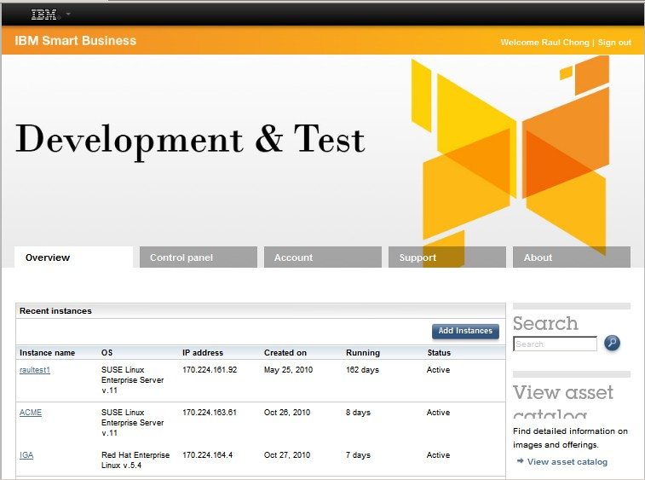

Figure 10.1 - The IBM Developer Cloud dashboard

Getting a system up and running can take just a few minutes. Simply click on the "Add instances" button to start. Next, choose from one of the many instances available as shown in *Figure 10.2*.

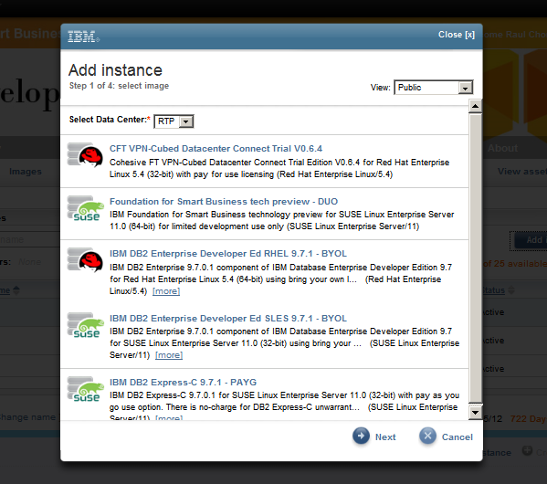

Figure 10.2 - Choosing the instance to use on the IBM Developer Cloud

For example, if you would like to work with IBM DB2 Express-C 9.7.1 - PAYG (Pay as you go) on SUSE Linux, simply select that option. Once selected, click next, and you will be taken to a screen as shown in *Figure 10.3*

In this panel you can choose the type of instance you want (32-bit, 64-bit) and how many CPU cores to use classified by name (copper, bronze, silver, gold). For example, bronze on 32-bit typically gives you 1 CPU running at 1.25GHz, 2GB of memory, and 175GB of local storage.

*Figure 10.3* also shows that you need to input a string, which will be used to generate a key that you need to download to your own computer so that later you can SSH to the instance created using ssh software like the free [*putty.*](http://www.chiark.greenend.org.uk/%7Esgtatham/putty)

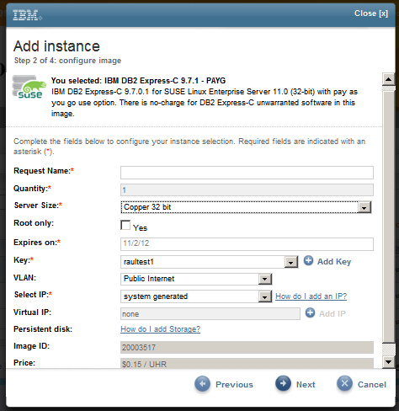

Figure 10.3 - Configuring the instance

After you click *Next*, your instance will be provisioned, which means that virtual CPUs and memory are allocated, the operating system is installed, and the software in the image (such as [DB2 Express-C](http://db2express.com/download?S_CMP=ECDDWW01&amp;S_TACT=DOCBOOK01) database server in this example) are also installed. This process can take a few minutes. Later on you can also add storage to attach to your instances.

* + - 1. Amazon Web Services

Amazon Web Services, or ***AWS,*** is the leading provider of public cloud infrastructure. AWS has data centers in four regions: US-East, US-West, Europe and Asia Pacific. Each region has multiple availability zones for improved business continuity.

Similarly to the IBM developer cloud, with AWS you can select virtual servers, called **Elastic Cloud compute (EC2) instances.** These instances are Intel-based (32 and 64- bit), and can run Windows or Linux (numerous distributions) operating systems. Pick from the different pre-defined types of instances based on your need for CPU cores, memory and local storage. *Figure 10.4* summarizes the different AWS EC2 instance types. Each type has a different price per hour as documented at aws.amazon.com.

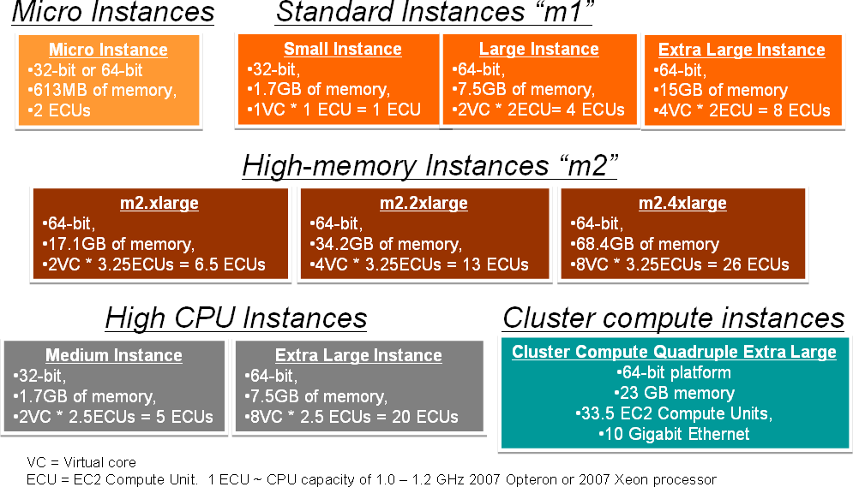

Figure 10.4 - AWS EC2 instance types

You can also add storage to your instance. AWS has three choices:

* + - * + Instance storage:

Instance storage is included with your instance at no extra cost; however, data is not persistent which means that it would disappear if the instance crashes, or if you terminate it.

* + - * + Simple Storage Service (S3).

S3 behaves like a file-based storage organized into buckets. You interact with it using http put and get requests.

* + - * + Elastic Block Storage (EBS).

EBS volumes can be treated as regular disks on a computer. It allows for persistent storage, and is ideal for databases.

##### Handling security on the Cloud

Security ranks high when discussing the reasons why a company may not want to work on the public Cloud. The idea of having confidential data held by a third party Cloud provider is often seen as a security and privacy risk.

While these concerns may be valid, Cloud computing has evolved and keeps evolving rapidly. Private clouds provide a way to reassure customers that their data is held safely on-premises. Hardware and software such as IBM Cloudburst™ and IBM WebSphere Cloudburst Appliance work hand-in-hand to let companies develop their own cloud.

Companies such as Amazon and IBM offer virtual private cloud (VPC) services where servers are still located in the cloud provider’s data centers yet they are not accessible to the internet; security can be completely managed by the company's own security infrastructure and processes.

Companies can also work with ***hybrid clouds*** where they can keep critical data in their private cloud, while data used for development or testing can be stored on the public cloud.

##### Databases and the Cloud

Cloud Computing is a new delivery method for IT resources including databases. IBM DB2 data server is Cloud-ready in terms of licensing and features.

Different DB2 editions for production, development and test are available on AWS and the IBM developer cloud. DB2 images are also available for private clouds using VMware or WebSphere Cloudburst appliance. *Figure 10.5* summarizes the DB2 images available on the private, hybrid and public clouds.

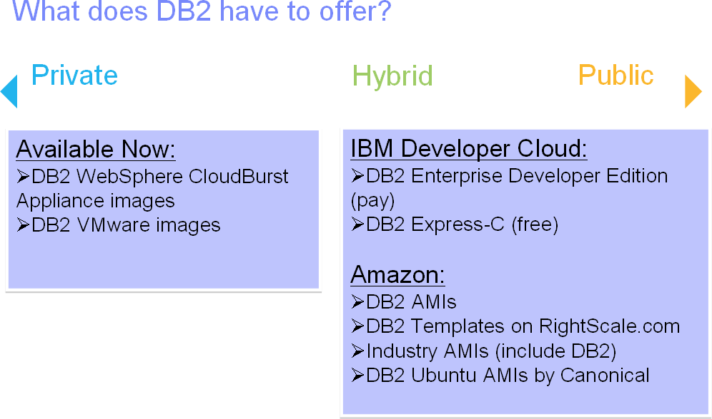

Figure 10.5 - DB2 images available on the private, hybrid and public clouds

In terms of licensing, you can use these methods:

* + - * + Bring your own license (BYOL) allows you to use your existing DB2 licenses on the cloud
        + Pay as you go (PAYG) allows you to pay for what you use

You can always use DB2 Express-C on the Cloud at no charge, though you may have to pay the Cloud provider for using its infrastructure.

Chapter 10 – Technology trends and databases 243

In terms of DB2 features that can be particularly advantageous in a Cloud environment we have:

* + - * + Database Partitioning Feature (DPF)
        + High Availability Disaster Recovery (HADR)
        + Compression

DPF is based on the shared-nothing architecture that fits well into the Cloud provisioning model. DPF is ideal for Data Warehousing environments where there is a large amount of data that you need to query to obtain business intelligence reports. With DPF, queries are automatically parallelized across a cluster of servers; this is done transparently to your application. You can add servers on demand on the Cloud which would bring their own CPU, memory and storage. DB2 would then automatically rebalance the data, and the overall performance would improve almost linearly.

HADR is a robust feature of DB2 with more than 10 years in the market. HADR works with two servers, a primary and a stand-by. When both servers are placed on the same location the HADR feature provides for *high availability*. When one server is placed in one location, and the other is in another (typically a different state or country), then HADR provides for *disaster recovery*. Disaster Recovery (DR) is one of the most needed and most expensive IT areas. It is expensive because companies need to pay for space in another location, as well as for the IT resources (servers, storage, networking) required. Cloud Computing addresses all of these needs very well. In the Cloud you "rent space” in distributed data centre(s) but do not pay for the space, electricity, cooling, security, and so on. You also can get all the IT resources without capital budget. Accessing your “DR site” on the Cloud can be achieved from anywhere securely using a web browser and ssh. With HADR you can place your primary server on-premise, and your stand-by on the Cloud. For added security, you can place the stand-by on a virtual private cloud. HADR allows your system to be up and running in less than 15 seconds should your primary server crash.

If you really want to save money to the last penny, you can use DB2's compression feature on the Cloud to save on space. DB2's compression, depending on your workload, can also increase overall performance.

There are many other features of DB2 that are not discussed in this book but could be applicable to this topic.

### Mobile application development

***Mobile applications*** are software programs that run on a mobile device. Typical enterprise mobile applications utilize mobile computing technology to retrieve information from a main computer server to the mobile device at anytime and anywhere. Moreover, mobile applications using the Cloud as the backend are becoming more and more popular.

The design and implementation of mobile applications is not as straightforward as desktop PC application development. It is very important for mobile application developers to consider the context in which the application will be used. From a business point of view, it

is difficult for project managers to estimate the risk associated with a mobile application project due to the difficulties in comparing the various capabilities of existing mobile platforms.

Nowadays, the early mobile platforms like Symbian, Microsoft Windows Mobile, Linux and BlackBerry OS have been joined by Apple’s OS X iPhone, Android and recently Palm’s Web OS, adding a layer of complexity for developers. *Figure 10.6* illustrates the typical architecture of mobile application development.

|  |
| --- |
| Mobile Applications |
| Mobile Application development platform |
| Mobile device platform  (Embedded OS, and mobile device) |

Figure 10.6 - Mobile Application Development: The big picture

In *Figure 10.6*, we show how mobile applications sit on top of two layers:

***Mobile device platform*** refers to the mobile hardware device and its operating system and/or integrated software. For example, Microsoft Windows Mobile 5.0 OS is installed on a Dell AXIM X51v device.

***Mobile application development platform*** refers to the combination of programming languages, general development APIs, and the runtime environment for that language on the mobile device. The mobile application development platform runs on top of the mobile device platform and provides an extra layer of software as a protection barrier to limit the damage for erroneous or malicious software. For example, the typical development software for mobile applications for Windows Mobile 6.0 is Microsoft Visual Studio 2005/2008 plus Windows Mobile 6.0 SDK.

Since there are various types of mobile device platforms and mobile application development platforms to choose from, ask yourself the following question before assembling a list of application platforms: Are you developing an application for a specific device or an application development platform?

##### Developing for a specific device

When writing an application to a specific device (or set of devices) or device OS, the vendor of that device platform often provides an SDK, emulator, and other tools that can help developers write applications specific to that platform.

*Table 10.2* lists some of these mobile device platforms and what they offer in the way of SDKs, tools, and so on.

|  |  |  |  |
| --- | --- | --- | --- |
| **Operating System (OS)** | **Language/OS options** | **SDKs/Tools** | **Developer Web Site** |
| Symbian OS | C++, Java, Ruby, Python, Perl, OPL, Flash Lite,  .NET | Carbide C++, IDE(Nokia) – C++,  and Java SDKs, per device | developer.symbian.com |
| Windows Mobile | Java, C++ | Visual Studio, Platform Builder, Embedded Visual C++ (eVC), Free Pascal, and Lazarus | Microsoft Windows Embedded Developer Center |
| iPhone OS | Objective-C | Xcode | [www.apple.com/iphone](http://www.apple.com/iphone) |
| Android | Java | Eclipse, Android SDK, Android Development Tool Plugin, JDK 5 | [www.android.com](http://www.android.com/) |
| Palm OS | C, C++, Java | Palm OS SDK, Java development with IBM Websphere EveryPlace Micro Environment, Palm Windows Mobile SDK for Palm products on Windows Mobile platform | [www.palm.com/us/developer](http://www.palm.com/us/developer) |

Table 10.2 - Device platforms and tools

##### Developing for an application platform

Everyone has beliefs in a particular programming language and development environment. Why do you prefer that development language and application development environment?

Mobile application development raises this question time and again, and you may have to re-evaluate your answer in light of your mobile application .Java, .NET (C#, VB), C, C++, and other languages are all options available in mobile application development. In some ways, the same criteria that are used to evaluate these languages on the desktop or server can also be applied to mobile applications. However, mobile application development does

bring considerations, which distort the old desktop/server application development environment discussions.

For example, Java's strength has always been portability. Java is a widely available platform on many mobile devices. However, the exact same Java is not on all those devices. In order for Java to fit on so many different styles and shapes of platforms, the Java architecture has been broken into a set of configurations and profiles. The configurations and profiles differ according to device and device capabilities. Thus, writing to this platform may not get you to the customers you want to capture.

So how will you look at the software platforms for mobile devices? The next two sections explore several more prevalent mobile device platform and mobile application platform choices and looks at ways to compare and contrast these platforms.

##### Mobile device platform

Some of the most widely used mobile device platforms are described below.

* + - 1. Windows Mobile

Windows Mobile, derived from Windows CE (originally released in 1996), provides a subset of the Microsoft Windows APIs on a compact real-time operating system designed for mobile computing devices and wireless terminals. After several false starts on stand-alone PDAs, Windows Mobile has enjoyed reasonable success on a number of PDAs and handsets, perhaps most notably the Motorola Q and some Treo devices.

Microsoft provides the ActiveSync technology for synchronization for both personal and enterprise users. Moreover, the current version of Microsoft Windows Mobile is a versatile platform for developers, permitting application development in C or C++ as well as supporting managed code with the .NET Compact Framework.

* + - 1. Symbian OS

Symbian OS is a [proprietary](http://en.wikipedia.org/wiki/Proprietary_software) [operating system](http://en.wikipedia.org/wiki/Operating_system) designed for [mobile devices,](http://en.wikipedia.org/wiki/Mobile_device) with associated [libraries,](http://en.wikipedia.org/wiki/Library_%28computer_science%29) [user interface,](http://en.wikipedia.org/wiki/User_interface) frameworks and reference implementations of common tools, developed by [Symbian Ltd.](http://en.wikipedia.org/wiki/Symbian_Ltd) Symbian began its life as EPOC Release 5, the last software release of EPOC by Psion with a joint venture company of the same name. Symbian is a very powerful platform programmable in C++ using Symbian’s frameworks for applications and services. The Symbian platform itself runs Java ME, so Symbian phones can run both native Symbian applications as well as Java ME applications.

* + - 1. iPhone

The iPhone is an internet-connected, [multimedia](http://en.wikipedia.org/wiki/Multimedia) [smartphone](http://en.wikipedia.org/wiki/Smartphone) designed and marketed by [Apple Inc.](http://en.wikipedia.org/wiki/Apple_Inc) It is a closed platform, permitting mobile applications only through its robust WebKit-based Web Browser, Safari. Since its minimal hardware interface lacks a physical [keyboard,](http://en.wikipedia.org/wiki/Keyboard_%28computing%29) the [multi-touch](http://en.wikipedia.org/wiki/Multi-touch) screen renders a [virtual keyboard](http://en.wikipedia.org/wiki/Virtual_keyboard) when necessary.

The iPhone and iPod Touch SDK uses Objective C, based on the C programming language. The available IDE for iPhone application development is Xcode, which is a suite of tools for developing software on [Mac OS X](http://en.wikipedia.org/wiki/Mac_OS_X) developed by [Apple.](http://en.wikipedia.org/wiki/Apple_Inc)

* + - 1. Android

Android is an open and free software stack for mobile devices that includes operating system, middleware, and key applications. The development language for Android is Java.

Android application programming is exclusively done in Java. You need the Android specific Java SDK which includes a comprehensive set of development tools. These include a [debugger,](http://en.wikipedia.org/wiki/Debugger) [libraries,](http://en.wikipedia.org/wiki/Software_library) a handset [emulator](http://en.wikipedia.org/wiki/Emulator) (based on [QEMU](http://en.wikipedia.org/wiki/QEMU)), [documentation,](http://en.wikipedia.org/wiki/Documentation) sample code, and [tutorials.](http://en.wikipedia.org/wiki/Tutorials) Currently supported development platforms include [x86](http://en.wikipedia.org/wiki/X86)- architecture computers running [Linux](http://en.wikipedia.org/wiki/Linux_kernel) (any modern desktop [Linux Distribution](http://en.wikipedia.org/wiki/List_of_Linux_distributions)), [Mac OS X](http://en.wikipedia.org/wiki/Mac_OS_X)

10.4.8 or later, [Windows XP](http://en.wikipedia.org/wiki/Windows_XP) or [Vista.](http://en.wikipedia.org/wiki/Windows_Vista) Requirements also include [Java Development Kit,](http://en.wikipedia.org/wiki/Java_Development_Kit) [Apache Ant,](http://en.wikipedia.org/wiki/Apache_Ant) and [Python](http://en.wikipedia.org/wiki/Python_%28programming_language%29) 2.2 or later. The officially supported [integrated development environment](http://en.wikipedia.org/wiki/Integrated_development_environment) (IDE) is [Eclipse](http://en.wikipedia.org/wiki/Eclipse_%28software%29) (3.2 or later) using the Android Development Tools (ADT) Plug-in, though developers may use any text editor to edit Java and XML files then use [command line](http://en.wikipedia.org/wiki/Command_line) tools to create, build and debug Android applications.

##### Mobile application development platform

In this section, we will introduce the application development platforms to implement the mobile application on top of the mobile device.

* + - 1. Java Micro Edition (Java ME)

Java ME, formerly called ***Java 2 Micro Edition*** (***J2ME***), is a platform spanning lightweight mobile devices and other nontraditional computing devices including set-top boxes and media devices. Once promising “write once, run anywhere” to software developers, Java ME skills remain perhaps the most transferable from device to device, because lower-level languages such as C or C++ on other platforms require intimate knowledge of platform- specific APIs such as those found in Windows Mobile or Symbian OS.

There are actually different implementations of Java for different devices for the immense variety in devices supported by Java ME.

* + - 1. .NET Compact Framework

This platform is a version of the .NET Framework for Windows CE platforms. It is a subset of the standard .NET framework, but also includes some additional classes that address specific mobile device needs.

Currently there are .NET Compact Framework V1.0, V2.0 and V3.5 available. You might be wondering which version of the .NET Compact Framework should you choose as target? "The latest version" might be the obvious answer, but, as with many things concerning mobile devices, it is not quite that simple! As the mobile application developer, you must choose a version of the .NET Compact Framework on which to build your application. If you choose version 1.0, you can be reasonably confident that your application will run on all devices because versions 2.0 and later of the .NET Compact Framework runtime run applications that were built to run on an earlier version. However, if you write code that uses features only available in .NET Compact Framework 2.0, that version of the .NET Compact Framework runtime must be installed on your target device for your application to operate.

* + - 1. Native C++

C++ applications can run natively on the device, making the applications less portable, but this usually means you have more speed and more control over the device.

Generally, native C++ development needs IDE tools like Microsoft Visual C++ 6/.NET, Eclipse IDE together with specific C++ SDK, or Borland C++ Builder. Especially, for Symbian OS, you could also choose Metrowerks CodeWarrior Studio which also requires corresponding Symbian C++ SDK from Nokia.

* + - 1. Binary Runtime Environment for Wireless

The Binary Runtime Environment for Wireless (BREW) is a programming platform developed by Qualcomm for CDMA-based phones. BREW provides SDK and emulator for developing and testing applications written in C or C++.

To develop with BREW, you need development tools like BREW SDK, ARM RealView compilation tools, Visual C++, etc.

##### The next wave of mobile applications

A wide spectrum of next-generation mobile applications and services have begun to surface anywhere the coverage rate of cell phones PDAs is high. New mobile applications are being driven by mobile service providers seeking new value-added applications and services to take advantage of 3G systems and other wireless data infrastructures. Traditional mobile applications, such as voice, and simple data services, such as Internet surfing, are not enough today; consumers are looking forward to better leverage the mobility supplied by low-power, wireless-capable mobile devices to enjoy content rich entertainment, ubiquitous information access, and agile business operations.

A great many markets are yet to be saturated in the mobile world, such as telematics systems, m-commerce and m-enterprise services, mobile multimedia streaming service, mobile messaging, location based mobile computing, and so forth.

Surely, we will see many exciting technological breakthroughs and innovations of mobile computing in the next several years.

##### DB2 Everyplace

The DB2 edition for mobile devices is DB2 Everyplace. DB2 Everyplace features a small- footprint relational database and high-performance data synchronization solution that enables enterprise applications and data to be extended securely to mobile devices.

**Note:**

To learn more about mobile application development, refer to the free eBook [*Getting*](http://www.ibm.com/db2/books)[*started with mobile application development*,](http://www.ibm.com/db2/books) which is part of the DB2 on Campus book series.

### Business intelligence and appliances

Databases are commonly used for online transaction processing such as bank transactions, but they can also be used to derive business intelligence to see trends and patterns that can help businesses make better decisions. Companies today collect huge amounts of information daily. This information is stored in data warehouses that are used

to generate reports using software like IBM Cognos®.

Companies struggling to set up their data warehouses are now attracted to the idea of purchasing data warehouse appliances. An appliance consists of hardware and software that has been tightly integrated and tested to perform a given function or functions. ***IBM Smart Analytics System*** is one such appliance for Data Warehousing and Business Intelligence.

**Note:**

To learn more about data warehousing and business intelligence, refer to the free eBook

[*Getting started with data warehousing*,](http://www.ibm.com/db2/books) which is part of the DB2 on Campus book series.

### db2university.com: Implementing an application on the Cloud (case study)

Advances in technology enable advances in other fields. Thanks to the internet, many universities are offering online degrees. Credits towards a degree are given to students who register and participate in online courses. These courses often consist of recorded webinars, live sessions over the Web, online forums, and more. Pundits argue that in the near future everyone with access to the internet will be able to get excellent education without having to physically attend a university.

Online education gives you the ability to learn at your own pace, in the comfort of your own home or wherever you are. Moreover, thanks to mobile devices you can participate "on the go".

In this section we introduce [**db2university.com**,](http://www.db2university.com/) an educational Web site that has been implemented using many of the technologies described in this chapter. *Figure 10.7* illustrates how db2university.com looks like at the time of writing.

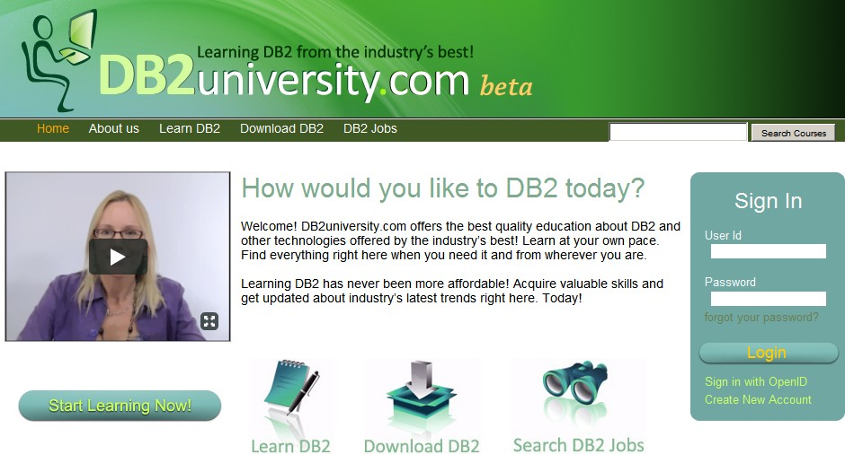

Figure 10.7 - db2university.com home page

##### 10.4.1 Moodle open source course management system

A vast range of materials, from videos to podcasts and eBooks are available right now on the internet for self-study; however, they are often not arranged in a way that is easily consumable. Some of this information may also be obsolete. ***Course management systems*** allow instructors to create and arrange existing materials for easy consumption. At [**db2university.com**](http://www.db2university.com/)we use the ***Moodle*** open source course management system (CMS).

Moodle, written in PHP, is one of the best, if not the best, open source CMS in the market. Martin Dougiamas at Curtin University of Technology in Perth, Australia developed the first version in 2001. Today, there are over 52,000 registered Moodle sites and over 950,000 registered users from more than 175 countries around the world on moodle.org.

Our journey with Moodle started late in 2009. Students at California State University, Long Beach (CSULB) were assigned, as part of one of their courses, the task to enable Moodle

1.9.6 to work with [DB2 Express-C.](http://db2express.com/download?S_CMP=ECDDWW01&amp;S_TACT=DOCBOOK01) Their contribution to the community (provided as a patch) can be found at [http://moodle.org/mod/data/view.php?d=13&rid=3100&filter=1.](http://moodle.org/mod/data/view.php?d=13&amp;rid=3100&amp;filter=1)

Early in 2010 we started the enablement of Moodle 2.0 to use [DB2 Express-C.](http://db2express.com/download?S_CMP=ECDDWW01&amp;S_TACT=DOCBOOK01) Moodle 2.0 is a major revision of the Moodle software, and it has fundamental changes from the previous version in the way it interfaces with databases. At the time of writing, Moodle 2.0 Release Candidate 1 has been made available to the public. This is the version we have enabled to use DB2 Express-C, and the one we are running at [**db2university.com**.](http://www.db2university.com/) When the official version of Moodle 2.0 is available, we will be updating db2university.com and committing our contribution to the Moodle community.

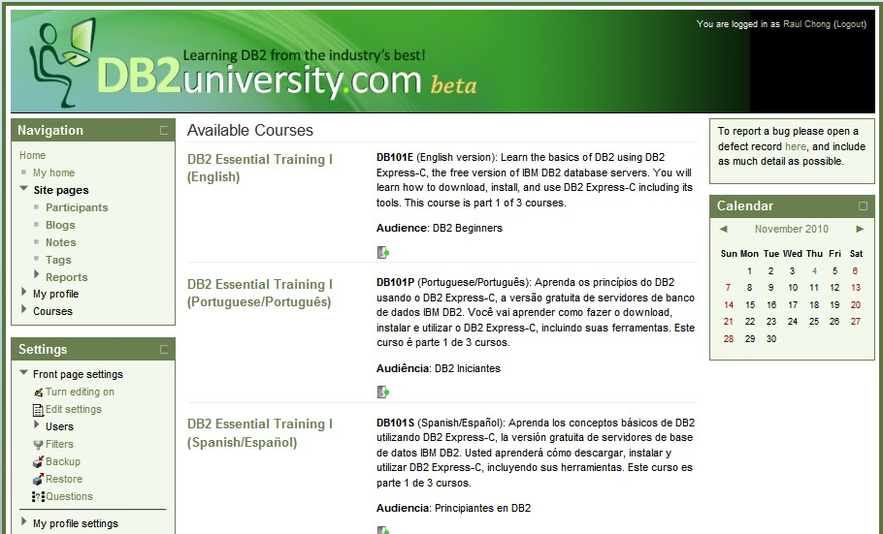*Figure 10.8* shows different courses available at [**db2university.com**.](http://www.db2university.com/) You can reach this page by clicking on the *Learn* tab in the home page. The Learn tab shows our implementation of Moodle. We created a Moodle theme specific for db2university.

Figure 10.8 - Learn tab takes you to the Moodle implementation in db2university

Courses at [**db2university.com**](http://www.db2university.com/) are not just about DB2. They can be about other topics like PHP or Ruby on Rails for example, but any lesson in those courses that requires interaction with a database will be using DB2. Instructors for the courses are members of the DB2 community including university professors, professionals, IBM employees, and students.

There are two main categories for courses at the site: *Free* courses, and *Paid* courses. For

*Paid* courses we will use the Paypal plug-in included with Moodle.

*Figure 10.9* and *10.10* provide more details about the course "DB2 Essential Training I". We picked this course as an example of what you could do with our implementation of Moodle. Note the course has many videos, transcripts (PDF files), and links to an eBook to use as reference. Not shown in the figure are links to a course forum, Web pages, assignments, and exams.

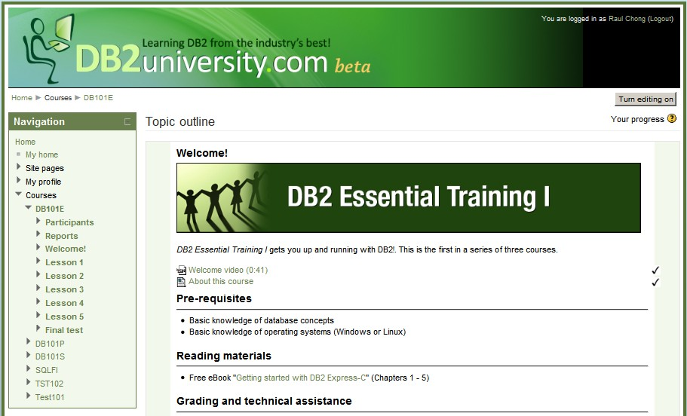

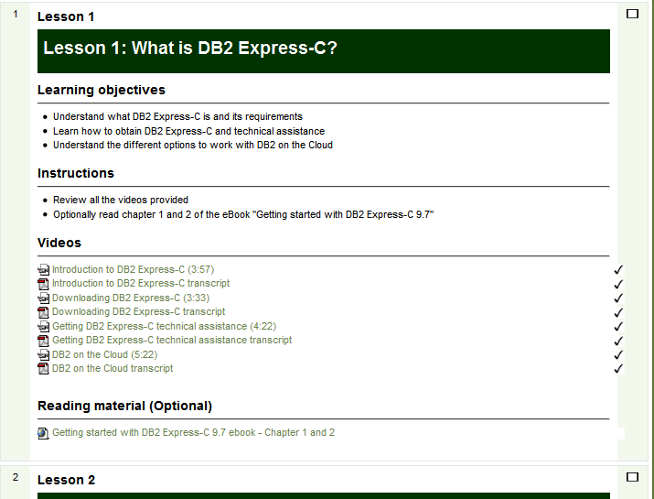Figure 10.9 - Contents of the DB2 Essential Training I course

**Figure 10.10 - Contents of the DB2 Essential Training I course (continued)**

A tutorial is available at [IBM developerWorks](https://www.ibm.com/developerworks/data/)® to teach you how to create a course in db2university.com.

**Note:**

To learn more about what it takes to develop open source software, take a look at the free eBook [*Getting started with open source development*,](http://www.ibm.com/db2/books) which is part of the DB2 on Campus book series.

##### 10.4.2 Enabling openID sign-in

Research shows that people landing on a Web page with a complicated or long registration process tend to walk away from the site quickly. To ensure users stay and register to [**db2university.com**](http://www.db2university.com/)we enabled openID sign in, in addition to allowing users to register on the site. This means that people who already have a Facebook, Google, Yahoo, AOL, ChannelDB2, and other accounts need not input registration information. db2university would instead ask those providers -- with your consent -- to share the information. *Figure*

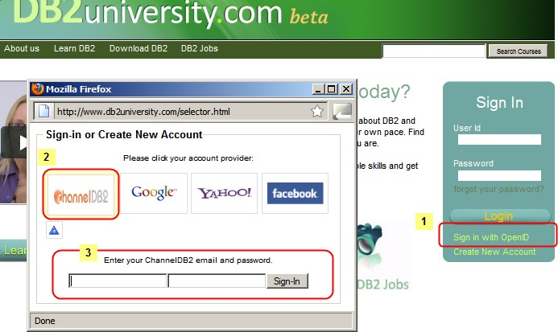*10.11* illustrates the process.

Figure 10.11 - OpenID sign-in process

First you click on the *Sign in with OpenID* link. A window will pop up showing you the different openID providers supported. Then you select one provider. In the example we chose *ChannelDB2*. Finally you input your ChannelDB2 user/email ID and the corresponding password. Only the first time you go through this process will you get another page from your provider asking for your consent to share information between the sites. If you accept, the information is shared, and you will be automatically registered to

db2university!. After this process every time you want to log on to [**db2university.com**](http://www.db2university.com/) you follow the same steps.

An article available at [IBM developerWorks](https://www.ibm.com/developerworks/data/) explains you how the enablement of the openID providers were done.

##### Running on the Amazon Cloud

[**db2university.com**](http://www.db2university.com/) is hosted on the Amazon cloud. This allows us to take full advantage of Cloud computing benefits, including setting up DB2 HADR for disaster recovery on the Cloud. These are the AWS resources we are using:

* + - * EC2 standard large instance (64-bit, 4 ECUs, 7.5 GB of memory, 850GB instance storage)
      * EBS volumes of 50 GB size
      * S3 buckets of 3 and 1 GB size
      * CloudFront

Three EC2 instances in the US-East region have been provisioned. One of them is used to run the Moodle application and the Web server, and another one to run the DB2 database server (DB2 HADR Primary server). The DB2 HADR stand-by server uses a third EC2 instance in a different availability zone within the US-East region as the disaster recovery site.

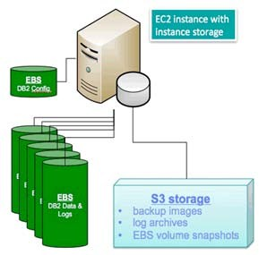In terms of storage, we use instance storage, S3 and EBS volumes. *Figure 10.12* provides the details.

Figure 10.12 - DB2 storage on the Amazon cloud

In the figure:

* + - * EBS volumes are used to store DB2 data and DB2 recovery logs. We chose 50GB to satisfy our needs. Optionally we are considering using RAID.
      * A different small EBS volume of 2GB is used to store the DB2 code and the DB2 configuration files.
      * Instance storage is used to temporarily store DB2 backup images. Later we move these backups to S3 for longer retention period.
      * S3 storage is used for storing backup images and log archives for long retention periods. EBS volume snapshots are taken often, and they are stored in S3.

AWS CloudFront is used to allow users to download course videos and materials from an Amazon "edge" server that is closer to the location where the user lives. The files to download are first copied to a S3 bucket, and are later replicated to the edge servers.

In terms of software, this is the set up used:

* + - * Ubuntu Linux 10.04.1 LTS
      * DB2 Express 9.7.2 for Linux 64-bit
      * Moodle 2.0 Release Candidate 1
      * PHP 5.3.3

DB2 Express is used, as opposed to DB2 Express-C, because we are using the DB2 HADR feature, which is only available starting with the DB2 Express edition.

RightScale is ideal to manage AWS resources. RightScale is a partner of IBM, and its software gives the ability to build environments quickly using [templates](http://www.rightscale.com/partners/isv/ibm.php) and scripts.

An article available at [IBM developerWorks](https://www.ibm.com/developerworks/data/) explains the AWS details used for db2university.

##### Using an Android phone to retrieve course marks

Moodle allows students to see their marks for assignments and exams on the Web; however, we have also developed a mobile application for the Android phone using App Inventor.

This simple application is illustrated in *Figure 10.13*. First you need to input a *mobile access code* which is a unique keyword that each student can obtain from their profile in Moodle. Next, they can choose the course they took or are currently taken, and display all their marks.

In order for this application to work, coding on the Client side using App Inventor, and on the server side (using a Web service created with Ruby/Sinatra) is required. An article available at [IBM developerWorks](https://www.ibm.com/developerworks/data/) explains you the details.

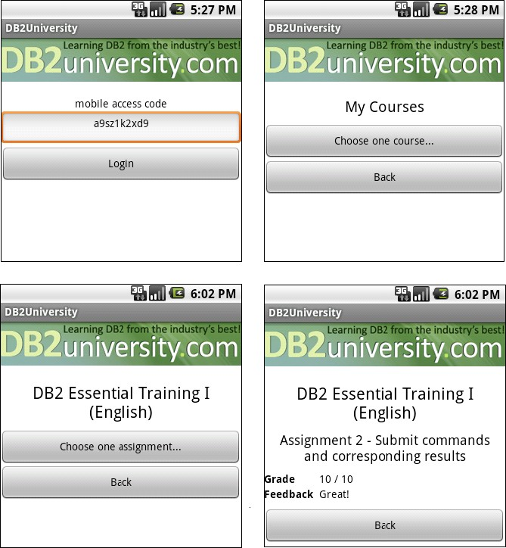

Figure 10.13 - App Inventor for Android application to access db2university

### Summary

This chapter discussed important technology trends that will be realized by 2015, and highlighted the role of databases in these technologies. Cloud computing is at the top of the list, and is currently the hottest IT topic. Cloud computing is a new delivery method for IT resources allowing companies and individuals access to practically any amount of computer resources on-demand. Cloud computing is cost-effective since you only need to pay for what you consume.

Later in the chapter we talked about mobile applications. Mobile applications is another area of enormous growth. The chapter introduced you to different mobile device platforms and platforms for development.

The chapter then briefly discussed about business intelligence and appliances. Companies want to gain intelligence from the data they store to make better decisions for their businesses. At the same time, they do not want to have their in-house IT department spend large amount of time setting up their warehouses and configuring them. A data warehouse and business intelligence appliance such as IBM Smart Analytics system can help solve these issues.

Finally the chapter talked about [**db2university.com**](http://www.db2university.com/) as a case study where many of the technologies described in the chapter were used.

# A

## Appendix A – Solutions to review questions

Chapter 1

1. A database is a repository of data, designed to support efficient data storage, retrieval and maintenance.
2. A database management system, or simply DBMS, is a set of software tools that control access, organize, store, manage, retrieve and maintain data in a database.
3. An information model is an abstract, formal representation of entities that includes their properties, relationships and the operations that can be performed on them. Data Models, on the other hand, are defined at a more concrete level and include many details. Data models are more specific, and serve as blueprints of a database system.
4. The main advantage is the data independence (not specific to physical storage)
5. Install and test new versions of the database management system (DBMS), and control access permissions and privileges
6. A. pureXML model
7. C. Performance
8. E. None of the above
9. D. Integration
10. B. Though pureXML is a clear differentiatior of DB2 in general versus other RDBMS's, for the Cloud the key differentiator is DB2's Database Partitioning Feature (DPF). This allows for scalability on the cloud where only standard instances are provided.

Chapter 2

* 1. An entity integrity constraint or a unique and a not null constraint defined for supplier identification number, a not null constraint defined for supplier name, a range constraint and a not null constraint defined for supplier discount.
  2. Intersection: **R1** ∩ **R2 = R1-(R1-R2)**.

Join: **R1**join_condition ►◄**R2 = *σ*** join_condition **(R1X R2)**

Division for relation **R1(A,B)** and **R2(A):**

Database Fundamentals 260

**R1**÷**R2 = *π*B**(**R1**) - ***π*B((R2X*π*B(R1)) - R1)**

* 1. ***π***Name(***σ***Address=**’New York‘ AND Discount>0.05(R))**
  2. RANGE OF SUPPLIERS IS SUPPLIERS.Name WHERE (SUPPLIERS.Address

**=’New York’ AND SUPPLIERS.Discount>0.05)**

* 1. **NameX WHERE ** **(DiscountX >0.05 AND SUPPLIERS (Name:NameX**, **Discount:DiscountX, Address:’New York’)**
  2. A. A real-world data feature modeled in the database.

C. A data characteristic.

* 1. B. There aren’t duplicate tuples in a relation.

1. Attributes have atomic values.
   1. B. An instance.
2. A degree.
   1. A. A primary key is also a candidate key.
   2. D. Cascade.

Chapter 3

1. D.
2. A.
3. C.
4. A.
5. B.
6. D.
7. B.
8. D.
9. C.
10. B.

Chapter 4

1. Refer to Example in section 4.6.1 Lossless and Lossy Decompositions
2. C
3. B
4. E

Chapter 10 – Technology trends and databases 261

1. B
2. C

Chapter 5

1. D.
2. D.
3. A, C.
4. D.
5. D.
6. A.
7. B.
8. D.
9. D.
10. B.

Chapter 6

1. C
2. C
3. E
4. C
5. C
6. D
7. D
8. D
9. A
10. A

Chapter 7

1. B.
2. A.
3. B.
4. A.
5. B.
6. B.

Database Fundamentals 262

1. B.
2. A.
3. B.
4. B.

Chapter 8

1. D.
2. B.
3. B.
4. D.
5. A.
6. A.
7. C.
8. A.
9. A.

Chapter 9

1. The development of information technology leads to big volumes of data collected by the organizations. These data cover a vide area of the activity and they can be the background of critical decisions. To keep these data secrets, coherent and available is the purpose of security measures.
2. No. Focusing on database security alone will not ensure a secure database. All parts of the system must be secure: the database, the network, the operating system, the building in which the database resides physically and the persons who have any opportunity to access the system.
3. In a complete security plan there are more threats that must be addressed. These are: theft and fraud, loss of privacy or confidentiality, loss of data integrity, loss of availability and accidental loss of data.
4. Discretionary control of access is a method that allows users to access and to perform various operations on data based on their access rights or their privileges on individual items.
5. DB2 works with three forms of recorded authorization: administrative authority, privileges and Label-Based Access Control (LBAC) credentials
6. Privileges are authorities assigned to users, groups or roles, which allow them to accomplish different activities on database objects.
7. Trusted context establishes a trusted relationship between DB2 and an external entity, like a Web server or an application server. This relationship is based upon

system authorization, IP address and data stream encryption and is defined by a trusted context object in the database.

1. A view is a virtual table obtained as a dynamic result of one or more relational operations that apply to one or more base tables. It can be built to present only the data to which the user requires access and prevent the viewing other data that may be private or confidential.
2. Integrity control aims to protect data from unauthorized use and update by restricting the values that may be hold and the operations that can be performed on data. For these purposes, the following can be used: domain definition, assertions and triggers.
3. The most used security policies and procedures are: personnel controls and physical access controls

# B

## Appendix B – Up and running with DB2

This appendix is a good foundation for learning about DB2. This appendix is streamlined to help you get up and running with DB2 quickly and easily.

In this appendix you will learn about:

* DB2 packaging
* DB2 installation
* DB2 Tools
* The DB2 environment
* DB2 configuration
* Connecting to a database
* Basic sample programs
* DB2 documentation

**Note:**

For more information about DB2, refer to the free e-book *Getting Started with DB2 Express-C* that is part of this book series.

### DB2: The big picture

DB2 is a data server that enables you to safely store and retrieve data. DB2 commands, XQuery statements, and SQL statements are used to interact with the DB2 server allowing you to create objects, and manipulate data in a secure environment. Different tools can be used to input these commands and statements as shown in *Figure B.1*. This figure provides an overview of DB2 and has been extracted from the *Getting Started with DB2 Express-C* e-book.

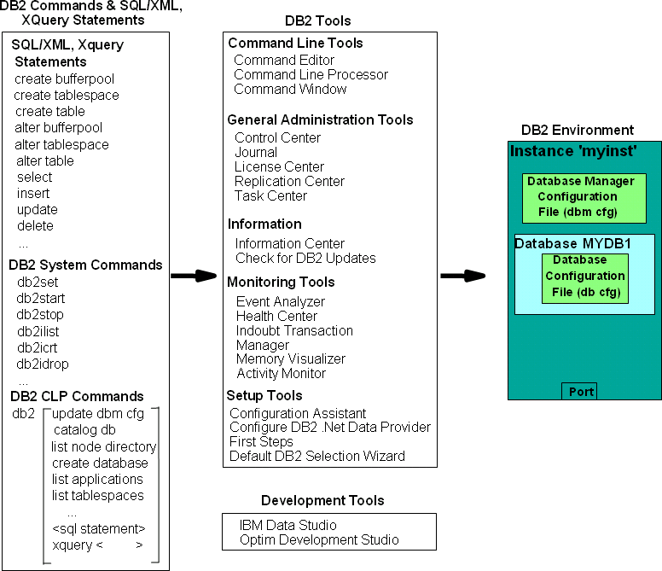

Figure B.1 - DB2 - The big picture

On the left-hand side of the figure, we provide examples of different commands and statements that users can issue. In the center of the figure, we list some of the tools where you can input these commands and statements, and on the right-hand side of the figure you can see the DB2 environment; where your databases are stored. In subsequent sections, we discuss some of the elements of this figure in more detail.

### DB2 Packaging

DB2 servers, clients and drivers are created using the same core components, and then are packaged in a way that allows users to choose the functions they need for the right price. This section describes the different DB2 editions or product packages available.

##### DB2 servers

*Figure B.2* provides an overview of the different DB2 data server editions that are available.



Extra

functionality

**+**

**DB2 Enterprise Edition**

Extra

functionality

**+**

**DB2 Workgroup Edition**

Extra

functionality

**+**

**DB2 Express Edition**

**DB2 Express-C**

Figure B.2 - DB2 Server Packaging

As shown in *Figure B.2*, all DB2 server editions are built one on top of the other. DB2 Express-C is a free version of DB2, and it is the core component of all DB2 products. When additional functionality is added to DB2 Express-C, it becomes DB2 Express. Additional functionality added to DB2 Express, becomes DB2 Workgroup, and so on. *Figure B.2* illustrates why it is so easy to upgrade from DB2 Express-C to any other DB2 server should you need to in the future: *All DB2 servers editions are built based on DB2 Express-C*.

Also applications built for DB2 Express-C are applicable on other DB2 Editions as well. Your applications will function without any modifications required!

##### DB2 Clients and Drivers

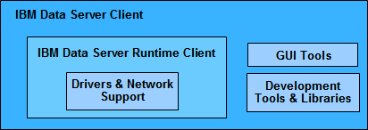When you install a DB2 server, a DB2 client component is also installed. If you only need to install a client, you can install either the IBM Data Server Client, or the IBM Data Server Runtime Client. *Figure B.3* illustrates these two clients.

Figure B.3 - DB2 Clients

From the above figure, you can see the IBM Data Server Runtime client has all the components you need (driver and network support) to connect and work with a DB2 Data Server. The IBM Data Server client has this same support and also includes GUI Tools and libraries for application development.

In addition to these clients, provided are these other clients and drivers:

* + - * DB2 Runtime Client Merge Modules for Windows: mainly used to embed a DB2 runtime client as part of a Windows application installation
      * IBM Data Server Driver for JDBC and SQLJ: allows Java applications to connect to DB2 servers without having to install a client
      * IBM Data Server Driver for ODBC and CLI: allows ODBC and CLI applications to connect to a DB2 server without having to install a client
      * IBM Data Server Driver Package: includes a Windows-specific driver with support for

.NET environments in addition to ODBC, CLI and open source. This driver was previously known as the IBM Data Server Driver for ODBC, CLI and .NET.

There is no charge to use DB2 clients or drivers.

### Installing DB2

In this section we explain how to install DB2 using the DB2 setup wizard.

##### Installation on Windows

DB2 installation on Windows is straight-forward and requires the following basic steps:

1. Ensure you are using a local or domain user that is part of the Administrator group on the server where you are installing DB2.
2. After downloading and unzipping DB2 Express-C for Windows from [ibm.com/db2/express,](http://www.ibm.com/db2/express/download.html?S_CMP=ECDDWW01&amp;S_TACT=RFCBOOK08AppB) look for the file setup.exe, and double-click on it.
3. Follow the self- explanatory instructions from the wizard. Choosing default values is normally sufficient.
4. The following is performed by default during the installation:
   * DB2 is installed in C:\Program Files\IBM\SQLLIB
   * The DB2ADMNS and DB2USERS Windows operating system groups are created.
   * The instance **DB2** is created under C:\Program Files\IBM\SQLLIB\DB2
   * The DB2 Administration Server (DAS) is created
   * Installation logs are stored in:

My Documents\DB2LOG\db2.log My Documents\DB2LOG\db2wi.log

* + Several Windows services are created.

##### Installation on Linux

DB2 installation on Linux is straight-forward and requires the following basic steps:

1. Log on as the Root user to install DB2.
2. After downloading DB2 Express-C for Linux from [ibm.com/db2/express,](http://www.ibm.com/db2/express/download.html?S_CMP=ECDDWW01&amp;S_TACT=RFCBOOK08AppB) look for the file db2setup, and execute it: **./db2setup**
3. Follow the self-explanatory instructions from the wizard. Choosing default values is normally sufficient.
4. The following is performed by default during installation:
   * DB2 is installed in /opt/ibm/db2/V9.7
   * Three user IDs are created. The default values are listed below:

***db2inst1*** (instance owner)

***db2fenc1*** (Fenced user for fenced routines)

***dasusr1*** (DAS user)

* + Three user groups are created corresponding to the above user IDs:

***db2iadm1 db2fadm1 dasadm1***

* + Instance ***db2inst1*** is created
  + The DAS ***dasusr1*** is created
  + Installation logs are stored in:

/tmp/db2setup.his

/tmp/db2setup.log

/tmp/db2setup.err

### DB2 tools

There are several tools that are included with a DB2 data server such as the DB2 Control Center, the DB2 Command Editor, and so on. Starting with DB2 version 9.7 however; most of these tools are deprecated (that is, they are still supported but no longer enhanced) in favor of IBM Data Studio. IBM Data Studio is provided as a separate package not included with DB2. Refer to the ebook [*Getting started with IBM Data Studio for DB2*](http://www.ibm.com/db2/books) for more details.

##### Control Center

Prior to DB2 9.7, the primary DB2 tool for database administration was the Control Center, as illustrated in *Figure B.4*. This tool is now deprecated, but still included with DB2 servers.

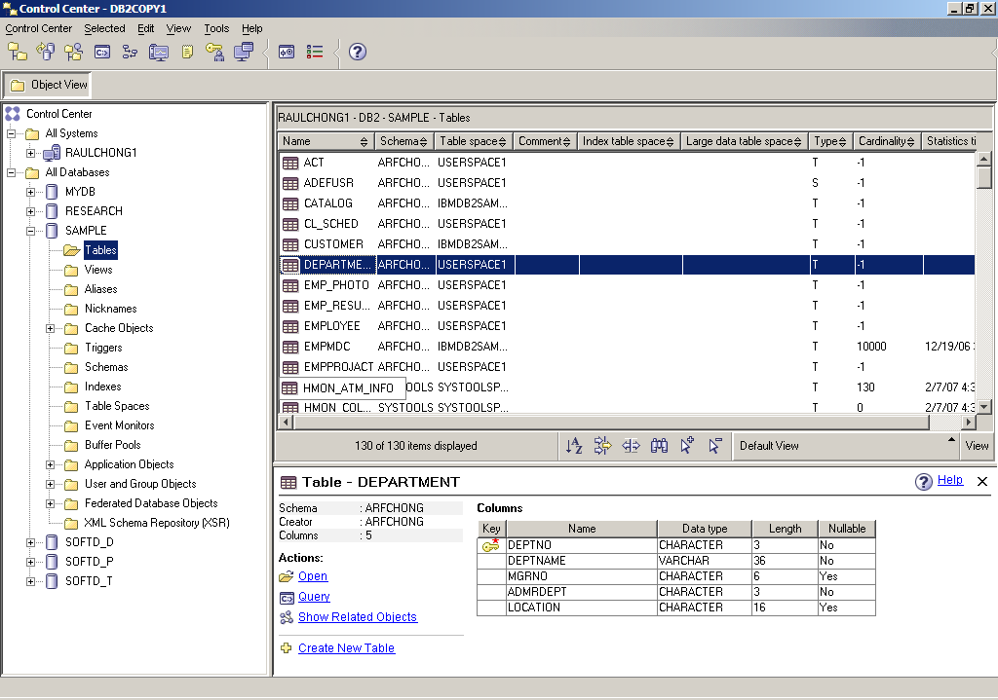

Figure B.4 - The DB2 Control Center

To start the Control Center on Windows use *Start -> Programs -> IBM DB2 -> DB2COPY1 (Default) -> General Administration Tools -> Control Center* or alternatively, type the command **db2cc** from a Windows Command Prompt or Linux shell.

The Control Center is a centralized administration tool that allows you to:

* View your systems, instances, databases and database objects;
* Create, modify and manage databases and database objects;
* Launch other DB2 graphical tools

The pane on the left-hand side provides a visual hierarchy of the database objects on your system(s), providing a folder for Tables, Views, etc. When you double-click a folder (for example, the Tables folder, as shown in *Figure B.5*), the pane on the top right will list all of the related objects, in this case, all the tables associated with the **SAMPLE** database. If you select a given table in the top right pane, the bottom right pane provides more specific information about that table.

Right-clicking on the different folders or objects in the Object tree will bring up menus applicable to the given folder or object. For example, right-clicking on an instance and choosing *Configure parameters* would allow you to view and update the parameters at the instance level. Similarly, if you right-click on a database and choose *Configure parameters*, you would be able to view and update parameters at the database level.

##### Command Line Tools

There are three types of Command Line tools:

* + - * DB2 Command Window (only on Windows)
      * DB2 Command Line Processor (DB2 CLP)
      * DB2 Command Editor (GUI-based, and deprecated) These tools are explained in more detail in the next sections.
      1. DB2 Command Window

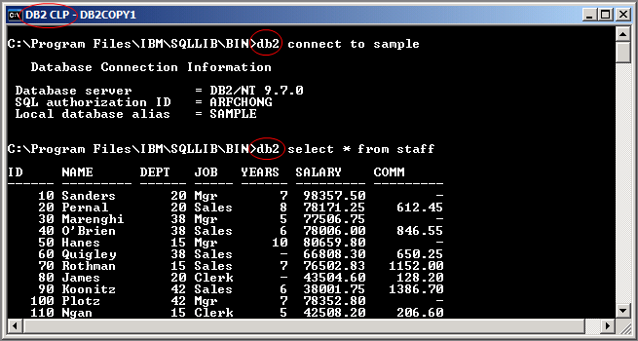The DB2 Command Window is only available on Windows operating systems; it is often confused with Windows Command Prompt. Though they look the same, the DB2 Command Window, however, initializes the environment for you to work with DB2. To start this tool, use *Start -> Programs -> IBM DB2 -> DB2COPY1 (Default) -> Command Line Tools -> Command Window* or alternatively, type the command **db2cmd** from a Windows Command Prompt to launch it on another window. *Figure B.5* shows the DB2 Command Window.

Figure B.5 - The DB2 Command Window

You can easily identify you are working in the DB2 Command Window by looking at the window title which always includes the words *DB2 CLP* as highlighted in the figure. From the DB2 Command Window, all commands must be prefixed with **db2**. For example, in the above figure, two statements are issued:

db2 connect to sample db2 select * from staff

For Linux, the equivalent of the DB2 Command Window is simply the Linux shell (or terminal) where the DB2 environment has been set up by executing the db2profile file. This file is created by default and added to the .login file for the DB2 instance owner. By default the DB2 instance owner is ***db2inst1***.

* + - 1. DB2 Command Line Processor

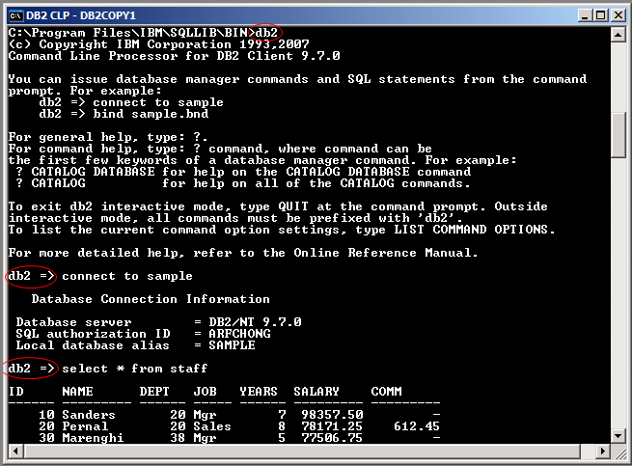The DB2 Command Line Processor (CLP) is the same as the DB2 Command Window, with one exception that the prompt is **db2=>** rather than an operating system prompt. To start the DB2 Command Line Processor on Windows, use *Start -> Programs -> IBM DB2 -> DB2COPY1 (Default) -> Command Line Tools -> Command Line Processor* or alternatively from a DB2 Command Window or Linux shell type **db2** and press *Enter*. The prompt will change to **db2** as shown in *Figure B.6*.

Figure B.6 - The DB2 Command Line Processor (CLP)

Note that *Figure B.6* also illustrates that when working in the CLP, you do not need to prefix commands with DB2. To exit from the CLP, type **quit**.

* + - 1. DB2 Command Editor

The DB2 Command Editor is the GUI version of the DB2 Command Window or DB2 Command Line Processor as shown in *Figure B.7*. This tool is deprecated for DB2 version 9.7.

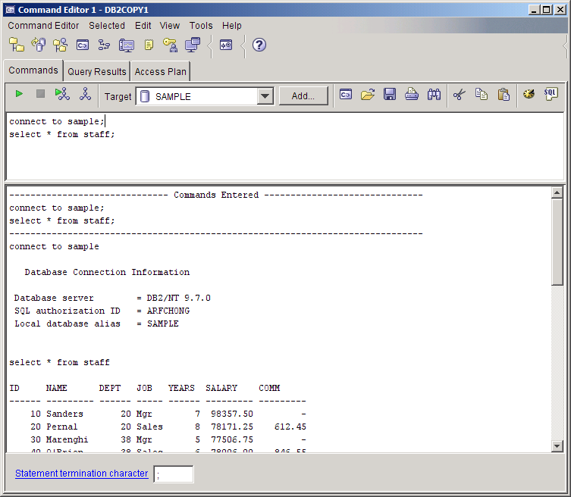

Figure B.7 - The DB2 Command Editor

### The DB2 environment

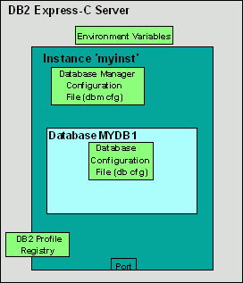*Figure B.8* provides a quick overview of the DB2 environment.

Figure B.8 - The DB2 Environment

The figure illustrates a server where DB2 Express-C has been installed. The smaller boxes in light green (Environment Variables, Database Manager Configuration File, Database Configuration File, DB2 Profile Registry) are the different areas where a DB2 server can be configured, and they will be explained in more detail in the next section. The larger dark green box represents an instance which in this example has the name ***myinst***.

An ***instance*** is an environment where database objects can be created. On the same server, you can create several instances, each of which is treated independently. For example, you can use an instance for development, another one for test, and another one for production. *Table B.1* shows some useful commands you can use at the instance level. Note that the commands shown in this section can also be performed from DB2 GUI Tools.

|  |  |
| --- | --- |
| **Command** | **Description** |
| db2start | Starts the current instance |
| db2stop | Stops the current instance |
| db2icrt <instance_name> | Creates a new instance |
| db2idrop <instance_name> | Drops an instance |
| db2ilist | Lists the instances you have on your system |

|  |  |
| --- | --- |
|  |  |
| db2 get instance | Lists the current active instance |

Table B.1 - Useful instance-level DB2 commands

Within an instance you can create many databases. A ***database*** is a collection of objects such as tables, views, indexes, and so on. For example, in Figure B.8, the database ***MYDB1*** has been created within instance ***myinst***. *Table B.2* shows some commands you can use at the database level.

|  |  |
| --- | --- |
| **Command/SQL statement** | **Description** |
| create database <database_name> | Creates a new database |
| drop database <database_name> | Drops a database |
| connect to <database_name> | Connects to a database |
| create table/create view/create index | SQL statements to create table, views, and indexes respectively |

Table B.2 - Commands and SQL Statements at the database level

### DB2 configuration

DB2 parameters can be configured using the Configuration Advisor GUI tool. The Configuration Advisor can be accessed through the Control Center by right clicking on a database and choosing *Configuration Advisor*. Based on your answers to some questions about your system resources and workload, the configuration advisor will provide a list of DB2 parameters that would operate optimally using the suggested values. If you would like more detail about DB2 configuration, keep reading. Otherwise, use the Configuration Advisor and you are ready to work with DB2!

A DB2 server can be configured at four different levels as shown earlier in *Figure B.8*:

* + - * + ***Environment variables*** are variables set at the operating system level. The main environment variable to be concerned about is DB2INSTANCE. This variable indicates the current instance you are working on, and for which your DB2 commands will apply.
        + ***Database Manager Configuration File (dbm cfg)*** includes parameters that affect the instance and all the databases it contains. *Table B.3* shows some useful commands to manage the dbm cfg.

|  |  |
| --- | --- |
| **Command** | **Description** |
| get dbm cfg | Retrieves information about the dbm cfg |

|  |  |
| --- | --- |
| update dbm cfg using  <parameter_name> <value> | Updates the value of a dbm cfg parameter |

Table B.3 - Commands to manipulate the dbm cfg

* + - * + ***Database Configuration File (db cfg)*** includes parameters that affect the particular database in question. *Table B.4* shows some useful commands to manage the db cfg.

|  |  |
| --- | --- |
| **Command** | **Description** |
| get db cfg for <database_name> | Retrieves information about the db cfg for a given database |
| update db cfg for <database_name>  using <parameter_name> <value> | Updates the value of a db cfg parameter |

Table B.4 - Commands to manipulate the db cfg

* + - * + ***DB2 Profile Registry variables*** includes parameters that may be platform specific and can be set globally (affecting all instances), or at the instance level (affecting one particular instance). *Table B.5* shows some useful commands to manipulate the DB2 profile registry.

|  |  |
| --- | --- |
| **Command** | **Description** |
| db2set -all | Lists all the DB2 profile registry variables that are set |
| db2set <parameter>=<value> | Sets a given parameter with a value |

Table B.5 - Commands to manipulate the DB2 profile registry

### Connecting to a database

If your database is local, that is, it resides on the same system where you are performing your database operation; the connection setup is performed automatically when the database is created. You can simply issue a connect to database_name statement to connect to the database.

If your database is remote, the simplest method to set up database connectivity is by using the Configuration Assistant GUI tool following these steps:

* + 1. Start the Configuration Assistant from the system where you want to connect to the database. To start this tool, use the command **db2ca** from a Windows command prompt or Linux shell. *Figure B.9* shows the Configuration Assistant.

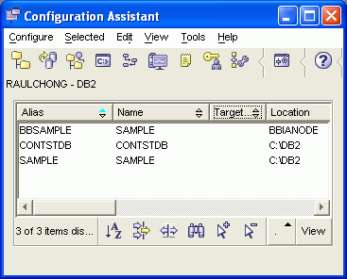

Figure B.9 - The DB2 Configuration Assistant

* + 1. From the Configuration Assistant, click on the *Selected --> Add database using Wizard* menu
    2. From the *Select how you want to set up a connection* window, you can use *Search the network* if your network is small without many hubs. If you know the name of the server where DB2 resides, choose *Known systems* and drill down all the way to the database you want to connect. Proceed with the wizard using default values. If you do not know the name of your system, choose *Other systems* (*Search the network*). Note that this may take a long time if your network is large.
    3. If *Search the network* does not work, go back to the *Select how you want to set up a connection* window, and choose *Manually configure a connection to a database*. Choose TCP/IP and click *next*. Input the *hostname or IP address* where your DB2 server resides. Input either the *service name or the port number*.
    4. Continue with the wizard prompts and leave the default values.
    5. After you finish your set up, a window will pop up asking you if you want to test your connection. You can also test the connection after the setup is finished by right-clicking on the database, and choosing *Test Connection*.

### Basic sample programs

Depending on the programming language used, different syntax is required to connect to a DB2 database and perform operations. Below are links to basic sample programs which connect to a database, and retrieve one record. We suggest you first download (from <ftp://ftp.software.ibm.com/software/data/db2/udb/db2express/samples.zip>) all the sample programs in this section:

CLI program

[http://www.ibm.com/developerworks/db2/library/techarticle/dm-](http://www.ibm.com/developerworks/db2/library/techarticle/dm-0401chong/index.html#scenario1) [0401chong/index.html#scenario1](http://www.ibm.com/developerworks/db2/library/techarticle/dm-0401chong/index.html#scenario1)

ODBC program

[http://www.ibm.com/developerworks/db2/library/techarticle/dm-](http://www.ibm.com/developerworks/db2/library/techarticle/dm-0401chong/index.html#scenario2) [0401chong/index.html#scenario2](http://www.ibm.com/developerworks/db2/library/techarticle/dm-0401chong/index.html#scenario2)

C program with embedded SQL

[http://www.ibm.com/developerworks/db2/library/techarticle/dm-](http://www.ibm.com/developerworks/db2/library/techarticle/dm-0401chong/index.html#scenario3) [0401chong/index.html#scenario3](http://www.ibm.com/developerworks/db2/library/techarticle/dm-0401chong/index.html#scenario3)

JDBC program using Type 2 Universal (JCC) driver

[http://www.ibm.com/developerworks/db2/library/techarticle/dm-](http://www.ibm.com/developerworks/db2/library/techarticle/dm-0401chong/index.html#scenario6) [0401chong/index.html#scenario6](http://www.ibm.com/developerworks/db2/library/techarticle/dm-0401chong/index.html#scenario6)

JDBC program using Type 4 Universal (JCC) driver

[http://www.ibm.com/developerworks/db2/library/techarticle/dm-](http://www.ibm.com/developerworks/db2/library/techarticle/dm-0401chong/index.html#scenario8) [0401chong/index.html#scenario8](http://www.ibm.com/developerworks/db2/library/techarticle/dm-0401chong/index.html#scenario8)

Visual Basic and C++ ADO program - Using the IBM OLE DB provider for DB2 (IBMDADB2)

[http://www.ibm.com/developerworks/db2/library/techarticle/dm-](http://www.ibm.com/developerworks/db2/library/techarticle/dm-0402chong2/index.html#scenario1) [0402chong2/index.html#scenario1](http://www.ibm.com/developerworks/db2/library/techarticle/dm-0402chong2/index.html#scenario1)

Visual Basic and C++ ADO program - Using the Microsoft OLE DB Provider for ODBC (MSDASQL)

[http://www.ibm.com/developerworks/db2/library/techarticle/dm-](http://www.ibm.com/developerworks/db2/library/techarticle/dm-0402chong2/index.html#scenario2) [0402chong2/index.html#scenario2](http://www.ibm.com/developerworks/db2/library/techarticle/dm-0402chong2/index.html#scenario2)

Visual Basic and C# ADO.Net using the IBM DB2 .NET Data Provider

[http://www.ibm.com/developerworks/db2/library/techarticle/dm-](http://www.ibm.com/developerworks/db2/library/techarticle/dm-0402chong2/index.html#scenario3) [0402chong2/index.html#scenario3](http://www.ibm.com/developerworks/db2/library/techarticle/dm-0402chong2/index.html#scenario3)

Visual Basic and C# ADO.Net using the Microsoft OLE DB .NET Data Provider

[http://www.ibm.com/developerworks/db2/library/techarticle/dm-](http://www.ibm.com/developerworks/db2/library/techarticle/dm-0402chong2/index.html#scenario4) [0402chong2/index.html#scenario4](http://www.ibm.com/developerworks/db2/library/techarticle/dm-0402chong2/index.html#scenario4)

Visual Basic and C# ADO.Net using the Microsoft ODBC .NET Data Provider

[http://www.ibm.com/developerworks/db2/library/techarticle/dm-](http://www.ibm.com/developerworks/db2/library/techarticle/dm-0402chong2/index.html#scenario5) [0402chong2/index.html#scenario5](http://www.ibm.com/developerworks/db2/library/techarticle/dm-0402chong2/index.html#scenario5)

### DB2 documentation

The DB2 Information Center provides the most up-to-date online DB2 documentation. The DB2 Information Center is a web application. You can access the DB2 Information Center online (<http://publib.boulder.ibm.com/infocenter/db2luw/v9r7/index.jsp>), or you can download and install the DB2 Information Center to your local computer. Links to the online DB2 Information Center as well as downloadable versions are available at [http://www.ibm.com/software/data/db2/9/download.html?S_TACT=download&S_CMP=exp](http://www.ibm.com/software/data/db2/9/download.html?S_TACT=download&amp;S_CMP=expcsite) [csite](http://www.ibm.com/software/data/db2/9/download.html?S_TACT=download&amp;S_CMP=expcsite)

## Resources

### Web sites

* + 1. DB2 Express-C home page

[ibm.com/db2/express](http://www.ibm.com/db2/express/download.html?S_CMP=ECDDWW01&amp;S_TACT=DOCBOOK08)

This site is the home page of DB2 Express-C. You can find links to download the free DB2 Express-C from this page.

* + 1. IBM Data Studio home page

<http://www-01.ibm.com/software/data/optim/data-studio/>

This site is the home page of the free IBM Data Studio, an Eclipse-based tool you can use with DB2.

* + 1. Free DB2 Express-C and IBM Data Studio download

[http://www.ibm.com/db2/express/download.html?S_CMP=ECDDWW01&S_TACT=D](http://www.ibm.com/db2/express/download.html?S_CMP=ECDDWW01&amp;S_TACT=DOCBOOK01) [OCBOOK01](http://www.ibm.com/db2/express/download.html?S_CMP=ECDDWW01&amp;S_TACT=DOCBOOK01)

* + 1. InfoSphere Data Architect home page

<http://www-01.ibm.com/software/data/optim/data-architect/>

### Books

* + - 1. Free ebook: Getting started with DB2 Express-C (3rd Edition) Raul F. Chong et all - June 2009 [http://www.db2university.com](http://www.db2university.com/)
      2. Free ebook: Getting started with IBM Data Studio for DB2 Debra Eaton et all - Dec 2009 [http://www.db2university.com](http://www.db2university.com/)
      3. DB2 9 pureXML® Guide

Whei-Jen Chen, Art Sammartino, Dobromir Goutev, Felicity Hendricks, Ippei Komi, Ming-Pang Wei, Rav Ahuja

August 2007 - SG24-7315-01

<http://www.redbooks.ibm.com/abstracts/sg247315.html>

* + - 1. Free Redbook®: DB2 Security and Compliance Solutions for Linux, UNIX, and Windows, Whei-Jen Chen, Ivo Rytir, Paul Read, Rafat Odeh, March 2008, SG 24- 7555-00

<http://www.redbooks.ibm.com/abstracts/sg247555.html?Open>

### References

[1.1] CODD, E.F. *A relational model of data for large shared data banks*, CACM 13, NO 6, 1970

[2.1] DATE, C.J. *An introduction to database* systems, Addison-Wesley Publishing Company, 1986

[2.2] MITEA, A.C. *Relational and object-oriented databases*, “Lucian Blaga” University Publishing Company, 2002

[2.3] CODD, E.F. *Relational completeness on data base sublanguage*, Data Base Systems, Courant Computer Science Symposia Series, Vol.6 Englewood Cliffs, N.J,

Prentice-Hall, 1972

[2.4] KUHNS, J.L. *Answering questions by computer: A logical study*, Report RM-5428-PR,

Rand Corporation, Santa Monica, California, 1967

[2.5] CODD, E.F. *A data base sublanguage founded on the relational calculus*, Proceedings ACM SIGFIDET Workshop on Data Description, Access and Control, 1971

[2.6]LACROIX, M., PIROTTE, A. *Domain oriented relational languages*, Proceedings 3rd International Conference on Very Large Data Bases, 1977

[2.7]LACROIX, M., PIROTTE, A. *Architecture and models in data base management systems*, G.M. Nijssen Publishing company, North-Holland, 1977

[3.1] IBM Rational Data Architect Evaluation Guide

[3.2] Connolly, T., Begg, C., Strachan, A. – Database Systems – A Practical Approach to Design, Implementation and Management, Addison Wesley Longman Limited 1995, 1998

[3.3] IBM InfoSphere Data Architect – Information Center [3[.4]](http://publib.boulder.ibm.com/infocenter/rdahelp/v7r5/index.jsp%205) <http://www.ibm.com/developerworks/data/bestpractices/>

[3.5] 03_dev475_ex_workbook_main.pdf, IBM Rational Software, Section 1: Course Registration Requirements, Copyright IBM Corp. 2004

[4.1] Codd, E. F. The Relational Model for Database Management

[4.2] Codd, E.F. "Further Normalization of the Data Base Relational Model." [4.3] Date, C. J. "What First Normal Form Really Means"

[4.4] Silberschatz, Korth, Sudershan - Database System Concepts

[4.5] William Kent - A Simple Guide to Five Normal Forms in Relational Database Theory [4.6] Raghu Ramakrishnan, Johannes Gehrke - Database management systems

[4.7] Vincent, M.W. and B. Srinivasan. "A Note on Relation Schemes Which Are in 3NF But Not in BCNF."

[4.8] C. J Date : An Introduction to Database Systems 8th Edition

[4.9] William Kent: A simple guide to five normal forms in relational database theory

<http://www.bkent.net/Doc/simple5.htm>

[4.10] Ronald Fagin, C J Date: Simple conditions for guaranteeing higher normal forms in relational databases

<http://portal.acm.org/citation.cfm?id=132274>

[4.11] Ronald Fagin: A Normal Form for Relational Databases That Is Based on Domains and Keys

<http://www.almaden.ibm.com/cs/people/fagin/tods81.pdf>

[4.12] C. J. Date, Hugh Darwen, Nikos A. Lorentzos: Temporal data and the relational model p172

[4.13] C J Date: Logic and databases, Appendix –C

[5.1] Differences between SQL procedures and External procedures

<http://publib.boulder.ibm.com/infocenter/dzichelp/v2r2/topic/com.ibm.db29.doc.apsg/db2z_> differencesqlprocexternalproc.htm

[5.2] SQL Reference Guide

<http://www.ibm.com/developerworks/data/library/techarticle/0206sqlref/0206sqlref.html> [6.1]

<http://publib.boulder.ibm.com/infocenter/dzichelp/v2r2/topic/com.ibm.db29.doc.apsg/db2z_> differencesqlprocexternalproc.htm

### Contact

Contact emails:

General DB2 on Campus program mailbox: [db2univ@ca.ibm.com](mailto:db2univ@ca.ibm.com)

##### Getting started with Database Fundamentals couldn't be easier.



**Read this book to:**

* **Find out what databases are all about**
* **Understand relational, information and conceptual models**
* **Learn how to design databases**
* **Start writing SQL statements, database functions and procedures**
* **Know how DB2 pureXML seamlessly integrates XML and relational data**
* **Understand database security**
* **Practice using hands-on exercises**

###### Data is one of the most critical assets of any business. It is used and collected practically everywhere, from businesses trying to determine consumer patterns based on credit card usage, to space agencies trying to collect data from other planets. Database software usage is pervasive, yet it is taken for granted by the billions of daily users worldwide.

This book gets you started into the fascinating world of databases. It provides the fundamentals of database management systems with specific reference to IBM DB2. Using DB2 Express-C, the free version of DB2, you will learn all the elements that make up database systems, databases, the SQL language, and XML.

The book includes examples and exercises that will give you good hands- on experience and allow you to explore yourself how database concepts actually work.

To learn more about database fundamentals and information management topics, visit:

[ibm.com/developerworks/data/](http://www.ibm.com/developerworks/data/)

To learn more or download DB2 Express-C, visit [ibm.com/db2/express](http://www.ibm.com/db2/express/download.html?S_CMP=ECDDWW01&amp;S_TACT=DOCBOOK01)

To socialize and watch related videos, visit [channelDB2.com](http://www.channeldb2.com/)

This book is part of the DB2 on Campus book series, free eBooks for the community. Learn more at [db2university.com](http://www.db2university.com/)

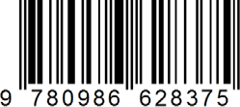

Price: 24.99USD