Ai Audio Toolkits

- Overview: Artificial intelligence (AI) can also be used to analyze audio data. This includes:
- Audio Analysis:
Sound classification, which can identify and categorize different types of sounds, such as a dog's bark or a car horn.
Speaker recognition, which can identify the who the speaker is based on their voice.
Speech recognition, which can transcribe spoken words into text. This is useful for applications like TV captions or translating speech to text.
- Audio Synthesis: speech synthesis, voice synthesis and speech translation
Speech synthesis, which can convert text to spoken words. This is useful for applications like pronunciation guides.

- Setup Azure
In order to use Microsoft Speech recognition, we need to create speech resource as the following:
- Log into your azure account, click on create resource -> AI + Machine Learning ->Click on Speech as shown
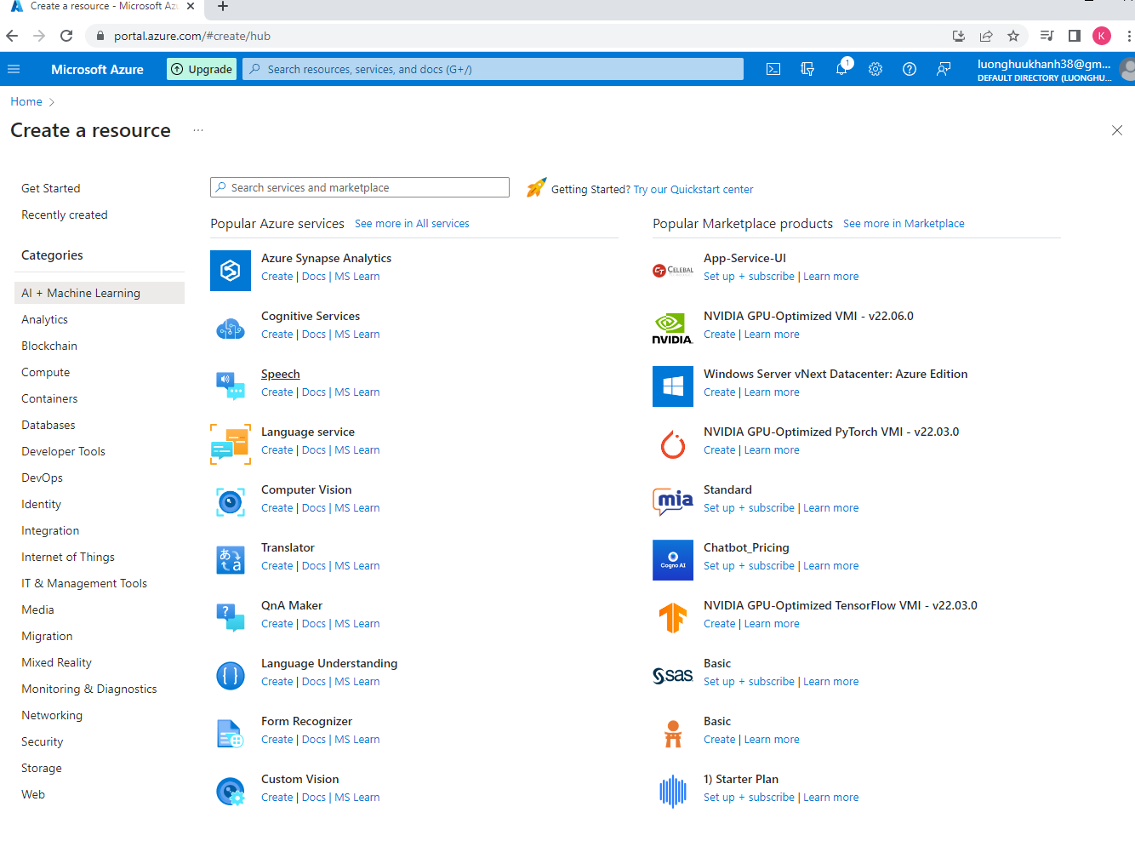

- Click on Create under Speech from above screen shot and fill out information.
- Click on review + Create as shown.
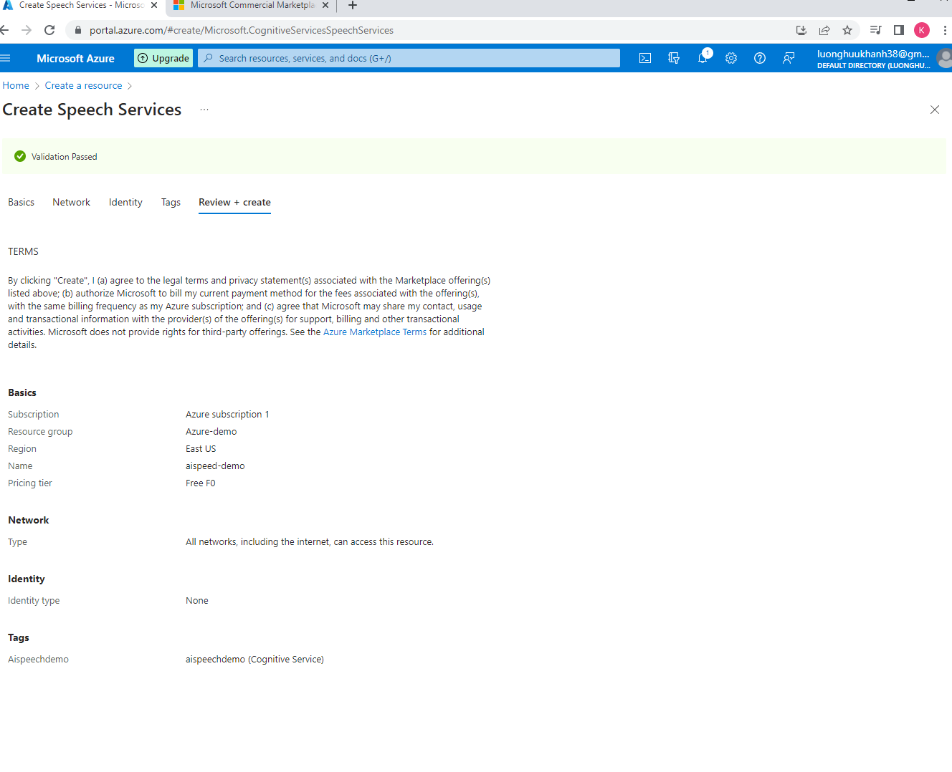

- Click on go to resource
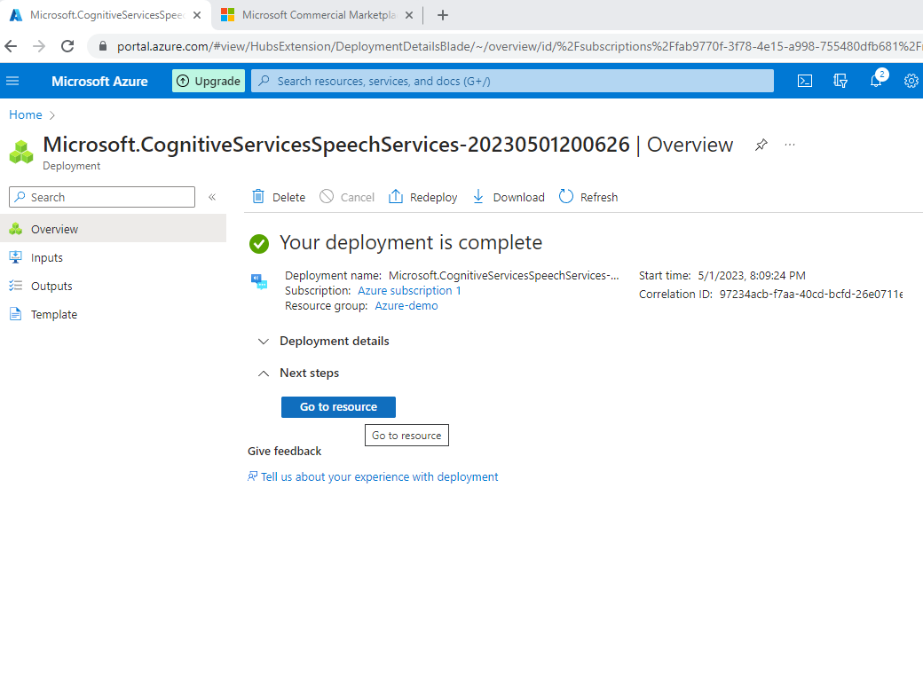

- Click on show key and copy the endpoint url and the key guid for this speech resource to put in python program for calling the MS API
- Using PyCharm to create Python project and interface to speech API.
- Name the project AiAudio
- Open terminal and install azure package as shown below
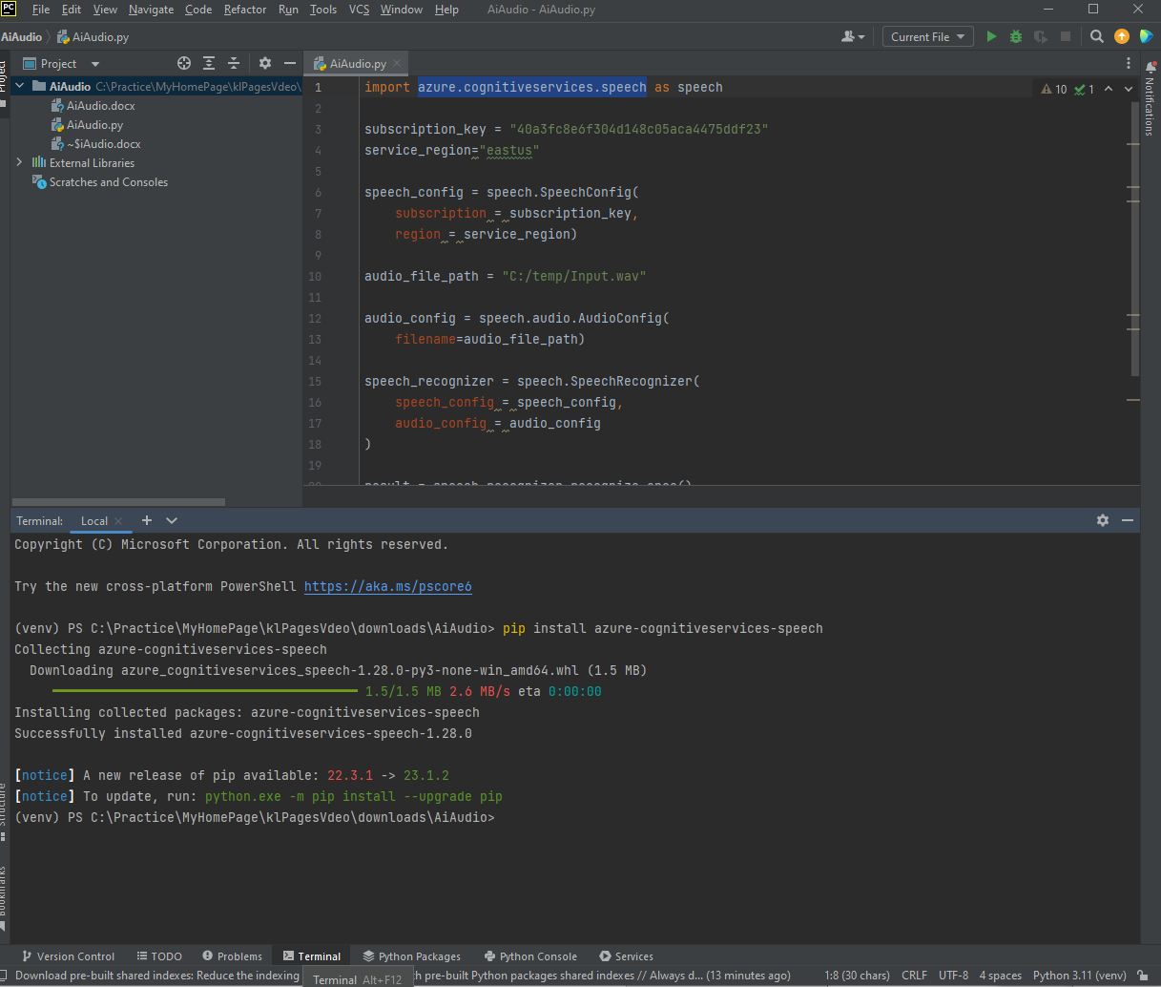

- Place the sample input audio file .wav at the project root directory \Audio\input.wav
- Import library and edit python code to invoke speech API
- Run program, it will interpret wave audio file into text as the output
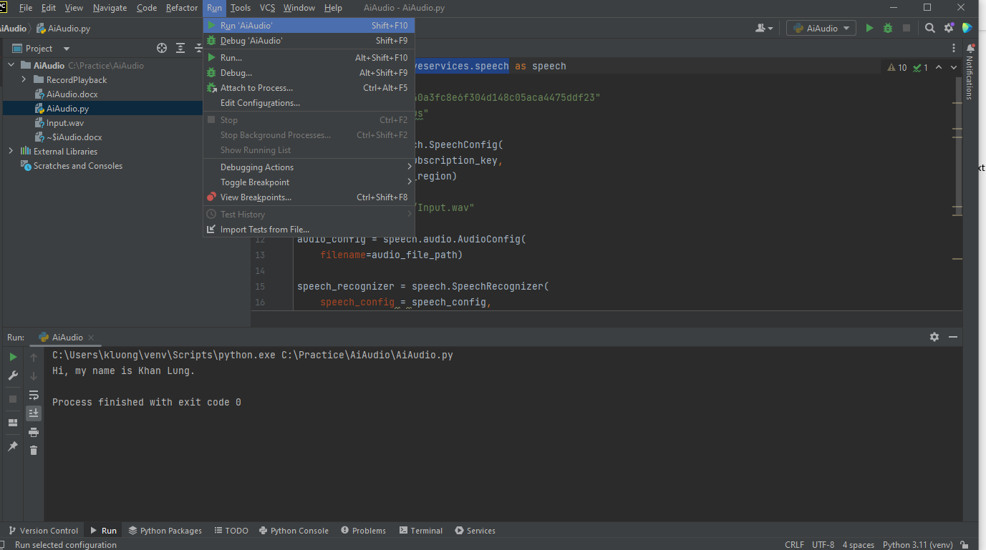

If we’ve ever fail to run python program, it is more likely that the python editor did not refresh the python path. Please click on Run->Edit Configuration to change the path to point to your virtual environment for python and rerun the app as shown below.
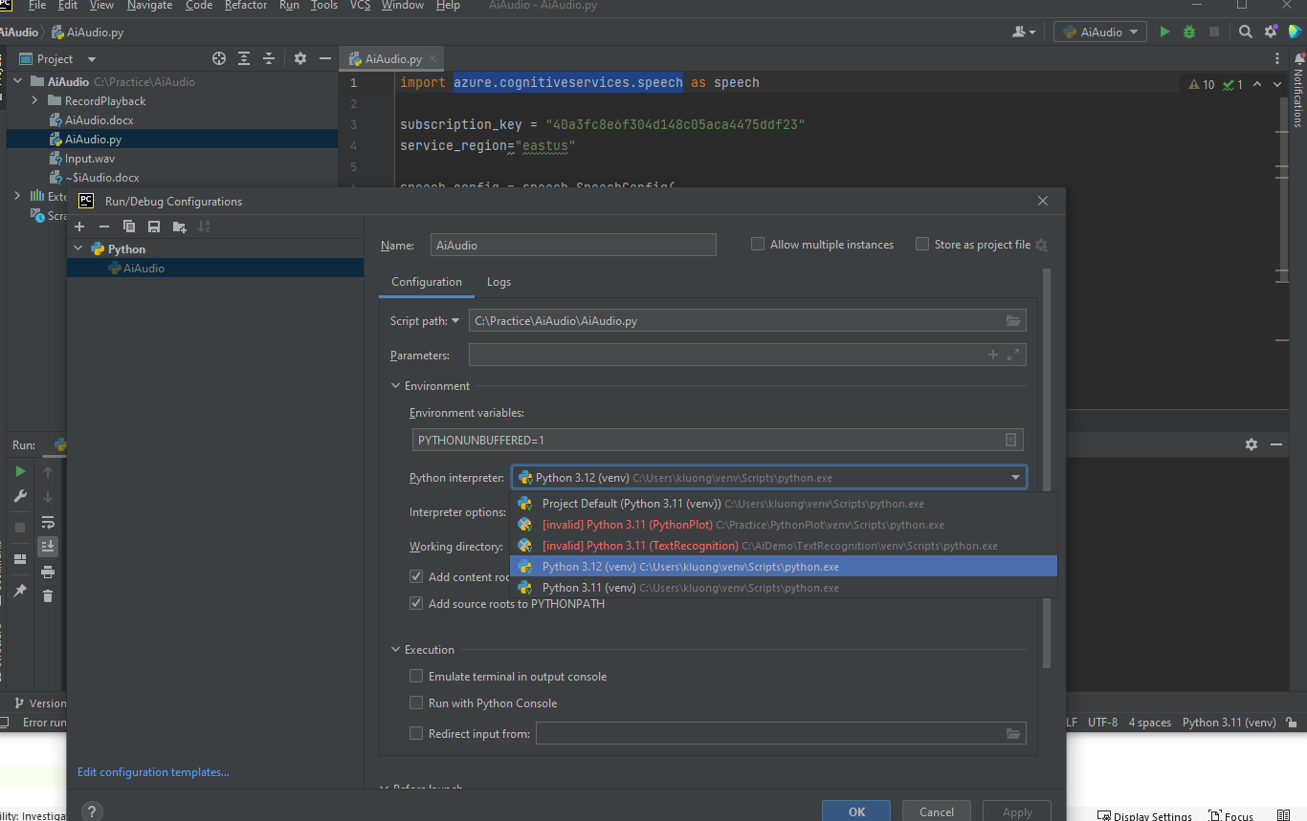

- C# App interface with Ai API
To use the C# Application program for Speed Recognition, start by downloading and launching the program. Open solution file at screen shot shown below
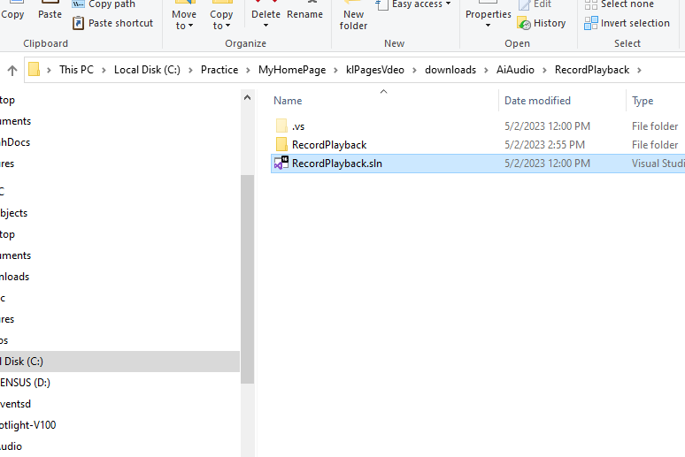

Then, click on Debug -> "Start without Debug" to begin. To record your own voice input, press the recording button provided. By default, the recording time is limited to 5 seconds. Once you have finished recording, it will translate your voice into text and display.

One potential use case for our app is to demonstrate the ability to input user commands using voice recognition. Instead of manually clicking on a "Circle" button, users could simply speak the command aloud. By pressing the Record button and saying "Circle," the app would automatically convert the user's voice to text and interpret it as a "circle" command. This would trigger the app to draw a circle on the screen. Ideally, the app would respond immediately upon recognizing the command instead of a pause of 5 seconds, creating a seamless user experience. It's important to note that this feature is currently an exercise to demonstrate the concept only.

If you need more time to record your voice input, you can change the code to allow for a longer recording time (e.g. 9000 milliseconds).
