All test results

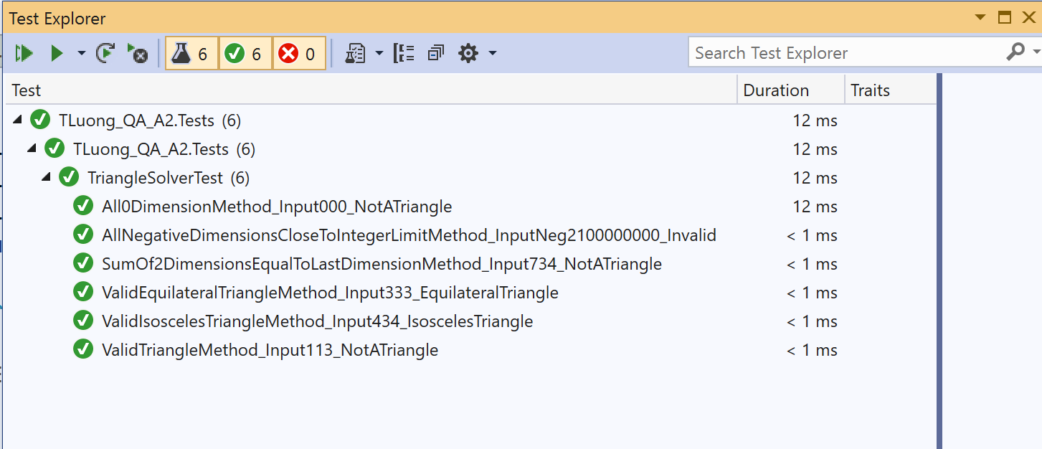

Test 1

Input 1 1 3 are selected as they are simple and easy to visualize in mind that these lengths cannot form a triangle.

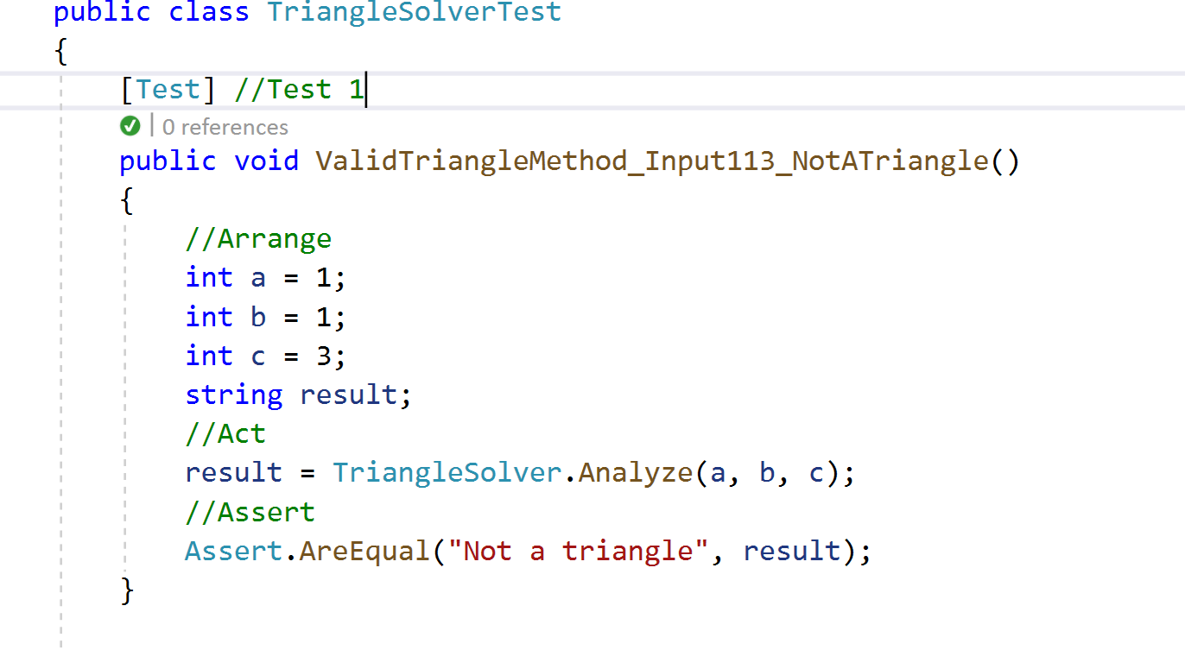

Test 2

Input 3 3 3 are selected because they represent the number of phalanges of index and middle finger. Index and middle finger of one hand form a V then combine with index finger of the other hand will create an equilateral triangle.

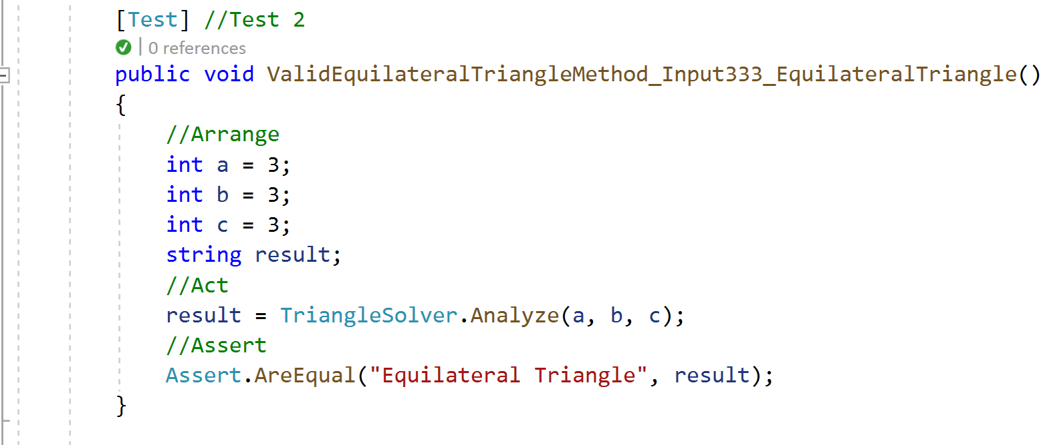

Test 3

Input 4 3 4 are selected to test comparison of first dimension a and third dimension c.

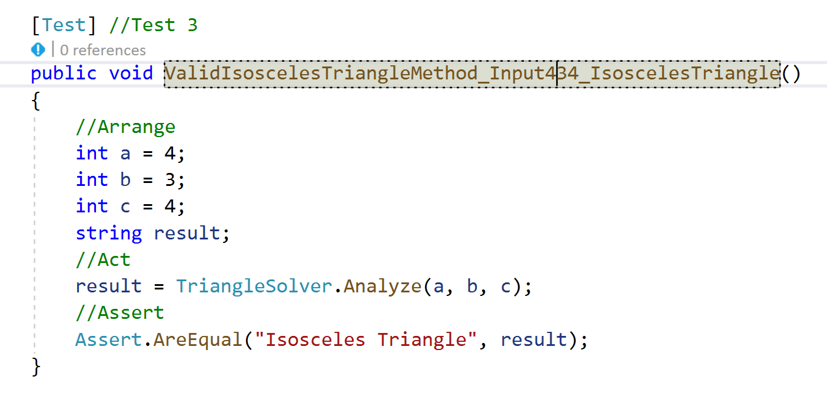

Test 4

Input 7 3 4 are selected to test calculation between second dimension b and third dimension c.

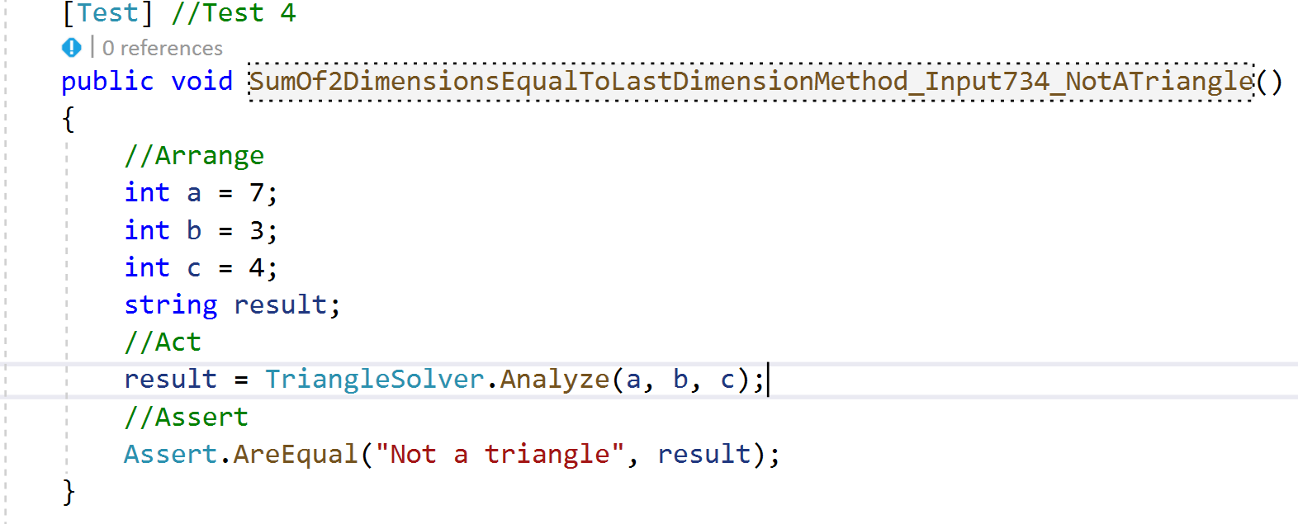

Test 5

Input 0 0 0 are selected to justified the method ability to detect invalid triangle even if invalid input get pass through.

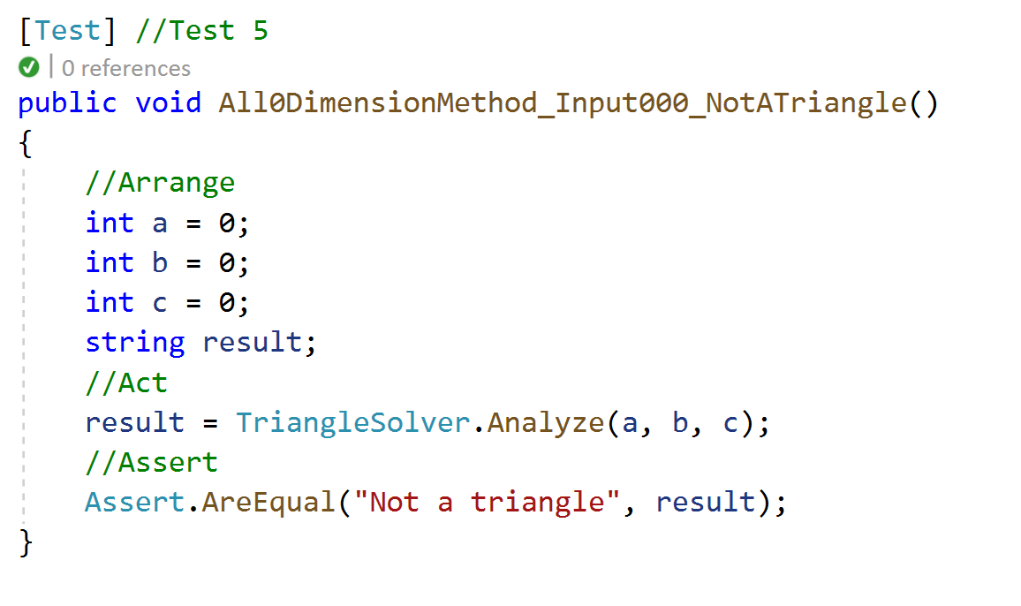

Test 6

Input -2100000000 are selected to further test the method ability to detect invalid input if these input somehow get pass through. -2100000000 is very close to int32 limit, thus, calculation around that point can get messy and confuse the program.

