**6.5 Premise**

1. Maintain Premise

a. Use-case diagram

b. Use-case Description:

* List the Premise & Filter & Sort

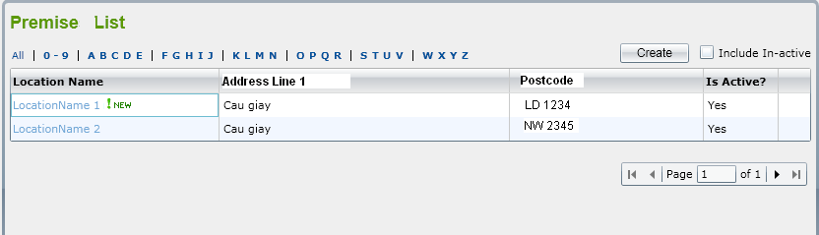

|  |  |
| --- | --- |
| **Key components** | **List the Premise in the system** |
| **Name** | List Premise |
| **Actors** | User or Super User |
| **Description** | showing all active Premises or both in-active and active Premise  when user clicks on “Include in-active” check box |
| **Goal** | Showing Premise |
| **Pre-condition** | ‘Premise List’ screen is displayed successfully |
| **Trigger** | Click on “Premise” from the menu |
| **Post-condition** | List of Premise is displayed |
| **Normal flow** | User logs in  User select Premise on the menu |
| **Alternative flow** | Repeat steps in normal flow |
| **Exception flow** | Notify error when display list Premise |

|  |  |
| --- | --- |
| **Key components** | **Filter Premise by name** |
| **Name** | Filter Premise |
| **Actors** | User or Super User |
| **Description** | User can filter premise by selecting ‘All’ or ‘0-9’=> All premise  that begin with the selected letter will be shown. |
| **Goal** | Showing Premise |
| **Pre-condition** | ‘Premise List’ screen is displayed successfully |
| **Trigger** | Click on group letter |
| **Post-condition** | List of Premise is displayed |
| **Normal flow** | User logs in  User select Premise on the menu |
| **Alternative flow** | Repeat steps in normal flow |
| **Exception flow** | Notify error when display list Premise |

|  |  |
| --- | --- |
| **Key components** | **Sort premise** |
| **Name** | List Premise |
| **Actors** | User or Super User |
| **Description** | Sort the premise when user click on column name |
| **Goal** | Showing Premise |
| **Pre-condition** | ‘Premise List’ screen is displayed successfully |
| **Trigger** | Click on column name |
| **Post-condition** | List of Premise is displayed |
| **Normal flow** | User logs in  User select Premise on the menu |
| **Alternative flow** | Repeat steps in normal flow |
| **Exception flow** | Notify error when display list Premise |

* Change status of the Premise

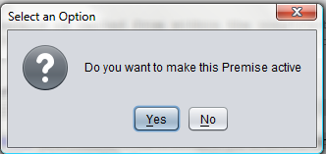

|  |  |
| --- | --- |
| **Key components** | **Change status of premise** |
| **Name** | Change status |
| **Actors** | User or Super User |
| **Description** | Change status of premise from In-active to active |
| **Goal** | Showing Premise |
| **Pre-condition** | ‘Premise List’ screen is displayed successfully |
| **Trigger** | User select an in-active Premise in the list to view |
| **Post-condition** | List of Premise is displayed |
| **Normal flow** | User logs in  User select Premise on the menu |
| **Alternative flow** | Repeat steps in normal flow |
| **Exception flow** | Notify error when display list Premise |

* Create new Premise

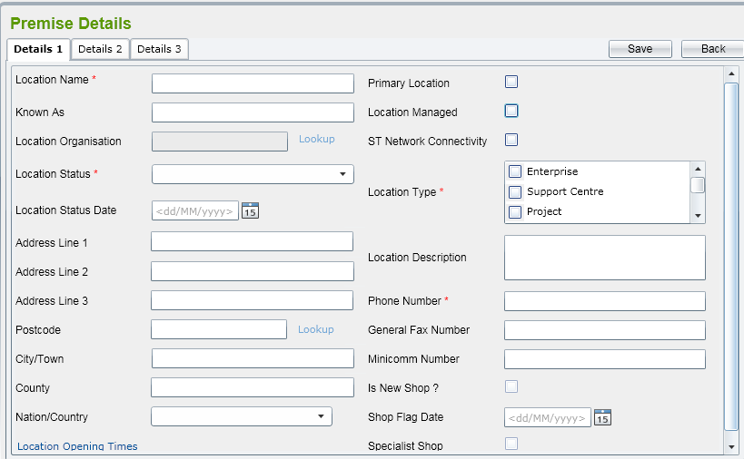

|  |  |
| --- | --- |
| **Key components** | **Create new Premise** |
| **Name** | Create new Premise |
| **Actors** | User or Super User |
| **Description** | Create a new premise |
| **Goal** | Create a new premise |
| **Pre-condition** | ‘Premise Detail’ screen is displayed successfully |
| **Trigger** | User click on ‘Create’ button on the ‘Premise List ’ screen |
| **Post-condition** | A new premise will be created |
| **Normal flow** | User logs in  User select Premise on the menu |
| **Alternative flow** | Repeat steps in normal flow |
| **Exception flow** | Notify error when display list Premise |

* Amend Premise

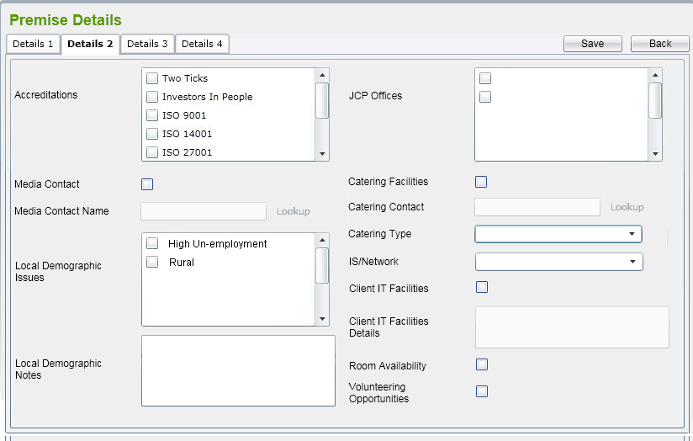

|  |  |
| --- | --- |
| **Key components** | **Edit information** |
| **Name** | Amend Premise |
| **Actors** | User or Super User |
| **Description** | By selecting an active Premise from the list , the Premise Detail  Screen is displaying allowing user to amend |
| **Goal** | Edit information of the premise |
| **Pre-condition** | ‘Premise List’ screen is displayed successfully |
| **Trigger** | Selecting an active Premise from the list |
| **Post-condition** | List of Premise is displayed |
| **Normal flow** | User logs in  User select Premise on the menu |
| **Alternative flow** | Repeat steps in normal flow |
| **Exception flow** | Notify error when display list Premise |

* Mark in-active Premise

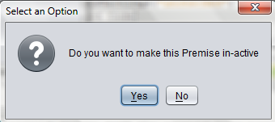

|  |  |
| --- | --- |
| **Key components** | **Mark in-active Premise** |
| **Name** | Mark in-active Premise |
| **Actors** | User or Super User |
| **Description** | Change status of the Premise from active to in-active |
| **Goal** | Change status of the Premise |
| **Pre-condition** | ‘Premise List’ screen is displayed successfully |
| **Trigger** | Click on ‘In-active’ button on the details screen |
| **Post-condition** | List of Premise is displayed |
| **Normal flow** | User logs in  User select Premise on the menu |
| **Alternative flow** | Repeat steps in normal flow |
| **Exception flow** | Notify error when display list Premise |

2. Maintain Facility (Tương tự phần 1)

a. Use-case diagram

b. Use-case Description:

|  |  |
| --- | --- |
| **Key components** | **Filter facilities by name** |
| **Name** | Filter facilities by name |
| **Actors** | User or Super User |
| **Description** | filter Premises by selecting ‘All’ or ‘0-9’ or ‘ABCDE’  or ‘FGHIJ’, etc |
| **Goal** | Filter Premise |
| **Pre-condition** | ‘Premise List’ screen is displayed successfully |
| **Trigger** | Select the group of character as “ABCD”…. |
| **Post-condition** | All Premises that begin with the selected group of  character will be shown. |
| **Normal flow** | User logs in  User select Premise on the menu  User select character to filter |
| **Alternative flow** | Repeat steps in normal flow |
| **Exception flow** | Notify error when display list Premise  Notify error when filter Premise |