1 | docker --version | 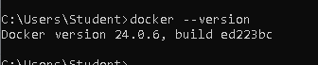
2 | docker run hello-world | 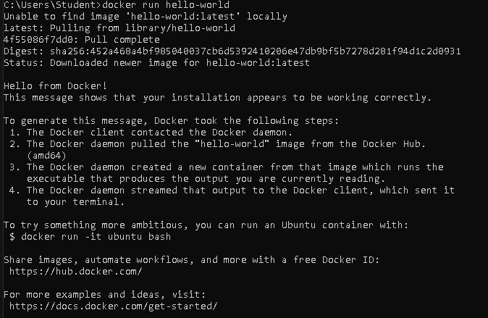
3 | docker pull nginx | 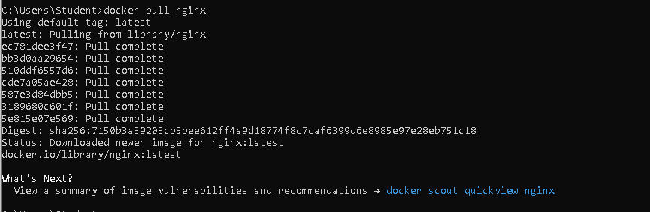
4 | docker images | 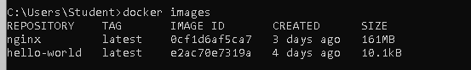
5 | docker run -d nginx
6 | docker ps
7 | docker ps -a | 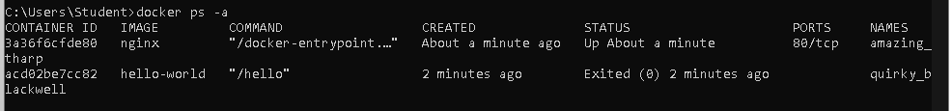
8 | docker logs <container_id> | 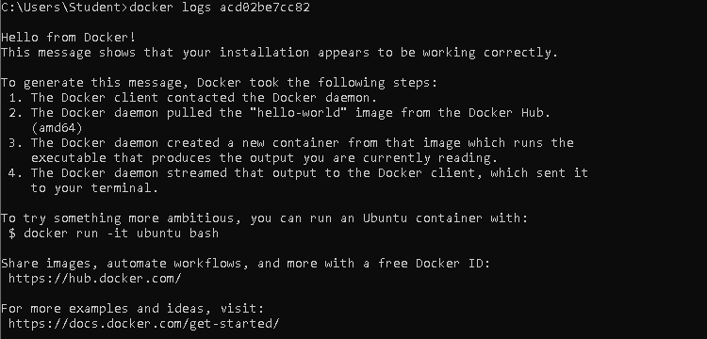
9 | docker exec -it <container_id> /bin/sh
10 | docker stop <container_id> | 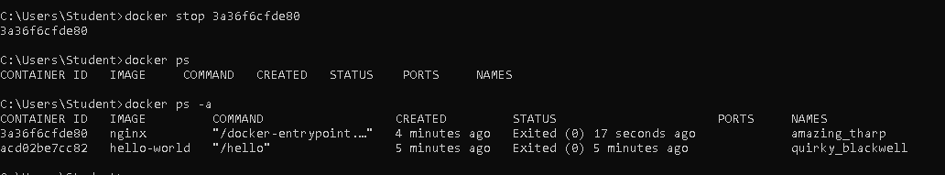
11 | docker restart <container_id> | 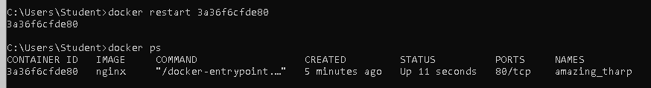
12 | docker rm <container_id> | 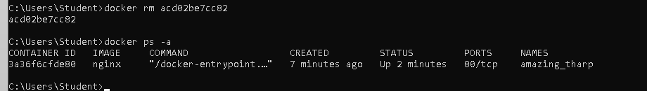
13 | docker container prune | 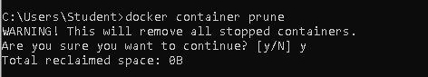
14 | docker rmi <image_id> xoa image | 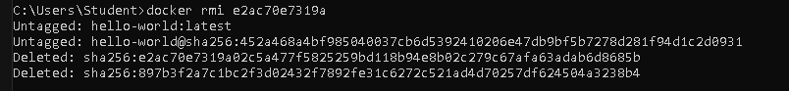
15 | docker image prune -a | 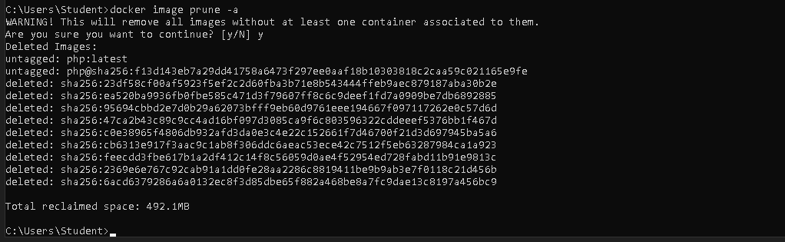
16 | docker run -d -p 8080:80 nginx
 |  | 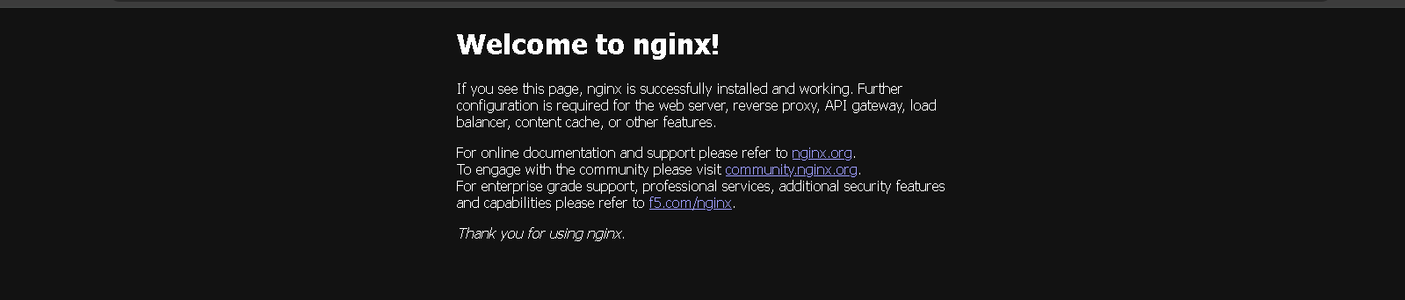
17 | docker inspect <container_id> | 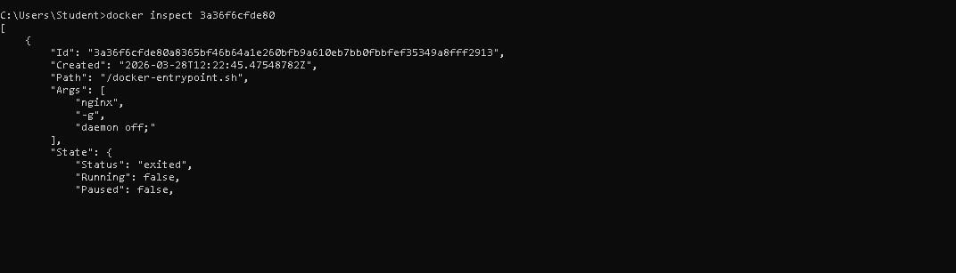
18 | docker run -d -v mydata:/data nginx
19 | docker volume ls | 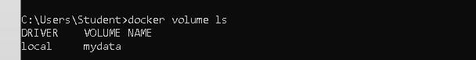
20 | docker volume prune | 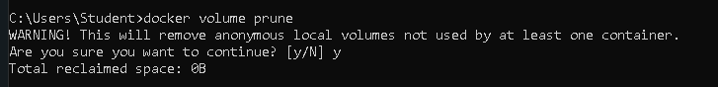
21 | docker run -d --name my_nginx nginx
22 | docker stats | 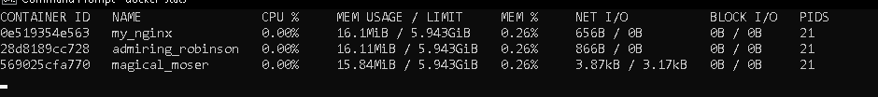
23 | docker network ls | 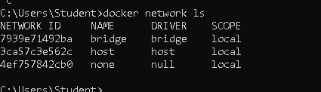
24 | docker network create my_network | 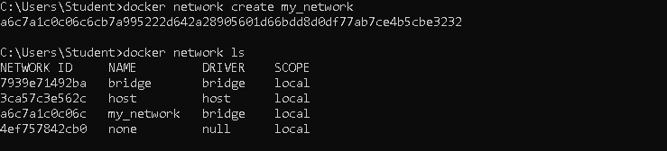
25 | docker run -d --network my_network --name my_container nginx | 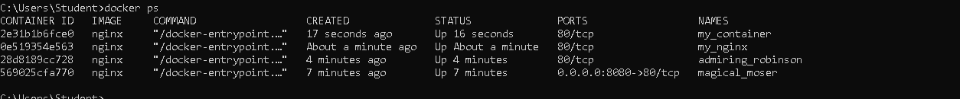
26 | docker network connect my_network my_nginx | 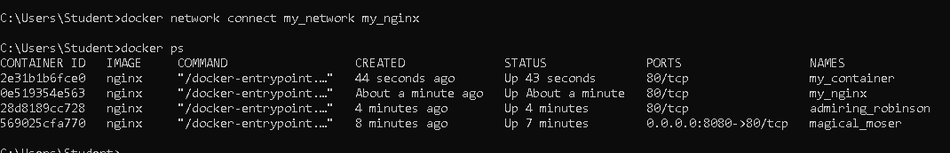
 |  | 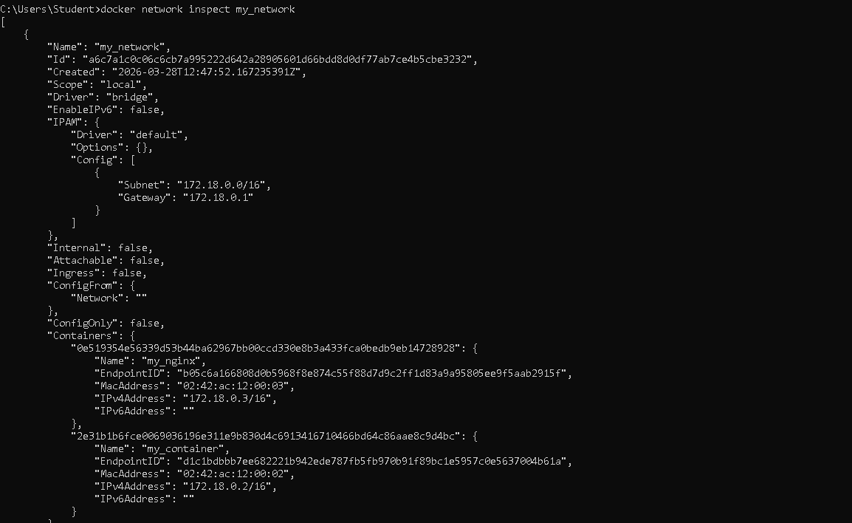
27 | docker run -d -e MY_ENV=hello_world nginx
28 | docker logs -f my_nginx | 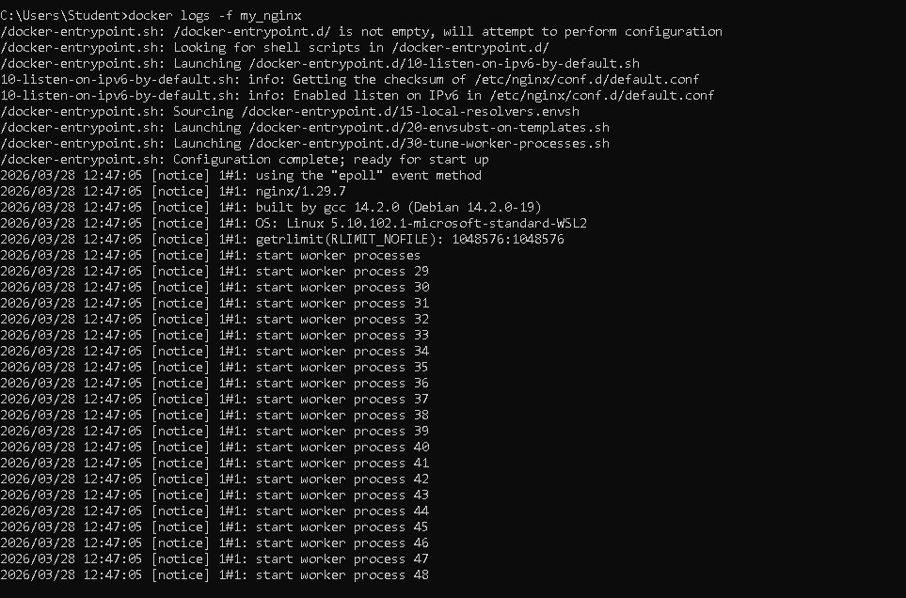
29 | FROM nginx
 | COPY index.html /usr/share/nginx/html/index.html
30 | docker build -t my_nginx_image .
31 | docker run -d -p 8080:80 my_nginx_image

