# Lương Thành Đạt_1150070009

# Lab06 - Animation trong Android

## MainActivity.java

package com.example.thanhdat;  
  
public class MainActivity extends AppCompatActivity {  
 private Button btnFadeInXml, btnFadeInCode, btnFadeOutXml, btnFadeOutCode,  
 btnBlinkXml, btnBlinkCode, btnZoomInXml, btnZoomInCode, btnZoomOutXml,  
 btnZoomOutCode, btnRotateXml, btnRotateCode, btnMoveXml, btnMoveCode,  
 btnSlideUpXml, btnSlideUpCode, btnBounceXml, btnBounceCode,  
 btnCombineXml, btnCombineCode;  
 private ImageView ivUitLogo;  
 private Animation.AnimationListener animationListener;  
  
 @Override  
 protected void onCreate(Bundle savedInstanceState) {  
 super.onCreate(savedInstanceState);  
 setContentView(R.layout.activity_main);  
 findViewsByIds();  
 initVariables();  
  
 // XML animations  
 handleClickAnimationXml(btnFadeInXml, R.anim.anim_fade_in);  
 handleClickAnimationXml(btnFadeOutXml, R.anim.anim_fade_out);  
 handleClickAnimationXml(btnBlinkXml, R.anim.anim_blink);  
 handleClickAnimationXml(btnZoomInXml, R.anim.anim_zoom_in);  
 handleClickAnimationXml(btnZoomOutXml, R.anim.anim_zoom_out);  
 handleClickAnimationXml(btnRotateXml, R.anim.anim_rotate);  
 handleClickAnimationXml(btnMoveXml, R.anim.anim_move);  
 handleClickAnimationXml(btnSlideUpXml, R.anim.anim_slide_up);  
 handleClickAnimationXml(btnBounceXml, R.anim.anim_bounce);  
 handleClickAnimationXml(btnCombineXml, R.anim.anim_combine);  
  
 // Code animations  
 handleClickAnimationCode(btnFadeInCode, buildFadeIn());  
 handleClickAnimationCode(btnFadeOutCode, buildFadeOut());  
 handleClickAnimationCode(btnBlinkCode, buildBlink());  
 handleClickAnimationCode(btnZoomInCode, buildZoomIn());  
 handleClickAnimationCode(btnZoomOutCode, buildZoomOut());  
 handleClickAnimationCode(btnRotateCode, buildRotate());  
 handleClickAnimationCode(btnMoveCode, buildMove());  
 handleClickAnimationCode(btnSlideUpCode, buildSlideUp());  
 handleClickAnimationCode(btnBounceCode, buildBounce());  
 handleClickAnimationCode(btnCombineCode, buildCombine());  
  
 ivUitLogo.setOnClickListener(v -> {  
 startActivity(new Intent(this, NewActivity.class));  
 overridePendingTransition(R.anim.slide_in_right, R.anim.slide_out_left);  
 });  
 }  
}  
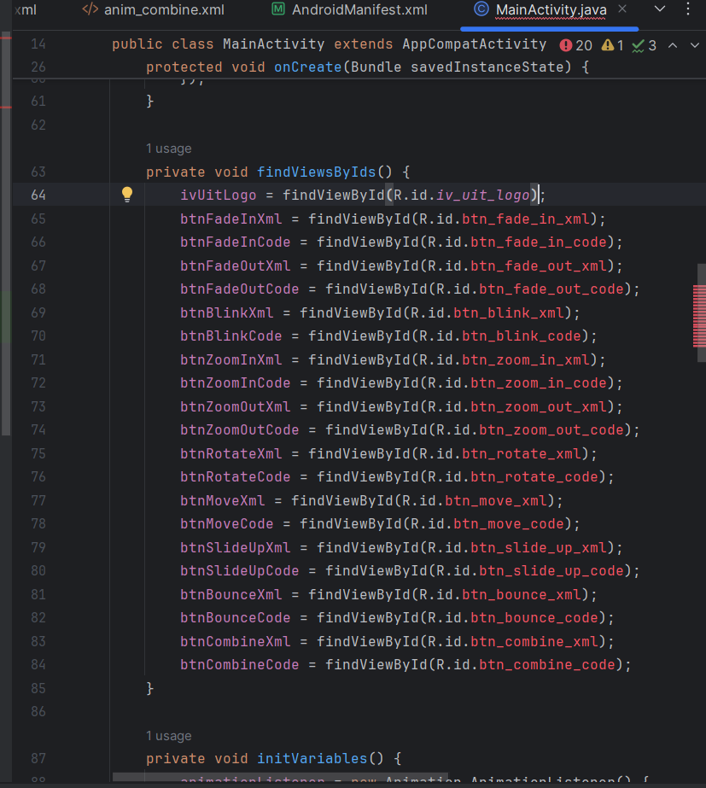

## NewActivity.java

package com.example.thanhdat;  
  
public class NewActivity extends AppCompatActivity {  
 @Override  
 protected void onCreate(Bundle savedInstanceState) {  
 super.onCreate(savedInstanceState);  
 setContentView(R.layout.activity_new);  
  
 Button btnBack = findViewById(R.id.btn_back);  
 btnBack.setOnClickListener(v -> {  
 finish();  
 overridePendingTransition(R.anim.slide_in_left, R.anim.slide_out_right);  
 });  
 }  
}

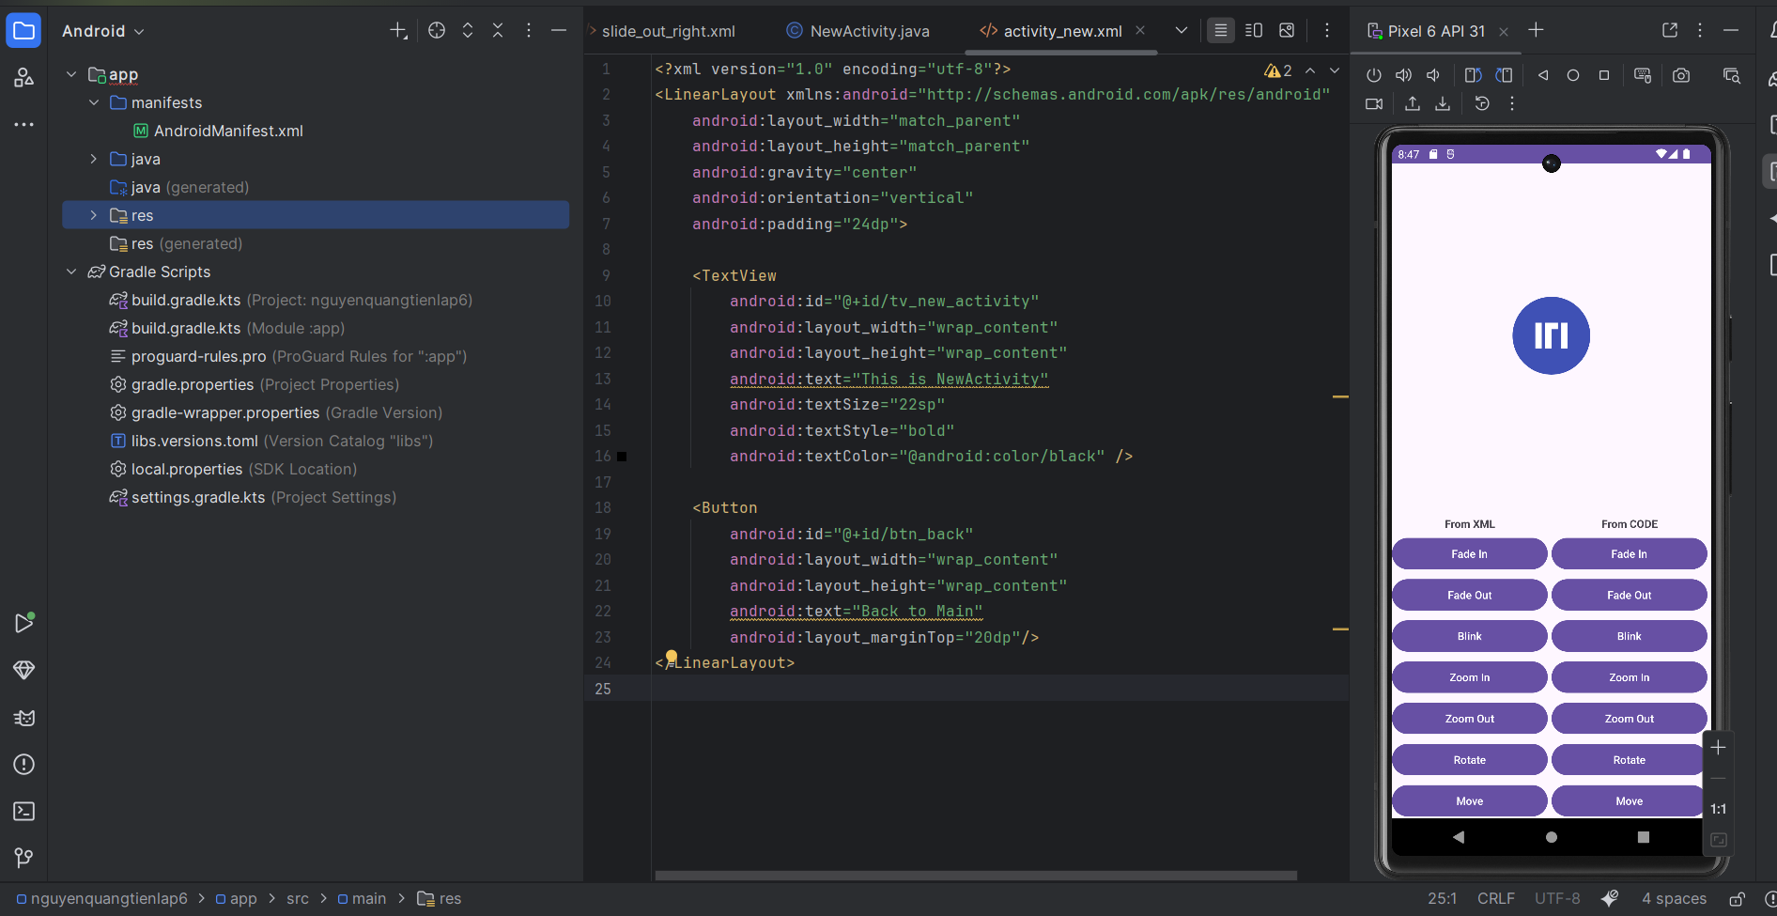

## SlideActivity.java

package com.example.thanhdat;  
  
public class SlideActivity extends FragmentActivity {  
 private ViewPager2 pager;  
 @Override  
 protected void onCreate(Bundle savedInstanceState) {  
 super.onCreate(savedInstanceState);  
 pager = new ViewPager2(this);  
 setContentView(pager);  
 pager.setAdapter(new ScreenSlidePagerAdapter(this));  
 pager.setOffscreenPageLimit(1);  
 }  
  
 private static class ScreenSlidePagerAdapter extends FragmentStateAdapter {  
 public ScreenSlidePagerAdapter(@NonNull FragmentActivity fa) {  
 super(fa);  
 }  
 @NonNull  
 @Override  
 public Fragment createFragment(int position) {  
 return position == 0 ? new ScreenOneFragment() : new ScreenTwoFragment();  
 }  
 @Override  
 public int getItemCount() { return 2; }  
 }  
}

## ScreenOneFragment.java

package com.example.thanhdat;  
  
public class ScreenOneFragment extends Fragment {  
 @Nullable  
 @Override  
 public View onCreateView(@NonNull LayoutInflater inflater,  
 @Nullable ViewGroup container,  
 @Nullable Bundle savedInstanceState) {  
 TextView tv = new TextView(getContext());  
 tv.setText("This is Screen One");  
 tv.setGravity(Gravity.CENTER);  
 return tv;  
 }  
}

## ScreenTwoFragment.java

package com.example.thanhdat;  
  
public class ScreenTwoFragment extends Fragment {  
 @Nullable  
 @Override  
 public View onCreateView(@NonNull LayoutInflater inflater,  
 @Nullable ViewGroup container,  
 @Nullable Bundle savedInstanceState) {  
 TextView tv = new TextView(getContext());  
 tv.setText("This is Screen Two");  
 tv.setGravity(Gravity.CENTER);  
 return tv;  
 }  
}

## activity_main.xml

<LinearLayout ...>  
 <FrameLayout ...>  
 <ImageView  
 android:id="@+id/iv_uit_logo"  
 android:layout_width="@dimen/image_base"  
 android:layout_height="@dimen/image_base"  
 android:src="@drawable/uit_logo" />  
 </FrameLayout>  
  
 <ScrollView>  
 <LinearLayout>  
 <LinearLayout>  
 <Button android:id="@+id/btn_fade_in_xml" ... />  
 <Button android:id="@+id/btn_fade_in_code" ... />  
 </LinearLayout>  
 <!-- Các nhóm FadeOut, Blink, ZoomIn, ZoomOut, Rotate, Move, SlideUp, Bounce, Combine -->  
 </LinearLayout>  
 </ScrollView>  
</LinearLayout>

## activity_new.xml

<LinearLayout ... android:gravity="center">  
 <TextView  
 android:id="@+id/tv_new_activity"  
 android:text="This is NewActivity" />  
 <Button  
 android:id="@+id/btn_back"  
 android:text="Back to Main" />  
</LinearLayout>

## Animations

slide_in_right.xml:  
<translate xmlns:android="http://schemas.android.com/apk/res/android"  
 android:fromXDelta="100%p"  
 android:toXDelta="0"  
 android:duration="300"/>  
  
slide_out_left.xml:  
<translate xmlns:android="http://schemas.android.com/apk/res/android"  
 android:fromXDelta="0"  
 android:toXDelta="-100%p"  
 android:duration="300"/>

## values/dimens.xml

<resources>  
 <dimen name="image_base">120dp</dimen>  
 <dimen name="margin_base">8dp</dimen>  
 <dimen name="margin_basex2">16dp</dimen>  
</resources>

## values/strings.xml

<resources>  
 <string name="app_name">thanhdat</string>  
 <string name="from_xml">From XML</string>  
 <string name="from_code">From Code</string>  
 <string name="fade_in">Fade In</string>  
 <string name="fade_out">Fade Out</string>  
 <string name="blink">Blink</string>  
 <string name="zoom_in">Zoom In</string>  
 <string name="zoom_out">Zoom Out</string>  
 <string name="rotate">Rotate</string>  
 <string name="move">Move</string>  
 <string name="slide_up">Slide Up</string>  
 <string name="bounce">Bounce</string>  
 <string name="combine">Combine</string>  
</resources>  
