INSTALL TOMCAT ON RASHPERRY PI

Step 1 - Install Java

Java installation is very straightforward with the following command

- sudo apt-get install oracle-java7-jdk

Once that has finished you can check that Java installed correctly with the command java -version. You should get something like this

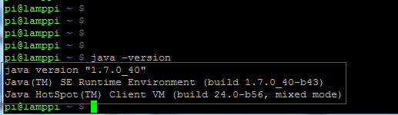

To double check that it was installed I wrote and compiled a simple java class - of course it had to be "HelloWorld".

Using the 'nano' editor, I created a file called HelloWorld.java which contains the following ;

- public class HelloWorld {
- public static void main(String args[]) {
- System.out.println("Hello World !!");
- }
- }

I compiled this with the command javac HelloWorld.java which created class file HelloWorld.class.

Finally I executed the class using command java Helloworld and saw the expected output - i.e.
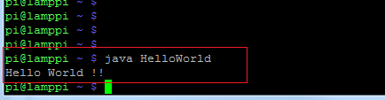

Step 2 - install Tomcat

Download Distribution

Get the Tomcat distributions and unzip it as follows

- wget http://mirrors.axint.net/apache/tomcat/tomcat-7/v7.0.42/bin/apache-tomcat-7.0.42.tar.gz
- tar xzf apache-tomcat-7.0.42.tar.gz

This will unpack the distribution underneath your current location (e.g. /home/pi/apache-tomcat-7.0.42)

Configure user

Before we start tomcat we need to configure an administrator user. Edit file tomcat-users.xml in the conf subdirectory (e.g. sudo nano conf/tomcat-users.xml) and add an entry under <tomcat-user>

e.g. add <user username="system" password="raspberry" roles="manager-gui"/>

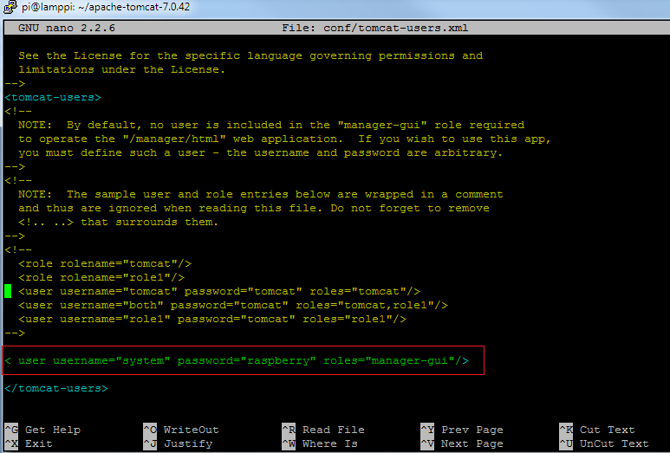

Start up

To start up Tmcat run startup.sh in the bin sub-directory - e.g. sudo bin/startup.sh
A small informational message will display and then the console will free up . Tomcat is now running in the background - to check this enter ps -ef | grep java and you should see something similar to the following;

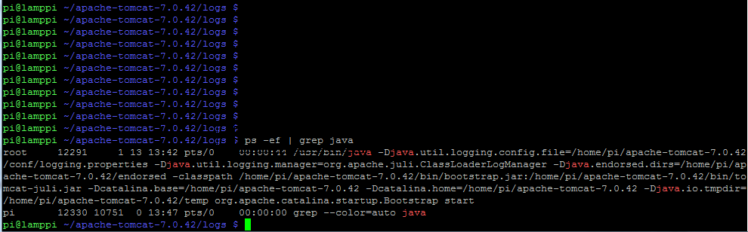

The best test of course is to try it in a browser - open a browser (which can be on another machine on your network) and enter URL e.g.10.13.36.255:8080 (i.e. <server_name>:8080) and you should see something like this:
