COS 30020 – Lab 07

Task 1: Creating a table and entering data
-- Using your existing database ‘s<7-digit Swinburne id>_db’, create a new table cars for a used car dealership.
-- Include the following fields in the cars table:
-- car_id (AUTO_INCREMENT PRIMARY KEY),
-- make,
-- model,
-- price, and
-- yom (year of manufacture).
CREATE TABLE `s103488117_db`.`cars` (
`car_id` INT(10) NOT NULL AUTO_INCREMENT,
`make` VARCHAR(255) NOT NULL,
`model` VARCHAR(255) NOT NULL,
`price` DECIMAL(10, 2) NOT NULL,
`yom` INT(10) NOT NULL,
PRIMARY KEY (`car_id`)
) ENGINE = InnoDB;
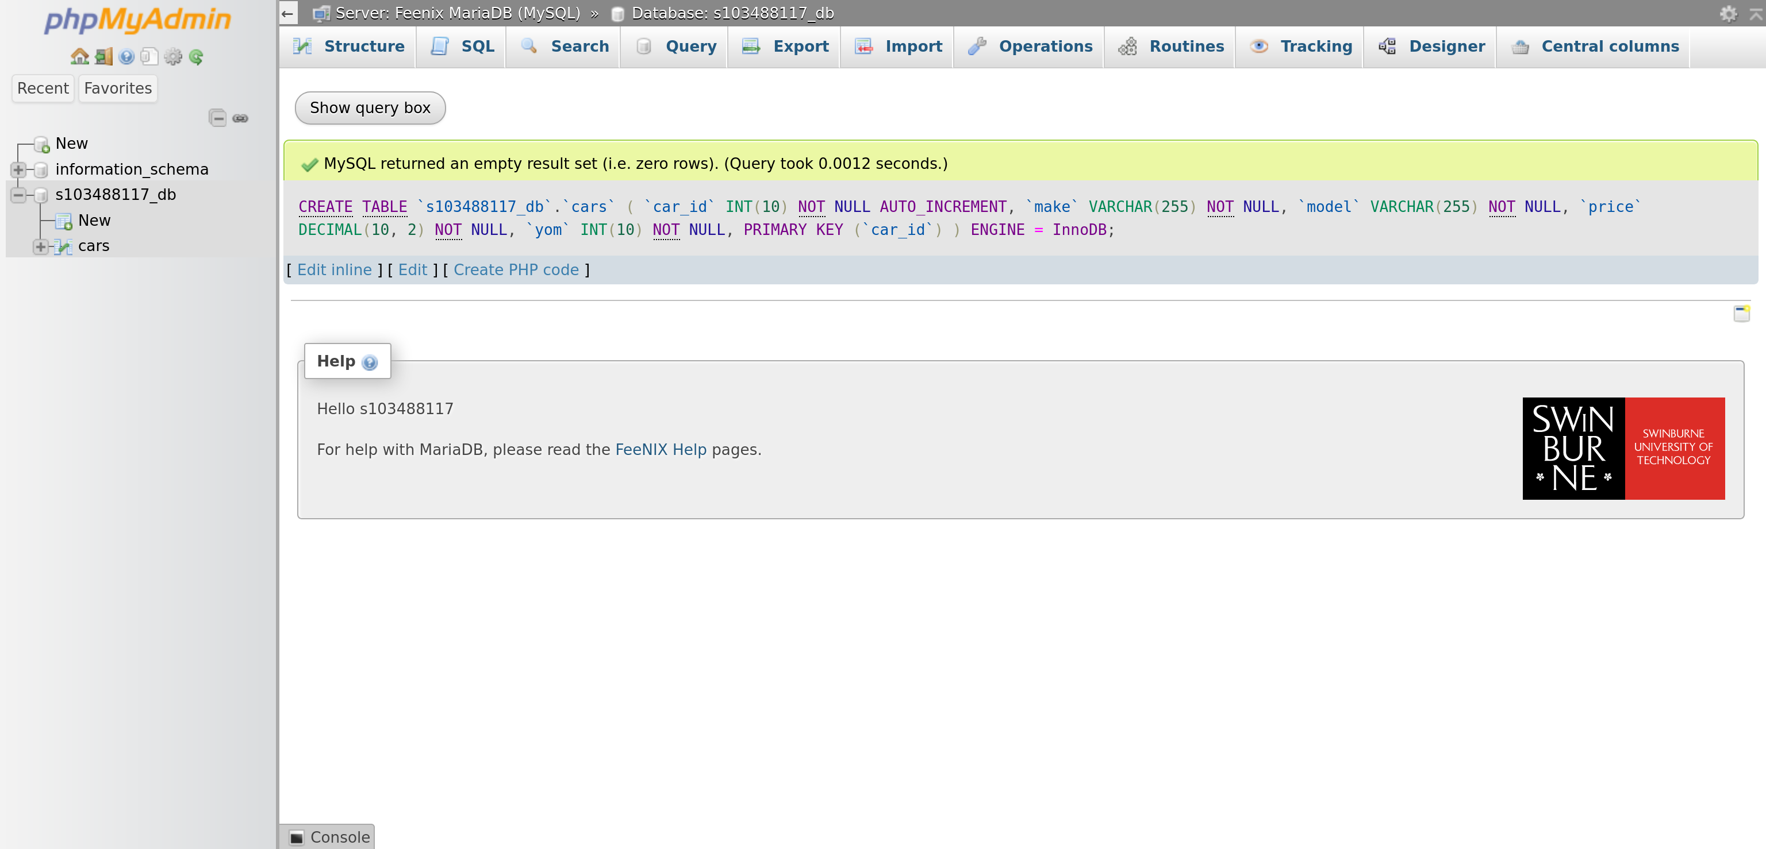Figure 1: Create table
-- Enter at least 10 records into the table.
INSERT INTO cars (make, model, price, yom)
VALUES ('Holden', 'Astra', 14000.00, 2005),
('BMW', 'X3', 35000.00, 2004),
('Ford', 'Falcon', 39000.00, 2011),
('Toyota', 'Corolla', 20000.00, 2012),
('Holden', 'Commodore', 13500.00, 2005),
('Holden', 'Astra', 8000.00, 2001),
('Holden', 'Commodore', 28000.00, 2009),
('Ford', 'Falcon', 14000.00, 2007),
('Ford', 'Falcon', 7000.00, 2003),
('Ford', 'Laser', 10000.00, 2010),
('Mazda', 'RX-7', 26000.00, 2000),
('Toyota', 'Corolla', 12000.00, 2001),
('Mazda', '3', 14500.00, 2009);
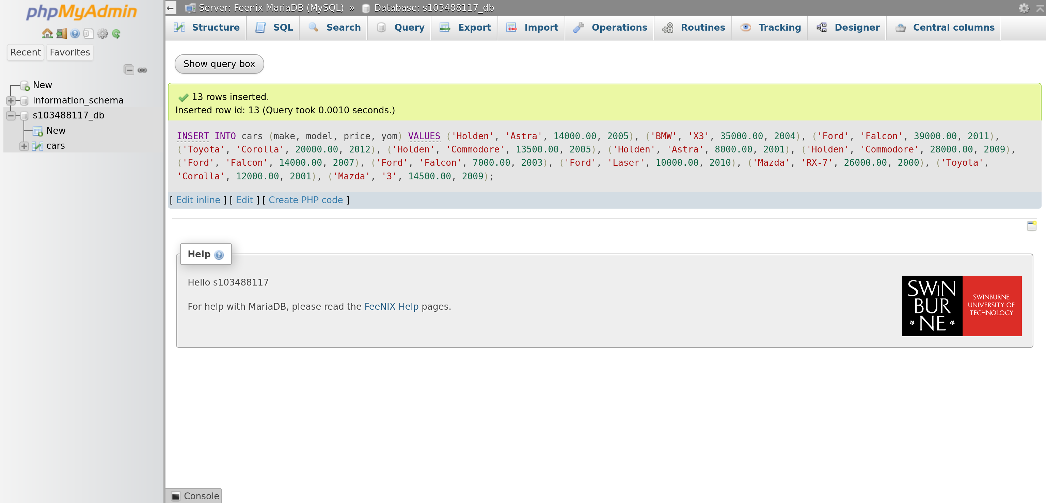Figure 2: Insert records

Task 2: Querying the table
-- Write queries that return the following:
-- 1. All records
SELECT * FROM cars;
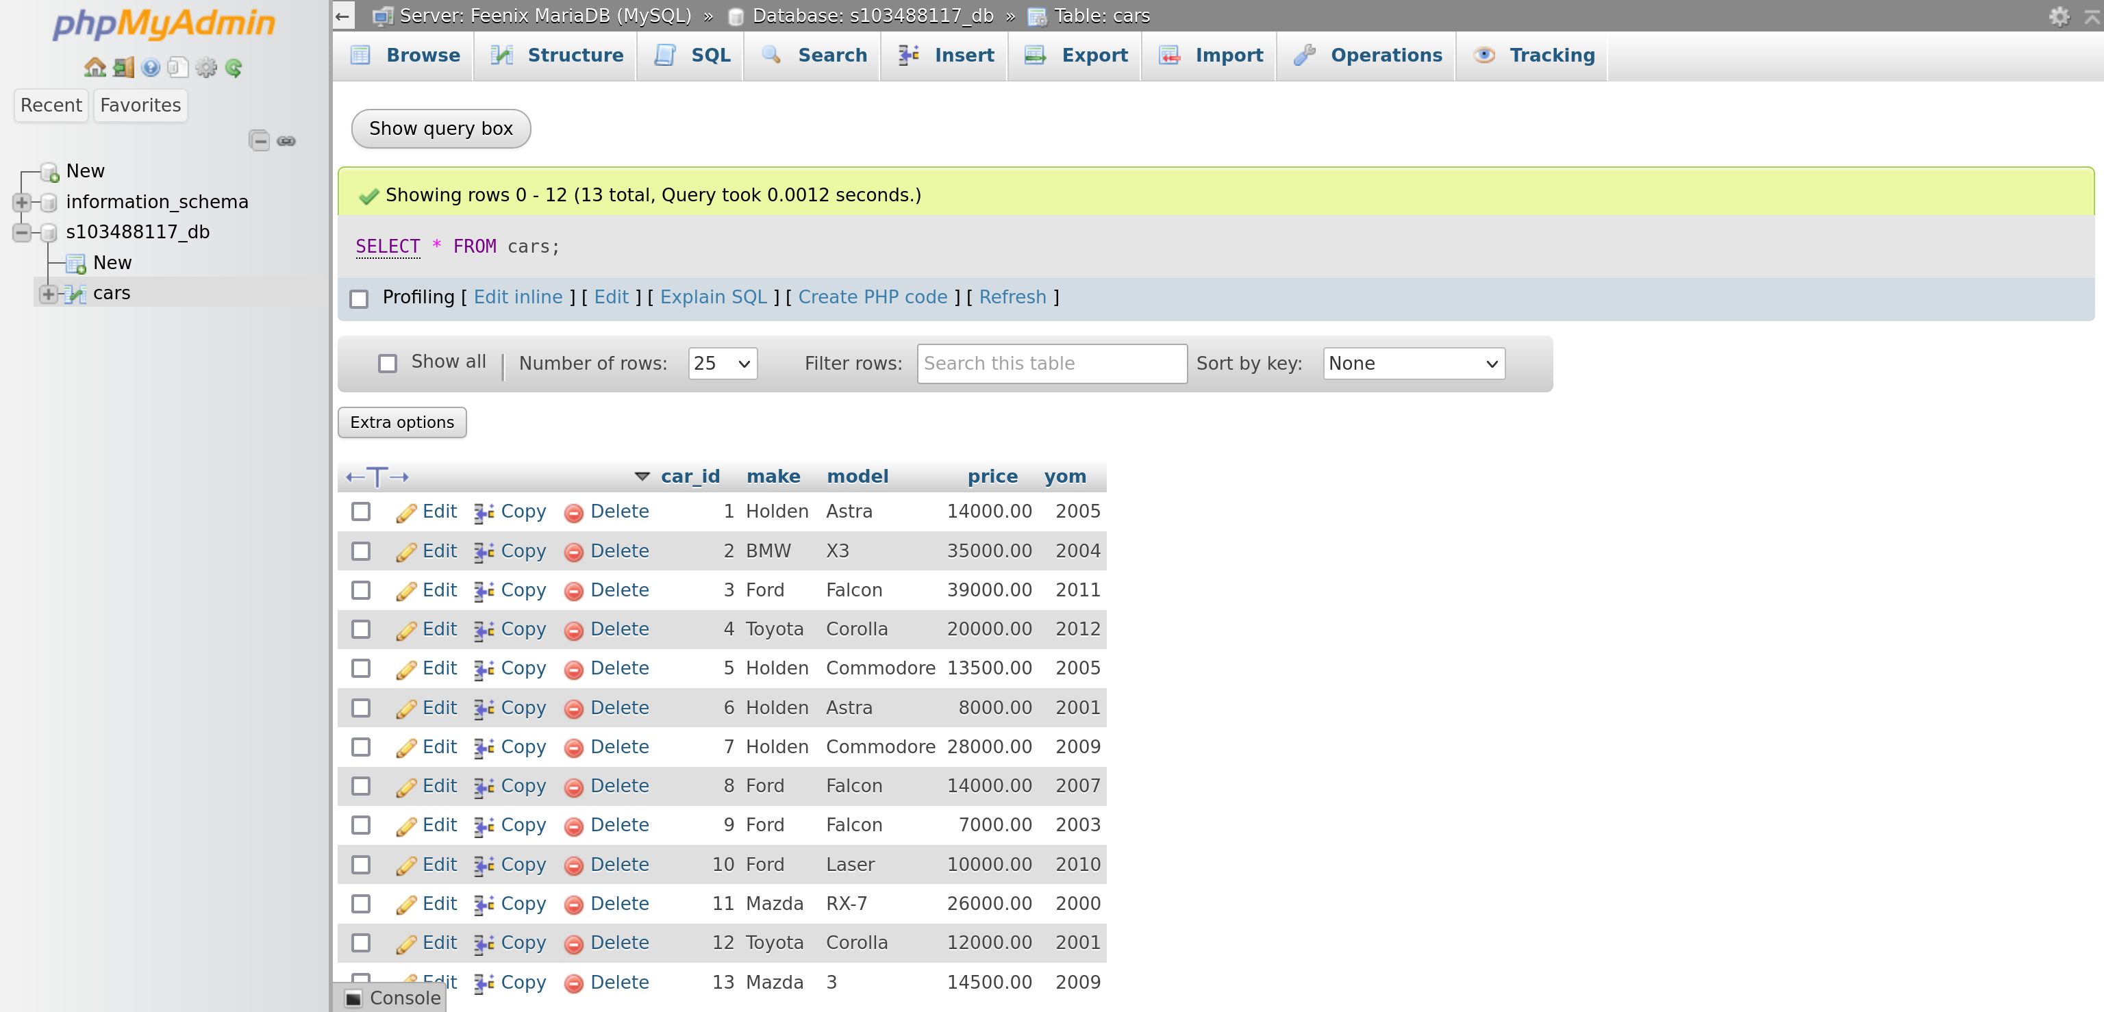Figure 3: Query results for all records
-- 2. Make, model, and price, sorted by make and model
SELECT make, model, price FROM cars ORDER BY make, model;
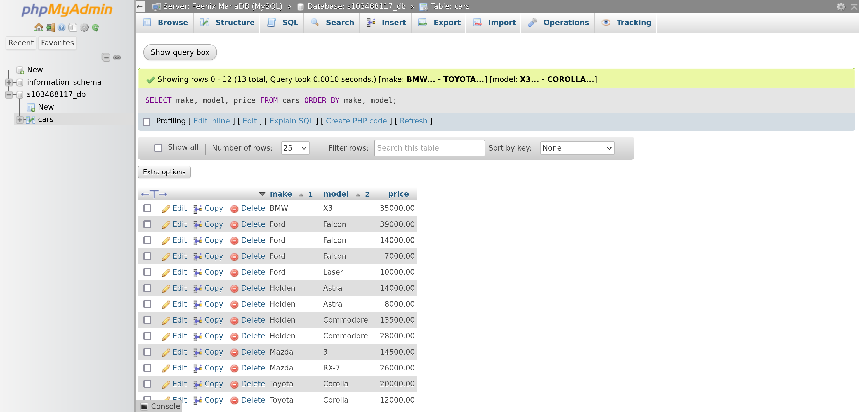Figure 4: Query results for make, model, and price sorted by make and model

-- 3. The make and model of the cars which cost $20,000.00 or more.
SELECT make, model FROM cars WHERE price >= 20000.00;
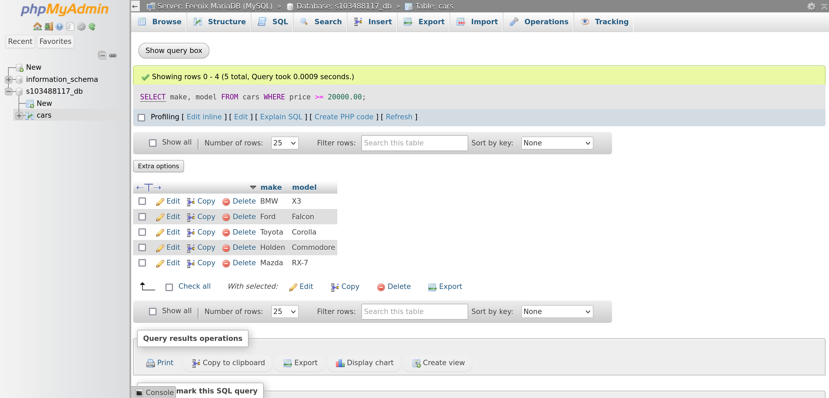Figure 5: Query results for make and model of the cars which cost $20,000.00 or more
-- 4. The make and model of the cars which cost below $15,000.00.
SELECT make, model FROM cars WHERE price < 15000.00;
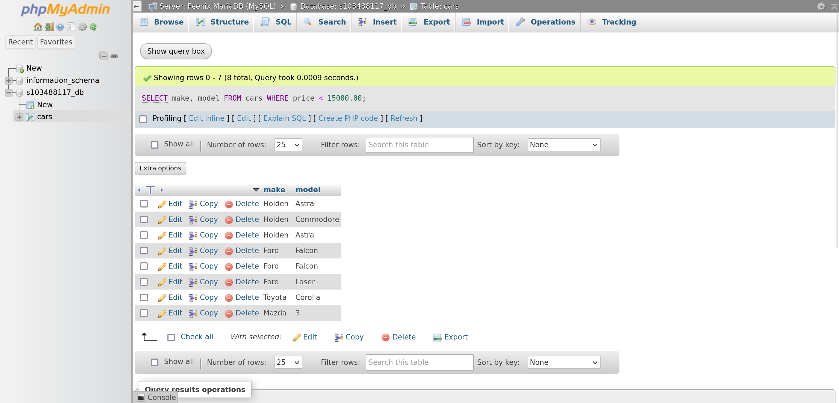Figure 6: Query results for make and model of the cars which cost below $15,000.00

-- 5. The average price of cars for similar make.
SELECT make, AVG(price) as average_price FROM cars GROUP BY make;
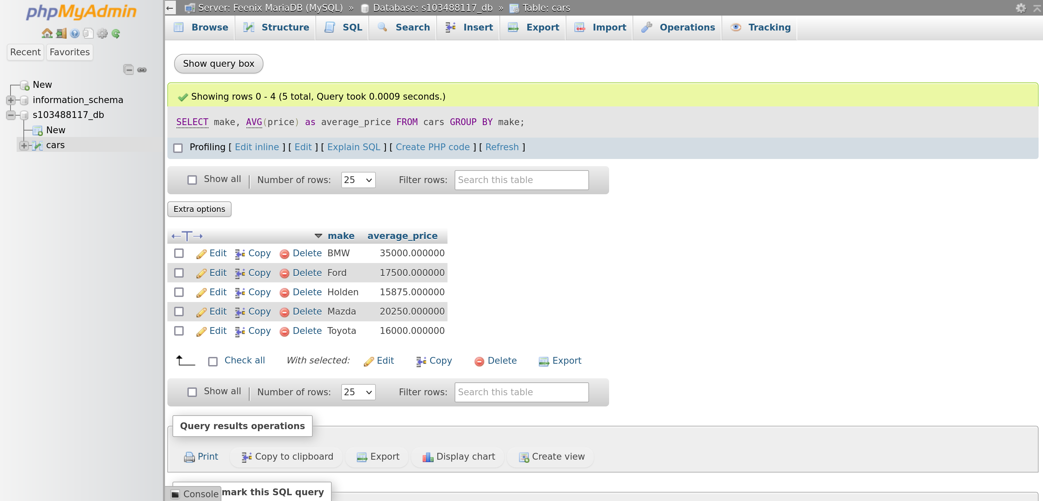Figure 7: Query results for average price of cars for similar make

