**CloudFront Distribution Documentation**

***Part One: Setting up Origin Access Control to CloudFront***

1. Log into AWS account and search for CloudFront. Then click on CloudFront



2. Then click on Create distribution.

3. For Origin domain, select the S3 Bucket you created earlier. Next click Use website endpoint. This is necessary as the S3 Bucket is being used for a website.

4. Leave everything default and scroll down to Viewer and select Redirect HTTP to HTTPS.



5. Leave everything else default and scroll down to Web Application Firewall (WAF) and select Do not enable security protections.

6. Scroll down to Settings and click on add item.



Next type in the domain name you created earlier in the Alternate domain name (CNAME) – optional.



Furthermore, you should see Custom SSL certificate – optional, click on the downward pointing arrow.

In the dropdown menu, under ACM certificates, select the certificate you created in the previous ACM section.

Now scroll down to the default root object – optional and type your default home page, which is usually *index.html*

After that scroll down and click Create distribution.



You will see a success screen like this. This may take some time and when last modified changes to a date, it is finished.

After several minutes, Last Modified should look like this when finished.

7. Testing, type in the Distribution domain name into a new tab in your web browser and navigate to the site, see eg. Below.

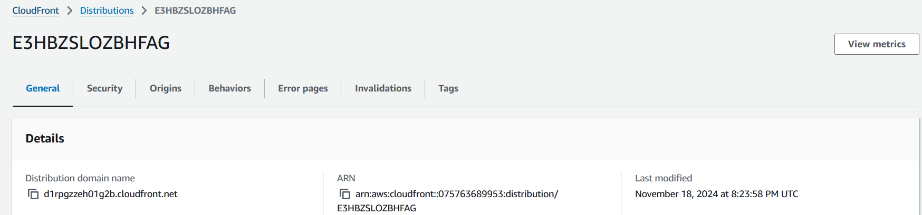

Example of our webpage being navigated to successfully. The padlock icon means that the connection is secure.

***Part Two: Updating the A Record in Route53 to point to CloudFront distribution***

1. Navigate to Route53 that you previously created and select A under type and click Edit record.



In Edit record, change Alias to S3 website endpoint to Alias to CloudFront Distribution, see eg’s of before and after below.

Example of what to change to.

Now choose distribution and select the one it generates below it.

Then click on Save.

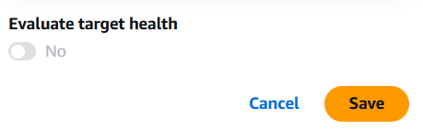

A screen like this should appear.

Furthermore, view the propagation status by clicking on view status.

The status should show it is insync.

2. Testing. In a new browser tab, type in your domain name, do not use the distribution domain name. You should be navigated to the name of your website.

