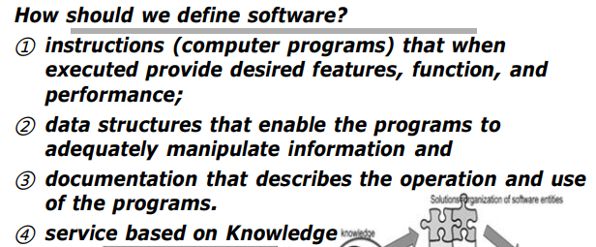 第一章：什么是软件，什么是遗留软件，什么是软件工程；

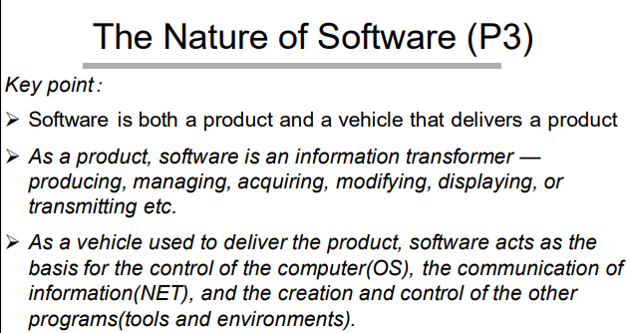

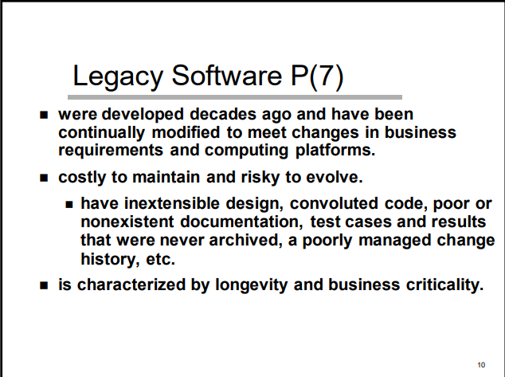

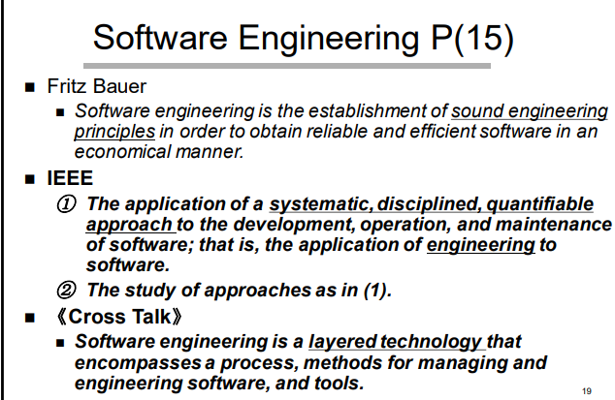

第二，三章 ：2.2节如何对当前项目自适应调整（3.3节有例子小型项目沟通活动）

第四章：4.1节传统的过程模型（特点（xx驱动），怎么运用，并发模型的例子）

第五章只关注极限编程（为什么极限编程把5个框架活动简化成了4个）  
第七章：理解需求：7.2建立根基（4步）；  
第八章：用例图（8.2画用例图的步骤；课件里的用例图），活动图  
第九章：类图（9.1-9.6画类图的步骤；课件里的类图，组合设计模式）；多态概念  
第十章：顺序图和状态图（区别和联系，顺序图开发了一个交互场景，状态图整个图聚焦于一个对象的生存周期）[UML图 | 时序图（顺序、序列）绘制 - 知乎 (zhihu.com)](https://zhuanlan.zhihu.com/p/422509874)

见PPT

第十一章：11.3设计概念  
第十二章：风格和模式  
十三章：13.2七个面向对象原则（前四个必考）；内聚和耦合的理解  
  
第十七章：什么是总体测试策略；四个步骤（单元测试（测五种错误），集成测试（自顶向下，自底向上，三明治法；冒烟测试，回归测试），确认测试（阿尔法测试，贝塔测试），系统测试（五种测试））知道这些概念在这章

第十八章（面向过程）：基本路径测试前三步（给定程序或流程图）（必考）  
第十九章（面向对象）：面向对象测试和传统软件测试的区别（在单元测试和集成测试不一样，为什么）

第二十二章4p中的product和7章中的建立根基有关  
第二十二章重点：组建团队考虑的因素（people）(课本附近找答案)，w5hh原则（project）

W5H2是项目开发原则，解决 项目目标，里程碑和时间表，职责，管理和技术方法以及所需资源。

1.WHY：它代表着开发系统的目的。所有利益相关者都应评估软件工作的商业理由是否有效，这让团队专注于软件的**业务目的**。软件工程的通用过程框架定义了五种框架活动：沟通，策划，建模，构建以及部署。我们需要在沟通阶段和客户讨论以明确**业务目的，这就是所谓的“首次提问”。这有助于识别对构建软件感兴趣的利益相关者，同时还可以让我们根据业务目的灵活的选择过程模型，比如如果客户急需产品上市，那么我们就可以采用增量过程模型。**

2.WHAT ——它的意思时明确项目的任务集。软件工程过程并不是教条的法则，我们应该针对不同项目进行适应性调整，以兼顾软件质量和开发敏捷性。比如在“需求获取”动作中，小型项目和大型项目所生成的任务集是不同的，大型项目的任务集往往更加复杂。

3.WHEN —— 什么时候做？它的意思是制定项目进度，明确项目的重要里程碑和时间表。复杂的系统中很多软件工程任务都是并行的进行（比如并发开发模型），如果没有进度安排，任务之间的相互依赖性将非常难以理解，这可能会导致项目的延期。

4.WHO —— 它意味着确定哪个团队成员承担哪些职责。人们是4P中最重要的一项。一个优秀的管理者应该以能够最大程度地发挥每个人的技术和能力的方式进行组织。团队成员的技能分布必须适合于待解决的问题。

5.WHERE —— 他们的机构组织位于何处(Where)？

参与软件过程的利益相关者分为5类，不仅仅是开发人员，还包括高级管理者和客户。在需求建模中应该识别多重观点，并协同合作（），

6.HOW —— 一旦确定了产品范围，就必须定义技术策略和管理策略。技术策略体现在选择什么样的过程模型？如何进行需求建模，设计建模？如何进行软件测试？管理策略体现在软件配置管理和对团队成员的管理（采用何种组织范型）。

7.HOW MUCH —— 通过软件项目估算得到。估算首先要描述产品的范围，然后将问题分解成一组较小的问题，再对每个小问题进行估算。

5W2H就是一个做事，条理化，标准化，逻辑化的一个过程，每次接受一项工作任务的时候，就可以套用这个分析法，这样，你就可以做到从容不迫，不会没有头绪。因为它将发现问题和解决问题的关键提取了出来，这对于决策和执行的措施非常有帮助，也有助于弥补考虑问题和做事过程的疏漏。这个方法现在广泛使用在企业管理中，当然也包括软件开发管理。

W5H2 is a project development principles that addresses project objectives, milestones and schedules, responsibilities, management and technical approaches, and required resources.

1.WHY: All stakeholders should assess the validity of business reasons for software work, which allows the team to focus on the business purpose of the software. The Generic Process Framework for Software Engineering encompasses five framework activities: communicate, planning, modeling, construction, and deployment. We need to discuss with the client in the communication activity to clarify the business purpose, which is called "asking the first questions". This helps to identify stakeholders who are interested in building the software, while also giving us the flexibility to choose a process model based on business purposes. For example ,if a customer is in a hurry to get a product to market, we may as well choose the Incremental Process Model.

2. WHAT - It means to define the task set required for the project. The software engineering process is not a dogmatic rule, which needs ‘Process Adaptation’ in order to balance software quality and development agility. For example, in the ‘communication’ activity, the task sets generated by small projects and large projects are different, and the task sets of large projects are often more complex.

3.WHEN - when to do it? It means developing a project schedule, defining important milestones and timelines for the project. Many software engineering tasks in complex systems are carried out in parallel (such as concurrent development models), and without scheduling, the interdependencies between tasks will be very difficult to understand, which may lead to project delays.

4. WHO - It means determining which team member has which responsibilities. Since ‘People’ are the most important part of the 4Ps. A good project manager should organize in a way that maximizes everyone's skills and abilities. The distribution of skills among team members must be appropriate for the problem to be solved.

5.WHERE - Where is their organization located? The stakeholders involved in the software process are divided into 5 categories, not only developers but also senior managers and customers, who have responsibilities alike. We ought to recognize Multiple viewpoints and work toward collaboration in requirements modeling .

6. HOW - Once the product scope is determined, the technical strategy and management strategy must be defined. The technical strategy is addresses such questions: what kind of process model is selected? How to carry out requirement modeling, design modeling? How to do software testing? Management strategy is about software configuration management and management of team members (what organizational paradigm is adopted).

7. HOW MUCH – The cost is estimated through the life cycle of software projects. Estimation begins by describing the scope of the product, then breaks the problem down into a set of smaller problems, and estimates for each. Reasonable allocation of resources determines the smoothness and efficiency of software process.

5W2H is a process of doing things organized, standardized, and logical. Every time you accept a work task, you can apply this analysis method, so that you can be calm and not have no clue. Because it extracts the key to finding and solving problems, which is very helpful for decision-making and implementation measures.

