KC Cab Driver Application – Progress Report

Team – Cab Drivers

Team members- Josh Basic, Jacob Davis, David Gamino, Paul Horner, Erin Parsons

Supervisor- Dr. Davendra

Client- Mr. Stephen Jennings

Contents

Introduction 2

Progress 2

Winter Break: 2

Winter Quarter: 2

User Interface (UI) 3

Navigation 4

Server 4

Amended Requirements 4

Implemented Technologies 5

• Xamarin: 5

• GitHub: 5

• C#: 5

• Ubuntu: 5

• CentOS: 5

Future 5

Timeline 5

2/1/2019 – 2/6-2019 5

2/6/2019- 2/14/2019 5

2/14/2019- 2/20/2019 5

2/20/2019 – 3/6/2019 5

# Introduction

Our client Mr. Jennings has requested that two teams from Central Washington University develop an application for his local taxi company, KC Cab. This project has been broken up into a team for the rider side and a team for the driver side. This is a report for the team developing the drivers side application.

The driver application is designed for the drivers of the KC Cab company to use while they are working to allow for them to interface with the rider application. It is intended for the drivers to be able to accept a ride and then pick up the rider.

This application needs to maintain a simple design while limiting the driver’s ability to make choices. The rides will be selected from a queue so that drivers will not pick which rider they would like to pick up and canceled rides will go back to the top of the queue. There will be driver accounts to allow for potential analytics in the future. The map page will have navigation to the rider’s location as well as the riders name, a cancel and done button, and a call button that will allow the driver to contact the rider.

# Progress

## Winter Break:

During winter break, the team worked on becoming more familiar with the tools to be used during the project, focusing mostly on Xamarin. Members also became more familiar with C#, which is the programming language being used for the application and only one member had previous experience.

## Winter Quarter:

Upon returning from Winter Quarter, we held a meeting to determine our progress learning the tools we will be using and to plan what each member would work on from here on out. We have split the work into different areas to accommodate each team members skills. The areas of focus for each team member have been divided the following way: UI, Navigation, Server, Programming, and Documentation.

During the first week of class the group decided to meet with the client to confirm the UI design and solidify all the features and requirements. During this meeting the design was confirmed, and navigation was added as a feature. This allowed for the applications development to continue unhindered.

The group ran into several issues with the server and this has created some overall team delays, however, the application development is on schedule.

# User Interface (UI)

The UI has made several advancements in the last few weeks. The UI lead David has created the mockup that was approved and has now implemented it using Xamarin. The UI has gone through several different stages and is currently still being worked on. Below is the initial UI mockup:

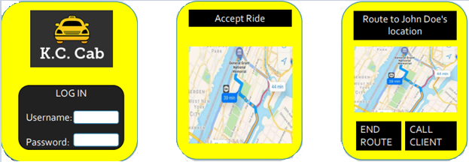

Upon returning from Winter break the new layout was presented that included all the requirements stated in the SRS. This layout was presented to the client Mr. Jennings, was approved, and David moved ahead with development. Below is the prototype presented to the client:

 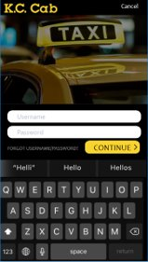  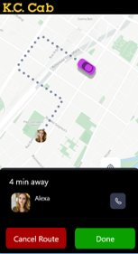

Within a week David implemented and nearly functional UI per SRS requirements. During review several features were suggested by the team, such as dynamic programing to allow the application to be functional in all sorts of phones and tablets. Development has continued with dynamic allocation in consideration. These are the current screens for the application notice the navigation page is not displayed, this is because Jacob has taken over the page. Below are the implemented Welcome Page, Sign-In Page, and Accept Job Page:

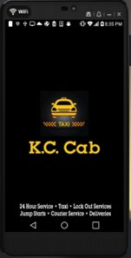   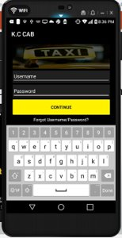  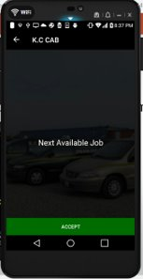

# Navigation

The map page of the project that will indicate where the rider is located is currently being developed by Jacob. The process started with him producing the map and then the difficult work of navigating the driver to the rider began. He started by developing the ability to draw a line from the starting point to a middle point and then to the rider. This initial implantation simply created a large V shape. However, improvements in this navigation page have been accomplished and we can see and actual route within the map.

The addition of all the coordinates created the appearance of a traditional navigation line. The line also will update as the driver moves creating a far smoother appearance. Currently the navigation does not reroute if the driver takes a different path than the suggested one.

# Server

The server was the biggest problem for the team. Although the database was created within the first week of returning from break, finding a server was a different story. The server was a delay for the team as one was not originally available and once one was obtained it would not accept a kernel. This lack of functional hardware caused a huge delay in the server development.

Dr. Vajda kindly allowed the team access to some extra hardware that he at his disposal which allowed the development to continue. Although the server is still massively behind schedule, the team still has enough time and resources to remain on track for testing with the other team. This is the area we must devote the most resources to.

# Amended Requirements

As of the client meeting on January 9th, 2019 one additional requirement was created. The additional requirement is that of navigation and it is currently being addressed by Jacob.

# Implemented Technologies

In order to complete the requirements for this project the team was required to use the following technologies.

* Xamarin: This is the app development tool being used by the team for the UI development.
* GitHub: is being used for version control during this project. It is being used by all members of the team to share work.
* C#: Is the language being used to develop on Xamarin.
* Ubuntu: Is the operating system that is currently being used for development of the server.
* CentOS: Is a version of the Linux operating system that will be used for the server.

# Future

Currently the groups focus is to finish the server and produce a smoother navigation page. Once the navigation page is finished the additional features such as displaying rider information and a call button for the rider will also be added.

After all features are added testing will become the top priority for the team and ensuring that the product as polished for the client as possible.

# Timeline

## 2/1/2019 – 2/6-2019

Completion of the server and map page

## 2/6/2019- 2/14/2019

Server app communication implemented

## 2/14/2019- 2/20/2019

Communication with the other application

## 2/20/2019 – 3/6/2019

UI Testing

Debugging

Functionality Testing

Deployment