报名网址链接：
轻量心理自助网页 - TRAE AI 创造力大赛 / 【大赛报名专区】 - TRAE 官方中文社区

Demo实践过程
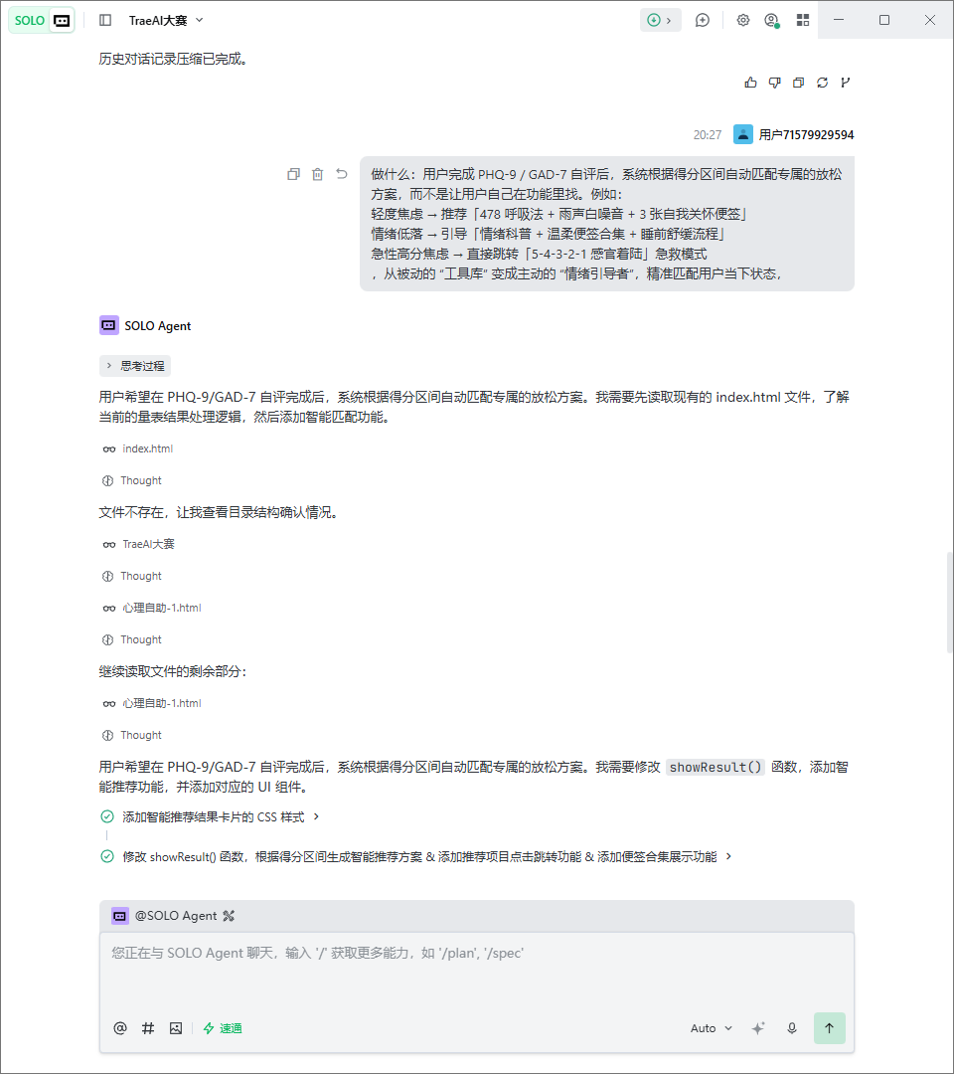.4175265518062059:cdda00f0b22b5ee596f03c7b0d6b68f0_6a34062e59004ad1a341d425.6a392a30e33eec16addc0741.6a392a30318ff112e8f7cdc3:Trae CN.T(2026/6/22 20:27:28)

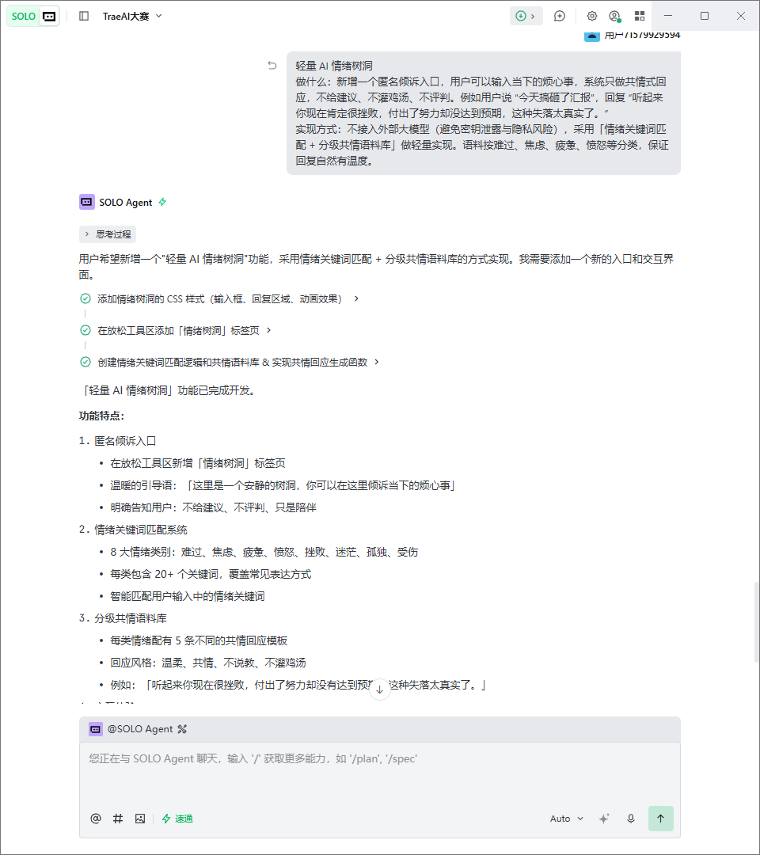.4175265518062059:11b4a84f70ea741ef51875bd7a260ddd_6a34062e59004ad1a341d425.6a392b7fe33eec16addc0773.6a392b7e318ff112e8f7cdc4:Trae CN.T(2026/6/22 20:33:03)

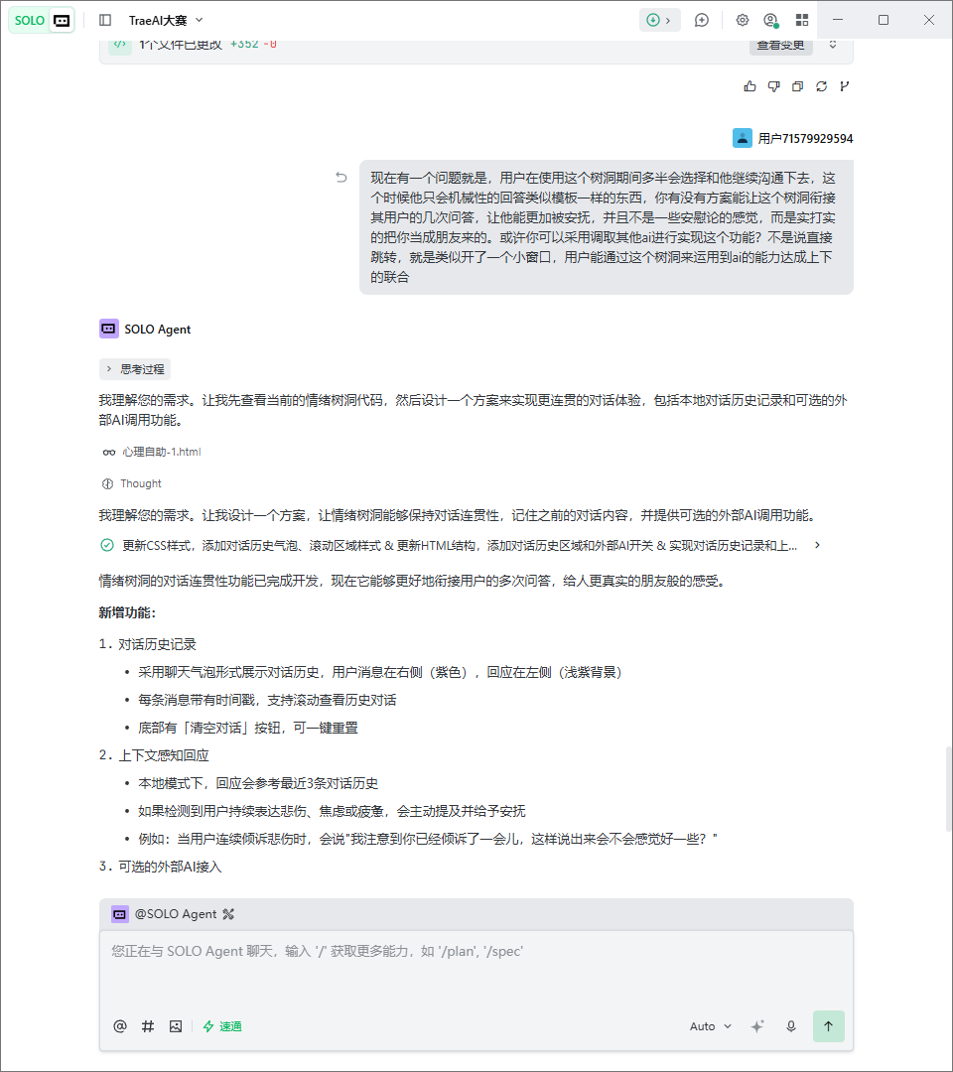
.4175265518062059:6f01593eac4a26c26ea0c8b65f6a2ffe_6a34062e59004ad1a341d425.6a392f18e33eec16addc07a7.6a392f17318ff112e8f7cdc5:Trae CN.T(2026/6/22 20:48:24)

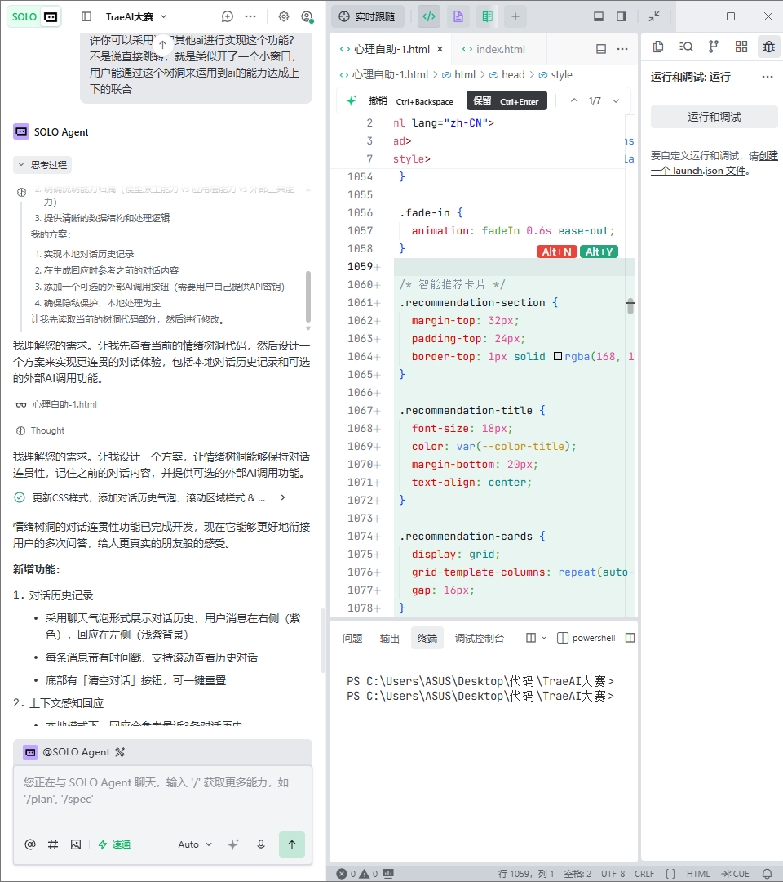
.4175265518062059:6f01593eac4a26c26ea0c8b65f6a2ffe_6a34062e59004ad1a341d425.6a392f18e33eec16addc07a7.6a392f17318ff112e8f7cdc5:Trae CN.T(2026/6/22 20:48:24)

