assets/ 素材文件夹
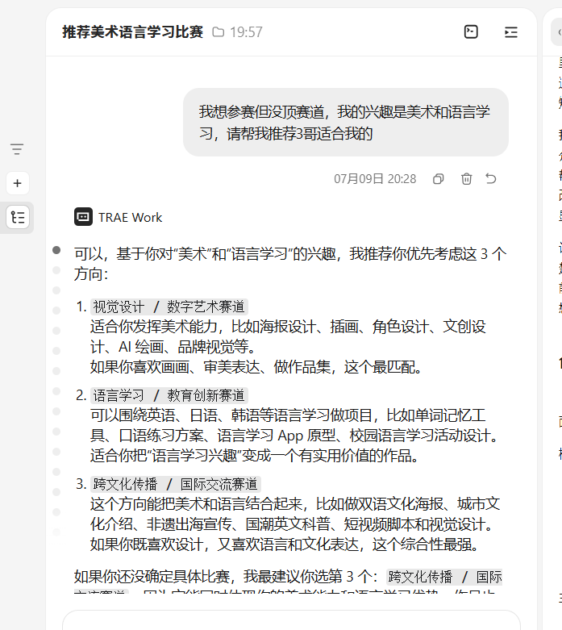
2715127541925312:4e4b4cbb5e8243acdbf2fd329020449e_6a4f93e99807f54c998cd3c1.6a4f93ea9807f54c998cd3c4.6a4f93e99807f54c998cd3c2:TRAE Work CN.0.1.32.no_sid.no_ppe.T(2026/7/9 20:28:26)
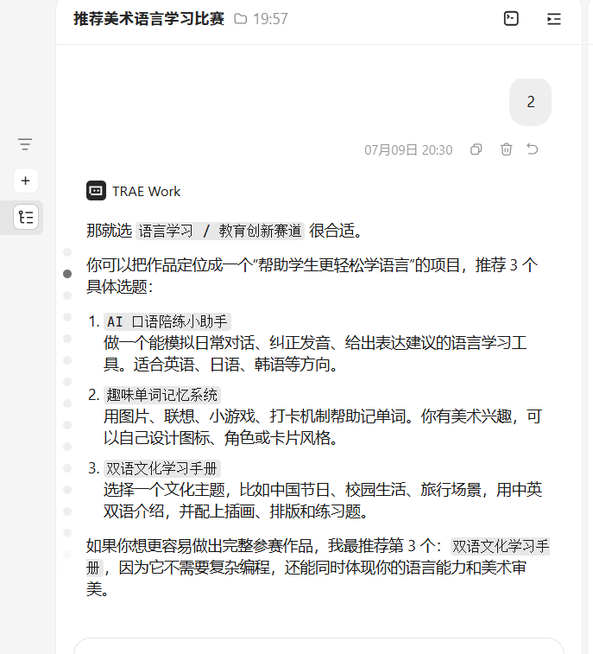
2715127541925312:c88000a6dcf59131dbef5828f7a737f6_6a4f93e99807f54c998cd3c1.6a4f94689807f54c998cd3d0.6a4f94689807f54c998cd3ce:TRAE Work CN.0.1.32.no_sid.no_ppe.T(2026/7/9 20:30:32)
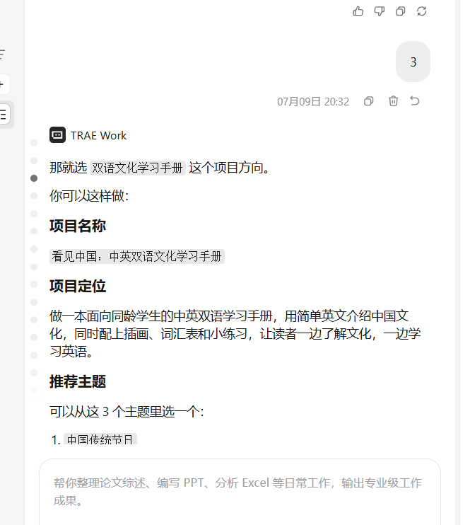
2715127541925312:e220c87ea0acf0b900961d3ccfb71d85_6a4f93e99807f54c998cd3c1.6a4f94ea9807f54c998cd3db.6a4f94ea9807f54c998cd3d9:TRAE Work CN.0.1.32.no_sid.no_ppe.T(2026/7/9 20:32:42)

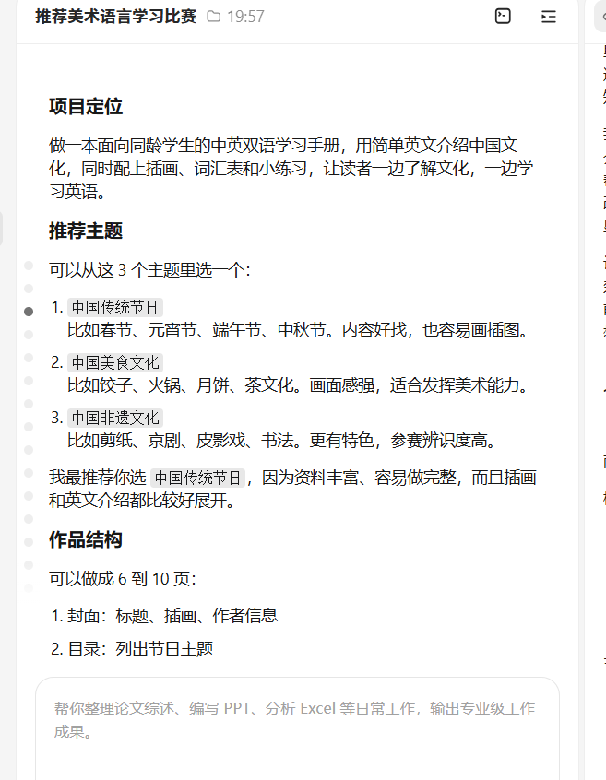
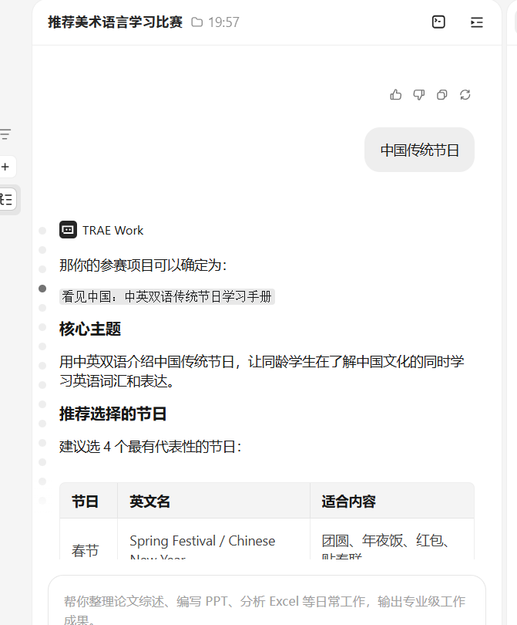
2715127541925312:d84bf06ae0e1ad4565e1b9dd07c9586c_6a4f93e99807f54c998cd3c1.6a4f95b89807f54c998cd3e6.6a4f95b89807f54c998cd3e4:TRAE Work CN.0.1.32.no_sid.no_ppe.T(2026/7/9 20:36:08)

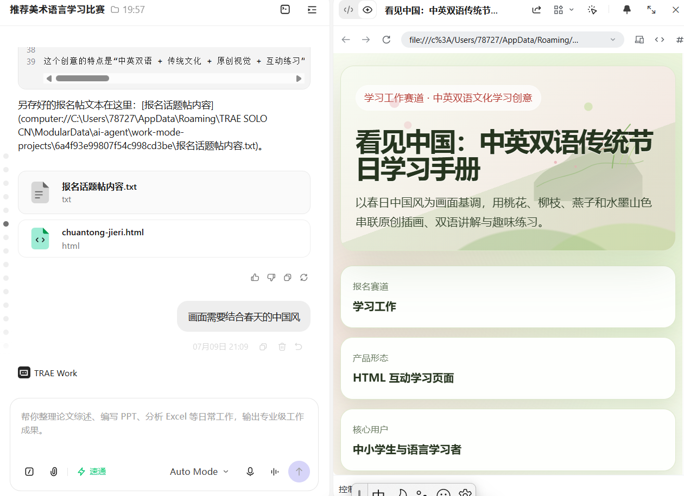
2715127541925312:456a58de21afd923661cca99e7f66655_6a4f93e99807f54c998cd3c1.6a4f9b439807f54c998cd42b.6a4f9b439807f54c998cd429:TRAE Work CN.0.1.32.no_sid.no_ppe.T(2026/7/9 20:59:47)


2715127541925312:77a980fe5d5080e66ad18626d97b0663_6a4f93e99807f54c998cd3c1.6a4f9e3d9807f54c998cd474.6a4f9e3d9807f54c998cd472:TRAE Work CN.0.1.32.no_sid.no_ppe.T(2026/7/9 21:12:29)


2715127541925312:68b3285e63eafa4643e64a273425cb39_6a4f93e99807f54c998cd3c1.6a51c4912969a5021b18909a.6a51c4912969a5021b189099:TRAE Work CN.0.1.32.no_sid.no_ppe.T(2026/7/11 12:20:34)


2715127541925312:7c4056e826ffa986f6b127ebdc16212b_6a4f93e99807f54c998cd3c1.6a51c67f2969a5021b189126.6a51c67f2969a5021b189124:TRAE Work CN.0.1.32.no_sid.no_ppe.T(2026/7/11 12:28:47)

2715127541925312:5c61194bf1c5338249d559391907ba84_6a4f93e99807f54c998cd3c1.6a51c6cf2969a5021b189151.6a51c6ce2969a5021b18914f:TRAE Work CN.0.1.32.no_sid.no_ppe.T(2026/7/11 12:30:07)


2715127541925312:d63d671451bfa7a4d89cbe38fa0f4fd8_6a4f93e99807f54c998cd3c1.6a51daa72969a5021b18935f.6a51daa72969a5021b18935d:TRAE Work CN.0.1.32.no_sid.no_ppe.T(2026/7/11 13:54:47)

2715127541925312:e65b0eb4bde093a386af1ca22d31b9ba_6a4f93e99807f54c998cd3c1.6a51dbab2969a5021b189391.6a51dbab2969a5021b18938f:TRAE Work CN.0.1.32.no_sid.no_ppe.T(2026/7/11 13:59:07)

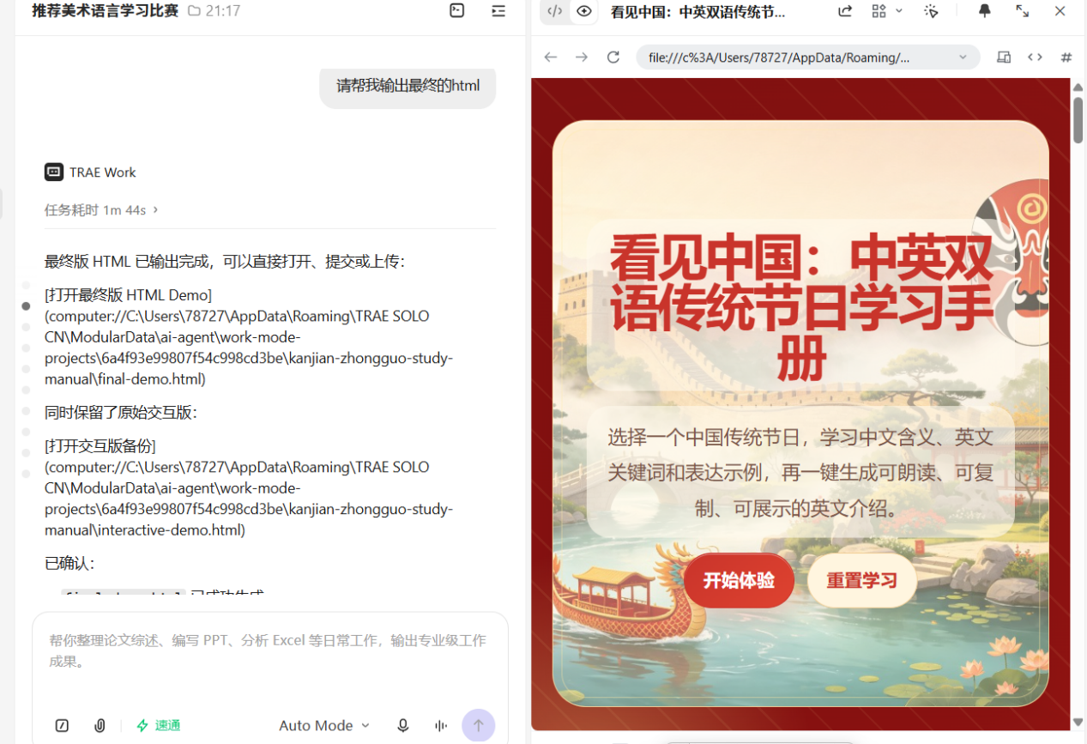
2715127541925312:d94b8d0ec6ec05722a4831c3d193c00f_6a4f93e99807f54c998cd3c1.6a51eb542969a5021b18948b.6a51eb532969a5021b189489:TRAE Work CN.0.1.32.no_sid.no_ppe.T(2026/7/11 15:05:56)


2715127541925312:793c599b94d4068b9e0bf0b31b706006_6a4f93e99807f54c998cd3c1.6a51fb972969a5021b1894c1.6a51fb972969a5021b1894bf:TRAE Work CN.0.1.32.no_sid.no_ppe.T(2026/7/11 16:15:19)

