2. In this problem you will develop two different implementations of the computation of **pi** numerically using pthreads and OpenMP. Then you will compare them in terms of scalability. In this problem, you will develop a program that computes the value of **pi**.

System: Intel(R) Xeon(R) CPU E5-2680 v4 @ 2.40GHz

CPUs: 28

Sockets: 2

Cores per socket: 14

Threads per core: 1

1. Evaluate the speedup that you achieve by using pthreads and multiple cores. You are free to use as many threads as you like. The program should take two input parameters, the number of threads and the number of “darts” thrown. Your program should print out the time required to compute pi and the final value of pi. Make sure to document the system you are running on and the number of hardware threads available.

Number of darts: 1, 000, 000, 000

Number of threads: 1, 2, 4, 8, 16, 28

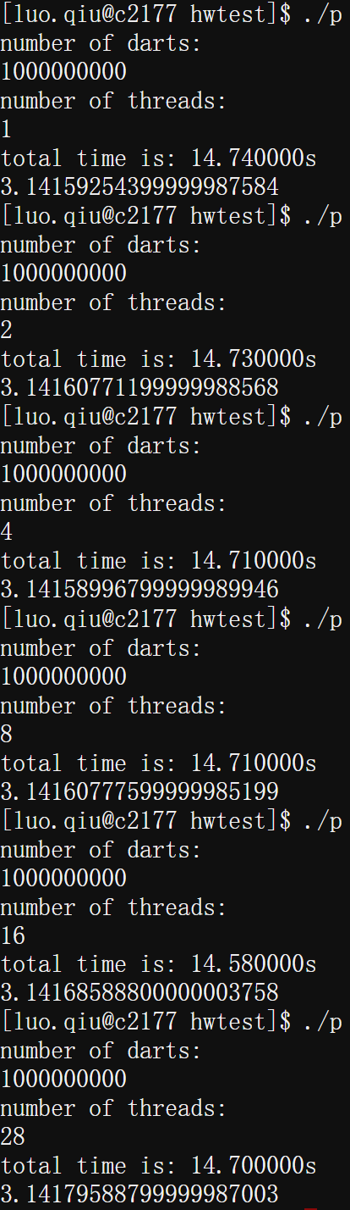

1. Now develop the same program using OpenMP. Repeat all of the steps requested in part a).

Number of darts: 1, 000, 000, 000

Number of threads: 1, 2, 4, 8, 16

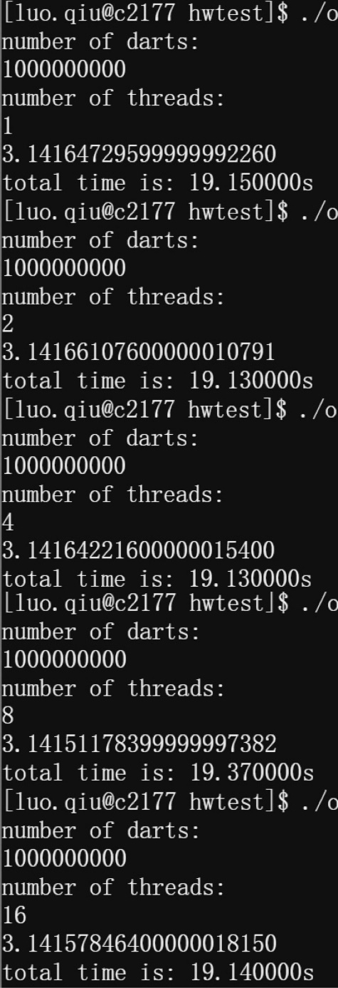

1. Now compare the two implementations in terms of strong and weak scaling, where the number of Monte Carlo simulations (i.e., “darts” thrown) is used to assess weak scaling.

According to the formula: $Speedup = t(1)/t(N)$

For Strong Scaling, If the amount of time needed to complete a serial task t(1), and the amount of time to complete the same unit of work with N processing elements (parallel task) is t(N). For Weak Scaling, If the amount of time to complete a work unit with 1 processing element is t(1), and the amount of time to complete N of the same work units with N processing elements is t(N). (Cited from <https://hpc-wiki.info/hpc/Scaling_tutorial>)

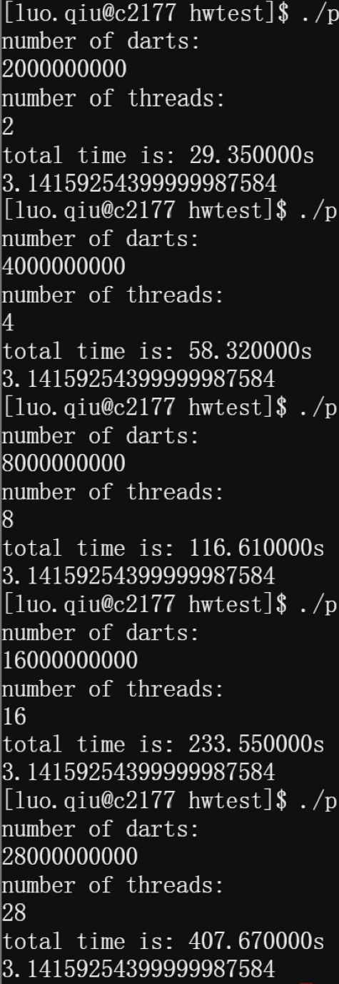

Pthreads:

|  |  |  |  |  |  |  |
| --- | --- | --- | --- | --- | --- | --- |
| Threads | 1 | 2 | 4 | 8 | 16 | 28 |
| Strong Scaling | 100% | 100.07% | 100.20% | 100.20% | 101.10% | 100.27% |
| Weak Scaling | 100% | 50.22% | 25.27% | 12.64% | 6.31% | 3.62% |

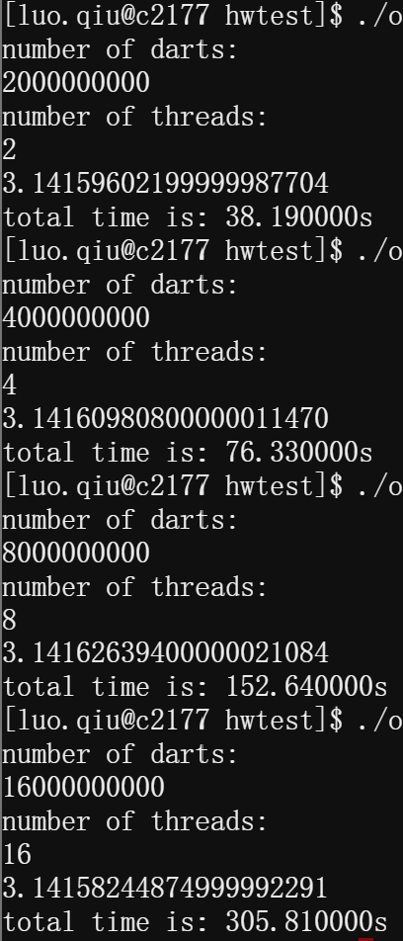

OpenMP:

|  |  |  |  |  |  |
| --- | --- | --- | --- | --- | --- |
| Threads | 1 | 2 | 4 | 8 | 16 |
| Strong Scaling | 100% | 100.10% | 100.10% | 98.86% | 100.05% |
| Weak Scaling | 100% | 50.14% | 25.09% | 12.55% | 6.26% |