1. In this problem, you will utilize the IEEE 754 format and evaluate the performance implications of using floats versus doubles in a computation.

1. Compute $f(x)=sin(x)$ using a Taylor series expansion. To refresh your memory:

$$\sin\left(x\right)=Σ_{0}^{∞}\frac{{\left(-1\right)}^{n}}{\left(2n+1\right)!}x^{2n+1}$$

$$\sin\left(x\right)=x-\frac{x^{3}}{3!}+\frac{x^{5}}{5!}-\frac{x^{7}}{7!}+\frac{x^{9}}{9!}···$$

You select the number of terms you want to compute (but at least 10 terms).

Compute $sin(x)$ for 4 different values, though be carful not to use too large a value.

Generate two versions of your code, first defining $x$ and $sin(x)$ to use floats (SP), and second, defining them as doubles (DP). Discuss any differences you find in your results for $f(x)$. You should provide an in-depth discussion on the results you get and the reasons for any differences.

System: AMD Ryzen 7 4800H with Radeon Graphics 2.90 GHz

I choose 10 terms to compute and 1.0, 2.0, 3.0, 4.0 as values.

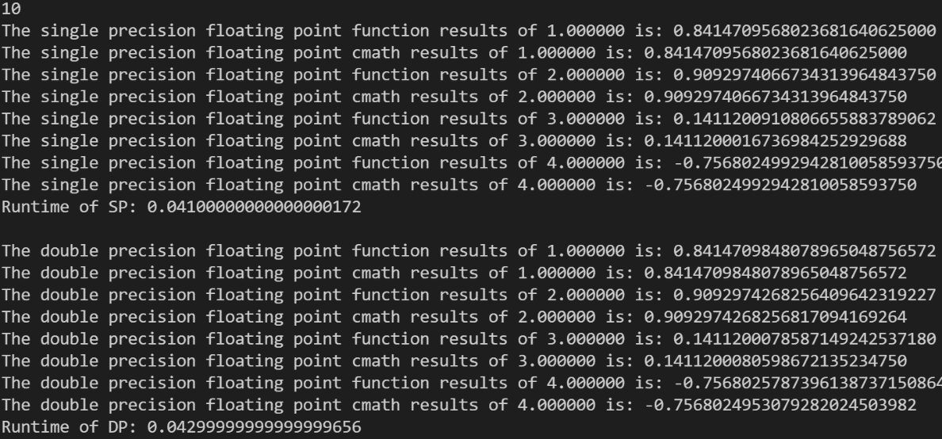

We can see that the result of the taylor calculation function I wrote is generally consistent with the system's own cmath function, so there is no principled problem in the result. As the single operation time is too short, I used a large loop to amplify the time comparison and can see that the double precision operation is slower than the single precision operation in non-AVX environment. However, when the input x is too large, say 2000 or 2500, then the single precision based taylor function fails and Inf overflows occur at each iteration step, while the double precision based taylor function does not fail and still performs the calculation normally. This is due to the fact that they take up different amounts of memory. Single precision floating point numbers take up 4 bytes (32 bits) of memory to store a floating point number, including 1 bit of sign, 8 bits of order and 23 bits of mantissa. Double precision floating point numbers use 8 bytes (64 bits) of memory to store a floating point number, including 1 bit for the sign, 11 bits for the order, and 52 bits for the tail. The range of values for single precision floating point numbers is -3.4e38 to 3.4e38, while the absolute value range of numbers that can be represented by double precision floating point numbers is -2.23e308 ~ 1.79e308.

1. Explore the benefits of compiling on the Discovery cluster with floating point vector extensions (e.g., AVX). Use the single-precision code from part (a). First run on a node on Discovery that does not support AVX-512. Then run on a node that supports AVX-512 and report on the performance benefits. Additional information is provided on AVX support on Discovery.

System: Intel(R) Xeon(R) Platinum 8276 CPU @ 2.20GHz

CPU(s): 56

Thread(s) per core: 1

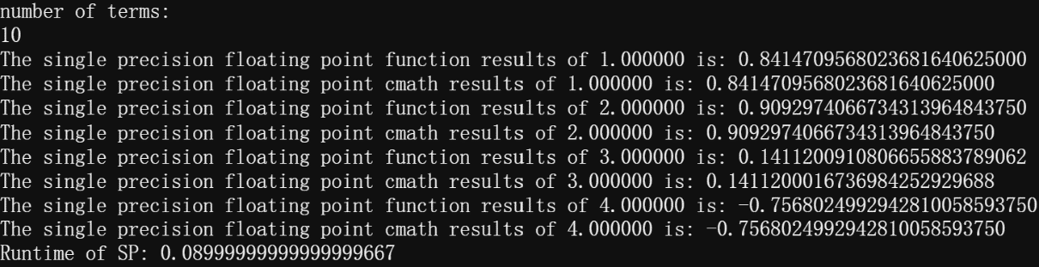

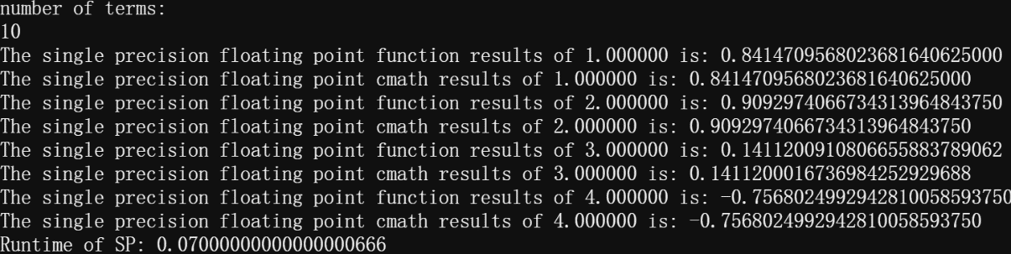

The image above shows the results in the non-AVX environment and the image below shows the results in the AVX environment, which shows the speedup in floating point operations in the AVX environment. AVX-512 is a new set of instructions, all vector instructions, which further extends the instruction width to 512 bits, doubling the width and number of data registers and the width of FMA cells compared to AVX2, so that 32 double-precision and 64 single-precision floating-point operations, or 8 64-bit and 16 32-bit integers, can be packed in each clock cycle.

1. Continuing with part (b), generate an assembly listing (using the -S flag) and identify 2 different AVX instructions that the compiler generated, explaining their operation.

vmovss: move or merge scalar single-precision floating-point value.

vmovd: move doubleword.

1. Provide both IEEE 754 single and double precision representations for the following numbers: 2.1, 6300, and -1.044.

(Hexadecimal based 4-bytes representation for single-precision values and 8-bytes representation for double-precision values)

2.1 (single precision): 40 | 06 | 66 | 66

2.1 (double precision): 40 | 00 | CC | CC | CC | CC | CC | CD

6300 (single precision): 45 | C4 | E0 | 00

6300 (double precision): 40 | B8 | 9C | 00 | 00 | 00 | 00 | 00

-1.044 (single precision): BF | 85 | A1 | CB

-1.044 (double precision): BF | F0 | B4 | 39 | 58 | 10 | 62 | 4E