2. In this problem, you will modify the matmul.c program provided, optimizing the

execution of the matrix multiplication with first a dense matrix, and second with a sparse matrix. You are welcome to use pthreads, OpenMP or any of the optimizations

that were presented in class to accelerate this code. There will be prizes awarded for the fastest dense and the fastest sparse implementations.

System: Intel(R) Xeon(R) CPU E5-2680 v4 @ 2.40GHz

Thread(s) per core: 1

Core(s) per socket: 14

Socket(s) 2

The running result of the original matmul.c:

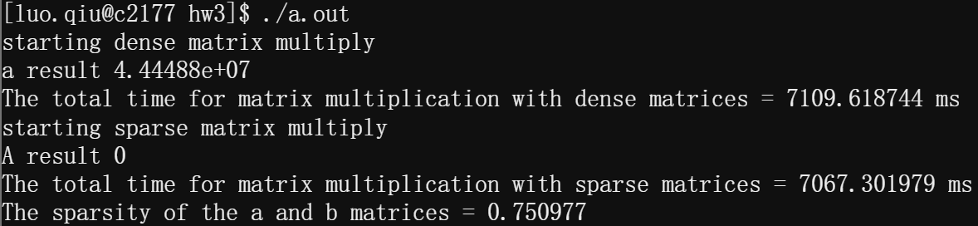

The running result of the optimized matmul.c:

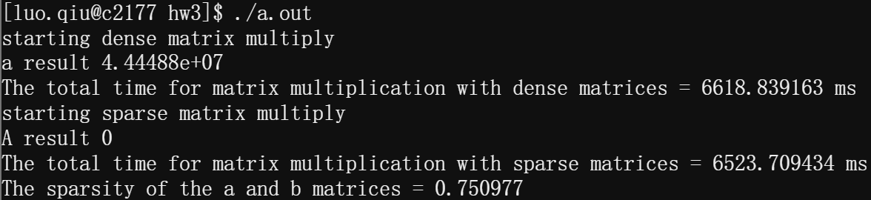

Based on Pthreads implementation, I use 16 threads to breakdown the whole task into sub-tasks, and each sub-task calculate the multiplication of 512 / 16 = 32 sub-rows or sub-columns of the matrix.

And the speedup of dense matrix multiplication is 107.41%, the speedup of sparse matrix multiplication is 108.37%.