3. In this problem, you will utilize the OpenBLAS library available on Discovery. To use OpenBLAS, you will need to issue load openblas/0.3.6. Using the malmul.c program, replace the math with a call to appropriate gemm library function. Compare the speed of your solution for problem 2 with the gemm method you use.

System: Intel(R) Xeon(R) CPU E5-2680 v4 @ 2.40GHz

Thread(s) per core: 1

Core(s) per socket: 14

Socket(s) 2

The running result of malmul.c based on OpenBLAS:

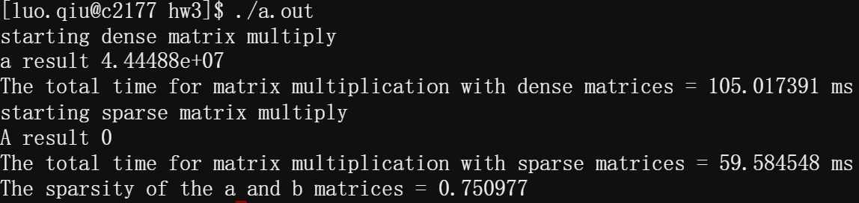

The runtime of the OpenBlas-based program is orders of magnitude less than the runtime of the Pthreads-based program I wrote. The initial analysis is that OpenBlas performs vector operations, while my Pthreads-based implementation still performs scalar operations.