1.
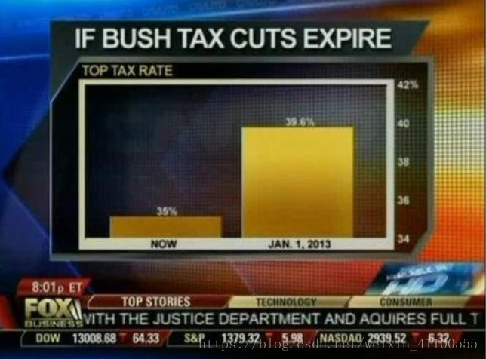
This chart is an example of a chart shown by Fox News in 2012. The chart above wants to show the changing tax rates. From the graph you can see that the tax rate has changed a lot (5 times more). However, if you analyze the actual numbers, you can see that it only increased from 35% to 39.6%, which is only a 13% increase (4.6 percent increase). This makes it easy to assume that the baseline of the bar chart is 0, but the baseline of this chart is 34%, which is outside the range envisioned. It is likely that the creator of this graph was trying to trick the viewer into thinking that there was a large change in the tax rate, but that is not the case. If the chart were to be recreated to show the values accurately, the change would be almost negligible. Now we need to calculate the lie factor of the Fox News bar above. The smaller bars are 27 pixels high and the larger bars are 146 pixels high. So the graphical effect is (146 - 27) / 27 = 4.407 and the data effect is (39.6 - 35) / 35 = 0.131, so the lie factor is 33.54.

Here is the analysis from the Data-Ink-Ratio perspective. Data-Ink-Ratio is the ratio between the amount of "ink" used to display data on the display media / page and the total amount of "ink" on the media / page. Data ink, the part of the ink that represents the actual data or information, will reduce the amount of information in the graph if the data ink is erased, in other words, the data ink is the non-erasable core on the graph. You can see that the histogram showing the comparison of tax rates is too thick, while the numbers showing the percentages are particularly small, which makes the data-ink-rate very small.
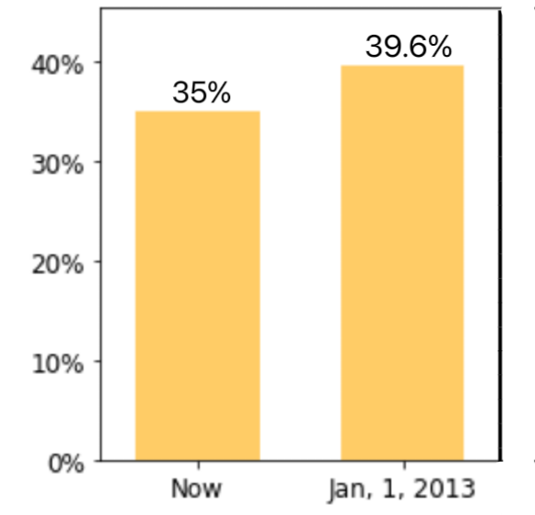

2.
R = 137 / 255 = 0.5372549019607843
G = 56 / 255 = 0.2196078431372549
B = 146 / 255 = 0.5725490196078431

Code Resource: http://www.easyrgb.com/index.php?X=MATH
CIE XYZ: [16.919008156730108, 10.222034728739088, 28.275448239970974]
CIE xyY: [0.3053063774541846, 0.1844583538427325, 10.222034728739088]
CMYK: [0.06164383561643833, 0.6164383561643836, 0.0, 0.4274509803921569]
HSV: [0.8166666666666665, 0.6164383561643836, 0.5725490196078431]
HSL: [0.8166666666666665, 0.44554455445544555, 0.396078431372549]


3.
CVPR Data by Year
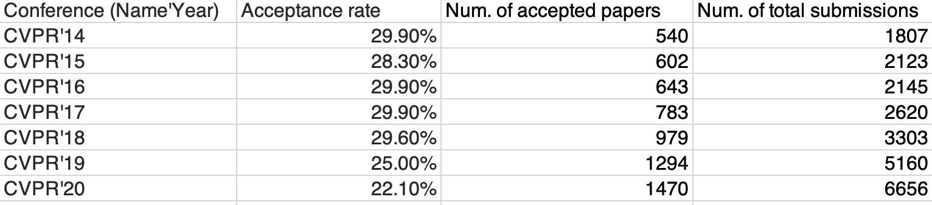

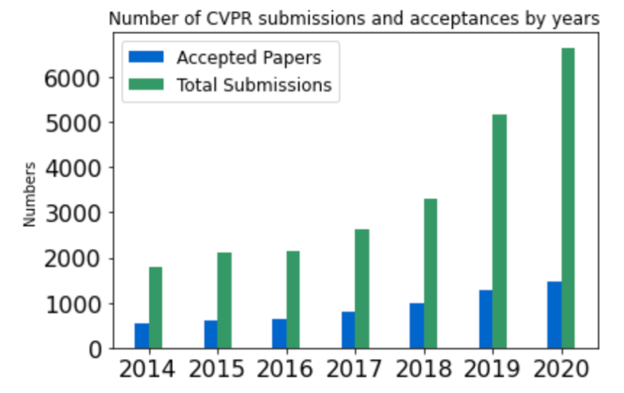
Here the table is loaded with larger dimensional data and the reader scans through the rows and columns and compares the values in them. Plotting into a table is also an advantage when the data has many different units of measure, as in this case the acceptance rate and the two rows on the right are different units of measure, but the table can be represented in a higher dimension. But the disadvantage of the table also lies in its numbers, i.e., it is not intuitive enough for us to quickly find trends or changes in the data through the table. For example, assuming there are more years in CVPR, a quick glance at the rows does not give a quick read on whether the number of submissions is increasing or decreasing. The graph below the table quickly shows that both the acceptance rate and the number of submissions are increasing year by year, and at a greater rate. Charts can quickly present large amounts of data in an easy-to-use way, and they are especially useful when the data is used to show how different things (variables) are related to each other. Charts can interact more actively with the reader and stimulate visual perception.

4.
By looking at the image, we see that the color background is exactly the same shade of yellow, and there are 3 letters or numbers in the center of the background. When I look at the left image, these 3 images become letters "A, B, C", but when I look at the right image, these 3 images become numbers "12, 13, 14", but actually the left image "B" and "13" on the right are actually identical images, i.e., the outline size and shape are exactly the same, but different visual perceptions are generated in the two images respectively. The most basic law of Gestalt psychological perception theory is the law of simple refinement, which holds that people tend to understand visual perception as regular, simple, connected, symmetrical, or ordered structures when making observations and will tend to understand things as a whole rather than as a collection of all the parts that make up a thing when acquiring visual perception. So when I look at the left image, I will define the middle of the 3 images as letters, and when I look at the right image, I will define the middle of the 3 images as numbers.

