1.

a)

① It chose the wrong visualization method. The line in this chart could easily be mistaken for a trend in prices between commodities, but in reality the trend should be reflected on a quarterly basis, and this chart shows the wrong dimension.

② Improper use of 3D graphics. The figure shows the 3D graphics of the same quarter blocking the graphics of the later quarters. This is the result of simulating space in the natural world, where objects have different X, Y and Z coordinates. This blocking obscures important data and creates the wrong hierarchy, resulting in the reader not being able to see the price trend for the same product between the 4 quarters.

③ The values are misleading and it is difficult for the reader to know the exact magnitude of the values. Since the chart is presented by the 3D module tilt, there are problems with visual perspective when looking at the price values of the products, such as difficulty in aligning the price values of the products to the coordinate y-axis.

b)

① Use bar charts and each bar represents a quarter, with horizontal coordinates set to different products.

② Use 2D graphics instead of 3D graphics and use the same color to represent the same quarter.

③ Can put dots on the coordinates to represent specific values, use lines to show the trend of the values, or create a table with the relevant values.

c)

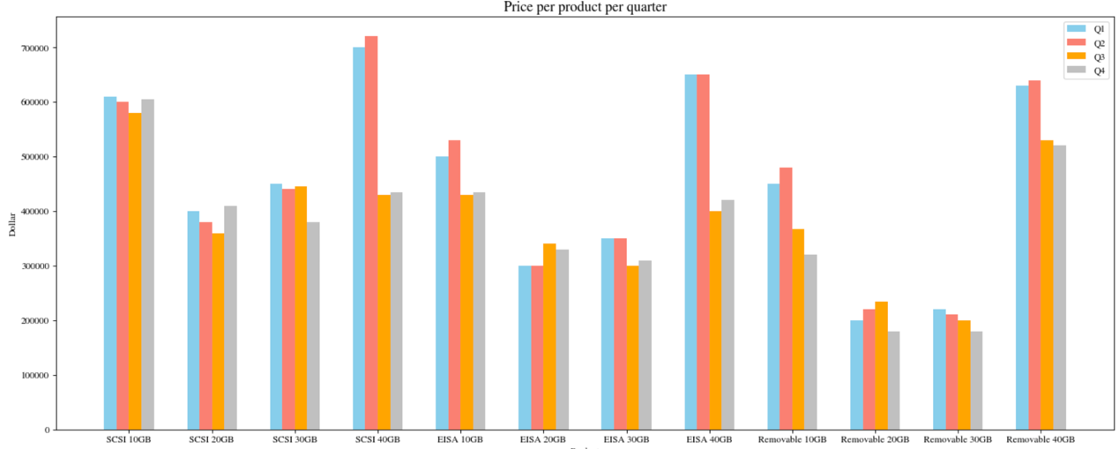

2.

a)

b)

Since VP does not consider specific numbers but deviation between budget and actual amounts, there is no need to use complex 3D images to represent the numbers in the table. I used line graphs to show the changes of the deviation over the quarters, and used different colored dashes to represent different departments respectively, while corresponding scatter plots and grids were drawn in order to facilitate the reader to locate the specific values of the deviation.

C)

The graph I have drawn clearly and concisely shows the change in expense deviation over the quarter, along with a good discrimination between different departments. My graphs also have a grid and scatter as supporting legends, which makes it easier for the reader to locate the values on the axes. The graph also has a good data-ink ratio, without huge gaps or visual obscurations. At the same time, the color contrast is also set relatively well, neither too harsh nor confusing.