** Team member: Qiulin Luo, Jiayuan Huang

Wireshark Lab:  DNS v8.1  Supplement to Computer Networking: A Top-Down Approach, 8th ed., J.F. Kurose and K.W. Ross  “Tell me and I forget. Show me and I remember. Involve me and I understand.” Chinese proverb  © 2005-2021, J.F Kurose and K.W. Ross, All Rights Reserved | 

0. Academic Integrity

We have read and understood the course academic integrity policy located under this link: http://www.cse.buffalo.edu/faculty/dimitrio/courses/cse4589_s20/index.html#integrity.

1. Tracing DNS with Wireshark

Now that we are familiar with nslookup and ipconfig, we’re ready to get down to some serious business. Let’s first capture the DNS packets that are generated by ordinary Web-surfing activity.

- Use ipconfig to empty the DNS cache in your host.
- Open your Web browser and empty your browser cache.
- Open Wireshark and enter ip.addr == <your_IP_address> into the filter, where you obtain <your_IP_address> with ipconfig. This filter removes all packets that neither originate nor are destined to your host.
- Start packet capture in Wireshark.
- With your browser, visit the Web page: http://www.ietf.org
- Stop packet capture.

Answer the following questions:

- Locate the DNS query and response messages. Are they sent over UDP or TCP?

- What is the destination port for the DNS query message? What is the source port of DNS response message?

- To what IP address is the DNS query message sent? Use ipconfig to determine the IP address of your local DNS server. Are these two IP addresses the same?

- Examine the DNS query message. What “Type” of DNS query is it? Does the query message contain any “answers”?

- Examine the DNS response message. How many “answers” are provided? What do each of these answers contain?

- Consider the subsequent TCP SYN packet sent by your host. Does the destination IP address of the SYN packet correspond to any of the IP addresses provided in the DNS response message?

- This web page contains images. Before retrieving each image, does your host issue new DNS queries?

Now let’s play with nslookup.
- Start packet capture.
- Do an nslookup on www.mit.edu
- Stop packet capture.

You should get a trace that looks something like the following in your Wireshark window.

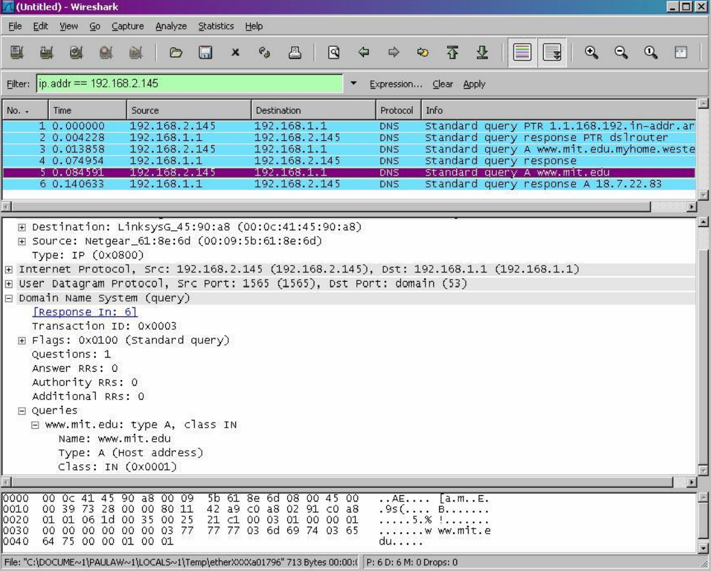

We see from the above screenshot that nslookup actually sent three DNS queries and received three DNS responses. For the purpose of this assignment, in answering the following questions, ignore the first two sets of queries/responses, as they are specific to nslookup and are not normally generated by standard Internet applications. You should instead focus on the last query and response messages.

- What is the destination port for the DNS query message? What is the source port of the DNS response message?

- To what IP address is the DNS query message sent? Is this the IP address of your default local DNS server?

- Examine the DNS query message. What “Type” of DNS query is it? Does the query message contain any “answers”?

- Examine the DNS response message. How many “answers” are provided? What do each of these answers contain?

Now repeat the previous experiment, but instead issue the command:

nslookup –type=NS mit.edu

and then answer the following questions:

- To what IP address is the DNS query message sent? Is this the IP address of your default local DNS server?

- Examine the DNS query message. How many questions does the query have? Does the query message contain any “answers”?

- Examine the DNS response message. What MIT name servers does the response message provide? Does this response message also provide the IP addresses of the MIT name servers?

2. Content Distribution Networks and DNS

A browser running on a UB host with IP address 128.205.39.99 accesses a video on www.youtube.com. We used Wireshark to capture the incoming/outgoing packets during this process. Download the Wireshark pcap trace from the link given below and answer the following questions. Consider only IPV4 addresses.

Link: http://www.cse.buffalo.edu/faculty/dimitrio/courses/cse4589_s20/material/labs/cdn.pcap

- What are the IP addresses returned by DNS when the host requests a DNS lookup for www.youtube.com? If there is more than one DNS query, list all the unique IPs in the DNS responses.

- What are the IP addresses returned by DNS when the host requests a DNS lookup for any hostname containing googlevideo.com? If there is more than 1 DNS query, list all the unique IPs in the DNS responses.

- What are the IP addresses returned by DNS when the source requests a DNS lookup for s.youtube.com? If there is more than 1 DNS query, list all the unique IPs in the DNS responses.

- Are the IPs in questions (15), (16), and (17) the same or different? How do you explain this?

- Identify the GET request containing “videoplayback”. To which IP is this request sent to?

- Check the authoritative nameservers in all the DNS response packets corresponding to DNS queries for any hostname containing youtube.com or googlevideo.com. What do you observe about the order of the nameservers listed in each response? Is it the same or different? Justify your answer.

