W5HH Principle Analysis Document

1. WHY - Why undertake this project? (Project background and value)
1.1 Market pain points
Difficulty in dog breed identification: Ordinary users encounter dogs they don't recognize and cannot quickly and accurately identify the breed.
Fragmented dog care knowledge: Online dog breed information is scattered and lacks systematic and professional encyclopedic knowledge.
Unknown breeding risks: Blindly raising dogs without understanding their characteristics (such as shedding levels and common diseases) leads to abandonment.
Low efficiency in information search: Users have to search multiple platforms repeatedly to obtain complete breed information.
1.2 Project value
User value: Upload a picture to get breed identification results and complete encyclopedic information, solving the problems of "What kind of dog is this?" and "How to raise this dog?" in one go.
Social value: Popularize scientific dog care knowledge and reduce the phenomenon of abandonment due to lack of understanding of breed characteristics.
Technical value: Practice the application of deep learning in image recognition and explore the landing scenarios of AI in the pet field.
Educational value: Help potential dog owners understand breed characteristics before making a decision, promoting responsible pet ownership.
1.3 Project goals
Core goal: Develop a lightweight desktop application that can accurately identify over 120 dog breeds and has an inbuilt comprehensive dog breed encyclopedia, enabling every dog lover to "identify dogs by pictures and raise them scientifically."

2.WHAT - What to do? (Project scope and functions)
2.1 Core functions (Based on the product backlog)
Picture selection and preview P006, P007, P008 Support for selecting, previewing, and button state linkage of jpg/png/bmp format pictures
Core dog breed recognition P001, P002, P009, P010, P011 Implement recognition of over 120 dog breeds based on the ResNet50 model, with result cleaning and matching
Encyclopedia information display P012, P013, P014 Display 11 information dimensions (name, alias, size, weight, height, lifespan, personality, fur, origin, care points, detailed introduction)
Alias mapping enhancement P005, P015, P016 Support for matching Chinese and English aliases (e.g., "Erha" → Husky) to improve recognition accuracy
Baidu Encyclopedia backup P017, P018, P019 Automatically query Baidu Encyclopedia for supplementary information when no local match is found
User experience optimization P020, P021, P022 Loading animations, error prompts, interface beautification
Performance optimization P023, P024 Recognition speed optimization, memory usage control
Completeness and delivery P025, P026, P027 Packaging as an exe, user manual, project documentation
2.2 Data scope
Number of dog breeds: Over 120 (small dogs, medium dogs, large dogs, terriers, poodle series, etc.)

Each dog breed must contain at least 11 information dimensions.

Number of alternative names: ≥50 alternative names for mainstream dog breeds

2.3 Excluded Features
User registration/login system
Community sharing/commenting function
Video recognition function Simultaneous recognition of multiple dogs

3. WHERE - Where to do it? (Application scenarios and deployment environment)
3.1 Application scenarios
Family dog keeping: Families interested in keeping dogs can identify dog breeds to understand their characteristics and assist in decision-making. Target users: Families considering getting a dog.
Stray dog rescue: Rescue stations can identify stray dog breeds to facilitate classification and adoption. Target users: Rescue station staff.
Pet socializing: Dog owners can take pictures of unfamiliar dogs they encounter while walking their pets to identify and learn about them. Target users: Ordinary dog lovers.
Science popularization and education: Schools and institutions can use it for dog breed knowledge popularization and teaching. Target users: Educators.
Pet industry: Veterinarians and groomers can quickly understand dog breed characteristics. Target users: Industry practitioners.
3.2 Deployment environment
Operating system: Windows 10/11 (64-bit)
Running mode: Local desktop application, double-click the exe file to run
Network requirements: Basic functions do not require a network; Baidu Baike backup query requires a network connection.
Hardware requirements: CPU: Intel i5 or equivalent performance and above; Memory: ≥8GB (recommended); Hard disk: ≥500MB available space.
Dependency environment: No need to install Python environment after packaging.
4. WHEN - When to do it? (Project time planning)
4.1 Overall timeline (2 months/8 weeks)
Sprint Period Weeks Core goals
Sprint 1 2 weeks Weeks 1-2 Complete the project's basic framework and data preparation
Sprint 2 2 weeks Weeks 3-4 Implement core recognition function and complete a runnable prototype
Sprint 3 2 weeks Weeks 5-6 Enhance functions and optimize user experience
Sprint 4 2 weeks Weeks 7-8 Complete integration and delivery of the final version
4.2 Key milestones
Milestone Weeks Core outputs
Project initiation Week 1 Team formation, Scrum process confirmation
Requirement confirmation Week 1 Project scope statement, product backlog
Data preparation completed Week 2 120+ dog breed encyclopedia database, alias mapping table
MVP prototype completed Week 4 Runnable prototype (image selection → recognition → basic display)
Function enhancement completed Week 6 Alias mapping, Baidu Baike backup query, interface optimization
Testing and bug fixing Weeks 7-8 Comprehensive testing, bug fixing
Final delivery Week 8 Executable file, user manual, project documentation
5. WHO - Who will do it? (Project Team and Division of Labor)
5.1 Team Roles
Product Owner: Wen Minxing
Responsibilities: Product backlog management, requirement priority definition, function acceptance
All PBI acceptance
Scrum Master/Back-end Core Developer: Zhang Yeheng
Responsibilities: Scrum process promotion, model integration, core recognition algorithm, code architecture
P001, P002, P009, P010, P011, P015, P016, P027
Back-end Developer: Luo Shirui
Responsibilities: Baidu Baike interface integration, data parsing, exception handling
P017, P018, P019
Back-end Developer: Zhang Chenjia
Responsibilities: Image preprocessing optimization, performance tuning, packaging and release
P023, P024, P025
Front-end Developer: Li Zhuolin
Responsibilities: GUI interface design, user interaction implementation, interface beautification
P003, P006, P007, P008, P012, P013, P020, P021, P022
Documentation/Data Support: Wen Minxing
Responsibilities: Dog breed encyclopedia data organization, document writing, test support
P004, P005, P014, P026
5.2 Collaboration Methods
Code Management: Git + GitHub, main branch protection, feature branch development
Task Tracking: Product backlog + burn-down chart (Excel/online document)
Instant Communication: Project WeChat group, daily stand-up meeting synchronization
Document Sharing: Leangoo shared project documents
Code Review: At least one other member reviews the code before merging

6. HOW - How to do it? (Technical solutions and implementation methods)
6.1 Technical architecture
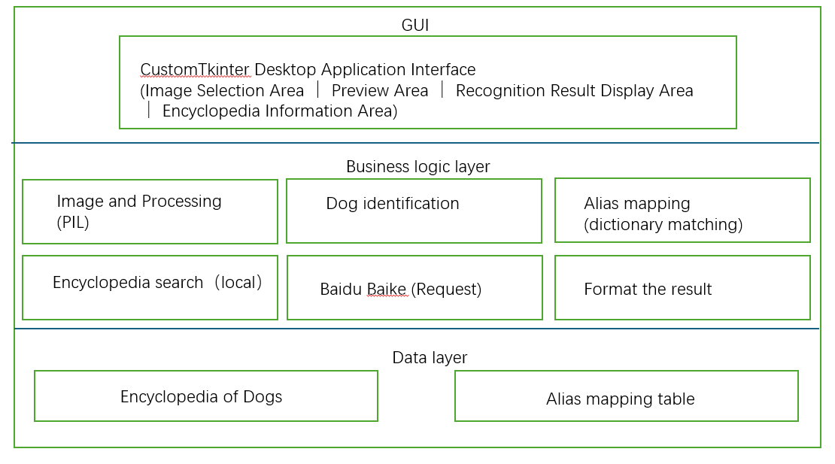
6.2 Core Technology Stack
Python Development Language 3.8+
CustomTkinter GUI Framework 5.2.0+
PIL/Pillow Imaging Processing 9.5.0+
PyTorch Deep Learning Framework 2.0.0+
torchvision Models and Preprocessing 0.15.0+
Requests HTTP Requests 2.28.0+
BeautifulSoup4 HTML Parsing 4.12.0+
PyInstaller Exe Packaging 5.13.0+
6.4 Development Implementation Steps
Environment Setup Install dependencies, configure Git Uniform version in requirements.txt
Data Preparation Organize data of over 120 dog breeds Store in JSON format
Model Integration Load ResNet50, test inference Accelerate inference without gradient
Interface Development Implement main window layout Responsive design with CustomTkinter
Recognition Function Preprocess image → Inference → Parse Normalize image, clean up results
Encyclopedia Display Load local data → Format display Scroll support in Textbox
Alias Mapping Implement dictionary matching logic Case-insensitive for Chinese and English
Baidu Encyclopedia Implement search → Parse → Fallback Exception handling, timeout setting
Performance Optimization Speed optimization, memory optimization Load model once, release resources
Packaging and Release Exe packaging with PyInstaller Single-file mode
7. HOW MUCH - How many resources are needed? (Workload and cost estimation)
7.1 Workload Estimation
Sprint PBI Quantity Number of Tasks Total Estimated Hours Team Size Converted Person Days
Sprint 1 5 11 46h 5 5.75 days
Sprint 2 8 15 52h 5 6.5 days
Sprint 3 9 15 51h 5 6.375 days
Sprint 4 5 12 54h 5 6.75 days
Total 27 53 203h 5 25.375 days
7.2 Resource Requirements
Resource Type Requirement Description Acquisition Method
Human Resources 5 developers (including product owner) Project team members
Hardware Resources 1 development computer per person (8GB+ memory) Bring your own
Software Resources Python development environment, Git, IDE Free and open source
Data Resources Encyclopedia data of over 120 dog breeds Manual organization + online collection
Model Resources Pre-trained ResNet50 model Automatically downloaded by torchvision
Collaboration Tools WeChat group, Leangoo, GitHub Free
7.3 Cost Estimation
Labor Cost 0 yuan Student project, no salary expenses
Hardware Cost 0 yuan Using personal computers
Software Cost 0 yuan All using open source/free software
Data Cost 0 yuan Manual organization, no purchase needed
Other Expenses 0 yuan Not applicable
Total 0 yuan Zero-cost project
7.4 Expected Benefits
Benefit Type Description
Learning Benefits Team members master the full process of deep learning and desktop application development
Project Outcome Complete a usable dog breed recognition encyclopedia tool
Knowledge Accumulation Form a complete project documentation and technical solution
Work Value Can be used as a course design, graduation project, or open source project
8. W5HH Summary Matrix
WHY Solve the problems of difficult dog breed recognition and fragmented dog care knowledge, promoting scientific dog care
WHAT A desktop application for recognizing over 120 dog breeds and displaying complete encyclopedia information WHERE: Windows desktop environment, for use in multiple scenarios such as home, shelters, and schools
WHEN: 2 months (8 weeks), divided into 4 Sprint iterations for development
WHO: A team of 5 people, namely Zhang Yeheng, Wen Minxing, Luo Shirui, Zhang Chenjia, and Li Zhuolin
HOW: Python + CustomTkinter + ResNet50 + Local encyclopedia data
HOW MUCH: 203 working hours, zero cost

