1. 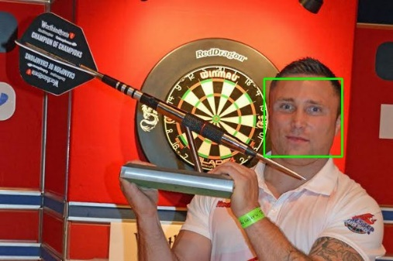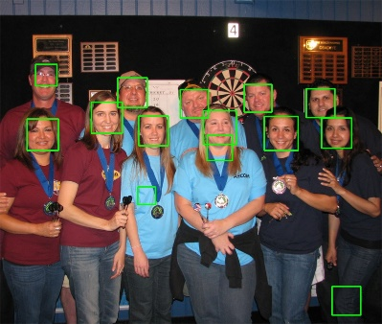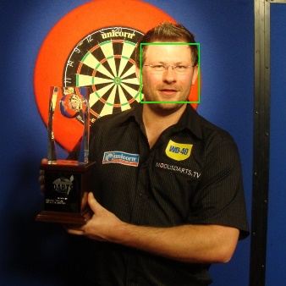**The Viola-Jones Object Detector**

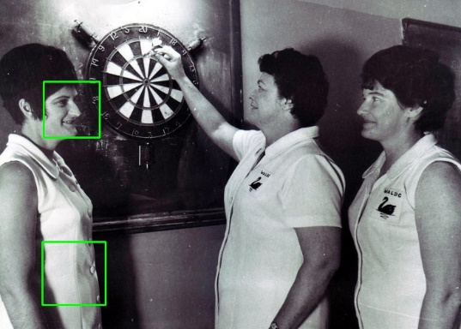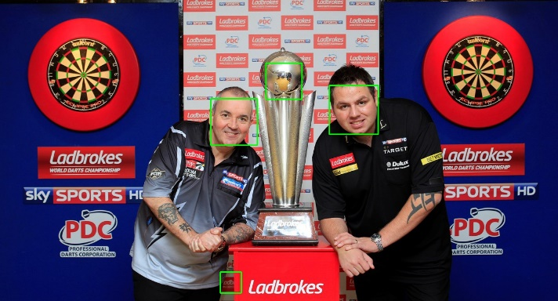**Dart4.jpg Dart5.jpg Dart13.jpg**

**Dart15.jpg Dart14.jpg**

TPR_dart5­=successfully detected faces / all valid faces=11/11=1

TPR_dart 15 TPR=successfully detected faces / all valid faces=0.3333

**Practical difficulties in assessing the TPR accurately**

There might be more than one bounding boxes overlapping on a same object, resulting in an inaccurate TPR.

The detector cannot distinguish between a dartboard-pattern and real dartboard. For example, the dartboard pattern printed on a t-shirt can also be recognized as a dartboard.

**Why it is always possible to achieve a TPR of 100% on any detection task**

TPR=TP/ (TP+FN). So from this formula we can see, TPR is decided by FN and TP.

Also, based on the fact that on average only 0.01% of all sub-windows are positive (e.g. faces), which enables the first classifier to achieve a false negative rate (FNR) of approximately 0%. FNR=FN/ (TP+FN). FN =FNR*(TP+FN) also approaches 0.Therefore, TPR=TP/ (TP+FN) approximately equal to TP/TP, which 100%. [1]

**Measures and Rules to calculate the F1-score:**

* The dartboard object can be classified to positive only if it is at least 60*60 Pixels
* The dartboard object can be classified to positive only if at least 50% of its area is visible ( not covered by other object)
* The dartboard object can be classified to positive only if it is a real dartboard instead of a dartboard-pattern

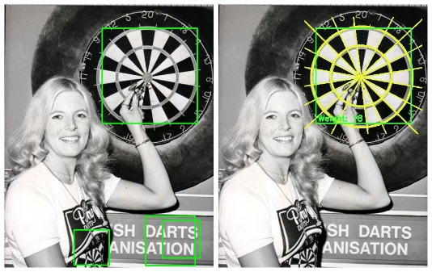

Here is an example of applying those measures and rules.

The dartboard-pattern on the t-shirt will not be dected.

Before applying the rules After applying the rules

**Reference:**

[1]<https://en.wikipedia.org/wiki/Viola%E2%80%93Jones_object_detection_framework#cite_note-6>

**2 Building & Testing your own Detector**

**(a)**

**Figure1: TPR vs FPR graph.[1]**

Every point in the ROC space represents a classification result, the(x, y) coordinates of which are determined by the corresponding FPR and TPR respectively.

A point in coordinate (0, 1) of the ROC is the best classification because it has no false negatives and no false positives while a point on the diagonal highlighted in orange dash indicates a completely random guess. So according to this figure, the classifier in fist stage can only do a poor prediction. The FPR got a sharp drop after every training integration, while TRP remained the same. In stage 2, the FPR of this detector approached to 0.

**(b)**

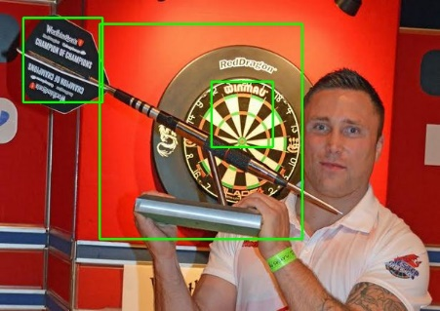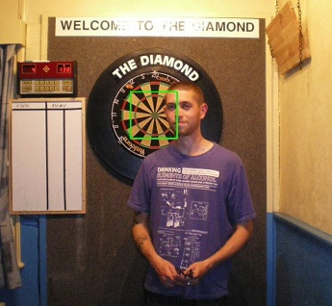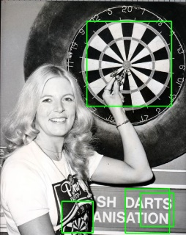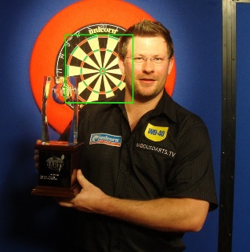

* F1-score=2∗precision∗recall/ (precision + recall) =2*(0.5+0.9)/ (0.5+0.9)= 0.6444 [2]
* The low F1-score shows that there is a significant difference between recall and precision. Recall is the number of correct positive results divided by the number of positive results. The recall of this classifier is 0.9, indicating that this classifier is good at classify positive results, which also explains why the TPR are very high( always =1 in this case )and low FPR(responding only to positive cases) in Figure1. [3]
* The ROC space graph can clearly display the relationship between sensitivity and specificity as well as give us a general idea of how good classification results are.

**Reference:**

**[1] https://en.wikipedia.org/wiki/Receiver_operating_characteristic**

**[2]** **https://en.wikipedia.org/wiki/F1_score**

**[3]** **http://www.cs.toronto.edu/~jepson/csc2503/recognition.pdf**

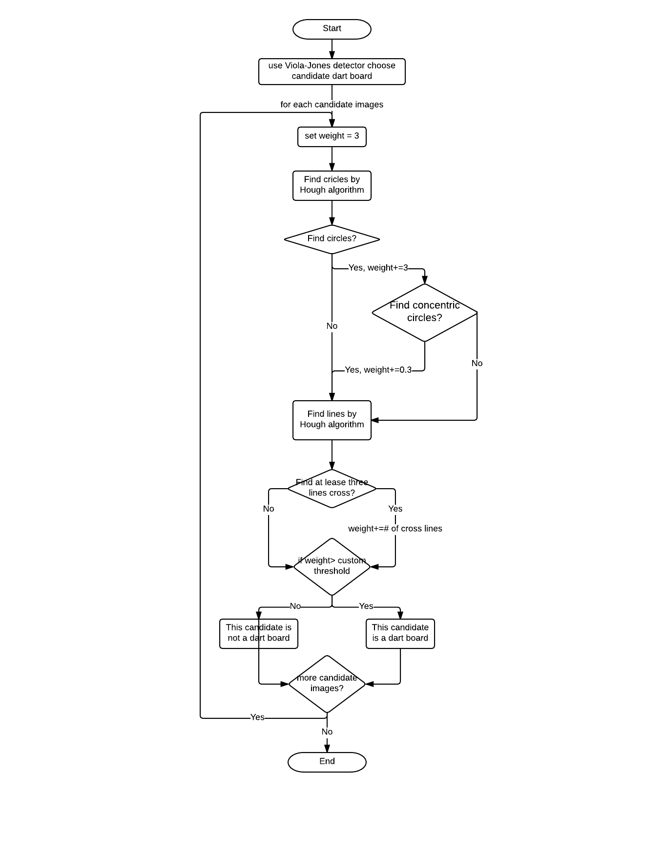**3. Integration with Shape Detectors**

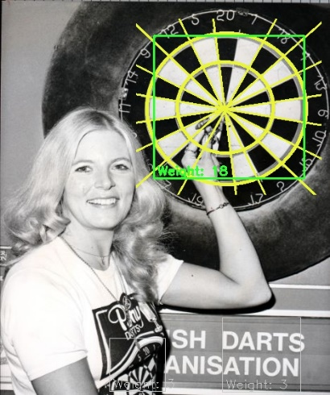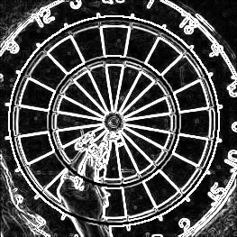

**Gradient magnitude image(dart9.jpg)**

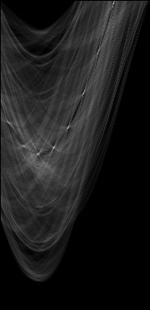

**Final detections (dart9.jpg)**

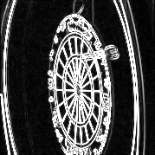 :

**Hough space (dart9.jpg)**  **Gradient image (dart12.jpg)**

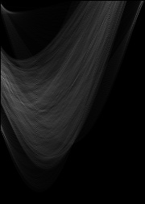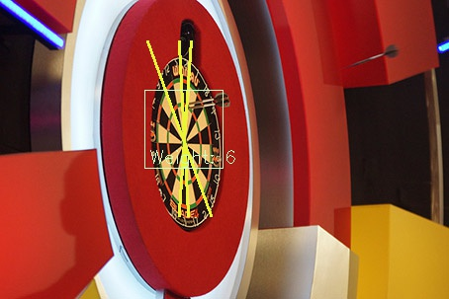

**Final detections (dart12.jpg)**  **Hough space (dart12.jpg)**

**(b)** TP = 14, FP = 4 FN = 8

P = TP/(TP+FP) = 14/(14+4) = 0.7778

R = TP/(TP+FN) = 14/(14+8) = 0.6364

F1 = (2*P*R)/(P+R) = 0.7

**Flow diagram**

**Merits**

* This program detects both concentric circles and cross lines based on the Viola-Jones detector. Hence the precision value is very high
* Since we only apply the Hough transform to the output of ellipse instead of the whole image, the efficiency is much higher

**Shortcomings:**

* The efficiency may become lower when detecting an ellipse compared with other shapes such as a circle.
* Short cross lines may not be detected in some cases.

**(c)** **Combining evidence from the Hough Transform and Viola-Jones detector**

* Use Viola-Jones detector to find candidate dart boards
* For each candidate window, try to find concentric circles and/or cross lines if there is any, and evaluate each candidate with a score according to the number of lines and concentric circles found in that window
* Apply a custom threshold (default is 6) to filter candidates according to their score

**4. Improve the detector**

**(a) Approach:**

* Eliminate the similar circles (the circles with similar radius and center) to improve the accuracy in the “find_concentric_circles” method.
* Eliminate the similar lines in the “find_cross_lines” method.
* Use weight system to evaluate the candidate image, so that we can set a custom threshold to determine the result.
* Assuming that two darts are never overlaps, we remove one of the overlapping candidate by following rules:

1. Remove the candidate image with lower weight score
2. If both candidates have same weight score, remove the smaller one

**(B)** **Important aspects of your technique**



**Before improved After improved**

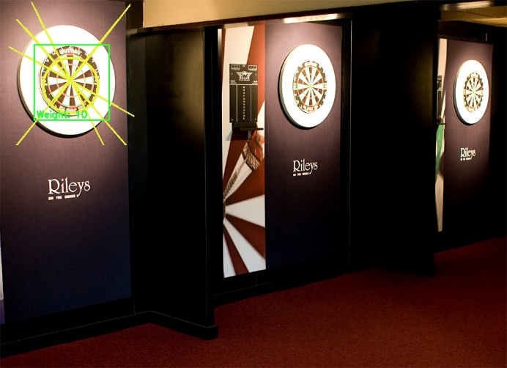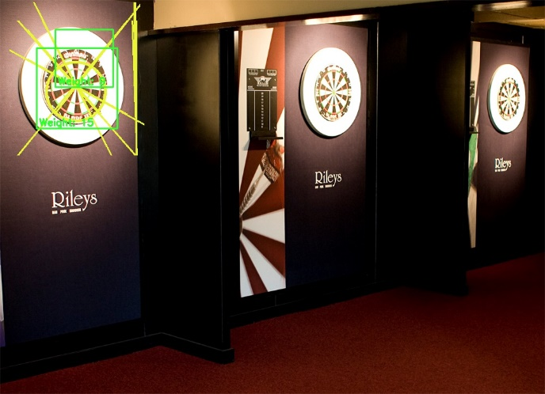

**Before improved** **After improved**

From these 2 contrast results, we can see the improved detector eliminate the similar lines and overlapped detectors.

**(c)** The improved detector brings the F1 score to 0.8237, and the Precision reach to 1.

Let threshold = 5: TP = 14, FP = 0 FN = 6

P = TP/(TP+FP) = 14/(14+0) = 1

R = TP/(TP+FN) = 14/(14+6) = 0.7

F1 = (2*P*R)/(P+R) = 0.8235

**Merits:**

* Both similar circles and lines are deleted when deciding cross lines and concentric circles, which improves the recall value.
* The threshold of Hough transform is automatically adjusted according to the image size
* We fixed the overlapping bounding boxes problem, which improves the Precision to 1

**Shortcomings:**

The program probably unable to detect the concentric circles and single circle on very small dart board