1. **(a.)**

We can compute the probability distribution as follows:

|  |  |  |  |  |  |  |  |  |  |  |  |  |  |  |  |  |  |  |  |  |  |  |  |  |  |  |  |  |  |
| --- | --- | --- | --- | --- | --- | --- | --- | --- | --- | --- | --- | --- | --- | --- | --- | --- | --- | --- | --- | --- | --- | --- | --- | --- | --- | --- | --- | --- | --- |
| |  |  | | --- | --- | | a | p(a) | | 0 | 0.6 | | 1 | 0.4 | | |  |  | | --- | --- | | b | p(b) | | 0 | 0.592 | | 1 | 0.408 | | |  |  |  | | --- | --- | --- | | a | b | p(a,b) | | 0 | 0 | 0.336 | | 0 | 1 | 0.264 | | 1 | 0 | 0.256 | | 1 | 1 | 0.144 | |

Therefore p(a)p(b) is:

|  |  |  |
| --- | --- | --- |
| a | b | p(a)p(b) |
| 0 | 0 | 0.3552 |
| 0 | 1 | 0.2448 |
| 1 | 0 | 0.2368 |
| 1 | 1 | 0.1632 |

Since p(a)p(b) $≠$ p(a, b) , a and b are dependent.

|  |  |  |
| --- | --- | --- |
|  |  |  |
| |  |  | | --- | --- | | c | p(c) | | 0 |  | | 1 |  | | |  |  |  | | --- | --- | --- | | c | a | p(a|c) | | 0 | 0 | 0.5 | | 0 | 1 | 0.5 | | 1 | 0 | 0.6923 | | 1 | 1 | 0.3077 | | |  |  |  | | --- | --- | --- | | c | b | p(b|c) | | 0 | 0 | 0.8 | | 0 | 1 | 0.2 | | 1 | 0 | 0.4 | | 1 | 1 |  | |
|  |  |  |
| |  |  |  |  | | --- | --- | --- | --- | | c | a | b |  | | 0 | 0 | 0 | 0.4 | | 0 | 0 | 1 | 0.1 | | 0 | 1 | 0 | 0.4 | | 0 | 1 | 1 | 0.1 | | 1 | 0 | 0 | 0.2769 | | 1 | 0 | 1 | 0.4154 | | 1 | 1 | 0 | 0.1231 | | 1 | 1 | 1 | 0.1846 | | |  |  |  |  | | --- | --- | --- | --- | | c | a | b |  | | 0 | 0 | 0 | 0.4 | | 0 | 0 | 1 | 0.1 | | 0 | 1 | 0 | 0.4 | | 0 | 1 | 1 | 0.1 | | 1 | 0 | 0 | 0.2769 | | 1 | 0 | 1 | 0.4154 | | 1 | 1 | 0 | 0.1231 | | 1 | 1 | 1 | 0.1846 | |  |

Therefore p(a|c)p(b|c) = p(a,b|c), hence $a⊥b | c$

**(b.)**

|  |
| --- |
|  |
| |  |  |  | | --- | --- | --- | | a | c | p(c|a) | | 0 | 0 | 0.4 | | 0 | 1 | 0.6 | | 1 | 0 | 0.6 | | 1 | 1 | 0.4 | |

Then p(a)p(b|c)p(c|a) is

|  |  |  |  |
| --- | --- | --- | --- |
| a | b | c | p(a)p(b|c)p(c|a) |
| 0 | 0 | 0 | 0.192 |
| 0 | 0 | 1 | 0.144 |
| 0 | 1 | 0 | 0.048 |
| 0 | 1 | 1 | 0.216 |
| 1 | 0 | 0 | 0.192 |
| 1 | 0 | 1 | 0.064 |
| 1 | 1 | 0 | 0.048 |
| 1 | 1 | 1 | 0.096 |

Hence p(a)p(b|c)p(c|a) = p(a,b,c)

The corresponding Bayes network is:

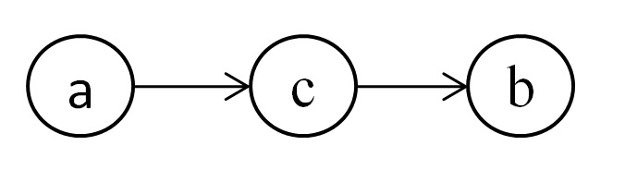

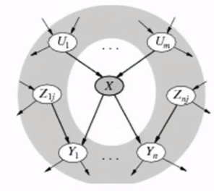

**2.**

Consider Figure 14.4 (b) on the textbook:

The grey part is the Markov Blanket. We need to consider all possible paths from the center node X to all possible nodes outside the blanket. There are three kinds of such paths. First, consider U1…Um, they are parents of X. For any node Ui among U1…Un, the link between X and Ui has its tail on Ui. In this case, the path between X and outer nodes on the parent could be either tail-to-tail or head-to-tail. Once the parent is given, X is independent with all such nodes. Second, consider Y1…Yn, they are children of node X. For any node Yi among Y1…Yn, the link between X and Yi has its head on Yi. In this case, the path between X and outer nodes which are children of any Yi is head-to-tail on Yi. Once Yi is given, X is independent with all such nodes. The last kind of path comes from Z1j…Znj, they share children with X. The path will be head-to-head on the shared children Y1…Yn, thus given Yi cannot ensure independence of X and nodes on such paths. However, such path will be either tail-to-tail or head-to-tail on Zij (a node among Z1j…Znj), then, once Zij and Yi is given, X will be independent with outer nodes in such path. So, conditioned on all the nodes in the Markov Blanket, X will be independent with all the remaining variables in the graph.

**3. (a.)**

Independent pairs of variables are:

$$(e⊥c) , (a⊥c) , (b⊥c)$$

**(b.)**

Given a third variables, conditionally independent pairs of variables are:

$$(e⊥b | a) , (e⊥d | a) , (e⊥c | a) , (e⊥d | b) , (e⊥c | b) , (a⊥d | b) , (a⊥c | b)$$

**4. (a.)**

p(a,b,c) = p(a)p(b|a)p(c|b)

**(b.)**

$p(c) = \sum_{a,b}{p\left(a,b,c\right) = \sum_{a,b}{p\left(a\right)p\left(b | a\right)p\left(c | b\right)}}$

$p(a,c) = \sum_{b}{p(a,b,c) = \sum_{b}{p(a)p(b|a)p(c|b) = p(a)\sum_{b}{p(b|a)p(c|b)}}}$

$p(a)p(c) = p(a)\sum_{a,b}{p\left(a\right)p\left(b | a\right)p\left(c | b\right)} ≠ p(a)\sum_{b}{p(b|a)p(c|b)} = p(a,c)$

Therefore a and c are dependent.

**(c.)**

$$p(a|b)=\frac{p(a,b)}{p(b)}=\frac{\sum_{c}{p(a,b,c)}}{p(b)}=\frac{\sum_{c}{p(a)p(b|a)p(c|b)}}{p(b)}=\frac{p(a)p(b|a)\sum_{c}{p(c|b)}}{p(b)}$$

$$p(c|b)=\frac{p(c,b)}{p(b)}=\frac{\sum_{a}{p(a,b,c)}}{p(b)}=\frac{\sum_{a}{p(a)p(b|a)p(c|b)}}{p(b)}=\frac{p(c|b)\sum_{a}{p(a)p(b|a)}}{p(b)}$$

$$p\left(a | b\right)p\left(c | b\right)= \frac{p(a)p(b|a)\sum_{c}{p(c|b)}}{p(b)} ×\frac{p(c|b)\sum_{a}{p(a)p(b|a)}}{p(b)}$$

$$= \frac{p(a)p(b|a)p(c|b)\sum_{c}{p(c|b)\sum_{a}{p(a)p(b|a)}}}{p(b)p(b)}$$

$$= \frac{p(a,b,c)\sum_{a}{\sum_{c}{p(a)p(b|a)p(c|b)}}}{p(b)p(b)}$$

$$= \frac{p(a,b,c)\sum_{a,c}{p(a,b,c)}}{p(b)p(b)}$$

$$= \frac{p(a,b,c)}{p(b)}$$

$$= p(a,c|b)$$

Therefore p(a|b)p(c|b) = p(a,c|b) , a and c are conditionally independent given b.

**5. (a.)**

p(a,b,c) = p(a)p(b|a,c)p(c)

**(b.)**

$p(a,c)=\sum_{b}{p(a,b,c)=\sum_{b}{p(a)p(b|a,c)p(c)=p(a)p(c)\sum_{b}{p\left(b | a,c\right)}}}$

$$=p(a)p(c)$$

Therefore a and c are independent.

**(c.)**

$$p(a|b)=\frac{p(a,b)}{p(b)}=\frac{\sum_{c}{p(a,b,c)}}{p(b)}=\frac{\sum_{c}{p(a)p(b|a,c)p(c)}}{p(b)}=\frac{p(a)\sum_{c}{p(b|a,c)p(c)}}{p(b)}$$

$$p(c|b)=\frac{p(c,b)}{p(b)}=\frac{\sum_{a}{p(a,b,c)}}{p(b)}=\frac{\sum_{a}{p(a)p(b|a,c)p(c)}}{p(b)}=\frac{p(c)\sum_{a}{p(a)p(b|a,c)}}{p(b)}$$

$$p\left(a | b\right)p\left(c | b\right)=\frac{p\left(a\right)\sum_{c}{p\left(b | a,c\right)p\left(c\right)}}{p\left(b\right)}×\frac{p\left(c\right)\sum_{a}{p\left(a\right)p\left(b | a,c\right)}}{p\left(b\right)}$$

$$= \frac{p(a)p(c)\sum_{c}{p\left(b | a,c\right)p\left(c\right)}\sum_{a}{p(a)p(b|a,c)}}{p(b)p(b)}$$

$$= \frac{p(a)p(c)p(b|a,c)}{p(b)}×\frac{\sum_{c}{p\left(b | a,c\right)p\left(c\right)}\sum_{a}{p(a)p(b|a,c)}}{p\left(b\right)p(b|a,c)}$$

$$= \frac{p(a,b,c)}{p(b)}×\frac{\sum_{c}{p\left(b | a,c\right)p\left(c\right)}\sum_{a}{p(a)p(b|a,c)}}{p\left(b\right)p(b|a,c)}$$

$$= p(a,c|b)×\frac{\sum_{c}{p\left(b | a,c\right)p\left(c\right)}\sum_{a}{p(a)p(b|a,c)}}{p\left(b\right)p(b|a,c)}$$

$$≠ p(a,c|b)$$

Therefore a and c are not conditionally independent given b.

**6. (a.)**

From the given net work, we know that $J⊥I,M,B|G$

Therefore (ii) **P**(J|G)=**P**(J|G,I) and (iii) **P**(M|G,B,I)=**P**(M|G,B,I,J) are asserted.

**(b.)**

From the given Bayes net, we know that

**P**(B,I,M,G,J) = **P**(J|G)**P**(G|B,I,M)**P**(I|B,M)**P**(B)**P**(M)

Therefore:

$$P(b,i,¬m,g,j)= P(j|g)P(g|b,i,¬m)P(i|b,¬m)P(b)P(¬m)$$

$$= 0.9×0.8×0.5×0.9×0.9$$

$$= 0.2916$$

**(c.)**

**P**(J|B,I,M) = $\sum_{g}{P(J|G)P(G|B,I,M)}$, and the problem can be described as P(J|b,i,m)

Therefore, the probability is

$P\left(J | b,i,m\right)= \sum_{g}{P\left(J | G\right)P\left(G | b,i,m\right)}$

$$= [P\left(j | g\right)P(g|b,i,m)+P\left(j | ¬g\right)P(¬g|b,i,m),$$

$P\left(¬j | g\right)P(g|b,i,m)+P\left(¬j | ¬g\right)P(¬g|b,i,m)]$

$$= [0.9×0.9+0×0.1, 0.1×0.9+1×0.1]$$

$$= [0.81, 0.19]$$

**(d.)**

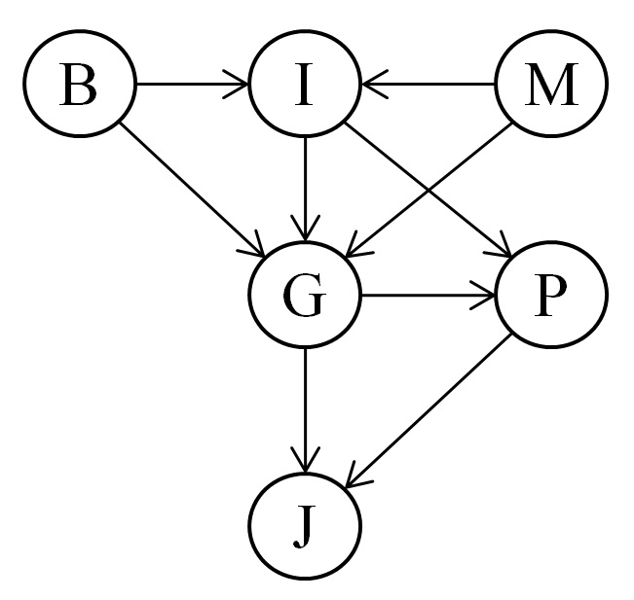In this Bayes net, one will not be FoundGuilty if he/she is not Indicted regardless of whether he/she BrokeElectionLaw, regardless of whether he/she PoliticallyMotivatedProsecutor.

So G is context-specifically independent of B and M given I = false.

**(e.)**

Three links added to the net.

I to P : Inducted could result in PresidentPardon

G to P : FoundGuilty could result in PresidentPardon

P to J : PresidentPardon could lead to not Jailed

**7. (a.)**

$$Since q1 and q2 are in detailed balance with π$$

$$We have: π\left(x\right)q1\left(x→x^{'}\right)=π\left(x^{'}\right)q1(x^{'}→x)$$

$$π\left(x\right)q2\left(x→x^{'}\right)=π\left(x^{'}\right)q2(x^{'}→x)$$

$$For their combination α q1+\left(1-α\right) q2$$

$$We have π\left(x\right)\left( α q1\left(x→x^{'}\right)+\left(1-α\right) q2\left(x→x^{'}\right)\right)$$

$$=π\left(x\right)α q1\left(x→x^{'}\right)+π\left(x\right)\left(1-α\right) q2\left(x→x^{'}\right)$$

$$=απ\left(x\right) q1\left(x→x^{'}\right)+\left(1-α\right)π\left(x\right) q2\left(x→x^{'}\right)$$

$$=απ\left(x'\right) q1\left(x'→x\right)+\left(1-α\right)π\left(x'\right) q2\left(x'→x\right)$$

$$=π\left(x^{'}\right)(α q1\left(x^{'}→x\right)+\left(1-α\right) q2\left(x^{'}→x\right))$$

Therefore the combination is in detailed balance with $π$

**(b.)**

$q\left(x→x^{'}\right)=\left(q1∘q2\right)\left(x→x^{'}\right)=\sum_{x"}{q1(x→x")q2(x"→x')}$

Therefore:

$\sum_{x}{π(x)q(x→x')=}\sum_{x}{π(x)}\sum_{x"}{q1(x→x")q2(x"→x')}$

$=\sum_{x"}{q2(x"→x')\sum_{x}{π(x)}q1(x→x")}$

$=\sum_{x"}{q2(x"→x')π(x")}$

$=π(x')$

Therefore, q $=q1∘q2$ also has $π$ as its stationary distribution.