Possible causes of differences between heads:

1. General diameter sensor assembly
2. Cable grounding pins
3. Cable shields
4. Algorithm filtering

Relevant projects:

1. ATK
2. 777X
3. 8 Tow heads
4. Top Heads

Mechanical setup

3777

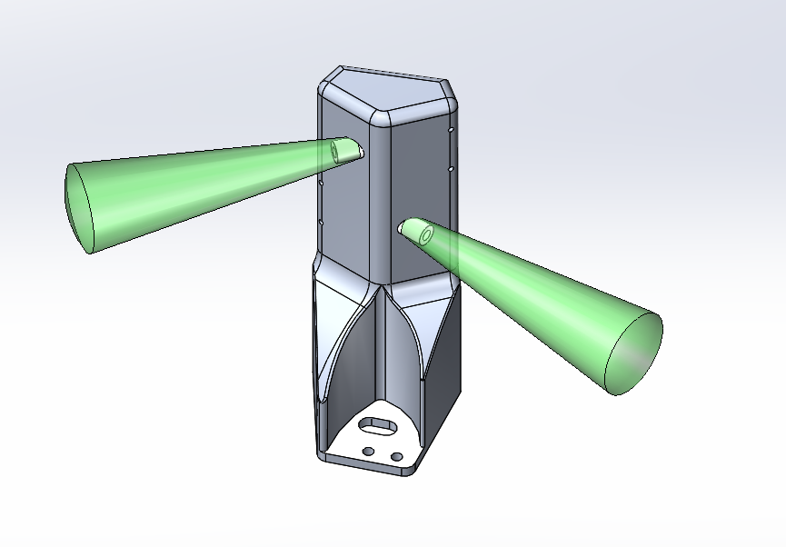

Top Heads (4026-41-0087)

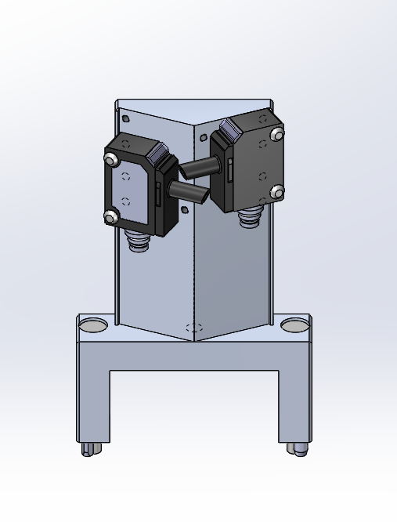

8 Tow heads

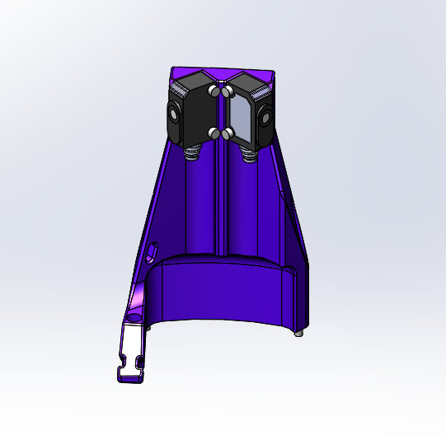

Plan of action:

1. Ask TOP when these diameter sensor errors are occurring
   1. If it is in process, it is unlikely a code error since resetting only happens during manual reset mode
   2. What does the failure look like? Is the diameter fluctuating and if so how long? Is it static over time and just offset?
2. Actionable items
   1. Since 777x has the same cables as TOP (unshielded and ungrounded) maybe a code check between the two projects can help
      1. This assumes that 777x is not seeing any unsolved issues with the diameter sensors
   2. Hopefully it is as simple as uploading new code to the TOP heads, Chris Pauly is currently on site
3. Confirm that there are ultrasonic funnels on the sensors with TOP staff, Chris Connair has already confirmed installing all of the funnels more than a year ago
4. Charles will check the performance of the diameter sensors on the 777X and whether they are being used instead of the brake spoke sensors

Possible resolutions:

1. Assuming that 777X diameter sensor algorithm is different and also working properly, we copy the code
2. Check code for improper filter reset/calibration errors
3. Development of new algorithms to detect signal errors
4. Grounded/Shielded cable replacement
5. Purchase/test alternative sensors

Previous background:

1. BenW has tested resolutions to bad analog signals from the diameter sensors
   1. Overall it seems that they bad signal only lasts a few seconds and is not sustained indefinitely
   2. This is strange since the error that they sometimes observe is an offset, which makes it seem that there is some form of calibration error instead of signal noise
2. It is known that the sync pulse pin on TOP is not grounded, therefore the diameter sensor can be turned on and off when getting data.
   1. Grounding the Pin 2 on the sensor will ensure that it is always reading
   2. The disadvantage is that there is possible interference
   3. If the sensors are simply turning on and off all the time, the cables probably need to be replaced
3. The mechanical configuration of the diameter sensors is identical to H16 EXP (4026). To my knowledge although the raw signal on H16EXP is not great, the filter does a good job at identifying a reasonable diameter reading.