Figure 1

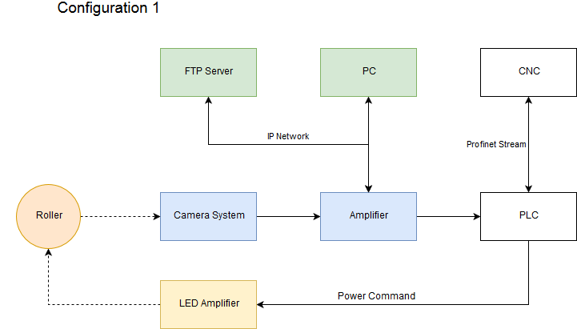

Figure 2

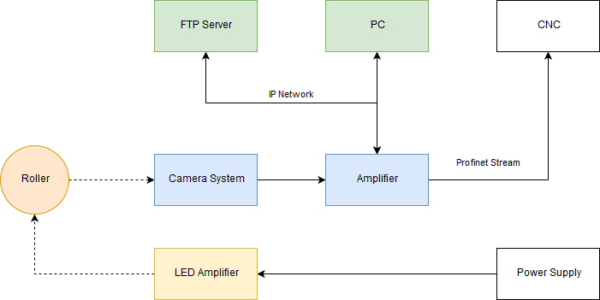

Figure 3

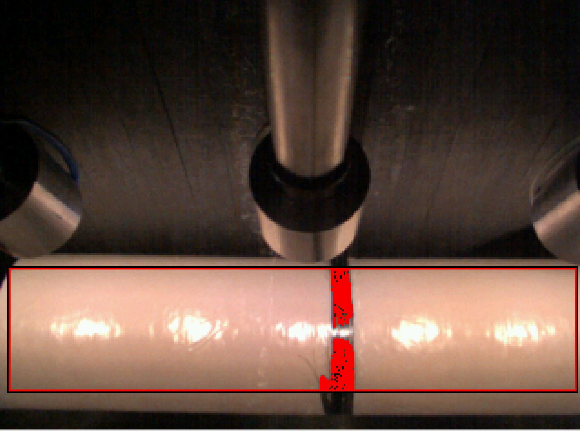

Figure 4

Real system operation

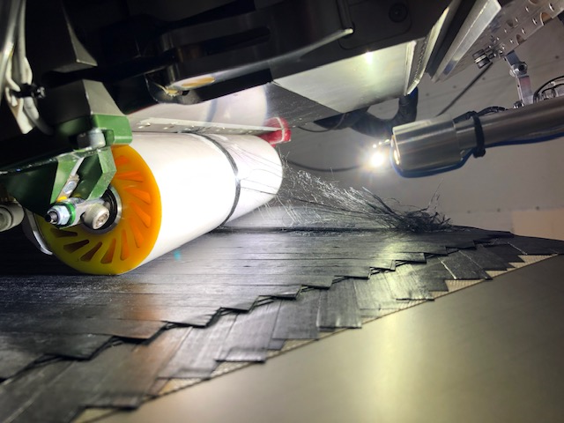

Figure 5

Solidworks figure of the lighting and system

Figure 6

Solidworks figure of the amplifier and camera

Figure 7

Solidworks figure of the system on the head and operational