Software Start-Up Project
Project 2: Hypothesis Validation & MVP Experimentation
CampusPrint - No-Queue Residence/Campus Pickup Printing MVP
Evidence-integrated submission version based on Revised Project 1 v5 Residence Scope Clarification

Team Splendor
Submission note  This evidence-integrated version includes actual Google Form response analysis, MVP evidence figures and the final GitHub repository URL for Project 2 technical documentation. | Name | Email
MCS251008 | LIU RUNKUN | liurunkun@graduate.utm.my
MCS251009 | LUO XI | luoxi@graduate.utm.my
MCS251015 | CHU YANQIAO | chuyanqiao@graduate.utm.my
MCS251036 | FAHIM KAMAL AHMED | kamalahmed@graduate.utm.my
MCS251006 | ZHU TAORUN | zhutaorun@graduate.utm.my

Submission note
This document includes actual Google Form response analysis and evidence figures from the controlled MVP order-flow test. The team should add the final GitHub/GitLab repository URL before submission.

Executive Summary
CampusPrint is a residence/campus-pickup focused printing service concept for UTM KL students who experience long queues, walking distance, USB-related risks and timing pressure when using campus print shops. Project 1 v5 refined the earlier specific-block wording into a safer pilot context: one selected UTM KL residence or nearby student accommodation area, with the exact residence/block name to be confirmed during the pilot test.
Project 2 tests the riskiest assumptions behind this refined model. The MVP is not a full automated platform. It is a concierge-style, low-code MVP where students see a QR poster or WhatsApp message, upload PDF files through Google Form or WhatsApp, review basic black-and-white pricing, show payment proof or payment intent, receive a WhatsApp pickup code, and collect the printed document from a controlled residence/campus pickup point.
The Project 2 learning objective is to determine whether UTM KL students can understand and complete the simulated MVP order-flow, show willingness to submit files online, indicate willingness to reserve or pay, and value no-queue nearby pickup enough to justify a later live Concierge MVP. Evidence was collected through a controlled Google Form MVP order-flow test, payment-intent questions, usability feedback and response-summary analysis.
Important scope correction from Project 1 v5
The Project 2 MVP excludes 24/7 service, door-to-door delivery, color printing, binding, lecturer delivery, club packages, smart lockers, full mobile app and TNG API integration. These remain future scope after the pilot workflow proves demand, willingness to pay and operational feasibility.

Assessment Alignment Checklist
Project 2 required component | Where it is addressed in this report
Part A - Assumption & Hypothesis Extraction | Covered by extracting assumptions from Project 1 v5 BMC, VPC, target scope clarification and MVP risk table.
Part B - Risk Prioritization | Covered by uncertainty-impact-priority mapping focused on simulated order-flow completion, payment intent, online file submission, pickup preference and manual operation.
Part C - Hypothesis Formulation | Covered using precise “We believe that...” hypotheses with metrics and success criteria.
Part D - Experiment Selection & Justification | Covered with selected tools aligned to desirability, feasibility and viability risks; quantity is limited intentionally.
Part E - Experiment Design | Covered with goals, users, procedure, evidence, success/failure indicators and decision logic.
Part F - MVP Development | Covered by low-code MVP architecture, workflow, functional requirements and evidence sections.
Part G - Code Repository & Development Logs | Covered by repository structure, README requirements, daily log table and deliverable checklist.
Part H - Evidence Collection | Covered by evidence chain, actual Google Form response analysis and interpretation tables.
Part I - Learning Analysis & Interpretation | Covered by validation matrix and decision rules for validated, partially validated or invalidated hypotheses.
Part J - Iteration & Improvement | Covered by keep/revise/postpone actions that feed Project 3 UX refinement.
Part K - Technical & Startup Reflection | Covered by technical and startup reflection linked to Project 1 v5 scoping decisions.

1. Project Overview and Continuity from Project 1 v5
Item | Description
Project name | CampusPrint - No-Queue Residence/Campus Pickup Printing MVP
Broader target market | UTM KL students living in the university residence or nearby student accommodation who need to print assignments, lecture notes, forms and study materials.
MVP pilot / beachhead segment | Students in one selected UTM KL residence or residence/student-accommodation cluster, such as the selected UTM KL residence. This keeps the experiment operationally controllable and produces clearer evidence.
Future expansion segments | Other residences/student-accommodation areas, lecturers, staff, student clubs and societies. These are excluded from the Project 2 MVP validation sample.
Core customer problem | Students lose time and experience stress because campus print shops can be crowded, far from residences/student-accommodation areas, limited by operating hours and dependent on USB or staff-operated workflows.
Core MVP feature | Upload a PDF online, receive manual confirmation, and collect basic black-and-white prints from a nearby controlled pickup point without queueing at a campus print shop.
Main learning objective | Validate whether students will use and pay for a faster no-queue residence/campus pickup printing workflow before building an automated system.

2. MVP Scope
The MVP is designed as a learning instrument. It is deliberately smaller than the long-term product vision so that the team can test demand, payment willingness and operational feasibility within a short course timeline.
MVP scope | Deferred scope | Why
Google Form or WhatsApp PDF submission | Native mobile app or full website | A full platform is not needed to test whether students submit files and orders.
Basic black-and-white academic printing | Color printing and binding | These add pricing and operational complexity and were moved to future scope in Project 1 v5.
Static QR payment, payment screenshot, pre-order or payment-intent tracking | TNG API or automated payment gateway integration | Payment willingness can be tested without waiting for API approval.
Manual confirmation and WhatsApp pickup code | Automated WhatsApp Business API | Manual confirmation is sufficient for the first controlled pilot.
Controlled residence/campus pickup point and service window | 24/7 unattended smart-locker pickup | The team must first test peak-period/no-queue demand and operational feasibility.
Post-service feedback survey and evidence logging | Campus-wide launch, lecturer delivery and club bulk packages | The first experiment should test one segment and one core workflow only.

Meaning of “No-Queue”
In this Project 2 report, “no-queue” means users avoid waiting in the campus print-shop queue by submitting files online and collecting prepared documents from a nearby pickup point. It does not mean instant printing, full 24/7 availability or a guaranteed 3-minute pickup.

Part A - Assumption and Hypothesis Extraction
The assumptions below are extracted from the refined Project 1 v5 logic: BMC Version 2, VPC findings, target user scope clarification, revised MVP workflow and future validation metrics. Each assumption is written as a testable risk rather than a fixed truth.
ID | Assumption extracted from Project 1 v5 | Linked hypothesis | Risk type
A1 | Residence students have a real time and convenience pain when using campus print shops. | H1, H4 | Desirability
A2 | Students in the pilot residence will submit real PDF files online when the process is simple and privacy is clear. | H2 | Desirability / feasibility
A3 | Students will place real printing orders, not only say the idea is useful. | H3 | Desirability
A4 | Students will complete the order-to-pickup workflow through a controlled residence/campus pickup point. | H3, H5 | Desirability / feasibility
A5 | Students will show willingness to pay through payment proof, QR payment attempt, pre-order or mock-order/payment-intent action. | H6 | Viability
A6 | The no-queue value proposition is more attractive than the no-USB supporting message for the first segment. | H4 | Desirability / channel
A7 | The team can manually operate order intake, confirmation, printing, pickup and issue tracking within the defined service window. | H7 | Feasibility
A8 | Privacy and trust concerns can be reduced through PDF-only upload, a clear privacy statement and file deletion policy. | H2, H5 | Desirability / trust

Part B - Risk Prioritization
Risks are prioritized by impact and uncertainty. The first testing cycle focuses on high-impact assumptions that can invalidate the business model if they fail.
Risk / assumption | Uncertainty | Impact | Priority | Reason
Students may not complete the simulated order flow or show serious ordering intent. | High | High | Critical | If students do not complete the order-flow test or show reservation/payment intent, positive opinions are not enough to justify building.
Students may not show payment intent or willingness to pay. | High | High | Critical | Viability depends on receiving money or clear payment-intent behavior.
Students may abandon the online file submission flow. | Medium | High | High | PDF upload and form/WhatsApp submission are core MVP steps.
Students may not complete pickup after ordering. | Medium | High | High | Order completion proves the full no-queue value, not just initial interest.
No-queue may not be the strongest message. | Medium | Medium | Medium | Marketing and positioning should be based on conversion evidence.
The team may not operate the manual workflow reliably. | Medium | High | High | Manual errors or delays reduce trust and block future scaling.
Users may worry about file privacy. | Medium | Medium | Medium | Privacy concerns can reduce file submission, especially for official documents.
Students may want color printing or binding. | Medium | Low | Low | These are future features and not required to validate the core B/W academic workflow.
Lecturers, clubs or delivery may be attractive. | Medium | Low for MVP | Low for Project 2 | They are future expansion segments and should not distract from the pilot residence test.

Highest-priority test logic
The first validation cycle should not try to prove every feature. It should answer four binary questions: Will students complete the MVP order-flow? Will they show willingness to submit files online? Will they choose a pickup slot? Will they show willingness to reserve or pay?

Part C - Hypothesis Formulation
The following hypotheses use the “We believe that...” structure and define measurable success criteria. They are deliberately specific to the MVP pilot segment rather than all UTM students.
Code | Hypothesis | Success criteria | Evidence
H1 - Problem intensity | We believe that students in the pilot residence experience meaningful queue, distance or waiting-time pain when using campus print shops. | At least 70% of interviewed/observed target users report or demonstrate queue, distance or waiting-time friction during academic printing. | Interview notes, observation records, queue counts, selected quotes
H2 - Online file submission | We believe that students in the pilot residence will submit real PDF printing files through Google Form or WhatsApp when the process is clear and privacy is explained. | At least 10 valid PDF submissions are received within 7 days, and invalid/incomplete submissions remain below 20%. | Google Form records, WhatsApp screenshots, submission error log
H3 - Order-flow completion | We believe that students will complete the simulated CampusPrint order-flow test during the validation period. | At least 10 completed MVP order-flow responses are collected from UTM KL students within the testing period. | Google Form response records, response-summary charts, order-flow completion table
H4 - Value proposition message | We believe that the no-queue residence/campus pickup message will generate stronger conversion than the no-USB message for the first student segment. | The no-queue advertisement has a higher order conversion rate than the no-USB advertisement. | Ad A/B records, link clicks, inquiries, order conversion table
H5 - Workflow completion | We believe that students will complete the upload-to-pickup workflow because it reduces queueing and walking compared with campus print shops. | At least 70% of valid orders are collected at the pickup point, and users report at least 50% waiting/travel-time reduction compared with their usual process. | Pickup checklist, timestamp log, feedback form
H6 - Willingness to pay | We believe that students will show willingness to pay for no-queue residence/campus pickup printing before we build a full automated system. | At least 60% of valid orders include payment proof, QR payment attempt, mock-order click, pre-order, or deposit-style evidence. | Payment screenshots, QR/payment-intent log, pre-order records
H7 - Manual operational feasibility | We believe that the team can structure a clear manual workflow that could later support a live Concierge MVP. | Participants can understand the form, pickup slot and confirmation logic; the average ease-of-use score is at least 3.5/5. | Usability score, issue log, workflow screenshots
H8 - Satisfaction and repeat potential | We believe that users who complete pickup will be satisfied and show repeat usage potential. | At least 80% of users rate the service 4 or 5 out of 5, and at least 70% say they would use it again during assignment deadlines. | Validation survey, repeat-use question, post-service comments

Part D - Experiment Selection and Justification
The team selects a small number of experiments from the 44 experimentation tools introduced in class. The experiments are chosen because each one matches a specific desirability, feasibility or viability risk. The sequence moves from weaker discovery evidence to stronger behavior evidence.
Experiment | Risk type | Hypotheses | Why this tool is suitable | Evidence produced | Evidence strength
A Day in the Life Observation | Desirability | H1 | Observe real printing queues and user behavior instead of relying only on opinions. | Queue length, waiting time, photos if allowed, observation notes | Medium
Customer Follow-up Interview | Desirability / trust | H1, H2 | Clarifies the most important pain points and privacy concerns for the pilot segment. | Short notes, quotes, pain frequency table | Weak to medium
Online Ad / Smoke Test | Desirability / channel | H4 | Tests whether the value proposition creates real interest before students use the service. | Views, clicks, inquiries, order link visits | Medium
Split Test | Desirability / positioning | H4 | Compares “No Queue” versus “No USB” to decide the strongest first message. | Ad A/B conversion rate | Medium
Usability Test of Order Form | Feasibility / UX | H2, H5 | Checks whether students can complete the form without confusion before the live MVP. | Task completion, time to complete, confusion points | Medium to strong
Wizard-of-Oz / controlled MVP order-flow test | Desirability / feasibility | H2, H3, H5, H7 | Simulates the order workflow through Google Form and manual backend logic without building a full platform or running a live paid printing service. | Completed form responses, file-submission willingness, pickup-slot choices, reservation/payment-intent records, issue logs | Strong
Mock Sale / Payment-Intent Test | Viability | H6 | Tests willingness to pay without automated payment integration. | Payment proof, QR attempt, pre-order, mock-order click | Strong
Validation Survey | Product learning | H8 | Collects satisfaction, repeat-intention and improvement feedback after real service use. | Ratings, repeat-use answer, open comments | Medium to strong

Part E - Experiment Design

E1. A Day in the Life Observation
Item | Design
Goal | Measure actual printing friction during peak periods before the MVP launch.
Participants / setting | Campus print shop users observed between 5 PM and 7 PM, plus walking-time observation from the pilot residence to the print shop.
Procedure | Record queue length every 15 minutes, estimate waiting time, note visible bottlenecks, record walking time from the pilot residence to the shop, and note whether students use USB or staff-assisted printing.
Evidence to collect | Observation sheet, queue count, time records, walking time record, photos only if allowed.
Success / failure indicator | Success if meaningful waiting, distance or workflow friction is observed. Failure if printing access is consistently fast and nearby, weakening the problem statement.

E2. Customer Follow-up Interview
Item | Design
Goal | Confirm which pains matter most for the pilot residence segment and identify trust concerns before live testing.
Participants | 8-12 students from the selected pilot residence or nearby residence/student-accommodation cluster. Lecturers are not part of the core Project 2 sample.
Core questions | How often do you print academic documents? What is frustrating? Would you submit a PDF online? What privacy or payment concern would stop you? Would nearby pickup help you during deadlines?
Evidence to collect | Interview notes, pain ranking, selected quotes, consented screenshots or audio notes.
Success / failure indicator | Success if most participants identify queue, distance, waiting time or file-transfer risk as meaningful. Failure if the problem appears rare or low priority.

E3. Online Ad / Smoke Test and Split Test
Item | Design
Goal | Measure which value proposition attracts more action before or during the MVP.
Ad A | No Queue Printing - Upload your PDF online and collect near your residence or campus pickup point.
Ad B | No USB Needed - Submit your PDF safely through Google Form or WhatsApp.
Channel | Pilot residence WhatsApp group, class group, QR poster near the residence/study area, or Facebook group if available.
Evidence to collect | Views, link clicks, inquiries, form starts, valid submissions, completed orders by ad source.
Success / failure indicator | Success if one message clearly generates higher conversion. If both perform weakly, revise messaging before further scaling.

E4. Usability Test of Order Form
Item | Design
Goal | Check whether a first-time user can complete the order form without help.
Participants | 5 pilot users before launch or during early MVP testing.
Task | Open the QR/order link, upload a PDF, select basic B/W settings, choose pickup time, read privacy/payment instructions, and submit.
Evidence to collect | Task completion, time to complete, error points, skipped fields, user comments.
Success / failure indicator | Success if at least 4/5 users complete the form without help and average completion is under 3 minutes. Failure indicates Project 3 UX refinement needs.

E5. Concierge MVP
Item | Design
Goal | Validate real demand and workflow completion using actual printing orders.
Users | 10-15 students from the selected pilot residence or residence/student-accommodation cluster.
Process | Student reviews MVP concept -> completes Google Form order-flow -> selects B/W print details -> chooses pickup slot -> answers payment/reservation-intent question -> provides usability feedback.
Operating window | Controlled service window, for example 5 PM-9 PM during the test week. The team may adjust but must state the window clearly before launch.
Evidence to collect | Form records, response summary, payment/reservation-intent data, usability score, pickup-slot preference, issue log.
Success / failure indicator | Success if at least 10 valid orders are completed and at least 70% are collected. Failure requires revising the segment, message, pricing or pickup process.

E6. Mock Sale / Payment-Intent Test
Item | Design
Goal | Test business viability without building TNG API or full payment gateway integration.
Payment evidence options | Static TNG QR payment screenshot, QR scan attempt, pre-order, mock-order click, or deposit-style confirmation.
Procedure | Display transparent B/W pricing before confirmation and record whether the user provides proof or takes a payment-intent action.
Evidence to collect | Payment screenshots, mock-order click logs, pre-order sheet, payment-intent column in Google Sheets.
Success / failure indicator | Success if at least 60% of valid orders show payment proof or payment-intent behavior. Failure suggests pricing/value proposition revision.

E7. Validation Survey
Item | Design
Goal | Measure post-use satisfaction, repeat potential and improvement needs.
Participants | Students who completed pickup or attempted to use the service.
Core questions | Satisfaction 1-5, ease of submission 1-5, convenience 1-5, disappointment if service disappeared 1-5, use again yes/no/maybe, acceptable price, improvement suggestion.
Evidence to collect | Survey responses, charts, open comments, repeat-usage intention.
Success / failure indicator | Success if at least 80% rate 4 or 5 and at least 70% indicate repeat-use potential.

Part F - MVP Development
The MVP is a low-code, human-operated service designed to test the value proposition before building automation. The user should experience a clear order flow, while the backend can remain manual for learning.

F1. Core MVP Workflow
- Student sees QR poster or WhatsApp message in the selected residence/class group.
- Student opens Google Form or WhatsApp order link.
- Student uploads PDF only and enters contact, residence/accommodation name, page count, copies and pickup preference.
- Form displays basic black-and-white pricing and privacy note.
- Student provides payment proof or takes a tracked payment-intent / mock-order action.
- Order appears in Google Sheets; team verifies file, payment evidence and pickup slot.
- Team prints the document using manual B/W printing.
- Team labels the order with order ID/pickup code.
- Student receives WhatsApp confirmation and pickup window/code.
- Student collects the printed document at the controlled pickup point.
- Student completes validation survey; team records completion, issue and time-saving metrics.

F2. MVP Components
MVP component | Implementation | Evidence to show
Promotion and acquisition | QR poster, WhatsApp message, Ad A/B copy | Ad screenshots, QR/link click count, group post screenshots
Order intake | Google Form or WhatsApp with PDF upload only | Form screenshot, test submission, actual submission records
Order tracking | Google Sheets order log | Order rows, status updates, timestamps
Payment evidence | Static QR payment, payment screenshot, mock-order click or pre-order tracker | Payment proof/intent column and screenshots
Manual printing | Team prints basic B/W PDF documents | Processing checklist, issue log
Pickup | Controlled residence/campus pickup point, pickup code/window | Pickup completion checklist
Feedback | Google Form validation survey | Survey response charts and comments
Evidence storage | GitHub/GitLab docs folder plus evidence appendix | Repository URL, screenshot folder structure, README file

F3. Google Form Fields
Field | Status | Purpose
Full name / nickname | Required | Order identification
WhatsApp number | Required | Manual confirmation and pickup code
Residence/accommodation name or pickup location | Required | Confirm pilot segment and pickup feasibility
PDF file upload | Required | MVP accepts PDF only
Number of copies and pages | Required | Basic B/W price estimate
Basic B/W print setting | Required | Color printing and binding are excluded from MVP
Pickup time preference | Required | Controlled pickup window
Payment proof or payment-intent option | Required for experiment tracking | Tests viability without payment gateway API
Privacy consent | Required | User agrees that files are used only for printing and deleted after completion
How did you hear about us? | Optional | Links orders to Ad A/B or QR poster source

F4. Functional and Non-Functional Requirements
ID | Requirement | Acceptance condition
FR1 | The order form must collect WhatsApp contact, PDF file, basic B/W settings, pickup preference and privacy consent. | Each valid submission creates one complete order row.
FR2 | The MVP must support PDF upload only. | Non-PDF files are rejected or users are asked to convert to PDF.
FR3 | The payment step must record payment proof or payment intent. | Each valid order has a payment proof, QR attempt, mock-order click or pre-order status.
FR4 | The team must send WhatsApp confirmation and pickup code. | Each accepted order receives order ID and pickup instruction.
FR5 | The team must track order status. | Every order has a status: received, verified, printing, ready, collected, cancelled, or issue.
NFR1 | The order flow should be usable by first-time users. | At least 4/5 usability test users complete the form without help.
NFR2 | The MVP must protect user files. | Files are accessed only for printing and deleted after completion.
NFR3 | The operation must be auditable. | Order time, confirmation time, pickup time, issue and feedback are recorded.

Part G - Code Repository and Development Logs
Although the MVP is low-code, a GitHub or GitLab repository is still required to show technical organization, experiment transparency and development progress. The repository should not be empty; it should include the prototype/landing page, README, screenshots and testing documents.
Repository URL: https://github.com/luox62620-crypto/campusprint-mvp-validation
The repository is used as the technical evidence space for README documentation, experiment plan, Google Form screenshots, anonymized evidence analysis, Project 2 report files and optional prototype/landing-page assets.
Repository item | Required content
Repository URL | https://github.com/luox62620-crypto/campusprint-mvp-validation
README.md | Project description, team members, MVP scope, testing workflow, how to access the form/prototype.
/prototype or index.html | Simple landing page or prototype page with value proposition and order link.
/forms | Google Form screenshots, form field design, privacy statement.
/ads | Ad A/B images and message copy.
/docs | Experiment plan, interview questions, observation sheet, validation survey, risk plan.
/logs | Daily development and testing logs.
/evidence | Final screenshots and anonymized order/survey evidence for submission.
/analysis | Spreadsheet exports, charts, hypothesis interpretation and decision tables.

Development Log Template
Day | Development / testing activity | Output / evidence | Responsible role
Day 1 | Finalize Project 2 hypotheses, MVP scope and operating window. | Hypothesis table, workflow diagram, service-window decision. | All members
Day 2 | Create Google Form, privacy note and Google Sheets order log. | Form screenshot, test submission, order sheet. | Technical + operations members
Day 3 | Prepare Ad A/B and QR poster. | No-queue and no-USB ad screenshots. | Marketing/research members
Day 4 | Run usability test and internal order simulation. | Usability notes, issue list, corrected form fields. | All members
Day 5 | Launch Concierge MVP in the pilot residence. | Order records, payment-intent records, pickup plan. | Operations members
Day 6 | Continue MVP, run split test and collect survey responses. | Ad conversion table, survey charts, pickup records. | Research + operations members
Day 7 | Analyze evidence and write final learning/iteration decisions. | Hypothesis validation table, iteration table, Project 3 UX issues. | All members

Part H - Evidence Collection
The team conducted a controlled MVP order-flow test using Google Form. A total of 12 completed responses were collected. The test did not operate a full live printing service. Instead, it simulated the core CampusPrint workflow: consent, participant classification, online file-submission willingness, black-and-white print details, pickup slot selection, payment/reservation intent, and usability feedback.
This evidence should therefore be interpreted as simulated workflow-completion and payment-intent evidence, not as live printing or actual paid-order evidence. It is still useful for Project 2 because it directly tests whether users can understand the order flow, show interest in online submission, choose a pickup slot, and indicate willingness to reserve or pay before a full system is built.
Table H1. Evidence Result and Validation Summary
Evidence item | Target | Actual result | Validation status | Interpretation
Completed MVP order-flow responses | 5-8 responses | 12 completed responses | Validated | The minimum response target was exceeded, showing enough early evidence for a controlled MVP test.
Residence / nearby accommodation sample | Majority of responses from residence / nearby users | 8/12 = 66.7% | Validated | Most responses came from the intended pilot context. Non-residence responses are treated as supporting evidence.
Online file submission willingness | >=70% Yes or Maybe | 12/12 Yes or Maybe; 9/12 Yes = 75.0% | Validated | Users did not reject online file submission, but privacy concerns remain important.
Payment / reservation intent | >=60% Yes or Maybe | 12/12 Yes or Maybe; 9/12 Yes = 75.0% | Validated | The test provides payment-intent evidence without requiring real payment gateway integration.
Mock reservation action | >=60% would reserve | 11/12 = 91.7% would click Reserve Slot | Validated | Most participants were willing to take a reservation-style action.
Ease of order-flow test | Average >=4/5 or >=70% rating 4-5 | Average 3.75/5; 7/12 = 58.3% rating 4-5 | Partially validated | The flow is understandable, but not yet smooth enough. The prototype should be simplified.
Deadline usage potential | >=70% Yes or Maybe | 12/12 Yes or Maybe; 8/12 Yes = 66.7% | Validated for deadline use | Users see value during assignment deadlines, but daily usage still needs further testing.
Product attachment / disappointment | >=80% rating 4 or 5 | 7/12 = 58.3% rating 4 or 5 | Not fully validated | The idea has interest, but emotional attachment is not strong enough yet.
Key user concerns | Identify top blockers | File privacy 7/12; pickup reliability 7/12; price concern 5/12 | Actionable findings | These concerns directly inform Project 3 UX refinement and next MVP iteration.
Pickup slot preference | Identify realistic operating window | 5:00-6:00 PM selected by 5/12 | Validated direction | A fixed pickup window is more realistic than 24/7 or instant pickup at this stage.
Table H2. Evidence Categories and Appendix Locations
Evidence category | What was collected | Appendix location | Status
Google Form MVP tool | Form overview, consent, order-flow, payment-intent sections | Appendix H | Completed - documented with form evidence figures
Response summary | 12 completed Google Form responses and summary charts | Appendix H | Completed
MVP usage evidence | Form completion, online submission willingness, pickup-slot selection | Part H and Appendix H | Completed
Payment-intent evidence | Willingness to pay/reserve and mock reserve-slot action | Part H and Appendix H | Completed
Usability evidence | Ease score and open-ended improvement comments | Part I and Part J | Completed
Issue evidence | Privacy, pickup reliability, price and upload concerns | Part J | Completed
Real printing order evidence | Actual paid orders and physical pickup records | Future test cycle | Not collected in this controlled simulation

Part I - Learning Analysis and Interpretation
The findings were interpreted using the Project 2 hypothesis-validation logic. Each hypothesis is classified as validated, partially validated, or not fully validated based on the actual Google Form evidence. The team did not treat positive opinions alone as strong evidence; the analysis focuses on completed form actions, payment/reservation intent, and usability feedback.
Table I1. Hypothesis Validation Analysis
Hypothesis | Evidence used | Result | Interpretation | Decision
H1: We believe that UTM KL students have printing pain related to distance, queues, or convenience. | Pain-point question | Walking/distance 6/12; long queue 3/12 | Validated | Keep no-queue nearby residence/campus pickup as the main value proposition.
H2: We believe that students are willing to submit files online. | Online submission question | 9/12 Yes; 3/12 Maybe; 0 No | Validated | Keep online file submission as the core MVP workflow, but improve trust wording.
H3: We believe that users will complete the MVP order-flow simulation. | Completed Google Form responses | 12 completed responses | Validated for simulated MVP | Use this as workflow-completion evidence, not as real paid order evidence.
H4: We believe that the order flow is easy enough to use. | Ease score | Average 3.75/5; 7/12 rated 4 or 5 | Partially validated | Simplify the next prototype into a clearer 3-step flow.
H5: We believe that students show willingness to pay or reserve. | Payment intent and mock reserve question | 9/12 Yes to pay/reserve; 11/12 would click Reserve Slot | Validated | Keep payment intent as viability evidence; avoid full payment gateway for now.
H6: We believe that deadline-period usage potential exists. | Deadline usage and disappointment score | 12/12 Yes or Maybe for deadlines; 7/12 high disappointment score | Partially validated | Position CampusPrint around deadline and urgent academic printing first.
H7: We believe that fixed pickup windows are more realistic than 24/7 service. | Pickup-slot choice | 5:00-6:00 PM was the most selected slot | Validated | Use fixed pickup windows instead of 24/7 or 3-minute pickup promises.
Overall learning: the MVP test supports the core direction of online submission plus nearby residence/campus pickup. However, the team should not claim that live printing demand or real payment behavior has been fully validated yet. The current evidence validates interest, workflow completion, reservation intent, and UX issues. A later Concierge MVP can test actual paid orders and physical pickup completion.

Part J - Iteration and Improvement
The MVP should now be refined based on the response data. The changes below are evidence-based and should be carried into Project 3 UX refinement, especially the before-after wireframes and clickable prototype.
Table J1. Evidence-Based MVP and Prototype Iteration Decisions
Finding / issue | Evidence source | Decision | Prototype / MVP change | Status
File privacy is a major blocker. | 7/12 selected file privacy concern. | Revise | Add a clear privacy statement before upload: files are used only for printing and deleted after completion. | Use in Project 3
Pickup reliability is a major concern. | 7/12 selected pickup reliability concern. | Revise | Add order status steps: Submitted, Confirmed, Ready for Pickup, Collected. | Use in Project 3
Price concern affects adoption. | 5/12 selected price concern; comments requested reasonable pricing. | Revise | Show estimated total price before the reserve action. | Use in Project 3
The order flow is not yet smooth enough. | Average ease score 3.75/5. | Revise | Simplify the user journey into three steps: Upload File -> Print Details & Price -> Pickup/Reserve Confirmation. | Use in Project 3
Fixed pickup slots are more realistic than 24/7. | 5:00-6:00 PM was the most selected slot. | Keep / refine | Use selected pickup windows instead of 24/7 or instant pickup promises. | Keep
Black-and-white printing should remain the MVP scope. | MVP scope and feedback; color requests are future needs only. | Keep / postpone | Keep B/W only in the MVP and move color printing/binding to future scope. | Keep
The MVP is a controlled simulation, not a full service. | No actual paid orders or physical pickup were executed in this validation cycle. | Clarify | State clearly that the current test validates order-flow behavior and payment intent, while actual paid orders require a later Concierge MVP. | Completed
Decision summary: CampusPrint should continue with a focused residence/campus pickup MVP, but the next prototype must improve privacy assurance, pickup status visibility, pricing transparency, and step-by-step clarity. These changes provide a direct input for Project 3 UX refinement.

Part K - Technical and Startup Reflection

Technical Reflection
The CampusPrint Project 2 MVP intentionally uses Google Form, Google Sheets, WhatsApp, static QR/payment-intent evidence and manual workflow tracking instead of a full software platform. This technical decision is appropriate because the key uncertainty is not whether a printing app can be built. The current validation cycle focuses on whether students understand the workflow, show willingness to submit files, indicate willingness to reserve/pay, and find the nearby pickup concept useful.
The technical learning focus is therefore workflow reliability. Even with a manual backend, the user-facing process must be structured: PDF-only upload, clear B/W pricing, privacy consent, payment proof or payment-intent capture, pickup code and order status. The most important technical artifact is not only code, but the evidence infrastructure: order logs, timestamps, issue logs, screenshots, survey charts and repository documentation.
Future technical development should only follow validated learning. If a later live Concierge MVP achieves actual paid orders and pickup completion, the next technical layer can include a secure web ordering page, temporary file storage, automated status notification, automated payment integration, admin dashboard and eventually controlled pickup hardware. If demand is weak, the team should revise the segment or value proposition before building more software.

Startup Reflection
Project 1 v5 corrected the original risk of overbuilding. The original idea mixed many features: 24/7 printing, smart lockers, color printing, binding, delivery, lecturers, clubs, TNG API and campus-wide deployment. Project 2 now follows a more disciplined startup logic: test one core workflow with one pilot segment before expanding.
The most important startup learning is that positive opinions are not enough. The MVP must generate stronger evidence: real file submissions, completed orders, payment proof or payment-intent behavior, pickup completion, user satisfaction and repeat-use intention. These behaviors are more useful than asking whether students “like” the idea.
If the MVP succeeds, CampusPrint can move toward Project 3 by refining the user flow, improving the order form, clarifying pickup instructions, strengthening the privacy/payment screens and preparing a clickable prototype. If it fails, the team can pivot quickly by changing the pilot segment, price, service window, message or pickup process before wasting time on a large system.

7-Day MVP Testing Timeline
Day | Main activity | Expected output
Monday | Finalize hypotheses, service window, Google Form, payment-intent method and evidence checklist. | MVP workflow, form draft, payment-intent tracker.
Tuesday | Run pilot-residence follow-up interviews and form usability test. | Interview notes, usability issues, revised form.
Wednesday | Run A Day in the Life observation and launch Ad A/B smoke test. | Observation sheet, QR/link clicks, inquiries.
Thursday | Launch controlled MVP order-flow test and collect first responses. | Google Form response records, payment-intent evidence, usability notes.
Friday | Continue Concierge MVP and compare no-queue vs no-USB conversion. | Ad conversion table and updated order log.
Saturday | Collect validation survey and complete pickup/issue analysis. | Survey charts, issue log, completion rate.
Sunday | Interpret hypotheses, write learning analysis and prepare Project 3 UX refinement inputs. | Validated/invalidated table, iteration plan, evidence appendix.

Risk Mitigation Plan
Risk | Impact | Mitigation action
Low order volume | Weak demand evidence. | Improve QR/poster message, increase pilot residence exposure, extend test period, or test another residence/student-accommodation cluster.
Low payment intent | Business viability remains uncertain. | Test lower price point, clearer benefit, bundle pricing, or stronger no-queue deadline message.
File privacy concern | Students may not upload documents. | Add privacy notice, PDF-only rule, deletion policy, restricted file access and optional test file first.
Pickup confusion | Orders may not be collected. | Send clear pickup code, map/photo instruction, reminder message and fixed pickup slots.
Printing delay or wrong order | Trust decreases and satisfaction drops. | Use accepted-order limit, status tracker, operator checklist and redo/refund policy.
Weak ad performance | Value proposition may be unclear. | Test shorter headline, deadline-focused copy, no-queue vs no-USB message, and poster position.
Unclear 24/7 demand | Team may overpromise. | Only test defined service windows first; future 24/7 requires separate evidence.
Requests for color/binding/delivery | Scope creep. | Record as future demand but do not add during Project 2 MVP.

Conclusion
This Project 2 report translates Revised Project 1 v5 into a focused evidence-driven validation plan. The report avoids the earlier contradiction of trying to test a campus-wide, 24/7, feature-heavy printing platform. Instead, it tests the smallest meaningful workflow: online PDF submission intention, payment/reservation intent, basic B/W printing preference, pickup-slot selection and controlled residence/campus pickup.
The strongest evidence in this validation cycle comes from actual user behavior inside the MVP test: completed form responses, file-submission willingness, reservation/payment intent, pickup-slot selection and repeat-use intention. These results will determine whether CampusPrint should proceed to a later live Concierge MVP, revise the workflow, or pivot. They also provide evidence for Project 3 UX iteration and the final pitch/demo.

Appendices - Evidence Instruments and Supporting Materials

Appendix A - Pilot User Interview Questions
- How often do you print academic documents such as assignments, notes, reports or thesis materials?
- Where do you usually print, and how long does the whole process usually take?
- What is the most frustrating part: queueing, walking distance, shop hours, USB/file transfer, pricing or something else?
- Would you submit a PDF through Google Form or WhatsApp if the privacy process is clear?
- Would you prefer residence/campus pickup during deadline periods?
- What price would feel acceptable for basic B/W residence/campus pickup printing?
- What concern would stop you from using this MVP?
- Would you use this service again if the first order worked well? Why or why not?

Appendix B - Observation Sheet Template
Time slot | Queue length | Estimated waiting time | Observed issue | Notes
5:00-5:15 PM
5:15-5:30 PM
5:30-5:45 PM
5:45-6:00 PM
6:00-6:15 PM
6:15-6:30 PM
6:30-6:45 PM
6:45-7:00 PM

Appendix C - Ad Copy Instruments
Ad version | Draft message
Ad A - No Queue | Deadline printing? Upload your PDF online and collect near your residence or campus pickup point. No campus print-shop queue.
Ad B - No USB | No USB needed. Submit your PDF safely through Google Form or WhatsApp and collect your print near your residence or campus pickup point.

Appendix D - Order Log Template
Order ID | Time received | User code | Pages/copies | Payment proof/intent | Status | Pickup time | Issue
CP-001
CP-002
CP-003

Appendix E - Validation Survey Questions
- How satisfied are you with CampusPrint? (1-5)
- How easy was it to submit your PDF? (1-5)
- How convenient was the pickup point? (1-5)
- How much time did this save compared with your usual printing process?
- How disappointed would you be if this service disappeared tomorrow? (1-5)
- Would you use CampusPrint again during assignment deadlines? (Yes/No/Maybe)
- Would you recommend CampusPrint to a friend? (Yes/No/Maybe)
- What price would be acceptable for this service?
- What was the best part of the service?
- What should be improved in the next version?
- Did you have any privacy, payment or trust concerns?

Appendix F - Privacy Statement Instrument
Privacy statement for MVP order form
Uploaded files will only be used for printing your order during the MVP test. Files will be accessed only by the team member processing the order and will be deleted after order completion or at the end of the test period. Please do not upload highly sensitive documents if you are uncomfortable with manual handling during the MVP stage.

Appendix G - Evidence Insertion Checklist
Evidence item | Completed? | Appendix / folder location
Observation records | Not executed in this minimum validation cycle | Appendix B provides the observation template; current actual evidence comes from Google Form order-flow testing.
Pilot interview notes | Background evidence only | Project 1 interview evidence informed the MVP scope; Project 2 actual evidence is the Google Form MVP test.
Ad A/B screenshots and performance | Instrument prepared; not executed as actual A/B test | Appendix C contains draft ad copy. No ad performance data was claimed in Part H.
Usability test notes | Completed | Part H / Part I / Part J; usability evidence from ease score, user concerns and open-ended improvement comments.
Google Form screenshots and submissions | Completed | Appendix H; repository folder evidence/screenshots and evidence/data.
WhatsApp order screenshots | Not used in this controlled test | The MVP test used Google Form rather than WhatsApp order screenshots to avoid claiming live printing orders.
Payment proof or payment-intent records | Completed as payment-intent evidence | Part H; repository folder evidence/data; no real payment collection was claimed.
Pickup checklist and issue log | Simulated only | Pickup slot preference and pickup reliability concern captured in Part H; physical pickup checklist deferred to next Concierge MVP cycle.
Validation survey charts | Completed | Appendix H Figure H5; repository folder evidence/screenshots and evidence/data.
GitHub/GitLab repository link | Completed | https://github.com/luox62620-crypto/campusprint-mvp-validation
This checklist distinguishes completed Google Form MVP evidence from tools/templates that were prepared but not executed during the minimum validation cycle.

Appendix H - Google Form MVP Test Evidence Figures
The following figures document the Google Form MVP order-flow test and summarize the actual response data collected from 12 participants. Figures H1-H4 show the form sections used for the controlled MVP test. Figure H5 summarizes the Google Form response data used in Part H, Part I, and Part J.
Figure H1. Google Form MVP test overview.
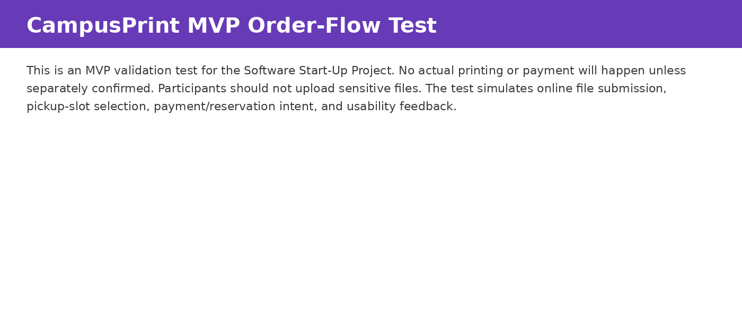

Figure H2. Consent question used before the MVP order-flow test.
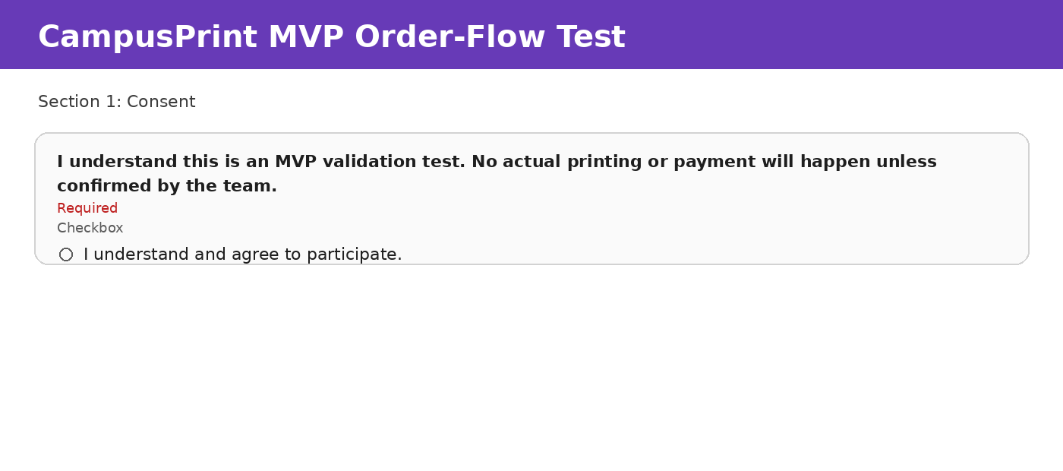

Figure H3. Simulated order-flow questions: participant type, online file submission, B/W print details, and pickup slot.
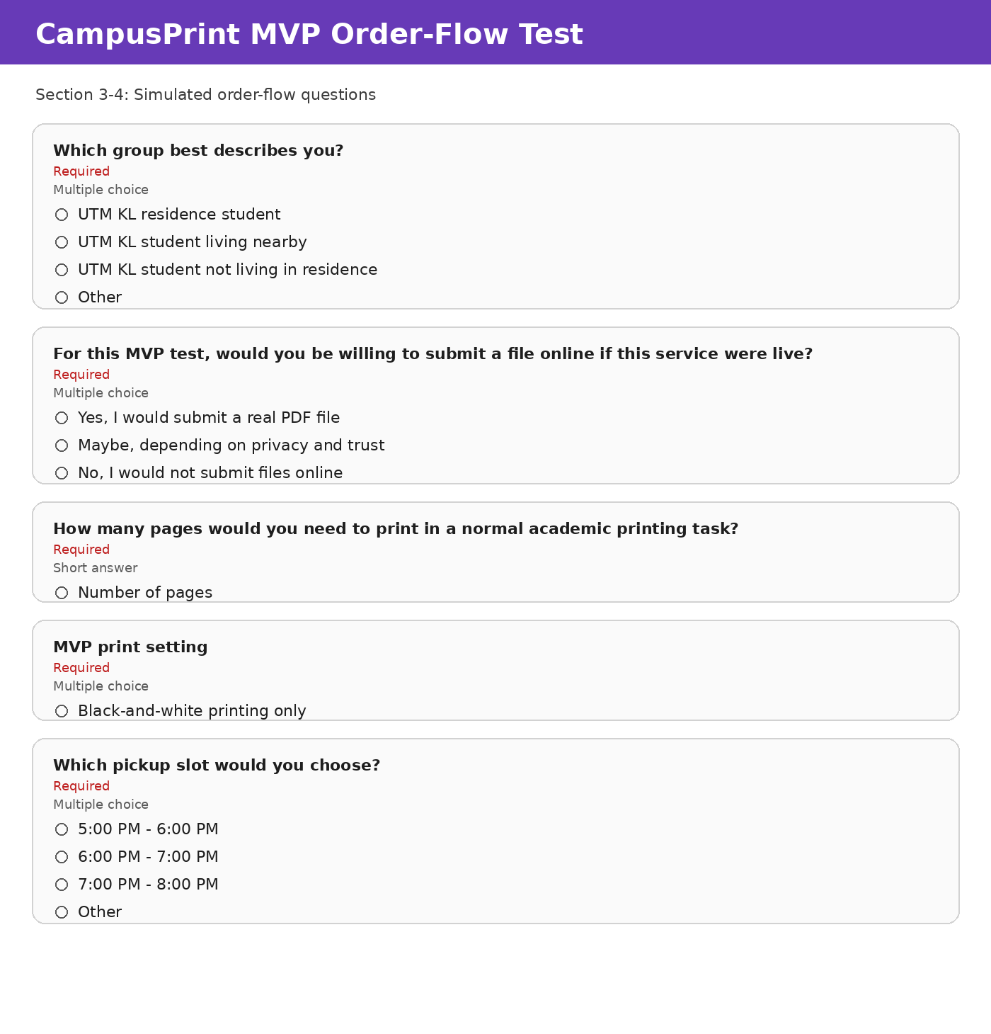

Figure H4. Payment and reservation-intent questions.
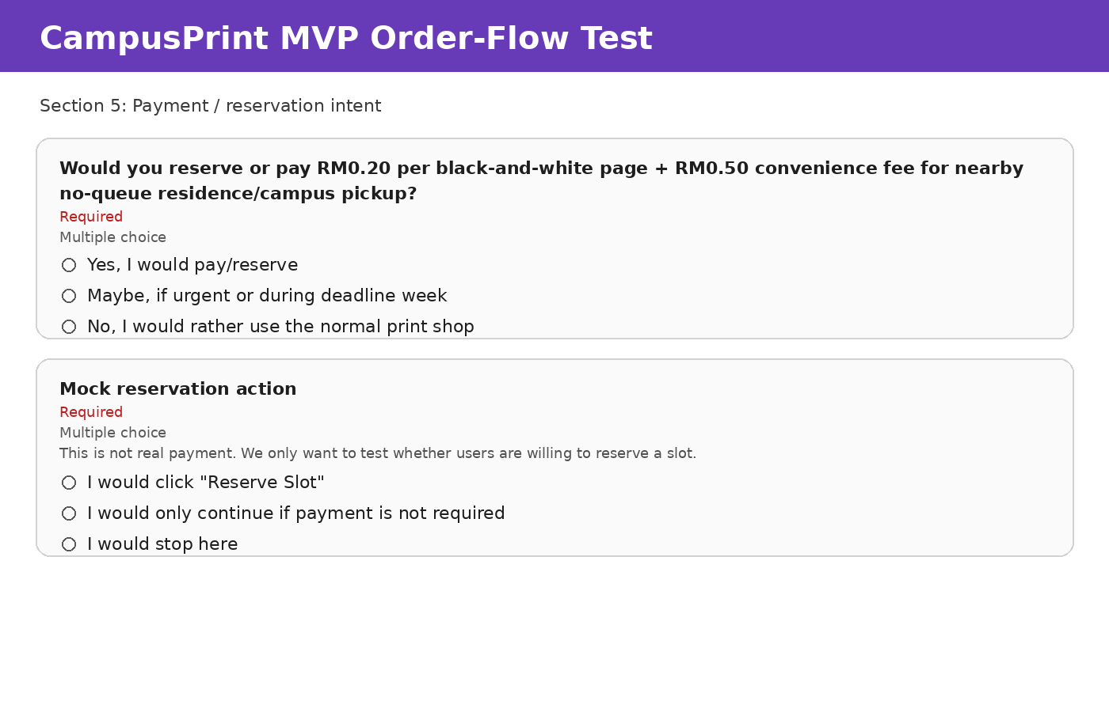

Figure H5. Google Form response summary generated from the CSV responses.
