记录some

是

终于搞定了resharper

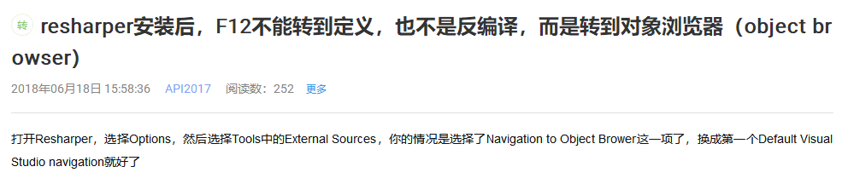

[http://localhost:3410/Image/Viewer?DicomDirPath=E:\work\ct-dhw\DICOMDIR](http://localhost:3410/Image/Viewer?DicomDirPath=E:/work/ct-dhw/DICOMDIR)

1. 访问：http://localhost:3410/Image/Viewer?DicomDirPath=E:\work\ct-dhw\DICOMDIR
2. 过滤器验证[TokenAuthentication]

是

综合点：

1. @Styles.Render("~/Front/style/ImageStyle")调用css
2. @Scripts.Render("~/bundles/ImageViewer")