云归档处理问题：

1.

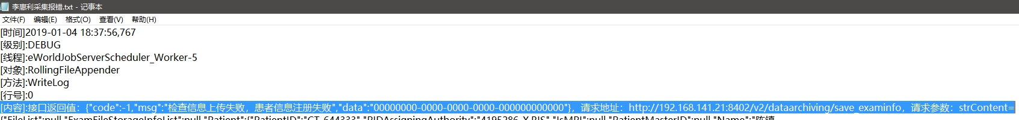

入参：

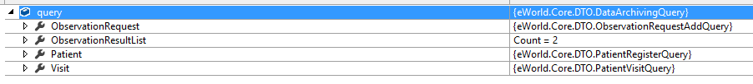

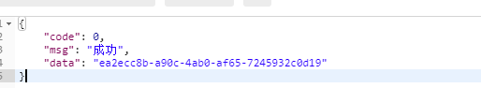

{

"code": 0,

"msg": "成功",

"data": "ea2ecc8b-a90c-4ab0-af65-7245932c0d19"

}

找到错误原因了。是JobServer（采集服务）出错了。

2.

[时间]2019-01-04 18:37:56,767

[级别]:DEBUG

[线程]:eWorldJobServerScheduler_Worker-5

[对象]:RollingFileAppender

[方法]:WriteLog

[行号]:0

调用接口的方法后，记录：

string strOrganizationID = info.ObservationRequest.OrganizationID;

string webApiUrl = AppConfig.WebApiUrl() + "/v2/dataarchiving/save_examinfo";

string strContent = JsonConvert.SerializeObject(info);

var auth = GetAuth();

string userToken = string.Format("{0} {1}", auth.token_type, auth.access_token);

string value = HttpHelper.Post(webApiUrl, strContent, userToken);

logger.Debug(LogType.CommLog, string.Format("接口返回值：{0}，请求地址：{1}，请求参数：strContent={2}", value, webApiUrl, strContent));

[内容]:接口返回值：{"code":-1,"msg":"检查信息上传失败，患者信息注册失败","data":"00000000-0000-0000-0000-000000000000"}，请求地址：http://192.168.141.21:8402/v2/dataarchiving/save_examinfo，请求参数：strContent={"FileList":null,"ExamFileStorageInfoList":null,"Patient":{"PatientID":"CT-644333","PIDAssigningAuthority":"4195286-X.RIS","IsMPI":null,"PatientMasterID":null,"Name":"陈镇棠","NameSpell":null,"MotherName":null,"Sex":"男","BirthDate":"","BirthPlace":null,"Nation":null,"Citizenship":null,"MaritalStatus":null,"IDCardNO":"未带","HealthCardNO":null,"ContactPhoneNO":"","HomePhoneNO":null,"BusinessPhoneNO":null,"Email":null,"AddressProvince":null,"AddressCity":null,"AddressDistrict":null,"AddressStreet":null,"AddressRoad":null,"AddressDetail":"宁波鄞州石器镇陈横楼工业区","Postalcode":null,"Occupation":null,"WorkUnit":"","Language":null,"InsuranceType":null,"InsuranceID":"","CreateUserID":null,"CreateUserName":null,"CreateOrgnizationID":"4195286-X","InHospitalFlag":null},"Visit":{"VisitID":"","AssigningAuthority":"4195286-X.RIS","PatientID":null,"PIDAssigningAuthority":null,"OrganizationID":"4195286-X","PatientClass":"住院","PatientType":"","MedRecNO":"28253114","OutPatientNO":"","InPatientNO":"201854346","CardType":null,"CardNO":"","Age":"55","AgeUnit":"岁","PregnancyFlag":"3","Occupation":null,"AdmitDate":null,"ReAmissionFlag":null,"AdmissionType":null,"AdmitPatCondition":null,"AdmitDeptID":null,"AdmitDeptName":null,"DeptID":null,"DeptName":null,"PointOfCare":"","PointOfCareID":null,"Room":null,"Bed":"急诊病房-02026","AdmittingDoctorID":null,"AdmittingDoctorName":null,"AttendingDoctorID":null,"AttendingDoctorName":null,"DirectorDoctorID":null,"DirectorDoctorName":null,"CurPatCondition":null,"NursingGrade":null,"DietType":null,"PrimaryDiagnosis":null,"DischargeDate":null,"DischargeDisposition":null,"TotalCharges":null,"TotalPayments":null,"PaymentMode":null,"MedicalPaymentMode":null,"PatientMasterID":null,"HasPacemaker":null},"ObservationRequest":{"ImageViewUrl":null,"EWorldViewUrl":null,"ObservationUID":null,"CollectionMark":null,"PatientID":"CT-644333","PIDAssigningAuthority":null,"PatientMasterID":null,"PatientClass":"住院","OrderUID":null,"OrganizationID":"4195286-X","OrganizationName":"宁波市医疗中心李惠利医院","ClinicInfoType":null,"PlacerOrderNO":"Z002018121802110.2.1","PlacerAssigningAuthority":null,"PlacerOrderDetailNO":null,"FillerOrderNO":"2988739","FillerAssigningAuthority":"4195286-X.RIS","FillerPatientID":null,"AccessionNumber":"2988739","ServiceID":"","ServiceCodeScheme":null,"ServiceText":"常规CT","ServiceSectID":"CT","ProcedureID":"","ProcedureName":"盆腔平扫|上下腹平扫","ProviderID":"","ProviderName":"应泽亮","ProviderPhone":null,"RequestDeptID":"","RequestDeptName":"急诊病房","RequestedDate":null,"ResultOrganizationID":null,"ResultServiceCenterUID":null,"Reason":null,"Attention":"","Symptom":"","AdverseReaction":"","ClinicDiagnosis":"外伤证","RelevantClinicalInfo":"高处坠落伤10小时\r\n体检","FastingFlag":null,"TransportationMode":null,"SpecimenID":"","SpecimenName":null,"SpecimenType":null,"SpecimenSource":null,"CollectorID":null,"CollectorName":null,"CollectionDept":null,"CollectionMethod":null,"CollectionVolume":null,"SpecimenReceivedDate":null,"ResultStatus":"审核完成","ResultStatusCode":null,"RegTime":"2018-12-19T08:02:15","RegisterID":"","RegisterName":"周艳","ObservationDeptID":null,"ObservationDeptName":null,"ObservationDate":"2018-12-19T08:22:58","ObservationEndDate":null,"ObservationLocation":"","ObservationEquipmentID":"","ObservationEquipment":"","ObservationMethod":"","StudyInstanceUID":null,"TechnicianID":"","TechnicianName":"马军","ResultPrincipalID":"","ResultPrincipalName":"董海波","ResultReviseID":"","ResultReviseName":"","ResultAssistantID":"","ResultAssistantName":"赵亦军/杨姣娜","ResultAssistantPhone":null,"PreliminaryDate":"2018-12-19T14:45:03","AuditDate":"2018-12-19T15:47:48","ReviseDate":null,"ResultDate":"2018-12-19T14:45:03","AbnormalFlags":"阳性","CriticalValue":"","ResultPrintCount":null,"InfectionName":"","Charges":null,"Payments":null,"PaymentsFlag":null,"FilmCount":null,"FilmNeed":null,"HasImage":null,"ImageLocation":null,"ConsultStatus":null,"ConsultRequestDate":null,"ConsultEndDate":null,"ResultPrintTime":null,"ServiceIDInsur":null,"EquipmentModel":null,"PrivacyLevel":0,"PrivacyLevelExt":null,"RequestOrgName":"宁波市医疗中心李惠利医院","RequestOrgID":null,"LastUpdateDate":null,"DataSource":"RIS","DataSourceName":"放射科","ScheduleSeq":null,"ScheduleID":null,"ScheduleResourceUID":null,"ScheduleResourceName":null,"ScheduleStartDate":null,"ScheduleEndDate":null,"ScheduleNotice":null,"ScheduleOperatorID":null,"ScheduleOperatorName":null,"ReceiptPrintCount":null,"ReceiptPrintTime":null,"ScheduleStatus":null,"LockFlag":null,"LockReason":null,"LockUserUID":null,"InWritingUserUID":null,"MessageCount":0,"UnProcessWorkflowCount":null,"PushState":false,"DeleteFlag":null,"RowTimestamp":null,"DiskSpace":null,"IsSummary":null,"SourceOrganizationID":"4195286-X","SourceOrganizationName":"宁波市医疗中心李惠利医院","ReloadLastUpdateTime":null,"VisitUID":null,"RequestUserUID":null,"RequestUserID":null,"RequestUserName":null,"RequestTimestamp":null,"RequestToken":null,"UserKind":null,"ClientKind":null,"recordLog":null,"ClientHost":null},"ObservationSchedule":null,"ObservationResultList":[{"ResultSeq":null,"ObservationUID":null,"SetID":1,"ObservationID":"GDT","ObservationCodeScheme":null,"ObservationText":null,"SubID":null,"ValueTitle":"影像所见","ValueType":null,"ValueText":" 肝脏密度普遍减低，CT值约为24HU。肝内未见异常密度灶，表面光滑，肝叶比例协调，肝裂不宽, 肝内外胆管无扩张。胆囊不大，壁不厚，内未见高密度灶，胰腺大小形态未见异常。脾不大，质均匀。腹膜后未见肿大淋巴结。双肾大小形态未见异常，右肾内见点状高密度影。\r\n 盆腔区组织密度正常，肠道走行自然，密度无殊，周边组织分界尚清。前列腺及精囊形态、密度正常。膀胱充盈差。盆腔各组肌肉形态密度正常。盆腔未见明显肿大淋巴结影。\r\n","ValueCode":null,"ValueCodeSystem":null,"ValueUnits":null,"ResultStatus":null,"ResultStatusCode":null,"ReferencesRange":null,"AbnormalFlags":null,"ObservationMethod":null,"ObservationDate":null,"PreliminaryDate":"2018-12-19T14:45:03","AuditDate":"2018-12-19T15:47:48","ResultPrincipalID":"","ResultPrincipalName":"董海波","ResultAssistantID":"","ResultAssistantName":"赵亦军/杨姣娜","LowerLimit":null,"UpperLimit":null,"ParentResultSeq":null,"ParentObservationID":null,"Memo":null,"LastUpdateDate":null,"DeleteFlag":null,"RequestUserUID":null,"RequestUserID":null,"RequestUserName":null,"RequestTimestamp":null,"RequestToken":null,"UserKind":null,"ClientKind":null,"recordLog":null,"ClientHost":null},{"ResultSeq":null,"ObservationUID":null,"SetID":2,"ObservationID":"IMP","ObservationCodeScheme":null,"ObservationText":null,"SubID":null,"ValueTitle":"影像诊断","ValueType":null,"ValueText":" 重度脂肪肝。\r\n 右肾微小结石。\r\n","ValueCode":null,"ValueCodeSystem":null,"ValueUnits":null,"ResultStatus":null,"ResultStatusCode":null,"ReferencesRange":null,"AbnormalFlags":null,"ObservationMethod":null,"ObservationDate":null,"PreliminaryDate":"2018-12-19T14:45:03","AuditDate":"2018-12-19T15:47:48","ResultPrincipalID":"","ResultPrincipalName":"董海波","ResultAssistantID":"","ResultAssistantName":"赵亦军/杨姣娜","LowerLimit":null,"UpperLimit":null,"ParentResultSeq":null,"ParentObservationID":null,"Memo":null,"LastUpdateDate":null,"DeleteFlag":null,"RequestUserUID":null,"RequestUserID":null,"RequestUserName":null,"RequestTimestamp":null,"RequestToken":null,"UserKind":null,"ClientKind":null,"recordLog":null,"ClientHost":null}],"RequestUserUID":null,"RequestUserID":null,"RequestUserName":null,"RequestTimestamp":null,"RequestToken":null,"UserKind":null,"ClientKind":null,"recordLog":null,"ClientHost":null}

[异常]:

---------------------------------------------------------------

[时间]2019-01-04 18:37:56,931

[级别]:ERROR

[线程]:eWorldJobServerScheduler_Worker-5

[对象]:RollingFileAppender

[方法]:WriteLog

[行号]:0

logger.Error(LogType.CollectLog, $"{JobDesc}文档采集失败, ObservationUID: {model.ObservationUID}", ex);

[内容]:[eCenterToIDCAS]文档采集失败, ObservationUID:

if (result.code == ResultCodeEnum.Fail)

{

throw new Exception(string.Format("调用存储方法SaveExamInfo出错，ExamIndex={0}，错误信息：{1}", exam.GetColumnValue("ExamIndex"), result.msg));

}

这个错误说明是调用到了接口，接口返回的是faled，也就是-1的code。

[异常]:System.Exception: 调用存储方法SaveExamInfo出错，ExamIndex=4860430，错误信息：检查信息上传失败，患者信息注册失败

在 eWorld.Job.eCenterToIDCASJob.CollectExam(DataRow exam, eCenterModel model)

最终跳到了这个方法体：

else

{

result.msg = "检查信息上传失败，患者信息注册失败";

_log.Info("检查信息上传失败,患者信息注册失败，：" + patientregister.msg);

}

意味着这里的患者注册，返回的code不是成功的0。

var patientregister = PatientRegister(query.Patient, query.Visit);

if (patientregister.code == ResultCodeEnum.Success)//患者信息注册成功方可写入检查信息

{

3.

但是主索引表里面为什么会出现两条呢？

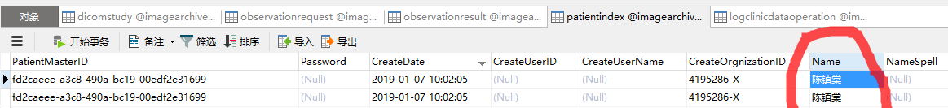

数据删了再测一遍：



还是如此，它确实是先自动地建立一条主索引的，然后后面的主索引号直接用主索引表（ISMPI=1）的那条。

4.

（1）采集服务上传到的数据库是哪个。

（2）192.168.141.21 远程连接的账号密码

5.

远程连接查看日志：

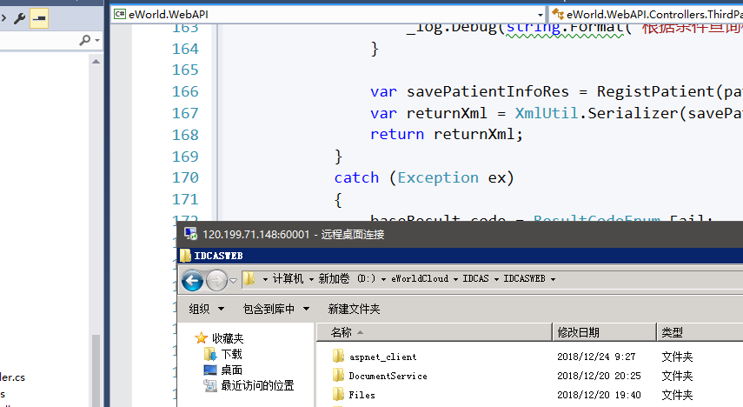

C:\Users\ywb\AppData\Local\Temp\%W@GJ$ACOF(TYDYECOKVDYB.png120.199.71.148:60001  
  
运营部-庞天浩 2019/1/7 13:43:28  
  
ceshi  
q8wAC72VuvzrtJgyGR  
  
运营部-庞天浩 2019/1/7 13:43:35  
  
登录方式：mstsc

6.

这个应该最终采集服务部署的地方，数据库：

各个采集站等，所有的数据都到了这里来。

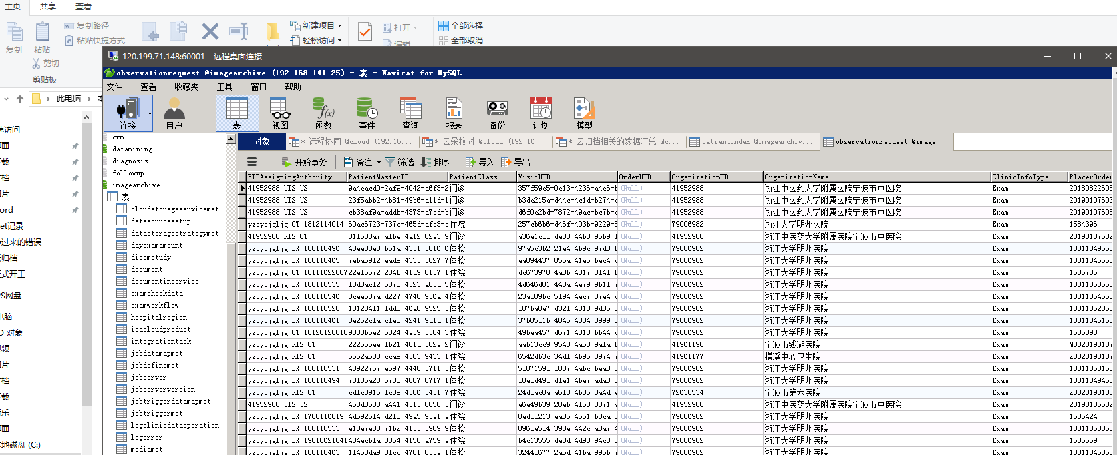

采集的日志：

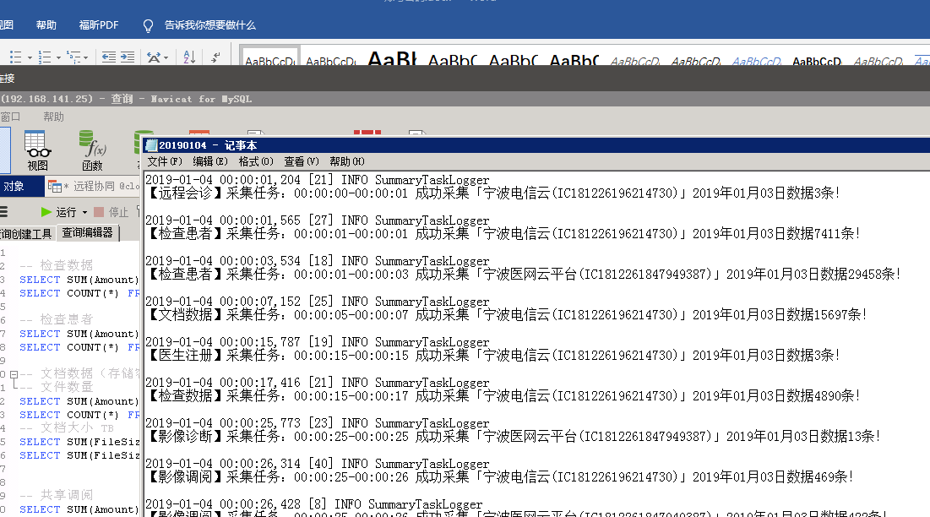

7.

这是数据库的字段，tinyint

`TaskStatus` tinyint(4) NOT NULL DEFAULT '0' COMMENT '任务状态，0：待处理，1：处理中，2：处理成功，3:处理失败。',

但Entity中是：

public byte TaskStatus { get; set; }

解答：

tinyint

从 0 到 255 的整型数据。存储大小为 1 字节。

在C#对应的是byte

8.

看到了患者主索引同步服务：

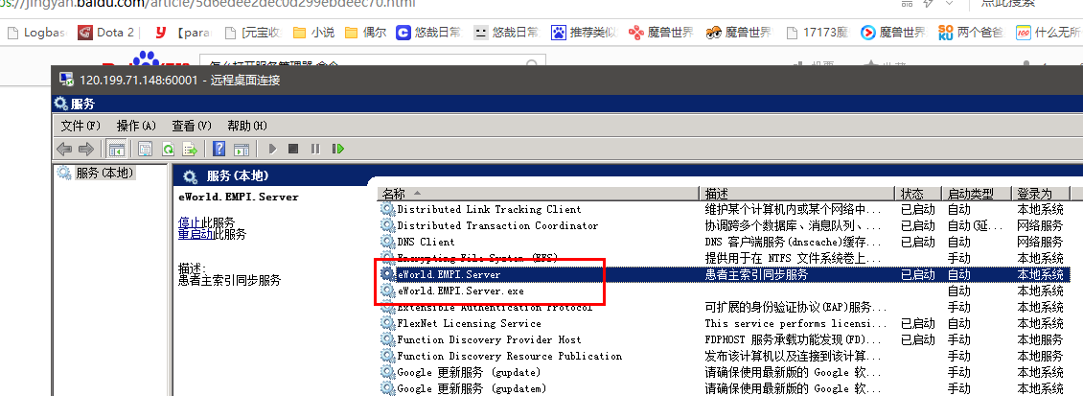

9.

注册失败对应的wcf log：

[时间]2019-01-04 18:37:57,860[内容]:原数据有主索引且原主索引不存在记录，则匹配主索引，原主索引：479bb753-736a-4ac6-83a7-e0771090d16d[异常]:

---------------------------------------------------------------

[时间]2019-01-04 18:37:57,878[内容]:患者信息注册成功[异常]:

---------------------------------------------------------------

[时间]2019-01-04 18:37:57,898[内容]:患者检查信息注册成功[异常]:

---------------------------------------------------------------

[时间]2019-01-04 18:37:57,916[内容]:患者就诊信息注册成功[异常]: 10.

11.

12.

13.