我要做的

1.

图片的上传，在Common当中的一个方法，调用，然后把图片的guid给存起来。

2.

直接调用之前写的接口，是前端直接调，还是参数传给后台，我用HttpClient？

3.

之前杨杨那边的接口调用，申请好友与同意添加，默认调用注册peerId的接口，要舍去？

4.

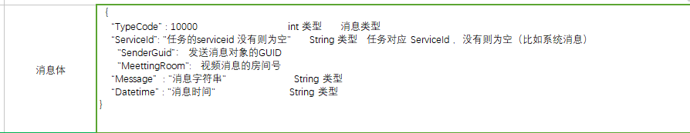

｛

“TypeCode” : 10000 int 类型 消息类型

“ServiceId”: "（customer guid ，没有就空）（我这里填空）任务的serviceid 没有则为空" String 类型 任务对应 ServiceId ，没有则为空（比如系统消息）

"SenderGuid”：（当前用户guid） 发送消息对象的GUID

"MeettingRoom": 视频消息的房间号

“Message” : "消息字符串" （customerName某某人添加你为好友） String 类型

“Datetime” : "消息时间" （时间） String 类型

｝

添加好友，同意好友申请的时候给对方发送一个消息通知。



调用结果：

（1）

调用地址：

apiurl=http://192.168.1.202:9001/api/common/Notice/PostNotice?mac=b2cb04ba-1790-424d-94f9-262588095d7f；传入参数：{"Content":"会诊诊断医生B请求添加你为好友。","ReceiveCustomerGuid":"9fb704ce-8041-47d2-bbda-27d39b017cd3","ServiceId":"","Kind":null,"SendCustomerGuid":"f5ff10df-f9c8-4682-bbba-f1480fd56f21","SendKind":null,"MessageKind":"JM","TypeCode":12401,"RoomId":null,"Id":null,"IP":null,"OperatorUID":"f5ff10df-f9c8-4682-bbba-f1480fd56f21","OperatorName":"会诊诊断医生B","ClientFrom":3,"AppKeyType":null}，返回结果：{"Code":-1,"Info":"非法参数"}

（2）

调用地址：

apiurl=http://192.168.1.202:9001/api/common/Notice/PostNotice?mac=b2cb04ba-1790-424d-94f9-262588095d7f；传入参数：{"Content":"会诊诊断医生B请求添加你为好友。","ReceiveCustomerGuid":"9fb704ce-8041-47d2-bbda-27d39b017cd3","ServiceId":"","Kind":0,"SendCustomerGuid":"f5ff10df-f9c8-4682-bbba-f1480fd56f21","SendKind":null,"MessageKind":"JM","TypeCode":12401,"RoomId":null,"Id":null,"IP":null,"OperatorUID":"f5ff10df-f9c8-4682-bbba-f1480fd56f21","OperatorName":"会诊诊断医生B","ClientFrom":3,"AppKeyType":null}，返回结果：{"Code":-1,"Info":"非法参数"}

（3）

调用地址：

apiurl=http://192.168.1.202:9001/api/common/Notice/PostNotice?mac=b2cb04ba-1790-424d-94f9-262588095d7f；传入参数：{"Content":"会诊诊断医生B请求添加你为好友。","ReceiveCustomerGuid":"9fb704ce-8041-47d2-bbda-27d39b017cd3","ServiceId":"","Kind":0,"SendCustomerGuid":"f5ff10df-f9c8-4682-bbba-f1480fd56f21","SendKind":1,"MessageKind":"JM","TypeCode":12401,"RoomId":null,"Id":null,"IP":null,"OperatorUID":"f5ff10df-f9c8-4682-bbba-f1480fd56f21","OperatorName":"会诊诊断医生B","ClientFrom":3,"AppKeyType":null}，返回结果：{"Code":-1,"Info":"非法参数"}

传入参数：{"Content":"会诊诊断医生B请求添加你为好友。","ReceiveCustomerGuid":"9fb704ce-8041-47d2-bbda-27d39b017cd3","ServiceId":"","Kind":0,"SendCustomerGuid":"f5ff10df-f9c8-4682-bbba-f1480fd56f21","SendKind":1,"MessageKind":"JM","TypeCode":12401,"RoomId":null,"Id":null,"IP":null,"OperatorUID":"f5ff10df-f9c8-4682-bbba-f1480fd56f21","OperatorName":"会诊诊断医生B","ClientFrom":3,"AppKeyType":null}，返回结果：eWorld.Core.DTO.BaseApiModel

将ServiceId变成Guid.Empty就可以了。

传入参数：{"Content":"会诊诊断医生B请求添加你为好友。","ReceiveCustomerGuid":"9fb704ce-8041-47d2-bbda-27d39b017cd3","ServiceId":"00000000-0000-0000-0000-000000000000","Kind":null,"SendCustomerGuid":"f5ff10df-f9c8-4682-bbba-f1480fd56f21","SendKind":null,"MessageKind":"JM","TypeCode":12401,"RoomId":null,"Id":null,"IP":null,"OperatorUID":"f5ff10df-f9c8-4682-bbba-f1480fd56f21","OperatorName":"会诊诊断医生B","ClientFrom":3,"AppKeyType":null}，返回结果：eWorld.Core.DTO.BaseApiModel

5.