RESTful API based on HTTP/JSON

1. technologies use: java, jsp
2. framework used: springmvc+spring+hibernate
3. database:Mysql
4. JDK: jdk1.7.0_60
5. table structure:

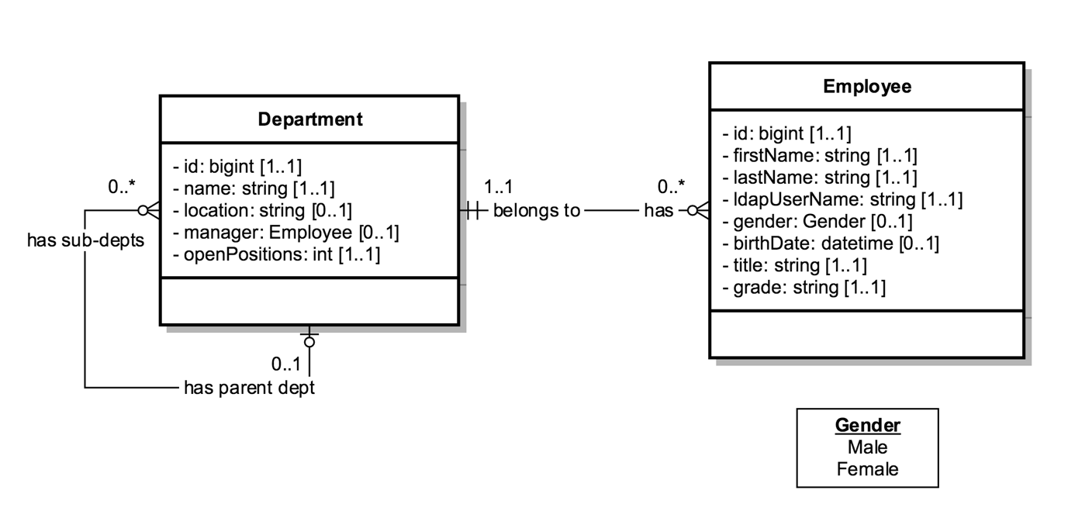

1. project structure:

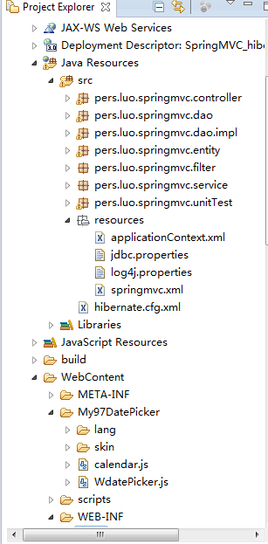

1. Functions:

* Retrieve all the departments
* Retrieve one department by departmentId
  + Retrieve the sub-departments of this department
  + Retrieve the parent department of this department
  + Retrieve all the employees that belong to this department
  + Update this department
  + Remove this department
* Retrieve all the employees
* Retrieve one employee by employeeId
  + Retrieve the department of this employee
  + Update this employee
  + Remove this employee
* Create a new department as a sub-department of a given department
* Create a new employee in a given department

1. Specification of resource files:

jdbc.properties: connection params for database

applicationContext.xml: configure dataSource ,sessionFactory, transaction manager, aop,..etc

springmvc.xml: configure ViewResolver and default servlet

hibernate.cfg.xml: be used for unit test

