Task1

Overview: We have developed a Sudoku game that allows people to kill the time and relax by using Java.

Product Purpose:

1. Target Audience: The target population of our product is relatively wide. Applicable to people of all ages and industries. As long as they have the need to pass the time, or hope to exercise their thinking skills through Sudoku games, then they can all become the target population of our product. Office workers can play on the subway or bus. Students or toddlers can play this game to exercise their mathematical thinking and computing skills.

B. Creativity: We added timers and scoreboards to increase user motivation. At the same time, when the user encounters difficulties, we have a prompt box to choose from. If the user needs, we can choose to accept our prompts to complete the game, so as to avoid difficult problems and no prompts, resulting in the loss of users.

Features: We have a regular Sudoku grid, in addition to timers and scoreboards, we hope that we can increase the enthusiasm of players by saving the highest records of players. At the same time, if the player feels that our problem is more difficult, then there will be a prompt bar below, the system will judge the existing number on the current square and give the player a hint, which numbers can be filled in the square of.

Design:

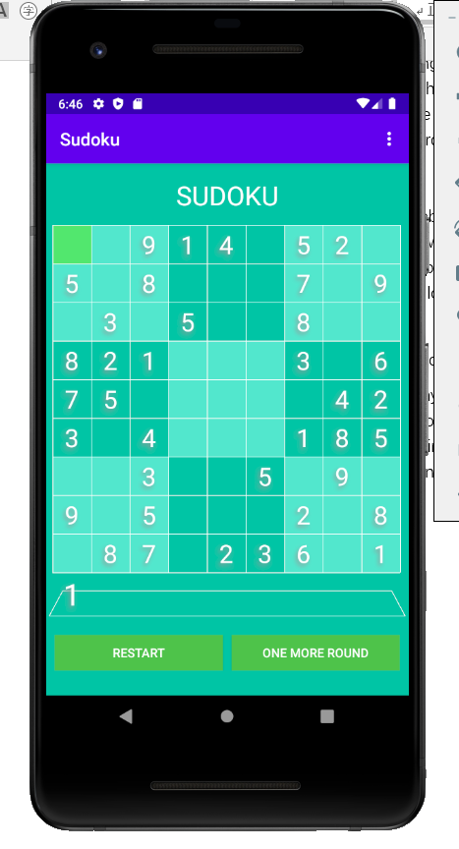 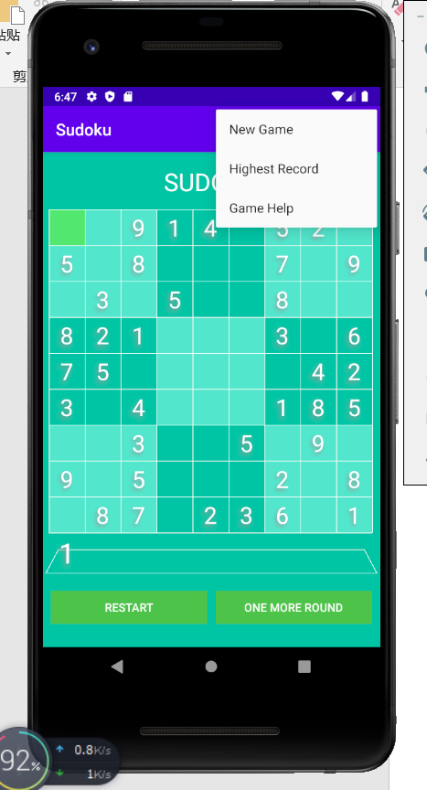

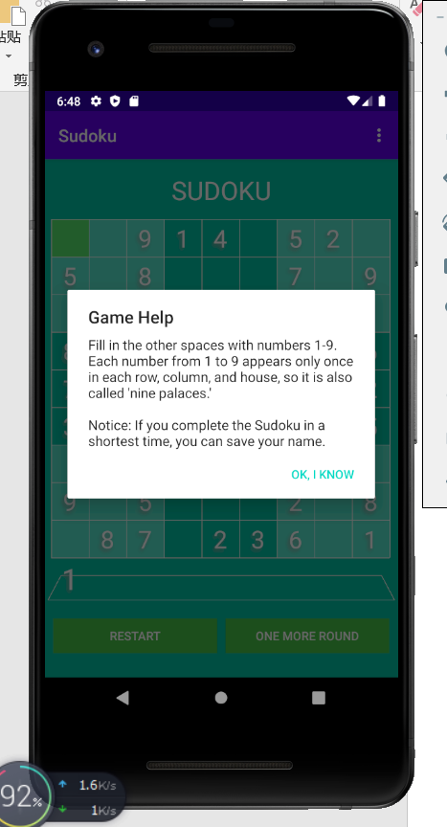 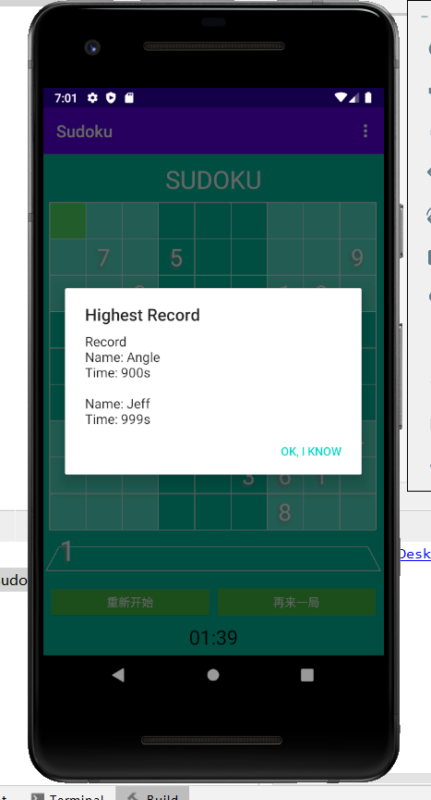

Data: