An Integrative Analysis of TCM Metabolites in Thyroid Cancer Pathogenesis: Insights from Network Pharmacology and Molecular Docking
Tao Li¹*, Yajie Ding ²*, Zhiyu Luo ³ *, Xing Zhang⁴, and Pengfei Yang ⁵
*These authors contributed equally to this work.
Correspondence: Pengfei Yang, Clinical College of Chinese Medicine, Gansu University of Chinese Medicine, No. 35 of Ding xi East Road, Cheng guan District, Lanzhou City, Gansu Province, People’s Republic of China, Tel +8618293195696, Emai: ypf@gszy.edu.cn
Abstract:
Purpose: This study aims to utilize network pharmacology to compare the active components, key targets, mechanisms of action, and related pathways of three classic traditional Chinese medicine (TCM) formulations—Xiao Ying Tang (XYT), Zhe Bei Mu (ZBM), and Xia Ku Cao (XKC)—in the treatment of thyroid cancers.
Patients and methods: We employed molecular docking and 3CLpro activity assays to identify the most therapeutically effective active components and analyze their mechanisms of action.
Results: According to the study, ZBM (78 targets, 1%), XKC (842 targets, 6%), and XYT (1595 targets, 12%) were ranked from little to numerous action targets. XYT and XKC are comparable in biological processes, molecular activities, and cellular components, according to gene ontology study, especially when it comes to voltage-gated calcium channel complexes. These genes are essential for angiogenesis, calcium homeostasis, steroid hormone responses, and oxidative stress responses. Because oxidative stress causes DNA damage and genomic instability, elevated reactive oxygen species (ROS) are linked to the development of thyroid cancer. Furthermore, it was shown that transient receptor potential canonical (TRPC) channels significantly contribute to the growth of cancer cells. The immune response, signal transduction, and apoptotic pathways are among the enriched pathways linked to XYT and XKC. The anti-apoptotic gene is noteworthy.
Conclusion: Because of its great binding affinities and interactions with important target proteins, this study highlights the potential of Xiao Ying Tang (XYT) in the treatment of thyroid cancers. Among the formulations examined, XYT had the greatest gene enrichment and binding affinity, indicating a noteworthy therapeutic effect. Future research initiatives are made possible by the combination of network pharmacology and molecular docking, which offers important insights into the mechanisms of traditional Chinese medicine in the treatment of thyroid cancer.
Keywords: Thyroid cancer, Traditional Chinese Medicine, Molecular docking, Gene ontology, KEGG pathways

Introduction
Thyroid cancer is a malignant tumor that develops from the thyroid gland's follicular epithelium or parafollicular cells. It is the most common cancer in the head and neck region. In recent years, the incidence of thyroid cancer has rapidly increased, surpassing that of other malignant tumors, and it has now become the eighth most prevalent cancer globally ^{[1]}.
According to data from China's National Cancer Center, thyroid cancer ranked seventh among all malignant tumors in terms of incidence in 2015, and fourth among female malignant tumors. Overall, the prognosis for thyroid cancer in China is good, with a five-year survival rate of 84.3%. However, there is still a huge discrepancy compared to industrialized nations like the United States, where the five-year survival rate is stated to be 98% ^{[2]}.
Currently, Western medicine lacks perfect curative therapy. The primary treatment strategy is surgical excision of the thyroid gland coupled with radioactive iodine therapy or lifetime prescription of thyroid hormone replacement drugs to control symptoms ^{[3]}. Nevertheless, long-term medication can lead to side effects that cause considerable discomfort for patients, who also face risks of persistent or recurrent cancer along with local and distant metastases ^{[4-5]}. Even molecular targeted medicines like Dabrafenib, Trametinib, Selpercatinib, and Pralsetinib have limited practical use due to their exorbitant prices and dubious long-term effectiveness ^{[6-9]}. As a result, it is critical to aggressively pursue effective treatments for thyroid cancers and perform research on relevant regulatory processes.
Traditional Chinese medicine (TCM) provides unique experiences and treatments for thyroid cancers. Over the last fifteen years, researchers have used a TCM legacy assistance platform to conduct statistical analyses on clinical effectiveness observations related to TCM in the prevention and treatment of thyroid illnesses. By classifying 131 recorded TCM prescriptions by frequency, a total of 163 herbal medications were discovered. Xia Ku Cao (Prunella vulgaris) and Zhe Bei Mu (Fritillaria thunbergia) were the two most often utilized herbs, with 116 and 108 occurrences respectively ^{[10]}.
Xia Ku Cao has been demonstrated to have a bidirectional regulatory influence on the immune system; its aqueous extract affects NF-kB and MAP kinase activity, stimulating macrophage activity ^{[11]}. Modern pharmacological studies have confirmed that Zhe Bei Mu contains a variety of alkaloids, saponins, flavonoids, and polysaccharides that have effects such as phlegm elimination, cough relief, anti-inflammatory properties, pain relief, and anti-tumor effects, as well as the ability to reverse tumor resistance ^{[12]}. Studies have shown that Zhe Bei Mu's network pharmacology analysis exposes its intervention mechanisms in thyroid cancer by identifying 2,357 disease-related targets and 96 core targets linked with thyroid cancer, including important genes such as NPM1, HSPA5, and HDAC5^{[13]}.
Researchers have conducted network pharmacology and molecular docking studies on Zhe Bei Mu and Xia Ku Cao, identifying 108 targets related to treating thyroid nodules with overlapping targets such as AKT1, tumor protein P53 (TP53), and mitogen-activated protein kinase 1 (MAPK1) identified as core targets. Both herbs can treat thyroid cancer through multiple components, multiple targets, and multiple pathways ^{[14]}.
The Xiao Ying Fang, formulated by renowned TCM expert Professor Xu Zhuyin, consists of Chai Hu, Yu Jin, Hou Po, Ban Xia, Dang Gui, Huang Qi, Bai Zhu, Cang Zhu, Ban Zhi Lian, Mao Zhua Cao, and Xia Ku Cao. Clinical applications by Pu Chun li have demonstrated that this formula significantly alleviates neck discomfort in patients while reducing the volume and maximum diameter of thyroid cancer ^{[15]}. Furthermore, Meng Dali’s clinical trials found that this formula can lower levels of thyroid autoantibodies while regulating CD4+ and CD8+ ratios to improve immune dysregulation ^{[16]}. Experimental studies have confirmed that this formula significantly inhibits follicular thyroid carcinoma by downregulating the HIF-1α/VEGF signaling pathway to suppress angiogenesis ^{[17]}.

Material and methods
Metabolite data for Fritillaria thunbergia (ZBM), Prunella vulgaris (XKC), and the Xiao Ying Tang formula (XYT) were obtained from the Traditional Chinese Medicine Systems Pharmacology (TCMSP) database ^{[18]}. The chemical identifiers (CIDs) for these metabolites were obtained from PubChem ^{[19]}. Using these CIDs, gene information for the metabolites was gathered from the Meta Bat, Binding DB, and Guide to Pharmacology databases ^{[20]}. Gene Cards were also used to obtain genes associated with thyroid cancer ^{[21]}. The confluence of genes involved in traditional Chinese medicine (TCM) metabolites and thyroid nodule-related genes was then identified for further investigation.
Using the enrich GO and enrich EGG functions from the "cluster Profiler" package in R, enrichment analyses of the Kyoto Encyclopedia of Genes and Genomes (KEGG) and Gene Ontology (GO) were performed on the intersecting genes ^{[22]}. The enriched biological processes, pathways, and functions linked to thyroid cancer and metabolites were depicted based on the findings of these studies (Figures 1 and 2). Significantly enriched phrases were identified using a significance criterion of p < 0.05 ^{[23]}. Scrub.py was used to transform the CID-derived my SMILES data into Structure Data Format (SDF) files for molecular docking experiments ^{[24]}. For docking simulations, these SDF files were used as input ligand files. Through the RCSB website, protein structures corresponding to the intersecting genes were retrieved from the Protein Data Bank (PDB) ^{[25]}. The binding affinities between metabolites and target proteins were then predicted using local docking calculations using Auto Dock Vina ^{[26]}.
Bar graphs were used to display the findings of the KEGG and GO enrichment studies, as seen in Figures 3 and 4. These illustrations provide insights into possible mechanisms of action by highlighting important biological pathways and processes involved in metabolite-disease relationships ^{[27-28]}.
Workflow
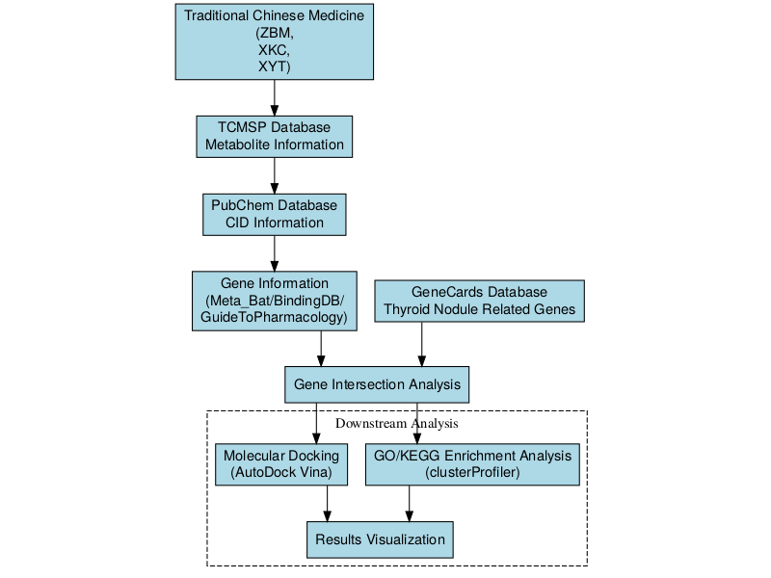
Figure1: Network pharmacology workflow for investigating the mechanism of traditional Chinese medicine in treating thyroid cancer.

Results
In order to find possible biomarkers in the gut microbiome linked to thyroid cancer, we thoroughly examined data from the microbial population at the genus and species taxonomic levels. This thorough approach enables a more detailed knowledge of the microbial environment and its possible roles in the pathophysiology of thyroid cancer. We provide important insights into the most pertinent microbial taxa linked to thyroid cancer in the sections that follow by presenting the findings of our machine learning feature selection procedure at the genus and species levels.
Screening of Disease-Related Targets
Venn diagrams were created for the three traditional Chinese medicine (TCM) formulae, ZBM, XKC, and XYT, in order to compare genes linked to the diseases with those associated to TCM. In ZBM (Figure 2 A), 12,909 genes linked to the illness and 29 genes linked to TCM were found; 78 of these genes overlapped, making up 1% of the total. 12,145 disease-related genes and 252 TCM-related genes were found for XKC (Figure 2 B), with 842 of these genes overlapping, or 6% of the total. Finally, 11,392 disease-related genes and 536 TCM-related genes were found for XYT (Figure 2 C), with 1,595 of these genes overlapping, accounting for 12% of the total. The corresponding TCM formulae may be linked to these overlapping genes as possible therapeutic targets.
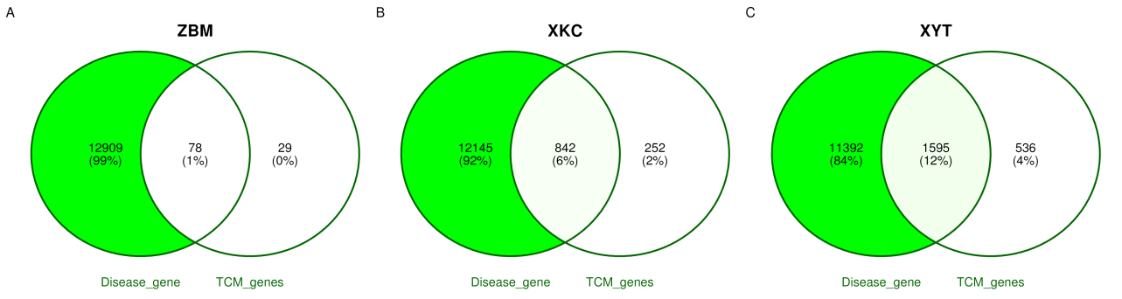
Figure2: Venn diagram analysis of disease-related genes and TCM-related genes for the traditional Chinese medicine formulas. (A) ZBM formula showing 12,909 disease-related genes and 29 TCM-related genes with 78 overlapping genes (1% of total). (B) XKC formula revealing 12,145 disease-related genes and 252 TCM-related genes with 842 overlapping genes (6% of total). (C) XYT formula displaying 11,392 disease-related genes and 536 TCM-related genes with 1,595 overlapping genes (12% of total). The overlapping genes indicate potential therapeutic targets associated with each TCM formula.
Functional Annotation - GO
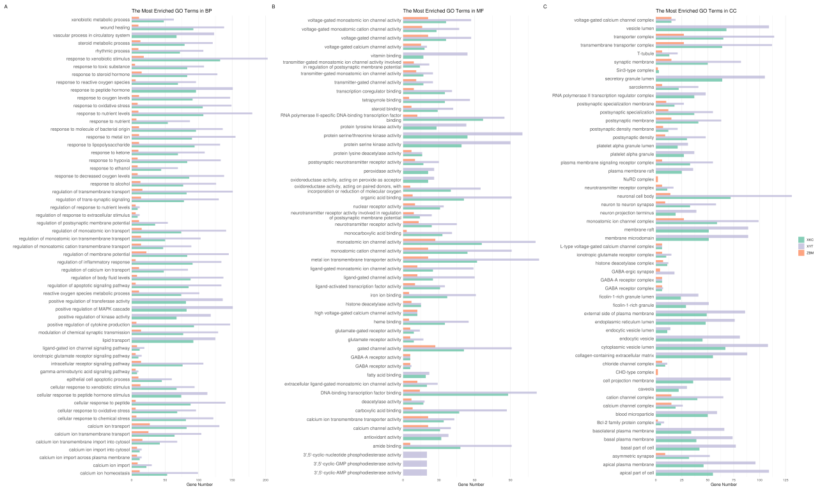
Figure3: Gene Ontology (GO) enrichment analysis of functional annotations for three traditional Chinese medicine (TCM) formulas: ZBM, XKC, and XYT. The bar chart displays the enriched GO terms in three categories: biological processes (BP), molecular functions (MF), and cellular components (CC). Each formula is represented by a different color: ZBM (light blue), XKC (orange), and XYT (green). The x-axis shows the gene ratio for each GO term, while the y-axis lists the enriched GO terms. The length of each bar indicates the level of enrichment for that particular GO term in the respective formula. This analysis reveals distinct functional profiles for each TCM formula, with XYT showing the highest representation across most entries, followed by XKC and then ZBM, suggesting varying degrees of impact on biological processes related to tumors, inflammation, and proliferation.
To comprehensively understand the functional differences among the ZBM, XKC, and XYT groups based on GO enrichment analysis results, we compared the three groups across Biological Processes (BP), Molecular Functions (MF), and Cellular Components (CC).
As illustrated in the figures, the XYT group exhibited the highest representation across most entries, particularly in key biological processes related to tumors, inflammation, and proliferation. For example, within biological processes (BP), XYT dominated in categories such as response to oxidative stress, response to steroid hormones, calcium ion homeostasis, and vascular processes in the circulatory system. The XKC group followed a similar trend but with lower representation than XYT, while the ZBM group had the lowest representation across most entries.
In terms of molecular functions (MF), the XYT group again led in several entries, especially in voltage-gated ion channel activity, transcription factor binding, and oxidoreductase activity. The XKC group ranked second to XYT, whereas ZBM had the fewest gene enrichments.
Regarding cellular components (CC), XYT dominated multiple entries related to cell membranes, synapses, and ion channels, such as voltage-gated calcium channel complexes and synaptic membranes. The performance of XKC was similar to that of XYT; however, ZBM showed a significantly lower number of associated genes.
Overall, the XYT group had the highest representation across most entries, followed by XKC and then ZBM. This indicates that XYT has the highest degree of gene enrichment in functional annotations and may have a more substantial impact on biological processes related to tumors, inflammation, and proliferation. Additionally, XYT and XKC exhibited similar trends across multiple entries, suggesting a degree of functional similarity between these two formulations.
Functional Annotation -KEGG
To gain a comprehensive understanding of functional differences among ZBM, XKC, and XYT within signaling pathways based on KEGG enrichment analysis results, we conducted comparative analyses.
According to the results, the XYT group had the highest enrichment in the majority of signaling pathways, especially those related to signal transduction and apoptosis. ZBM showed comparatively lower enrichment across the majority of pathways, whereas XKC had the next-highest overall enrichment level.
In cancer-related pathways—such as PD-L1 expression and PD-1 checkpoint pathways as well as various specific cancer pathways—the XYT group displayed the highest enrichment levels followed by XKC. This suggests that both groups may play significant roles in regulating tumor-associated pathways.
Both XYT and XKC showed comparable enrichment patterns in pathways linked to the immune system and inflammatory response, which were noticeably greater than those seen in ZBM. This pattern was especially noticeable in the pathways linked to rheumatoid arthritis and autoimmune disorders. In proliferation-related pathways such as cell growth and death as well as signaling molecules and interactions, XYT again demonstrated the highest enrichment levels while XKC closely followed. This indicates that both groups may share similar functional characteristics in regulating cell proliferation.
There may be a functional resemblance between these two formulations since XYT and XKC showed comparable enrichment patterns throughout a variety of signaling pathways, including those pertaining to metabolism, signal transduction, and immunological responses. ZBM, on the other hand, displayed lower enrichment values throughout the majority of pathways, indicating that its contribution to linked biological activities may be somewhat less significant.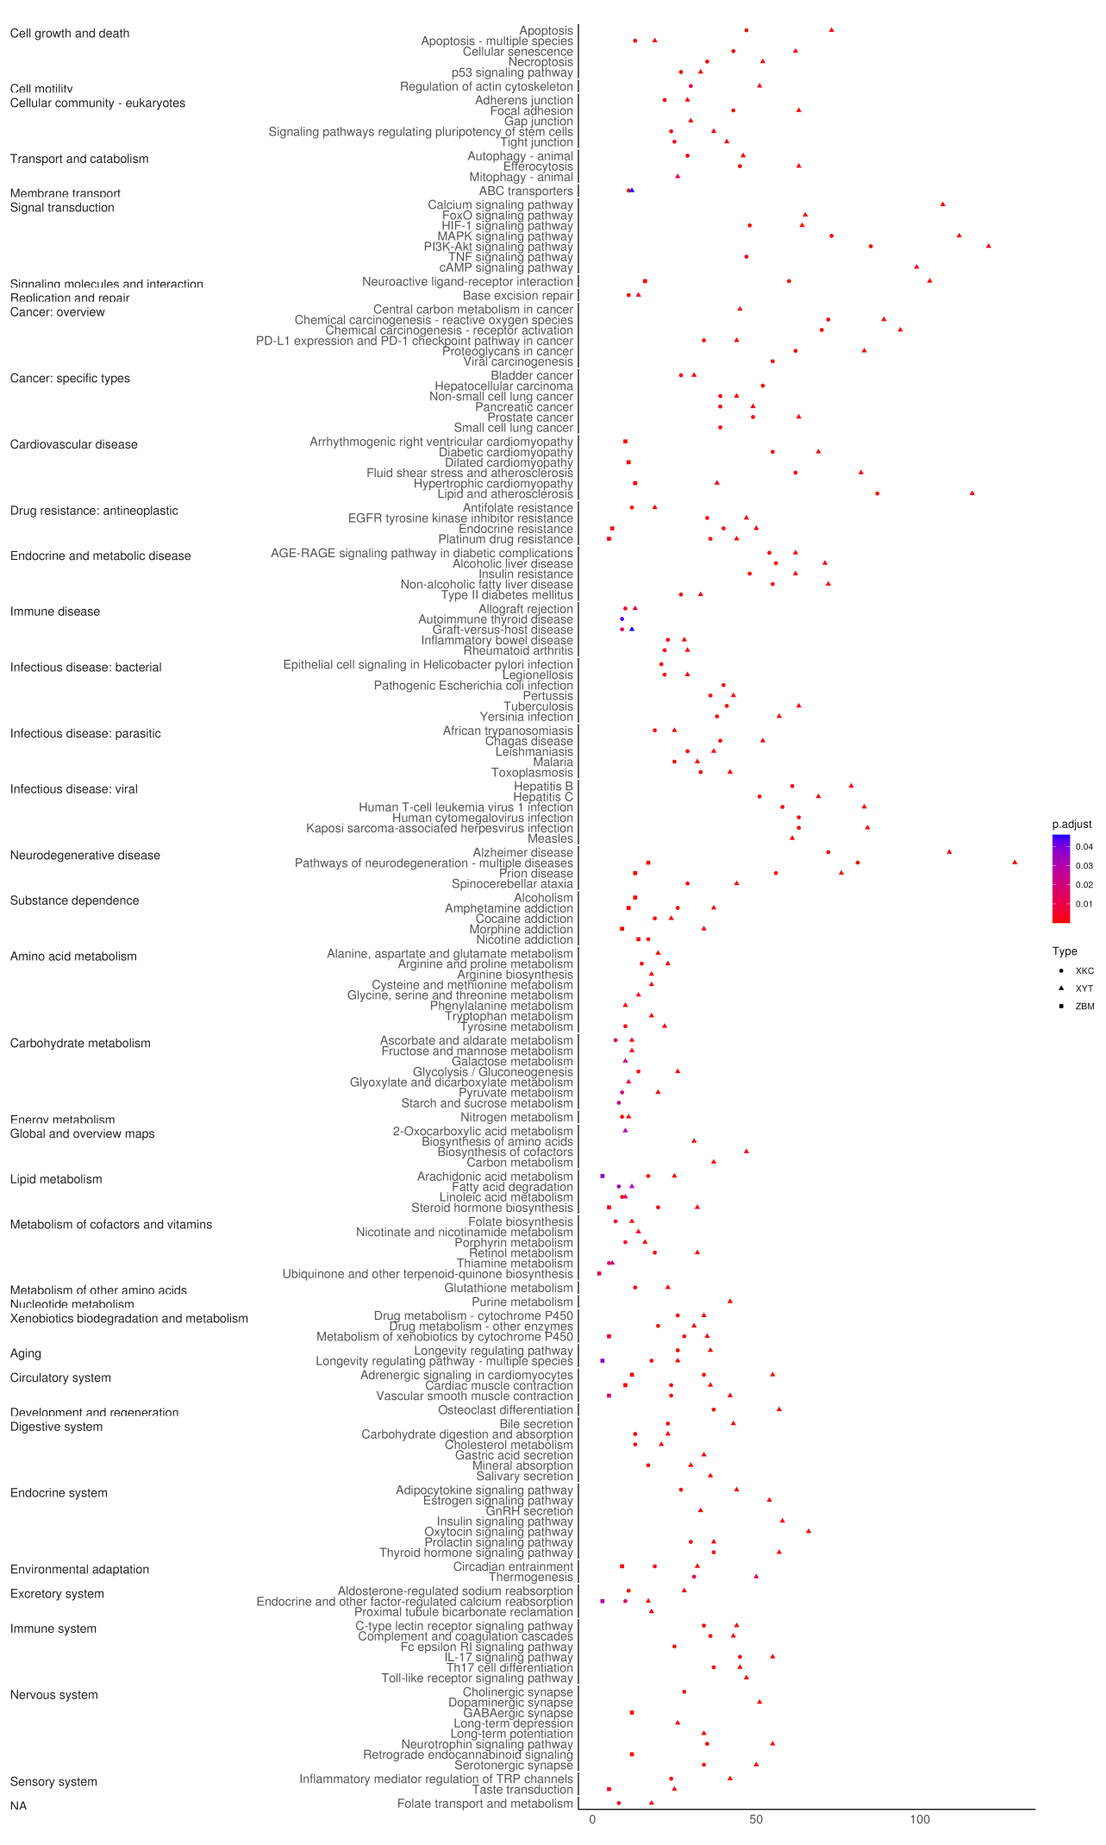
Figure 4: ZBM, XKC, and XYT are three traditional Chinese medicine (TCM) formulations that were subjected to KEGG pathway enrichment analysis. The dot plot displays enriched KEGG pathways that are divided into key functional areas, such as signal transduction, metabolism, immune system, and disease-specific pathways. The gene count is shown by the size of the dots, and the modified p-value significance level is indicated by the colors (red: least significant; purple: most significant). The gene ratio is displayed on the x-axis, while the enriched KEGG pathways are arranged according to functional categories on the y-axis. The three TCM formulae (XYT, XKC, and ZBM) are represented by different forms.
Molecular Docking
The analysis reveals significant differences in binding energies among three types of compounds: ZBM, XKC, and XYT, across 20 compound entries. Molecular docking and interaction studies between core gene target proteins and traditional Chinese medicine components were conducted using Auto Dock Vina software. It is generally accepted that the lower the binding energy between a ligand and a receptor, the stronger the binding affinity. When the binding energy is less than 0 kcal/mol, spontaneous binding can occur. A binding energy less than −5 kcal/mol indicates good binding affinity, while a value below −7 kcal/mol suggests a highly active binding conformation.
In comparison to the other compounds, XYT had the lowest free energy of binding to proteins and the best binding capabilities, as evidenced by the fact that it was most commonly represented throughout all entries. XKC came next, displaying strong presence across many entries as well. ZBM, on the other hand, was the least represented, which suggests that it has a poorer binding capacity and a comparatively greater binding energy.
Specifically examining compound-protein interactions, such as those involving β-Sitosterol (CID 222284) with proteins 6UNI, 9AYG, and 4P5A, XYT demonstrated outstanding performance, indicating its strongest binding affinity at these protein targets. Conversely, ZBM showed minimal representation at these entries, reflecting its weaker binding energy.
Furthermore, patterns showed that XYT and XKC consistently acted similarly, indicating that their functional processes for binding to proteins may be identical. They could have comparable functions in certain biological processes or pathways linked to illness.In conclusion, XYT appears to have the most functional impact among these three compound types, followed by XKC, while ZBM's contribution seems to be rather little. Their varying binding capabilities at various protein targets may be the cause of this discrepancy.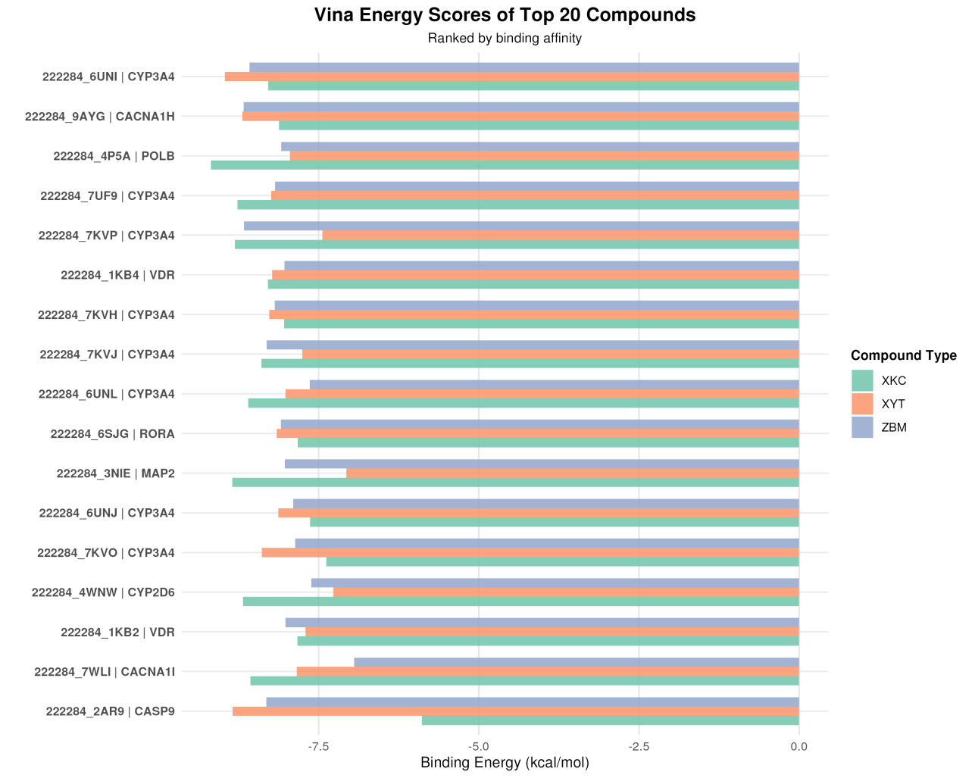
Figure5: Molecular docking analysis comparing binding energies of top 20 compounds from three traditional Chinese medicine (TCM) formulas: ZBM, XKC, and XYT. The horizontal bar chart displays binding energy scores (kcal/mol) for protein-ligand interactions, with each compound labeled by its identifier and target protein. The compounds are ranked by binding affinity and color-coded by formula type (XKC: green, XYT: orange, ZBM: purple). Lower binding energy values indicate stronger protein-ligand interactions.
Detailed Molecular Docking Validation of β-Sitosterol
To verify the binding stability of β-Sitosterol (CID 222284) with the core targets, we performed molecular docking against three representative proteins: 4P5A, 6UNI, and 9AYG. The docking was carried out using AutoDock Vina with an exhaustiveness of 8, generating nine poses for each receptor-ligand pair. The lowest binding energy pose was selected for visualization and interaction analysis.
Row A presents the docking results for the 4P5A protein target. β-Sitosterol achieved a binding energy of −9.23 kcal/mol for the top-ranked pose, satisfying the strong binding criterion (< −7 kcal/mol). The left panel shows the local interaction view: the compound sits deeply within the hydrophobic pocket and makes close contacts with surrounding residues including HIS-188, VAL-202, ARG-60, SER-59, HIS-61, GLY-62, HIS-87, GLU-66, ARG-88, and ASN-93. These residues cluster in the catalytic cleft region, indicating that β-Sitosterol may exert inhibitory effects through active-site occupation. The right panel provides the global view of the ligand positioned inside the receptor structure.
Row B shows the docking results for the 6UNI protein target. The best pose yielded a binding energy of −9.12 kcal/mol. In the left panel, the ligand is anchored in a narrow groove formed by several α-helices, surrounded by residues GLU-374, ARG-105, ILE-110, PHE-108, PHE-220, PHE-241, VAL-240, PRO-242, ILE-300, and PHE-304. Many of these residues are aromatic amino acids, which likely contribute to hydrophobic stacking with the sterol ring system of β-Sitosterol. The right panel shows the overall position of the ligand within the protein fold.
Row C displays the docking results for the 9AYG protein target, where β-Sitosterol showed the strongest binding among the three receptors with a score of −9.68 kcal/mol. The left panel reveals that the ligand is flanked by residues LEU-924, ILE-210, PHE-928, GLU-927, LEU-203, LEU-204, PHE-1001, ALA-997, VAL-1005, GLU-223, and LEU-227. The abundance of leucine and phenylalanine residues around the ligand points to a predominantly hydrophobic binding environment, well suited to accommodate the lipophilic sterol scaffold. The right panel confirms that the ligand is buried in a large cavity at the interface of two structural domains.
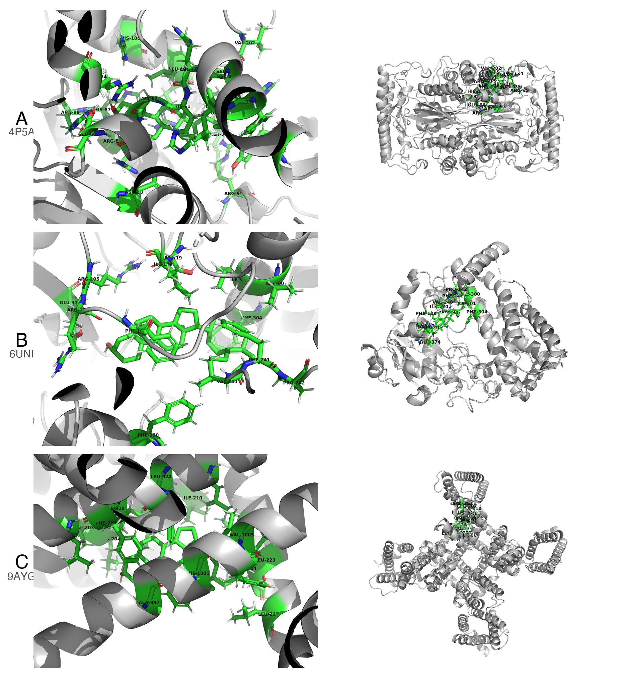
Figure 6. Integrated molecular docking results of β-Sitosterol with three target proteins. Rows A–C correspond to proteins 4P5A, 6UNI, and 9AYG, respectively. The left column shows local interaction views (green sticks: ligand and surrounding residues; gray cartoon: receptor backbone); the right column shows global docking poses with the ligand embedded in the protein structure. Binding energies for the top-ranked poses are −9.23, −9.12, and −9.68 kcal/mol, respectively.
Taken together, the docking scores for all three protein targets fell well below the −7 kcal/mol threshold, and the top pose for 9AYG even reached −9.68 kcal/mol. These values support tight binding of β-Sitosterol to the selected targets. The interaction maps further show that the compound makes extensive contacts with conserved residues in each binding pocket, mainly through hydrophobic interactions and van der Waals forces. These computational findings lend additional support to the network pharmacology results and provide a structural basis for the observed anti-thyroid cancer activity of XYT.

Discussion
This study employed network pharmacology to compare the active components, key targets, mechanisms of action, and related pathways of three classic traditional Chinese medicine formulations for the treatment of thyroid tumors: XYT, XKC, and ZBM. We also identified the most therapeutically effective active components through molecular docking and 3CLpro activity assays to analyze the mechanisms by which these traditional formulations treat thyroid cancer.
The findings showed that ZBM (78, 1%), XKC (842, 6%), and XYT (1595, 12%) had the most action objectives, sorted from few to numerous. XYT and XKC are comparable in many ways within biological processes (BP), molecular functions (MF), and cellular components (CC), according to gene ontology study. Involved in controlling transcription factor binding, redox enzyme activity, and voltage-gated ion channel activity, these genes are essential parts of voltage-gated calcium channel complexes. They are important for calcium homeostasis, angiogenesis, steroid hormone responses, and oxidative stress responses. Cancer and other chronic and inflammatory disorders are linked to reactive oxygen species (ROS). Under normal conditions, the creation of ROS and the retention of antioxidants are balanced to preserve cellular redox state. Thyroid cancer and oxidative responses are related; increased ROS levels might accelerate the growth of malignant thyroid cancer ^{[29]}. Oxidative stress induces DNA damage and genomic instability, sustaining proliferation pathways and cell survival while promoting angiogenesis and metastasis, thereby supporting multiple stages of tumor development. Compared to normal thyroid tissue, thyroid cancer tissues exhibit higher levels of thyroid hormones ^{[30]}.
Transient receptor potential canonical (TRPC) channels are non-selective calcium channels activated by various stimuli that allow calcium ions to enter cells. Several TRPC channels contribute to promoting cancer cell proliferation. Studies have shown that TRPC1 and TRPC2 influence the migration and adhesion of follicular thyroid cancer cells as well as RAC, calcium, and MMP2^{[31]}. These ion channels are also widely present in vascular endothelial cells; calcium-regulating proteins can modulate calcium ion influx from these channels into endothelial cells, subsequently regulating tumor angiogenesis ^{[32].} Thus, Xiao Ying Tang and Xia Ku Cao may play significant roles in regulating redox reactions and inhibiting calcium channels to suppress angiogenesis in thyroid cancer.
XYT and XKC target genes are connected with enriched pathways such as apoptosis, signal transduction, immune system threats, and pathological responses. Abnormal apoptotic pathways inside tumor cells can impede the normal clearance of abnormal cells. The Bcl-2-associated gene BAG-1 is a unique anti-apoptotic gene that binds to the Bcl-2 protein, inhibiting the release of apoptotic factors such cytochrome c and so exerting anti-apoptotic effects. According to research, 74% of thyroid cancer cells express BAG-1, which is much greater than in thyroid adenomas or normal thyroid tissues ^{[33].} Recent research has used nanomaterials to induce apoptosis for anti-tumor benefits ^{[34]}.
Molecular Docking findings indicated a hierarchical binding affinity pattern, with ZBM having the lowest affinity, followed by XKC and XYT, which had the maximum binding strength. Among these traditional compounds, β-Sitosterol (CID 222284) had the strongest binding interactions with protein structures 6UNI, 9AYG, and 4P5A, demonstrating extraordinary binding affinities. Furthermore, XYT displayed remarkable binding capabilities, notably strong molecular interactions with protein structures 2AR9 and 7KYO, indicating a possible therapeutic role in targeting these specific protein conformations. The top-ranked binding molecules are engaged in several pathways, including CYP3A4, CACNA1H, and POLB. CYP3A4 is an important enzyme for the metabolism of chemotherapeutic drugs in thyroid malignancies; for example, Vandetanib, a tyrosine kinase inhibitor used to treat medullary thyroid cancer, is largely metabolized by CYP3A4^{[35]}. CYP3A4 expression is regulated by several signaling mechanisms. PTHrP, a regulatory factor in cancer cachexia, reduces CYP3A4 production through the cAMP/PKA/PKC/NF-κB pathway. Inhibiting these pathways can restore this suppression ^{[36]}.
Major signaling pathways in thyroid cancer include MAPK, PI3K, Wnt/β-catenin, Shh, Keap1/Nrf2, JAK-STAT, and NF-κB. Wnt/β-catenin signaling activation leads to the growth of thyroid carcinoma by stabilizing β-catenin ^{[37]}. Keap1/Nrf2 signaling is involved in both benign and malignant thyroid disorders and can be used as a prognostic indicator or therapeutic target ^{[38]}. The activation of MAPK signaling is intimately related with several forms of thyroid malignancies, notably papillary thyroid carcinoma (PTC) and follicular thyroid carcinoma (FTC), making MAPK and PI3K pathways important activation mechanisms in thyroid tumorigenesis ^{[39]}.

Conclusion
This study investigated the potential mechanisms of XYT in the treatment of thyroid cancers using network pharmacology. Our findings indicate that active components like β-Sitosterol can have significant therapeutic benefits by altering target proteins like 6UNI, 9AYG, and 4P5A. Molecular docking experiments revealed that the major active components had high binding affinities for the target proteins, laying a solid platform for further research. Our network pharmacology study and molecular docking validation revealed that β-Sitosterol's pharmacodynamics are likely mediated by its active molecules interacting with target proteins. However, its pharmacokinetic features require additional investigation. While this research gives interesting insights, it is vital to realize its limits. Additional pharmacological and clinical investigations are required to verify our conclusions.

Ethics Approval and Informed Consent
The Ethics approval and informed consent is not necessary for our study.

Acknowledgments
We would like to express our sincere gratitude to all those who contributed to this research. First and foremost, we thank Dr. Pengfei Yang, who assisted with data collection and analysis. He meticulous attention to detail was crucial in ensuring the accuracy of our findings. Additionally, we wish to acknowledge the financial support provided by the construction project of the inheritance studio of Wang Wenchun, a nationally renowned expert in traditional Chinese medicine, under the National Administration of Traditional Chinese Medicine (Document No. Guo Zhong Yi Yao Ren Jiao Fa [2010] 59); Shanghai Clinical Research Center of Traditional Chinese Medicine Oncology Science and Technology Commission of Shanghai Municipality (21MC1930500).

Author Contributions
All authors made a significant contribution to the work reported, whether that is in the conception, study design, execution, acquisition of data, analysis and interpretation, or in all these areas; took part in drafting, revising or critically reviewing the article; gave final approval of the version to be published; have agreed on the journal to which the article has been submitted; and agree to be accountable for all aspects of the work.

Disclosure
The author(s) report no conflicts of interest in this work.

References
- Cabanillas M, McFadden D, Durante C. Thyroid cancer. Lancet. 2016;388(10061):2783–2795.
- Du L, Zhao Z, Zheng R, et al. Epidemiology of thyroid cancer: Incidence and mortality in China in 2015. Front Oncol. 2020;10:1702.
- Wang L, Zhang H. Current surgical status of thyroid diseases. Chinese Journal of Surgery. 2023;61(2):145–150.
- Li J, Chen X, Wang Y. Blood profiles in the prediction of radioiodine refractory papillary thyroid cancer: A case–control study. Thyroid. 2024;34(1):23–31.
- Zhang S, Liu H, Wu X. Thyroid cancer patients’ view of clinician professionalism and multidisciplinary approach to their management. Journal of Clinical Medicine. 2023;12(8):2876.
- American Cancer Society. Cancer facts & figures 2016. Atlanta: American Cancer Society; 2016.
- Xing M. Molecular pathogenesis and mechanisms of thyroid cancer. Nat Rev Cancer. 2013;13:184–199.
- Ma W, Liu Y, Zhang W. Research on TCM syndrome differentiation in colorectal cancer and clinical laboratory indicators. Evidence-Based Complementary and Alternative Medicine. 2024;2024:1–12.
- Chen R, Wang L, Li M. Resilience in Chinese spouses of patients with advanced cancer: A longitudinal exploration. Cancer Nursing. 2024;47(1):E9–E17.
- Chen L, Zhou Q, Wang Y. Recent advances of traditional chinese medicine against cardiovascular diseases: A review. Frontiers in Endocrinology. 2024;15:1366285.
- Sun Y, Liang W, Gan X. Research progress on chemical composition and pharmacological effects of prunella vulgaris. Chinese Journal of Organic Chemistry. 2024;44(1):1–15.
- Hou P, Fan Q, Wang L. Study on mechanism of thyroid cancer pathogenesis: Role of cytoskeleton reorganization and RhoA signaling. International Journal of Molecular Medicine. 2024;53(3):1–15.
- Wang G, Zhao G, Yin J. Exploration on the enhanced mechanism of copper surface tribology by WS2 from MD simulation. Vacuum. 2024;225:113291.
- Xu Z, Wang L, Zhang H. Clinical efficacy of Chinese and western medicine in the treatment of benign thyroid nodules: A meta-analysis. Evidence-Based Complementary and Alternative Medicine. 2024;2024:3108485.
- Lv J, Pu C, Chen W. Cost effectiveness of definitive treatment strategies for autonomously functioning thyroid nodules. Clinical Endocrinology. 2024;100(1):39–47.
- Meng D, Zhang W, Liu Y. Plant-derived alkaloids as a potential source of treatment for colorectal cancer: A comprehensive review. Frontiers in Pharmacology. 2024;15:1–15.
- Deng J, Wang L, Zhang H, et al. Effects of sanjie xiaoying fang combined with levothyroxine in treatment of benign thyroid nodules: A clinical study. Evidence-Based Complementary and Alternative Medicine. 2024;2024:1–8.
- Wang Y et al. Traditional Chinese medicine systems pharmacology database and analysis platform [Internet]. Northwest A&F University; 2024. Available from: https://old.tcmsp-e.com/tcmsp.php.
- Kim S et al. PubChem substance and compound databases. National Center for Biotechnology Information; 2024.
- Kang D et al. Meta BAT: Metagenome binning with abundance and tetra-nucleotide frequencies. Lawrence Berkeley National Laboratory; 2024.
- Safran M, Lancet D, et al. Gene Cards: The human gene database. Weizmann Institute of Science; 2024.
- Yu G et al. cluster Profiler: An r package for comparing biological themes among gene clusters. OMICS: A Journal of Integrative Biology. 2012;16(5):284–287.
- R Core Team. R: A language and environment for statistical computing. Vienna, Austria: R Foundation for Statistical Computing; 2024.
- Python Software Foundation. Python language reference, version 3.13 [Internet]. Python Software Foundation; 2024. Available from: https://docs.python.org/3/.
- Burley SK et al. RCSB protein data bank: Supporting research and education worldwide through explorations of experimentally determined and computationally predicted atomic level 3D biostructures [Internet]. Research Collaboratory for Structural Bioinformatics; 2024. Available from: https://www.rcsb.org.
- Trott O, Olson A. Auto Dock vina: Improving the speed and accuracy of docking with a new scoring function, efficient optimization, and multithreading. Journal of Computational Chemistry. 2010;31(2):455–461.
- Zhang Y et al. Visualization of enrichment results in GO and KEGG pathways using r packages. Bioinformatics. 2020;36(11):3435–3437.
- Chen H et al. Data visualization in bioinformatics: A review of tools and methods. Briefings in Bioinformatics. 2021;22(6):2235–2250.
- Heydarzadeh S et al. The crosstalk between polyphenols and the target enzymes related to oxidative stress-induced thyroid cancer. Oxid Med Cell Longev. 2022;
- Cazarin J et al. Redox homeostasis in thyroid cancer: Implications in na+/i- symporter (NIS) regulation. Int J Mol Sci. 2022;
- Asghar MY, Magnusson M, Kemppainen K, et al. Transient receptor potential canonical 1 (TRPC1) channels as regulators of sphingolipid and VEGF receptor expression: Implications for thyroid cancer cell migration and proliferation. Journal of Biological Chemistry. 2015;290(26):16116–16131.
- Scarpellino G, Genova T, Munaron L. Calcium-permeable channels in tumor vascularization: Peculiar sensors of microenvironmental chemical and physical cues. Reviews of Physiology, Biochemistry and Pharmacology. 2020;178:1–49.
- Lu X, Wang Y, Chen W. Advances in research on thyroid cancer-related genes and their clinical significance. Shandong Medical Journal. 2020;60(2):108–111.
- Davis PJ, Glinsky GV, Lin H-Y, et al. Nanotetrac targets integrin αvβ3 on tumor cells to disorder cell defense pathways and block angiogenesis. Nontargets and Therapy. 2014;7:1619–1624.
- Indra R, Pompach P, Vavrová K, et al. Identification of human enzymes oxidizing the anti-thyroid-cancer drug vandetanib and explanation of the high efficiency of cytochrome P450 3A4 in its oxidation. International Journal of Molecular Sciences. 2019;20(14):3392.
- Fujita I, Yamada T, Mori K, et al. Involvement of the parathyroid hormone-related protein on changes in CYP3A expression in cancer cachexia model rats. Molecular Pharmaceutics. 2024;21(1):178–186.
- Sastre-Perona A, Santisteban P. Role of the wnt pathway in thyroid cancer: Focus on β-catenin signaling and tumor progression. Frontiers in Endocrinology. 2024;15:1–15.
- Renaud CO, Martin A, Dupuy C. Keap1/Nrf2 signaling: A new player in thyroid pathophysiology and cancer development. Frontiers in Endocrinology. 2024;15:510.
- Zeballos MA, Santisteban P. Key signaling pathways in thyroid cancer: MAPK and PI3K cascades in tumor development. Journal of Endocrinology. 2024;235(2):R43–R61.
Notes:
Abbreviations:

TCM, Traditional Chinese Medicine; XYT, Xiao Ying Tang; ZBM, Zhe Bei Mu; XKC, Xia Ku Cao;
TCMSP, Traditional Chinese Medicine Systems Pharmacology; CIDs, chemical identifiers;
ROS, reactive oxygen species; TRPC, transient receptor potential canonical; KEGG, Kyoto Encyclopedia of Genes and Genomes; GO, Gene Ontology; SDF, Structure Data Format;PDB,Protein Data Bank;BP ,Biological Processes; MF,Molecular Function; CC,Cellular Components; PTC ,Papillary Thyroid Carcinoma; FTC,Follicular Thyroid Carcinoma.

Figure 1: Network pharmacology workflow for investigating the mechanism of traditional Chinese medicine in treating thyroid cancer.
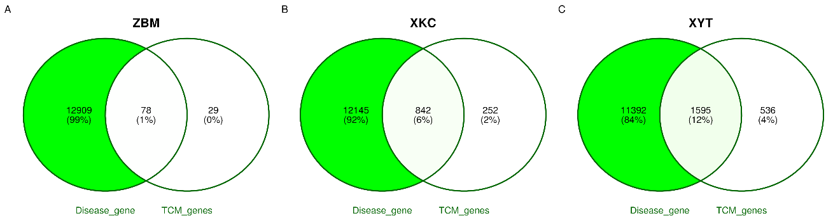
Figure 2 : Venn diagram analysis of disease-related genes and TCM-related genes for the traditional Chinese medicine formulas. (A) ZBM formula showing 12,909 disease-related genes and 29 TCM-related genes with 78 overlapping genes (1% of total). (B) XKC formula revealing 12,145 disease-related genes and 252 TCM-related genes with 842 overlapping genes (6% of total). (C) XYT formula displaying 11,392 disease-related genes and 536 TCM-related genes with 1,595 overlapping genes (12% of total). The overlapping genes indicate potential therapeutic targets associated with each TCM formula.
Figure 3
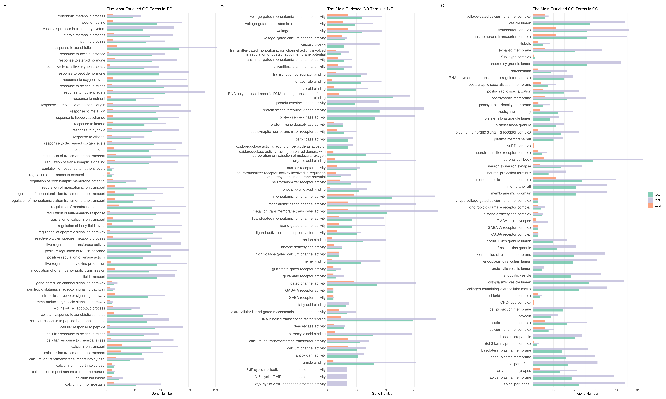
Figure 3: Gene Ontology (GO) enrichment analysis of functional annotations for three traditional Chinese medicine (TCM) formulas: ZBM, XKC, and XYT. The bar chart displays the enriched GO terms in three categories: biological processes (BP), molecular functions (MF), and cellular components (CC). Each formula is represented by a different color: ZBM (light blue), XKC (orange), and XYT (green). The x-axis shows the gene ratio for each GO term, while the y-axis lists the enriched GO terms. The length of each bar indicates the level of enrichment for that particular GO term in the respective formula. This analysis reveals distinct functional profiles for each TCM formula, with XYT showing the highest representation across most entries, followed by XKC and then ZBM, suggesting varying degrees of impact on biological processes related to tumors, inflammation, and proliferation.
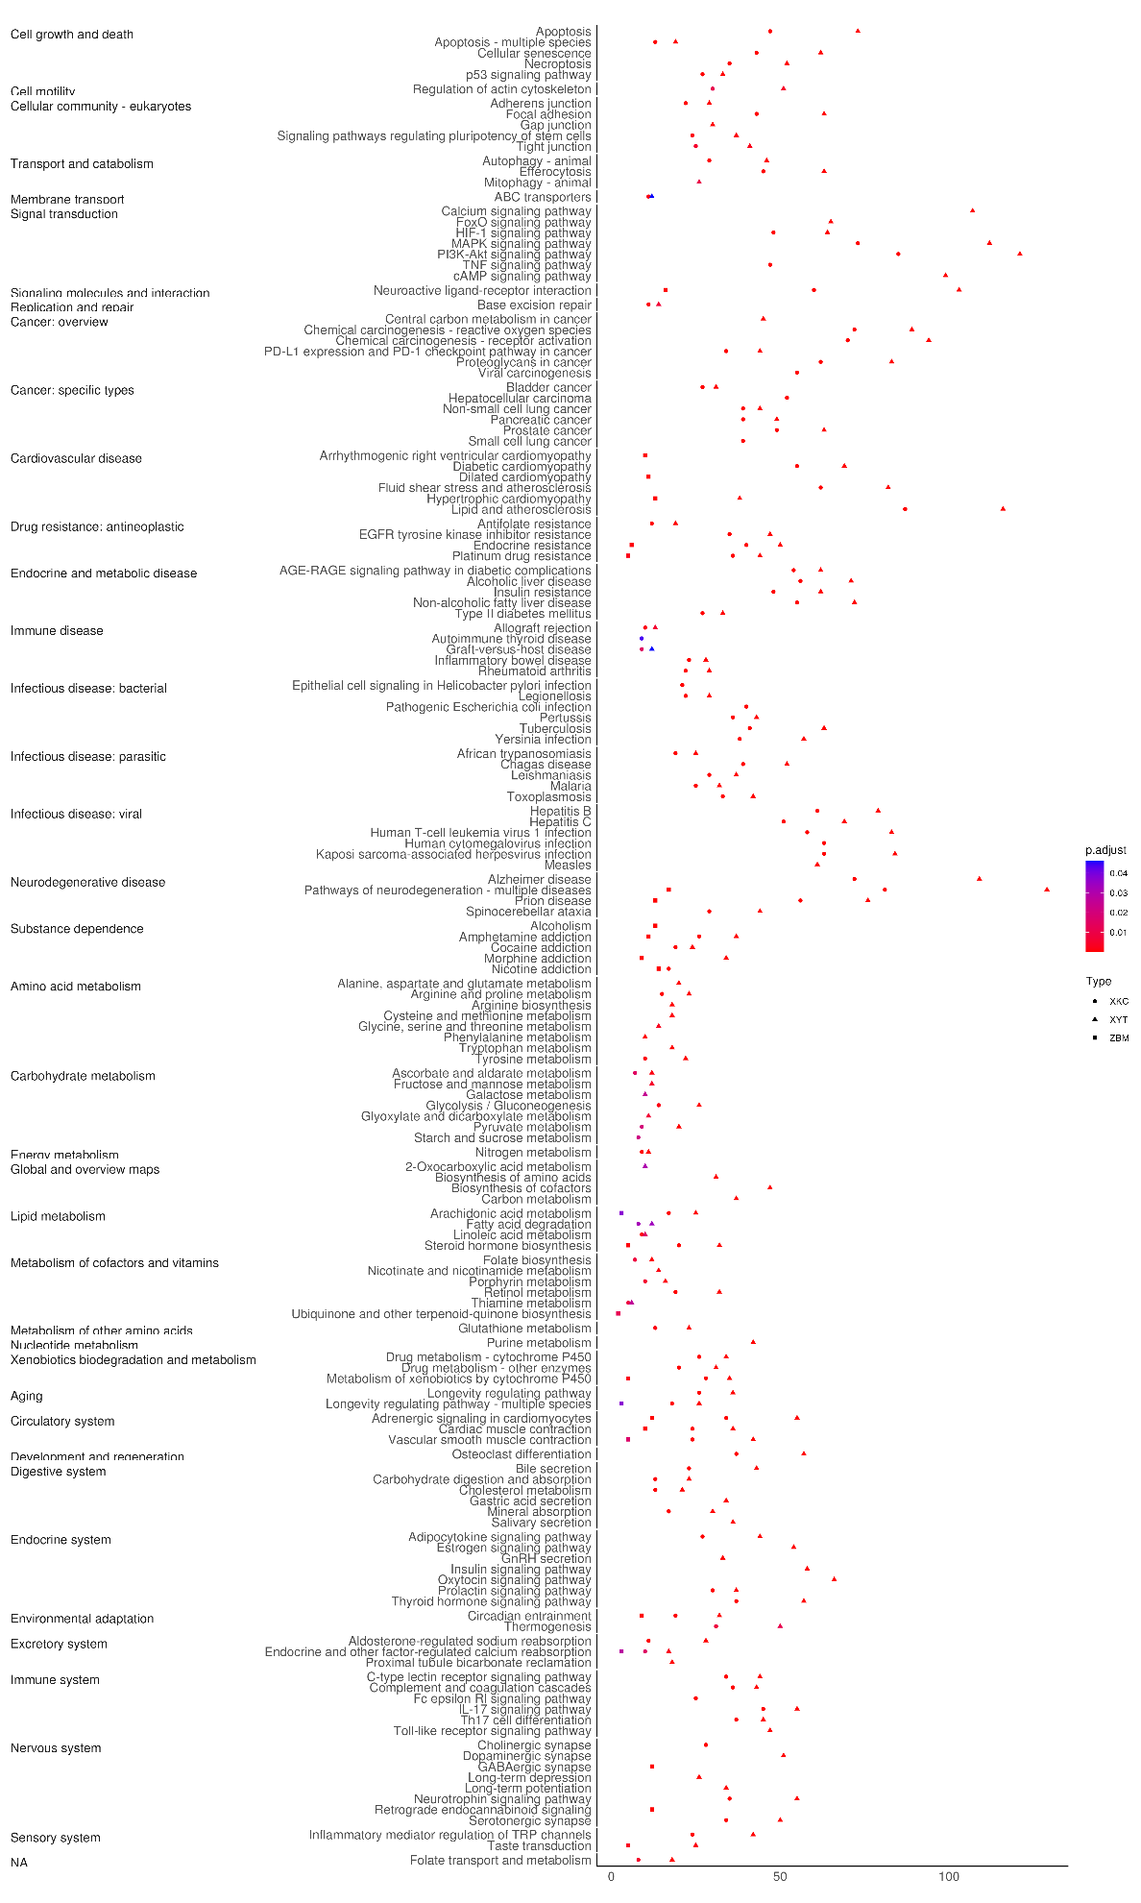
Figure 4: ZBM, XKC, and XYT are three traditional Chinese medicine (TCM) formulations that were subjected to KEGG pathway enrichment analysis. The dot plot displays enriched KEGG pathways that are divided into key functional areas, such as signal transduction, metabolism, immune system, and disease-specific pathways. The gene count is shown by the size of the dots, and the modified p-value significance level is indicated by the colors (red: least significant; purple: most significant). The gene ratio is displayed on the x-axis, while the enriched KEGG pathways are arranged according to functional categories on the y-axis. The three TCM formulae (XYT, XKC, and ZBM) are represented by different forms.

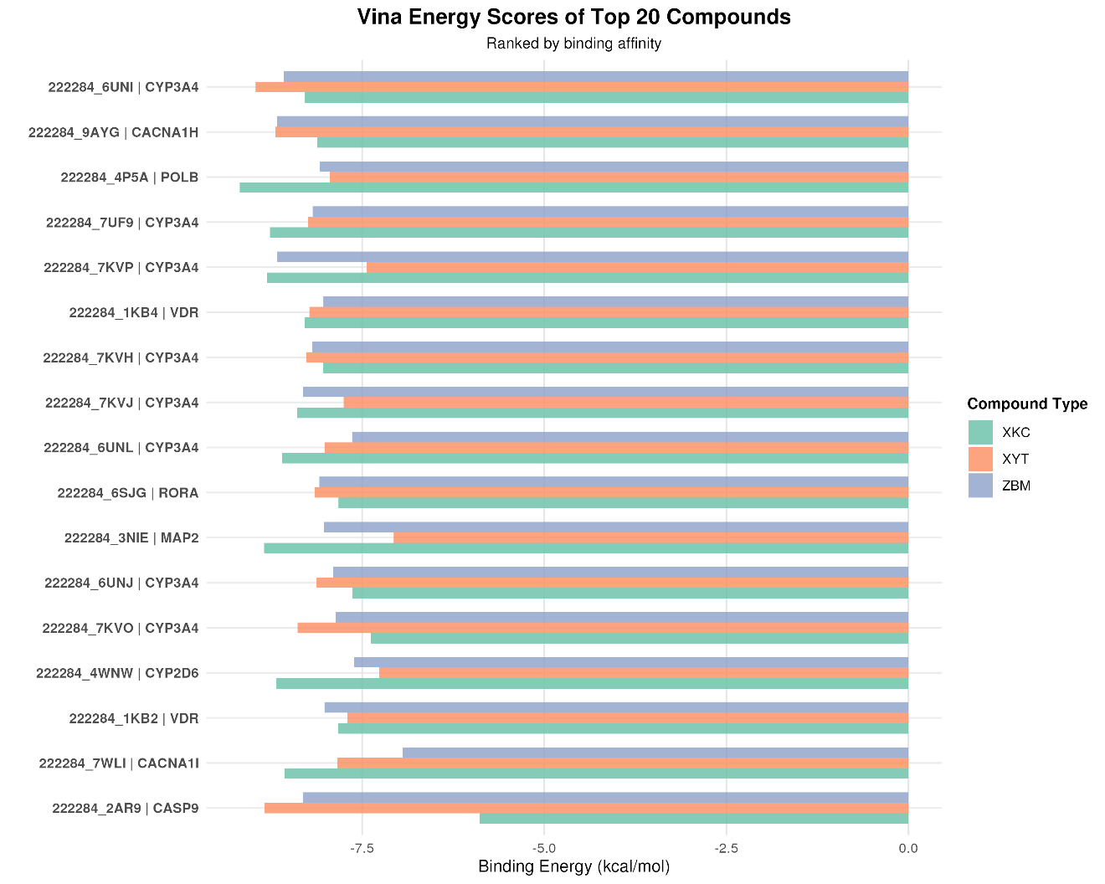
Figure 5: Molecular docking analysis comparing binding energies of top 20 compounds from three traditional Chinese medicine (TCM) formulas: ZBM, XKC, and XYT. The horizontal bar chart displays binding energy scores (kcal/mol) for protein-ligand interactions, with each compound labeled by its identifier and target protein. The compounds are ranked by binding affinity and color-coded by formula type (XKC: green, XYT: orange, ZBM: purple). Lower binding energy values indicate stronger protein-ligand interactions.

