Supplementary figures
Original manuscript Figure 1 is Supplementary Figure S1; original Figure 5 is Supplementary Figure S2. Main Figures 1–3 correspond to original Figures 2–4.

Supplementary Figure S1: Gene-set intersections for ZBM, XKC, and the XYT core-herb set. Shared disease genes total 78, 842, and 1,595, respectively. All comparisons use the same 12,987-gene disease set. Circle areas are schematic and are not proportional to set sizes. XYT denotes the core herbs selected from Xiao Ying Tang for thyroid disease.

Supplementary Figure S2: Exploratory docking poses of β-sitosterol (CID 222284). (A) Human CYP3A4 (PDB 6UNI); (B) human CaV3.2/CACNA1H (PDB 9AYG). Left panels show the local view of the docked ligand (green sticks) and surrounding residues; right panels show the global receptor view. Poses correspond to the minimum supplementary smina scores of −9.12 and −9.68 kcal/mol, respectively. The poses should be interpreted in light of the receptor-preparation and search-region limitations described in the text.

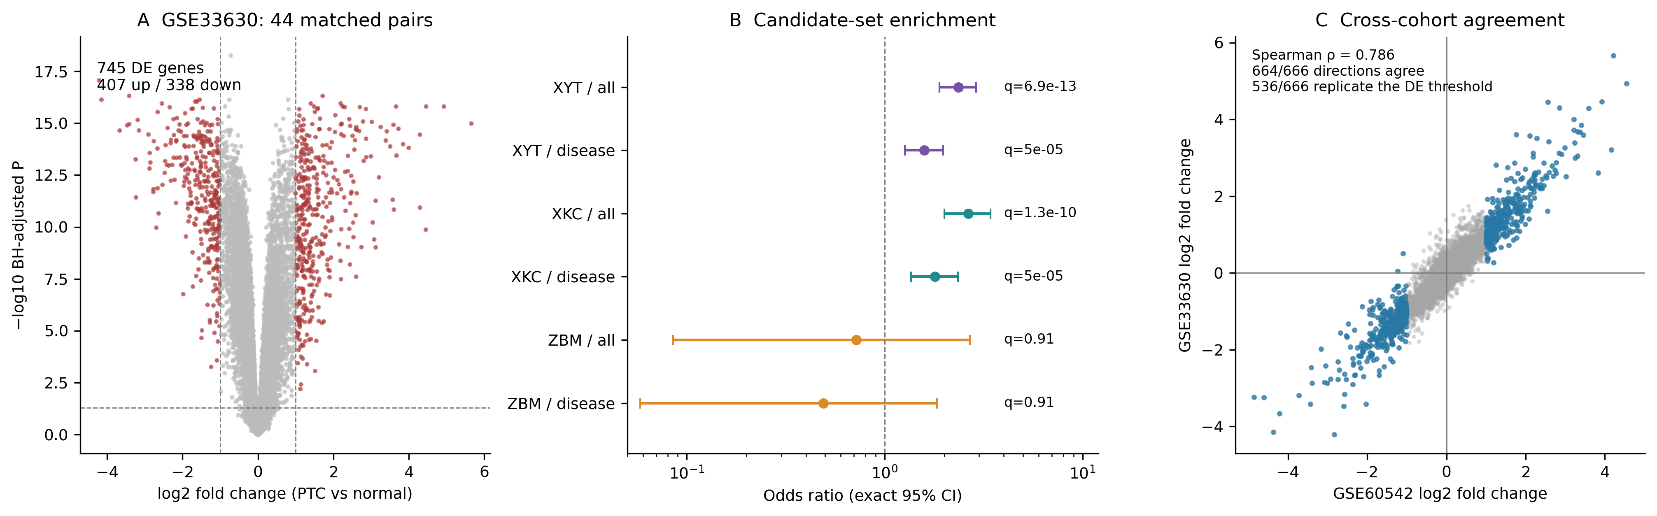
Supplementary Figure S3: Independent replication in GSE33630 (44 matched patients). (A) Paired-limma differential expression: BH-adjusted P <0.05 and |log2FC| ≥1. (B) Candidate-set enrichment against all 20,848 measured genes or 10,655 disease-associated measured genes. Points indicate conditional odds ratios; bars show two-sided exact 95% confidence intervals. q labels are BH-adjusted P values from six one-sided Fisher tests in GSE33630. (C) Gene-level log2 fold changes across cohorts; blue points mark the 666 genes meeting the differential-expression criteria in GSE60542. Of these, 664 had the same direction and 536 met the same criteria with the same direction in GSE33630. The correlation uses all 20,848 genes.

