Supplementary Figures
Network Pharmacology of Xiao Ying Tang Core Herbs with Transcriptomic Assessment in Papillary Thyroid Carcinoma

Supplementary Figure S1: Gene-set intersections for ZBM, XKC and the XYT herb set. Disease-overlapping genes total 78, 842 and 1,595, respectively. All comparisons use the same 12,987-gene disease list. Circle areas are schematic and are not proportional to set sizes. XYT denotes the database-derived herb inventory defined in the Methods, not a chemically characterised preparation.

Supplementary Figure S2: Exploratory docking outputs for β-sitosterol (CID 222284). (A) Human CYP3A4 (PDB 6UNI); (B) human CaV3.2/CACNA1H (PDB 9AYG). Left panels show the ligand (green sticks) and surrounding residues; right panels show the receptor overview. Poses correspond to minimum smina scores of −9.12 and −9.68 kcal/mol, respectively. CYP3A4 was prepared without haem, although the autobox reference contained both haem and inhibitor; the 9AYG reference included several non-protein residue types. Binding sites and docking accuracy were not validated. Scores are computational outputs, not measured binding energies, and cannot establish specific binding or relative affinity across receptors.
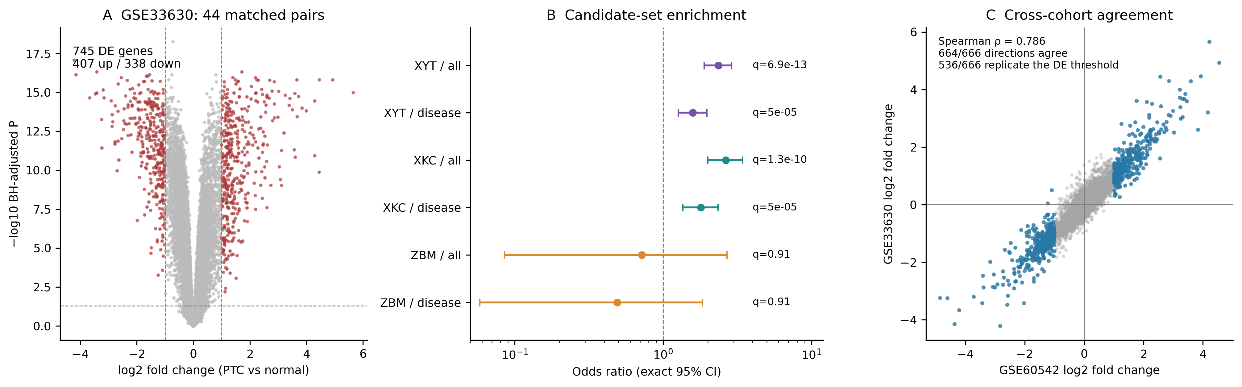
Supplementary Figure S3: Independent expression replication in GSE33630 (44 matched patients). (A) Paired-limma differential expression, with Benjamini–Hochberg-adjusted P <0.05 and |log2FC| ≥1. (B) Candidate-set enrichment against all 20,848 measured genes or 10,655 disease-associated measured genes. Points show conditional odds ratios; bars show two-sided exact 95% confidence intervals. q labels are adjusted P values from six one-sided Fisher tests in this cohort. (C) Gene-level log2 fold changes across cohorts; blue points mark the 666 genes meeting the differential-expression criteria in GSE60542. Of these, 664 agreed in direction and 536 met the same criteria with concordant direction in GSE33630. Spearman correlation uses all 20,848 genes. Gene-set replication indicates disease association, not response to herbal treatment.

