Abstract
Background: False localizing signs are neurological manifestations that are easily misdiagnosed, and no bibliometric mapping of this field has been reported to date. This study performed a bibliometric and visualization analysis of research on false localizing signs to summarize publication trends, major contributors, research hotspots, and emerging directions for this rare clinical phenomenon.
Methods: We searched PubMed and the Web of Science Core Collection for publications indexed between January 1, 1904, and July 31, 2026. After parsing, deduplication, and exclusion of retracted and irrelevant records, we used Python to analyze publication trends, geographic distribution, journal and institutional contributions, author collaboration networks, and keyword co-occurrence.
Results: A total of 159 publications from 1904 to 2026 were included. Annual output increased over time with marked fluctuation. High-output journals were concentrated in neurosurgery and neurology. The United States contributed the most publications, whereas collaboration among countries, institutions, and authors was sparse. Research hotspots included imaging and differential diagnosis, increased intracranial pressure, brain neoplasms, and false localizing signs associated with cervical spinal cord lesions. Over the study period, research shifted from descriptions of clinical phenomena toward imaging-based differential diagnosis and mechanistic investigation.
Conclusions: Research on false localizing signs has grown slowly but steadily for more than a century, and timely, accurate diagnosis remains essential. These findings may help guide clinical practice. Future work should focus on sharing diagnostic and therapeutic experience and data and on clarifying the mechanisms that underlie these signs.
Keywords: false localizing signs; bibliometrics; visualization analysis; Python; developmental trends
Abbreviations: WoSCC, Web of Science Core Collection; FLS, false localizing sign.
Web of Science Core Collection (WoSCC).
- 1. Introduction
False localizing signs are rare neurological manifestations in which the lesion location inferred from clinical examination does not correspond to the actual site of pathology [1]. The concept was first described by Collier in 1904 [2]. Classic examples include cranial neuropathies caused by intracranial lesions [3] and distal sensory or motor abnormalities resulting from spinal cord lesions [4]. Because these signs are misleading, they often lead to misdiagnosis and delayed treatment, and they have long attracted the attention of neurologists, neurosurgeons, and radiologists. Over the past century, many investigators have reported their varied clinical presentations and causes. Despite this accumulated literature, however, no study has defined the overall research trends in this field.
Bibliometric analysis uses mathematical and statistical methods, such as co-occurrence analysis, to study how scientific knowledge develops, and specialized software can visualize the literature of a given field [5]. Co-occurrence analysis of countries, authors, and keywords can quickly reveal current research hotspots and trends [6].
Accordingly, we collected studies on false localizing signs published between 1904 and 2026 and applied bibliometric tools to trace the evolution of the field, describe its current state, identify research gaps, and suggest future directions, with the aim of improving understanding of this uncommon clinical problem.
2. Materials and Methods
2.1 Data sources and search strategy
We obtained the data for this study from the Web of Science Core Collection (WoSCC) and PubMed, covering January 1, 1904, through July 31, 2026. Only English-language publications were considered, including journal articles, reviews, and case reports. The PubMed search query was: (false localizing sign*[Title/Abstract]) OR (false localising sign*[Title/Abstract]) OR (Pseudo-localization sign[Title/Abstract]). In WoSCC, we searched the Topic field using: TS=(false localizing sign*) OR TS=(false localising sign*) OR TS=(pseudo-localization sign). The search results were exported in TXT format and processed with Python. Three researchers (LT, LZY, and GY) independently screened the titles and abstracts and examined the full texts when necessary. Merging the two datasets yielded 526 records, of which 315 were excluded during topic screening. Exclusion criteria were conference abstracts, duplicate publications, and records with missing information that could not be parsed. After deduplication removed 53 further records, 159 remained for bibliometric analysis. Figure 1 shows the study selection process.
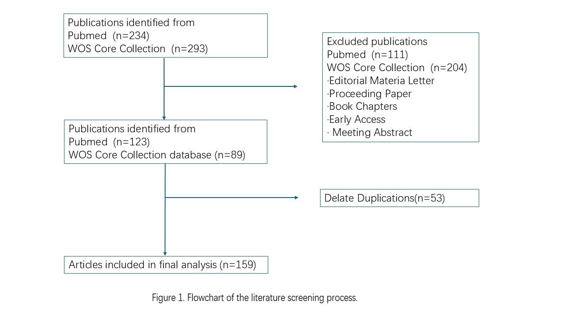
2.2 Data analysis
We imported the processed TXT files into Python. Annual publication output and the core authors, countries, journals, and high-output institutions were calculated with the pandas and NumPy libraries. Keyword clustering was performed with SciPy, and burst-term analysis with spaCy. Finally, we used matplotlib and seaborn to visualize publication trends, keyword co-occurrence networks, keyword clusters, and emerging keywords.
3. Results
3.1 Retrieval and deduplication results
The search retrieved 123 records from PubMed and 89 from WoSCC. Sequential deduplication by PMID, DOI, and normalized title removed 53 duplicates, leaving 159 publications from 1904 to 2026 for analysis. Of these, 135 records had a DOI and 123 had an abstract. We classified the publications into mutually exclusive categories according to a predefined priority order: 72 case reports (45.3%), 11 reviews, including systematic reviews (6.9%), 1 clinical trial (0.6%), 4 letters, editorials, or commentaries (2.5%), 4 historical or biographical publications (2.5%), 66 other journal articles (41.5%), and 1 other publication type (0.6%) (Figure 2).
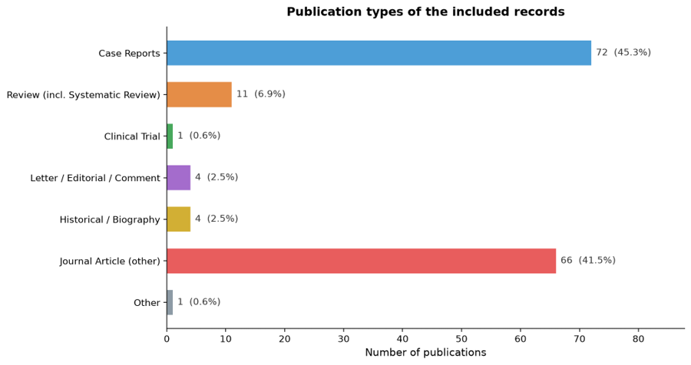
Fig. 2. Distribution of publication types among the included records (exclusive single-label classification).
3.2 Annual publication output and trend analysis
Figure 3 uses a dual-axis design: blue bars represent annual publications and the red line cumulative publications. The analysis covered 159 publications on false localizing signs published between 1904 and 2026. The field developed in several phases. During the emergence and sporadic-publication phase (1900s–1970s), output was low and discontinuous, with occasional years reporting one or two publications, such as 1904, 1921, and 1949; over roughly 70 years, the cumulative literature reached only about 20 publications. During the acceleration and breakthrough phase (1980s–1990s), the spread of neuroimaging was accompanied by a steady increase in publications. From around 1978 onward, annual output rose to two or three publications, followed by a modest peak of five in 1993. The cumulative curve began to move beyond its plateau, with a marked increase in slope, and reached approximately 60 publications by 2000. During the rapid-expansion phase (2000s to the present), annual output frequently reached four to six publications and peaked at nine in both 2021 and 2024, and the cumulative curve rose steeply.
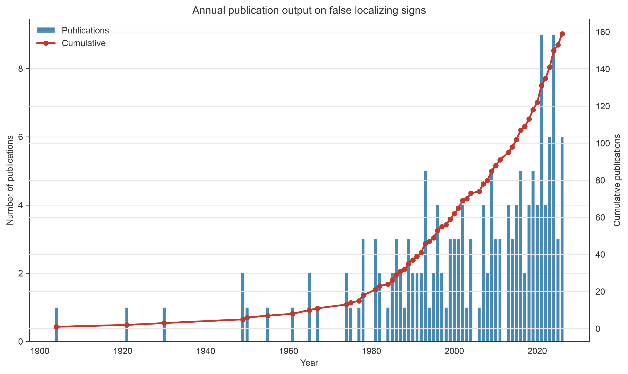
Fig. 3. Annual publication output and cumulative trend of studies on false localizing signs.
3.3 Journal distribution
Figure 4 shows the distribution of journals. Traditional clinical neurology and neurosurgery journals predominated. The Journal of Neurology, Neurosurgery, and Psychiatry (JNNP) ranked first with nine publications, followed by Neurosurgery (seven) and Surgical Neurology (five). Other productive journals included Survey of Ophthalmology in ophthalmology, AJNR: American Journal of Neuroradiology in neuroimaging, and Movement Disorders Clinical Practice in movement disorders.

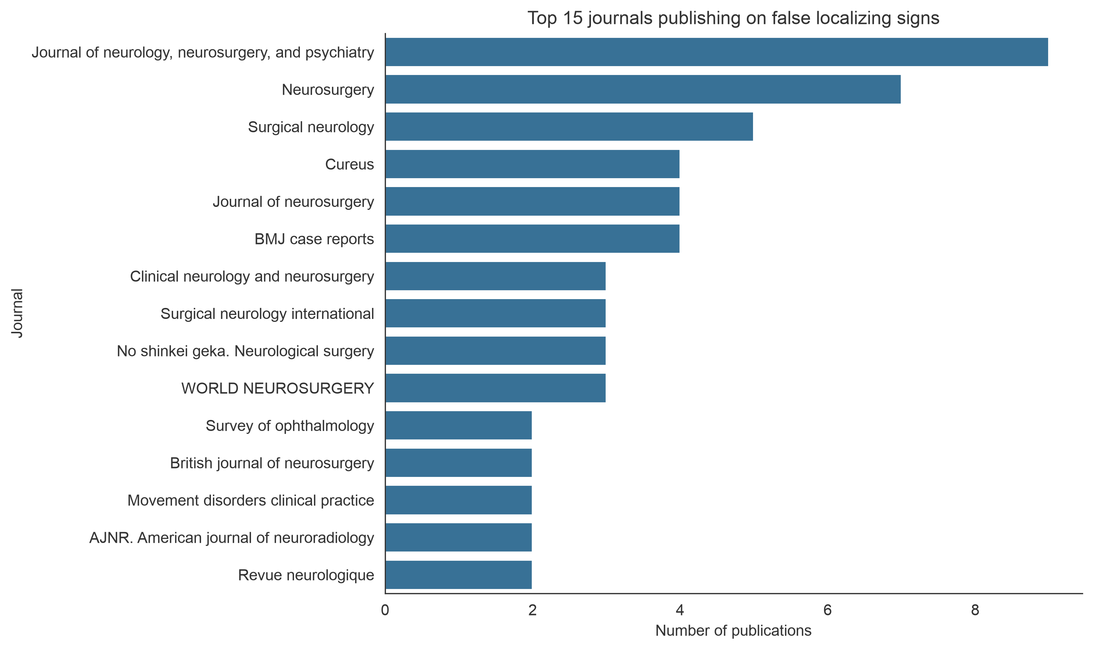
Fig. 4. Top journals publishing studies on false localizing signs.
3.4 Geographic distribution and co-occurrence network
Figure 5 shows the geographic distribution of publications. The United States led with 24 publications, approximately 15% of the total. India and Japan ranked second and third, with 13 publications each, followed by the United Kingdom (9), Spain (8), Australia (5), Italy (3), Malaysia (3), South Korea (3), and China (3).
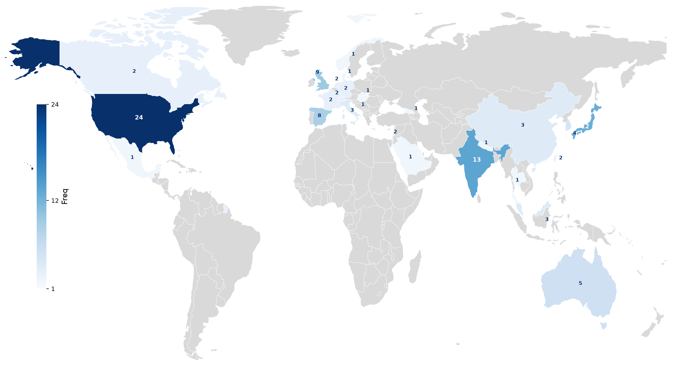
Fig. 5. Geographic distribution of false localizing sign publications worldwide. The color intensity reflects the publication frequency of each country, with darker shades indicating higher research productivity (grey: no records).
Figure 6 presents the country co-occurrence network. Node size corresponds to the number of publications from a country, links indicate collaboration, and link thickness represents collaboration strength. The United States–Mexico–Italy–Slovenia cluster occupied the central position, with the United Kingdom–Denmark–Australia, Malaysia–South Korea, and Germany–Switzerland clusters as secondary centers. The remaining countries and regions formed no collaborative networks.
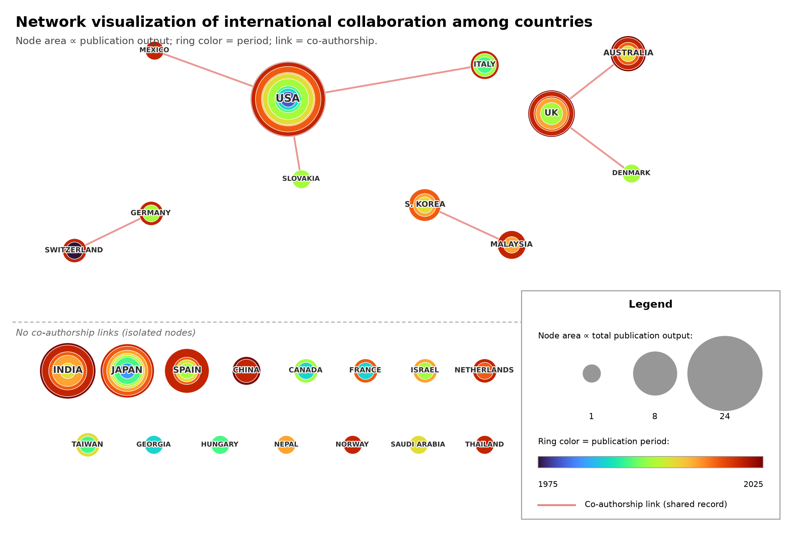
Fig. 6. Network visualization of international collaboration among countries in false localizing sign research. Each node represents a country, with node area proportional to total publication output. Concentric rings represent 5-year periods with publication activity: ring color indicates the publication period (1975–2025, see color scale) and ring area is proportional to the number of publications in that period. Links indicate co-authorship within one record; countries without co-authorship links (isolated nodes) are arranged in the bottom strip.

3.5 Research institutions
We extracted and standardized the institution names in Table 1 from affiliation fields. Because the same institution may appear in different forms, some fragmentation across entries is likely; the results should therefore be read as a descriptive indication of where research activity is concentrated rather than as exact counts.
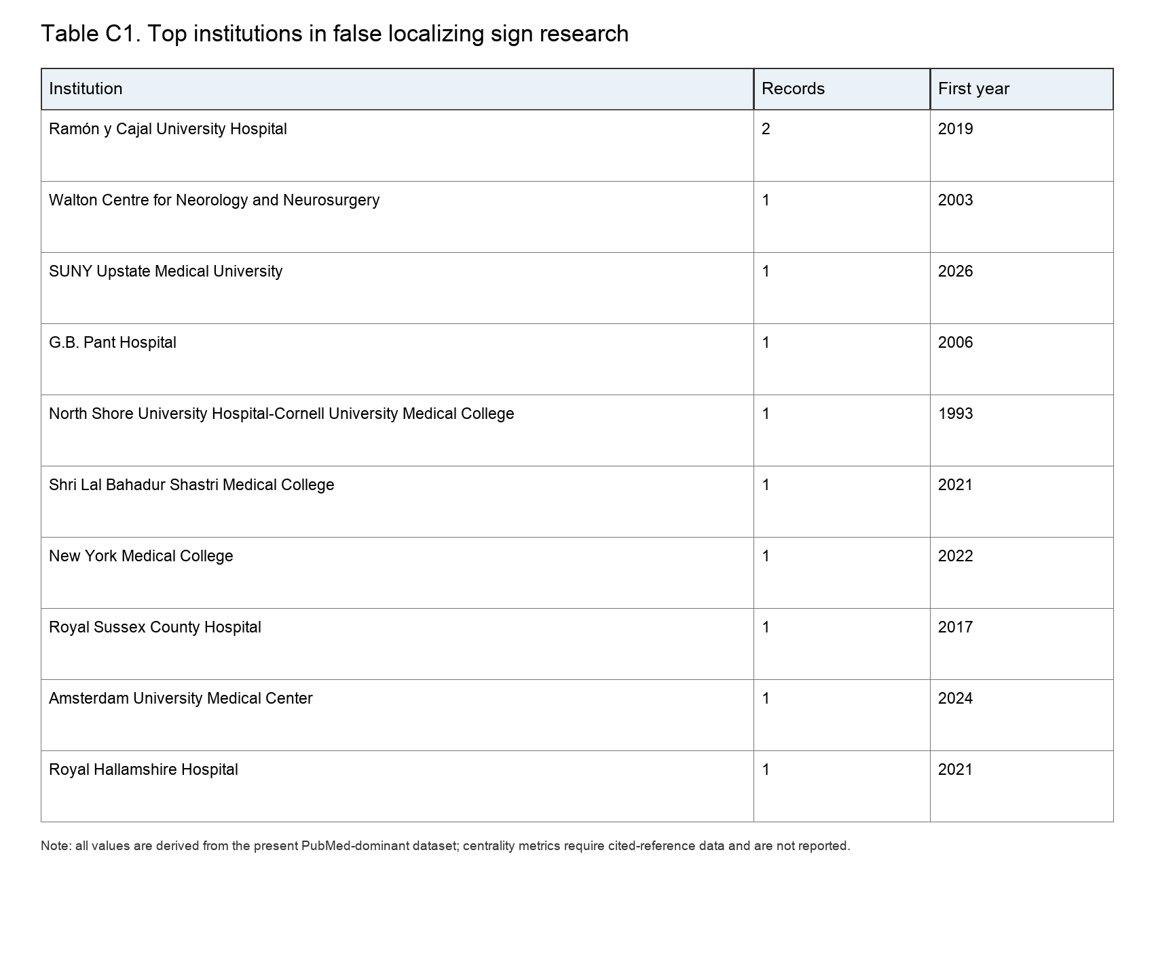
Table 1. Top institutions extracted from affiliation fields.
3.6 Core first authors and author collaboration network
To avoid counting the same publication multiple times across coauthors, Table 2 reports publication output by first author, with each publication counted once for its first author. Figure 7 shows the co-authorship network of the field.
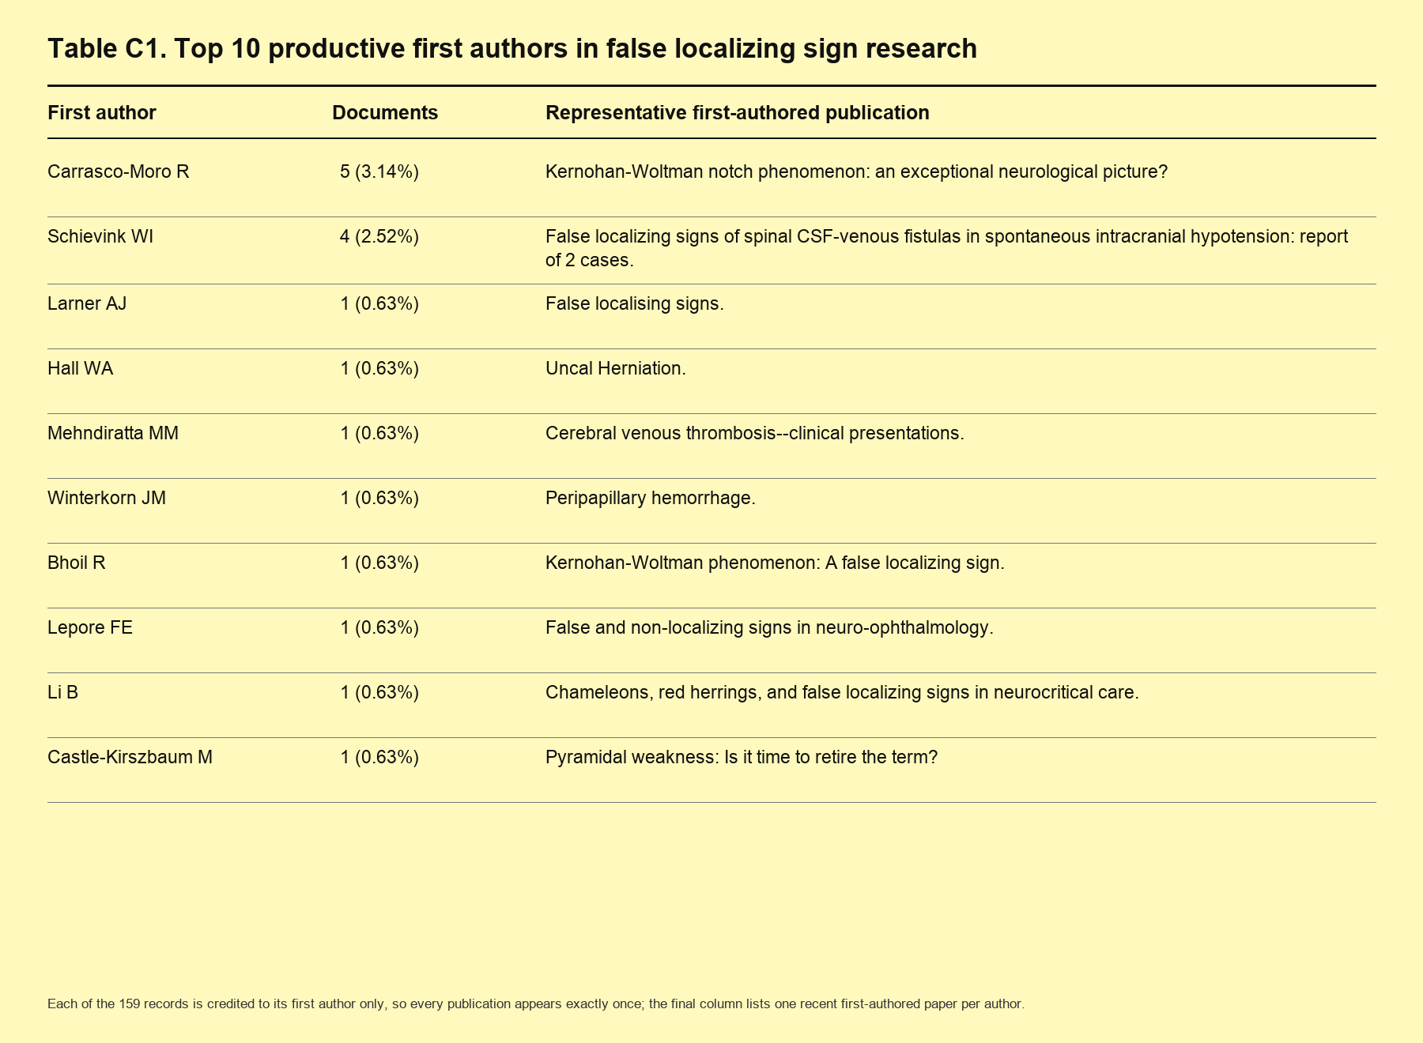
Table 2. Top 10 productive first authors in false localizing sign research.

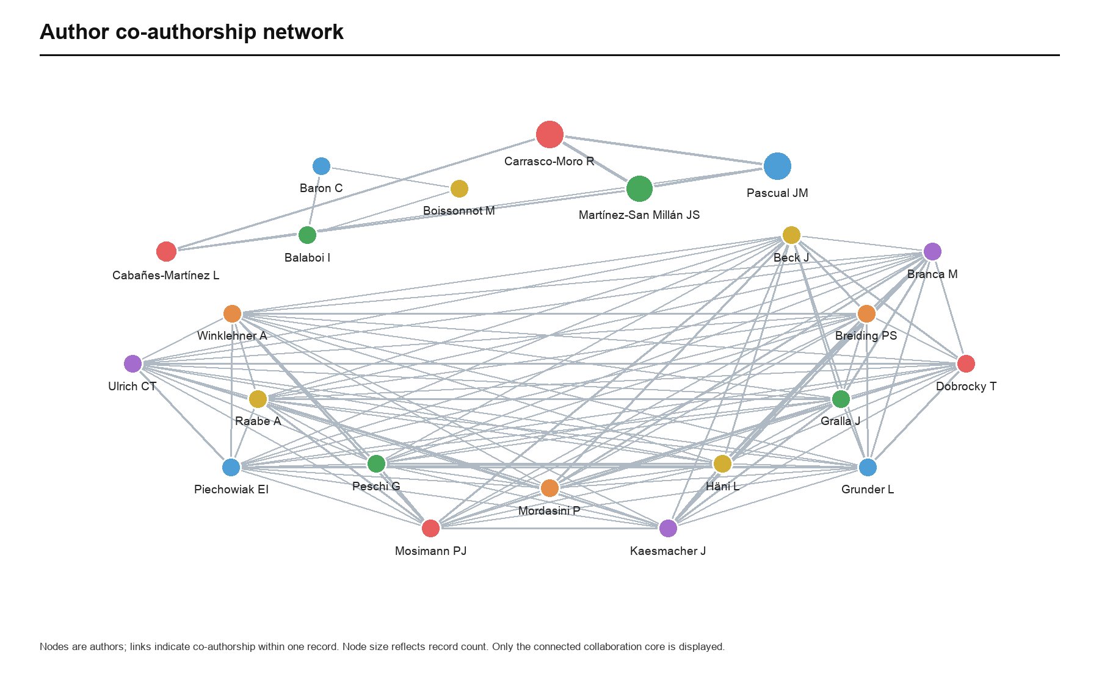
Fig. 7. Co-authorship network of authors in false localizing sign research.
3.7 Keyword co-occurrence network
The keyword co-occurrence network for false localizing sign research comprised 480 nodes and 2,937 links, with a density of 0.0255 (Figure 8). Keyword frequency reflects how much attention a topic receives: the three most frequent keywords were Magnetic Resonance Imaging (28 occurrences), False localizing sign (26), and Diagnosis, Differential (21). Keywords with betweenness centrality above 0.1 are generally regarded as hubs in a co-occurrence network; here, these were False localizing sign (0.19), Magnetic Resonance Imaging (0.16), and Tomography, X-Ray Computed (0.12). The same three keywords ranked highest when the analysis was restricted to keywords occurring at least five times with betweenness centrality of at least 0.05.
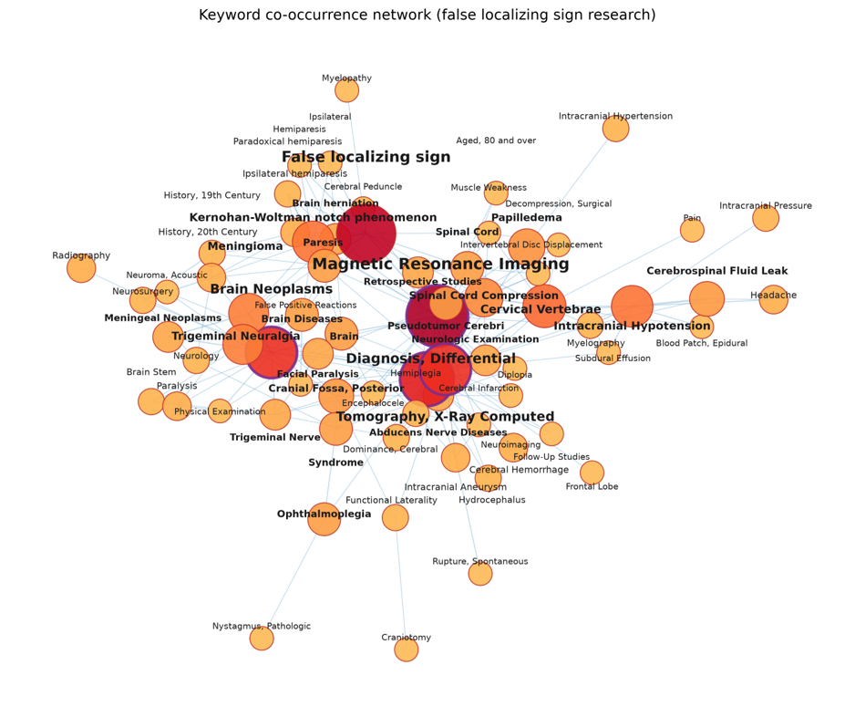
Fig. 8. Keyword co-occurrence network of false localizing sign research (480 nodes, 2,937 links; density = 0.0255). The visualization retains keywords with frequency >= 3 and links with co-occurrence weight >= 2; node size is proportional to keyword frequency, and purple rings mark keywords with betweenness centrality > 0.1. Synonymous variants were merged using a thesaurus file before analysis.
3.8 Keyword clusters and temporal evolution of themes
We used keyword co-occurrence relationships to cluster closely related terms, applying a modularity-based method and labeling clusters with the log-likelihood ratio (LLR) method; the results are shown in Figure 9. Six clusters (#0–5) were identified: #0 Magnetic Resonance Imaging, #1 Brain Neoplasms, #2 False localizing sign, #3 Tomography, X-Ray Computed, #4 Intracranial Hypotension, and #5 Syndrome. The modularity was Q = 0.466 (Q > 0.3 indicates a significant cluster structure), and the weighted mean silhouette coefficient was S = 0.271, indicating moderate within-cluster homogeneity. Given the small size of the literature and the thematic overlap among studies, we consider this clustering acceptable. In the timeline plot, the first and last years in which each keyword appears in the dataset define the plotted span; the red segments mark the period covered by the records and do not indicate citation-burst intensity.
Figure 10 shows the temporal span of themes based on the first and last years in which the corresponding keywords appear in the dataset; again, the red segments mark the period covered by the records rather than citation-burst intensity. Table 3 summarizes the interpreted keyword clusters.

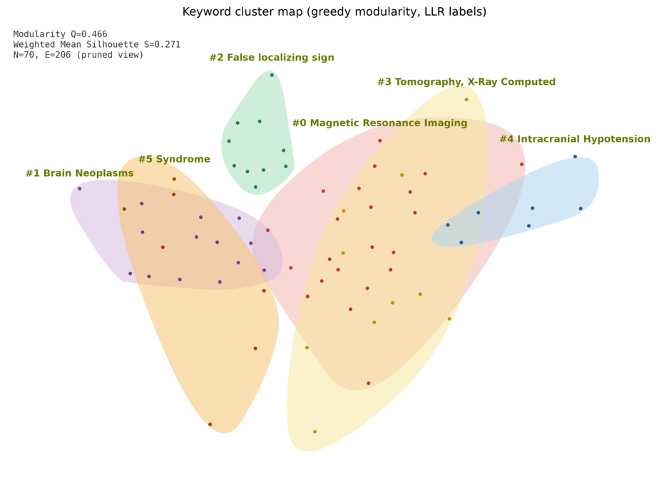
Fig. 9. Modularity-based cluster map of keywords in false localizing sign research. Six clusters (#0–5) were identified and labeled by the log-likelihood ratio (LLR) method (modularity Q = 0.466, weighted mean silhouette S = 0.271).
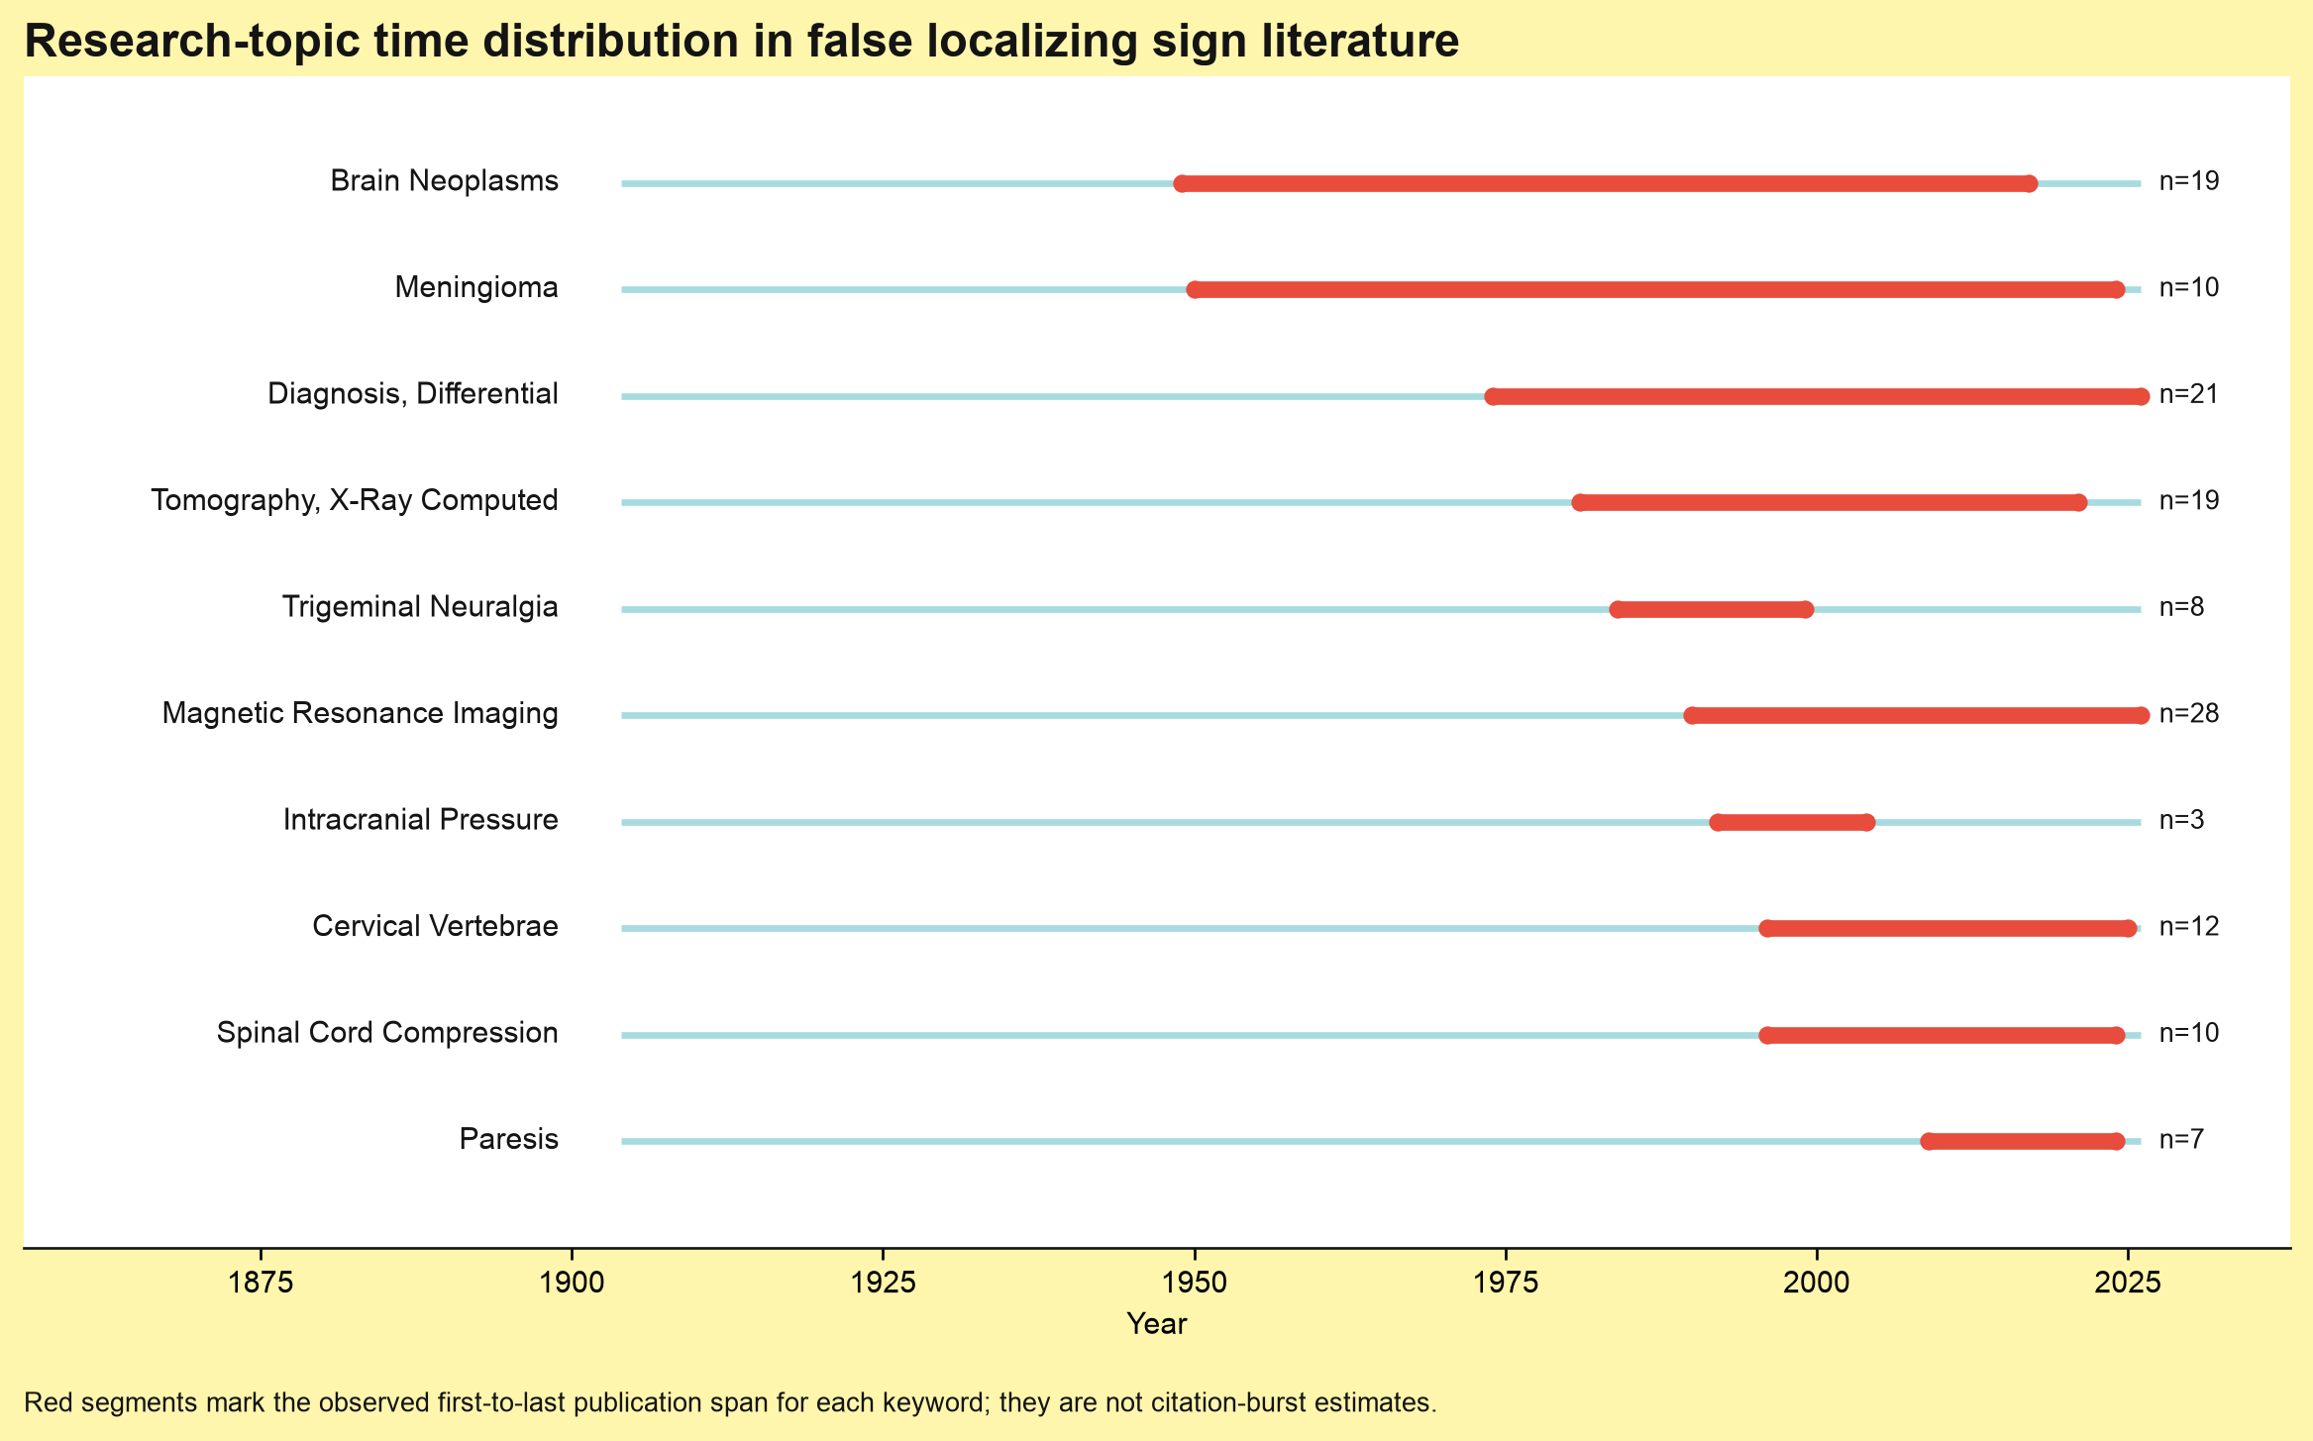
Fig. 10. Observed time span of major research topics.
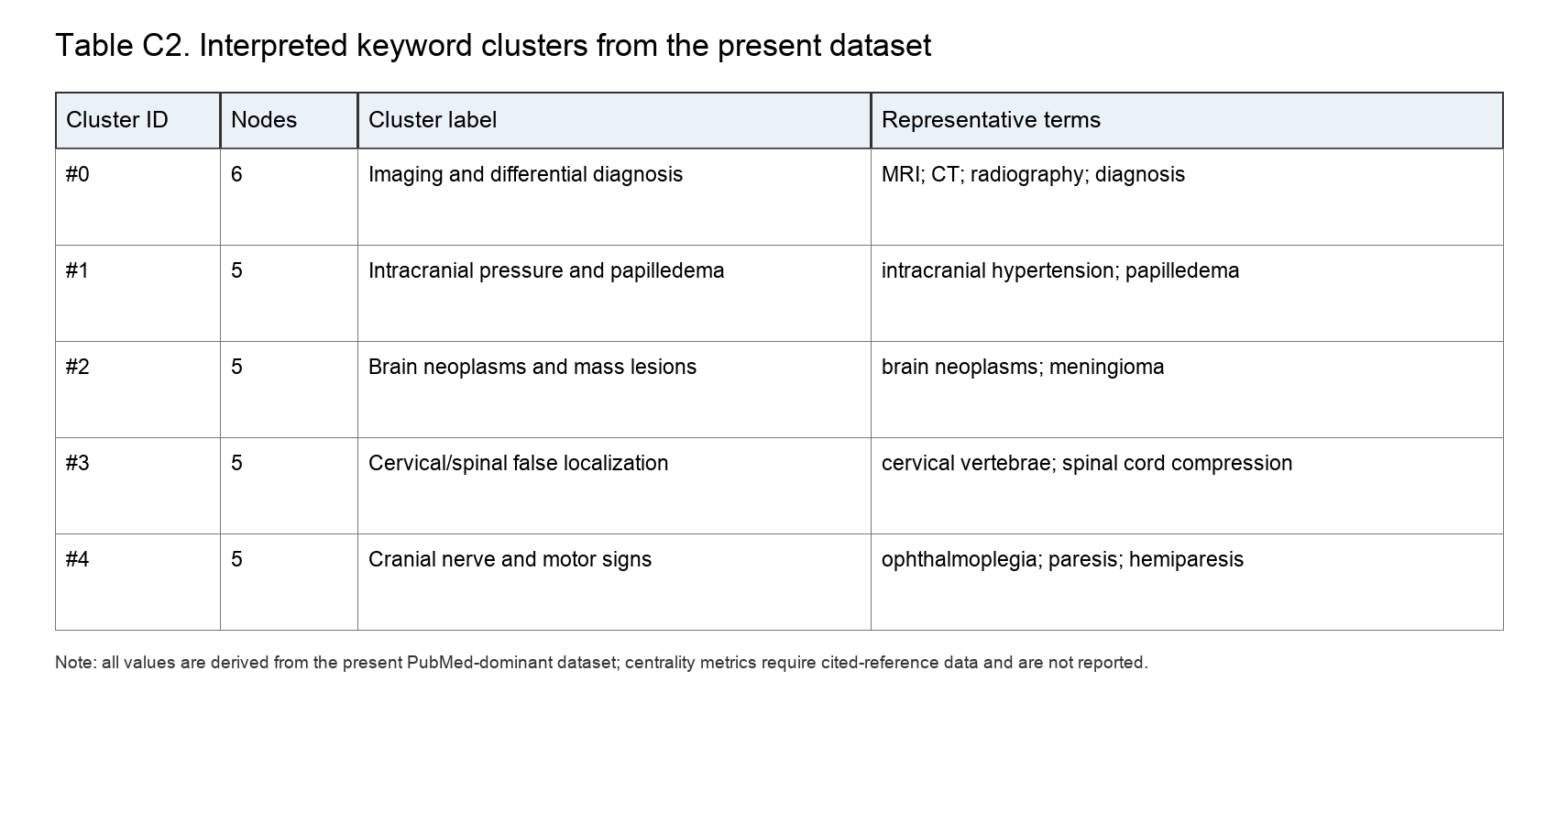
Table 3. Interpreted keyword clusters based on the present dataset.
4. Discussion
This bibliometric analysis covers research on false localizing signs from the first use of the term in 1904 through 2026. Publication output has remained generally steady, which reflects sustained global interest in these rare neurological manifestations. The peak in 2024 may be related to recent advances in the understanding of false localizing signs.
The steady increase in publication output, particularly over the past five years, suggests that research on false localizing signs has begun to accumulate at scale. This growth reflects a broadening of research interests and may be associated with advances in MRI- and CT-based diagnosis. Even so, only 159 publications have appeared in more than a century, and case reports (45.3%) and reviews (6.9%) make up a large share. Although case reports occupy the lowest level in the hierarchy of evidence-based medicine, they remain important sources of clinical guidance and scientific insight [7] and may have considerable implications for diagnosis, treatment, and complications [8]. For rare diseases in particular, case reports can guide timely diagnosis and treatment [9]. The Journal of Neurology, Neurosurgery, and Psychiatry (impact factor, 7.56) and Neurosurgery (impact factor, 4.196) are established neuroscience journals with long publication histories and international influence. Although the literature on false localizing signs has been dominated by individual cases, diagnostic precision is likely to improve as technology advances, and the field may gradually move from reliance on case reports toward higher-quality research.
Our analysis showed marked geographic concentration in false localizing sign research. The United States (24 publications), India (13), and Japan (13) were the main contributors. This pattern is broadly consistent with differences in healthcare and research capacity: high-income countries have traditionally led in neuroscience and can better support sustained scientific output. The collaboration network showed clear regional clustering with limited intercontinental collaboration; the main links were among the United States, Mexico, Italy, and Slovenia; the United Kingdom, Denmark, and Australia; and Switzerland and Germany. Only one institution, Ramony Cajal University Hospital, contributed two publications. This may be partly because many older records do not report the authors’ specific affiliations or countries in the databases, which also helps explain why the country and institution co-occurrence networks were relatively sparse. Other representative institutions included the Kessler Institute for Rehabilitation in the United States and the Department of Neurosurgery at Kitano Hospital in Osaka, Japan, both with substantial clinical experience and research capacity.
Keyword clustering revealed a clear thematic structure: imaging and differential diagnosis, increased intracranial pressure, brain neoplasms, and cervical spinal cord and localizing signs were the principal themes. Burst-term analysis pointed to three temporal directions. Imaging-related approaches, represented by X-ray, MRI, and differential diagnosis, have persisted from 1975 to the present. With successive technological advances, the field has moved from relatively low-resolution X-ray imaging toward MRI, reflecting the growing maturity of the tools used to differentiate false localizing signs. False localizing signs associated with higher central nervous system lesions, represented by brain neoplasms, meningioma, increased intracranial pressure, and trigeminal neuralgia, appeared as early as 1950 and have persisted to the present; this was the earliest and longest-lasting thematic direction, suggesting that intracranial lesions may produce particularly diverse and complex false localizing signs. False localizing signs associated with peripheral nervous system lesions, represented by cervical vertebrae and spinal cord pressure, emerged more recently.
Classic false localizing signs are currently thought to occur mainly in two settings: increased intracranial pressure and spinal cord lesions [10]. Intracranial hypertension caused by brain tumors may produce false localizing signs, most commonly involving the third and sixth cranial nerves [11], although other cranial nerves may also be affected. Simultaneous involvement of multiple nerves is uncommon; an example is an acoustic neuroma accompanied by trigeminal sensory disturbance, abducens palsy, and peripheral facial palsy [12], which can make diagnosis difficult. Ipsilateral functional deficits are harder to interpret than contralateral signs [13], because ipsilateral weakness results from compression of the contralateral brainstem [14]. One study reported false localizing signs in 8 of 11 patients with intracranial mass lesions and associated this finding with remote cerebral hyperemia [15]. Traction on cranial nerves [10] and compression of the relevant ascending and descending spinal pathways are the most commonly proposed explanations, but the underlying mechanisms remain unclear.
False localizing signs after spinal cord injury may manifest as distal sensory or motor abnormalities, such as a girdle sensation in the chest after cervical spinal cord injury [16] or symptoms involving the waist, perineum, and legs [17]. Particular caution is warranted because thoracic multiple myeloma may present with abdominal or pelvic pain. Somatic sensory innervation from the T7–T12 nerve roots supplies the upper abdominal wall, and pain arising from thoracic vertebral bodies or spinal nerves may therefore be mistaken for pain originating from abdominal organs [18]. Most cases of neuropathic pain below the level of spinal cord injury occur after incomplete injury; preserved axons in the spinal cord white matter continue to transmit ascending and descending pain signals [19]. Compression of midline ventral structures in the cervical spinal cord [16] and abnormal ascending and descending conduction through the spinal white matter may produce hyperesthesia [20], thereby resulting in false localizing signs.
Modern imaging techniques such as MRI and CT have reduced the likelihood of misdiagnosing false localizing signs, but recognizing these signs remains a challenge for clinicians in neurology, neurosurgery, and neurorehabilitation. As early as 1982, investigators used intra-arterial xenon-133 injection to study the mechanisms of false localizing signs [15]. With technological advances, noninvasive MRI has replaced such invasive techniques and allows more direct and precise assessment of neurological disease. One study found that, among patients with thoracic sensory disturbances, cervical MRI revealed compressive spinal cord lesions in eight patients and demyelinating lesions in four [21]. These findings suggest that abnormal truncal sensation should prompt consideration of a false localizing sign and timely MRI of the cervical spine and brain [16,17]. For ipsilateral hemiparesis, modern imaging has also demonstrated variability in brainstem morphology and anatomical position, supporting the validity of ipsilateral deficits first proposed in 1929 [22]. Multidisciplinary assessment has been advocated to improve the timeliness and accuracy of diagnosis [23].
This study has several limitations. The databases searched were limited, and only 159 publications were identified over nearly a century; this small evidence base itself points to the need for further research. Understanding false localizing signs should go beyond describing clinical phenomena and lesion locations: the underlying mechanisms must be explored so that clinical manifestations can be reliably linked to disease. Research on treatment should advance alongside efforts to improve diagnostic accuracy. For example, electroacupuncture may relieve girdle sensations after spinal cord injury [24]. Recognizing false localizing signs requires considerable clinical expertise, but neuroimaging has advanced rapidly and relevant imaging databases have begun to appear worldwide [25]. A dedicated public database for this field should be established, with imaging data for each type of false localizing sign recorded in a standardized, searchable form for clinicians and researchers. Machine learning could also be used to build differential-diagnosis models, which may substantially improve the identification of false localizing signs and the detection of their underlying primary lesions [26].
5. Conclusion
This bibliometric analysis covers more than a century of research since 1904 and shows steady growth in publication output together with an evolution in research themes. With advances in imaging technologies such as MRI, false localizing signs caused by intracranial and spinal cord lesions can now be diagnosed more clearly and studied in greater depth. The United States has remained the leading contributor, whereas international collaboration is still limited. Future research should emphasize the sharing of diagnostic and therapeutic experience and data, together with investigation of the underlying mechanisms. Stronger international collaboration will be essential for improving the recognition and understanding of these rare clinical signs.

[1] Park J.M., Kim J.H. False localizing sign caused by schwannoma in cervical spinal canal at C1-2 level: A case report [J]. Medicine (Baltimore), 2018, 97(36): e12215.
[2] J C. Collier J.The false localizing signs of intracranial tumour. Brain 1904; 27: 490–508.1904,
[3] Pellegrini F., Interlandi E., Cuna A., et al. Spontaneous chronic subdural hematoma as the cause of oculomotor cranial nerve palsy: A narrative review [J]. Brain Circ, 2022, 8(4): 188-191.
[4] Gao K., Cao Y., Wu Y., et al. Cervical cord compression with lower limb sensory disturbance: three case reports and a literature review [J]. J Int Med Res, 2023, 51(6): 3000605231178414.
[5] van Eck N.J., Waltman L. Software survey: VOSviewer, a computer program for bibliometric mapping [J]. Scientometrics, 2010, 84(2): 523-538.
[6] Ling F., Qi W., Li X., et al. Bibliometric Analysis of Acupuncture Therapy for Cancer Pain Over the Past 10 Years [J]. J Pain Res, 2023, 16(985-1003.
[7] Firat A.C., Araz C., Kayhan Z. Case reports: Should we do away with them? [J]. J Clin Anesth, 2017, 37(74-76.
[8] Yuksel Aslier N.G., Aslier M. The Bibliometric Aspects of Case Report/Series in Science Citation Index Otorhinolaryngology Journals [J]. Turk Arch Otorhinolaryngol, 2021, 59(3): 193-202.
[9] Erivan R., Dartus J., Villatte G., et al. Bibliometric analysis of case report citations and their effect on the impact factor: How does publishing case reports impact journals? [J]. Orthop Traumatol Surg Res, 2020, 106(8): 1463-1467.
[10] Larner A.J. False localising signs [J]. J Neurol Neurosurg Psychiatry, 2003, 74(4): 415-418.
[11] Lepore F.E. False and non-localizing signs in neuro-ophthalmology [J]. Curr Opin Ophthalmol, 2002, 13(6): 371-374.
[12] Ro L.S., Chen S.T., Tang L.M., et al. Concurrent trigeminal, abducens, and facial nerve palsies presenting as false localizing signs: case report [J]. Neurosurgery, 1995, 37(2): 322-324; discussion 324-325.
[13] McKenna C., Fellus J., Barrett A.M. False localizing signs in traumatic brain injury [J]. Brain Inj, 2009, 23(7): 597-601.
[14] Bhoil R., Ahluwalia A.K., Surya M., et al. Kernohan-Woltman phenomenon: A false localizing sign [J]. Natl Med J India, 2021, 34(1): 56.
[15] Gelmers H.J., Beks J.W. Relation of false localizing signs and remote hyperaemia in patients with intracranial mass lesions [J]. Acta Neurochir (Wien), 1982, 60(1-2): 81-89.
[16] Ochiai H., Yamakawa Y., Minato S., et al. Clinical features of the localized girdle sensation of mid-trunk (false localizing sign) appeared in cervical compressive myelopathy patients [J]. J Neurol, 2002, 249(5): 549-553.
[17] Houten J.K., Pasternack J., Norton R.P. Cervical Myelopathy without Symptoms in the Upper Extremities: Incidence and Presenting Characteristics [J]. World Neurosurg, 2019, 132(e162-e168.
[18] Georgiou A., Farmer A., Georgiou L., et al. Malignant spinal cord compression: Atypical presentation, false localizing signs, time course, and implications for the emergency physician [J]. Acad Emerg Med, 2024, 31(7): 710-712.
[19] Vierck C. Mechanisms of Below-Level Pain Following Spinal Cord Injury (SCI) [J]. J Pain, 2020, 21(3-4): 262-280.
[20] Shields R., Muqeet V. Subacute Girdle-Band Pain in a Chronic Tetraplegic Patient With Syringomyelia Following Traumatic Spinal Cord Injury [J]. Am J Phys Med Rehabil, 2025, 104(6): e92-e93.
[21] Hellmann M.A., Djaldetti R., Luckman J., et al. Thoracic sensory level as a false localizing sign in cervical spinal cord and brain lesions [J]. Clin Neurol Neurosurg, 2013, 115(1): 54-56.
[22] Carrasco-Moro R., Martinez-San Millan J.S., Pascual J.M. Beyond uncal herniation: An updated diagnostic reappraisal of ipsilateral hemiparesis and the Kernohan-Woltman notch phenomenon [J]. Rev Neurol (Paris), 2023, 179(8): 844-865.
[23] Davis M., Lucatorto M. The false localizing signs of increased intracranial pressure [J]. J Neurosci Nurs, 1992, 24(5): 245-250.
[24] Gao Y., Su X., Yang Y., et al. Electroacupuncture for girdle sensation following spinal cord injury as a false localizing sign: a case series [J]. Front Pain Res (Lausanne), 2026, 7(1794414.
[25] Alizadeh M., Collins D.L., Kersten-Oertel M., et al. A database of magnetic resonance imaging-transcranial ultrasound co-registration [J]. Med Phys, 2025, 52(5): 3481-3486.
[26] Yuan Y., Zhang Z., Shu Z., et al. Prediction of depression development in Parkinson's disease patients: a radiomics-based machine learning study [J]. BMC Neurol, 2026, 26(1):

