解决Python3 requests库 post方法 上传附件，name和filename中文乱码问题
https://blog.csdn.net/u013250071/article/details/82493892
https://www.crifan.com/mac_postman_post_upload_file_error_http_415_unsupported_media_type/

https://blog.csdn.net/layman1024/article/details/72934645
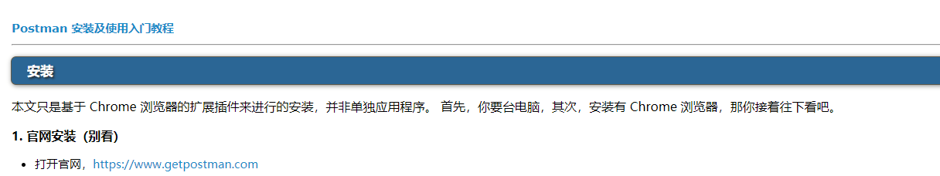
https://www.cnblogs.com/mafly/p/postman.html
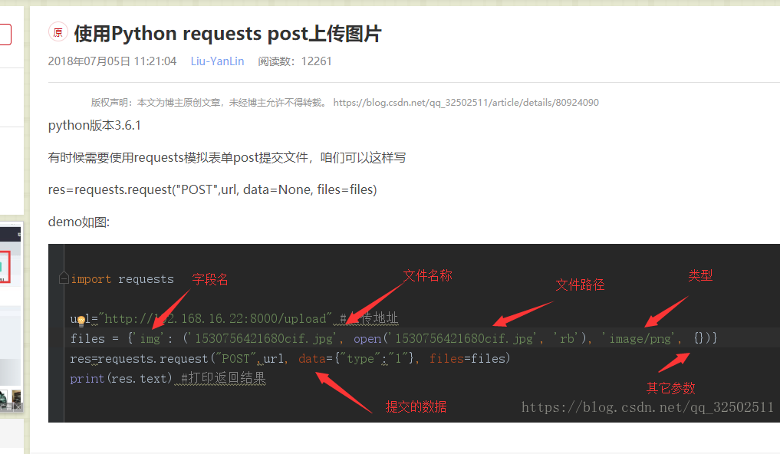
https://blog.csdn.net/qq_32502511/article/details/80924090

https://www.cnblogs.com/juandx/p/4962089.html
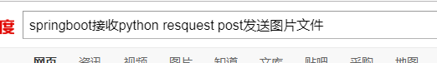

https://blog.csdn.net/five3/article/details/74913742
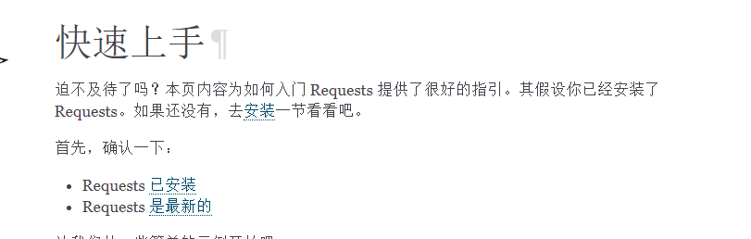
http://docs.python-requests.org/zh_CN/latest/user/quickstart.html

