SpringBoot跳转页面详解+thymeleaf
https://blog.csdn.net/jintingbo/article/details/81633615

使用AJAX实现页面跳转
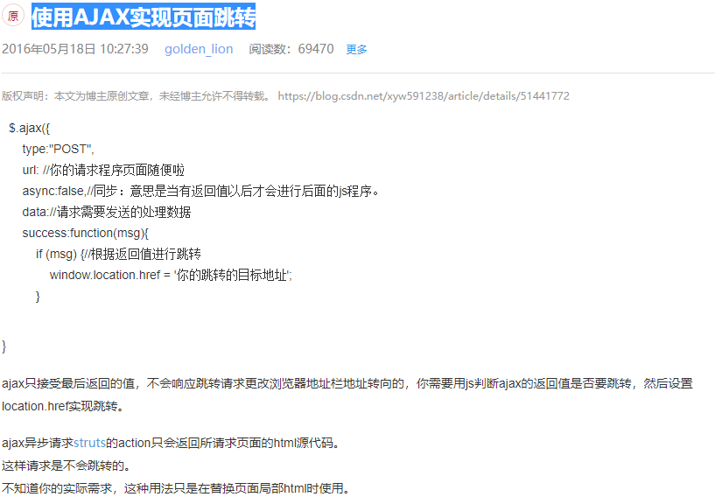
ajax获取String json对象
https://blog.csdn.net/liuhailiuhai12/article/details/59483564

https://blog.csdn.net/twinkle2star/article/details/75315235

Gson在java对象和json字符串之间转换
https://blog.csdn.net/JQ_AK47/article/details/52685298

对jQuery ajax请求成功（失败）回调执行前的统一处理（兼容较老版本jQuery）
https://blog.csdn.net/fendouzhe123/article/details/26622805

https://www.google.com/search?q=ajax%E8%BF%94%E5%9B%9E%E6%88%90%E5%8A%9F%E5%92%8C%E5%A4%B1%E8%B4%A5&rlz=1C1CHBD_zh-CNJP840JP840&oq=ajax%E8%BF%94%E5%9B%9E%E6%88%90%E5%8A%9F%E5%92%8C%E5%A4%B1%E8%B4%A5&aqs=chrome..69i57.4583j0j7&sourceid=chrome&ie=UTF-8

Springboot之返回json数据格式的两种方式-yellowcong
https://blog.csdn.net/yelllowcong/article/details/79718068
springboot response返回200但是ajax cancel
https://www.google.com/search?rlz=1C1CHBD_zh-CNJP840JP840&ei=0LyUXPfcNoHK8wWFgKQQ&q=springboot+response%E8%BF%94%E5%9B%9E200%E4%BD%86%E6%98%AFajax+cancel&oq=springboot+response%E8%BF%94%E5%9B%9E200%E4%BD%86%E6%98%AFajax+cancel&gs_l=psy-ab.3...1901.1901..2137...0.0..0.214.214.2-1......0....1..gws-wiz.qkbASkTm8EU

https://blog.csdn.net/xyw591238/article/details/51441772

https://blog.csdn.net/jintingbo/article/details/81633615

