**INFSCI 2560 Assignment 3**

Zhimeng Luo, [ZHL123@pitt.edu](mailto:ZHL123@pitt.edu), 4222308

1. Login

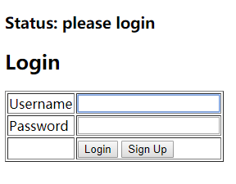

Default username is **admin** and password is **admin**.

1. Sign Up

Click Sign Up button if you want to create your account.

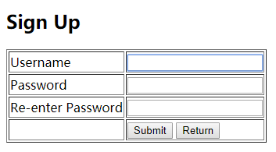

Click Submit to create your account. Click Return button to login page.

1. Homepage

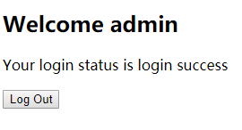

1. Log Out

Click Log Out to log out and return to login page.