**Objective**

**Deploy Final Project**

*Google Cloud operation Suite (<https://cloud.google.com/products/operations>).

*Benchmarking Tool Info: (<https://www.datadoghq.com/blog/apachebench/>)

*Setting up Monitoring/Logging Agents: (<https://www.cloudskillsboost.google/focuses/10599?parent=catalog>)

*Deploying Flask App to Google Compute Engine

(<https://www.section.io/engineering-education/deploy-flask-to-gce/>)

**Step 1: Select your Project**

From the GCP console either create a new project or select an existing one. For this project I created one named “real-estate”.

**Step 2: Create a Compute Engine VM Instance**

Navigate to the Compute Engine tab and click on “Create Instance''. Choose your machine type (CPU etc: for the final project I choose one with more memory and CPU but will shut it down after it gets graded to avoid building up charges) and make sure for the firewall you allow HTTP/HTTPS traffic. And also make sure to enable Cloud API access scope to allow full access to all Cloud APIs. Wait until you see a green check mark status to let you know the instance has launched.

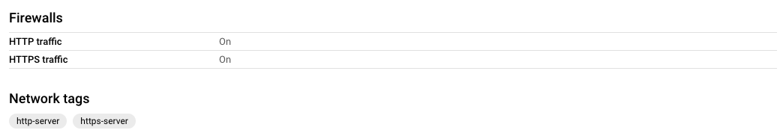

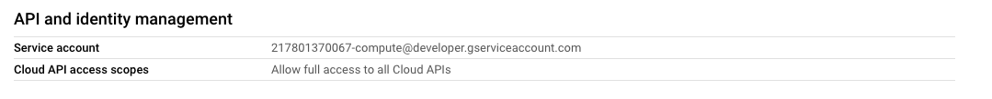

**Step 3: Update your VM**

From the project console page click on the SSH icon to open a terminal to connect to the instance. With any virtual machine you will want to update it with the following command

| sudo apt update |
| --- |

**Step 4: Install Git**

| sudo apt install git |
| --- |

* Ensure to have your requirement.txt file in your app folder that lists all the dependencies to deploy your app such as Flask.

**Step 5: Clone your Github Repo to your instance**

| git clone https://github.com/luperodriguez/MSDS434Project.git |
| --- |

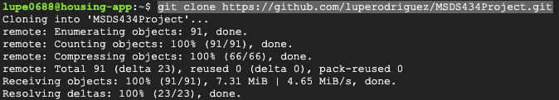

**Step 6: Change into the directory where your app file is located**

| cd MSDS434Project |
| --- |

| cd Front-End/source-code/app/ |
| --- |

| ls |
| --- |

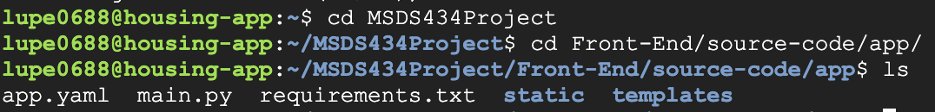

**Step 7: Deploy your App**

Prior to deploying your app ensure that you have permission to view applications on the project and that 217801370067-compute@developer.gserviceaccount.com has the App Engine Deployer (roles/appengine.deployer) role. If not then edit to add that role to that principle, see below:

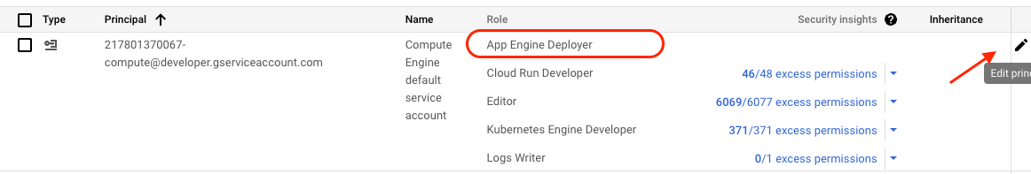

| gcloud app deploy app.yaml |
| --- |

*If you get an error again regarding having permission to view applications on the project. You can authorize with the following command:

| gcloud auth login |
| --- |

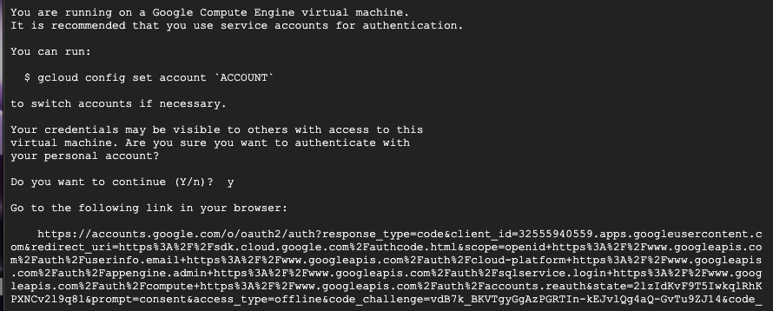

Copy the link to your browser and it will prompt you to sign in and redirect you to the SDK page to provide you with a verification code that you will enter into the terminal

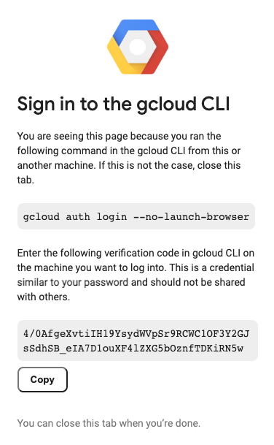

| gcloud app deploy app.yaml |
| --- |

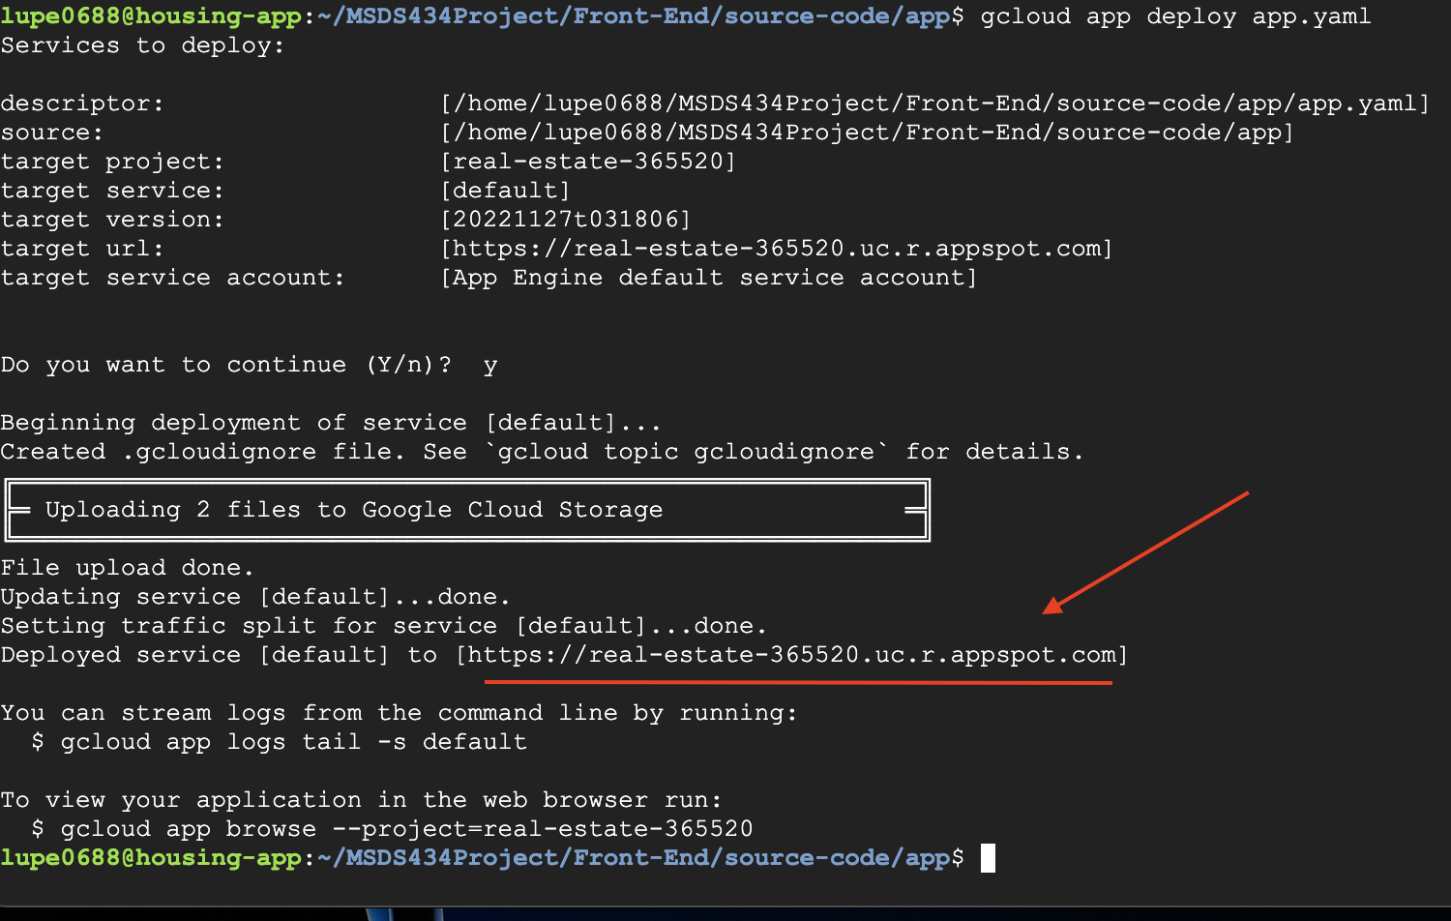

**Step 8: Add Apache2 HTTP Server to the instance**

From the project console page click on the SSH icon to open a terminal to connect to the instance.

Run the following commands on the terminal:

| sudo apt-get update |
| --- |

| sudo apt-get install apache2 php7.0 |
| --- |

| sudo apt-get install -y apache2-utils |
| --- |

When asked if you want to continue, enter **Y**.

| sudo service apache2 restart |
| --- |

**Step 9: Check External IP for Apache2 Default Page**

Return to the Cloud Console, on the VM instances page. Click the External IP for lamp-1-vm instance to see the Apache2 default page for this instance.

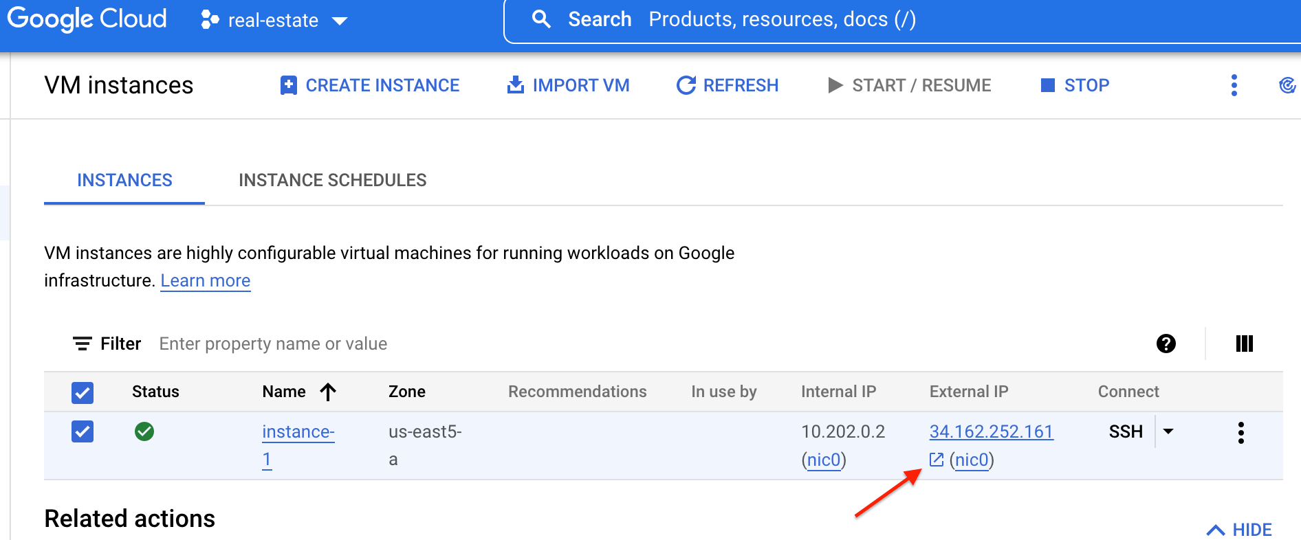

Once clicking the External IP (or copying and pasting IP to browser) from the console page it should open up the Apache2 Default page letting you know it works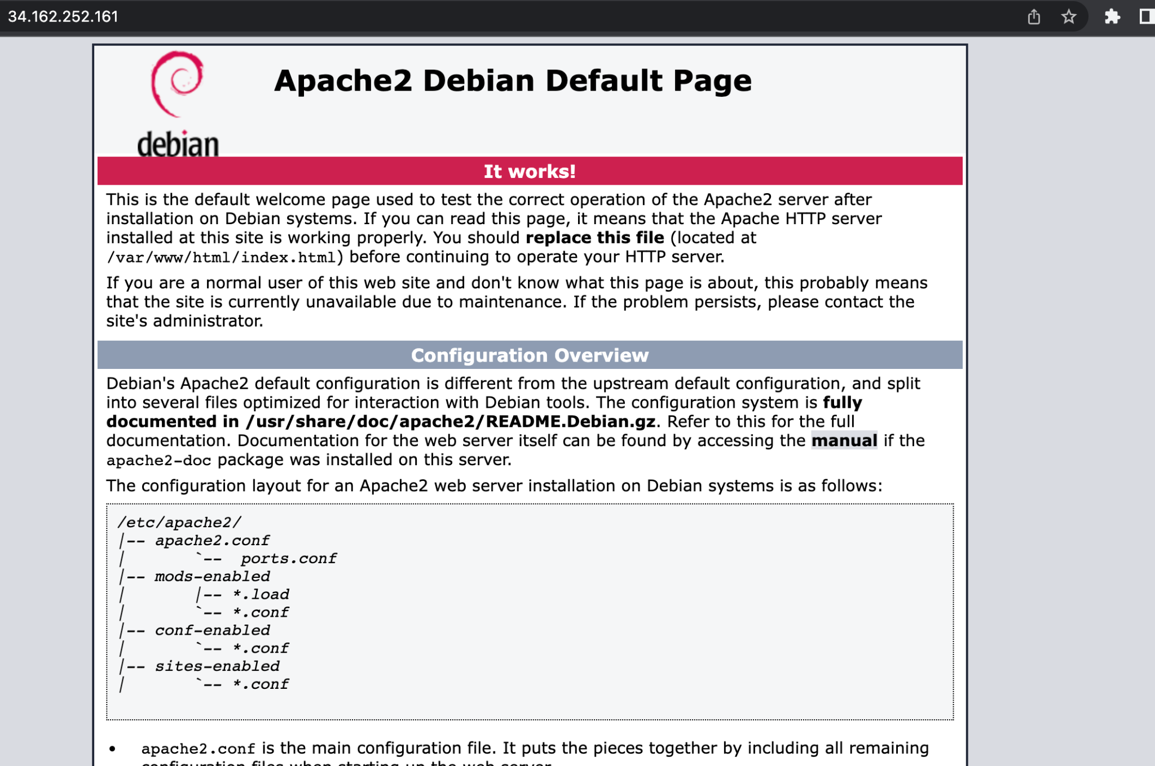.

**Step 10: Install the Monitoring Agents**

Set up a Monitoring Metric Scope by navigating to the Monitoring page in the console. Through the Overview page you will be able to set up alerts.

Run the Monitoring agent install script command in the SSH terminal of the VM instance to install the Cloud Monitoring agent through the following commands:

| curl -sSO https://dl.google.com/cloudagents/add-google-cloud-ops-agent-repo.sh |
| --- |

| sudo bash add-google-cloud-ops-agent-repo.sh --also-install |
| --- |

**Step 11: Install the Logging Agents**

Run the Logging agent install script command in the SSH terminal of the VM instance to install the Cloud Logging agent through the following commands:

| sudo systemctl status google-cloud-ops-agent"*" |
| --- |

| sudo apt-get update |
| --- |

**Step 12: Create an uptime check**

To confirm that the VM is always accessible, create an uptime check through the Monitoring page Menu and set the following parameters. Click on Test to verify that your uptime check can connect to the VM when you get a green check mark, click Create.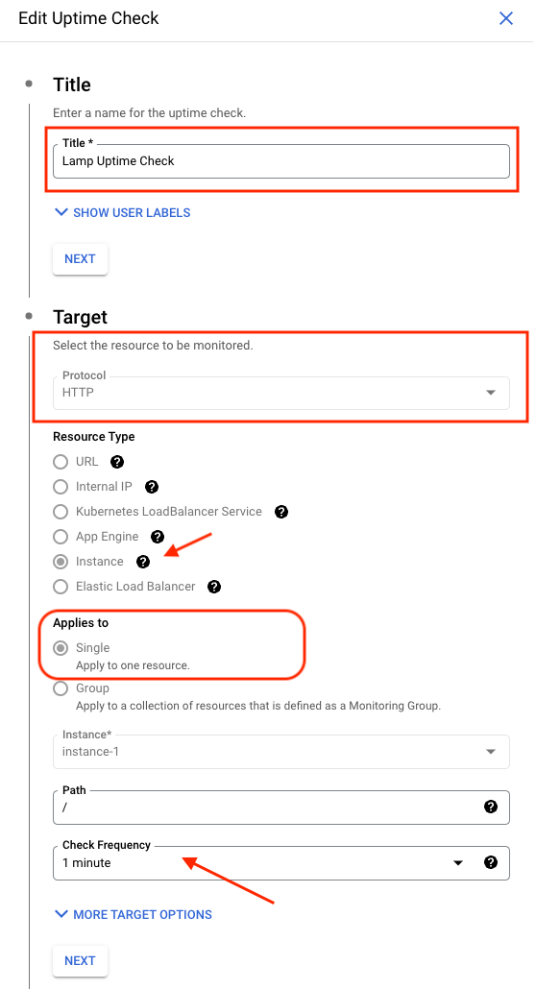

**Step 13: Create an Alerting Policy**

Create an alerting policy by navigating to the Monitoring page Menu and selecting the Alerting page. Through the Alerting page click on the CREATE POLICY icon and set up the following fields when selecting the metrics. 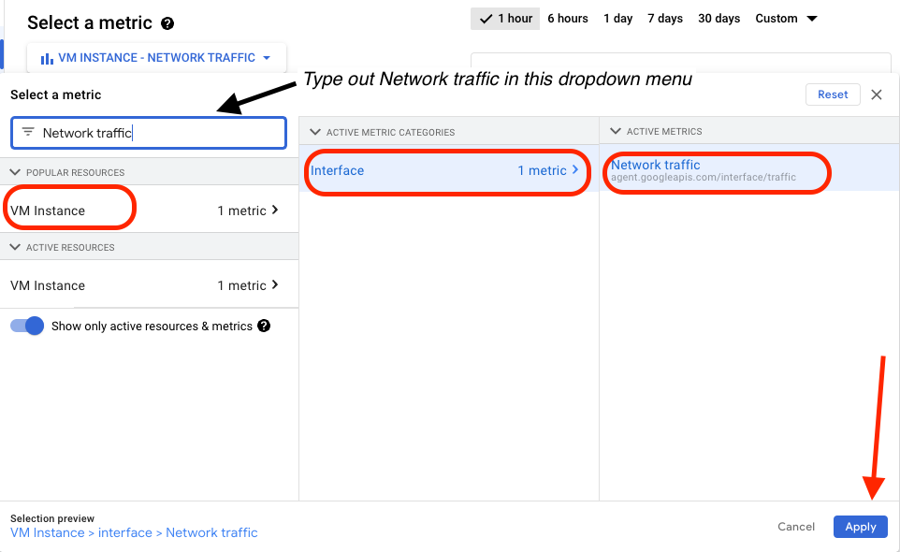

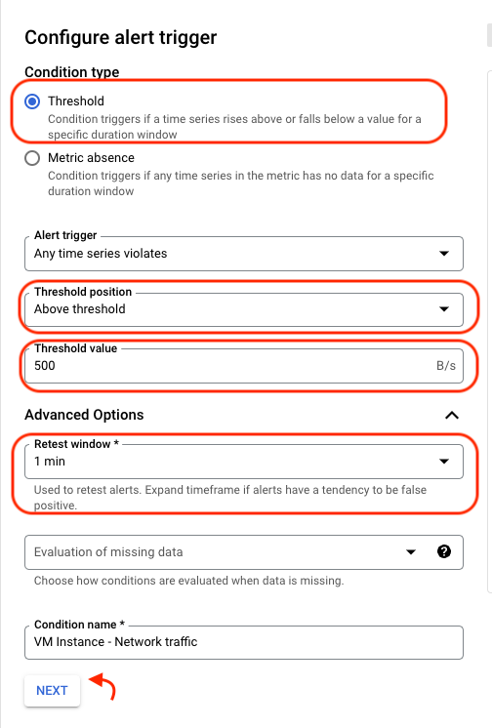

After applying the field above, click next to set your condition type and configure the alert trigger. Apply the following fields (highlighted in red) →

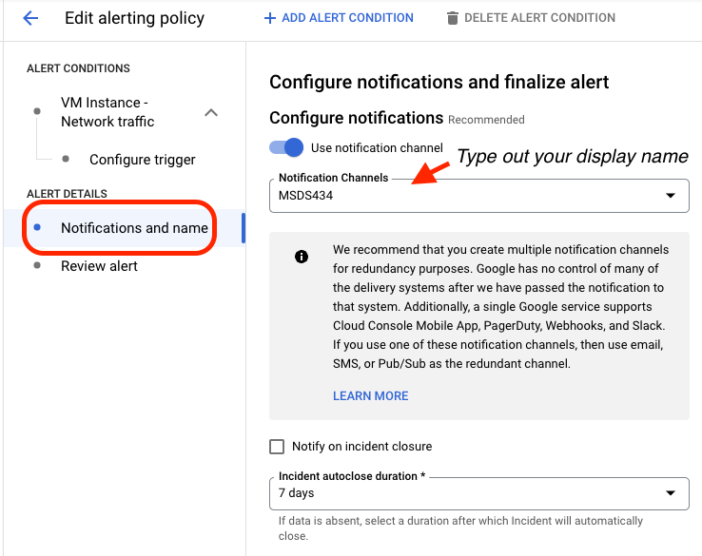

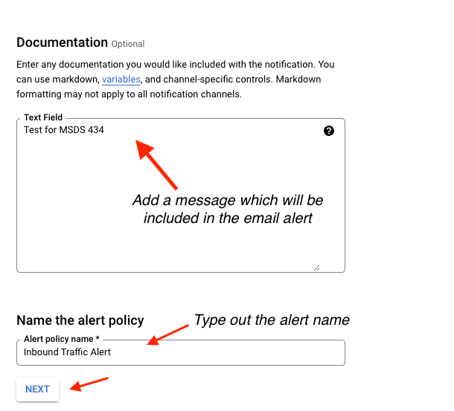

After reviewing the alert click on CREATE POLICY.

**Step 14: Create a Dashboard**

Create a dashboard to visualize your metrics by navigating to the Monitoring page Menu and selecting the Dashboards page. Through the Dashboard page click on the +CREATE DASHBOARD icon and complete the setup by following the example below.

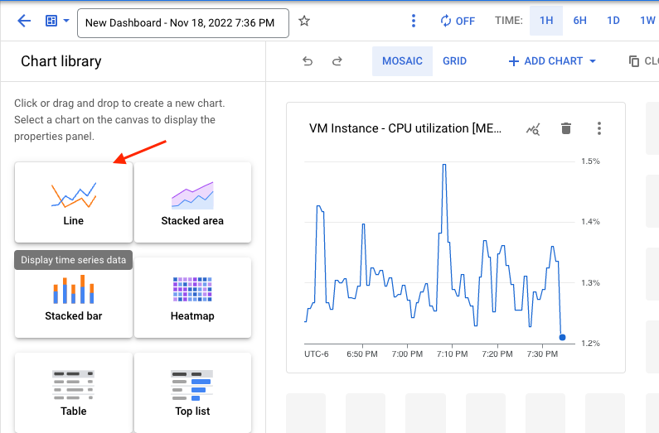

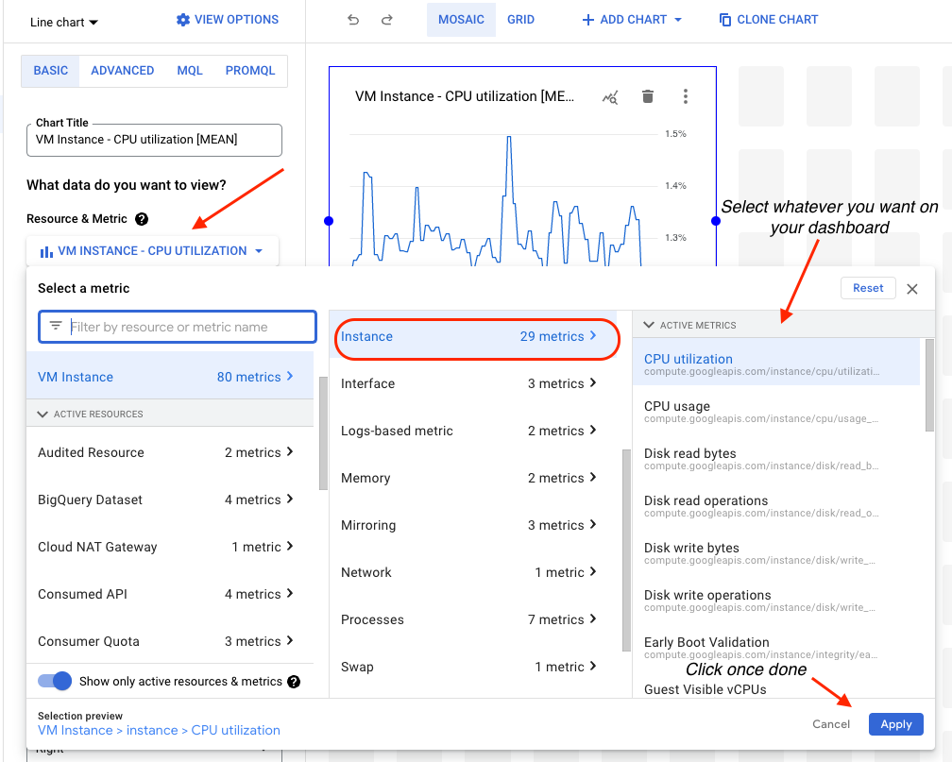

**Step 15: Monitor your Logs**

To monitor the logs on the VM instance navigate to the Logging page from the Monitor navigation menu and select Logs Explorer.  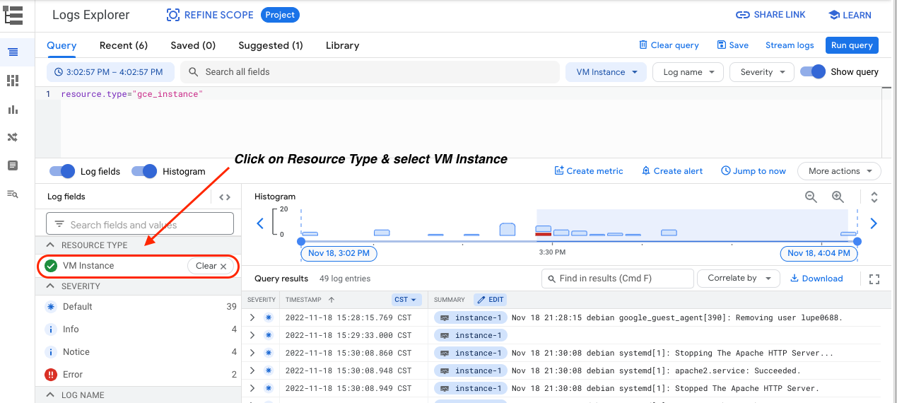

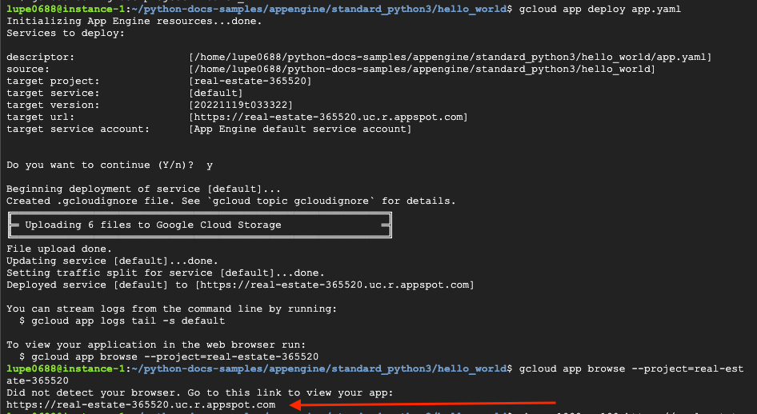

Result:

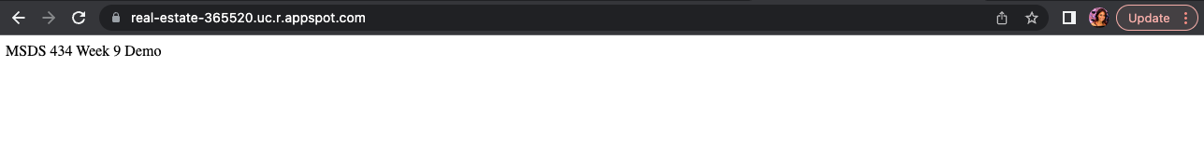

**Step 16: Perform Web Server Performance Testing**

Using ApacheBench ‘ab’ we can send a request argument

* -n: The number of requests to send
* -c: The number of concurrent requests to make

Template: ab -n 100000 -c 1000 <SERVER_ADDRESS>

| ab -n 1000 -c100 https://real-estate-365520.uc.r.appspot.com/ |
| --- |

