**Objective**

Train a multi-class classification model on AutoML.

*Hands-off machine learning with Google AutoML*[*https://towardsdatascience.com/hands-off-machine-learning-with-google-automl-e63b079f09d1*](https://towardsdatascience.com/hands-off-machine-learning-with-google-automl-e63b079f09d1)

*https://www.linkedin.com/pulse/using-google-automl-tables-predict-house-prices-victor-dantas-mehmeri*

**Step 1:** **Create a GCP project (Assuming you don’t already have a project)**

Once logged in to the Google Cloud console, you will create a new project by naming it and making sure that it has a billing profile attached to it. Once created, make sure that you select that project so that you are working under it, you should see a page that prompts you that “You’re working in <name of project>”.

**Step 2: Configure your project**

Click on the cloud shell icon on the right hand side of the page otherwise you can search for it on the search bar. If you were able to open it up via the cloud shell icon in the project page it should automatically be configured to that project on the shell. However, if it’s not, you will need to configure it through the following commands.

| **gcloud** projects list |
| --- |

| **gcloud** config set project <name **of** project> |
| --- |

**Step 3: Load your data to a cloud storage bucket**

Upload CSV data file either through the power shell or through the GUI console. The larger the dataset the longer it will take to upload. For example the Redfin dataset for city housing market that contains over 4 million rows of data took overnight for it to upload as a dataset in Vertex AI.

**Step 4: Enable Vertex AI API (& recommended APIs)**

Search Vertex AI through the search bar and enable it. Once enabled, scroll through the left hand side icons to locate the “Dataset” icon.

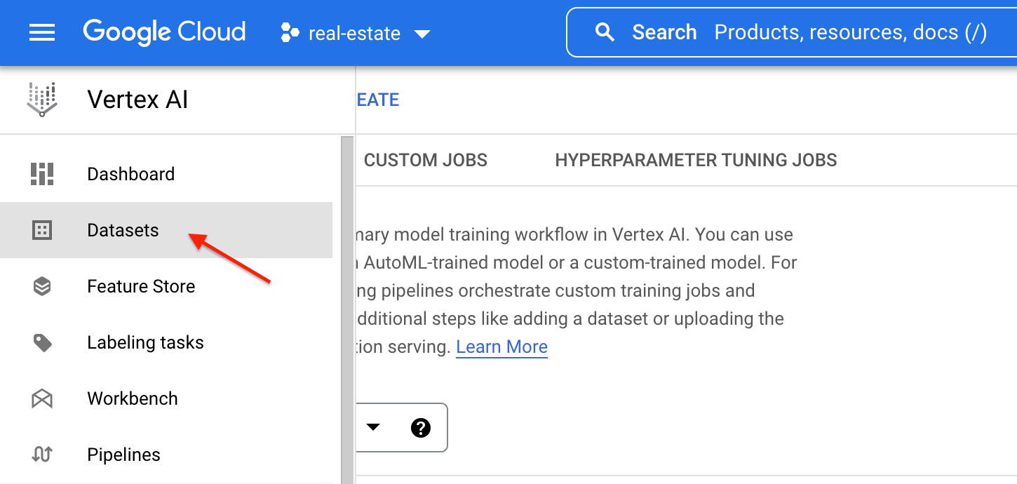

**Step 5: Create a dataset**

Create a dataset by uploading your data file either through your local computer, cloud storage, or BigQuery.