**Objective**

**Use the Google Cloud Platform Billing API and create a cost forecast using BigQuery ML.**

[**https://cloud.google.com/billing/docs/how-to/export-data-bigquery-setup**](https://cloud.google.com/billing/docs/how-to/export-data-bigquery-setup)

[**https://medium.com/google-cloud/google-cloud-export-billing-data-to-bigquery-ce004fb87ce3**](https://medium.com/google-cloud/google-cloud-export-billing-data-to-bigquery-ce004fb87ce3)

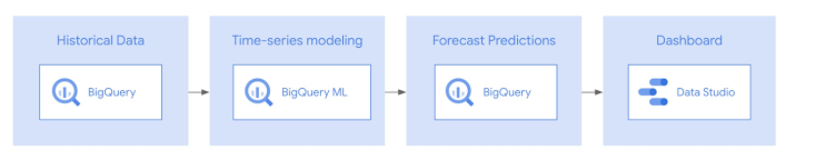

**Step 1: Enable Cloud Billing data export to BigQuery.**

Select an existing project or create a new project and assign its required roles and permissions. This project (real-estate, in this case) will be used to store billing data at regular intervals in a BigQuery dataset. Enable the following APIs in the same project :

* BigQuery Data Transfer API
* Cloud Billing API

**Step 2: Create a BigQuery Dataset**

Create a dataset under the project where you will be exporting the billing data. You can do this through the BigQuery page through the dropdown menus for that project. Once you have named that dataset, remember it as you will be asked about it in a later time when exporting.

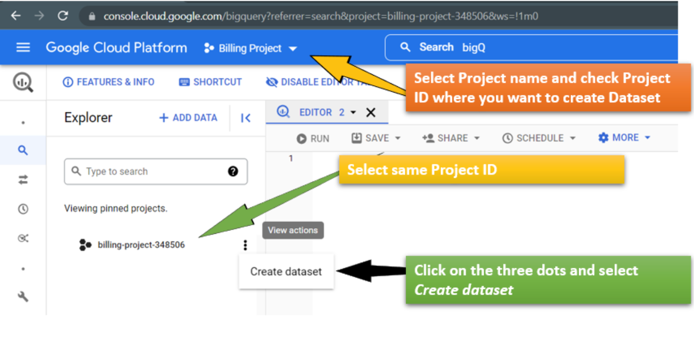

**Step 3: Export Billing Data into Dataset**

To enable your *Cloud Billing usage cost or pricing data* to be exportedto *BigQuery,* navigate to the Billing page and on the dropdown menu locate “Billing Export”. From there you can edit “standard usage cost” and “detailed usage cost” by clicking the EDIT SETTINGS button under each category to define to which dataset you will be exporting to.

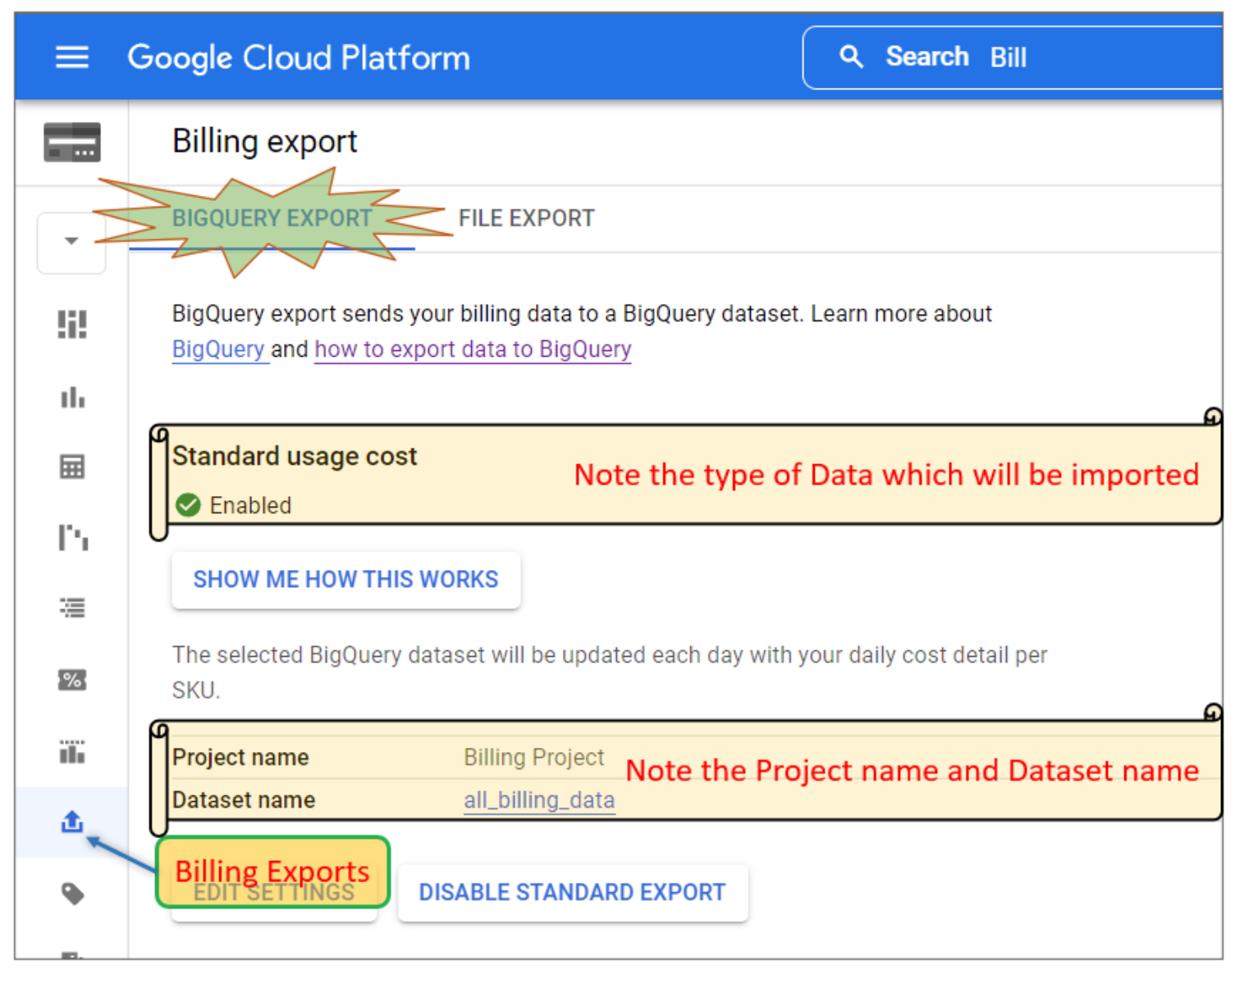

*** Important to note that after you update the settings and see a green enable check mark it will take a couple of hours for that data to populate into your dataset. According to the medium article it can take up to 48 hours.

References:

<https://medium.com/towards-data-science/how-to-do-time-series-forecasting-in-bigquery-af9eb6be8159>

<https://github.com/GoogleCloudPlatform/bigquery-oreilly-book/blob/master/blogs/bqml_arima/bqml_arima.ipynb>

https://medium.com/mlearning-ai/building-a-demand-forecasting-model-with-google-cloud-vertex-ai-and-bigquery-ml-8dd2b7ee5014